Supplementary Information

Polarization Effects on Interfacial Migration Between Molten Fe–Tramp Elements (Cu, Sn, Ni, Cr) and Molten Oxide Containing FeS
Masahiro Ambiru^{1,+}, Shungo Natsui^{2,*}, Akihisa Ito^{2,+}, Miho Hayasaka^{2,+}, and Hiroshi Nogami^{2,+}
¹Graduate School of Engineering, Tohoku University, Katahira 2−1−1, Aoba−ku, Sendai, Miyagi 980−8577, Japan
²Institute of Multidisciplinary Research for Advanced Materials, Tohoku University, Katahira 2−1−1, Aoba−ku, Sendai, Miyagi 980−8577, Japan
*natsui@tohoku.ac.jp
+these authors contributed equally to this work

Supplemental Note 1: Current–time curves
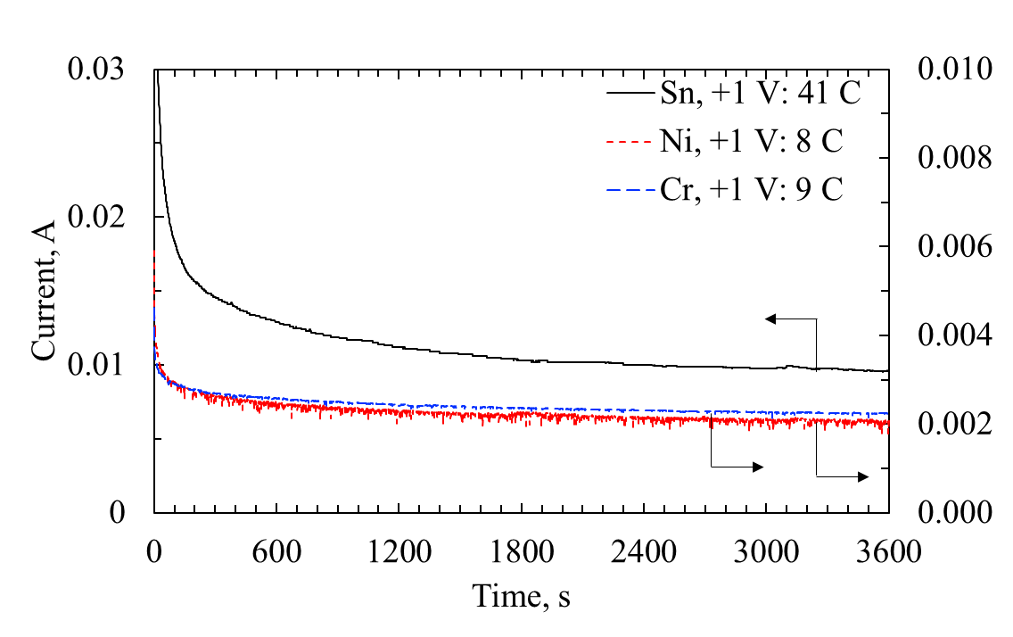
Fig. S1 | Time variations of current during constant−potential electrolysis. Current–time curves for experiments #2, #4, and #6 are shown as representative results of constant−potential electrolysis.

Supplemental Note 2: Formal Standard Formation Potentials for Oxidation and Sulfidation (1873 K)
This supplemental table summarizes formal standard electrode potentials (E°) at T = 1873 K for oxide and sulfide formation reactions of Fe, Cu, Sn, Ni, and Cr. The standard Gibbs energy change is expressed as:
$∆G°\left(T\right)=A+BT\log{T}+CT [J/mol]$ (S1)
$E°\left(T\right)=\frac{∆G°}{nF}[V], F=96485 [C/mol]$ (S2)
Here, ΔG°(T) denotes the standard Gibbs energy change normalized to 1 mol of the compound produced (e.g., divide by 2 for reactions producing 2 mol of oxide/sulfide), n is the number of electrons associated with forming 1 mol of the compound (e.g., n = 2 for MO with M²⁺; n = 2 for Cu₂O and Cu₂S; n = 6 for Cr₂O₃; n = 4 for Ni₃S₂).
Table S1 | Estimated standard electrode potentials for oxidation and sulfidation (1873 K).
A. Oxide systems (O₂ basis)
Formation reaction | ΔG° at 1873 K [kJ] | ΔG° per mol compound [kJ/mol] | n | E° [V]
4Cu(l) + O₂(g) = 2Cu₂O(l) | –79.802 | –39.901 | 2 | –0.2068
2Sn(l) + O₂(g) = 2SnO(g) | –174.917 | –87.458 | 2 | –0.4532
2Ni(l) + O₂(g) = 2NiO(s) | –149.004 | –74.502 | 2 | –0.3861
2Fe(l) + O₂(g) = 2FeO(l) | –295.767 | –147.883 | 2 | –0.7664
4/3Cr(s) + O₂(g) = 2/3Cr₂O₃(s) | –436.490 | –654.735 | 6 | –1.1310
B. Sulfide systems (S₂ basis)
Formation reaction | ΔG° at 1873 K [kJ] | ΔG° per mol compound [kJ/mol] | n | E° [V]
4Cu(l) + S₂(g) = 2Cu₂S(l) | –142.424 | –71.212 | 2 | –0.3690
2Sn(l) + S₂(g) = 2SnS(g) | –122.675 | –61.338 | 2 | –0.3179
3Ni(l) + S₂(g) = Ni₃S₂(l) | –116.081 | –116.081 | 4 | –0.3008
2Fe(l) + S₂(g) = 2FeS(l) | –110.248 | –55.124 | 2 | –0.2857
Cr(s) + 1/2 S₂(g) = CrS(s) | –96.723 | –96.723 | 2 | –0.5012
References
Knacke O, Kubaschewski O, Hesselmann K. Thermochemical Properties of Inorganic Substances. 2nd ed. Berlin: Springer−Verlag; 1991.
Oikawa K, Mitsui H, Ohtani H, Ishida K. Thermodynamic calculations of phase equilibria in the Fe–Cr–S system. ISIJ Int. 2000;40:182–190.

Supplemental Note 3: Thermodynamic interpretation using Wagner interaction parameters

Activities of dilute solutes in molten iron were discussed using Wagner’s first–order interaction parameter formalism:
$lnγ_{i}=\sum_{j}{ε_{ij}w_{j}}$ (S3)
Here, γ_{i} is the activity coefficient of solute i in molten Fe, ε_{ij} is the interaction parameter (wt% basis), and w_{j} is the solute concentration (wt%). On the grounds that insufficient data was found, the Cu–Ni interaction was set to zero (ε_{Cu,Ni} = 0). Table S2 lists the interaction parameters ε_{ij} used for the five–component subspace: Cu, Sn, Ni, Cr, S. Temperature–dependent terms were evaluated at 1873 K.
Table S2 | Estimated interaction parameters ε_{ij} (wt% basis).
i / j | Cu | Sn | Ni | Cr | S
Cu | –5.4 | –0.013 | 0 | 3.9 | –2.4
Sn | –0.024 | 0.0017 | –6.8 | 0.015 | –0.028
Ni | 0 | –6.8 | 0.0007 | 0 | –0.1
Cr | 4.1 | 0.009 | 0 | 0.005 | –22
S | –2.3 | –0.0044 | –0.1 | –22 | –5.7

Contribution analysis of lnγ_{i}
Using the composition in metal (wt%): Cu = 0.5, Sn = 0.2, Ni = 0.2, Cr = 0.2, S = 0.286, Eq. (S3) was evaluated and decomposed into individual contributions ε_{ij}·w_{j}. Each contribution in Table S3 is reported in natural log units (ln).
Table S3 | Estimated activity coefficient of solute i in molten Fe.
i | Cu contrib. | Sn contrib. | Ni contrib. | Cr contrib. | S contrib. | ln γ_{i} | γ_{i}
Cu | –2.700 | –0.003 | 0.000 | 0.780 | –0.686 | –2.609 | 0.0736
Sn | –0.012 | 0.000 | –1.360 | 0.003 | –0.008 | –1.377 | 0.252
Ni | 0.000 | –1.360 | 0.000 | 0.000 | –0.029 | –1.388 | 0.250
Cr | 2.050 | 0.002 | 0.000 | 0.001 | –6.292 | –4.239 | 0.0144
S | –1.150 | –0.001 | –0.020 | –4.400 | –1.630 | –7.201 | 0.000746

In the absence of applied potential, transfer from metal to slag is considered by chemical equilibrium involving sulfide formation/partitioning: i(in Fe) + S(in Fe) ⇌ iS(in slag)
Table S3 shows that sulfur in the metal has a very small activity coefficient (lnγ_{S} = –7.201, γ_{S} ≈ 7.46×10^{–4}), dominated by the strong negative contribution of Cr (ε_{S},_{Cr}·w_{Cr} = –4.400) and the sulfur self–term (ε_{S},_{S}·w_{S} = –1.630). Under such low effective sulfur activity in the metal, removal is not determined by γ_{i} alone; it is strongly influenced by the stability (low activity) of iS species in the slag (i.e., the slag–side ‘capacity’ for each sulfide). Thus, Sn and Cr can still be preferentially removed if the slag stabilizes SnS and CrS (or related sulfide/oxide species) more strongly than Ni sulfide under the present slag chemistry.
Notes on applied potential (1 V) and interfacial effects
When a potential is applied across the metal–slag interface, the final metal compositions differ from those at 0 V. This suggests additional electrochemical/interfacial effects beyond bulk chemical equilibrium, such as electric–double–layer formation and electrocapillarity that can modify interfacial adsorption and the effective reaction area.
References
Hino, M. & Ito, K. (eds) Thermodynamic Data for Steelmaking (Tohoku University Press, 2010).
Ueda, S. Measurements and theoretical predictions of thermodynamic properties of trace elements in molten iron. PhD thesis, The University of Tokyo. https://doi.org/10.15083/0002002001 (2019).

