Supplementary Figure S1. Raw read mapping of the assembled complete plastomes and 45S nrDNA in the Green Leaf Tissue and Albino Leaf Tissue of five Cornus cultivars. (A-B) C. florida Cherokee Daybreak; (C-D) C. kousa Doudou; (E-F) C. kousa Melanie; (G-H) C. kousa Tom Wood; (I-J) C. kousa Rutban

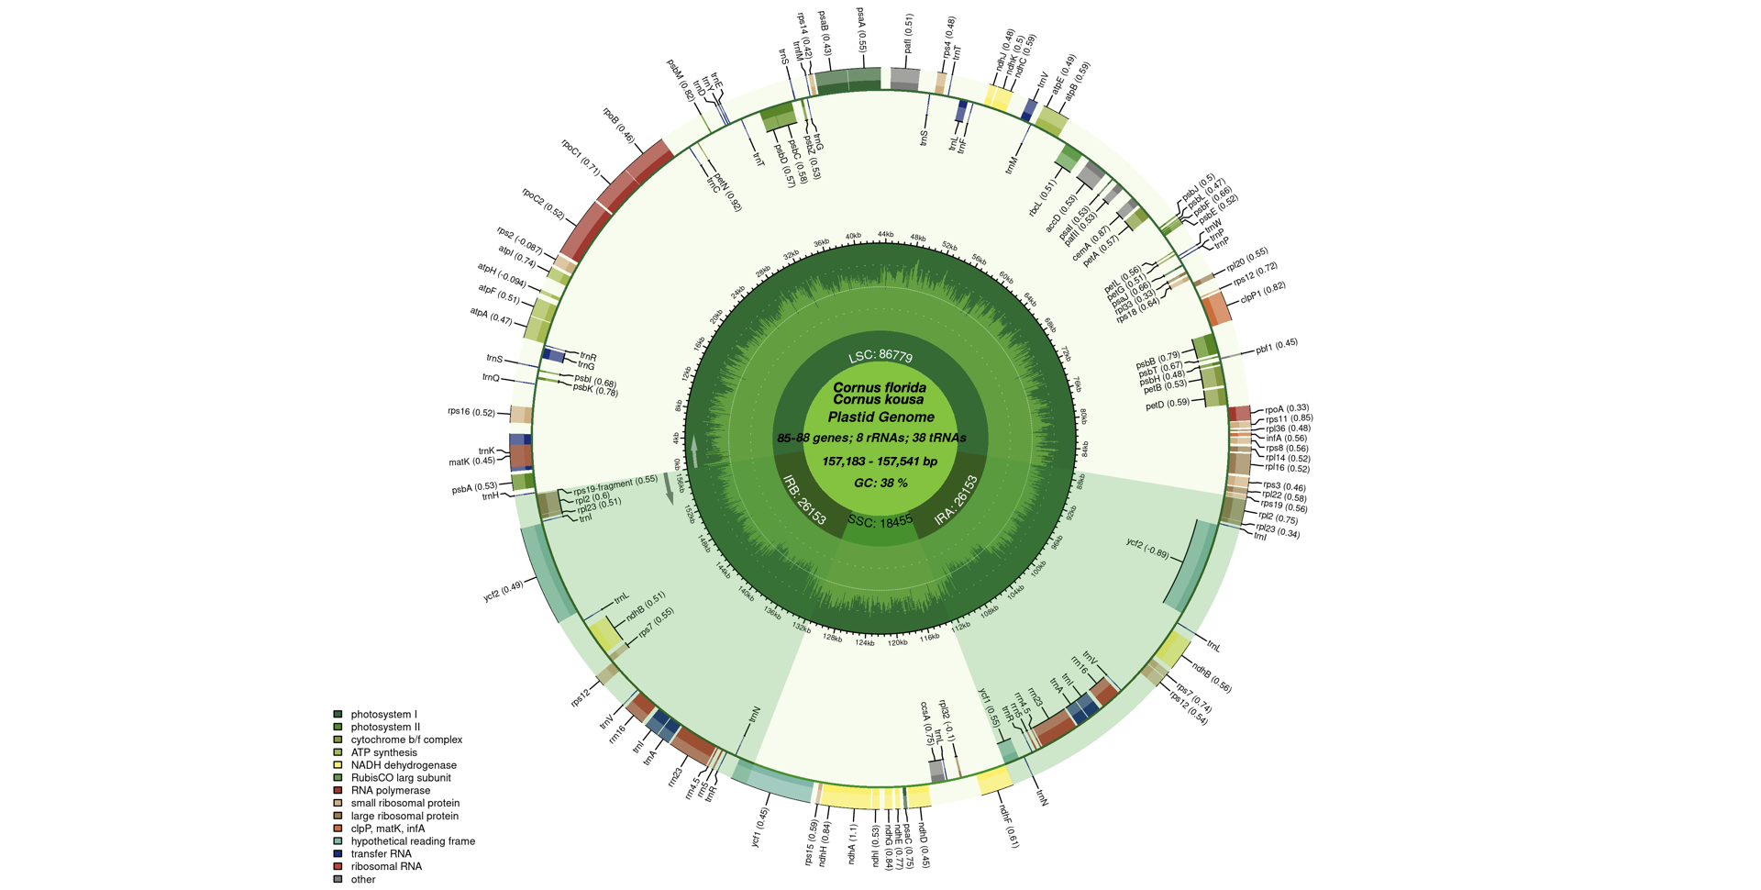
Supplementary Figure S2. Representative circular map of the Cornus florida and C. kousa cultivars chloroplast genome. Colored boxes represent genes. Genes situated within the circle are transcribed in a clockwise orientation, and genes external to the circle are transcribed in a counter-clockwise orientation. Dark green bar graphs in the inner circle indicate GC contents.

Supplementary Figure S3. Protein models of matK, rpoB and ycf3 gene products in the green and albino leaf tissues of Cornus florida Cherokee Daybreak, and C. kousa Melanie and Doudou. (A) C. florida Cherokee Daybreak matK amino acid sequence in green leaf tissue (GLT, top) and albino leaf tissue (ALT, bottom). A zoom of amino acid sequences from 25 to 33 with emphasis on position 29, TYR = tyrosine and ASP = aspartic acid, and their altered structural conformation (B) C. kousa Melanie rpoB amino acid sequence in GLT (top) and ALT (bottom). A schematic representation of the plastid-encoded RNA polymerase (PEP) β-subunit showing the regions of the protein structure: protrusion, lobe, flap, clamp, gate loop (GL), and fork loop (FL). In the PEP-associated proteins (PEP-PAP) complex, pink, encircled with dotted lines, is the β-subunit of the PEP core. Four RpoB domains are colored blue, light blue, light green, and orange. PAP: PEP-associated proteins (C) C. kousa Doudou ycf3 amino acid sequence in GLT (top) and ALT (inset). Three tetratricopeptide repeats (TPR) domains (blue-grey) in GLT. An illustration of the early assembly of the photosystem I (PSI) with the formation of the PsaA and PsaB heterodimer and assembly factors, Ycf3, Y3IP2, and Pyg7.

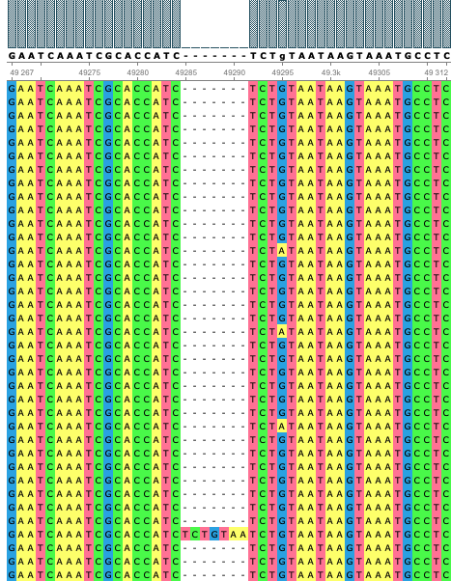
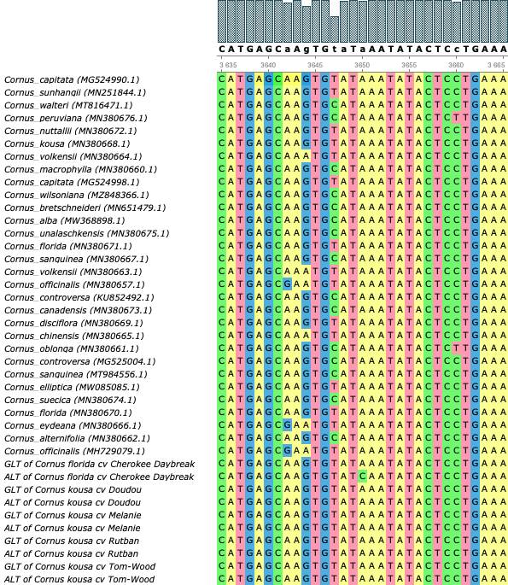
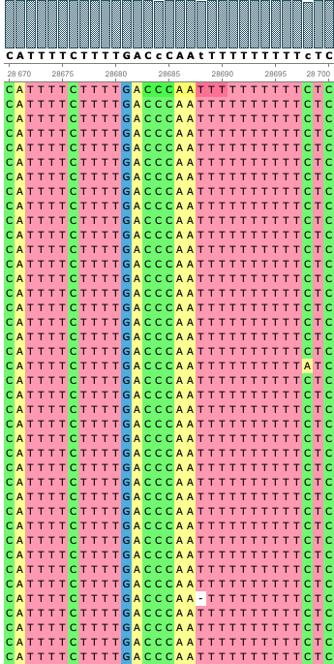
C
B
A

Supplementary Figure S4. Variations among genus Cornus and chimeric plants. Sequences comparison of the mutation sites among the genus Cornus and sequencing samples. (A) C. florida cv. Cherokee Daybreak matK gene; (B) C. kousa cv. Melanie rpoB gene; (C) C. kousa cv. Doudou ycf3 gene.

Supplementary Table S1. NGS data of plastomes and 45S nrDNAs of Cornus chimeric cultivars
No. | Scientific name | Leaf tissue type* | Sequencing Information
No. | Scientific name | Leaf tissue type* | Raw reads | Trimmed reads | Raw bases/bp | Trimmed bases/bp | Average read depth (x)
 |  |  |  |  |  |  | Plastome | 45S nrDNA
1 | C. florida  Cherokee Daybreak | GLT | 4,249,684 | 3,745,575 | 1,279,154,884 | 973,729,027 | 395.59 | 749.17
1 | C. florida  Cherokee Daybreak | ALT | 4,181,238 | 3,695,217 | 1,258,552,638 | 962,133,750 | 414.50 | 752.81
2 | C. kousa  Melanie | GLT | 3,928,904 | 3,459,287 | 1,182,600,104 | 903,003,441 | 280.80 | 679.92
2 | C. kousa  Melanie | ALT | 3,469,940 | 3,036,369 | 1,044,451,940 | 787,214,543 | 413.62 | 547.55
3 | C. kousa  Doudou | GLT | 4,519,482 | 4,099,958 | 1,360,364,082 | 1,139,251,616 | 230.17 | 249.85
3 | C. kousa  Doudou | ALT | 4,996,568 | 4,613,151 | 1,503,966,968 | 1,274,640,577 | 441.83 | 305.96
4 | C. kousa  Rutban (Aurora®) | GLT | 4,077,444 | 3,640,881 | 1,227,310,644 | 1,005,435,326 | 285.10 | 740.76
4 | C. kousa  Rutban (Aurora®) | ALT | 4,940,968 | 4,557,834 | 1,487,231,368 | 1,261,195,656 | 455.86 | 970.52
5 | C. kousa  Tom Wood | GLT | 5,386,994 | 4,962,063 | 1,621,485,194 | 1,370,622,300 | 290.16 | 905.87
5 | C. kousa  Tom Wood | ALT | 5,202,040 | 4,833,603 | 1,565,814,040 | 1,339,045,015 | 626.94 | 762.82
*GLT, Green leaf tissue; ALT, Albino leaf tissue

Supplementary Table S2. Predicting the effects of amino acid substitutions on the GLT and ALT of Cherokee Daybreak matK
Program Name | Amino Acid Substitution | Scores | Prediction | Interpretation | Reference
PROVEAN | Y29D | -4.690 | Deleterious | Default threshold is -2.5, that is:  -Variants with a score equal to or below -2.5 are considered "deleterious,"  -Variants with a score above -2.5 are considered "neutral." | Choi and Chan, 2015
PROVEAN | D29Y | 4.689 | Neutral |  | Choi and Chan, 2015
Note: Y, Tyrosine; D, Aspartic acid

Supplementary Table S3. Designed primer sets to distinguish Cornus florida and C. kousa cultivars
Primer name | Type | Locus | Primer sequence (5’– 3’) | Size/bp | Tm (°C)
C_HRM1 | HRM | matK-rpo16 | F: GTACTCTACCGTTGAGTTAGCAAC | CFC 92 / CKM 99 / CKD 97 / CKR 92 / CKT 98 | 58
C_HRM1 | HRM | matK-rpo16 | R: GCCACTGCCTCGTATAATCTC
C_HRM2 | HRM | psbZ-rps14 | F: GGATTCGGTATAGTTGGCTGTG | CFC 149 / CKM 152 / CKD 151 / CKR 149 / CKT 151 | 58
C_HRM2 | HRM | psbZ-rps14 | R: CAAATCCTGTCTCCGCAACA
CF_1 | HRM | matK | F: ATGGAGGAATTCCAAAGATATTTAGAAC | CFC-GLT 109 / CFC-ALT 108 / CK 109 | 58
CF_1 | HRM | matK | R: AACCACGATCATGAGCAAGTG
CK_1 | HRM | rpoB | F: CCCCGCCTACACAAGCAAAT | CKM-GLT 152 / CKM-ALT 151 / CK 152 / CFC 152 | 59
CK_1 | HRM | rpoB | R: AGCTATGGGTTCGAATCTAAGAGAA
CK_ 2 | Dominant | ycf3 | F: AACTTCACCTTCAACAAGCGT | CKD-GLT 240 / CKD-ALT 247 / CK 240 / CFC 240 | 58
CK_ 2 | Dominant | ycf3 | R: GCCTAGATCGCGAATAAATGGAA
Note: CFC, C. florida Cherokee Daybreak; CKD, C. kousa Doudou; CKM, C. kousa Melanie; CKR, C. kousa Rutban; CKT, C. kousa Tom Wood. GLT, Green leaf tissue; ALT, Albino leaf tissue

