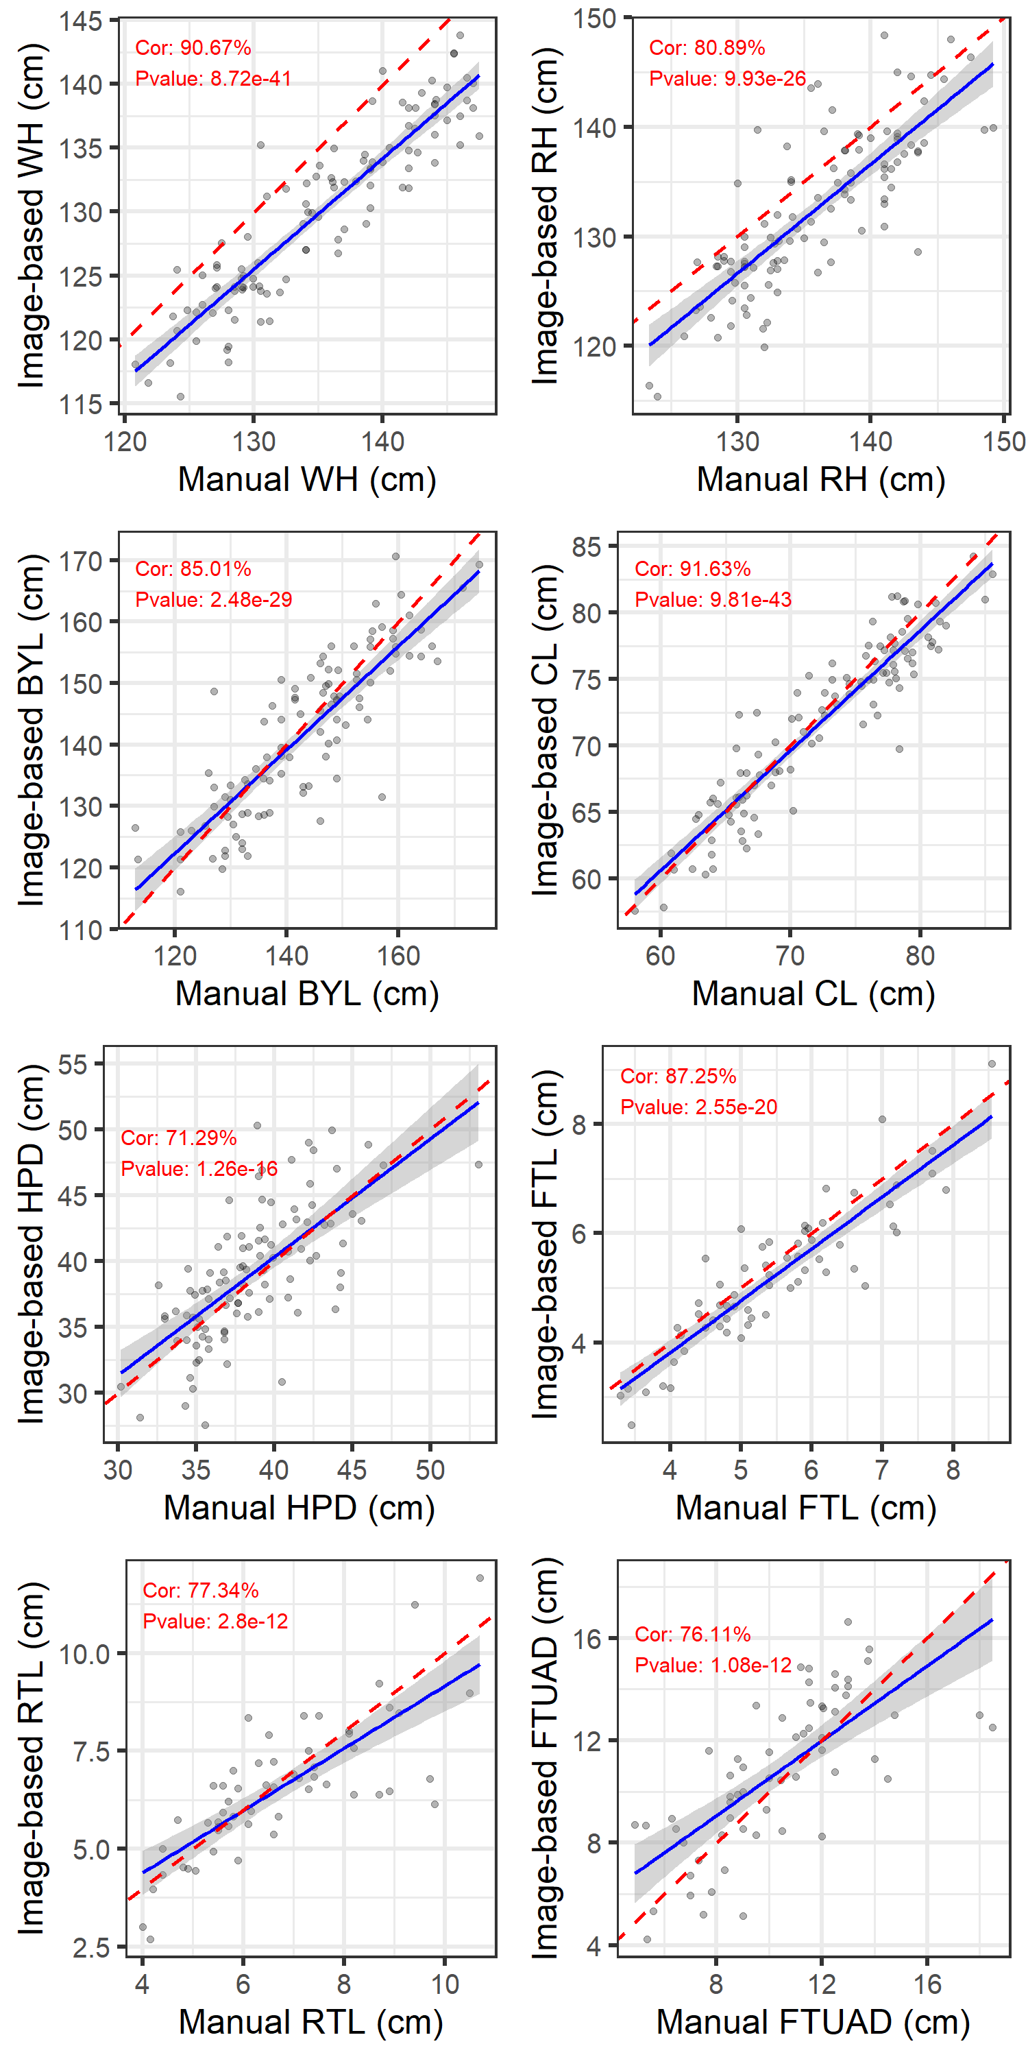
Figure S1. Scatter plots showing the relationship between manual and uncorrected image-based measurements for body traits derived from side views. The solid blue line indicates the fitted linear regression line, and the shaded area represents the 95% confidence interval. The red dashed line corresponds to the line of identity (y = x). Correlation coefficients (Cor) and associated p-values are displayed within each panel. wither height (WH), rump height (RH), body length (BYL), chest length (CL), hip–pin distance (HPD), fore teat length (FTL), rear teat length (RTL), and fore teat–udder attachment distance (FTUAD).

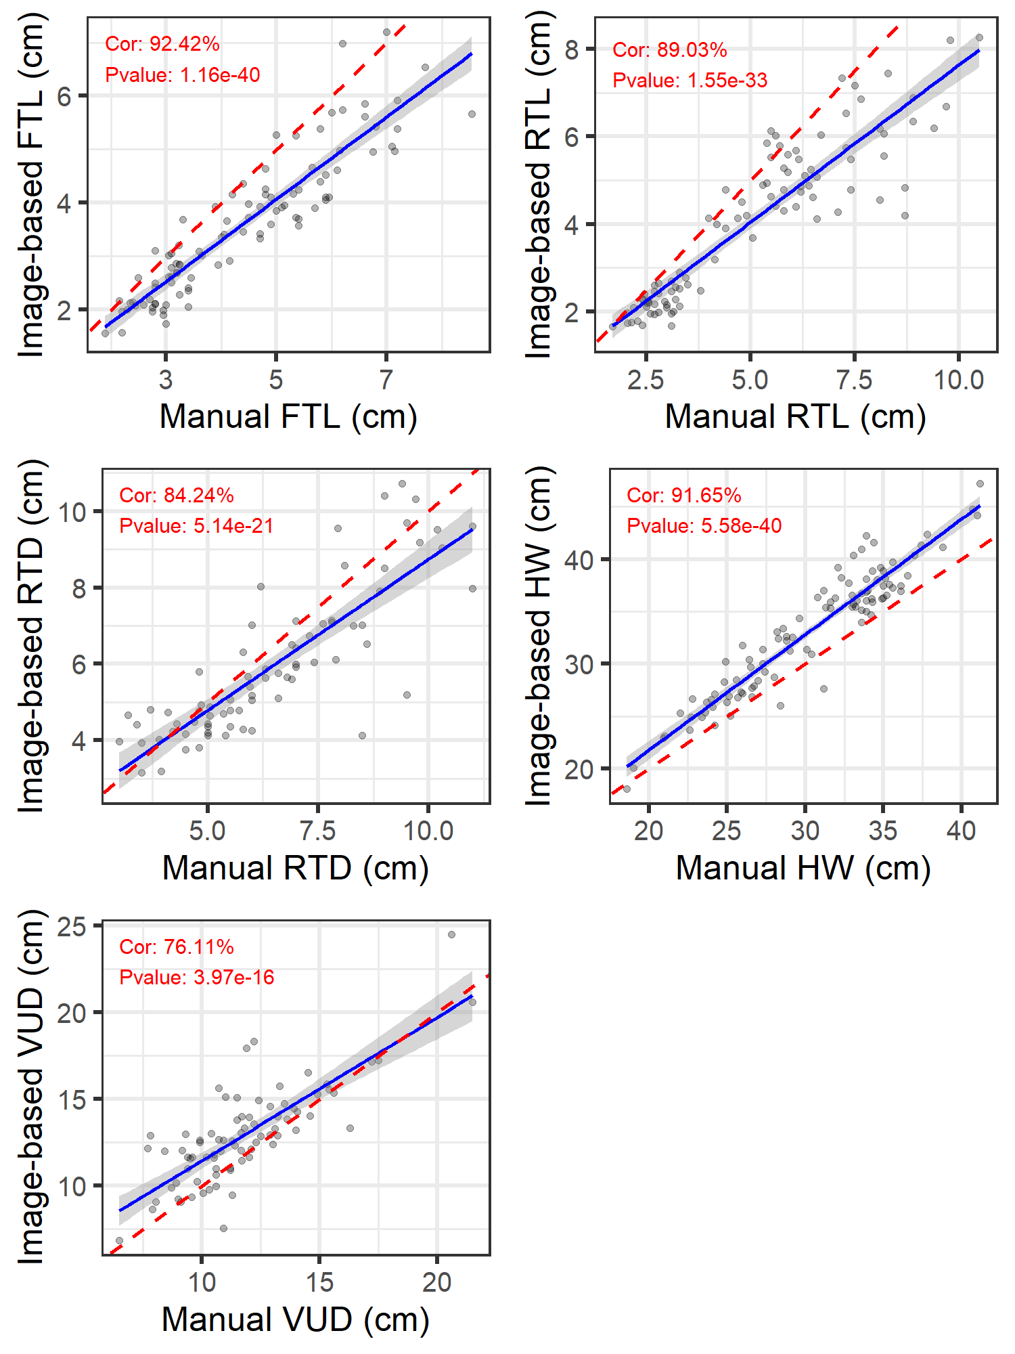
Figure S2. Scatter plots showing the relationship between manual and uncorrected image-based measurements for and body width body width and udder-related traits derived from rear views. The solid blue line indicates the fitted linear regression line, and the shaded area represents the 95% confidence interval. The red dashed line corresponds to the line of identity (y = x). Correlation coefficients (Cor) and associated p-values are displayed within each panel. Traits included: fore teat length (FTL), rear teat length (RTL), rear teat distance (RTD), hip width (HW), and vulva–udder distance (VUD).

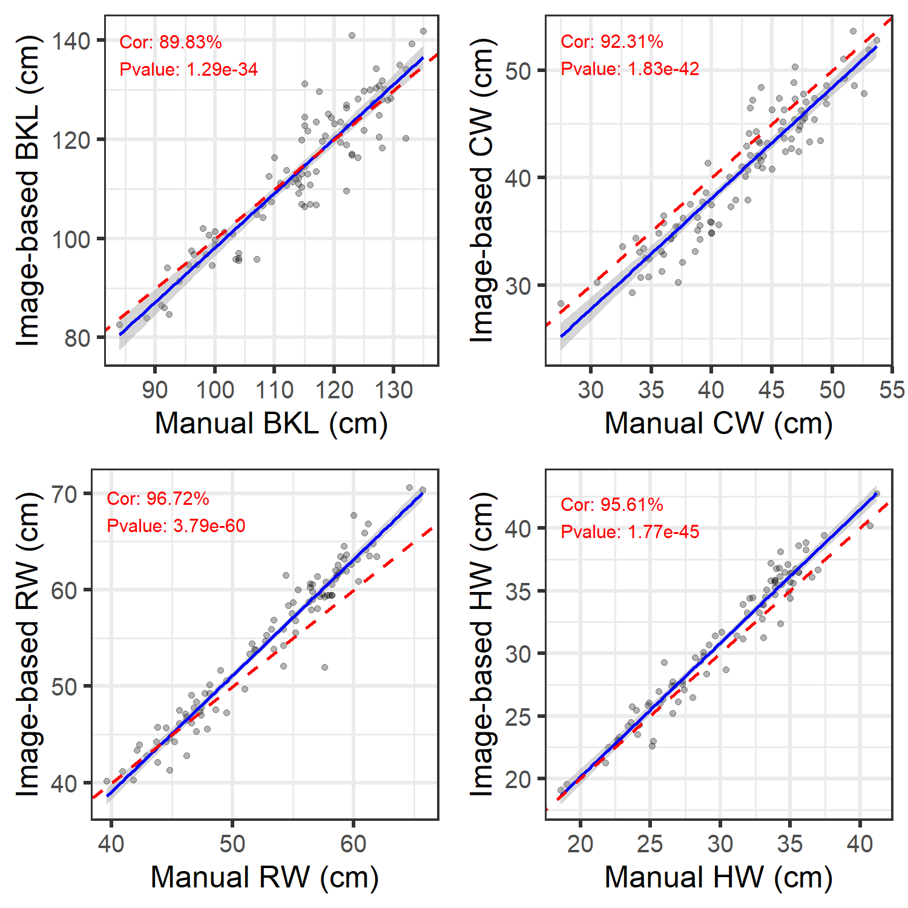

Figure S3. Scatter plots showing the relationship between manual and uncorrected image-based measurements for traits derived from the top view. Each point represents an individual animal. The blue line indicates the fitted regression model with a 95% confidence interval (shaded), and the red dashed line represents the line of identity (y = x). Correlation coefficients (Cor) and p-values are shown in each panel. Traits included: back length (BKL), chest width (CW), rump width (RW), and hip width (HW).

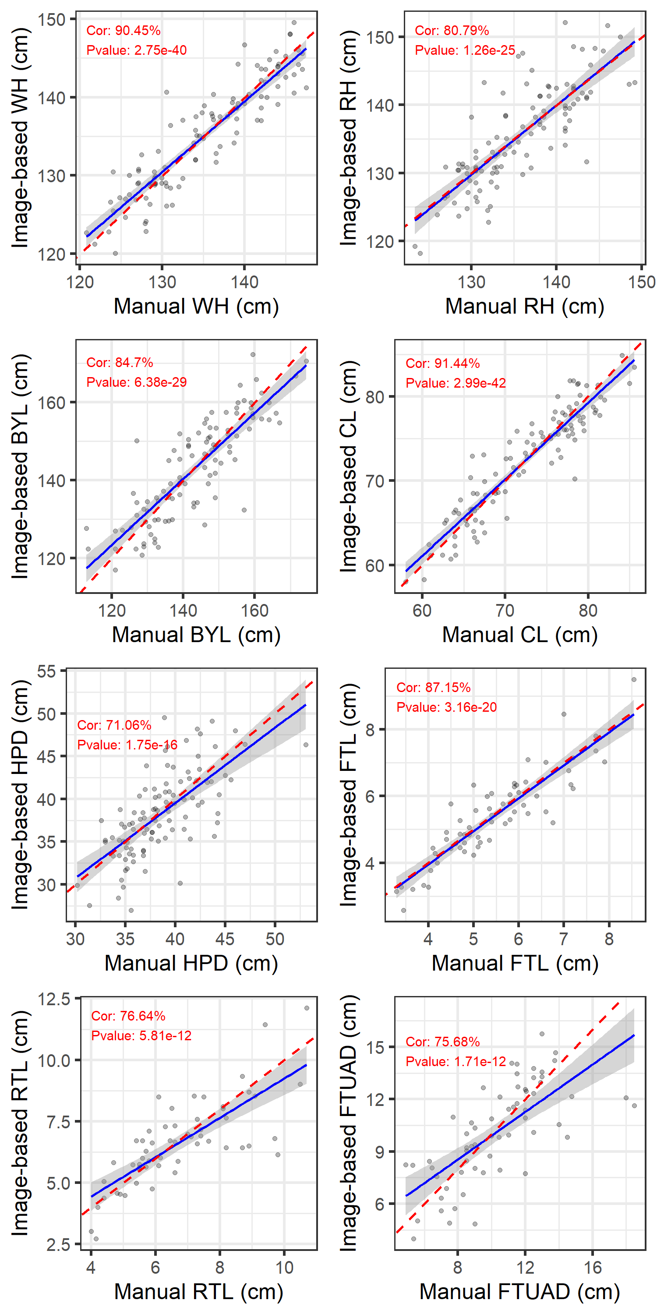
Figure S4. Scatter plots showing the relationship between manual and corrected image-based measurements for body traits derived from side-view images, using linear regression with leave-one-out cross-validation (LOOCV). The solid blue line indicates the fitted linear regression line, and the shaded area represents the 95% confidence interval. The red dashed line corresponds to the line of identity (y = x). Correlation coefficients (Cor) and associated p-values are displayed within each panel. wither height (WH), rump height (RH), body length (BYL), chest length (CL), hip–pin distance (HPD), fore teat length (FTL), rear teat length (RTL), and fore teat–udder attachment distance (FTUAD).

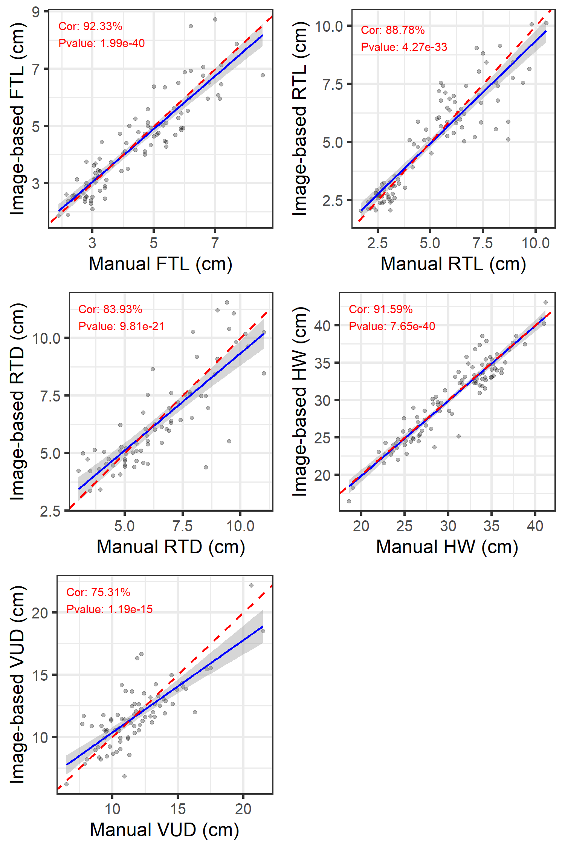
Figure S5. Scatter plots showing the relationship between manual and corrected image-based measurements for body traits derived from rear-view images, using linear regression with leave-one-out cross-validation (LOOCV). The solid blue line indicates the fitted linear regression line, and the shaded area represents the 95% confidence interval. The red dashed line corresponds to the line of identity (y = x). Correlation coefficients (Cor) and associated p-values are displayed within each panel. Traits included: fore teat length (FTL), rear teat length (RTL), rear teat distance (RTD), hip width (HW), and vulva–udder distance (VUD).

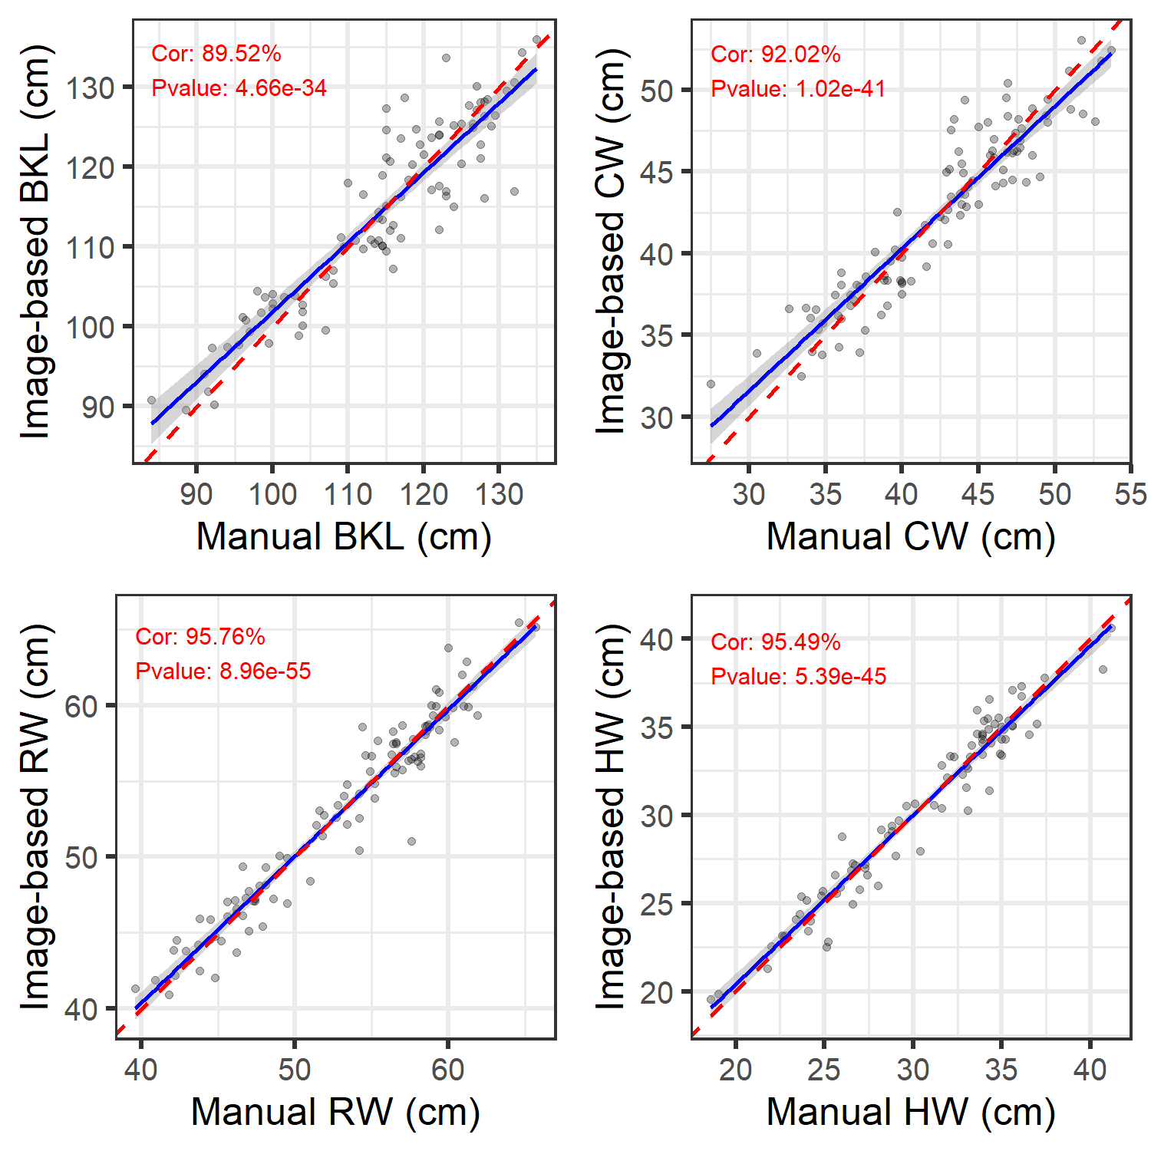

Figure S6. Scatter plots showing the relationship between manual and corrected image-based measurements for body traits derived from top-view images, using linear regression with leave-one-out cross-validation (LOOCV). Each point represents an individual animal. The blue line indicates the fitted regression model with a 95% confidence interval (shaded), and the red dashed line represents the line of identity (y = x). Correlation coefficients (Cor) and p-values are shown in each panel. Traits included: back length (BKL), chest width (CW), rump width (RW), and hip width (HW).

