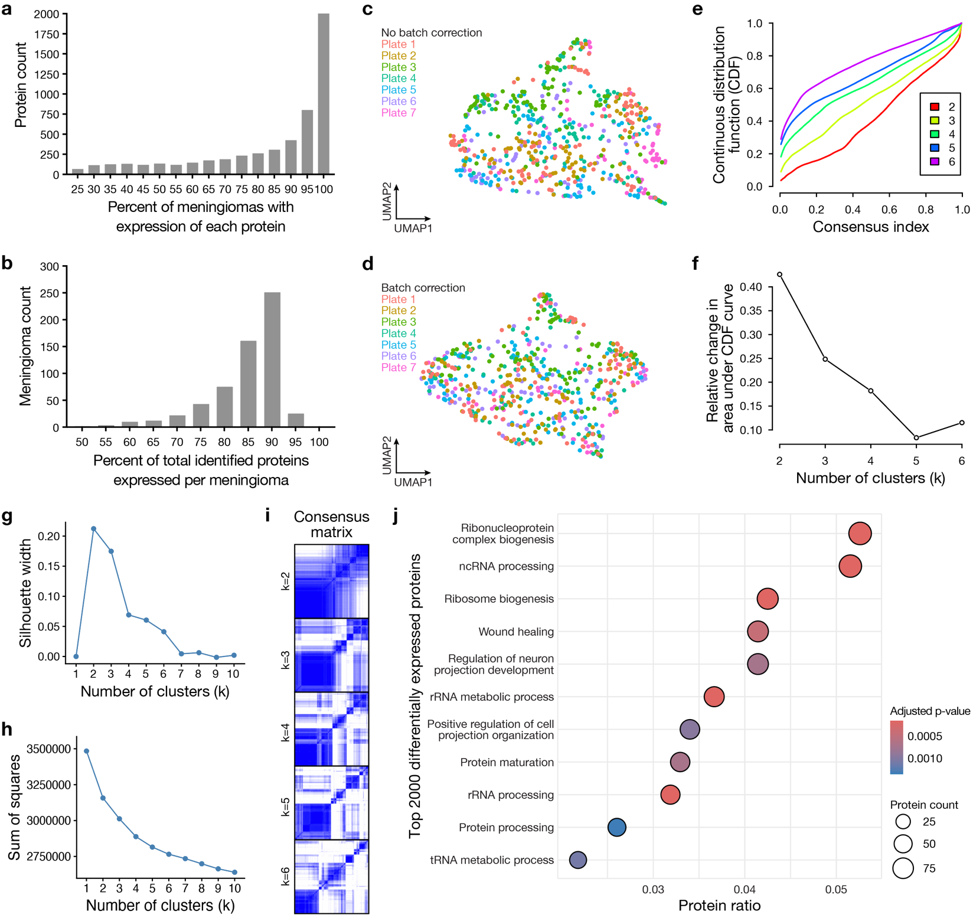Extended Data Fig. 1. Meningioma mass spectrometry-based proteomics. a, Distribution of the percentage of meningiomas (n=603) expressing each protein (n=6,472) that was identified from ≥2 peptides in ≥25% of samples by mass spectrometry-based proteomics. b, Distribution of the percentage of total identified proteins expressed in each meningioma. c, UMAP visualization of protein intensity distribution before batch correction, revealing minimal batch effects. d, UMAP visualization of protein intensity distribution after ComBat batch correction. e, Continuous distribution function (CDF) curves for k=2 to k=6 hypothetical meningioma proteomic clusters, revealing no optimal number of clusters. f, Relative change in the area under the CDF curve plotted against the number of hypothetical meningioma proteomic clusters, revealing no optimal number of clusters. g, Silhouette plot showing low average silhouette width plotted against different numbers of hypothetical meningioma proteomic clusters. h, Elbow plot showing the sum of squares plotted against different numbers of hypothetical meningioma proteomic clusters, revealing no optimal number of clusters. i, Consensus matrices for k=2 to k=6 hypothetical meningioma proteomic clusters, revealing no optimal number of clusters. Blue, high consensus. White, low consensus. j, Ontology analysis of the top 2000 differentially expressed proteins in meningioma.
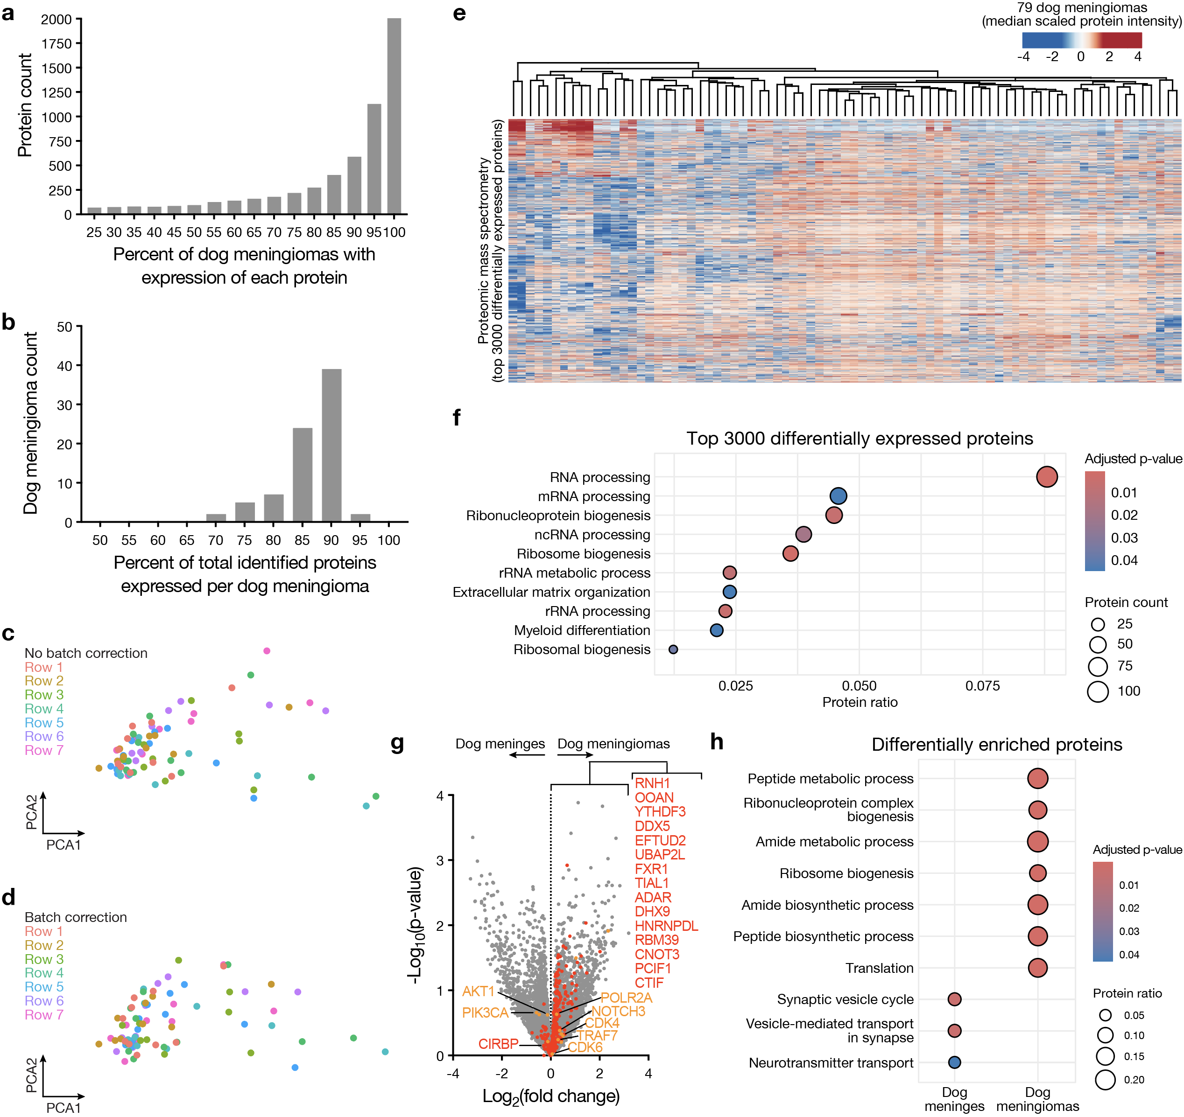Extended Data Fig. 2. Dog meningioma mass spectrometry-based proteomics. a, Distribution of the percentage of dog meningiomas (n=79) expressing each protein (n=6,694) that was identified from ≥2 peptides in ≥25% of samples by mass spectrometry-based proteomics. b, Distribution of the percentage of total identified proteins expressed in each dog meningioma. c, UMAP visualization of protein intensity distribution before batch correction, revealing minimal batch effects. d, UMAP visualization of protein intensity distribution after ComBat batch correction. e, Heatmap showing unsupervised hierarchical clustering of the top 3000 differentially expressed proteins from proteomic analysis of dog meningiomas. f, Ontology analysis of the top 3000 differentially expressed proteins in dog meningioma. g, Volcano plot showing differentially expressed proteins from proteomic analysis of dog meningiomas versus dog meningeal samples (n=15). RNA processing proteins are shown in red, and oncogenes and tumor suppressors are shown in orange. h, Ontology analysis of differentially enriched proteins in dog meningiomas versus dog meningeal samples.
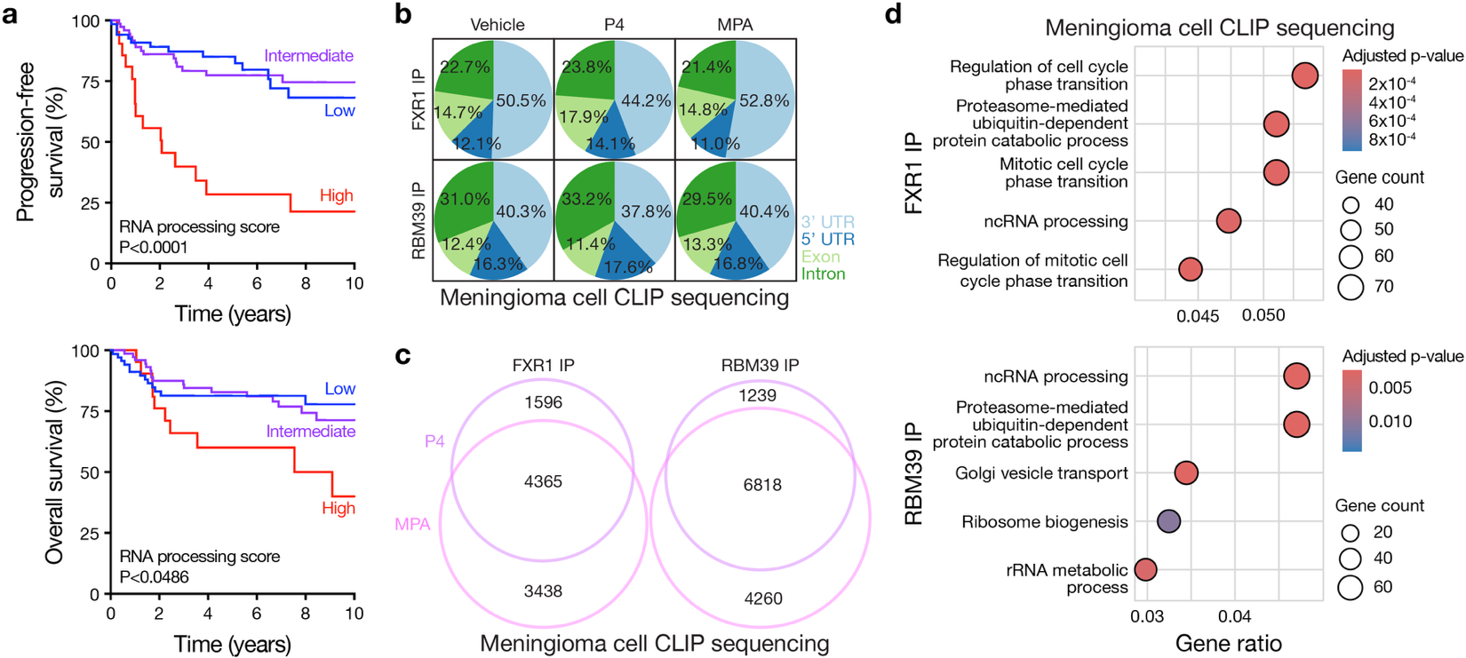Extended Data Fig. 3. Meningioma RNA processing score validation and CLIP sequencing. a, Kaplan-Meier curves showing clinical outcomes across RNA processing score risk strata using mass spectrometry-based proteomic data from validation cohort meningiomas that were not used for risk score development (n=176). Log-rank tests. b, Transcript recovery from CLIP sequencing of M10G meningioma cells after treatment with progesterone (P4) 1µm, medroxyprogesterone acetate (MPA) 1µm, or vehicle control for 4hrs and immunoprecipitation (IP) of FLAG-tagged FXR1 or RBM39. c, Overlapping and unique transcripts bound by FXR1 or RBM39 in M10G cells after treatment with P4 or MPA and CLIP sequencing as described in b. d, Ontology analysis of overlapping transcripts bound by FXR1 or RBM39 in M10G cells after treatment with P4 and MPA and CLIP sequencing.
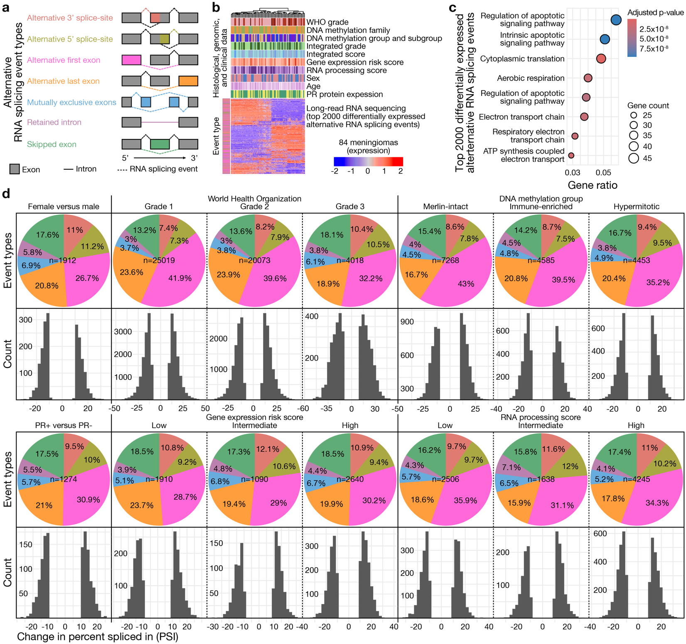Extended Data Fig. 4. Meningioma alternative RNA splicing events. a, Schematic of alternative RNA splicing event types detected by long-read RNA sequencing. b, Heatmap showing unsupervised hierarchical clustering of the top 2000 differentially expressed alternative RNA splicing events from meningioma long-read RNA sequencing (n=84). Alternative RNA splicing event type colors (rows) are defined in a. Histological, genomic, and clinical data colors for each meningioma (columns) are defined in Fig. 1a. c, Ontology analysis of the top 2000 differentially expressed alternatively splicing genes in meningioma. d, Pie charts showing alternative RNA splicing event types (colors defined in a) and histograms showing change in percent spliced in (PSI) for all differentially expressed alternative RNA splicing events identified across demographic, histological, or molecular groups of meningiomas. PR, progesterone receptor protein.
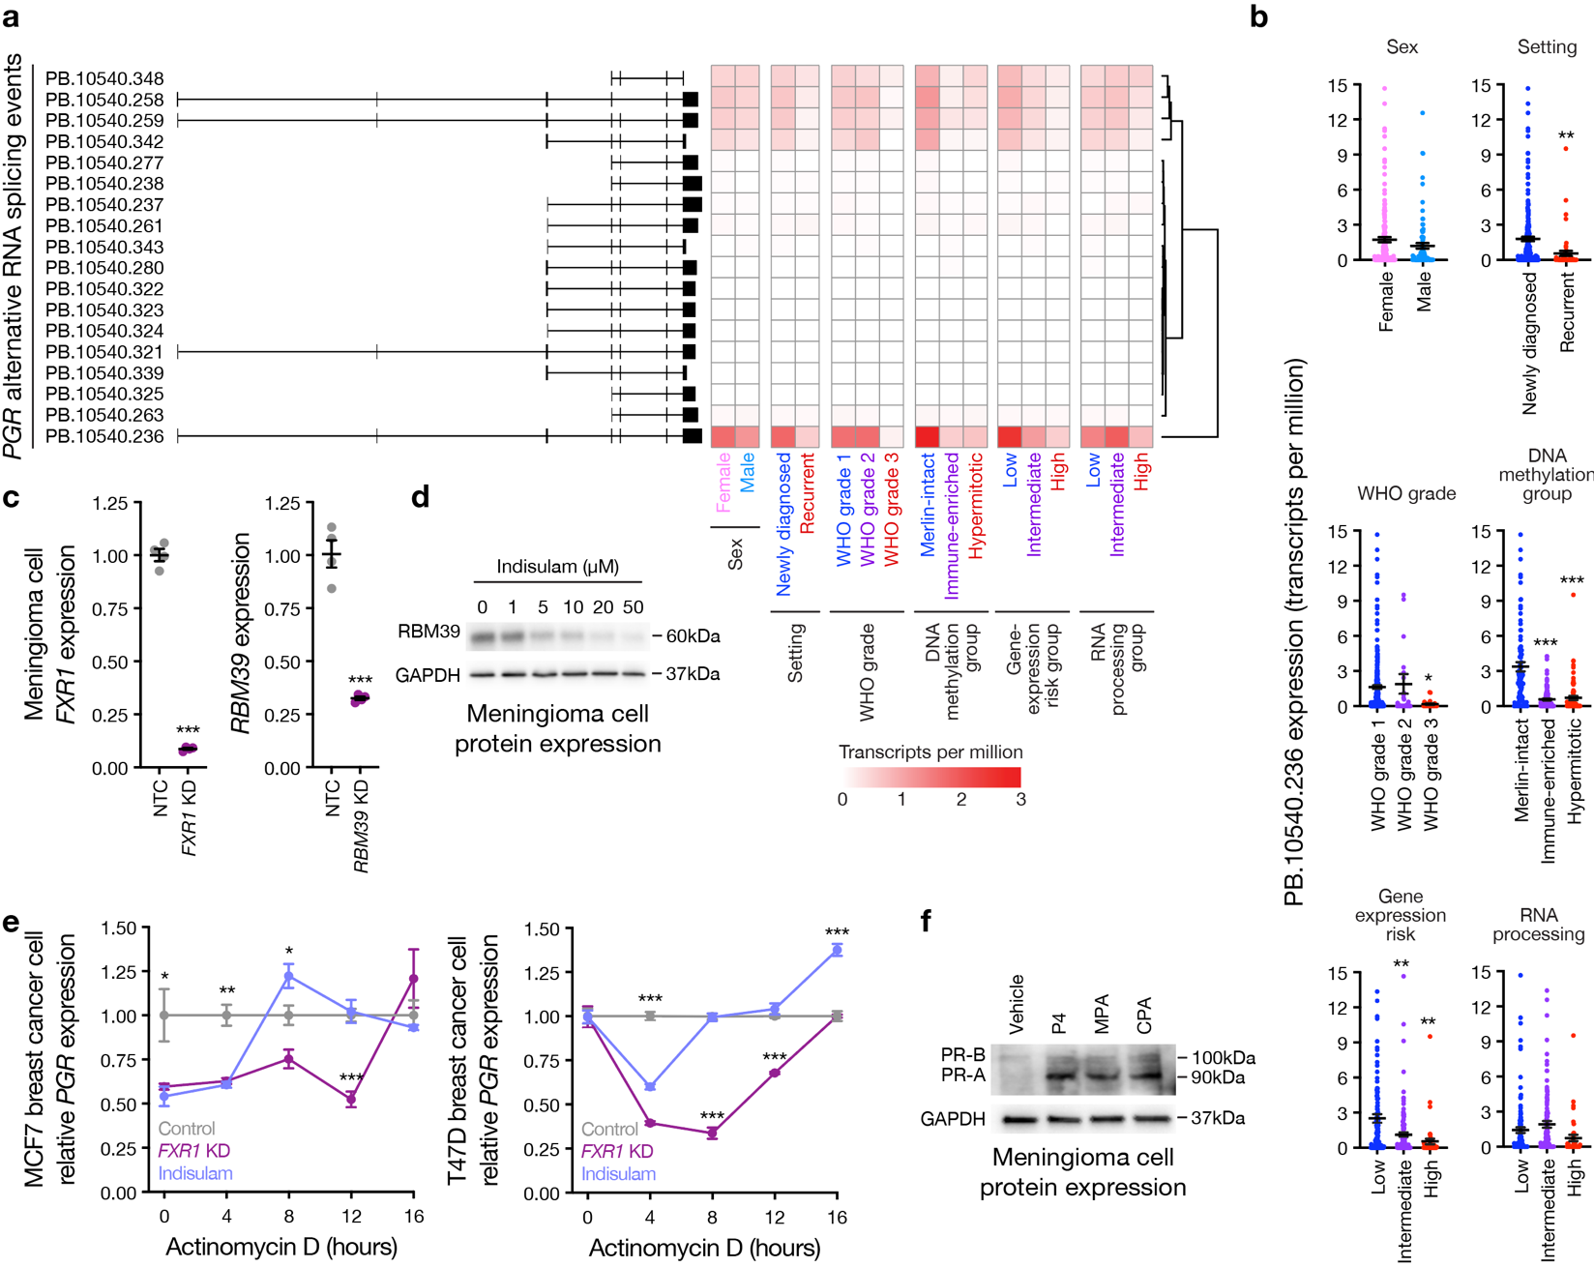Extended Data Fig. 5. Progesterone receptor alternative RNA splicing and stabilization. a, Progesterone receptor transcript (PGR) alternative RNA splicing events from meningioma long-read RNA sequencing (n=84) showing predominant expression of the same 5 transcripts across demographic, clinical, histological, or molecular groups. b, Expression of a representative PGR transcript (PB.10540.236) from meningioma long-read RNA sequencing across demographic, clinical, histological, or molecular groups. c, QPCR showing siRNA knockdown (KD) of FXR1 or RBM39 compared with non-targeted control (NTC) siRNA in CH157-MN meningioma cells. d, Immunoblot for RBM39 expression in CH157-MN meningioma cells treated with the RBM39 degrader indisulam for 48hrs. e, QPCR for PGR expression over time in MCF7 (left) or T74D (right) ER+/PR+ breast cancer cells treated with actinomycin D 5µM for the time shown ± FXR1 siRNA knockdown (KD) or treatment with indisulam 20µM for 48hrs. Data at each timepoint are normalized to PGR transcript expression in cells with control treatment, showing that RNA processing proteins transiently influence PGR expression and stability in breast cancer cells. f, Immunoblot for progesterone receptor protein (PR) expression in CH157-MN meningioma cells treated with progesterone (P4) 1µm, medroxyprogesterone acetate (MPA) 1µm, cyproterone acetate (CPA) 1µm, or vehicle control for 14 days. Lines represent means and error bars represent the standard error of the means. Student’s t-tests, *p≤0.05, **p≤0.01, ***p≤0.0001.
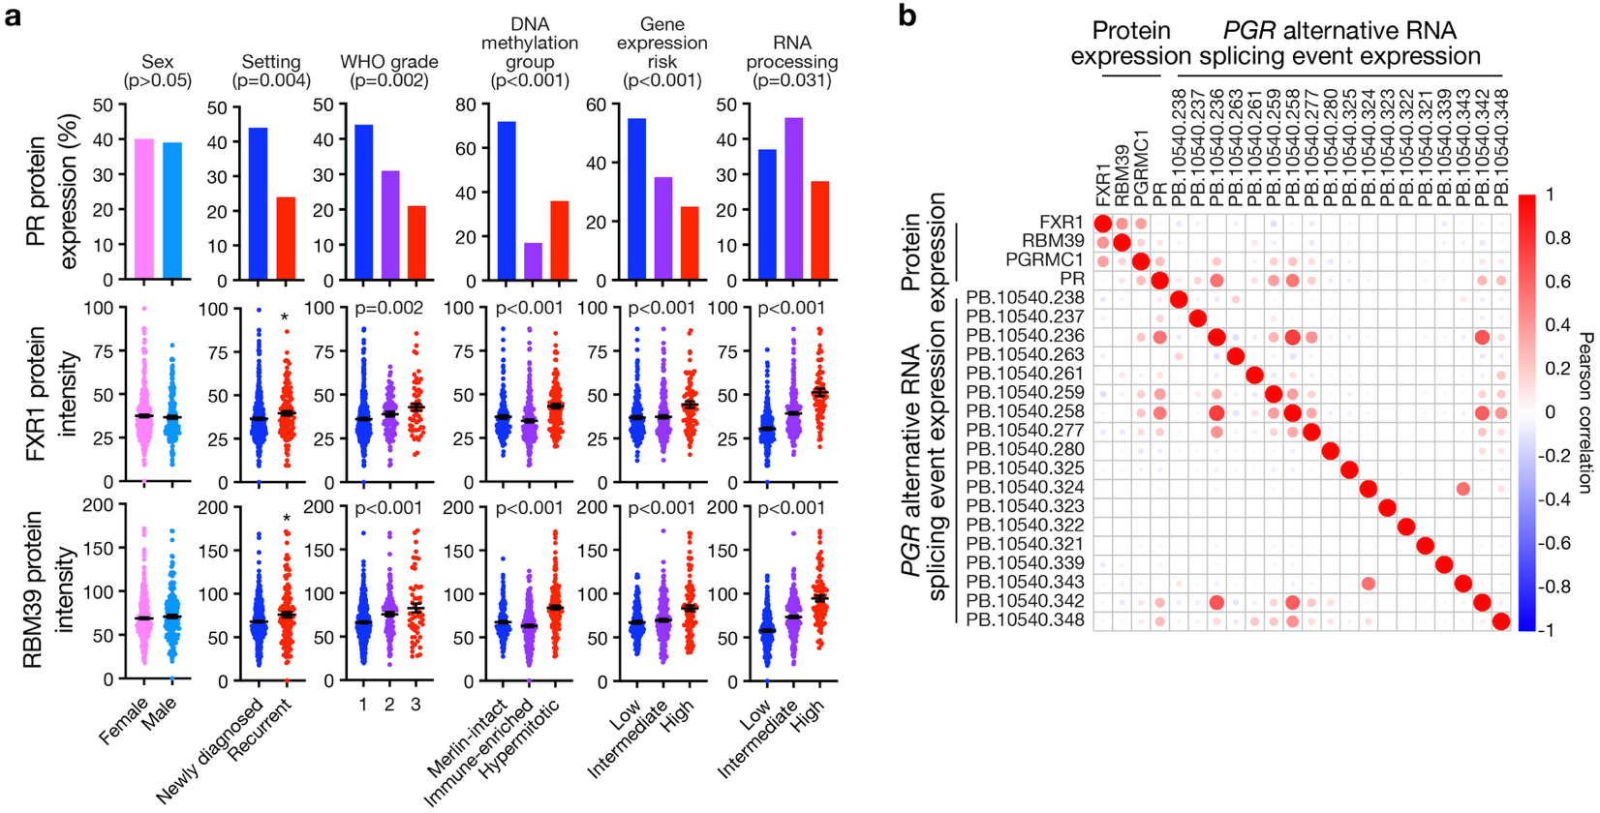Extended Data Fig. 6. Progesterone receptor and RNA processing protein expression in meningioma. a, Progesterone receptor protein (PR) expression, and FXR1 or RBM39 protein intensity, from meningioma mass spectrometry-based proteomics (n=603) across demographic, clinical, histological, or molecular groups. Lines represent means and error bars represent the standard error of the means. Student’s t-tests, *p≤0.05. All other p-values from ANOVA. b, Hierarchical clustering of Pearson correlation coefficients showing that FXR1 and RBM39 protein expression from meningioma proteomic analysis does not correlate with progesterone receptor transcript (PGR) expression from long-read RNA sequencing or PR expression from proteomic analysis, but that PGRMC1 protein expression does correlate with both PGR and PR expression.
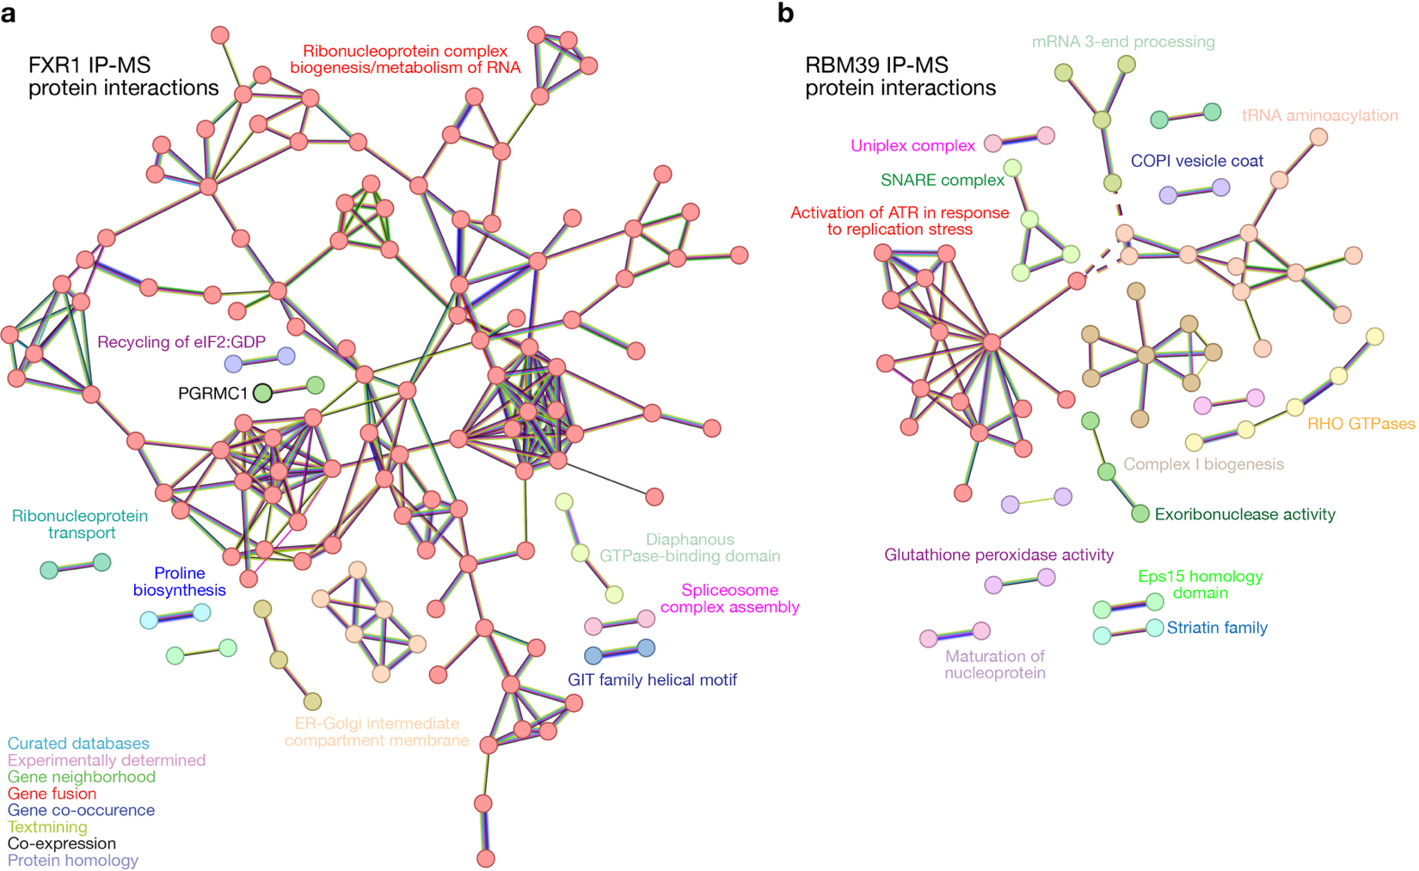Extended Data Fig. 7. FXR1 and RBM39 protein interactions in meningioma cells. a, STRING analysis of protein networks showing greater than 2-fold enrichment with vehicle control treatment as compared to medroxyprogesterone acetate (MPA) treatment with FXR1 immunoprecipitation mass spectrometry (IP-MS) from CH-157MN meningioma cells. Protein lists were uploaded to the STRING website (https://string-db.org/) and analyses were performed using high stringency with k-means clustering. Key describes evidence supporting protein interactions. b, STRING analysis as in a but with RBM39 IP-MS. Key as in b.
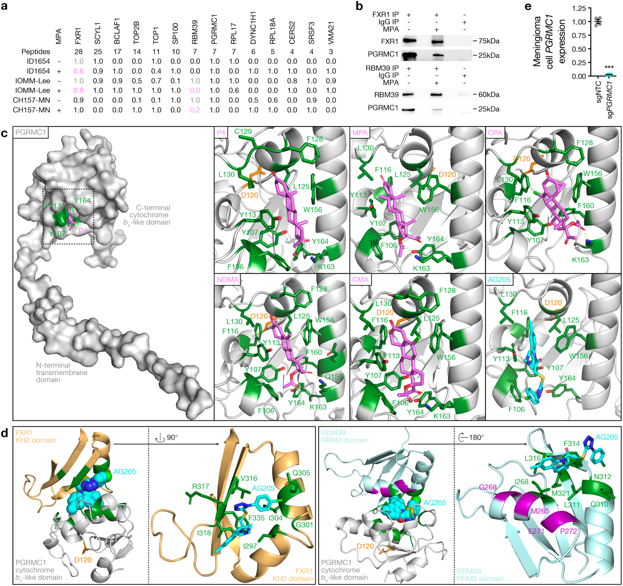Extended Data Fig. 8. PGRMC1 interacts with FXR1 and RBM39 in meningioma cells. a, Proteins identified after immunoprecipitation mass spectrometry (IP-MS) of endogenous PGRMC1 across 3 meningioma cell lines (ID1654, IOMM-Lee, CH157-MN) ± treatment with medroxyprogesterone acetate (MPA) 1µM for 1hr. The proteins displayed were identified from ≥2 peptides, were not present in IgG immunoprecipitation control conditions, and were identified in at least 2 cell lines. Protein intensity was normalized to PGRMC1 intensity in each condition and relative expression within conditions for each protein is shown. Grey and pink numbers show that FXR1 and RBM39 were the only proteins that decreased in proximity to PGRMC1 with MPA versus vehicle control treatment in at least 2 cell lines. b, FXR1 or RBM39 immunoprecipitation (IP) for co-IP immunoblots of PGRMC1 from CH157-MN meningioma cells treated with medroxyprogesterone acetate (MPA) 1µM versus vehicle control for 30 min. c, Structural modeling of full-length PGRMC1 interaction with progestogens or the small molecule antagonist AG205. Surface model (left) showing PGRMC1 in grey and Y107, Y113, and Y164 residues, which are necessary for heme interaction with PGRMC1, in dark green. Ribbon models (right) show PGRMC1 in grey and binding pocket residues within 4Å of ligands, including Y107, Y113, and Y164, in dark green. Polar interactions between ligands and binding pocket residues are shown by dashed yellow lines. Progestogens are shown in violet, AG205 is shown in cyan, and PGRMC1 residue D120, which is necessary for progesterone interaction, is shown in orange. Electronegative elements on ligands and binding pocket residues within 4Å of ligands are shown as follows: oxygen, red; nitrogen, blue; chloride, light green; sulfur, gold. P4, progesterone. MPA, medroxyprogesterone acetate. CPA, cyproterone acetate. NOMA, nomegestrol acetate. CMA, chlormadinone acetate. d, Structural modeling of full-length proteins showing that AG205 bridges interactions between the cytochrome b₅-like domain of PGRMC1 (grey residues 72-171) and the KH2 domain of FXR1 (gold residues 285-314, left), which regulates RNA binding and stability, and the RRM2 domain of RBM39 (aqua residues 250-328, right), which regulates RNA binding and interaction with the selective RBM39 degrader indisulam (purple residues). Binding pocket residues within 4Å of AG205 are shown in dark green and are labeled for FXR1 (left) and RBM39 (right). Electronegative elements on ligands and binding pocket residues within 4Å of AG205 are shown as follows: oxygen, red; nitrogen, blue; chloride, light green; sulfur, gold. e, QPCR for PGRMC1 transcript expression in CH157-MN cells stably expressing CRISPRi machinery (dCas9-KRAB) and sgRNAs targeting PGRMC1 (sgPGRMC1) versus non-targeted control sgRNAs (sgNTC). Lines represent means and error bars represent the standard error of the means. Student’s t-test, ***p≤0.0001.

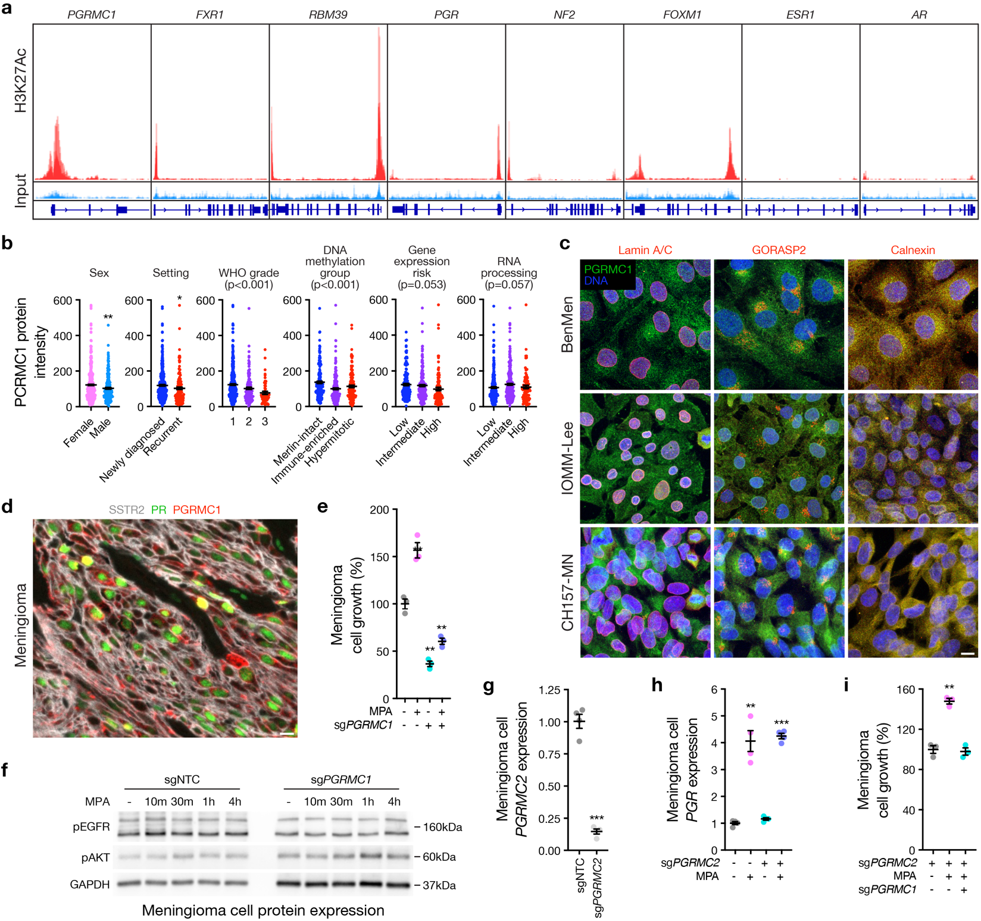Extended Data Fig. 9. PGRMC1 expression and activity in meningioma. a, Re-analysis of H3K27Ac ChIP sequencing data from 33 meningiomas showing peaks for PGRMC1, FXR1, RBM39, progesterone receptor (PGR), the meningioma tumor suppressor NF2, and the meningioma oncogene FOXM1, but not for estrogen receptor (ESR1) or androgen receptor (AR), which were not detected by mass spectrometry-based proteomics of human or dog meningiomas (Fig. 1, Extended Data Fig. 1, 2). b, PGRMC1 protein intensity from meningioma mass spectrometry-based proteomics (n=603) across demographic, clinical, histological, or molecular groups, showing similar trends as progesterone receptor protein (PR) expression across the same groups (Extended Data Fig. 6a). c, Immunofluorescence microscopy for PGRMC1, the nuclear envelop marker lamin A/C, the golgi marker GORASP2, the cell membrane marker calnexin, and DNA (Hoechst) across BenMen, IOMM-Lee, and CH157-MN meningioma cell lines showing that PGRMC1 localizes to the endoplasmic reticulum and other cell membranes. Scale bar, 10µm. d, Meningioma immunofluorescence microscopy showing expression of PGRMC1 and PR in tumor cells marked by SSTR2. Scale bar, 10µm. e, Clonogenic growth of CH157-MN cells after CRISPRi suppression of PGRMC1 ± treatment with medroxyprogesterone acetate (MPA) 1µM for 10 days showing that PGRMC1 drives the growth and response of meningioma cells to MPA. f, Immunoblots for reported downstream effectors of PGRMC1 activity in CH157-MN cells stably expressing CRISPRi machinery and sgPGRMC1 or sgNTC ± MPA treatment showing comparable phosphorylation of EGFR (pEGFR) and AKT (pAKT) with or without PGRMC1 suppression and/or MPA treatment, suggesting that PGRMC1 drives PGR expression and meningioma cell proliferation through alternative pathways. g, QPCR for PGRMC2 transcript expression in CH157-MN cells stably expressing CRISPRi machinery (dCas9-KRAB) and sgRNAs targeting PGRMC2 (sgPGRMC2) versus non-targeted control sgRNAs (sgNTC). h, QPCR for PGR expression in CH157-MN cells after CRISPRi suppression of PGRMC2 ± treatment with MPA for 48hrs showing that PGRMC2 does not regulate meningioma cell expression of PGR in response to MPA, in contrast to PGRMC1. i, Clonogenic growth of CH157-MN cells after CRISPRi suppression of PGRMC2 ± CRISPRi suppression of PGRMC1 and treatment with MPA for 10 days showing that PGRMC2 does not drive the growth of meningioma cells in response to MPA, in contrast to PGRMC1. Lines represent means and error bars represent the standard error of the means. Student’s t-tests, *p≤0.05, **p≤0.01, ***p≤0.0001. All other p-values from ANOVA.
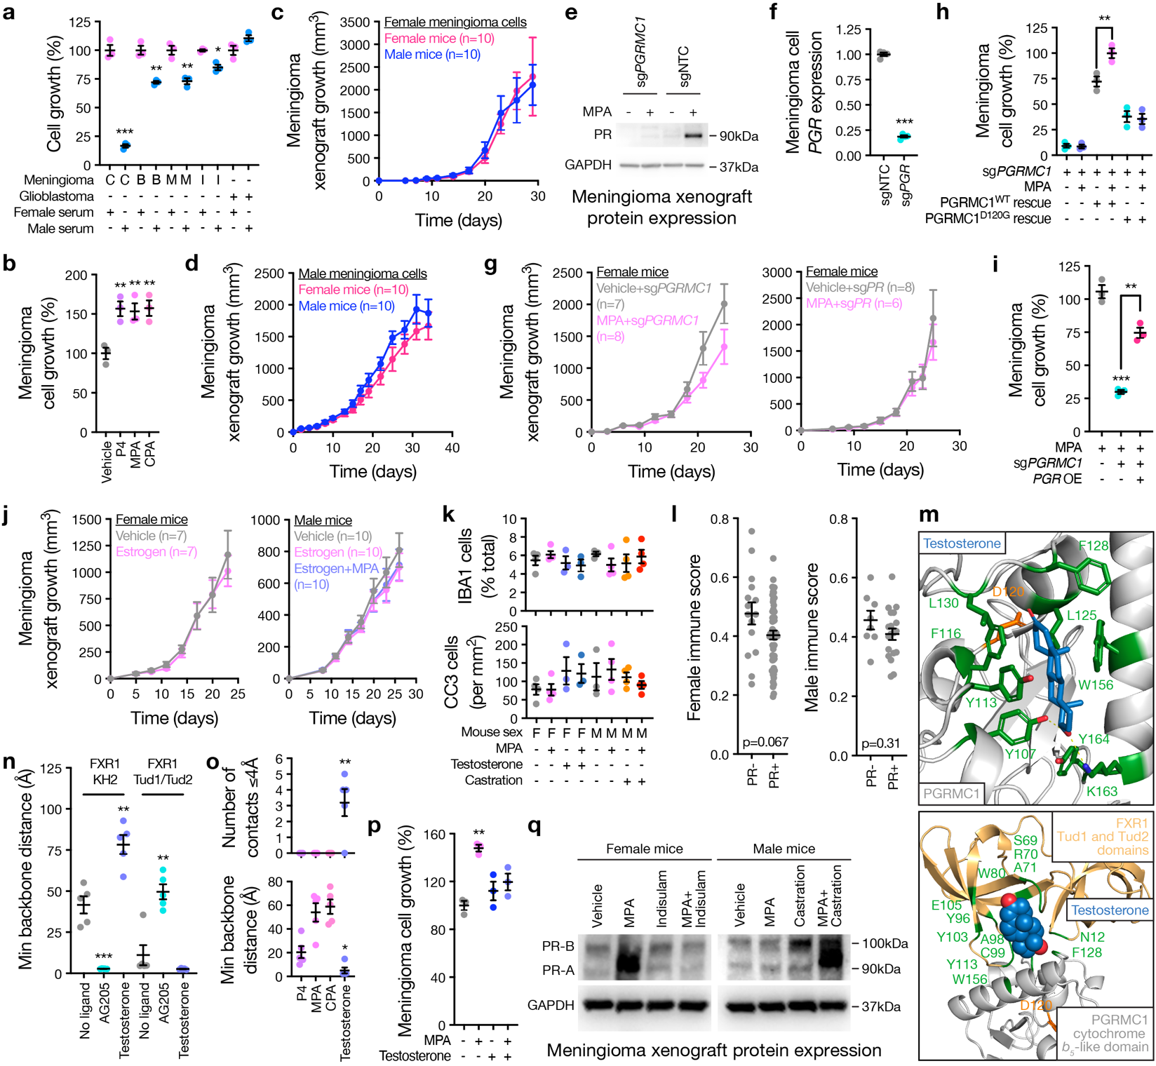Extended Data Fig. 10. Progestogens and testosterone regulate meningioma growth through PGRMC1, RNA processing proteins, and progesterone receptor. a, Clonogenic growth of CH-157MN (C), BenMen (B), M10G (M), or Iomm-Lee (I) meningioma cells, or LN18 glioblastoma cells, cultured in female versus male adult bovine serum for 10 days showing that meningioma but not glioma cell growth is attenuated by male bovine serum. b, Clonogenic growth of CH157-MN meningioma cells after treatment with progesterone (P4) 1µM, medroxyprogesterone acetate (MPA) 1µM, cyproterone acetate (CPA) 1µM, or vehicle control for 10 days showing that progestogens drive the growth of meningioma cells. c, Growth of CH157-MN female meningioma xenografts in male versus female Nu/Nu mice. d, Growth of IOMM-Lee male meningioma xenografts in male versus female Nu/Nu mice. e, Immunoblots for progesterone receptor protein (PR) expression in CH157-MN meningioma xenografts stably expressing CRISPRi machinery (dCas9-KRAB) and sgRNAs targeting PGRMC1 (sgPGRMC1) versus non-targeted control sgRNAs (sgNTC) in meningioma cells ± treatment of female Nu/Nu mice with MPA 10mg/kg daily via IP injection versus vehicle control for 25 days showing that PGRMC1 is required for progestin-induced PR expression in meningioma. f, QPCR for progesterone receptor transcript (PGR) expression in CH157-MN cells expressing CRISPRi machinery and sgRNAs targeting PGR (sgPGR) versus sgNTC. g, Growth of CH157-MN xenografts in female Nu/Nu mice with CRISPRi suppression of PGRMC1 (left) or PGR (right) in meningioma cells ± treatment of mice with MPA 10mg/kg daily via IP injection versus vehicle control showing that PGRMC1 and PR are required for progestin-induced meningioma growth. h, Clonogenic growth of CH157-MN cells with CRISPRi suppression of PGRMC1 ± MPA versus vehicle control treatment for 10 days ± rescue expression of PGRMC1^{WT} or PGRMC1^{D120G} showing that PGRMC1^{D120G} cannot rescue meningioma cell sensitivity to progestin treatment. i, Clonogenic growth of CH157-MN cells treated with MPA for 10 days ± CRISPRi suppression of PGRMC1 ± PGR over-expression (OE) showing that PR can rescue progestin-induced meningioma cell growth in the absence of PGRMC1. j, Growth of IOMM-Lee xenografts in female (left) versus male (right) Nu/Nu mice treated with beta-estradiol (estrogen) 1µg/day via IP injection ± MPA versus vehicle control showing that estrogen does not drive progestin-induced meningioma growth in either female or male mice. k, Histological quantification of meningioma xenograft cells expressing IBA1 (top) or cleaved caspase 3 (CC3, bottom) from Fig. 4c after 30 days of treatment, showing no significant changes in tumor-associated macrophages or meningioma apoptosis with sex hormone perturbations. l, Immune score deconvolution from RNA sequencing of Merlin-intact PR- versus PR+ human meningiomas showing no significant differences. Wilcoxon signed-rank tests. m, Structural modeling of full-length proteins showing that testosterone bridges interactions between the cytochrome b₅-like domain of PGRMC1 (grey residues 72-171), and the Tud1 (residues 4-50) and Tud2 (residues 65-115) domains of FXR1 (gold), which regulate protein-protein interactions. Binding pocket residues within 4Å of testosterone are shown in dark green, and electronegative elements on testosterone and binding pocket residues within 4Å of testosterone are shown as follows: oxygen, red; nitrogen, blue; chloride, light green; sulfur, gold. Polar interactions between testosterone and binding pocket residues are shown by dashed yellow lines, and PGRMC1 residue D120, which is necessary for progestogen interaction, is shown in orange. n, Quantification of minimum (Min) backbone distance of the best seed’s 5 structural models of the cytochrome b₅-like domain of PGRMC1 and FXR1 showing that AG205 enables interactions between PGRMC1 and the KH2 domain of FXR1 while testosterone enables interactions between PGRMC1 and the Tud1 and Tud2 domains of FXR1. o, Quantification of the number of residue contacts within 4Å (top) or the minimum backbone distance (bottom) from the best seed’s 5 structural models of the cytochrome b₅-like domain of PGRMC1 and the Tud1 and Tud2 domains of FXR1 in the presence of P4, MPA, CPA, or testosterone, showing that progestogens inhibit but testosterone enables PGRMC1 interactions with FXR1. p, Clonogenic growth of CH157-MN cells treated with MPA and/or testosterone 10µM for 10 days showing that testosterone blocks progestin-induced meningioma cell growth. q, Immunoblot for PR expression in IOMM-Lee xenografts grown in female versus male Nu/Nu mice treated with MPA and/or indisulam 25mg/kg daily via IP injection for 30 days showing that indisulam blocks progestin-induced PR expression and castration enables progestin-induced PR expression in male mice. Lines represent means and error bars represent the standard error of the means. Student’s t-tests, *p≤0.05, **p≤0.01, ***p≤0.05.

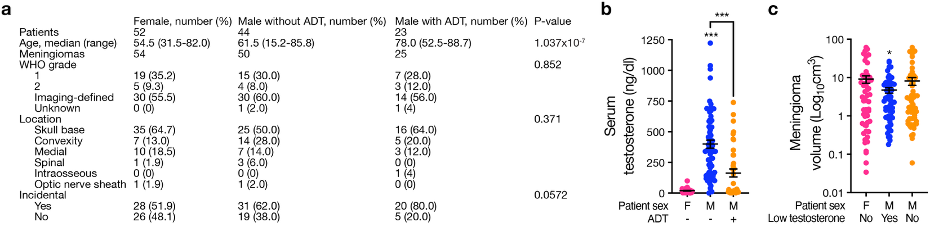Extended Data Fig. 11. Meningioma volume in the context of serum testosterone levels. a, All patients from the University of California San Francisco electronic medical record with serum testosterone measurements within 12 months of meningioma diagnosis and brain imaging sufficient for volumetric assessment. P-values from Kruskal-Wallis test (age), Fisher’s exact test, or Chi-squared test. ADT, androgen deprivation therapy. b, Serum testosterone measurements in female, male, and male patients on ADT with meningioma showing that testosterone levels are lower in female and in male patients on ADT. Student’s t-tests, *p≤0.05, ***p≤0.0001. c, Meningioma volumetrics from brain imaging showing that meningiomas are smaller in men with high testosterone levels compared to meningiomas in women or in men with low testosterone levels. Low testosterone defined according to American Urological Association guidelines (<300 ng/dl). Lines represent means and error bars represent the standard error of the means. ANOVA.
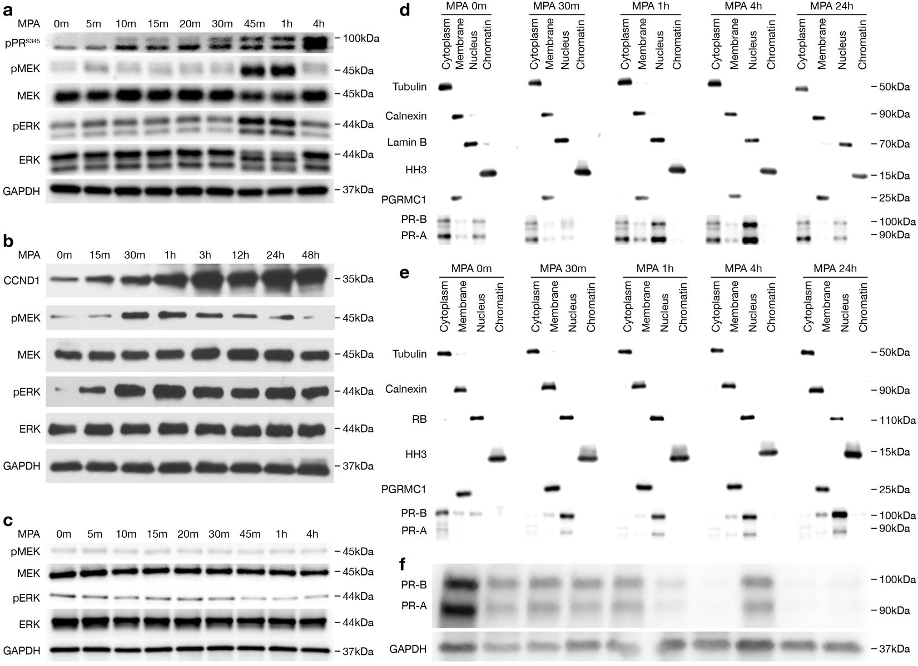Extended Data Fig. 12. Progesterone receptor signaling and subcellular compartmentalization in meningioma cells. a, Immunoblots for phosphorylated proteins in BenMen meningioma cells treated with medroxyprogesterone acetate (MPA) 1µM showing progestin-induced phosphorylation of progesterone receptor protein (PR) residue serine 345 (pPR^{S345}), and activation of the MAPK pathway through MEK (pMEK) and ERK (pERK) phosphorylation. b, Immunoblots for cell cycle and phosphorylated proteins in CH157-MN meningioma cells treated with MPA showing progestin-induced expression of CCND1. c, Immunoblots for phosphorylated proteins in BenMen cells treatment with MPA and stably expressing CRISPRi machinery (dCas9-Zim3) and sgRNAs suppressing endogenous progesterone receptor transcript (PGR) plus rescue expression of mutant PR (P422A, P423A, P426A) that is unable to bind c-SRC (an interaction that is necessary for PR-induced MAPK signaling) showing that inhibition of PR/c-Src interaction blocks progestin-induced MEK and ERK phosphorylation in meningioma cells. d, Immunoblots for PGRMC1 and PR after subcellular fractionation of CH157-MN cells treated with MPA 1µM showing progestin-induced nuclear enrichment of PR but no change the subcellular localization of PGRMC1 in meningioma cells. Immunoblots for tubulin, calnexin, lamin B, and HH3 mark the cytoplasmic, membrane, nuclear, and chromatin fractions of cells, respectively. e, Immunoblots for PGRMC1 and PR after subcellular fractionation of BenMen meningioma cells treated with MPA, showing similar results as in d. Immunoblots for tubulin, calnexin, pRB, and HH3 mark the cytoplasmic, membrane, nuclear, and chromatin fractions of cells, respectively. f, Immunoblots for PR-A and PR-B in meningioma showing that both variants are expressed, or not expressed, in human tumors (n=10).
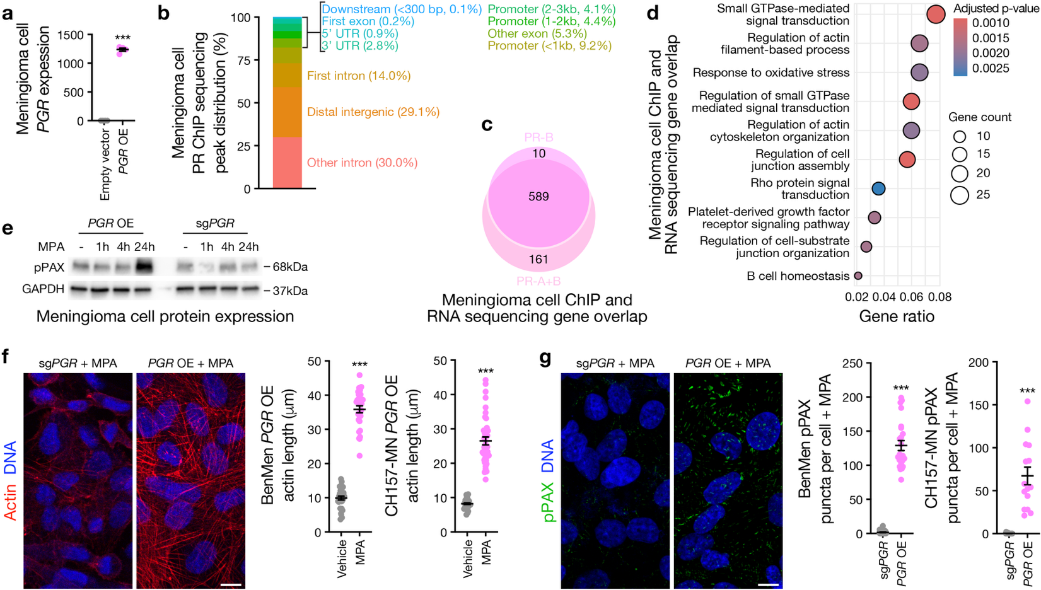Extended Data Fig. 13. Progestogen signaling drives actin remodeling and cell adhesion in meningioma. a, QPCR for progesterone receptor transcript (PGR) expression in CH157-MN meningioma cells with stable over-expression (OE) of PGR versus empty vector. b, Stacked bar plot showing the distribution of peaks from progesterone receptor protein (PR) ChIP sequencing of CH157-MN cells expressing full length PR-B or PR-A and PR-B treated with medroxyprogesterone acetate (MPA) 1µM for 4hrs, conditions which were selected to differentiate target genes bound by PR-B (e.g. present in both PR-B and PR-A+B conditions) from target genes which were specific to PR-A (e.g. present in PR-A+B but not overlapping with PR-B). c, Venn diagram showing overlapping versus unique genes with peaks from PR ChIP sequencing of CH157-MN meningioma cells in b intersected with RNA sequencing results from CH157-MN cells stably expressing CRISPRi machinery (dCas9-KRAB) and sgRNAs targeting PGR or PR OE ± MPA or vehicle control for 48hrs. Transcripts with increased expression after MPA treatment and PGR suppression (e.g. responsive to MPA but not downstream of PR) or with increased expression after PR OE without MPA (e.g. responsive to PR OE but not to ligand activation) were removed, leaving only transcripts that responded to MPA stimulation downstream of PR. d, Ontology analysis of overlapping genes from PR ChIP sequencing and RNA sequencing of CH157-MN meningioma cells from c showing enrichment of cell membrane and cytoskeleton remodeling genes. e, Immunoblot for phosphorylated paxillin (pPAX) expression in CH157-MN meningioma cells with over-expression or CRISPRi suppression of PGR and treatment with medroxyprogesterone acetate (MPA) 1µM showing that pPAX expression does not increase until long after treatment initiation, suggesting that these changes are a biproduct of gene expression. f, Immunofluorescence microscopy for actin (phallodin) and DNA (Hoechst) in BenMen meningioma cells with stable expression of CRISPRi machinery (dCas9-Zim3) and sgPGR, or with PGR over-expression, and treatment with medroxyprogesterone acetate (MPA) 1µM for 48hrs. Actin filament length is quantified for BenMen and CH157-MN cells with overexpression of PGR ± MPA treatment (right). Scale bar, 10µm. g, Immunofluorescence microscopy for pPAX and DNA (Hoechst) in BenMen cells with CRISPRi suppression or over-expression of PGR and treatment with MPA 1µM for 48hrs. pPax puncta are quantified for BenMen and CH157-MN cells with genetic perturbation of PGR and MPA treatment (right). Scale bar, 10µm. Lines represent means and error bars represent the standard error of the means. Student’s t-tests, ***p≤0.0001.
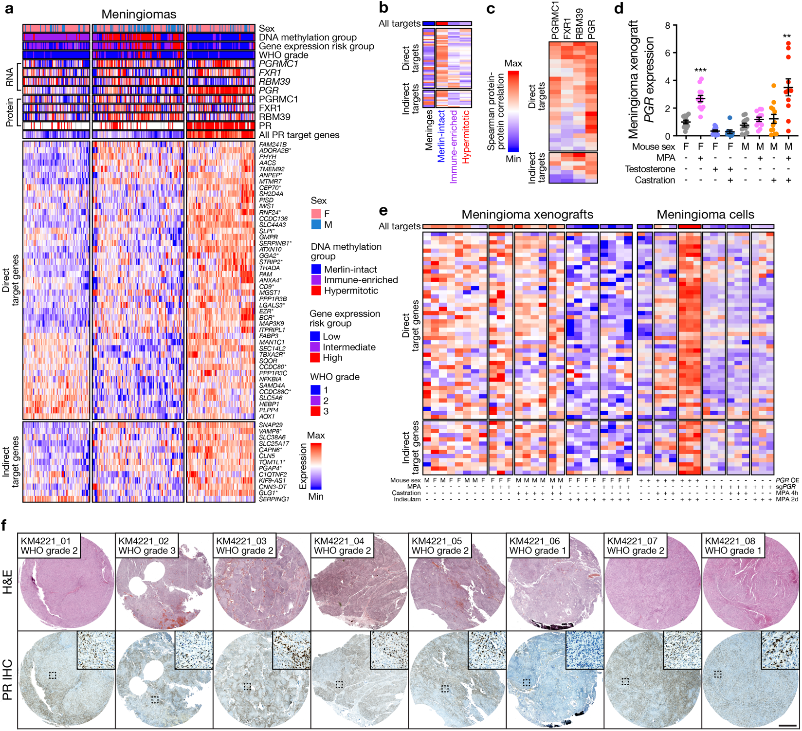Extended Data Fig. 14. Progesterone receptor target gene expression in meningioma. a, Weighted correlation network analysis (WGCNA) heatmap of meningiomas with matched proteomic, DNA methylation profiling, RNA sequencing, and histological data (n=200) showing 58 PR target genes that were identified through enrichment in (1) human tumors with expression of PR transcript and protein, (2) female xenografts treated with MPA, and (3) meningioma cells expressing with PR and treated with MPA from Extended Data Fig. 13a-d. Direct versus indirect PR target genes were defined using PR ChIP sequencing of meningioma cells in Extended Data Fig. 13b, c, where direct PR target genes were defined as those (1) overlapping with ChIP-sequencing peaks and (2) enriched in meningiomas cells expressing PR after MPA treatment. The two WGCNA modules that were enriched in tumors with high PGR and PR expression were distinguished by expression of direct or indirect PR target genes. Cell cycle and membrane and cytoskeleton remodeling genes are marked with asterisks. b, Expression of PR target genes from RNA sequencing of meningeal samples (n=6) compared with meningioma samples (n=200) across Merlin-intact, Immune-enriched, or Hypermitotic DNA methylation groups. PR target gene order and key for expression of PR target genes as in a. c, Protein-protein expression correlation of PR target genes (rows) with PGRMC1, FXR1, RBM39, or PR (columns) from meningioma mass spectrometry-based proteomics (n=603). PR target gene order as in a. d, QPCR for progesterone receptor transcript (PGR) expression in meningioma xenografts from Fig. 4c after 30 days of treatment, showing increased expression in female mice after MPA treatment and in male mice after castration and MPA treatment. Lines represent means and error bars represent the standard error of the means. Student’s t-tests, **p≤0.01, ***p≤0.0001. e, Heatmap of PR target gene expression (rows) from RNA sequencing of meningioma xenografts (columns) from Fig. 4c after 30 days of treatment, or from RNA sequencing of meningioma cells from Extended Data Fig. 13a-d. Xenograft data show enrichment of direct and indirect PR target genes in female mice after MPA treatment and in male mice after castration and MPA treatment, and suppression after indisulam treatment with or without MPA. Cell data show enrichment of direct and indirect PR target genes after long-term MPA treatment and PGR OE that is blocked by CRISRPi suppression of PGR (sgPGRMC1). PR target gene order and key for expression of PR target genes as in a. f, Hematoxylin and eosin (H&E) histology and progesterone receptor protein (PR) immunohistochemistry chemistry (IHC) staining for 8 meningiomas that were analyzed using spatial transcriptomic sequencing. Dashed squares correspond to inserts showing heterogeneity of PR IHC staining at high magnification. Scale bar, 1mm.
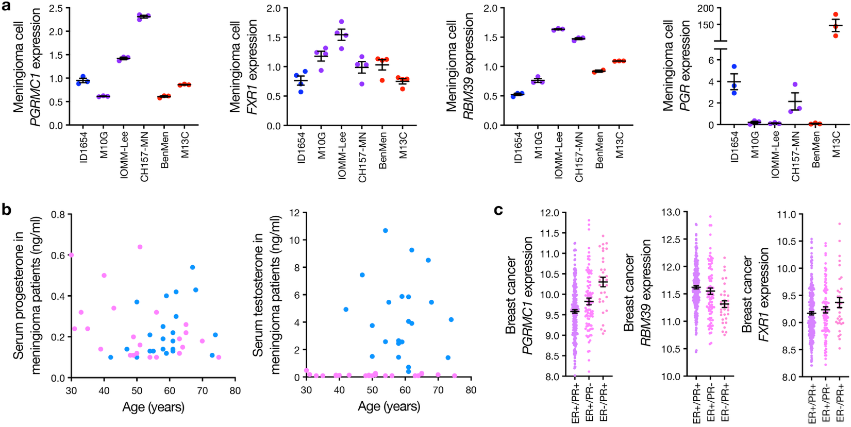Extended Data Fig. 15. Considerations for clinical translation to meningioma and breast cancer patients. a, QPCR for PGRMC1, FXR1, RBM39, or progesterone receptor transcript (PGR) expression across the meningioma cell lines used in this study colored according to DNA methylation group. Merlin-intact, blue. Immune-enriched, purple. Hypermitotic, red. b, Serum progesterone or testosterone measurements in female versus male patients with meningioma (n=55), none of which were receiving hormonal therapy, as a function of patient age. c, Breast cancer microarray expression data (n=375) showing that PGRMC1 and FXR1, but not RBM39, are enriched in rare cases of ER-/PR+ breast cancer. P-values from pairwise Wilcoxon tests with Benjamini-Hochberg adjustment. Lines represent means and error bars represent the standard error of the means.

