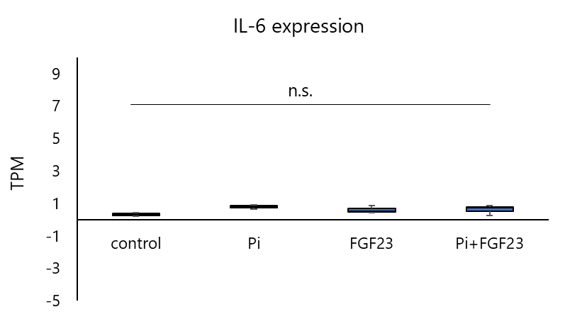

Supplementary Figure 1. IL6 expression in HepaRG cells treated with phosphate and/or FGF23.
HepaRG cells were treated with vehicle, phosphate (Pi), FGF23, or Pi plus FGF23, and IL6 expression was analyzed by RNA sequencing. TPM values are shown. Data are presented as mean ± SD from three independent experiments using different cell lots. Statistical analysis was performed using one-way ANOVA followed by Tukey’s multiple comparison test. No significant differences were detected among groups.

