Supplementary:

1. Analysis the reactions of the antibodies with target protein MSTN-SST
M&M
After separated with SDS-PEGA, the proteins were transferred to cellulose nitrate film. All the lanes were loaded with proteins from HEK-293a cells 24 h infection with rAd- MSTN-SST. Then the proteins in 1, 2, 3 were reacted with rabbit-anti-SST polyclonal antibodies, mouse-anti-MSTN polyclonal antibodies, mixed polyclonal antibodies against SST and MSTN, respectively. Proteins in lane 4 were incubated with 5% skim milk in phosphate buffer solution. The reactions were lasted for an hour at 37 ℃ and overnight in 4℃. Then the films were reacted with mixed secondary antibody.
Results
Protein MSTN-SST expressed by adenovirus was reacted with rabbit-anti-SST polyclonal antibodies and mouse-anti-MSTN polyclonal antibodies. And the protein size was about 35kDa with expected size.

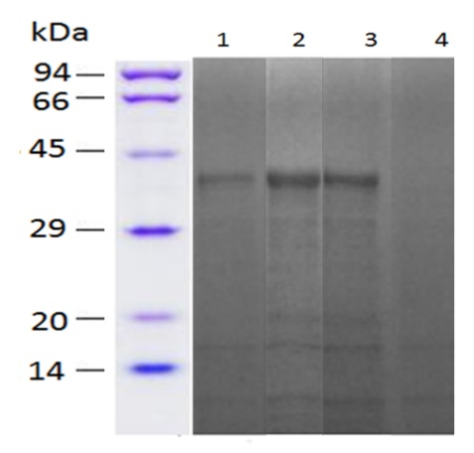
sFig 1 Analysis the reactions of the antibodies with target protein MSTN-SST expressed by adenovirus rAd- MSTN-SST. Lane 1.MSTN-SST reacted with rabbit-anti-SST polyclonal antibodies; Lane 2 MSTN-SST reacted with mouse-anti-MSTN polyclonal antibodies; Lane 3 MSTN-SST reacted with mixed polyclonal antibodies. Lane 4 MSTN-SST incubated with mixed secondary antibodies directly.

2. Analysis the purity of protein MSTN-SST expressed by E coli.
M&M
The lysis of the recombinant E. coli expressing MSTN-SST was centrifuged for 15 min at 4 ℃. The supernatant was collected and the target protein was purified with a Ni-NTA resin (Qiagen). Then, the protein was separated with SDS-PEGA.
Results
The purified recombinant Protein MSTN-SST were detected by SDS-PEGA and the purity of the target protein was acceptable as no miscellaneous bands were shown in the lanes loaded with purified recombinant Protein MSTN-SST.

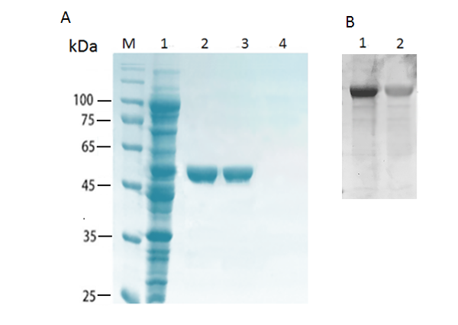
sFig 2. Analysis the purity of the protein MSTN-SST expressed by E. coli with SDS-PEGA and detection it’s reaction with mouse-anti-MSTN polyclonal antibodies and rabbit-anti-SST polyclonal antibodies with WB. (A)Lane 1. The supernatants of the lysis derived from the recombinant E coli expressing MSTN-SST; Lane 2 and Lane 3. Purified protein MSTN-SST. Lane 4. Phosphate buffer solution. (B) Lane1.MSTN-SST reaction with mouse-anti-MSTN polyclonal antibodies; Lane 2 MSTN-SST reaction with rabbit-anti-SST polyclonal antibodies.

