Supporting information
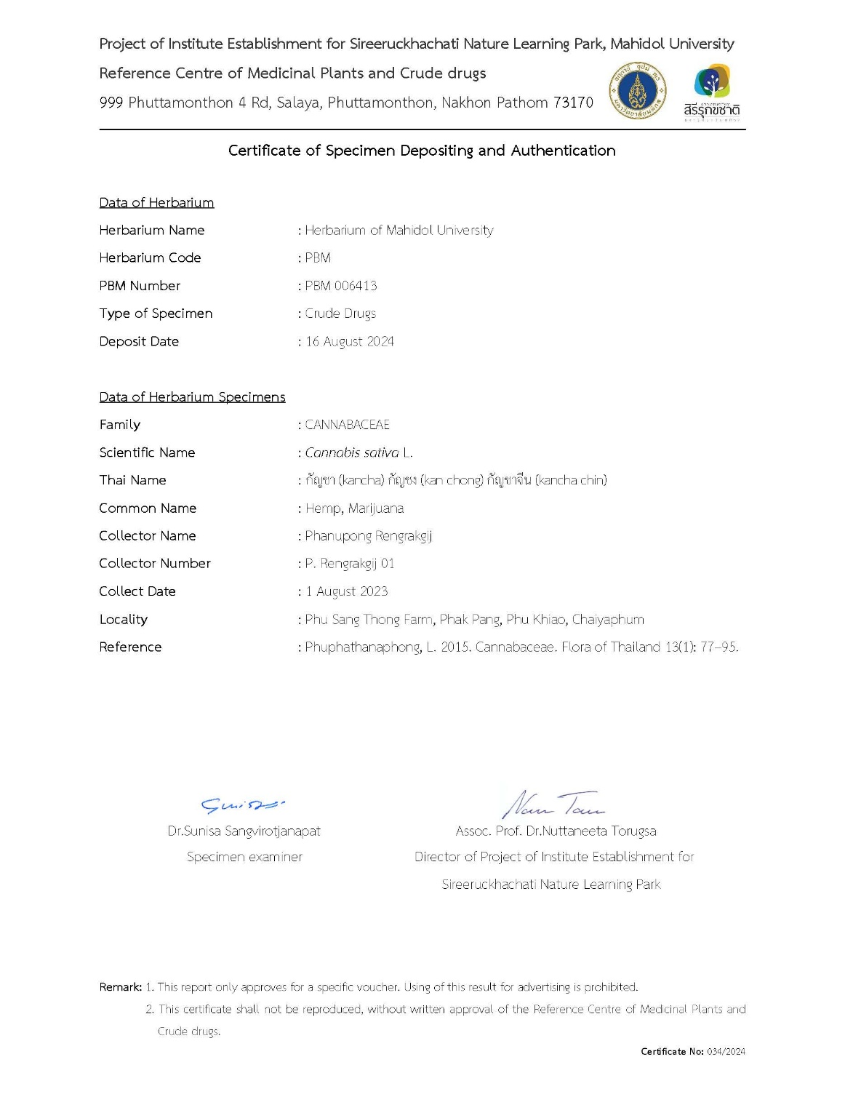

Supplementary Document 1. Certificate of specimen depositing and authentication. Official certification for the Cannabis sativa L. plant material (crude drug) used in this study, authenticated and deposited at the Herbarium of Mahidol University (Herbarium Code: PBM) under the voucher specimen number PBM 006413.
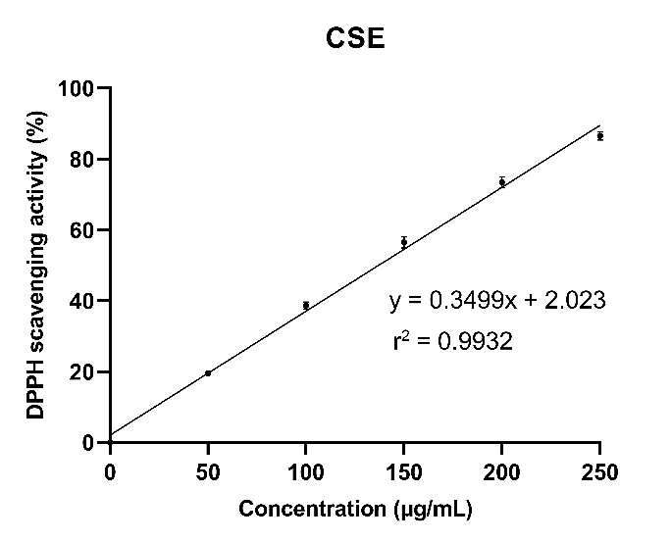

Supplementary Figure 1. Linear regression analysis of the DPPH radical scavenging activity of the ethanolic Cannabis sativa extract (CSE).

Target Gene | Direction | Sequence (5' -> 3')
B-actin | Forward | GAGACCTTCAACACCCCAGC
 | Reverse | ATGTCACGCACGATTTCCC
MITF | Forward | AATGGCAAATACGTTACCCG
 | Reverse | AAGGTTGGCTGGACAGGAGT
TYR | Forward | AGCCCAGCATCCTTCTTCTC
 | Reverse | AGTGGTCCCTCAGGTGTTCC
TYRP1 | Forward | AGTGCTTGGAGTCCGTGTA
 | Reverse | ATTCGTCAAAGACCGCATCA
TYRP2 | Forward | AAATAATGAGAAACTGCCAACC
 | Reverse | CGTCTGCTTTATCAAACCCT

Supplementary Table 1 . List of primer sequences used for quantitative real-time PCR (RT-qPCR) analysis. The specific forward and reverse primers targeting melanogenesis-related genes (MITF, TYR, TYRP1, and TYRP2) were utilized to quantify mRNA expression levels. β-actin (ACTB) (Gibthai Co., Thailand) served as the internal housekeeping control. All sequences are provided in the 5' → 3' direction.

No. | Analyte Peak Name/ Library Hit | Retention Time | Area | MW | Precursor Mass | Found At Mass | Library Score
1 | Trigonelline (NIST) Smart Confirmation | 2.87 | 5.611e+06 | {137.05093} | 138.058 | 138.0576 | 99.7
2 | Guanosine (NIST) Smart Confirmation | 4.40 | 2.433e+05 | {283.09975} | 284.106 | 284.1064 | 99.9
3 | Procyanidin B2 (NIST) Smart Confirmation | 8.43 | 8.194e+05 | {578.15908} | 579.166 | 579.1656 | 90.1
4 | (+)-Catechin (NIST) Smart Confirmation | 9.18 | 3.196e+05 | {290.08724} | 291.094 | 291.0941 | 97.7
5 | Orientin (NIST) Smart Confirmation | 10.04 | 4.593e+06 | {448.11271} | 449.119 | 449.1190 | 99.3
6 | Vitexin 4-O-glucoside (NIST) Smart Confirmation | 10.08 | 1.404e+07 | {594.17456} | 595.181 | 595.1813 | 99.6
7 | Vitexin-2''-O-rhamnoside (NIST) Smart Confirmation | 10.37 | 9.332e+06 | {578.17929} | 579.186 | 579.1861 | 98.7
8 | Vitexin (NIST) Smart Confirmation | 10.81 | 2.428e+06 | {432.11709} | 433.124 | 433.1235 | 98.6
9 | 9-Oxo-10E,12Z,15Z-octadecatrienoic acid (NIST EL) Smart Confirmation | 16.96 | 1.714e+06 | {292.21201} | 293.219 | 293.2187 | 91.4
10 | 9-Oxo-10E,12Z-octadecadienoic acid (NIST) Smart Confirmation | 18.03 | 1.154e+06 | {294.22761} | 295.234 | 295.2341 | 91.1
11 | Curcumol (NIST EL) Smart Confirmation | 25.38 | 5.270e+05 | {236.18476} | 237.191 | 237.1914 | 82.8
12 | Stearidonic acid (NIST EL) Smart Confirmation | 30.05 | 1.241e+06 | {276.21681} | 277.224 | 277.2234 | 91.7
13 | Cannabigerol (NIST) Smart Confirmation | 32.41 | 3.173e+06 | {316.24910} | 317.256 | 317.2557 | 94.6
14 | Tetrahydrocannabivarin (NIST) Smart Confirmation | 33.20 | 1.083e+07 | {286.20092} | 287.208 | 287.2074 | 98.1
15 | Cannabinol (NIST) Smart Confirmation | 35.06 | 6.526e+07 | {310.20053} | 311.207 | 311.2067 | 95.3
16 | (.+-.)-.DELTA.9-Tetrahydrocannabinol (NIST EL) Smart Confirmation | 36.29 | 2.683e+08 | {314.23133} | 315.238 | 315.2379 | 97.7
17 | (.+-.)-Cannabichromene (NIST EL) Smart Confirmation | 37.38 | 9.405e+06 | {314.23358} | 315.240 | 315.2400 | 97.7
18 | Cannabidiolic acid (NIST) Smart Confirmation | 37.83 | 2.371e+07 | {358.22398} | 359.231 | 359.2304 | 95.6
19 | Pheophorbide a (NIST) Smart Confirmation | 38.68 | 1.280e+08 | {592.28289} | 593.290 | 593.2891 | 88.0
20 | .DELTA.11-Tetrahydrocannabinol (NIST EL) Smart Confirmation | 40.91 | 5.632e+06 | {314.23356} | 315.240 | 315.2402 | 93.1

Supplementary Table 2. Comprehensive phytochemical profile of the ethanolic Cannabis sativa extract (CSE) identified via LC-QTOF-MS. Compounds are listed in order of elution (Retention Time). Identification was performed by matching precursor mass and fragmentation spectra against the NIST 2017 library. The Library Score indicates the confidence level of the spectral match (>85%). The table details the molecular weight (MW), chromatographic peak area, and specific retention times for key cannabinoids and flavonoids used to characterize the extract's chemotype.

