Supplementary Figure 1. outpatient volume before vs after implementation of the PPP-enabled digital booking system (January–June 2024 vs January–June 2025)
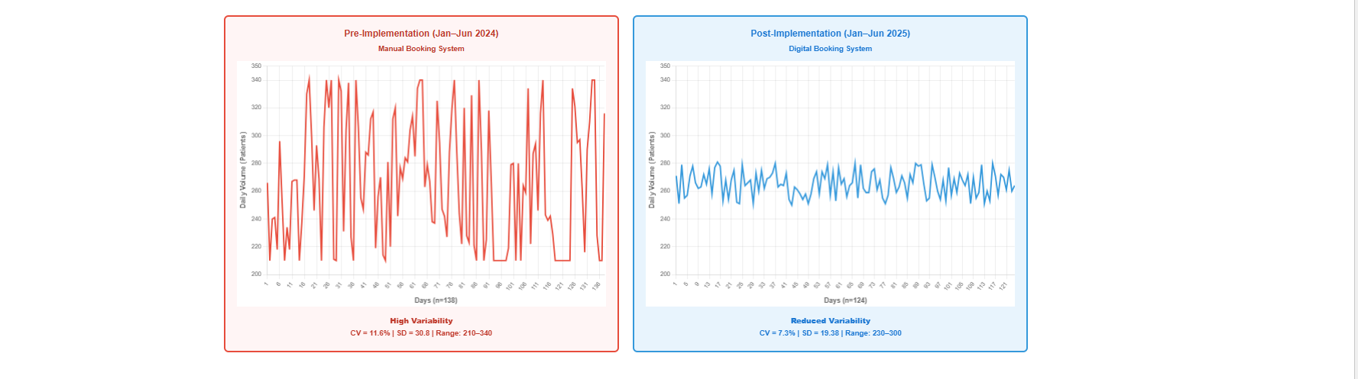
S-1A

Figure 1A (Daily total outpatient volume – run charts)
Run charts comparing daily attended total outpatient volume in the pre-implementation period (Jan–Jun 2024; Manual Booking System; n=138 days, red) versus the post-implementation period (Jan–Jun 2025; Digital Booking System; n=124 days, blue). The pre-implementation series demonstrates marked day-to-day volatility (CV=11.6%; SD=30.8; range: 210–340), whereas the post-implementation series shows reduced variability with a comparable mean volume (CV=7.3%; SD=19.38; range: 230–300), consistent with improved workload stability.
Figure 1B (Chemotherapy every-3-week/21-day stream – variability over time)
Time-series comparison of chemotherapy 21-day (every-3-week) activity in the pre-implementation (red) versus post-implementation (blue) periods. The post-implementation series shows a more stable pattern with fewer pronounced peaks, consistent with reduced workload volatility in this regimen subtype (see Table 1 for summary CV values).
Figure 1C (Hormonal/follow-up stream – variability over time)
Time-series comparison of the hormonal/follow-up clinic stream in the pre-implementation (red) versus post-implementation (blue) periods. The pre-implementation series shows substantial fluctuations with episodic peaks, while the post-implementation series demonstrates tighter clustering and improved stability, aligning with the marked reduction in variability reported in Table 1.
Abbreviations: CV, coefficient of variation; SD, standard deviation; PPP, public–private partnership.

