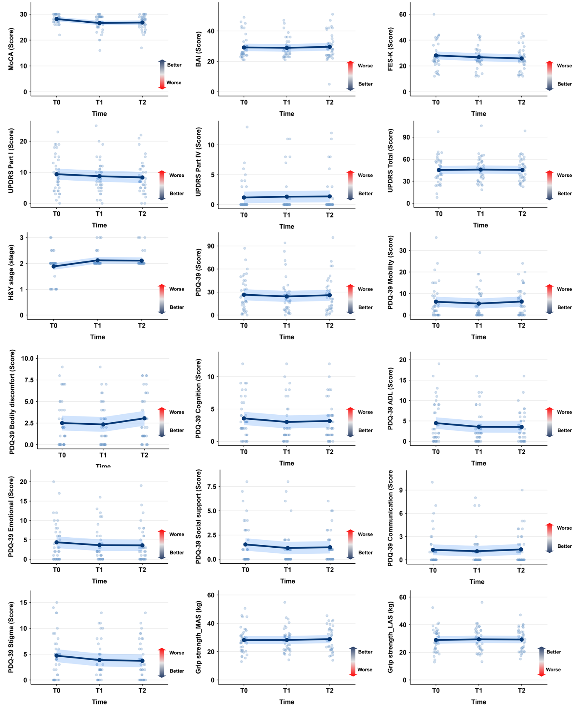
Supplementary Figure 1. Results of linear mixed model for non-significant variables. UPDRS: Unified Parkinson’s Disease Rating Scale; MoCA: Montreal Cognitive Assessment; BDI: Beck depression inventory; BAI: Beck Anxiety Inventory; FES-K: Falls Efficacy Scale-Korean; PDQ-39: 39-item Parkinson’s Disease Questionnaire

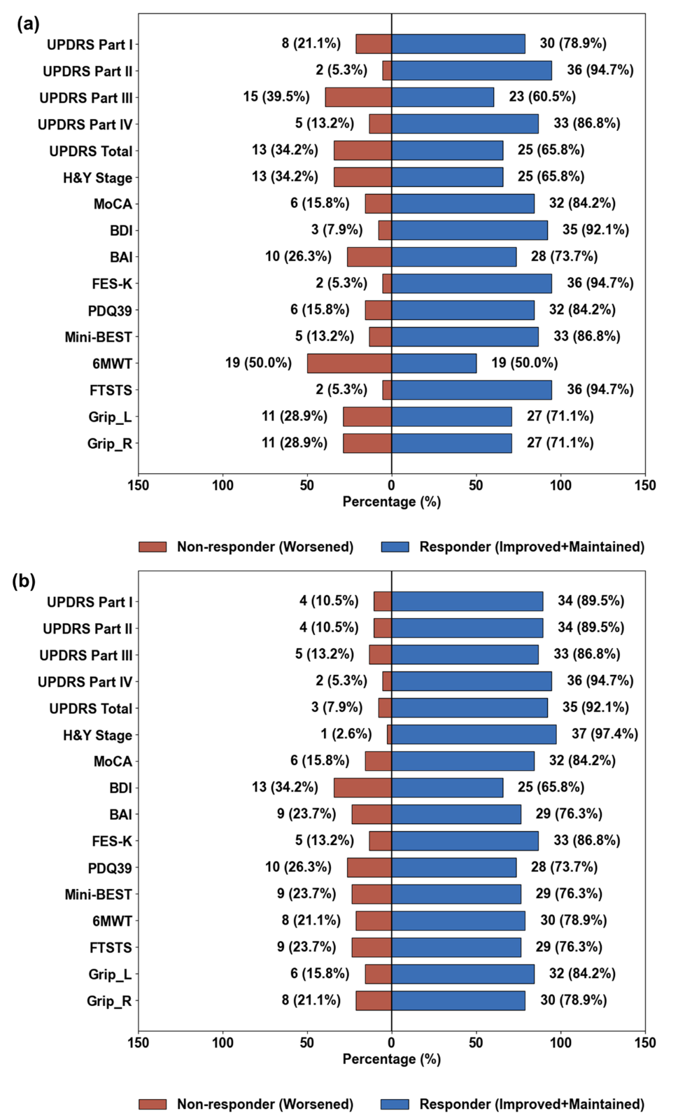
Supplementary Figure 2. Distribution of responders and non-responders based on clinically meaningful changes. (a) Distribution of responders and non-responders for early change (∆1), and (b) for later change (∆2). UPDRS: Unified Parkinson’s Disease Rating Scale; MoCA: Montreal Cognitive Assessment; BDI: Beck Depression Inventory; BAI: Beck Anxiety Inventory; FES-K: Falls Efficacy Scale-Korean; PDQ-39: 39-item Parkinson’s Disease Questionnaire; FTSTS: Five Times Sit-to-Stand Test; 6MWT: 6-minute walk test; Mini-BESTest: Mini Balance Evaluation Systems Test.
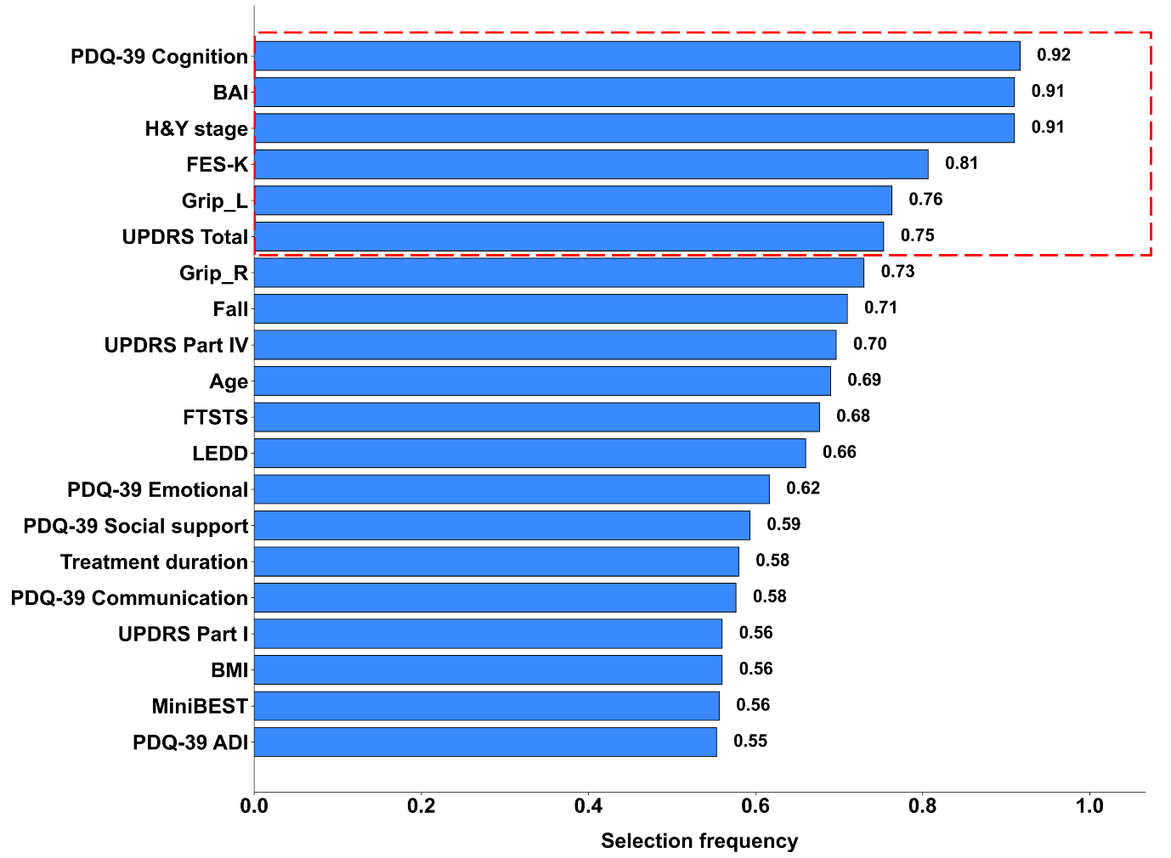
Supplementary Figure 3. Feature selection using logistic regression with elastic net. BMI: Body mass index; MoCA: Montreal cognitive assessment; UPDRS: Unified Parkinson’s Disease Rating Scale; LEDD: L-Dopa equivalent dose; BDI: Beck Depression Inventory; BAI: Beck Anxiety Inventory; FES-K: Falls Efficacy Scale-Korean; ; PDQ-39: 39-item Parkinson’s Disease Questionnaire; Emotional: emotional well-being; ADL: activities of daily living; Grip_L: Grip strength of left; Grip_R: Grip strength of right; FTSTS: Five Times Sit-to-Stand Test; 6MWT: 6-minute walk test; Mini-BESTest: Mini Balance Evaluation Systems Test.

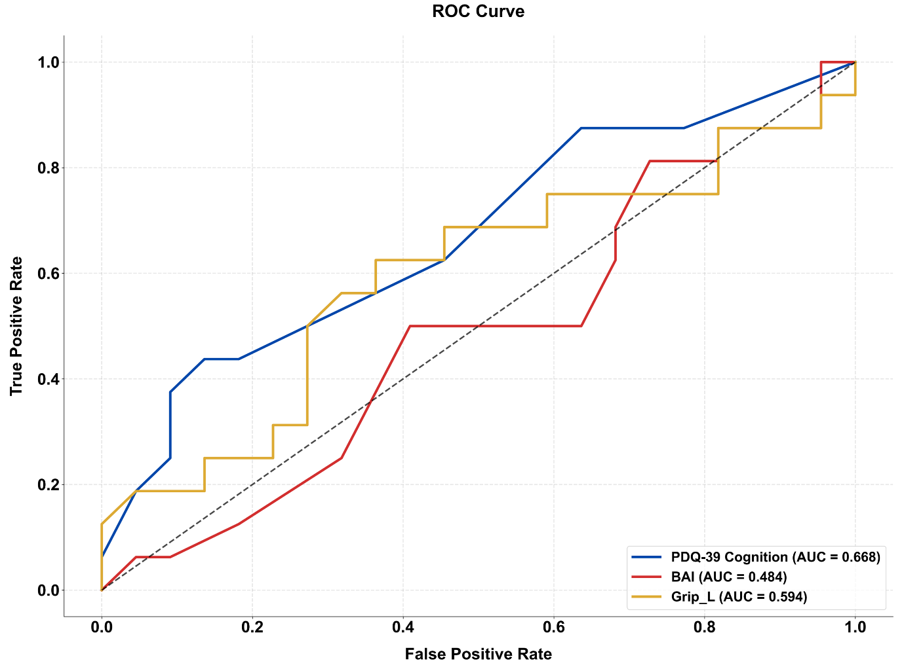
Supplementary Figure 4. AUC-ROC curve for predictors. PDQ-39: 39-item Parkinson’s Disease Questionnaire; BAI: Beck Anxiety Inventory; Grip_L: Grip strength of left; ROC: Receiver operating characteristic; AUC: area under the ROC curve.

