Supplementary Figures:
Fig. S1. Genomic heritability estimates (h²_{g}) for all traits at Arneberg, Løken, and quality (1st cut) datasets. Error bars represent approximate standard errors.
Fig. S2. Learning curves showing the effect of training population size (fraction of available training data) on GBLUP and Random Forest prediction accuracy for selected trait-dataset combinations.
Fig. S3. Effect of marker density on prediction accuracy for GBLUP and Random Forest. The x-axis shows the number of SNPs (log scale), and the y-axis shows mean cross-validation accuracy.
Fig. S4. Genomic correlation heatmaps between traits for (a) Arneberg yield, (b) Løken yield, and (c) quality 1st cut datasets. Values represent Pearson correlations between GEBVs from separate single-trait Ridge regression models.
Fig. S5. Model comparison with 95% bootstrap confidence intervals for selected trait-dataset combinations (Arneberg SUMDM, Løken SUMDM, Quality Fordøy). Error bars represent 2.5th-97.5th percentile intervals from 20 bootstrap replicates.

Fig S1
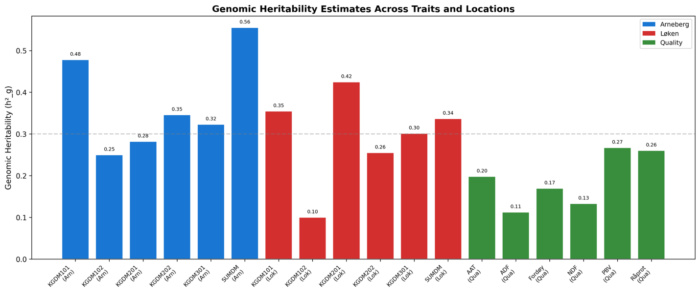
Fig S2.
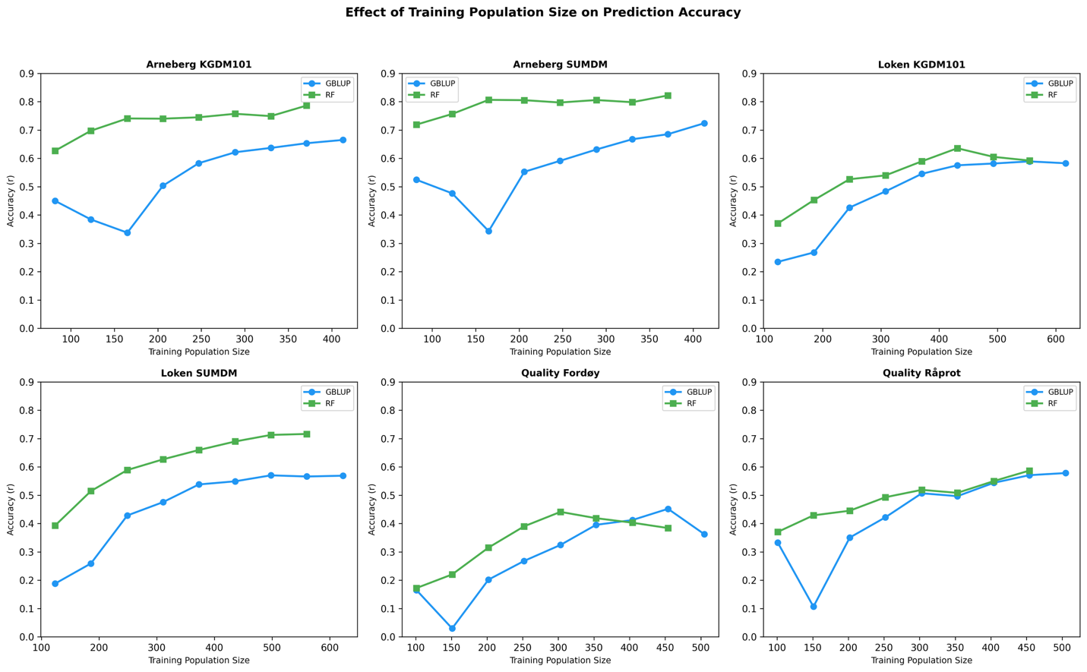
Fig S3
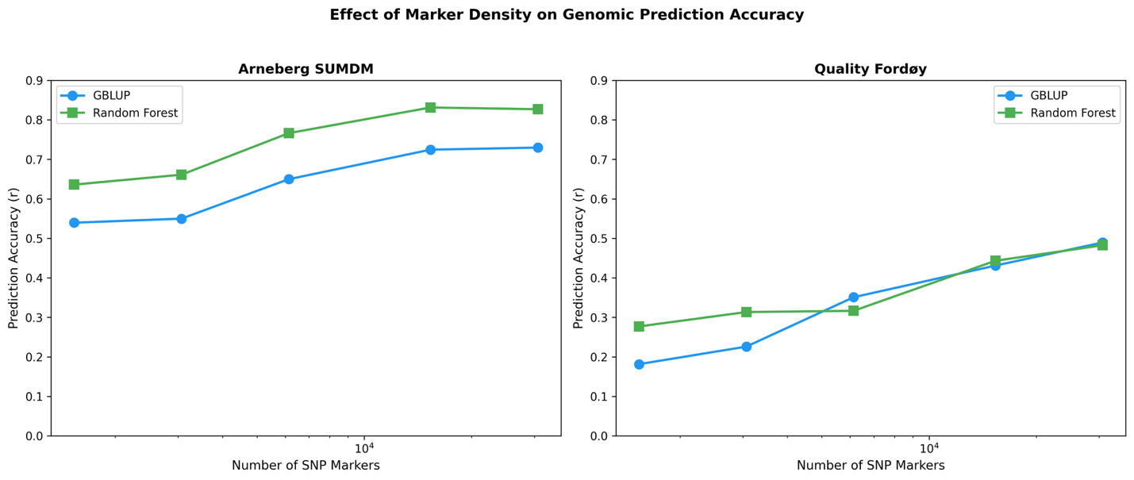
Fig S4
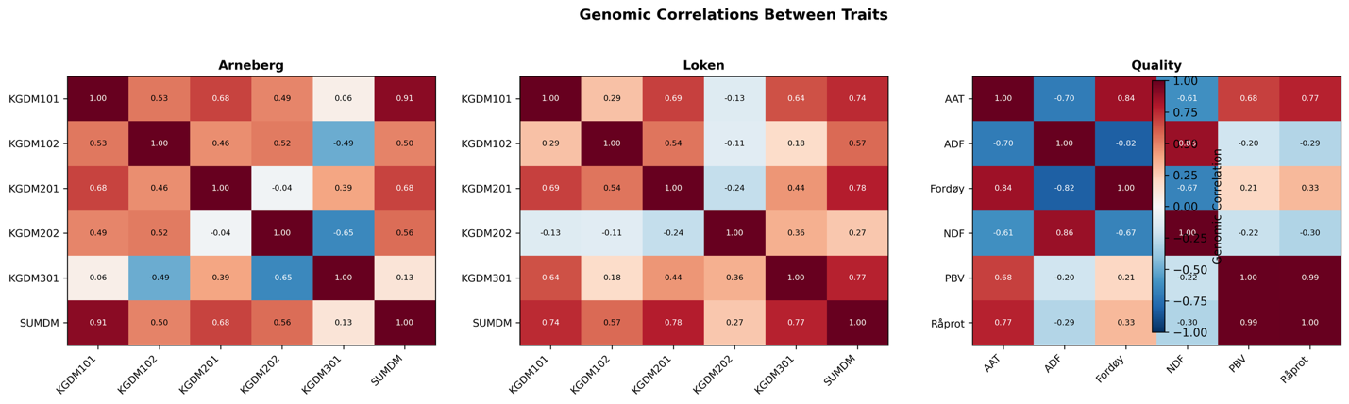
Fig S5
