Supp Table 1. Network Stability and Accuracy Indices
Metric | Value | Interpretation
CS-coefficient (Strength) | 0.75 | Excellent stability
Max case-drop proportion | 75.1% | Robust centrality estimates
Bootstrap iterations | 2,000 | High precision

Supp Table 2 Age-Based Network Comparison Test Results
Test | Statistic | p-value | Interpretation
Global strength difference | – | 0.352 | Not significant
Network structure difference | – | >0.05 | No global structural difference
Supp Table 3. Node Strength Differences Between Age Groups (NCT)
Symptom | p-value | Interpretation
anx1 | 0.597 | NS
anx2 | 0.831 | NS
anx3 | 0.400 | NS
anx4 | 0.083 | Trend-level
anx5 | 0.710 | NS
anx6 | 0.147 | NS
anx7 | 0.115 | NS
dep1 | 0.111 | NS
dep2 | 0.130 | NS
dep3 | 0.726 | NS
dep4 | 0.614 | NS
dep5 | 0.830 | NS
dep6 | 0.053 | Trend-level
dep7 | 0.011 | Significant

NS = not significant.
Supp Figure 1. Edge weight accuracy: nonparametric bootstrap confidence intervals

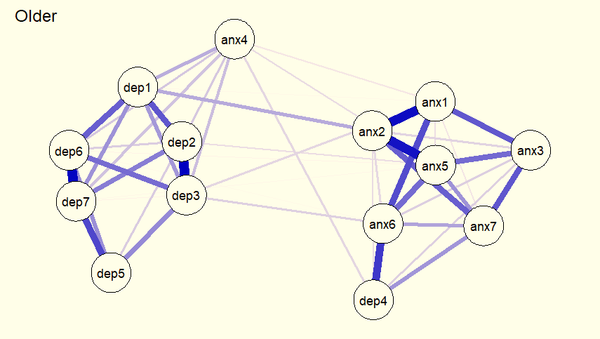

Supp Figure 2. Age-based network comparison: node strength differences

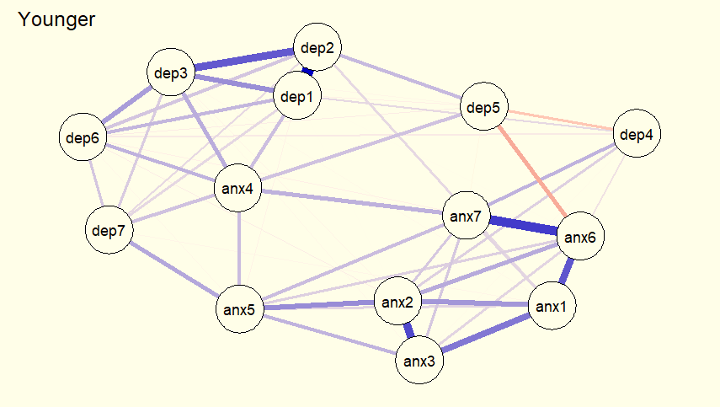

Supp Figure 3: HADS Items Descriptive Statics

Supp Figure 4: Centrality Indices
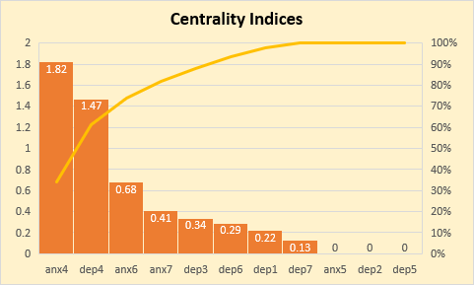
Supp Figure 5: Bridge Centrality Metrics

Supp Figure 6: Network Stability and Accuracy Indices
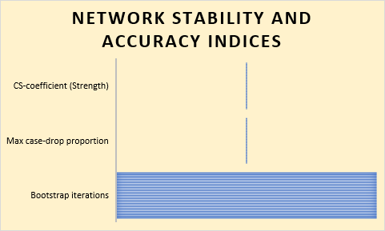
Supp Figure 6: p value of HADS items

