Table S1. Strain-level mean male frequency estimates. Values represent the proportion of male progeny produced per strain, calculated across individual hermaphrodite assays. Standard deviation (SD) and standard error (SE) are shown to indicate variability among replicates. The competitor strain ST2 is included for completeness but was excluded from statistical analyses in the main text.
Strain | Mean frequency | SD | SE
CB4856 | 0.0768 | 0.1200 | 0.0203
AB1 | 0.0363 | 0.0653 | 0.0112
ECA36 | 0.0109 | 0.0450 | 0.00761
PX176 | 0.00680 | 0.0292 | 0.00474
JU311 | 0.00325 | 0.0142 | 0.00248
MDX44 | 0.00276 | 0.0143 | 0.00224
N2 | 0.00270 | 0.0106 | 0.00170
ST2 | 0.000653 | 0.00296 | 0.000479
JU345 | 0.0000 | 0.0000 | 0.0000
MY16 | 0.0000 | 0.0000 | 0.0000

Table S2. Within-strain pairwise contrasts from estimated marginal means testing the effects of inbreeding and recovery on relative fitness in nine C. elegans strains. Negative estimates indicate lower relative fitness compared to the reference phase, whereas positive estimates indicate higher relative fitness. P-values were Tukey-adjusted for multiple comparisons.
Strain | Contrast | Estimate | SE | df | t.ratio | p.value
JU345 | After inbreeding - Before inbreeding | -0.3901 | 0.1489 | 703 | -2.621 | 0.0243
JU345 | After recovery - Before inbreeding | -0.2372 | 0.1490 | 703 | -1.592 | 0.2498
JU345 | After recovery - After inbreeding | 0.1529 | 0.1571 | 703 | 0.973 | 0.5940
MY16 | After inbreeding - Before inbreeding | -0.9511 | 0.1403 | 703 | -6.779 | <0.0001
MY16 | After recovery - Before inbreeding | -0.5903 | 0.1527 | 703 | -3.866 | 0.0004
MY16 | After recovery - After inbreeding | 0.3608 | 0.1527 | 703 | 2.363 | 0.0482
N2 | After inbreeding - Before inbreeding | -0.4084 | 0.1415 | 703 | -2.886 | 0.0112
N2 | After recovery - Before inbreeding | -0.2109 | 0.1519 | 703 | -1.389 | 0.3473
N2 | After recovery - After inbreeding | 0.1975 | 0.1508 | 703 | 1.310 | 0.3900
MDX44 | After inbreeding - Before inbreeding | 0.3571 | 0.1427 | 703 | 2.503 | 0.0336
MDX44 | After recovery - Before inbreeding | 0.6142 | 0.1484 | 703 | 4.140 | 0.0001
MDX44 | After recovery - After inbreeding | 0.2571 | 0.1484 | 703 | 1.732 | 0.1940
JU311 | After inbreeding - Before inbreeding | -0.2808 | 0.1457 | 703 | -1.928 | 0.1316
JU311 | After recovery - Before inbreeding | -0.0538 | 0.1489 | 703 | -0.361 | 0.9307
JU311 | After recovery - After inbreeding | 0.2271 | 0.1541 | 703 | 1.473 | 0.3044
PX176 | After inbreeding - Before inbreeding | -0.7082 | 0.1427 | 703 | -4.963 | <0.0001
PX176 | After recovery - Before inbreeding | -0.0746 | 0.1666 | 703 | -0.448 | 0.8955
PX176 | After recovery - After inbreeding | 0.6337 | 0.1666 | 703 | 3.804 | 0.0005
ECA36 | After inbreeding - Before inbreeding | -0.3343 | 0.1415 | 703 | -2.362 | 0.0483
ECA36 | After recovery - Before inbreeding | -0.2198 | 0.1519 | 703 | -1.447 | 0.3175
ECA36 | After recovery - After inbreeding | 0.1145 | 0.1508 | 703 | 0.759 | 0.7281
AB1 | After inbreeding - Before inbreeding | -0.2185 | 0.1403 | 703 | -1.558 | 0.2649
AB1 | After recovery - Before inbreeding | -0.0121 | 0.1415 | 703 | -0.085 | 0.9960
AB1 | After recovery - After inbreeding | 0.2065 | 0.1415 | 703 | 1.459 | 0.3114
CB4856 | After inbreeding - Before inbreeding | -0.4700 | 0.1428 | 703 | -3.292 | 0.0030
CB4856 | After recovery - Before inbreeding | -0.3617 | 0.1530 | 703 | -2.364 | 0.0481
CB4856 | After recovery - After inbreeding | 0.1083 | 0.1507 | 703 | 0.719 | 0.7525

Table S3. Estimated marginal means (EMMs) of relative fitness for each C. elegans strain across experimental phases (Before inbreeding, After inbreeding, After recovery), obtained from the mixed-effects model. Values are shown as mean ± SE with 95% confidence intervals.
Strain | Status | Relative fitness (emmean ± SE) | 95% CI (lower–upper)
JU345 | Before inbreeding | 1.477 ± 0.114 | 1.254–1.700
JU345 | After inbreeding | 1.087 ± 0.124 | 0.843–1.331
JU345 | After recovery | 1.240 ± 0.124 | 0.996–1.484
MY16 | Before inbreeding | 1.719 ± 0.114 | 1.495–1.942
MY16 | After inbreeding | 0.768 ± 0.114 | 0.544–0.991
MY16 | After recovery | 1.128 ± 0.129 | 0.876–1.381
N2 | Before inbreeding | 1.345 ± 0.115 | 1.119–1.571
N2 | After inbreeding | 0.937 ± 0.114 | 0.713–1.160
N2 | After recovery | 1.134 ± 0.126 | 0.886–1.382
MDX44 | Before inbreeding | 0.901 ± 0.115 | 0.675–1.128
MDX44 | After inbreeding | 1.259 ± 0.115 | 1.032–1.485
MDX44 | After recovery | 1.516 ± 0.122 | 1.276–1.756
JU311 | Before inbreeding | 1.518 ± 0.114 | 1.295–1.742
JU311 | After inbreeding | 1.237 ± 0.120 | 1.001–1.474
JU311 | After recovery | 1.464 ± 0.124 | 1.221–1.708
PX176 | Before inbreeding | 1.465 ± 0.115 | 1.239–1.691
PX176 | After inbreeding | 0.757 ± 0.115 | 0.530–0.983
PX176 | After recovery | 1.390 ± 0.144 | 1.108–1.673
ECA36 | Before inbreeding | 1.020 ± 0.115 | 0.794–1.246
ECA36 | After inbreeding | 0.686 ± 0.114 | 0.462–0.909
ECA36 | After recovery | 0.800 ± 0.126 | 0.552–1.048
AB1 | Before inbreeding | 1.291 ± 0.114 | 1.068–1.515
AB1 | After inbreeding | 1.073 ± 0.114 | 0.850–1.296
AB1 | After recovery | 1.279 ± 0.115 | 1.053–1.506
CB4856 | Before inbreeding | 1.158 ± 0.117 | 0.928–1.387
CB4856 | After inbreeding | 0.688 ± 0.114 | 0.464–0.911
CB4856 | After recovery | 0.796 ± 0.126 | 0.548–1.044

Table S4. Linear model estimates for the effect of male frequency on strain-level indices of inbreeding depression (ID) and recovery (IR), calculated from estimated marginal means of relative fitness. Spearman rank correlations are reported in the main text.
Response | Predictor | Slope | SE | 95% CI | p-value
Inbreeding depression (ID) | Male frequency | 1.70 | 4.02 | −7.80 to 11.20 | 0.685
Recovery (IR) | Male frequency | −1.42 | 1.52 | −5.01 to 2.18 | 0.383

Table S5. Strain-level developmental time estimates. Values represent mean developmental time (hours from late L4 to adulthood) for each strain, with standard deviation (SD) and standard error (SE) indicating variability among replicates. Minimum and maximum values show the observed range within each strain.
Strain | Mean (hrs) | SD (hrs) | SE (hrs) | Min (hrs) | Max (hrs)
MY16 | 63.0 | 4.38 | 0.86 | 58.5 | 72.4
PX176 | 64.5 | 5.19 | 1.11 | 58.3 | 74.3
JU311 | 65.2 | 5.43 | 0.96 | 58.1 | 77.4
ECA36 | 65.4 | 7.54 | 1.43 | 58.4 | 92.7
CB4856 | 66.3 | 6.12 | 1.22 | 57.4 | 81.9
AB1 | 66.4 | 5.92 | 1.06 | 58.7 | 81.9
JU345 | 67.0 | 4.12 | 0.75 | 60.5 | 77.4
ST2 | 69.0 | 5.16 | 0.99 | 62.3 | 87.2
MDX44 | 69.4 | 8.06 | 1.34 | 60.2 | 92.4
N2 | 70.2 | 4.39 | 0.94 | 62.3 | 77.4

Table S6. Effects of male frequency and developmental time on strain-level inbreeding depression (ID) and recovery (IR). Values are estimates from multiple linear models including both predictors.
Response | Predictor | Estimate | SE | 95% CI | p-value
ID | Male frequency | 1.52 | 3.31 | −6.57 to 9.61 | 0.662
ID | Developmental time | −0.077 | 0.037 | −0.168 to 0.013 | 0.082
IR | Male frequency | −1.43 | 1.62 | −5.39 to 2.52 | 0.409
IR | Developmental time | −0.008 | 0.018 | −0.053 to 0.036 | 0.665

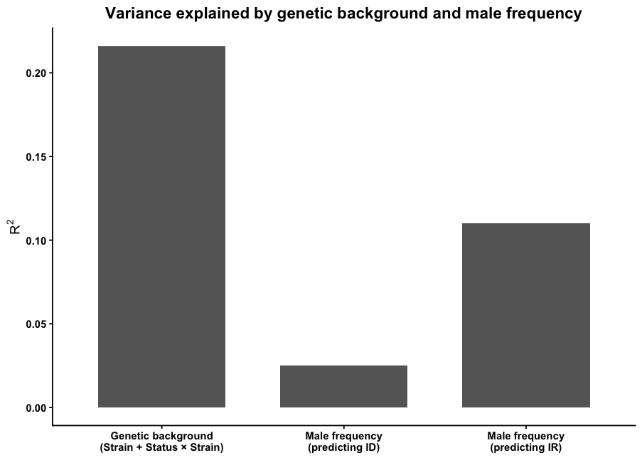
Figure 1: Genetic background explains substantially more variation in inbreeding responses than male frequency, which shows weak explanatory power for both inbreeding depression (ID) and recovery (IR).

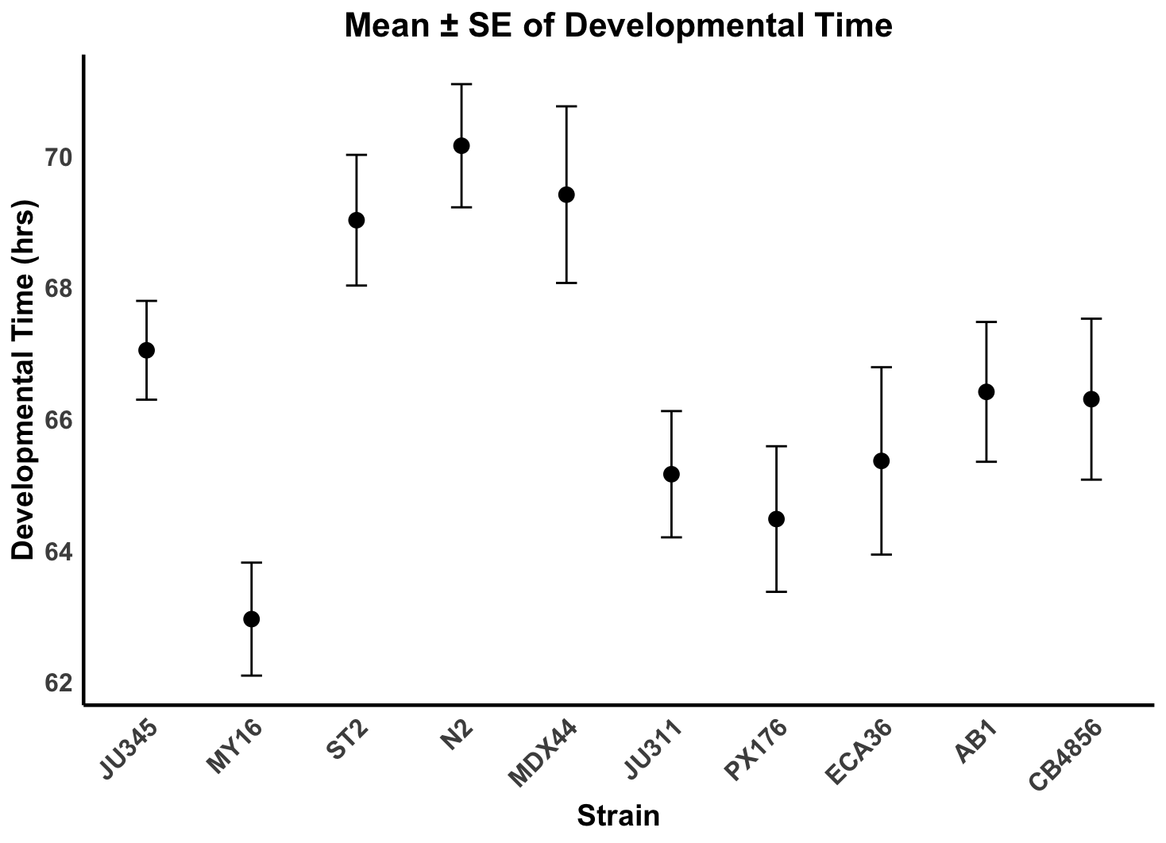
Figure S2: Mean ± SE of developmental time (hours from L1 to first reproduction) across nine C. elegans strains under common-garden conditions. Each point represents the strain mean based on replicate individuals. Developmental time differed significantly among strains, indicating inherent life-history variation beyond differences in male frequency.

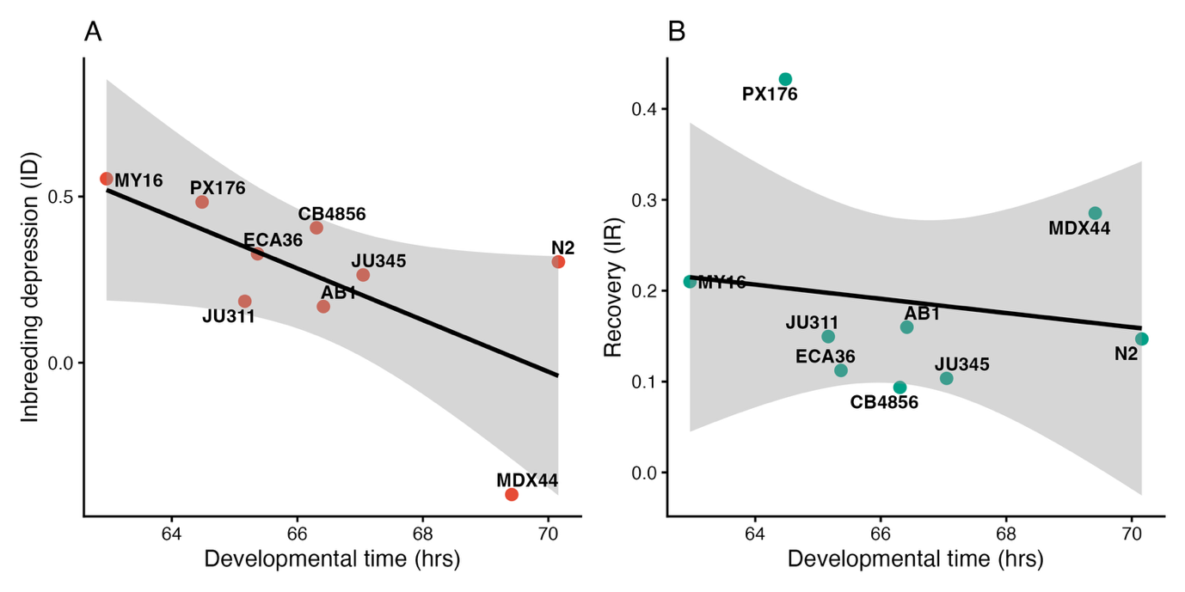

Figure S3. Developmental time does not explain variation in inbreeding response.
(A) Relationship between strain mean developmental time (L1 to first reproduction) and inbreeding depression (Δ relative fitness). (B) Relationship between developmental time and recovery following inbreeding. Points represent strain means; lines show linear model fits with 95% confidence intervals. Although a negative trend was observed between developmental time and inbreeding depression, this relationship was not statistically significant, and no association was detected for recovery. These results indicate that variation in relative fitness responses is unlikely to be explained by differences in developmental timing.

