Additional Files
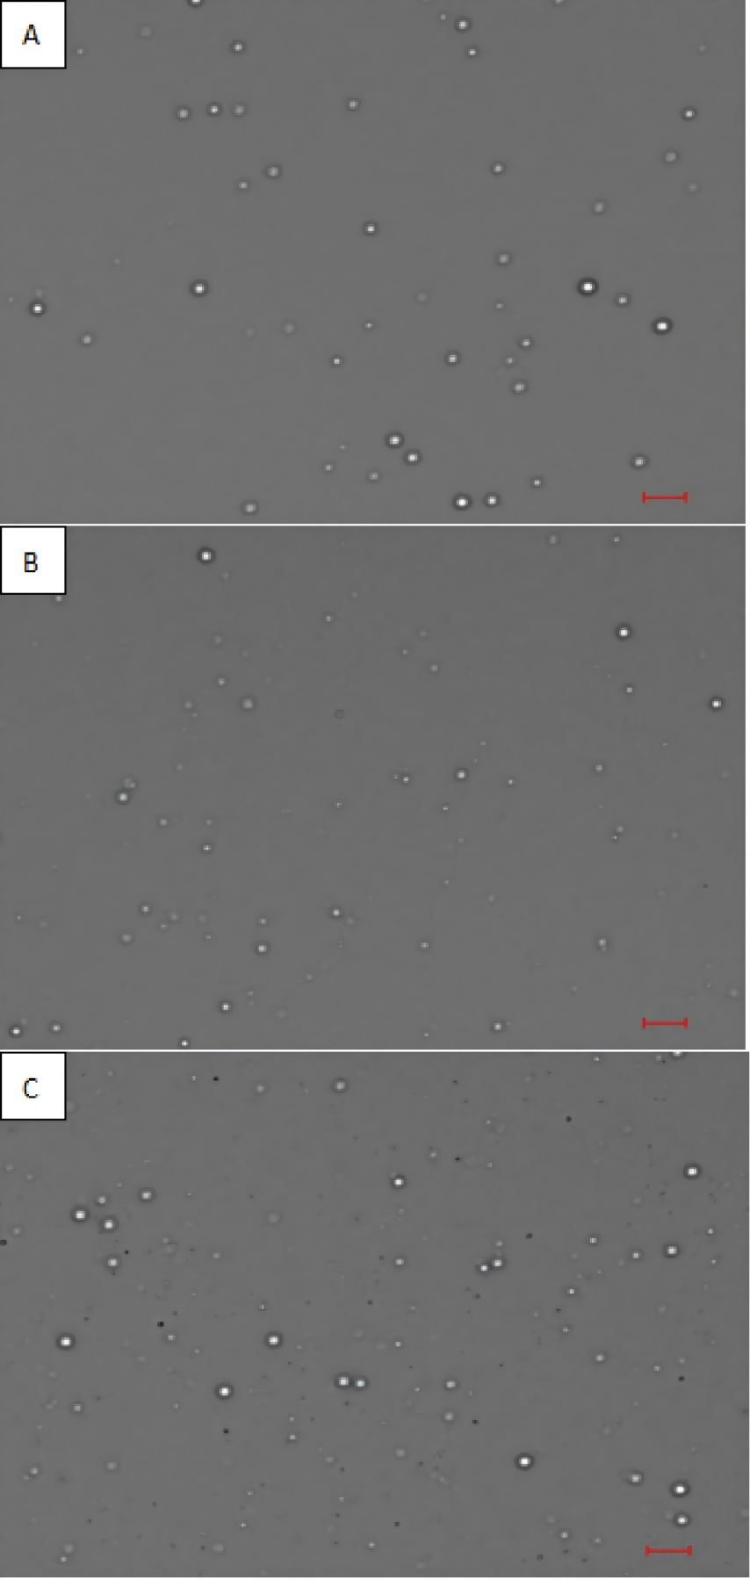
Additional File 1: Nanodroplets (A: PFB; B:PFP; C:PFH) observed under 63x objective oil lens. Red bars indicate 10 µm.

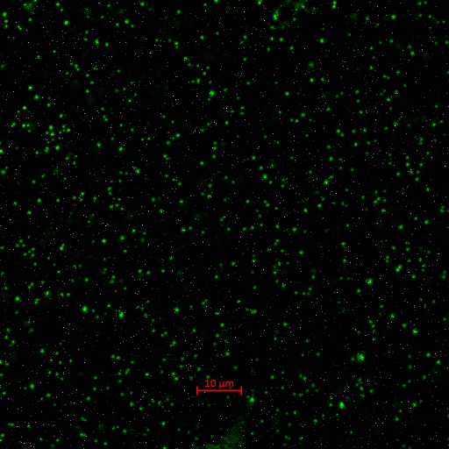
Additional File 2: Fluorescencely stained PFB nanodroplets with DiO observed under 63x objective oil lens. Some unstained nanodroplets were also noticed under the staining protocol used. Red bar indicates 10 µm.

Additional File (Video) Legends

Additional File 3: 2 droplets moving in a PFB nanodroplets treated erythrocyte. Bar indicates 2 µm.

Additional File 4: 1 droplet moving in a PFP nanodroplets treated erythrocyte, along with 1 droplet entrapped between membrane bilayers. Bar indicates 2 µm.

Additional File 5: 1 droplet moving in a PFH nanodroplets treated erythrocyte, along with 3 droplets entrapped between membrane bilayers. Bar indicates 2 µm.

Additional File 6: Droplets moving inside of a group of PFP nanodroplets treated erythrocytes. Bar indicates 2 µm.

