Supplement Figure 2: Comparative docking and interaction analyses of Lawsone and GSSG molecules within the GPx enzyme active site.
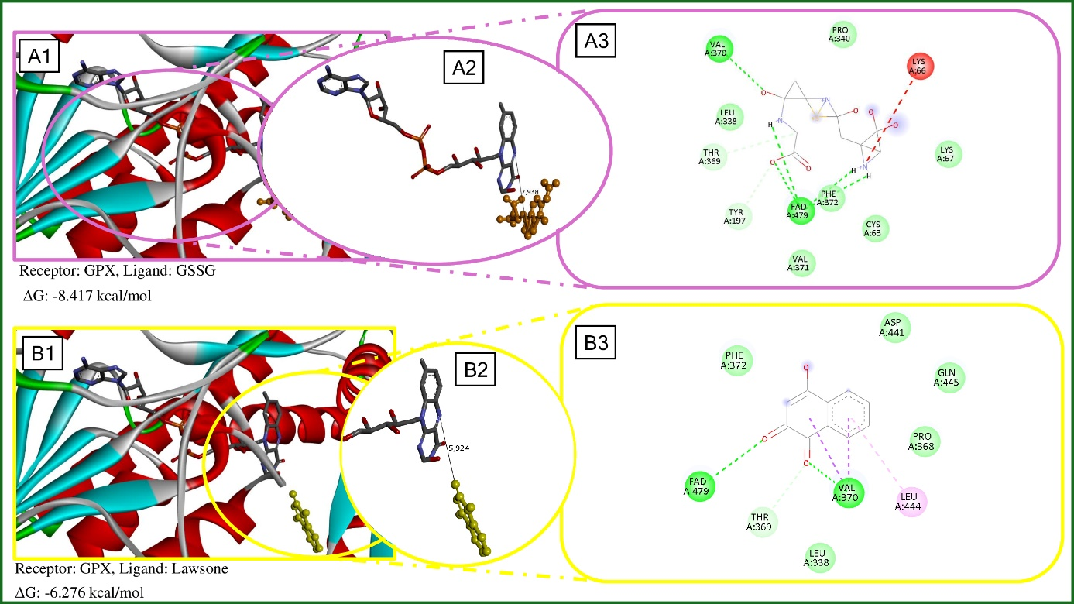
Note:(A1) 3D binding orientation of GSSG; (A2) Interatomic distance between GSSG and the catalytic center; (A3) 2D interaction map of GSSG illustrating the interaction network with surrounding residues; (B1) 3D binding orientation of Lawsone within the GPx pocket; (B2) Interatomic distance between Lawsone and the catalytic center; (B3) 2D interaction map of Lawsone illustrating interactions with surrounding residues and the cofactor.

