Supplement Figure 3: Comparative docking and interaction analyses of Lawsone and NADPH molecules within the Catalase (CAT) enzyme active site.
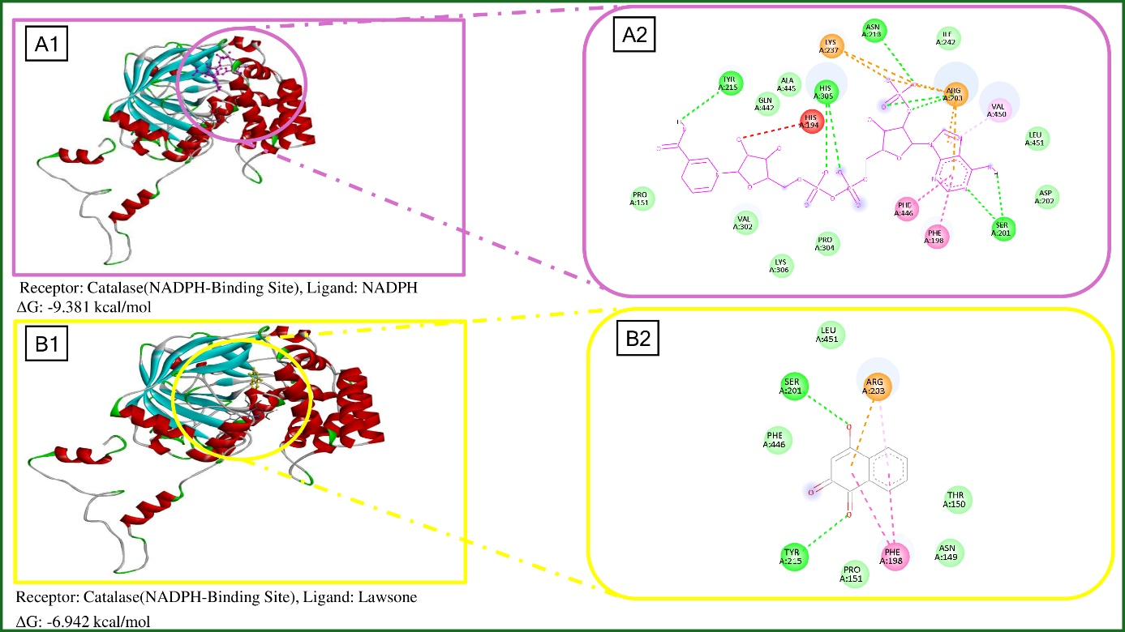
Note: (A1) 3D binding orientation of NADPH; (A2) 2D interaction map of NADPH illustrating the interaction network with surrounding residues; (B1) 3D binding orientation of Lawsone within the Catalase NADPH pocket; (B2) 2D interaction map of Lawsone illustrating interactions with surrounding residues and the cofactor site.

