Supplement Figure 1: Comparative docking and interaction analyses of Lawsone and H₂O₂ molecules within the LPO enzyme active site.
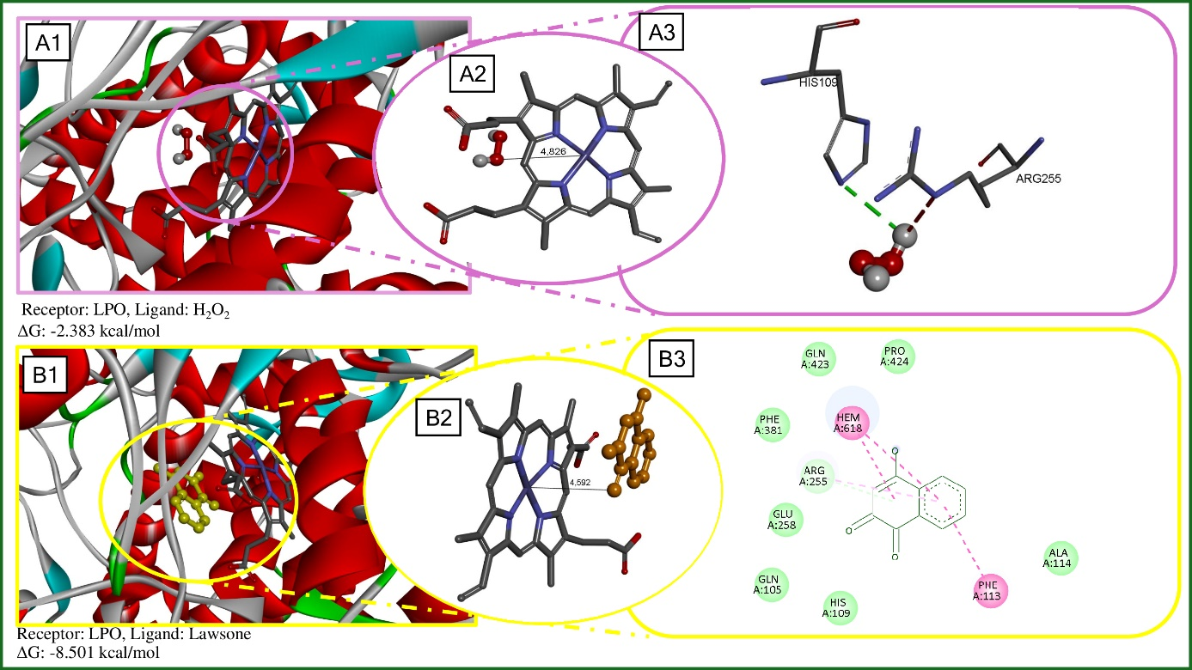
Note:(A1) 3D binding orientation of the H₂O₂ molecule;(A2) Interatomic distance between H₂O₂ and the heme center;(A3) Details showing the positional stability of H₂O₂ in the active center and its interactions with HIS A:109 and ARG A:255;(B1) 3D binding orientation of Lawsone within the LPO active site;(B2) Interatomic distance between Lawsone and the heme center;(B3) 2D interaction map illustrating the interactions established by Lawsone with the heme cofactor and surrounding residues.

