Supplementary file
S1 Table. Collinearity diagnostics in the association analysis of eGDR with all-cause, cardiovascular, and premature mortality
 | VIF
 | All-cause mortality | Cardiovascular mortality | Premature mortality
eGDR | 1.33 | 1.33 | 1.30
Age | 1.29 | 1.27 | 1.32
PIR | 1.11 | 1.10 | 1.10
Gender | 1.18 | 1.19 | 1.11
Race | 1.05 | 1.05 | 1.04
Education | 1.09 | 1.08 | 1.08
Marital | 1.12 | 1.12 | 1.08
Cancer | 1.05 | 1.04 | 1.06
Insurance | 1.10 | 1.08 | 1.10
Drinking | 1.09 | 1.10 | 1.08
Smoking status | 1.09 | 1.09 | 1.09
BMI | 1.16 | 1.16 | 1.15
SBP | 1.06 | 1.06 | 1.1
DBP | 1.12 | 1.11 | 1.19
BUN | 1.30 | 1.32 | 1.32
Cr | 1.27 | 1.28 | 1.30
eGDR, estimated glucose disposal rate; Cr, creatinine; VIF, variance inflation factor; PIR, poverty income ratio; BMI, body mass index; SBP, systolic blood pressure; DBP, diastolic blood pressure;BUN, blood urea nitrogen
S2 Table. Collinearity diagnostics in the association analysis of LE8 with all-cause, cardiovascular, and premature mortality
 | VIF
 | All-cause mortality | Cardiovascular mortality | Premature mortality
LE8 | 1.06 | 1.06 | 1.05
Age | 1.17 | 1.16 | 1.17
PIR | 1.11 | 1.10 | 1.10
Gender | 1.13 | 1.14 | 1.08
Race | 1.04 | 1.04 | 1.04
Education | 1.09 | 1.08 | 1.09
Marital | 1.11 | 1.11 | 1.07
Cancer | 1.04 | 1.04 | 1.06
Insurance | 1.08 | 1.06 | 1.10
Drinking | 1.07 | 1.07 | 1.05
BUN | 1.27 | 1.29 | 1.31
Cr | 1.26 | 1.28 | 1.30
Abbreviations: LE8, Life’s Essential 8; Cr, creatinine; VIF, variance inflation factor; PIR, poverty income ratio; BMI, body mass index; BUN, blood urea nitrogen.

S3 Table. Collinearity diagnostics in the association analysis of health factor score with all-cause, cardiovascular, and premature mortality
 |  | VIF
 | All-cause mortality | Cardiovascular mortality | Premature mortality
Health factor score | 1.02 | 1.03 | 1.02
Age | 1.2 | 1.19 | 1.20
PIR | 1.1 | 1.1 | 1.10
Gender | 1.15 | 1.17 | 1.10
Race | 1.05 | 1.04 | 1.04
Education | 1.08 | 1.08 | 1.08
Marital | 1.12 | 1.12 | 1.08
Drinking | 1.10 | 1.1 | 1.08
Smoking | 1.08 | 1.08 | 1.08
BUN | 1.28 | 1.3 | 1.30
Cr | 1.26 | 1.28 | 1.30
Cancer | 1.04 | 1.04 | 1.06
Insurance | 1.09 | 1.07 | 1.10
Abbreviations: Cr, creatinine; VIF, variance inflation factor; PIR, poverty income ratio; BUN, blood urea nitrogen.

S4 Table. Collinearity diagnostics in the association analysis of health behavior score with all-cause, cardiovascular, and premature mortality
 | VIF
 | All-cause mortality | Cardiovascular mortality | Premature mortality
Health behavior score | 1.07 | 1.06 | 1.06
Age | 1.25 | 1.23 | 1.29
PIR | 1.11 | 1.10 | 1.10
Gender | 1.14 | 1.15 | 1.10
Race | 1.05 | 1.04 | 1.04
Education | 1.10 | 1.09 | 1.09
Marital | 1.10 | 1.11 | 1.08
Cancer | 1.04 | 1.04 | 1.05
Insurance | 1.08 | 1.07 | 1.10
Drinking | 1.06 | 1.07 | 1.06
BMI | 1.02 | 1.02 | 1.02
SBP | 1.06 | 1.06 | 1.09
DBP | 1.12 | 1.11 | 1.17
BUN | 1.29 | 1.32 | 1.32
Abbreviations: VIF, variance inflation factor; PIR, poverty income ratio; BMI, body mass index; SBP, systolic blood pressure; DBP, diastolic blood pressure; BUN, blood urea nitrogen.

S5 Table. Covariate Adjustments for LE8, Health Behavior Score, Health Factor Score, and eGDR in Multivariable Regression Models.
 | Adjustment Strategy in Multivariable Analysis
Variable | Model 1 | Model 2 | Model 3
LE8 | Crude | Gender, race, age | Age, PIR, gender, race, education, marital, cancer, insurance, drinking, BUN, Cr
Health behavior score | Crude | Gender, race, age | Age, PIR, gender, race, education, marital, cancer, insurance, drinking, BMI, SBP, DBP, BUN, Cr
Health factor score | Crude | Gender, race, age | Age, PIR, gender, race, education, marital, drinking, smoking status, BUN, Cr, cancer, insurance
eGDR | Crude | Gender, race, age | Age, PIR, gender, race, education, marital, cancer, insurance, drinking, smoking status, BMI, SBP, DBP, BUN, Cr
Abbreviations: LE8, Life's Essential 8; eGDR, estimated glucose disposal rate; PIR, poverty income ratio; BUN, blood urea nitrogen; Cr, creatinine; BMI, body mass index; SBP, systolic blood pressure; DBP, diastolic blood pressure.

S6 Table. Associations of health behavior score and health factor score with mortality risk
 | Model 1 |  | Model 2 |  | Model 3
 | HR (95%CI) | P | HR (95%CI) | P | HR (95%CI) | P
All-cause mortality
Health behavior score (Per 10) | 0.87 (0.84-0.91) | <0.001 | 0.80 (0.77-0.83) | <0.001 | 0.82 (0.79-0.86) | <0.001
Health factor score (Per 10) | 0.94 (0.88-0.99) | 0.020 | 0.91 (0.85-0.97) | 0.004 | 0.91 (0.85-0.97) | 0.004
Cardiovascular mortality
Health behavior score (Per 10) | 0.89 (0.83-0.96) | 0.002 | 0.81 (0.75-0.87) | <0.001 | 0.84 (0.78-0.90) | <0.001
Health factor score (Per 10) | 0.88 (0.80-0.96) | 0.003 | 0.83 (0.75-0.92) | <0.001 | 0.84 (0.76-0.93) | <0.001
Premature mortality
Health behavior score (Per 10) | 0.77 (0.72-0.83) | <0.001 | 0.76 (0.71-0.82) | <0.001 | 0.79 (0.73-0.85) | <0.001
Health factor score (Per 10) | 0.83 (0.74-0.93) | 0.002 | 0.82 (0.73-0.92) | <0.001 | 0.81 (0.73-0.91) | <0.001

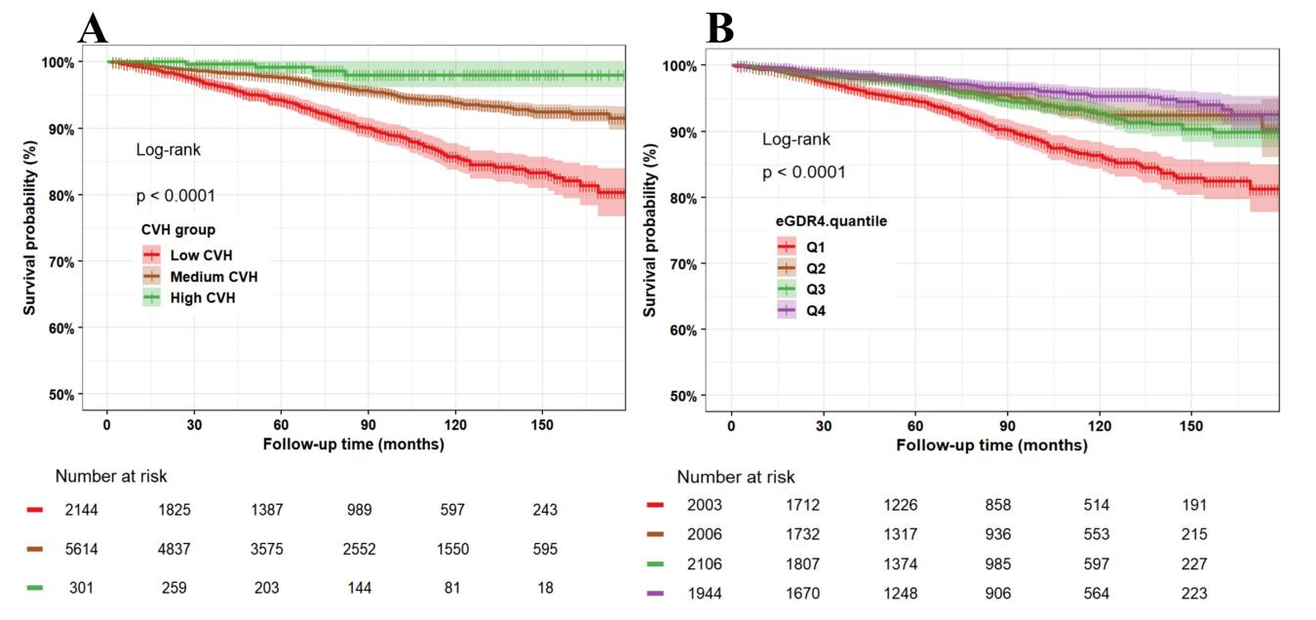
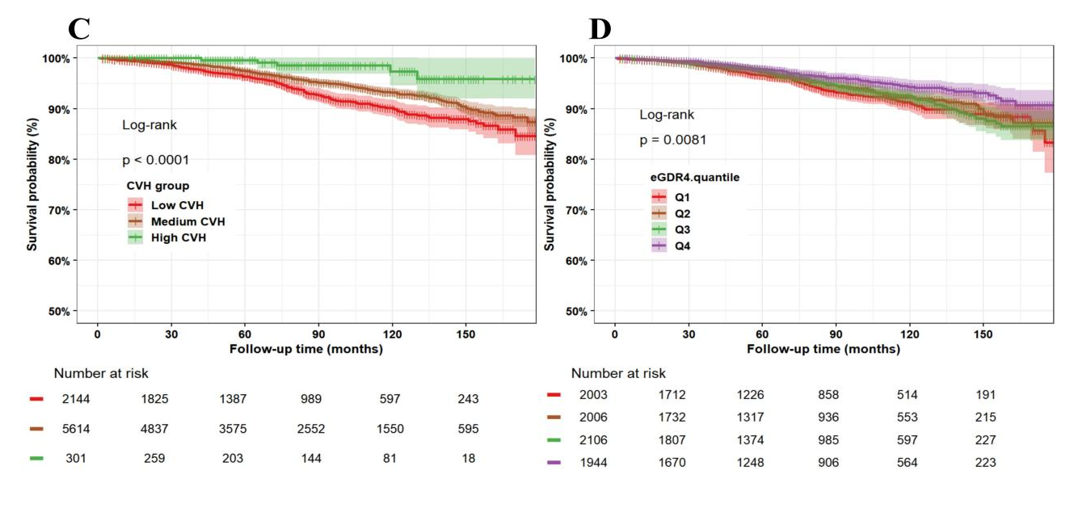
S7 Figure. K-M curves for premature mortality(A, B), cardiovascular mortality (C,D)
Abbreviations: K-M: Kaplan-Meier; eGDR, estimated glucose disposal rate;CVH, cardiovascular health

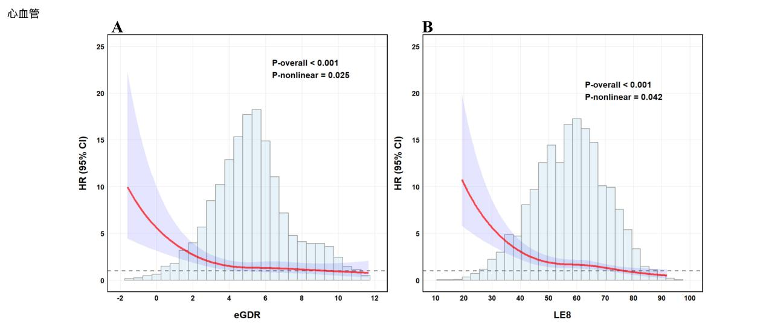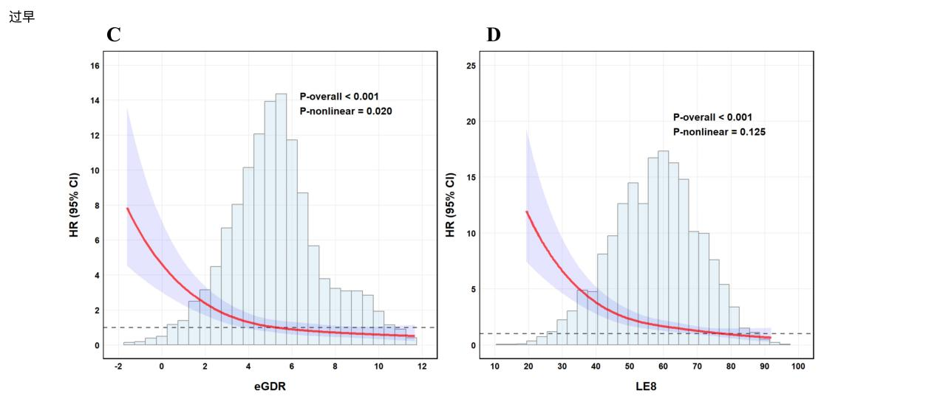
S8 Figure. RCS curves for cardiovascular mortality (A, B) and premature mortality (C, D). Abbreviations: eGDR, estimated glucose disposal rate; LE8, Life’s Essential 8; RCS, restricted cubic spline.

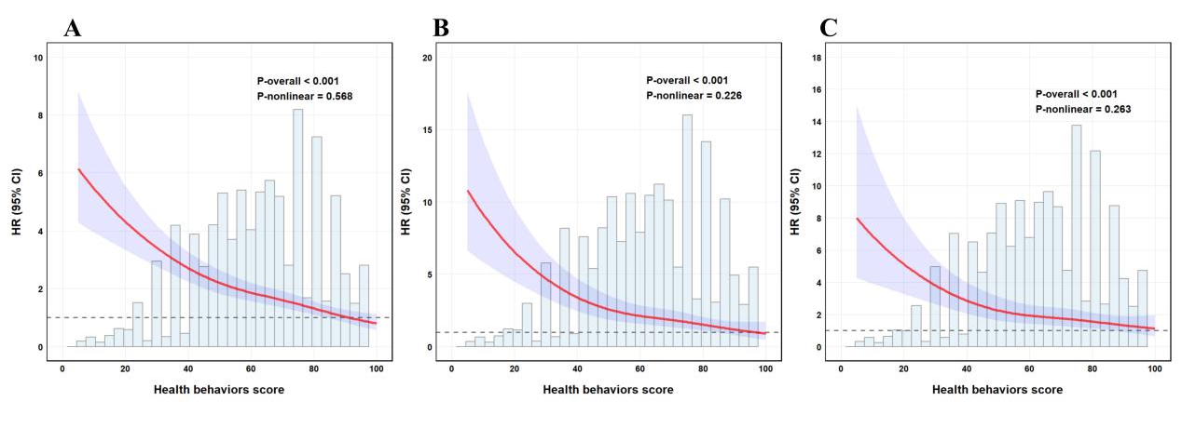
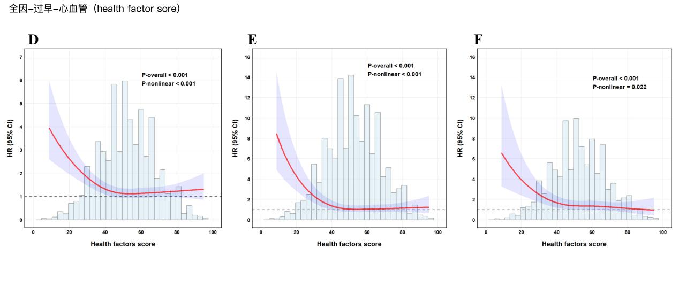
S9 Figure. RCS curves for all-cause（A, D）, cardiovascular mortality (B,E) and premature mortality (C, F).
Abbreviations:RCS, restricted cubic spline.

S10 Table. Associations of eGDR and LE8 levels with mortality risk.
 | Model 1 |  | Model 2 |  | Model 3
 | HR (95%CI) | P value | HR (95%CI) | P value | HR (95%CI) | P value
All-cause mortality
High eGDR + High CVH | Ref |  | Ref |  | Ref
High eGDR + Medium CVH | 1.34 (0.86-2.10) | 0.200 | 1.57 (1.02-2.39) | 0.038 | 1.46 (0.95-2.26) | 0.086
High eGDR + Low CVH | 2.42 (1.47-3.99) | <0.001 | 3.21 (2.03-5.07) | <0.001 | 2.63 (1.64-4.22) | <0.001
Low eGDR + High CVH | 1.35 (0.49-3.73) | 0.567 | 0.80 (0.28-2.25) | 0.668 | 0.82 (0.29-2.31) | 0.707
Low eGDR + Medium CVH | 1.66 (1.04-2.63) | 0.032 | 1.57 (1.02-2.43) | 0.042 | 1.39 (0.89-2.18) | 0.153
Low eGDR + Low CVH | 2.60 (1.64-4.1) | <0.001 | 3.25 (2.11-5.02) | <0.001 | 2.62 (1.67-4.11) | <0.001
Cardiovascular mortality
High eGDR + High CVH | Ref |  | Ref |  | Ref
High eGDR + Medium CVH | 2.34 (0.74-7.44) | 0.150 | 2.85 (0.95-8.57) | 0.063 | 2.73 (0.91-8.16) | 0.072
High eGDR + Low CVH | 2.71 (0.77-9.56) | 0.120 | 3.85 (1.13-13.04) | 0.031 | 3.17 (0.91-11.05) | 0.070
Low eGDR + High CVH | 1.52 (0.25-9.18) | 0.645 | 0.88 (0.15-5.06) | 0.882 | 0.95 (0.17-5.15) | 0.951
Low eGDR + Medium CVH | 2.96 (0.97-9.08) | 0.057 | 2.88 (0.97-8.52) | 0.056 | 2.60 (0.88-7.62) | 0.083
Low eGDR + Low CVH | 5.1 (1.61-16.12) | 0.006 | 6.8 (2.19-21.12) | <0.001 | 5.60 (1.8-17.4) | 0.003
Premature death
High eGDR + High CVH | Ref |  | Ref |  | Ref
High eGDR + Medium CVH | 2.73 (0.62-12.1) | 0.186 | 2.77 (0.63-12.25) | 0.180 | 2.58 (0.58-11.45) | 0.212
High eGDR + Low CVH | 8.64 (1.94-38.4) | 0.005 | 9.05 (2.04-40.16) | 0.004 | 7.68 (1.71-34.38) | 0.008
Low eGDR + High CVH | 4.98 (0.59-42.17) | 0.141 | 3.79 (0.44-32.55) | 0.225 | 3.74 (0.44-31.84) | 0.228
Low eGDR + Medium CVH | 3.58 (0.86-14.86) | 0.079 | 3.27 (0.79-13.61) | 0.103 | 2.98 (0.71-12.51) | 0.136
Low eGDR + Low CVH | 9.91 (2.39-41.04) | 0.002 | 10.05 (2.42-41.65) | 0.001 | 8.26 (1.96-34.76) | 0.004
Fully-adjusted model: the model was adjusted for: age, gender, race, education level, marital status, PIR,insurance status, drinking status, BUN, and Cr.
Abbreviations: CVH cardiovascular health; eGDR: estimated glucose disposal rate; PIR poverty income ratio;BUN, blood urea nitrogen Cr,serum creatinie.

S11 Table. Cox regression analyses for the association between eGDR and CVH with morality.
Group | Weighted mortality rate (%) | Absolute rate differences (%) (95% CI) | P value | NNT (95% CI)
All-cause mortality
High eGDR + High CVH | 7.67 (4.16–11.18) | Reference |  | Reference
High eGDR + Medium CVH | 10.32 (8.63–12.01) | 2.65 (-0.84–6.15) | 0.135 | 38 (17–120)
High eGDR + Low CVH | 18.20 (13.24–23.17) | 10.53 (4.79–16.27) | <0.001 | 10 (7–21)
Low eGDR + High CVH | 9.46 (1.14–17.79) | 1.79 (-7.30–10.88) | 0.696 | 56 (10–14)
Low eGDR + Medium CVH | 11.75 (10.26–13.24) | 4.08 (0.50–7.66) | 0.026 | 25 (14–200)
Low eGDR + Low CVH | 18.94 (16.53–21.35) | 11.27 (7.44–15.09) | <0.001 | 9 (7–14)
Cardiovascular mortality
High eGDR + High CVH | 1.41 (-0.15–2.97) | Reference |  | Reference
High eGDR + Medium CVH | 3.32 (2.56–4.09) | 1.91 (0.12–3.71) | 0.037 | 53·(27-83)
High eGDR + Low CVH | 3.77 (1.58–5.96) | 2.36 (-0.38–5.10) | 0.090 | 43·(20-264)
Low eGDR + High CVH | 1.98 (-0.72–4.68) | 0.57 (-2.60–3.74) | 0.722 | 176·(27-39)
Low eGDR + Medium CVH | 3.86 (3.01–4.72) | 2.45 (0.69–4.22) | 0.007 | 41·(24-145)
Low eGDR + Low CVH | 6.85 (5.20–8.50) | 5.44 (3.11–7.77) | <0.001 | 19·(13-33)
Premature mortality
High eGDR + High CVH | 1.11 (-0.44-2.66) | Reference |  | Reference
High eGDR + Medium CVH | 3.00 (2.04-3.96) | 1.89 (-0.04-3.83) | 0.055 | 53·(27-2500)
High eGDR + Low CVH | 9.27 (5.47-13.07) | 8.16 (3.95-12.38) | <0.001 | 13 (9-26)
Low eGDR + High CVH | 5.21 (-2.99-13.42) | 4.11 (-4.34-12.56) | 0.337 | 25 (8-24)
Low eGDR + Medium CVH | 3.66 (2.91-4.40) | 2.55 (0.85-4.25) | 0.003 | 40 (24-118)
Low eGDR + Low CVH | 10.4 (8.31-12.49) | 9.29 (6.78-11.81) | <0.001 | 11 (9-15)
Abbreviations: eGDR, estimated glucose disposal rate; CVH, cardiovascular health.

S12 Table. Sensitivity analysis of the associations between LE8 and all-cause, cardiovascular, and premature mortality across different eGDR strata after excluding participants with follow-up less than 2 years
 |  | Model 1 |  | Model 2 |  | Model 3
Group | N=7210 | HR (95%CI) | P value | HR (95%CI) | P value | HR (95%CI) | P value
High eGDR | 2435
All-cause mortality | 311 | 0.82 (0.73–0.92) | 0.001 | 0.76 (0.67–0.85) | <0.001 | 0.79 (0.70–0.89) | <0.001
Cardiovascular mortality | 94 | 0.84 (0.66–0.97) | 0.001 | 0.76 (0.60–0.96) | 0.021 | 0.79 (0.62–0.96) | <0.001
Premature mortality | 79 | 0.66 (0.54–0.81) | <0.001 | 0.64 (0.52–0.78) | <0.001 | 0.66 (0.52–0.83) | <0.001
Low eGDR | 4775
All-cause mortality | 787 | 0.80 (0.72–0.89) | <0.001 | 0.69 (0.62–0.77) | <0.001 | 0.71 (0.63–0.80) | <0.001
Cardiovascular mortality | 275 | 0.74 (0.64–0.86) | <0.001 | 0.64 (0.55–0.74) | <0.001 | 0.68 (0.59–0.79) | <0.001
Premature mortality | 279 | 0.66 (0.54–0.80) | <0.001 | 0.63 (0.52–0.76) | <0.001 | 0.64 (0.53–0.78) | <0.001
Abbreviations: eGDR, estimated glucose disposal rate; LE8, Life’s Essential 8.

S13 Table. Sensitivity analysis of the associations between LE8 and all-cause, cardiovascular, and premature mortality across different eGDR strata after excluding participants with pre-existing cardiovascular disease
 |  | Model 1 |  | Model 2 |  | Model 3
Group | N=6412 | HR (95%CI) | P value | HR (95%CI) | P value | HR (95%CI) | P value
High eGDR | 2371
All-cause mortality | 246 | 0.82 (0.73–0.92) | 0.001 | 0.76 (0.67–0.85) | <0.001 | 0.79 (0.71–0.89) | <0.001
Cardiovascular mortality | 66 | 0.84 (0.66–0.98) | 0.047 | 0.76 (0.60–0.96) | 0.021 | 0.79 (0.62–0.99) | 0.045
Premature mortality | 80 | 0.66 (0.54–0.81) | <0.001 | 0.64 (0.52–0.78) | <0.001 | 0.66 (0.53–0.82) | <0.001
Low eGDR | 4041
All-cause mortality | 522 | 0.80 (0.72–0.89) | <0.001 | 0.69 (0.62–0.77) | <0.001 | 0.71 (0.64–0.80) | <0.001
Cardiovascular mortality | 146 | 0.74 (0.64–0.86) | <0.001 | 0.64 (0.55–0.74) | <0.001 | 0.68 (0.58–0.79) | <0.001
Premature mortality | 217 | 0.66 (0.54–0.80) | <0.001 | 0.63 (0.52–0.76) | <0.001 | 0.64 (0.52–0.78) | <0.001
Abbreviations: eGDR, estimated glucose disposal rate; LE8, Life’s Essential 8.

