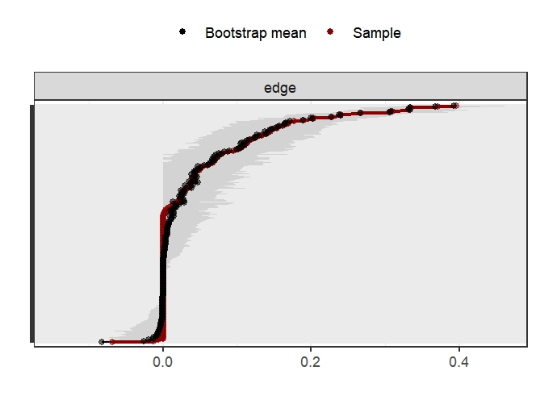
Figure S1. Bootstrapped confidence intervals of edge weights
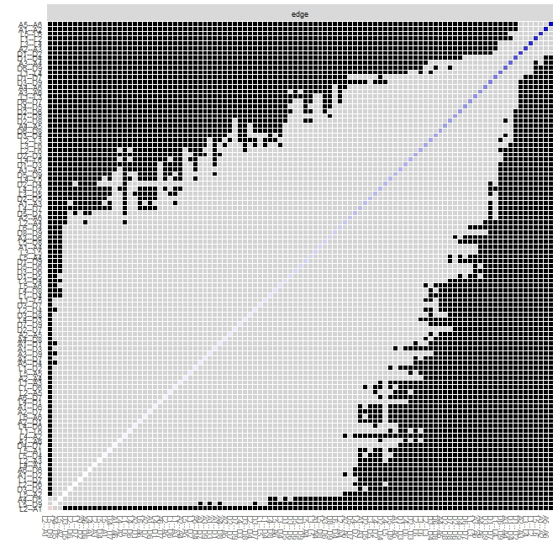
Figure S2. Estimation of edge weight difference by bootstrapped difference test
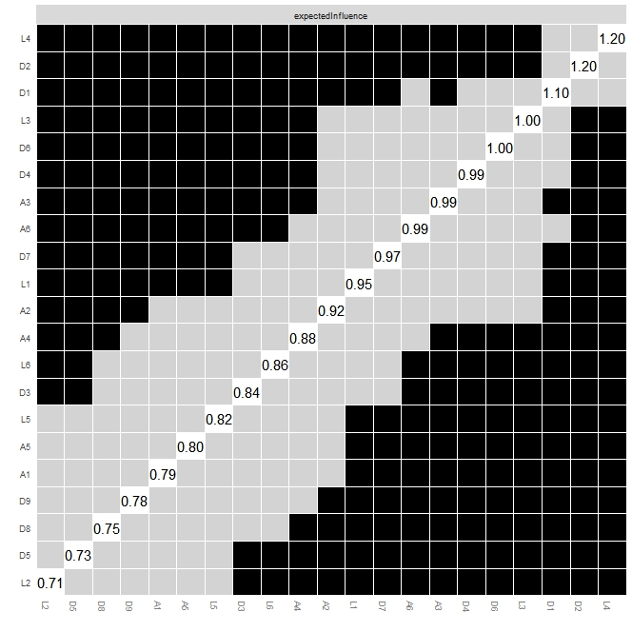
Figure S3. Bootstrapped stability test for expected influence.

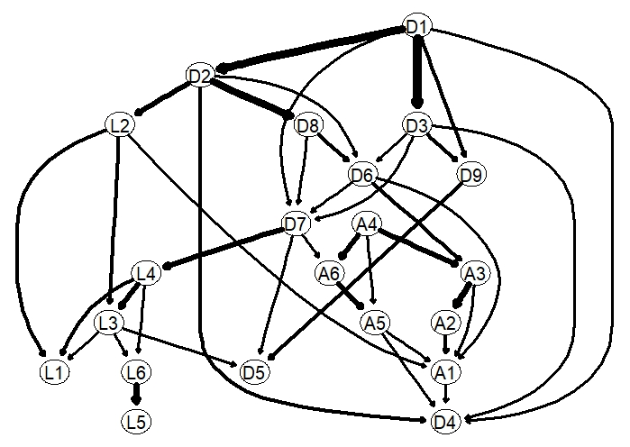
Figure S4. Directed Acyclic Graphs (DAG). Edge thickness signifies the magnitude of the Bayesian Information Criterion (BIC).

