Figure legends.
Fig .1
Ultrasongraphy picture showing measuring Muscle Thickness and Fascicle length of the gastrocnemius muscle.
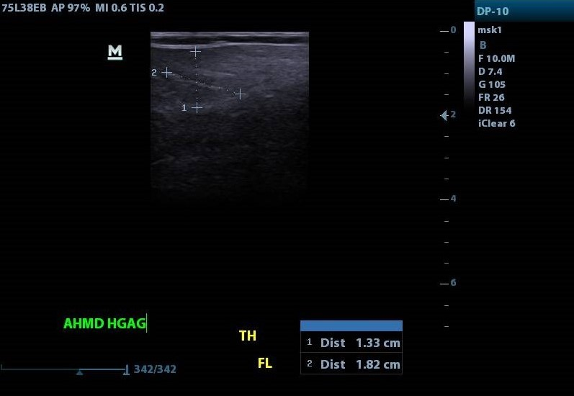
Fig 2:
2D ultrasonography device type (mindray dp 10) with frequency 7.5 MHz figure (5). was used to measure was used to measure the architectural parameters of the gastrocnemius muscle for DMD children. These parameters included muscle thickness and fascicle length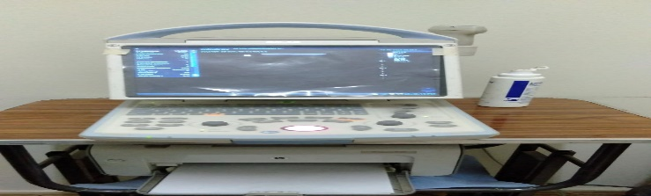

Fig .3
Pseudohypertrophy in calf muscle
