Supplementary Materials
PubMed search：
((Atherosclerosis[Mesh])OR(Atheroscleroses[Title/Abstract])OR(Atherogenesis[Title/Abstract]) OR (Coronary artery disease[Mesh]) OR (Artery Disease, Coronary[Title/Abstract]) OR (Artery Diseases, Coronary[Title/Abstract]) OR (Coronary Artery Diseases[Title/Abstract]) OR (Coronary Arteriosclerosis[Title/Abstract]) OR (Arterioscleroses, Coronary [Title/Abstract]) OR (Coronary Arterioscleroses [Title/Abstract]) OR (Arteriosclerosis, Coronary[Title/Abstract]) OR (Atherosclerosis, Coronary[Title/Abstract]) OR (Atheroscleroses, Coronary[Title/Abstract]) OR (Coronary Atheroscleroses [Title/Abstract]) OR (Coronary Atherosclerosis[Title/Abstract]) OR (Left Main Coronary Artery Disease[Title/Abstract]) OR (Left Main Coronary Disease[Title/Abstract]) OR (Left Main Disease[Title/Abstract]) OR (Left Main Diseases[Title/Abstract])) AND ((Risk prediction model[Title/Abstract]) OR (Prediction model[Title/Abstract]) OR (Risk prediction[Title/Abstract]) OR (Risk factors[Title/Abstract]) OR (Risk assessment[Title/Abstract]) OR (Risk score[Title/Abstract]) OR (Prediction tool[Title/Abstract]) OR (Nomogram[Title/Abstract])) AND ((Case-control studies[Title/Abstract]) OR (Case-control study[Title/Abstract]) OR (Study, case-control[Title/Abstract]) OR (Studies, case-control[Title/Abstract]) OR (Case-comparison studies[Title/Abstract]) OR (Case-comparison study[Title/Abstract]) OR (Study, case-comparison[Title/Abstract]) OR (Studies, case-comparison[Title/Abstract]) OR (Case control studies[Title/Abstract]) OR (Case control study[Title/Abstract]) OR (Study, case control[Title/Abstract]) OR (Studies, case control[Title/Abstract]) OR (Case comparison studies[Title/Abstract]) OR (Case comparison study[Title/Abstract]) OR (Study, case comparison[Title/Abstract]) OR (Studies, case comparison[Title/Abstract]) OR (Cohort study[Title/Abstract]) OR (Cohort studies[Title/Abstract]) OR (Study, cohort[Title/Abstract]) OR (Studies, cohort[Title/Abstract]))

Embase search：
(('coronary artery disease'/exp OR 'atherosclerosis'/exp) OR ('Atherosclerosis': ab, ti OR 'Atheroscleroses': ab, ti OR 'Atherogenesis': ab, ti OR 'Coronary artery disease': ab, ti OR 'Artery Disease, Coronary': ab, ti OR 'Artery Diseases, Coronary': ab, ti OR 'Coronary Artery Diseases': ab, ti OR 'Coronary Arteriosclerosis': ab, ti OR 'Arterioscleroses, Coronary': ab, ti OR 'Coronary Arterioscleroses': ab, ti OR 'Arteriosclerosis, Coronary': ab, ti OR 'Atherosclerosis, Coronary': ab, ti OR 'Atheroscleroses, Coronary': ab, ti OR 'Coronary Atheroscleroses' :ab, ti OR 'Coronary Atherosclerosis': ab, ti OR 'Left Main Coronary Artery Disease': ab, ti OR 'Left Main Coronary Disease': ab, ti OR 'Left Main Disease': ab, ti OR 'Left Main Diseases': ab, ti)) AND ('Risk prediction model': ab, ti OR 'Prediction model': ab, ti OR 'Risk prediction': ab, ti OR 'Risk factors': ab, ti OR 'Risk assessment': ab, ti OR 'Risk score': ab, ti OR 'Prediction tool': ab, ti OR 'Nomogram': ab, ti) AND ('Case-control studies': ab, ti OR 'Case-control study': ab, ti OR 'Study, case-control' : ab, ti OR 'Studies, case-control': ab, ti OR 'Case-comparison studies': ab, ti OR 'Case-comparison study': ab, ti OR 'Study, case-comparison': ab, ti OR 'Studies, case-comparison': ab, ti OR 'Case control studies': ab, ti OR 'Case control study': ab, ti OR 'Study, case control': ab, ti OR 'Studies, case control': ab, ti OR 'Case comparison studies': ab, ti OR 'Case comparison study': ab, ti OR 'Study, case comparison': ab, ti OR 'Studies, case comparison': ab, ti OR 'Cohort study' : ab, ti OR 'Cohort studies': ab, ti OR 'Study, cohort': ab, ti OR 'Studies, cohort': ab, ti)

Web of Science search:
((Atheroscleroses) ti, ab, kw OR (Atherogenesis) ti, ab, kw OR (Artery Disease, Coronary) ti, ab, kw OR (Artery Diseases, Coronary) ti, ab, kw OR (Coronary Artery Diseases) ti, ab, kw OR (Coronary Arteriosclerosis) ti, ab, kw OR (Arterioscleroses, Coronary) ti, ab, kw OR (Coronary Arterioscleroses) ti, ab, kw OR (Arteriosclerosis, Coronary) ti, ab, kw OR (Atherosclerosis, Coronary) ti, ab, kw OR (Atheroscleroses, Coronary) ti, ab, kw OR (Coronary Atheroscleroses) ti, ab, kw OR (Coronary Atherosclerosis) ti, ab, kw OR (Left Main Coronary Artery Disease) ti, ab, kw OR (Left Main Coronary Disease) ti, ab, kw OR (Left Main Disease) ti, ab, kw OR (Left Main Diseases) ti, ab, kw) AND ((Risk prediction model) ti, ab, kw OR (Prediction model) ti, ab, kw OR (Risk prediction) ti, ab, kw OR (Risk factors) ti, ab, kw OR (Risk assessment) ti, ab, kw OR (Risk score) ti, ab, kw OR (Prediction tool) ti, ab, kw OR (Nomogram) ti, ab, kw OR (model) ti, ab, kw OR (risk) ti, ab, kw OR (predict) ti, ab, kw OR (prediction) ti, ab, kw OR (diagnostic) ti, ab, kw OR (diagnosis) ti, ab, kw)

Figure S1 Meta-analysis and heterogeneity assessment of 58 articles (funnel plot)

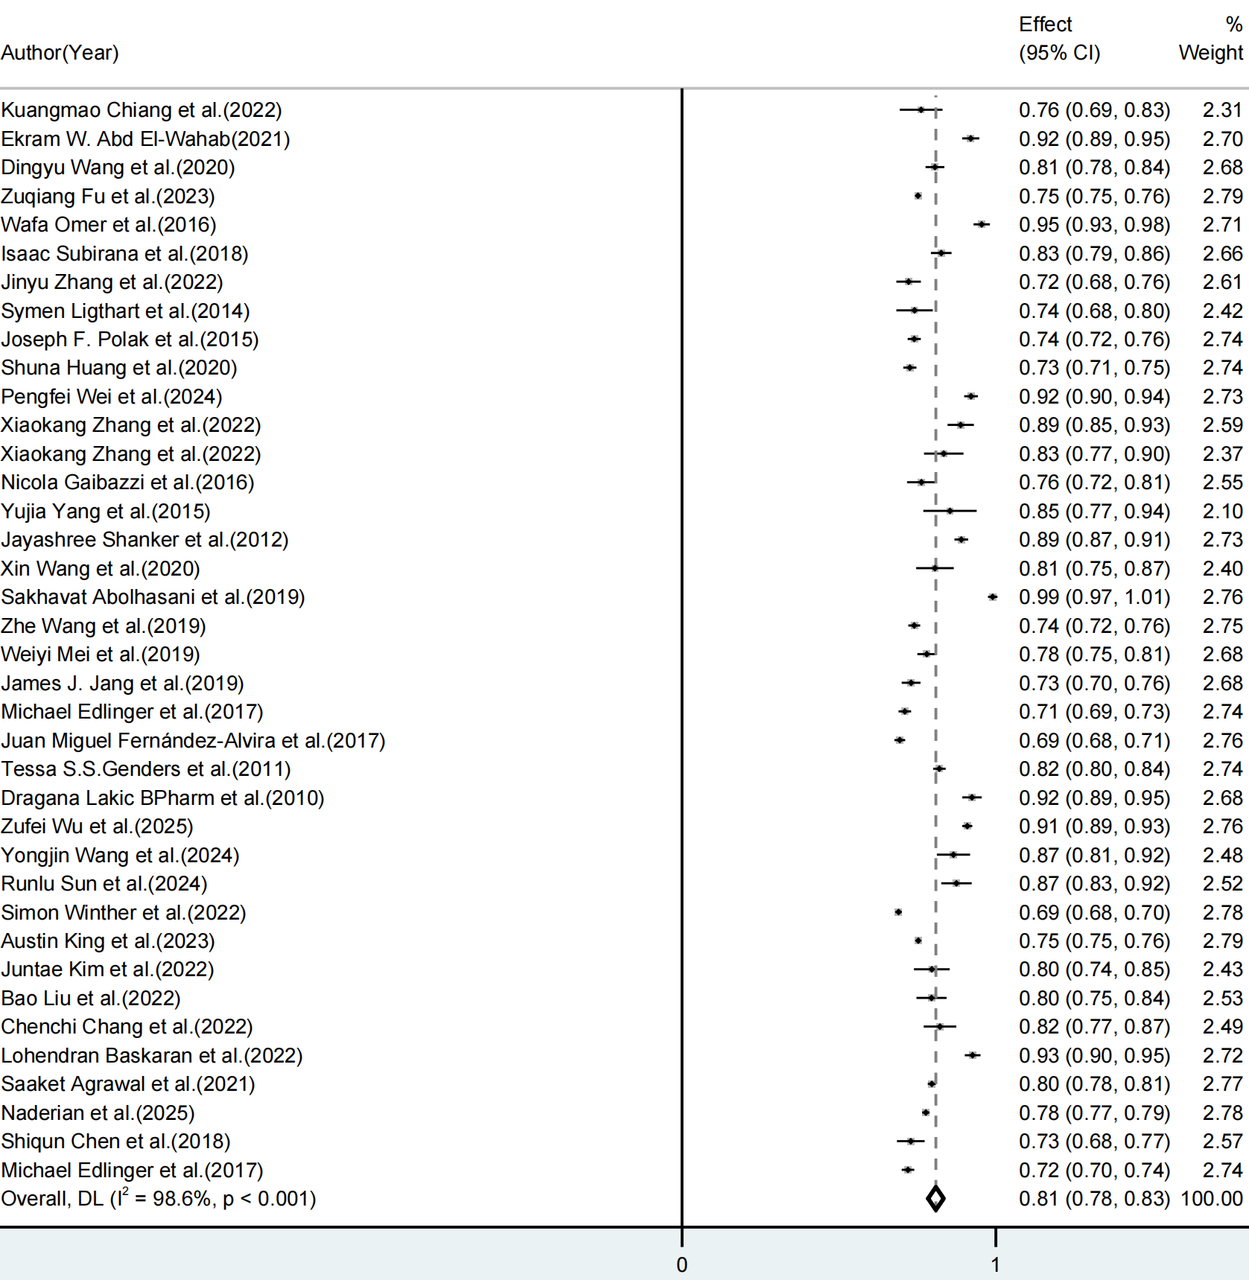
Figure S2 Meta-analysis and heterogeneity assessment of 38 articles with internal validation (forest plot)

Figure S3 Meta-analysis and heterogeneity assessment of 38 articles with internal validation (funnel plot)

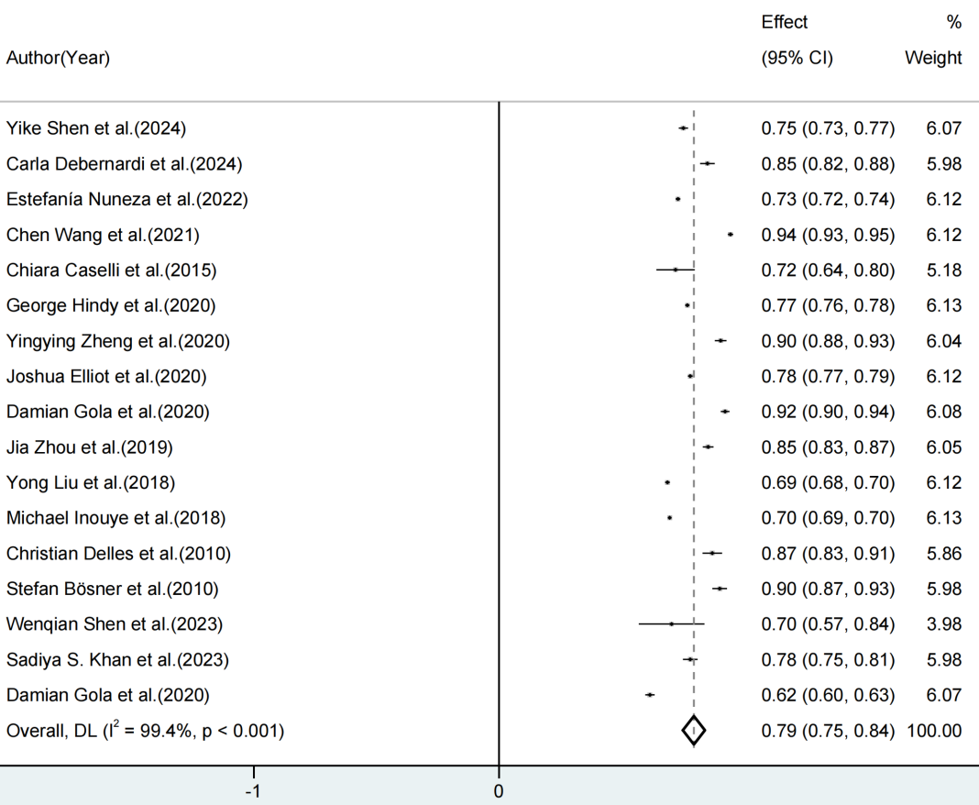
Figure S4 Meta-analysis and heterogeneity assessment of 17 articles with simultaneous internal and external validation (forest plot)

Figure S5 Meta-analysis and heterogeneity assessment of 17 articles with simultaneous internal and external validation (funnel plot)

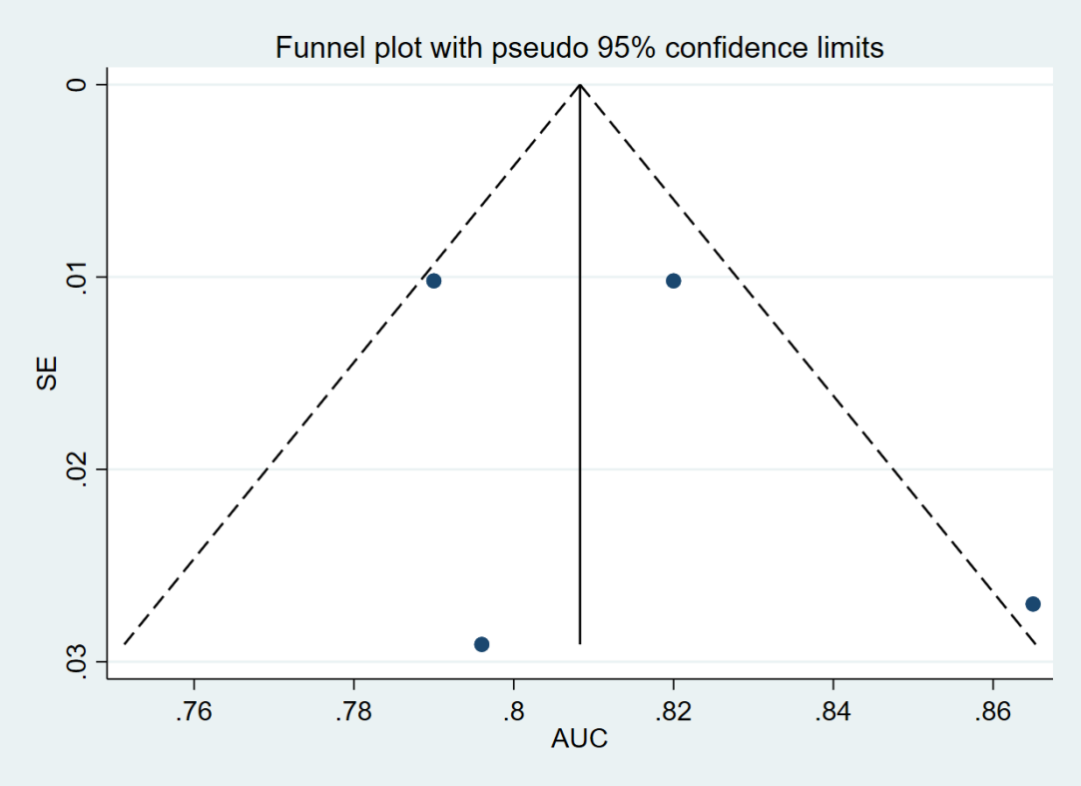
Figure S6 Meta-analysis and heterogeneity assessment of 4 articles with chronic ischemic syndrome (funnel plot)

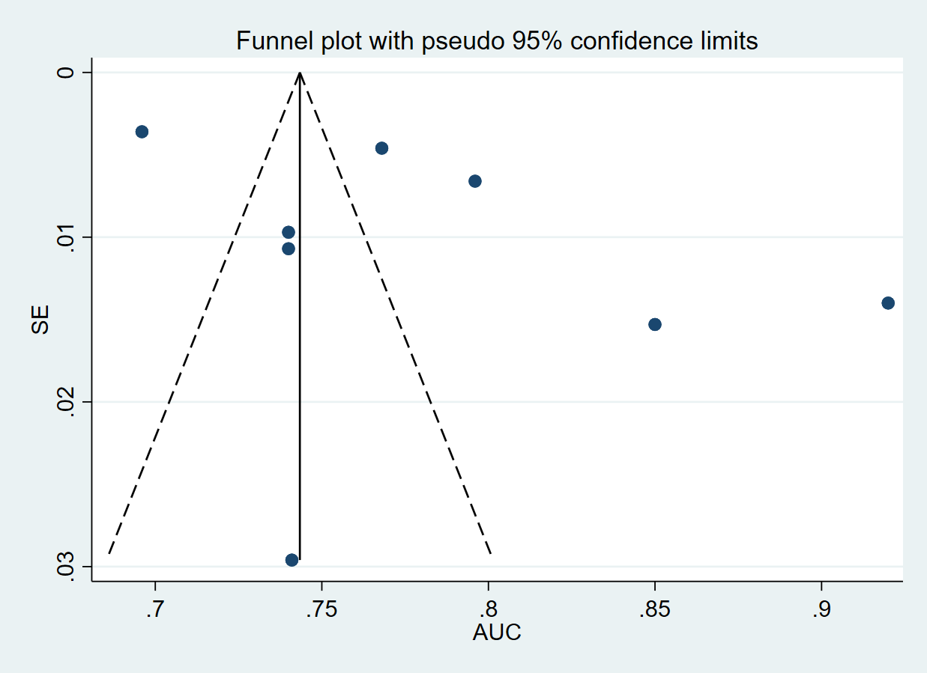
Figure S7 Meta-analysis and heterogeneity assessment of 8 articles with acute coronary syndrome (funnel plot)

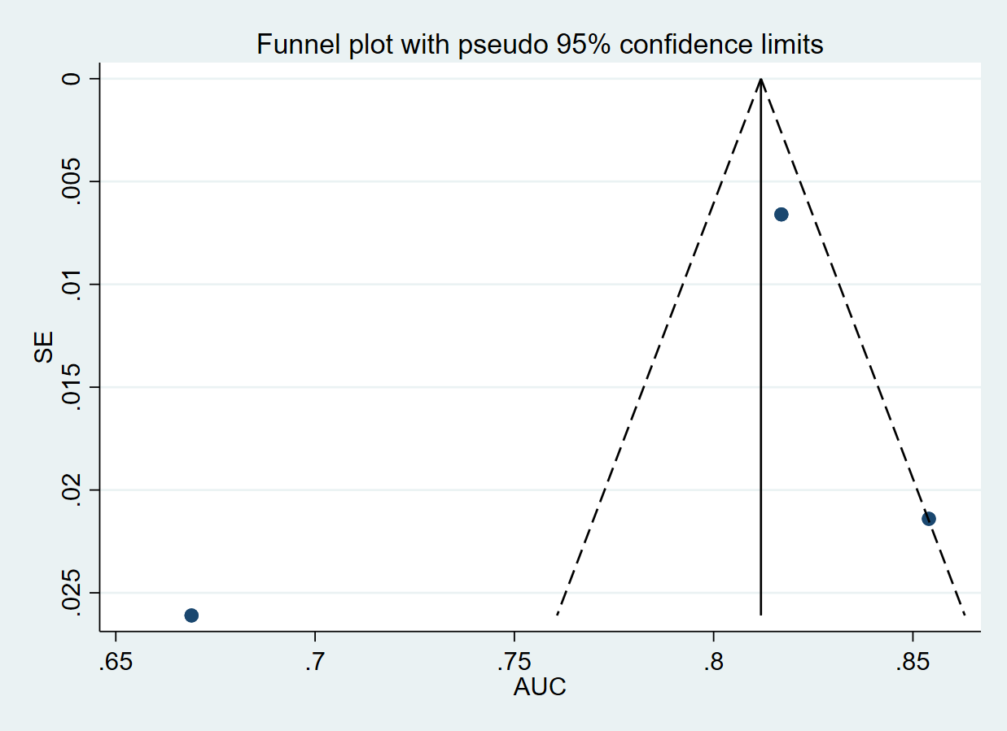
Figure S8 Meta-analysis and heterogeneity assessment of 3 articles with Framingham risk score (funnel plot)

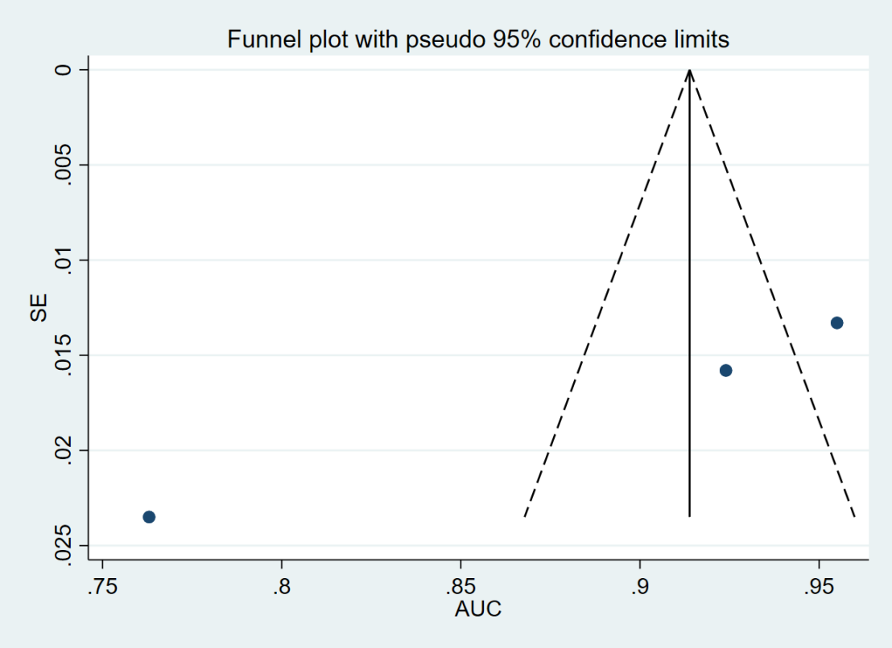
Figure S9 Meta-analysis and heterogeneity assessment of 3 articles with modified Framingham risk score (funnel plot)

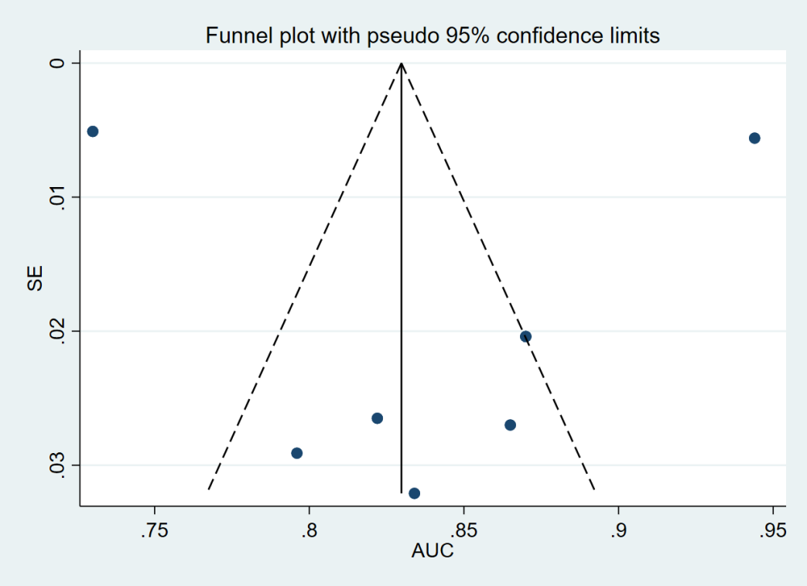
Figure S10 Meta-analysis and heterogeneity assessment of 8 articles using machine-learning to build models (funnel plot)

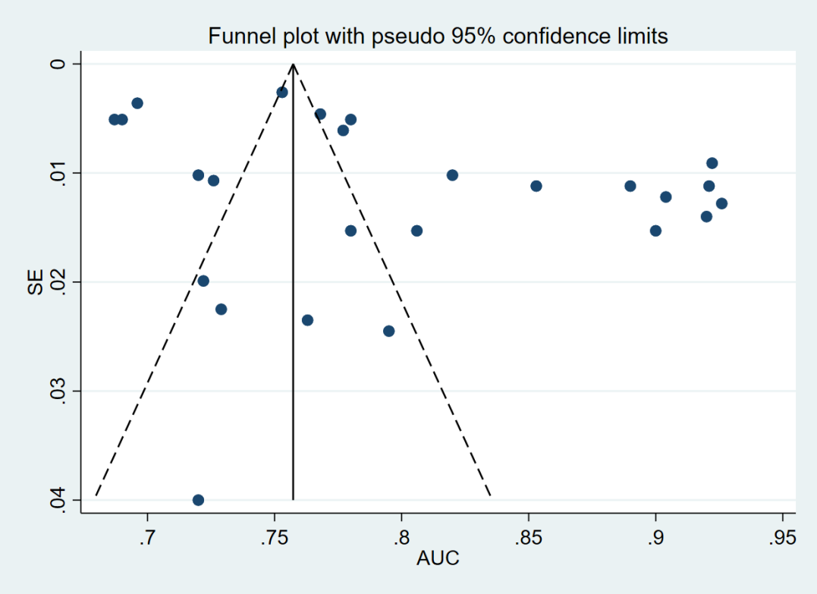
Figure S11 Meta-analysis and heterogeneity assessment of 25 articles using traditional methods to build models (funnel plot)

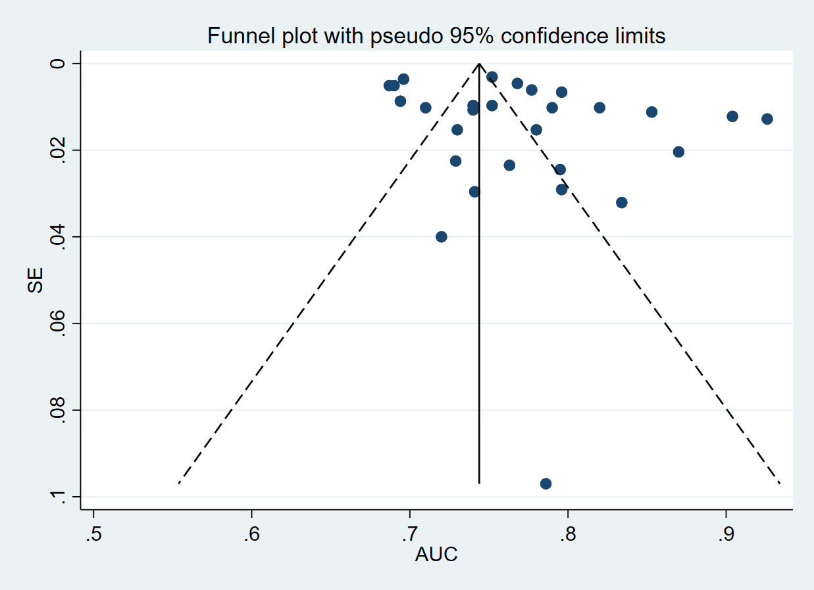
Figure S12 Meta-analysis and heterogeneity assessment of 28 cohort studies (funnel plot)

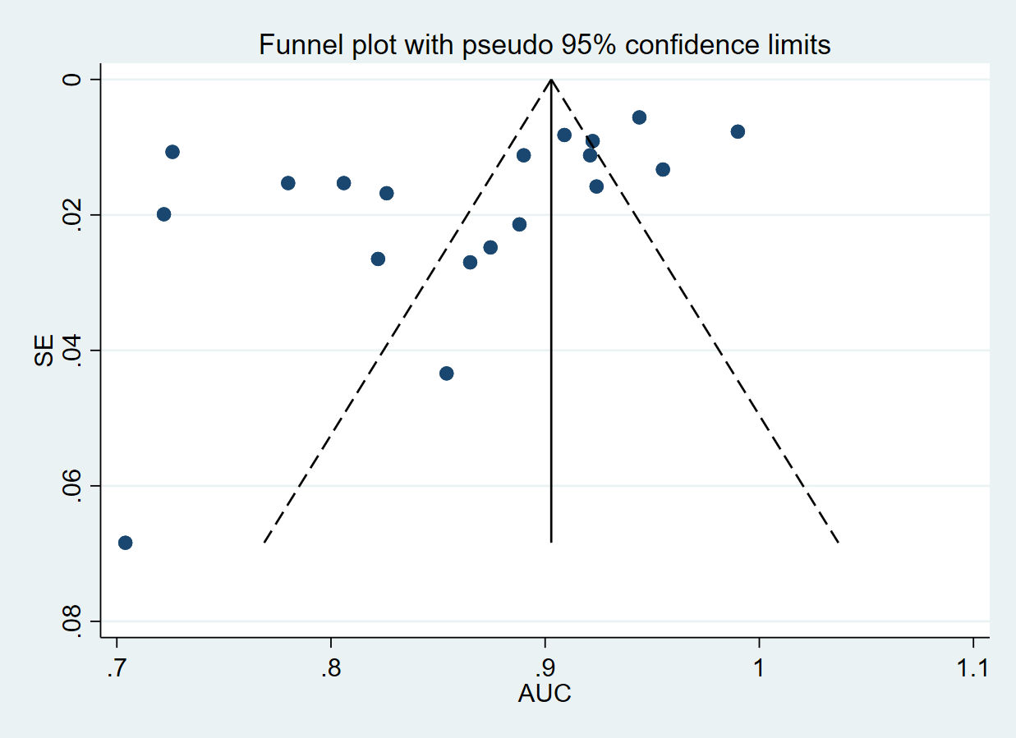
Figure S13 Meta-analysis and heterogeneity assessment of 19 case-control studies (funnel plot)

Table S1 Basic characteristics of the included studies
Author (Year) | Country | Study design | Participants | Data source | Cases/Sample size (%)
Yike Shen et al. (2024) | USA | Prospective cohort study | The participants in the SHS study were American Indians from the southwestern USA and the Great Plains, while the participants in the WHI study were postmenopausal women and focused on health issues such as CVD. | SHS, WHI | 749/2321 (32.2%) , 706/2107(33.5%)
Kuangmao Chiang et al. (2022) | China  (Taiwan) | Nested case-control study | Participants in the study were 211 individuals aged 50 to 70 years without prior CAD at baseline, with 77 developing CAD during the follow-up period. | NAHSIT | 77/211 (36.5%)
Ekram W. Abd El-Wahab (2021) | Egypt | Cross-sectional study | Participants in this study are adults over the age of 35, presenting with suspected CHD, and are recruited from the emergency department of a health insurance hospital in Alexandria, Egypt, for a cross-sectional screening survey. | Emergency department of a health insurance hospital in Alexandria, Egypt | 130/350 (37.0%)
Dingyu Wang et al. (2020) | China | Case-control study | The study included 576 CAD cases and 452 control subjects from the First Affiliated Hospital of Xinjiang Medical University. | The First Affiliated Hospital of Xinjiang Medical University | 576/1028 (56.0%)
Zuqiang Fu et al. (2023) | China | Prospective cohort study | Models were constructed and selected in a case-control study consisting of patients with CAD and matched controls, and performance was verified in a validation cohort without CAD at baseline. | UKB | 5513/118120 (4.7%)
Wafa Omer et al. (2016) | Pakistan | Case-control study | Three hundred forty subjects with >70% stenosis in at least one coronary vessel on angiography were labeled as PCAD cases and compared with 310 angio-negative controls. | AFIC | 340/650(52.3%)
Isaac Subirana et al. (2018) | Spain | Case-control study | A total of 105 patients with confirmed CAD at follow-up and 638 controls were randomly selected from a cohort aged 35 to 74 years without CVD at baseline. | REGICOR population-cohorts | 105/743(14.1%)
Jinyu Zhang et al. (2022) | China | Case-control study | Based on CCTA, the presence of at least one significant coronary artery stenosis of >50% luminal diameter was diagnosed as CAD and included in the case group. The control participants did not have any of the following conditions related to CAD: a positive family history, stable or UA, myocardial infarction, evidence of CAD by ECG and angiography, abnormality of regional wall motion, or relevant valvular abnormalities based on echocardiography. CAD patients and controls were matched for age and sex. | The First Affiliated Hospital of Xinjiang Medical University, Cardiovascular Risk Survey | 567/1022(55.5%)
Symen Ligthart et al. (2014) | Netherlands | Prospective cohort study | A total of 971 participants were randomly selected for the study, 132 participants with a history of CHD were excluded, and 839 participants were finally included in the analysis. Follow-up was 10.6 years. | RS | 99/839(11.8%)
Joseph F. Polak et al. (2015) | USA | Cohort study | A multiethnic population of 6814 men and women aged 45–84 years enrolled between July 2000 and August 2002 at six sites in the USA. The MESA cohort includes whites, African-American, Hispanic, and Chinese participants. | MESA | 484/6606(7.3%)
Carla Debernardi et al. (2024) | Italy | Nested case-control study | The study included 576 participants in the EPICOR study and 3359 participants in the ATVB study. | EPICOR Study, ATVB | 286/576(49.7%), 1691/3359(50.3%)
Estefanía Nuneza et al. (2022) | Spain | Nested case-control study | Participants were from the PESA study, AWHS study, and ILERVAS study, with PESA study participants set as nested case-controls for internal validation. | PESA, AWHS, ILERVAS study | 222/444(50.0%) , 175/350(50.0%) , 1595/2999(53.2%)
Shuna Huang et al. (2020) | China | Case-control study | The participants in this case-control study were enrolled from the Affiliated Union Hospital and the First Affiliated Hospital of Fujian Medical University between October 2014 and August 2019. A total of 4392 participants confirmed their participation by signing an informed consent form. | The Affiliated Union Hospital and the First Affiliated Hospital of Fujian Medical University | 1578/4392(35.9%)
Pengfei Wei et al.(2024) | China | Case-control study | All cases were newly diagnosed with CAD, admitted to the Yixing People's Hospital from February 2009 to December 2021 and aged 35–80 years at admission. The cohort studies were conducted in Yixing City, Jurong City and Suqian City, and baseline data were collected from 2009 to 2019. | The Yixing People's Hospital | 3139/6409(49.0%)
Chen Wang et al. (2021) | China | Case-control study | This three-stage case-control study, involving 3112 CAD patients and 3182 controls, was retrospectively collected from three clinical centers: the development cohort with 2014 CAD cases and 2018 controls from Wuhan Asia Heart Hospital, the validation cohort 1 with 837 CAD cases and 876 controls from Zhongnan Hospital of Wuhan University and the validation cohort 2 with 261 CAD cases and 258 controls from Shandong Provincial Hospital. | Wuhan Asia Heart Hospital, Wuhan University Zhongnan Hospital, Shandong Provincial Hospital | 2014/4032(50.0%) , 837/1713(48.9%) , 261/519(50.3%)
Xiaokang Zhang et al.( 2022) | China | Case-control study | A total of 139 ASCVD patients were recruited from Zhongnan Hospital of Wuhan University between December 2018 and July 2019. | Zhongnan Hospital of Wuhan University | 139/285 (48.8%)
Xiaokang Zhang et al. (2022) | China | Cohort Study | 2085 individuals from FHS. | FHS | Train 199/1563 (12.7%), validation 67/522(12.8%)
Iain S. Forrest et al. (2023) | USA | Cohort study | Participants were selected with the same criteria in BioMe and UKB. Cases of CAD were identified by the presence of CAD diagnosis codes, while controls had the absence of all CAD diagnosis codes. BioMe is used for model training and internal validation, and UKB is used for external validation. | BioMe, UKB | 5130/35749(14.4%), 8128/60186(13.5%)
Nicola Gaibazzi et al. (2016) | Italy | Cohort study | Involved eight Italian centers, between June 2012 and July 2013, and enrolled 457 patients scheduled for clinically indicated CCTA. Inclusion criteria were a history of any type of chest pain of recent onset in patients with risk factors and/or a positive (or inconclusive in high-risk subjects) stress test for ischaemia. Exclusion criteria were known CAD, previous acute coronary syndrome or coronary revascularization, known cardiomyopathy or reduced, more than mild valvular disease, atrial fibrillation or other sustained arrhythmias, pregnancy/lactation, and a technically poor acoustic window. | Niguarda Ca’ Granda Hospital and Milano-Bicocca University; Spedali Civili Cardiology and Internal Medicine, University Medical Centre, Brescia; University of Messina Hospital; Parma University Hospital; Hospital dell’Angelo’, Mestre-Venice; S. Giovanni-Addolorata Hospital, Roma | 267/445(60.0%)
Yujia Yang et al. (2015) | China | Case-control study | A case–control study was conducted on a cohort with 221 CAD patients and 187 non-CAD individuals, confirmed by CCTA, who were consecutively enrolled from January 2013 to March 2014. | No special report | 221/408(54.2%)
Chiara Caselli et al. (2015) | Italy | Cohort study | Plasma samples were collected at a central core laboratory in 619 of the 697 (89%) patients enrolled in the EVINCI study. Of these 619 patients, 50 were excluded from the analysis because of inadequate quality of the biological samples, and 42 patients were excluded because they did not complete the study protocol. Thus, 527 participants were eligible for the present investigation.186 consecutive patients with suspected CAD who were hospitalized between January 2000 and October 2005 and fulfilled the inclusion and exclusion criteria of the EVINCI study were selected from the whole population for model validation. | EVINCI trial, National Research Council Institute of Clinical Physiology/Fondazione Toscana G. Monasterio of Pisa, and registered in a dedicated database | 80/527(15.2%),  75/186(40.3%)
Jayashree Shanker et al. (2012) | India | Case-control study | Participants were selected from the IARS cohort. These subjects were enrolled from March 2003 to April 2004 in Phase I of the IARS and comprise CAD patients, their affected and unaffected family members above 18 years of age. | IARS | 287/764(37.6%)
George Hindy et al. (2020) | Qatar | Cohort study | The Malmö Diet and Cancer Study is a prospective population-based cohort that enrolled 30447 participants between 1991 and 1996, ranging in age from 44 to 73 years. The UKB is a prospective cohort study that recruited more than 500000 participants from the UK between 2006 and 2010. Age at baseline examination ranged between 40 and 69. | Malmö Diet and Cancer Study, UKB | 4122/28556(14.4%), 7708/325003(2.4%)
Xin Wang et al.(2020) | China | Cohort and case-control study | The CAD patients and healthy volunteers for case-control analysis in this study were recruited from three hospitals in northern China. The study cohort consisted of participants who participated in the China-CVD study from 2009-2010. | Xuanwu Hospital, Capital Medical University and Affiliated Hospital of Jining Medical University, Affiliated Hospital of Yanbian University, China-CVD study | 39/78(50.0%), 30/51(58.8%), 64/2812(2.3%)
Yingying Zheng et al.(2020) | China | Cohort study | The Xinjiang cohort (n = 257) was recruited from the First Affiliated Hospital of Xinjiang Medical University, and the Zhengzhou cohort (n = 52) was recruited from the First Affiliated Hospital of Zhengzhou University between January 2019 and May 2019, respectively. | The First Affiliated Hospital of Xinjiang Medical University and the First Affiliated Hospital of Zhengzhou University | Xinjiang 152/257((59.1%), zhengzhou 34/52(65.4%)
Joshua Elliot et al.(2020) | UK | Cohort and case-control study | CAD prevalent cases with random age and sex frequency-matched controls in the case-control study.352660 participants (no overlapping with case-control set), 6272 incident CAD over 8 y of follow-up. | UKB | Case control 15947/31894(50.0%), cohort 6272/352660(1.8%)
Damian Gola et al.(2020) | Germany | Case-control study | Six imputed data sets with samples of European descent from the German population. The original data includes a total of 9314 observations with diagnosed CAD (cases) and 8,160 observations without CAD(controls). | Six imputed datasets | 7736/14510(53.3%), test validation group 527/1000(52.7%)
Sakhavat Abolhasani et al. (2019) | Iran | Case-control study | 160 angiographically diagnosed CAD patients and 20 healthy individuals. | Shahid Madani Hospital | 160/180 (88.9%)
Zhe Wang et al. (2019) | USA | Prospective cohort study | 3598 African and European Americans. | ARIC study | 633/3598 (17.6%)
Weiyi Mei et al. (2019) | China | Case-control study | Retrospectively enrolled Chinese individuals who underwent coronary angiography and 12-lead resting ECG at the First Affiliated Hospital of Sun Yat-Sen University in Guangzhou, China, from March 2013 to December 2016. | First Affiliated Hospital of Sun Yat-Sen University | 2002/3785 (52.9%)
James J. Jang et al.(2019) | USA | Cohort study | Using the PROMISE cohort who were randomized to initial anatomical testing and received an interpretable CCTA as their first diagnostic test (n=4589) | PROMISE trial | 301/4589 (6.6%)
Jia Zhou et al.(2019) | China | Prospective cohort study | 5743 patients who underwent CCTA for SCP indicative of obstructive CAD were recruited between 2014 and 2016 in Tianjin Chest Hospital, Tianjin, China. From March 2014 to March 2015, we enrolled 2844 patients from the Chinese People’s Liberation Army General Hospital, Beijing, China, as an external validation cohort using the same inclusion and exclusion criteria and then patients were followed up for clinical outcome. | Tianjin Chest Hospital, Chinese People’s Liberation Army General Hospital | 1872/5743 (32.6%), 942/2844 (33.5%)
Yong Liu et al.(2018) | China | Prospective cohort study | The TRUST enrolled 17513 patients who underwent either CAG or PCI, or both, with intra-arterial administration of iopromide. The database for validation included the PRECOMIN study which was conducted between January 2010 to October 2010 in the Guangdong General Hospital. It was a prospective, observational study that recruited all patients who were undergoing PCI with non-ionic contrast agents. | TRUST, PRECOMIN (Guangdong General Hospital) | 10087/13082 (73.1%) in TRUST, 758/1009(75.1%) in PRECOMIN
Michael Inouye et al.(2018) | UK | Prospective cohort study | Participants were members of the general UK population between the ages of 40 and 69 years at recruitment, identified through primary care lists, who accepted an invitation to attend 1 of the 22 assessment centers that were serially established across the UK between 2006 and 2010. 480000 adults from the UKB for validation and 1000 for external validation. | UKB | Training 3000 total, external 22242/482629(4.6%)
Michael Edlinger et al.(2017) | Austria | Prospective Cohort Study | 4,888 patients without prior CAD from the CARDIIGAN cohort. | CARDIIGAN cohort | 1901/4888 (38.9%)
Juan Miguel Fernández-Alvira et al.(2017) | Spain | Prospective cohort study | 3983 participants, 40 to 54 years old, asymptomatic employees of Banco Santander. | PESA study | 2377/3983 (59.7%)
Tessa S.S. Genders et al. (2011) | Netherlands | Prospective Cohort Study | Data from 14 hospitals on patients with chest pain without a history of CAD and referred for CCTA were used. The primary outcome was obstructive CAD, defined as ≥50% stenosis in one or more vessels on CCTA. About 2260 patients were referred for CCTA. | CAD Consortium | 1319/2260 (58.4%)
Christian Delles et al.(2010) | UK | Cohort and case-control study | No special report. | No special report | 204/586 (34.8%), 71/138(51.5%)
Stefan Bösner et al.(2010) | Germany | Cross-sectional Study | Approached 209 primary care physicians in the State of Hesse, Germany, of whom 74 (35%) agreed to participate in the study. Participating physicians were asked to recruit all patients who had chest pain that was either the reason for the consultation or was described by the patient during the consultation when asked by the physician. The recruitment period lasted 12 weeks for each practice and, for logistical reasons was staggered in four waves between October 2005 and July 2006. | Primary care, TOPIC research | 180/1199 (15.0%), 85/672 (12.6%)
Dragana Lakic BPharm et al.(2010) | Serbia | Case-control study | Recruited 188 CAD patients (122 males and 66 females) from the Institute of Cardiovascular Disease, Clinical Centre of Serbia, Belgrade, and 197 asymptomatic CAD-free subjects (113 males and 84 females) who attended a regular annual medical checkup at various public health centers in Belgrade for comparison purposes. | Institute of Cardiovascular Disease, Clinical Centre of Serbia | 188/385 (48.8%)
Zufei Wu et al.(2025) | China | Retrospective case-control study | Using a retrospective analysis method, a total of 2756 patients who presented with chest pain at the outpatient or emergency department of Xuancheng People’s Hospital from January 2020 to December 2022 were identified from the Hospital Information System. 2100 patients with chest pain were recruited. | Xuancheng People's Hospital | 1268/2100 (60.4%)
Yongjin Wang et al.(2024) | China | Case-control study | The primary dataset of this case-control study encompassed 314 CAD patients and 314 healthy controls, examined between January 2022 and June 2023. All participants were recruited from the Wuxi People’s Hospital, affiliated with Nanjing Medical University in Jiangsu Province. | Wuxi People's Hospital | 314/628 (50.0%)
Runlu Sun et al.(2024) | China | Retrospective case-control study | Recruited 108 PCAD patients (female ≤65 years old and male ≤55 years old) and 96 healthy controls from Sun Yat-sen Memorial Hospital of Sun Yat-sen University between 01/01/2021 and 31/12/2022 | Sun Yat-sen Memorial Hospital | 108/204 (52.9%)
Wenqian Shen et al.(2023) | China | Two-center retrospective case-control study | Retrospectively enrolled patients with stable CAD and UA, and referred for CCTA at the Second Affiliated Hospital of Harbin Medical University from November 2020 to September 2021 as the derivation cohort. From March 2022 to August 2022, we enrolled patients at Guangdong Provincial People’s Hospital, Southern Medical University as an external validation cohort using the same inclusion and exclusion criteria. Finally, the derivation cohort and external validation cohort were comprised of 320 and 96 patients, respectively. | Second Affiliated Hospital of Harbin Medical University, Guangdong Provincial People’s Hospital, Southern Medical University | Derivation cohort: 134/320 (41.9%), external validation cohort: 44/96 (45.8%)
Sadiya S. Khan et al.(2023) | Chicago | Cohort study | Two observational population-based studies involving individuals aged 45 years through 79 years of European ancestry and free of clinical CHD at baseline: the MESA study involved 1991 participants at 6 US centers and the RS involved 1217 in Rotterdam, the Netherlands. | MESA and RS | MESA 187/1991 (9.4%), RS 98/1217 (8.1%)
Simon Winther et al.(2022) | Denmark | Cohort study | This study utilized two large cohorts of patients without previously diagnosed CAD presenting with symptoms suggestive of obstructive CAD referred for non-invasive testing: the WDHR and the PROMISE. 41177 patients from WDHR and 3952 patients from PROMISE. | WDHR and PROMISE | WDHR 10182/42784(23.9%), PROMISE 918/3952(23.2%)
Austin King et al.(2023) | USA | Cohort and case-control study | Summary data for three GWAS on CAD (CARDIoGRAMplusC4D, Finngen Biobank, Japan Biobank) that excluded the UKB and data on linkage disequilibrium were used. The calculated PRSs were applied to a nonoverlapping set of participants from the UKB with no preexisting CAD, aged 40 to 69 at baseline, and who were followed up for incident CAD events. | CARDIoGRAMplusC4D, Finngen Biobank, Japan Biobank, UKB | Cohort 7036/272307(2.6%)
Casper G.M.J. Eurlings et al.(2022) | Netherlands | Retrospective cohort study | The CVC cohort included 4344 patients, aged >18 years old, who were referred by GPs to the cardiology outpatient clinic at Maastricht University Medical Centre between April 2006 and November 2011. 696 outpatient clinic patients were finally recruited. | Maastricht University Hospital | 113/696 (16.2%)
Juntae Kim et al.(2022) | South Korea | Retrospective cohort study | Included a cohort of 4,906 patients who visited the outpatient department for angina or anginal equivalent symptoms and underwent invasive coronary angiography at Dankook University Hospital between August 2014 and January 2016. OCAD was defined as any stenosis 70% or greater in the epicardial coronary artery, 50% or greater in the left main coronary artery, or both. Non-OCAD was defined as a stenosis 20% or greater but less than 70% in any other epicardial coronary artery, or a coronary artery stenosis 20% or greater but less than 50% in the left main coronary artery, as recorded by physicians in the catheterization report. No apparent CAD was defined as all coronary stenoses less than 20% or luminal irregularities. The case group was defined as having OCAD, and the control group was defined as having no apparent CAD. 1312 patients (case group 861, control group 451) were selected for the analysis. | Dankook University Hospital | 861/1312 (65.6%)
Bao Liu et al.(2022) | China | Retrospective single-center cohort study | This is a retrospective single-center cohort study of patients who underwent ECG-gated SPECT MPI for suspected CAD at the Third Affiliated Hospital of Soochow University between February 2016 and April 2020. Of the 260 suspected CAD patients, 95 had OCAD. | Third Affiliated Hospital of Soochow University | 95/260 (36.5%)
Chenchi Chang et al.(2022) | China  (Taiwan) | Case-control study | 198 plasma samples (162 CAD patients and 36 healthy controls). Plasma samples from 162 patients with CAD (40 female and 122 male patients), and 36 healthy controls were obtained from the Department of Laboratory Medicine of Taipei City Hospital HepingFuyou Branch, and the Cardiovascular Center of Lo-Hsu Medical Foundation Luodong Poh-Ai Hospital. | Department of Laboratory Medicine of Taipei City Hospital HepingFuyou Branch, and the Cardiovascular Center of Lo-Hsu Medical Foundation Luodong Poh-Ai Hospital | 162 CAD patients (45 with <30% stenosis, 49 with 30–70% stenosis, 68 with >70% stenosis) and 36 healthy controls
Lohendran Baskaran et al.(2022) | Singapore | Retrospective single-center cohort study | 1035 symptomatic patients who underwent clinically indicated CT scans for suspected CAD from July 2015 to October 2017 were eligible. A total of 136 subjects with nondiagnostic CT scans were removed. A further 33 patients with a prior history of CAD were excluded. As this study was intended to evaluate the risk scores in symptomatic subjects, 344 patients without 2-way confirmation of the presence of risk factors or symptom typicality verified in both questionnaire and electronic health care records were excluded from the study. After these exclusions, 522 patients remained for analysis. | No special report | 126/522 (24.1%)
Saaket Agrawal et al.(2021) | USA | Prospective cohort study | 173274 UKB participants. Mean age was 56 years, 51% were male, and 95% were white. The analyzed cohort was randomly divided into 80% development cohort (n = 138619) and 20% holdout cohort (n = 34655) with similar baseline characteristics. | UKB | Development: 4103 /138619(3.0%), holdout: 1037/34655(3.0%)
Damian Gola et al.(2020) | Germany | Cohort and case-control study | Use data from UKB and EB as well as case-control data from the DE to develop and evaluate PRS in the same and different populations. | UKB, DE, EB | UKB train 471/10000(4.7%) test21025/431814(4.9%), DE train5302/10000(53.0%) test2919/5581(52.3%), EB train308/10000(3.1%) test840/27048(3.1%)
Naderian et al.(2025) | UK | Prospective cohort study | 388224 UKB participants recruited between 2006 and 2010. The UKB participants self-reported their ethnic background as White, Black or Black British, Asian or Asian British, Chinese, mixed, or other ethnic groups. The cohort is divided into three parts for model training and validation. | UKB | 9784/388224(2.5%)
Alexander A. Huang et al.(2023) | USA | Retrospective, cross-sectional study | The NHANES dataset is a series of cross-sectional, complex, multi-stage surveys conducted by the CDC on a nationally representative cohort of the USA population to provide health, nutritional, and physical activity data. In the present study, we analyzed adult (＞18 years old) patients in the NHANES dataset who completed the demographic, dietary, exercise, and mental health questionnaire and had laboratory and physical exam data. | NHANES | 338/7929 (4.5%)
Maria Isabel Mendonc et al.(2023) | Portugal | Case-control study | 3139 individuals (1723 patients and 1416 controls). All participants, aged between 30 and 65, were born and had been resident in Madeira Archipelago for at least two generations. | GENEMACOR research | 1723/3139 (54.9%)
Lingyun Zhou et al.(2020) | China | Cohort study | A retrospective study included hospitalized patients with suspected chest pain who were referred for invasive CAG at the Third Xiangya Hospital of Central South University from September 2007 to April 2019. | Third Xiangya Hospital of Central South University | 473/8963 (5.3%)
Vijay Nambi et al.(2012) | USA | Cohort study | The ARIC study is a population-based study of CVD incidence that enrolled 15,792 individuals in four communities in the USA between 1987 and 1989. | ARIC study | 1722/12576 (13.7%)
Mingjun Xu et al.(2019) | China | Case-control study | One hundred and sixteen consecutive patients with CAD (68 men, mean age 60.79 ± 9.03 years) and 79 age and gender-matched healthy controls (55 men, mean age 58.75 ± 9.12 years) were enrolled from Shandong University Qilu Hospital. | Shandong University Qilu Hospital | 116/195 (59.5%)
Hongzeng Xu et al.(2017) | China | Retrospective, multi-centre case-control study | A total of 8297 consecutive patients were studied in the Department of Cardiology between 2008 and 2014.7360 consecutive patients were suspected of CAD. | Fourth and First Affiliated Hospital of Chinese Medical University, Zhongda Hospital of Southeast University, and the First Affiliated Hospital of Soochow University | 4860/7360 (66.0%)
Masayuki Kawabe et al.(2017) | Japan | Retrospective cohort study | The present study was a retrospective cohort study based on 1,269 consecutive patients with suspected CAD not previously treated with percutaneous coronary intervention or coronary artery bypass grafting and prior myocardial infarction, who underwent CCTA in our institution between April 2008 and June 2014. 947 patients with suspected CAD. | Faculty of Medicine, University of Tsukuba, Tsukuba, Japan | 273/947 (28.9%)
Shiqun Chen et al.(2018) | China | Cohort study | The study population was derived from a prospective observational study PRECOMIN (NCT01400295) database between January 2010 and December 2013. The PRECOMIN study aimed at identifying the optimal contrast volume to prevent contrast-induced nephropathy among 3237 consecutive patients undergoing PCI/CAG. | Medical records | 945/1262 (74.9%)
Chris Lenselink et al.(2022) | Netherlands | Cohort study | Three cohorts: UKB (481628 participants), LifeLines (154289 participants), PREVEND (8035 participants). The UKB database contains demographic and medical history data of 502,536 participants aged 40–69 years from the UK, who were recruited from 2006 to 2010. Long-term follow-up was performed to investigate the association between environmental exposure or genetic predisposition and the development of disease, including CVD. In the LifeLines biobank study, 167729 inhabitants from the northern Netherlands were invited for visits and questionnaires between 2006 and 2013, with participants aged 6 months to 93 years. Follow-up visits are scheduled every 5 years. LifeLines aims to study environmental, phenotypic, and genotypic influences on the development of chronic diseases, including CVD, and healthy ageing. The PREVEND community-based cohort study assessed 8507 inhabitants from the Dutch city of Groningen to study the association between the presence of albuminuria and estimated glomerular filtration rate with the development of cardiovascular outcomes. | UKB, LifeLines, PREVEND studies | 15140/481628(3.1%), 641/154289(0.4%), 442/8035(5.5%)
Dennis T. Ko et al.(2020) | Canada | Cohort study | Individuals aged 40–79 years who visited their primary care physician from Jan. 1, 2010, to Dec. 31, 2014, and had blood pressure and cholesterol measurements taken within a year of each other were considered for inclusion. 84617 individuals aged 40–79 years without a history of ASCVD. | EMRALD | 2162/84617 (2.6%) according to Framingham Risk Score, 1224/84617 (1.4%) according to Pooled Cohort Equations
Lohendran Baskaran et al.(2018) | UK | Multicenter cohort study | 1738 patients with stable chest pain between 2010 and 2014, patients with suspected stable angina were recruited from chest-pain clinics and randomized to usual care plus CCTA versus usual care alone. | SCOT-HEART | 655 patients with OCAD, 655/1738(37.7%)
Michael Edlinger et al.(2017) | Austria | Cross-sectional study | 4888 patients with suspected CAD, without known previous CAD or other heart diseases, who underwent an elective coronary angiography between 2004 and 2008 as part of the prospective CARDIIGAN cohort. | CARDIIGAN cohort | 2127/4888 (43.5%)
Jacob K Kariuki et al.(2017) | USA | Prospective cohort study | The ARIC dataset features 11,601 individuals aged 45–64 years, who at baseline examination (i.e., 1987–1989) were free of CVD and had no missing data on the variables of interest (i.e., covariates for the non-LB and laboratory-based Framingham algorithms). | ARIC Study | 1545/11601 (13.3%)
SHS, Strong Heart Study; WHI, Women's Health Initiative; CVD,cardiovascular disease; CAD, coronary artery disease; NAHSIT, Nutrition and Health Survey in Taiwan; CHD, coronary heart disease; UKB, UK Biobank; PCAD, premature coronary artery disease; AFIC, Armed Forces Institute of Cardiology; CCTA, coronary computed tomographic angiography; UA, unstable angina; ECG, electrocardiogram; RS, Rotterdam Study; MESA, Multi-Ethnic Study of Atherosclerosis study; ATVB, the Atherosclerosis, Thrombosis, and Vascular Biology Italian Study Group; PESA, Progression of Early Subclinical Atherosclerosis study; AWHS, Aragon Worker Health Study; ASCVD, arteriosclerotic cardiovascular disease; FHS, Framingham Heart Study; EVINCI, Evaluation of Integrated Cardiac Imaging; IARS, Indian Atherosclerosis Research Study; ARIC, Atherosclerosis Risk in Communities; PROMISE, Prospective Multicenter Imaging Study for Evaluation of Chest Pain; SCP, stable chest pain; TRUST, The Safety and Tolerability of Ultravist in Patients Undergoing Cardiac Catheterization; CAG, coronary angiography; PCI, percutaneous coronary intervention; PRECOMIN, predictive value of contrast volume to creatinine clearance ratio; CARDIIGAN, Coronary Artery disease Risk Determination In Innsbruck by diaGnostic ANgiography; TOPIC, Thoracic Pain in Community; WDHR, Western Denmark Heart Registry; GWAS, genome-wide association study; PRS, polygenic risk scores; CVC, cardiovascular clinic; GP, general practitioners; OCAD, obstructive coronary artery disease; SPECT, single photon emission computerized tomography; MPI, myocardial perfusion imaging; CT, computed tomography; EB, Estonian biobanks; DE, German population; NHANES, National Health and Nutrition Examination Survey; CDC, Centers for Disease Control and Prevention; GENEMACOR, GENEs in MAdeira and CORonary Disease; PREVEND, Prevention of Renal and Vascular Endstage Disease; EMRALD, Electronic Medical Record Administrative Data Linked Database; SCOT-HEART, Scottish COmputed Tomography of the HEART trial.

Table S2 Basic characteristics of the included prediction models
Author (Year) | Missing data handling | Continuous variable processing method | Variable selection | Model development method | Calibration method | Validation method | Final predictor | Model performance | Model  resentation
Yike Shen et al. (2024) | In the WHI study, the k-nearest neighbor algorithm was used to interpolate a small number of CpG sites that failed quality control. | No special report | Elastic-net penalized Cox proportional hazard model | AESurv model, combining auto-encoders and the Cox proportional hazards model | No special report | Internal validation (5-fold cross-validation), external validation | Model building: DNA methylation and clinical features were included. Clinical features include: age, BMI, SBP, HDL-C, LDL-C, sex, type 2 diabetes, hypertension treatment, smoking status, albuminuria status, study center, and proportions of CD4T, CD8T, NK, B cells, and monocytes.635 DNA methylated CpG sites and 25 clinical features were combined in the SHS study, and 398 DNA methylated CpG sites were used in the WHI study. | Internal SHS C-index 0.864(SE 0.009)  external WHI C-index 0.752(SE 0.019) | Model code
Kuangmao Chiang et al. (2022) | Optimized the peak intensity value from three replicates of each sample | No special report | Conditional logistic regression, multivariate logistic regression, LASSO | Conditional logistic regression, multivariate logistic regression, LASSO | No special report | Internal validation | Traditional CAD predictors (age, sex, status of hypertension, diabetes, hypertriglyceridemia, hypercholesterolemia, smoking, drinking, and education).4 oxylipins: 13-oxo-ODE, 5-HETE, PGD2/PGE2 15-deoxy-PGJ2 | AUC 0.762(0.70-0.83) | No special report
Ekram W. Abd El-Wahab (2021) | No special report | No special report | Backward stepwise multivariate logistic regression | Multivariate logistic regression | No special report | Internal validation | Age, hypertension, diabetes, DBP and LDL-C/HDL-C ratio | AUC 0.92(SE 0.014) | No special report
Dingyu Wang et al. (2020) | No special report | No special report | Logistic regression | Multivariate logistic regression | Hosmer-Lemeshow test | Internal validation | GASDLY score: SelS rs117613208 T allele, age, smoking, diabetes, hypertension, ApoA1, Lp(a) | AUC 0.806(0.776-0.836) | Nomogram and GASDLY scoring formula
Zuqiang Fu et al. (2023) | Missing category variables: MILC  Missing continuous variables: MICE | No special report | Cox proportional hazards model | Multiple linear regression model | No special report | Internal validation | BMI, 65metabolites, FRS (includes biological factors (age, sex, SBP, HDL-C, TC), lifestyle factors (BMI, smoking status), baseline status, and antihypertensive drug use) | C statistic 0.752 (0.746-0.758) | No special report
Wafa Omer et al. (2016) | No special report | No special report | No special report | No special report | No special report | Internal validation | rs187238 (IL-18), rs1800795 (IL-6), rs1800629 (TNF-α), rs1800871 (IL-10), and rs1946519 (IL-18) SNPs, FRS. | AUC 0.955(0.928-0.981) | No special report
Isaac Subirana et al. (2018) | No special report | No special report | Cox proportional hazards model | Backwards elimination | No special report | Internal validation | Age, sex, SBP, DBP, HDL-C, TC, diabetes, smoking, statin use, IL-6, Insulin, TNF-α | C-index 0.826 (0.793-0.859) | No special report
Jinyu Zhang et al. (2022) | No special report | No special report | Logistic regression model | Multivariate logistic regression | Hosmer–Lemeshow test and calibration plot | Internal validation | ADRB3 genetic variation and clinical variables (drinking, diabetes) | AUC 0.722 (0.682-0.761) | Nomogram
Symen Ligthart et al. (2014) | Multiple imputation | No special report | Cox proportional hazards model | Multivariate analysis | No special report | Internal validation | Age, Gender, EN-RAGE, CD40, Complement 3, CRP, IL-18, IL-8, Monocyte chemotactic protein 1, Macrophage migration inhibitory factor, RANTES, Resistin, TNF-α | C-statistic 0.741（0.683-0.799） | No special report
Joseph F. Polak et al. (2015) | No special report | No special report | Cox proportional hazards model | No special report | No special report | Internal validation | Framingham risk factors (age, SBP, TC, HDL-C, smoking history, diabetes, sex), race/ethnicity, far wall CCA IMT | C statistic 0.740(0.720-0.761) | No special report
Carla Debernardi et al. (2024) | Interpolation | No special report | Kolmogorov-Smirnov test, Mann-Whitney test, BORUTA algorithm | Linear generalized model | No special report | Internal validation (10-fold cross-validation), external validation | Age, sex, diabetes, smoking status, HDL, LDL, and hypertension, PGS003727 | EPICOR AUC 0.76(0.66-0.85)  ATVB AUC 0.85(0.81-0.88)  Internal and external verification datasets are not specified | No special report
Estefanía Nuneza et al. (2022) | No special report | No special report | Logistic regression | Machine-learning model | No special report | Internal validation (10-fold cross-validation), external validation | Circulating proteome (IGHA2, ApoA, HPT) | External1 0.73(0.70-0.74)  external2 0.71(0.69-0.73) | No special report
Shuna Huang et al. (2020) | No special report | No special report | Backwald: Wald | Multivariate logistic regression | Calibration plot | Internal validation | Three non-modifiable (sex, age, and family history of CHD) and five modifiable (hypertension, hyperlipidemia, diabetes, recent experience of a major traumatic event, and anxiety) | AUC 0.726(0.709-0.747) | Nomogram
Pengfei Wei et al. (2024) | No special report | No special report | No special report | Multivariate logistic regression | No special report | Internal validation | Traditional risk factors (age, gender, smoking, drinking, hypertension, diabetes, and dyslipidemia), wGRS, 5 gene mRNA (PDGFA, PDGFB, PDGFC, PDGFD, PDGFRB) | AUC 0.921(0.898-0.943) | No special report
Chen Wang et al. (2021) | No special report | No special report | LASSO | Machine-learning model | No special report | Internal validation, external validation | Age, gender, alcohol drinking, smoking, histories of hyperlipidemia, hypertension, and type 2 diabetes mellitus, and clinical information (blood pressure, BMI, fasting plasma glucose, TC, total triglyceride, HDL-C, LDL-C) | Train 0.948（ 0.941-0.954）  validation1 0.944（ 0.934-0.955）  validation2 0.940（ 0.922-0.960） | No special report
Xiaokang Zhang et al. (2022) | No special report | No special report | Binary logistic regression | No special report | No special report | Internal validation | DNA methylation and expression characteristics (DYSF) | AUC 0.888(0.844-0.930) | No special report
Xiaokang Zhang et al. (2022) | No special report | No special report | No special report | LightGBM model | No special report | Internal validation | DNA methylation and expression characteristics (BACH2, CDKN1B, DHCR24, MPO, ATG7) | Train 1.0(1.0-1.0)  validation 0.834 (0.770-0.897) | No special report
Iain S. Forrest et al. (2023) | Continuous features and participants with >70% missing values were removed, and the remaining values were imputed using random forest-based algorithms | No special report | Random forest-based machine learning | Random forest-based machine learning system | Brier score | Internal validation (10-fold cross-validation), external validation | 88 diagnosis codes, 104 medications, 81 laboratory results, and 9 vital traits | BioMe train AUROC 0.95(0.94-0.95)  BioMe validation AUROC 0.93(0.92-0.93)  UKB external test AUROC 0.91(0.91-0.91) | Model code
Nicola Gaibazzi et al. (2016) | No special report | No special report | No special report | Multivariate logistic regression | Hosmer-Lemeshow test | Internal validation | CIMT, cPL, and eCS, FRS | AUC 0.763(0.7171-0.8091) | No special report
Yujia Yang et al. (2015) | No special report | No special report | Stepwise linear regression | Fisher | No special report | Internal validation | Hypertension, sex, smoking, alcohol consumption, lncRNA100865.1 | Train AUC 0.791(0.743-0.839)  validation AUC 0.854 (0.769-0.939) | Model formula
Chiara Caselli et al. (2015) | No special report | No special report | Logistic regression, backward and forward stepwise selection | Multivariate logistic regression | Hosmer-Lemeshow test | Internal validation, external validation | Age, gender, type of angina pectoris, Aspartate aminotransferase，hs-CRP, HDL | Validation ROC 0.70(SE 0.03)  external test ROC 0.72(SE 0.04) | No special report
Jayashree Shanker et al. (2012) | No special report | No special report | Pearson correlation analysis | Multivariate logistic regression | Hosmer-Lemeshow test | Internal validation | Age, gender, diabetes mellitus, hypertension, smoking, TC, HDL-C, BMI, WHR, adiponectin, leptin | ROC 0.890(0.867-0.912) | No special report
George Hindy et al. (2020) | Interpolation | No special report | Cox proportional hazards model | Multivariate logistic regression | No special report | Internal validation, external validation | Age, sex, and the first 10 PCs, SBP, DBP, ApoB, ApoA1, TC, LDL-C, HDL-C, BMI, current Smoker, diabetes, family history of CAD, GPSCAD, PCE risk estimator | Validation ROC 0.802(0.763-0.841)  test ROC 0.768(0.760-0.777) | No special report
Xin Wang et al. (2020) | No special report | The expression level of microRNA-423 3p is divided into continuous variables or three-category categorical variables. | Cox proportional hazards model | No special report | No special report | Internal validation | Age, gender, smoking status, hypertension, diabetes mellitus, BMI, HDL-C, and LDL-C, microRNA-423-3p | ROC 0.806 (0.747-0.866) | No special report
Yingying Zheng et al. (2020) | No special report | No special report | Random forest | Multivariate logistic regression | Calibration curve | Internal validation, external validation | Age, sex, diabetes, hypertension, smoking, peripheral white blood cell count, and lipid profiles, 48 microbial OTU | Xinjiang external 0.904(0.848-0.928) | Nomogram
Joshua Elliot et al. (2020) | Interpolation | No special report | LASSO | Cox proportional hazards model | Calibration figure | Internal validation, external validation | PRS, PCE (age, sex, race and ethnicity, smoking, TC, HDL-C, SBP, and diabetes) | Cohort 0.78(0.77-0.79) | No special report
Damian Gola et al. (2020) | Interpolation | No special report | Corrected Gini importance | Multivariate logistic regression | No special report | Internal validation, external validation | PRS (50,633 SNPs) | Test validation AUC PRS 0.9222(0.9045-0.94) | No special report
Sakhavat Abolhasani et al. (2019) | No special report | No special report | Logistic regression | No special report | No special report | Internal validation | Serum levels of hs-CRP, SA, VN, PAI-1, OX-LDL, MDA | AUC 0.99 (0.975-1.005) | Not specified
Zhe Wang et al. (2019) | No special report | No special report | LASSO, Cox regression | No special report | No special report | Internal validation (10-fold cross-validation) | 19 metabolites and traditional risk factors (age, sex, race, smoking, blood pressure, antihypertensive drugs, diabetes, HDL-C, TC) | C-statistic 0.740 (0.720-0.759) | No special report
Weiyi Mei et al. (2019) | No special report | No special report | Multivariate logistic regression | No special report | Hosmer-Lemeshow goodness-of-fit test | Internal validation | ERP, age, sex, BMI, SBP, HDL-C, LDL-C, type 2 diabetes, hypertension, smoking status, ECG | AUC 0.78(0.75-0.81) | No special report
James J. Jang et al. (2019) | No special report | No special report | Stepwise logistic regression | No special report | Hosmer-Lemeshow goodness-of-fit test | Internal validation (bootstrapping) | Family history of premature CAD, age, male sex, lower glomerular filtration rate, diabetes mellitus, elevated systolic blood pressure, and angina, smoking | C-statistic 0.73(0.71-0.76) | No special report
Jia Zhou et al. (2019) | No special report | CCS and EFV were registered as categorical variables. | Stepwise multivariate logistic regression | Multivariable logistic regression | Hosmer-Lemeshow goodness-of-fit test | Internal validation, external validation | Age, sex, symptom(angina), CCS, EFV | Internal AUC 0.8743(0.864-0.883)  external 0.853(0.831–0.875) | Nomogram
Yong Liu et al. (2018) | Multiple imputation (MCMC and FCS) | As continuous variables and gender, diabetes mellitus, hypertension, family history of CAD, history of renal disease, and LVEF were used as categorical variables. | Backward elimination approach | Logistic regression analysis | Hosmer–Lemeshow test | Internal validation bootstrap resampling (1000 times repeated), external validation in the PRECOMIN study | Age, gender, weight, diabetes, hypertension, family history of CAD, LVEF | Development 0.687(0.676-0.697)  validation 0.677 | No special report
Michael Inouye et al. (2018) | No special report | No special report | No special report | Cox proportional hazards regression | No special report | Internal validation, external validation | MetaGRS (based on 3 GRS: 1) a previously published score (GRS46K) of 46,000 SNPs derived from a genetic association study using Metabochip, a genotyping array with a focus on cardiometabolic genetic loci; 2) a score of 202 genetic variants significantly associated with CAD at false discovery rate <0.05 in a recent GWAS from CARDIoGRAMplusC4D; and 3) a genome-wide polygenic score (1000Genomes) based on the same GWAS),conventional risk factors (current smoking, diagnosed diabetes, high blood pressure, high BMI, family history of heart disease, and high cholesterol) | External c-index 0.696(0.688-0.703) | No special report
Michael Edlinger et al. (2017) | Multiple imputation (20 times) | No special report | No special report | Ordinal regression with bootstrapping | Calibration slopes | Internal validation (bootstrapping) | Age, sex, chest pain, diabetes, hypertension, dyslipidemia, smoking, HDL, LDL, fibrinogen, CRP | C-statistic: 0.71 (0.69-0.73) | Nomogram
Juan Miguel Fernández-Alvira et al. (2017) | No special report | No special report | Logistic regression | No special report | No special report | Internal validation | ICHS f lifestyle factors (smoking, body weight, physical activity, and diet) and 3 established risk factors (blood cholesterol, blood glucose, and blood pressure) and FBS metrics (blood pressure [B], exercise [E], weight [W], alimentation[A], and tobacco [T]) | AUC for ICHS 0.694 (0.678-0.711)  AUC for FBS 0.692 (0.676-0.709) | No special report
Tessa S.S.Genders et al. (2011) | Excluded patients with missing data | No special report | No special report | Logistic regression with bootstrapping | Hosmer-Lemeshow test, calibration plots | Internal validation | Age, sex, type of chest pain, and hospital heterogeneity | Update 0.79(0.77-0.81)  expansion 0.82(0.80-0.84) | Online calculator
Christian Delles et al. (2010) | Excluded missing data | No special report | No special report | SVM modeling | No special report | Internal validation, external validation | 238 CAD-specific polypeptides | Test 0.95(0.93-0.97)  validation 0.87 (0.83-0.91) | No special report
Stefan Bösner et al. (2010) | Excluded missing data | Age/sex categorization | Multivariable logistic regression | Logistic regression | No special report | Internal validation, external validation | Age/sex, known vascular disease, pain on exercise, non-reproducible pain | Test 0.87(0.83-0.91)  validation 0.90(0.87-0.93) | No special report
Dragana Lakic BPharm et al. (2010) | No special report | No special report | Multiple logistic regression | No special report | No special report | Internal validation | FRS(calculation of gender, age, TC, triglycerides, HDL-C, LDL-C, SBP, hypertension treatment and smoking), SOD, O2- | AUC 0.924(0.894-0.955) | No special report
Zufei Wu et al. (2025) | Multiple imputation | Defining age and neutrophil counts into segmented categories. | Multivariate logistic regression | No special report | Calibration curve | Internal validation (7:3 split) | Age, gender, diabetes, ECG ST-T changes, neutrophils, coronary artery calcification, and typical chest pain | C-index: experimental cohort 0.909(0.894-0.925)  validation cohort 0.897 | Nomogram
Yongjin Wang et al. (2024) | No special report | No special report | LASSO regression | XGBoost model | Calibration curve | Internal validation (7:3 split and 5-fold cross-validation) | 10 features (including SFA, n-3 PUFA, MUFA, history of hypertension, diabetes, nervonic acid, lignoceric acid, docosanedioic acid, 20:5n-3 EPA, and alcohol) | Training 0.910 (0.883-0.940)  test 0.865 (0.818-0.918)  refresh model training 0.985 test 0.896 validation 0.885 | Online computing platform
Runlu Sun et al. (2024) | No special report | No special report | LASSO regression and logistic regression | No special report | No special report | Internal validation (10-fold cross-validation) | 7 variables (BMI, history of PCAD, glucose, ApoA1, HDL-C, TC, and triglyceride) | AUC =0.8745 (0.8258-0.9232) | Nomogram
Wenqian Shen et al. (2023) | Multiple imputation method | For simplicity, age, LVEF, and hs-cTnI were coded as dichotomous variables. Age was transformed into a binary variable according to the best cut-off value used to diagnose functionally significant CAD. LVEF was transformed into a binary variable with a cut-off value of 55% according to the British Society of Echocardiography guideline; meanwhile, LVEF 55% was also the best cut-off value used to diagnose functionally significant CAD. And the elevated hs-cTnI was defined when it is above the upper limit of the 99th percentile for the healthy population (34.2 ng/L for men, 15.6 ng/L for women). | Univariate and multivariate logistic regression analysis | Multivariate stepwise regression analysis | Hosmer-Lemeshow test | Internal validation (bootstrap with 1000 replicates), external validation | Age, sex, hyperlipidemia, hs-cTnI, LVEF | Derivation cohort: AUC 0.807 (0.760-0.855)  external validation cohort: AUC 0.704 (0.570-0.838) | Nomogram
Sadiya S. Khan et al. (2023) | No special report | No special report | No special report | Cox proportional hazards models | Greenwood-Nam D’Agostino χ2 test | Internal and external validation (MESA and RS) | Traditional risk factors (PCEs include age, sex, smoking status (current vs none or former), SBP, TC, HDL-C, type 2 diabetes status, and treatment for hypertension for adults aged 45 through 79 years), CACS. | MESA: C statistic 0.76(0.71-0.79)  RS: C statistic 0.78 (0.73-0.81) | No special report
Simon Winther et al. (2022) | No special report | No special report | No special report | Cox proportional hazards models | No special report | Internal validation (WDHR and PROMISE) | Risk factors (age, sex, family history, smoking, dyslipidemia, hypertension, and diabetes), CACS | RF-CL model: Harrell’s C-statistic 0.64 (0.63-0.65)  CACS-CL model: Harrell’s C-statistic 0.69 (0.67-0.70) | No special report
Austin King et al. (2023) | Imputation method | No special report | No special report | Cox proportional hazards models | Calibration curve | Internal validation | PRS for CAD was derived as weighted sums of risk alleles using 3 CAD GWAS datasets (CARDIoGRAMplusC4D, FinnGen Biobank, Japan Biobank) that had no overlap with the present UKB study. The 3 GWAS datasets were filtered to only include SNPs present in the imputed UKB data. For all datasets, we aligned β and allele frequencies to the hg19 alternate allele. First, we performed a fixed-effect meta-analysis focused on GWAS datasets with subjects of European ancestry, specifically the CARDIoGRAMplusC4D and FinnGen datasets. Second, the PRSs were calculated by using either Japan Biobank data or combined European data and their corresponding population-specific 1000 Genome Project constructed reference panels. | PRS 0.640 (0.634-0.646)  PCE 0.718 (0.713-0.723)  PRS+PCE 0.753 (0.748-0.758) | No special report
Casper G.M.J. Eurlings et al. (2022) | No special report | No special report | No special report | Machine-learning model | No special report | External validation | Clinical: age, sex, weight, height, presence and type of chest pain, diabetes, nicotine use, pathological Q-waves (at ECG), systolic and diastolic blood pressure and relevant medication like statin use; laboratory results: MCHC, white blood cells, urea, uric acid, troponin, glucose, TC, LDL-C, HDL-C, ALAT, alkaline phosphatase, amylase, total protein, albumin and bilirubin. Three of these input variables (pathological Q-waves, white blood cells, and MCHC) were not available in the data collected in the CVC cohort, and the missing values were replaced with a constant value within the normal range. Missing values in BMI (n=205), SBP, and DBP (n=73) variables were replaced by the median value within the corresponding age group and sex. Missing values regarding smoking (n=140) were replaced with 0 (non-smoker). | AUC: MPA 0.87 (0.84-0.91)  PTP 0.80 (0.76-0.85)  CAD2 0.82 (0.79-0.85) | No special report
Juntae Kim et al. (2022) | MissForest algorithm for imputation of missing values in the ML models, except for boosting algorithms | No special report | No special report | Eight machine learning algorithms (CatBoost, XGBoost, etc.) | No special report | Internal validation (80% training, 20% validation) | Age, sex, cardiovascular risk factors [hypertension, diabetes, dyslipidemia, CKD, and smoking status], and biomarkers [HbA1c, creatinine clearance, high sensitivity cardiac troponin T, and lipid profile]. | CatBoost AUROC 0.796 (0.74-0.853) | No special report
Bao Liu et al. (2022) | No special report | No special report | LASSO regression and multivariable logistic regression | Logistic regression model | Calibration curve | Internal validation (enhanced bootstrapping validation, 500 bootstrap resamples) | Age, sex, SRS ≥ 4, SMS ≥ 2, STS ≥ 2, hypertension, diabetes, hyperlipidemia | AUC 0.795 (0.741-0.843) | Nomogram
Chenchi Chang et al. (2022) | No special report | No special report | Logistic regression model | Machine learning models (decision tree, random forest, SVM, XGBoost, lightGBM) | No special report | Internal validation (5-fold cross-validation) | Age, sex, hypertension, hyperglycemia, diabetes, ESRD, smoking, drinking, TC, HDL-C, LDL-C, TG, AACT | LightGBM AUC 0.822 (0.77-0.874) | No special report
Lohendran Baskaran et al. (2022) | No special report | No special report | No special report | Logistic regression model | Hosmer-Lemeshow test | Internal validation | Age, sex, symptom typicality, diabetes, hypertension, hyperlipidemia, smoking status, CAC | CAD2 clinical model AUC 0.718 (0.668-0.767)  CAD2 extended model AUC 0.896 (0.867-0.925)  LAH clinical model AUC 0.767 (0.721-0.814)  LAH extended model AUC 0.926 (0.900-0.951) | No special report
Saaket Agrawal et al. (2021) | No special report | No special report | Elastic net regularized Cox regression | ML4HEN-COX model | Hosmer-Lemeshow test | Internal validation (5-fold cross-validation) | 51 predictors(age, sex, smoking status, alcohol intake, hypertension (self-reported), lipid-lowering medication, diabetes, hypertension, BP-lowering medication, SBP, hip circumference, waist circumference, GPSCAD, PC, HDL-C, glycated hemoglobin, LDL-C, testosterone, ApoB, cystatin C, Lp(a), neutrophil count, ApoA, alkaline phosphatase, CRP, monocyte count, triglycerides, red blood cell distribution width, reticulocyte percentage, alanine aminotransferase, basophil count, total protein, calcium, total bilirubin, mean sphered cell volume, white blood cell count, mean corpuscular volume, monocyte percentage, hemoglobin concentration, albumin, urate, platelet crit, etc.) | Holdout 0.796 (0.784-0.809)  development 0.790 (0.783-0.797) | No special report
Damian Gola et al. (2020) | No special report | No special report | No special report | No special report | No special report | Internal validation and external validation (10-fold cross-validation) | SNPs (UKB 1940, EB 375822, DE 3423987) | DEmodel  DE：0.6752(0.6612-0.6891) EB：0.6156(0.5963-0.6349) UKB：0.5989(0.5950-0.6028)  EBmodel  EB：0.6565(0.6369-0.6760) DE：0.5407(0.5253-0.5561) UKB：0.6043(0.6004-0.6082)  UKBmodel  UKB：0.6133(0.6094-0.6172) DE：0.5143(0.4992-0.5294) EB：0.6049(0.5857-0.6241) | Model code
Naderian et al. (2025) | Predictive mean matching, polynomial regression | No special report | Elastic net regression, XGBoost | Cox proportional hazards models | Calibration figure | Internal validation | PSSCHD(education level, income level, housing type, social activity participation, frequency and intensity of physical activity, mental health status and sleep quality et al.), PRSCHD(multi-gene risk score based on 1.7 million SNVs), PCE(age, sex, race, smoking status, TC, HDL-C, SBP, height, and weight, whether you have diabetes, whether you use antihypertensive drugs, etc.), PREVENT(age, sex, TC, HDL-C, SBP, height, weight, creatinine level, diabetes, smoking status, use of antihypertensive drugs, use of lipid-lowering drugs, etc.), QRISK3(age, sex, race, smoking status, TC level, HDL-C, the standard deviation of SBP, height and weight, etc.) | CRSPCE 0.776 (0.764-0.788)  CRSPREVENT 0.768 (0.756-0.780)  CRSQRISK3 0.777 (0.765-0.789) | Model code and formula
Alexander A. Huang et al. (2023) | No special report | No special report | Univariate logistic models, then XGBoost | XGBoost model | No special report | Internal validation (Train: test (80:20)) | 58 features(Age, platelet count, albumin creatinine ratio, TC, blood urea nitrogen, blood lead, segmented neutrophils num, cholesterol, refrigerated serum, gender, HDL-C, lymphocyte percent, emphysema, albumin, urine, glycohemoglobin, Segmented neutrophils percent, creatinine, urine, alkaline phosphatase, lactate dehydrogenase, LDL-C, red cell distribution width, creatinine, refrigerated serum, osmolality, Uric acid, red blood cell folate, serum total folate, tetrahydrofolate, glucose, refrigerated serum, mean cell volume, total protein, monocyte percent, 5-methyl-tetrahydrofolate, fasting glucose, monocyte number, total bilirubin ,etc.) | AUROC 0.89 | No special report
Maria Isabel Mendonc et al. (2023) | No special report | No special report | No special report | Logistic regression models | Hosmer-Lemeshow test | Internal validation | Traditional risk factors (age, gender, smoking and alcohol habits, BMI, diabetes, dyslipidemia, physical inactivity, and arterial hypertension) and mGRS. | AUC traditional model with mGRS 0.75 | No special report
Lingyun Zhou et al.  (2020) | Multiple imputation | No special report | No special report | Random forest method | Calibration plots | Internal validation (bootstrap) | Eight laboratory and non-laboratory variables (age, gender, type of chest pain, hypertension, type 2 diabetes mellitus, smoking, LDL-C, and creatine) | The training set AUC 0.939  The validation set 0.927 | No special report
Vijay Nambi et al. (2012) | Single imputation. Individuals with missing data were excluded. | No special report | Logistic regression | Logistic regression models | Calibration plots | Internal validation(cross-validation) | Traditional risk factors (age, gender, TC, HDL-C, smoking, SBP, diabetes), CIMT, plaque | TRF + CCA-IMT + plaque AUC 0.753 | No special report
Mingjun Xu et al. (2019) | No special report | No special report | Logistic regression | Binary logistic regression | Bland-Altman analysis | Internal validation (reproducibility assessment) | Traditional risk factors (smoking, triglycerides), RIT, CIMT | 0.867 | Model formula
Hongzeng Xu et al. (2017) | No special report | No special report | Stepwise multivariate logistic regression analysis | Logistic regression | No special report | Internal validation | Eight significant risk factors including sex, age, smoking status, diabetes, hypertension, dyslipidaemia, serum creatinine, and angina | AUC of 0.74 (0.88-0.96) | Model formula
Masayuki Kawabe et al. (2017) | No special report | No special report | Univariate and multivariate logistic regression | Multivariable logistic analysis | No special report | Internal validation | BNP, Duke clinical score | AUC 0.745 | No special report
Shiqun Chen et al. (2018) | Multiple interpolation or direct deletion | No special report | Univariate analysis | Logistic regression | Hosmer and Lemeshow goodness-of-fit test | Internal validation (bootstrap) | Anemia, hs-CRP, LVEF, age, sex, TC, HDL-C, hypertension | C statistic 0.729(0.69-0.77) | No special report
Chris Lenselink et al. (2022) | No special report | No special report | No special report | No special report | Intercept and regression  slope | External validation in three large cohorts | Age, gender, BMI, smoking, HDL, LDL, TC, diabetes, hypertension, SBP, DBP, etc. | C-index for CAD: 0.698(SE 0.053) (UKB), 0.786(SE 0.097) (LifeLines), 0.754(SE 0.076) (PREVEND) | No special report
Dennis T. Ko et al. (2020) | Multiple imputation analysis | No special report | No special report | No special report | Calibration curve | External validation | FRS and PCE | FRS: C statistic 0.74  PCE: C statistic 0.73 | No special report
Lohendran Baskaran et al. (2018) | No special report | No special report | No special report | No special report | Hosmer-Lemeshow goodness-of-fit | External validation | Age, sex, symptom, smoking status, diabetes, hyperlipidemia, hypertension, BMI (CAD2) | AUC for CAD2: 0.790(0.77-0.81) | No special report
Michael Edlinger et al. (2017) | Multiple imputation | No special report | Logistic regression | Multivariable logistic analysis | Hosmer-Lemeshow test | Internal validation | Age, sex, chest pain, diabetes, hypertension, dyslipidemia, smoking, HDL, LDL, fibrinogen, CRP | C-statistic: 0.72 (0.71-0.74) | No special report
Jacob K Kariuki et al. (2017) | Exclusion of missing data | No special report | No special report | Cox proportional hazards model | Hosmer-Lemeshow test | Internal validation (ARIC dataset) | Non-laboratory-based Framingham variables (age, sex, BMI, SBP, antihypertensive use, smoking, diabetes) | C-statistic: 0.706 (non-LB) vs. 0.710 (LB) | No special report
WHI, Women's Health Initiative; AESurv, Deep learning autoencoder survival analysis; BMI, body mass index; SBP, systolic blood pressure; HDL-C, high-density lipoprotein cholesterol; LDL-C, low-density lipoprotein cholesterol; SHS, Strong Heart Study; LASSO, least absolute shrinkage and selection operator; DBP, diastolic blood pressure; CAD, coronary artery disease; MILC, multiple imputation based on latent class; MICE, multivariate imputation by chained equation; Apo, apolipoprotein; Lp(a), lipoprotein A; FRS, Framingham risk score; TC, total cholesterol; IL, interleukin; TNF, tumor necrosis factor; SNP, single-nucleotide polymorphism; ADRB3, β3-adrenergic receptor gene； EN-RAGE, Extracellular newly identified receptor for advanced glycation end-products binding protein; CRP, C-reactive protein; RANTES, regulated on activation, normal T cell expressed and secreted; CCA, carotid artery; CIMT, carotid intima-media thickness; PGS003727, Polygenic score 003727; ATVB, the Atherosclerosis, Thrombosis, and Vascular Biology Italian Study Group; IGHA2 Ig alpha-2 chain C region; HPT, haptoglobin; CHD, coronary heart disease; GRS, genetic risk score; PDGF, platelet-derived growth factors; DYSF, dysferlin; BACH2, BTB domain and CNC homolog 2 ; CDKN1B, cyclin dependent kinase inhibitor 1B; DHCR24, 24-dehydrocholesterol reductase; MPO, myeloperoxidase; ATG7, autophagy related 7; UKB, UK Biobank; cPL, carotid plaques; eCS, echocardiographic cardiac calcium score; WHR, waist to hip ratio; PCs, principal components; GPSCAD, the genome-wide polygenic score; PCE, the pooled cohort equations; PRS, polygenic risk scores; SA, sialic acid; VN, vitronectin; PAI-1, plasminogen activator inhibitor-1; OX-LDL, oxidized low density lipoprotein; MDA, malondialdehyde; ERP, early repolarization pattern; ECG, electrocardiogram; CCS, coronary calcium score; EFV, epicardial fat volume; MCMC, Markov Chain Monte Carlo; FCS, fully conditional specification; PRECOMIN, predictive value of contrast volume to creatinine clearance ratio; LVEF, left ventricular ejection fraction; GWAS, genome-wide association study; ICHS, Ideal Cardiovascular Health Score; FBS, Fuster-BEWAT score; SVM, support vector machine; SOD, superoxide dismutase; O2-, superoxide anion; SFA, saturated fatty acids; PUFA, polyunsaturated fatty acids; MUFA, monounsaturated fatty acids; EPA, eicosapentaenoic acid; PCAD, premature coronary artery disease; CACS, coronary artery calcium score; MCHC, mean corpuscular haemoglobin concentration; ALAT, alanine aminotransferase; CVC, cardiovascular clinic; MPA, memetic pattern-based algorithm; PTP, pretest probability; CAD2, CAD consortium clinical model; CKD, chronic kidney disease; HbA1c, hemoglobin A1c; SRS, summed rest score; SMS, summed motion score; STS, summed thickening score; AACT, alpha-1-antichymotrypsin; LAH, local assessment of the heart; EB, Estonian biobanks; DE, German population; PSS, polysocial score; PREVENT, Predicting Risk of cardiovascular disease EVENTs; RIT, radial artery intima thickness; BNP, B-type natriuretic peptide; PREVEND, Prevention of Renal and Vascular Endstage Disease.

Table S3 PROBAST results of the included studies
Author (Year) | Study type | ROB |  |  |  | Applicability |  |  | Overall
Author (Year) | Study type | Participants | Predictors | Outcome | Analysis | Participants | Predictors | Outcome | ROB | Applicability
Yike Shen et al. (2024) | B | + | - | + | - | + | + | + | - | +
Kuangmao Chiang et al. (2022) | A | + | + | + | - | + | + | + | - | +
Ekram W. Abd El-Wahab (2021) | A | + | + | + | - | + | + | + | - | +
Dingyu Wang et al. (2020) | A | - | + | + | - | + | + | + | - | +
Zuqiang Fu et al. (2023) | A | - | + | + | - | + | + | + | - | +
Wafa Omer et al. (2016) | A | + | + | + | - | + | + | + | - | +
Isaac Subirana et al. (2018) | A | + | + | + | - | + | + | + | - | +
Jinyu Zhang et al. (2022) | A | - | + | + | - | + | + | + | - | +
Symen Ligthart et al. (2014) | A | + | + | + | - | + | + | + | - | +
Joseph F. Polak et al. (2015) | A | + | + | + | - | + | + | + | - | +
Carla Debernardi et al. (2024) | B | + | + | + | - | + | + | + | - | +
Estefanía Nuneza et al. (2022) | B | - | + | + | - | - | + | + | - | -
Shuna Huang et al. (2020) | A | - | + | + | - | + | + | + | - | +
Pengfei Wei et al. (2024) | A | + | + | + | - | + | + | + | - | +
Chen Wang et al. (2021) | B | - | + | + | - | + | + | + | - | +
Xiaokang Zhang et al. (2022) | A | - | + | + | - | + | + | + | - | +
Xiaokang Zhang et al. (2022) | A | + | + | + | - | + | + | + | - | +
Iain S. Forrest et al. (2023) | B | + | + | + | - | + | + | + | - | +
Nicola Gaibazzi et al. (2016) | A | - | + | + | - | - | + | + | - | -
Yujia Yang et al. (2015) | A | - | + | + | - | + | + | + | - | +
Chiara Caselli et al. (2015) | B | - | + | + | - | - | + | + | - | -
Jayashree Shanker et al. (2012) | A | - | + | + | - | + | + | + | - | +
George Hindy et al. (2020) | B | + | - | + | - | + | + | + | - | +
Xin Wang et al. (2020) | A | + | + | + | - | + | + | + | - | +
Yingying Zheng et al. (2020) | B | - | + | + | - | + | + | + | - | +
Joshua Elliot et al. (2020) | B | + | + | + | - | + | + | + | - | +
Damian Gola et al. (2020) | B | - | + | - | - | - | + | - | - | -
Sakhavat Abolhasani et al. (2019) | A | - | + | + | - | + | + | + | - | +
Zhe Wang et al. (2019) | A | + | + | + | - | + | + | + | - | +
Weiyi Mei et al. (2019) | A | - | + | + | - | + | + | + | - | +
James J. Jang et al. (2019) | A | + | + | + | ? | + | + | + | ? | +
Jia Zhou et al. (2019) | B | - | - | + | - | - | + | + | - | -
Yong Liu et al. (2018) | B | + | + | + | - | + | + | + | - | +
Michael Inouye et al. (2018) | B | + | + | + | - | + | + | + | - | +
Michael Edlinger et al. (2017) | A | + | + | + | ? | + | + | + | ? | +
Juan Miguel Fernández-Alvira et al. (2017) | A | - | + | + | - | - | + | - | - | -
Tessa S.S.Genders et al. (2011) | A | + | + | + | ? | + | + | + | ? | +
Christian Delles et al. (2010) | B | - | + | + | ? | + | + | + | - | +
Stefan Bösner et al. (2010) | B | + | + | + | - | + | + | + | - | +
Dragana Lakic BPharm et al. (2010) | A | - | + | + | ? | + | + | + | - | +
Zufei Wu et al. (2025) | A | - | - | + | - | + | + | + | - | +
Yongjin Wang et al. (2024) | A | - | + | + | ? | + | + | + | - | +
Runlu Sun et al. (2024) | A | - | + | + | - | - | + | + | - | -
Wenqian Shen et al. (2023) | B | - | + | + | - | + | + | + | - | +
Sadiya S. Khan et al. (2023) | B | + | + | + | ? | + | + | + | ? | +
Simon Winther et al. (2022) | A | - | + | + | ? | + | - | + | - | -
Austin King et al. (2023) | A | + | + | + | ? | + | + | + | ? | +
Casper G.M.J. Eurlings et al. (2022) | C | - | + | + | ? | - | + | + | - | -
Juntae Kim et al. (2022) | A | - | + | + | ? | - | + | + | - | -
Bao Liu et al. (2022) | A | - | + | + | ? | - | + | + | - | -
Chenchi Chang et al. (2022) | A | - | + | + | ? | - | + | - | - | -
Lohendran Baskaran et al. (2022) | A | + | + | + | ? | + | + | + | ? | +
Saaket Agrawal et al. (2021) | A | + | + | + | ? | + | + | + | ? | +
Damian Gola et al. (2020) | B | + | + | + | ? | + | + | + | ? | +
Naderian et al. (2025) | A | + | + | + | ? | + | + | + | ? | +
Alexander A. Huang et al. (2023) | A | + | + | + | - | + | + | + | - | +
Maria Isabel Mendonc et al. (2023) | A | + | + | + | ? | + | + | + | ? | +
Lingyun Zhou et al. (2020) | A | - | + | + | ? | + | + | + | - | +
Vijay Nambi et al. (2012) | A | + | + | + | ? | + | + | + | ? | +
Mingjun Xu et al. (2019) | A | - | + | + | ? | + | + | + | - | +
Hongzeng Xu et al. (2017) | A | - | + | + | - | + | + | + | - | +
Masayuki Kawabe et al. (2017) | A | - | + | + | - | + | + | + | - | +
Shiqun Chen et al. (2018) | A | + | + | + | ? | + | + | + | ? | +
Chris Lenselink et al. (2022) | C | + | + | + | ? | + | + | + | ? | +
Dennis T. Ko et al. (2020) | C | - | + | + | ? | - | + | + | - | -
Lohendran Baskaran et al. (2018) | C | - | + | + | ? | + | + | + | - | +
Michael Edlinger et al. (2017) | A | + | + | + | ? | + | + | + | ? | +
Jacob K Kariuki et al. (2017) | A | - | + | + | ? | - | + | + | - | -
PROBAST, Prediction model Risk of Bias Assessment Tool; ROB, risk of bias. A indicates “development only”; B indicates “development and (external) validation in the same publication”, C indicates “validation only”. + indicates low ROB/ low concern regarding applicability; - indicates high ROB/ high concern regarding application; ? indicates unclear ROB/unclear concern regarding applicability.

Table S4. Sensitivity analysis results of 58 articles
Study omitted | Estimate | 95% Conf. Interval
Yike Shen et al. (2024) | 0.80637896 | [0.78485543, 0.82790244]
Kuangmao Chiang et al. (2022) | 0.80608016 | [0.78470939, 0.82745099]
Ekram W. Abd El-Wahab (2021) | 0.80332416 | [0.78209555, 0.82455277]
Dingyu Wang et al. (2020) | 0.80538684 | [0.78395486, 0.82681888]
Zuqiang Fu et al. (2023) | 0.80634803 | [0.78369230, 0.82900369]
Wafa Omer et al. (2016) | 0.80268478 | [0.78160644, 0.82376313]
Isaac Subirana et al. (2018) | 0.80502945 | [0.78361952, 0.82643944]
Jinyu Zhang et al. (2022) | 0.80686671 | [0.78546530, 0.82826817]
Symen Ligthart et al. (2014) | 0.80645621 | [0.78507560, 0.82783681]
Joseph F. Polak et al. (2015) | 0.80659765 | [0.78510964, 0.82808566]
Carla Debernardi et al. (2024) | 0.80459446 | [0.78320479, 0.82598412]
Estefanía Nuneza et al. (2022) | 0.80678952 | [0.78502518, 0.82855380]
Shuna Huang et al. (2020) | 0.80685568 | [0.78538674, 0.82832462]
Pengfei Wei et al. (2024) | 0.80328512 | [0.78215051, 0.82441974]
Chen Wang et al. (2021) | 0.80285394 | [0.78312796, 0.82257992]
Xiaokang Zhang et al. (2022) | 0.80395985 | [0.78261119, 0.82530850]
Xiaokang Zhang et al. (2022) | 0.80493957 | [0.78357029, 0.82630885]
Nicola Gaibazzi et al. (2016) | 0.80612779 | [0.78472805, 0.82752746]
Yujia Yang et al. (2015) | 0.80470037 | [0.78335440, 0.82604635]
Chiara Caselli et al. (2015) | 0.80667192 | [0.78531539, 0.82802844]
Jayashree Shanker et al. (2012) | 0.80385041 | [0.78258091, 0.82511991]
George Hindy et al. (2020) | 0.80607307 | [0.78404993, 0.82809627]
Xin Wang et al. (2020) | 0.80538917 | [0.78401136, 0.82676697]
Yingying Zheng et al. (2020) | 0.80360097 | [0.78236073, 0.82484114]
Joshua Elliot et al. (2020) | 0.80585396 | [0.78395236, 0.82775557]
Damian Gola et al. (2020) | 0.8032521 | [0.78226221, 0.82424200]
Sakhavat Abolhasani et al. (2019) | 0.80200487 | [0.78210115, 0.82190865]
Zhe Wang et al. (2019) | 0.80660063 | [0.78509039, 0.82811087]
Weiyi Mei et al. (2019) | 0.80585563 | [0.78441417, 0.82729703]
James J. Jang et al. (2019) | 0.80675822 | [0.78533107, 0.82818538]
Jia Zhou et al. (2019) | 0.80452579 | [0.78313690, 0.82591468]
Yong Liu et al. (2018) | 0.80761009 | [0.78629857, 0.82892162]
Michael Inouye et al. (2018) | 0.80744356 | [0.78606528, 0.82882184]
Michael Edlinger et al. (2017) | 0.80715364 | [0.78570974, 0.82859749]
Juan Miguel Fernández-Alvira et al. (2017) | 0.80745906 | [0.78605455, 0.82886356]
Tessa S.S.Genders et al. (2011) | 0.80512768 | [0.78365505, 0.82660025]
Christian Delles et al. (2010) | 0.8042661 | [0.78290075, 0.82563150]
Stefan Bösner et al. (2010) | 0.80369514 | [0.78239411, 0.82499623]
Dragana Lakic BPharm et al. (2010) | 0.80326879 | [0.78201717, 0.82452041]
Zufei Wu et al. (2025) | 0.80349088 | [0.78248012, 0.82450169]
Yongjin Wang et al. (2024) | 0.8044005 | [0.78303474, 0.82576621]
Runlu Sun et al. (2024) | 0.80422229 | [0.78286064, 0.82558393]
Wenqian Shen et al. (2023) | 0.80648464 | [0.78517652, 0.82779276]
Sadiya S. Khan et al. (2023) | 0.80585563 | [0.78441417, 0.82729703]
Simon Winther et al. (2022) | 0.80755228 | [0.78619874, 0.82890576]
Austin King et al. (2023) | 0.8063122 | [0.78319126, 0.82943320]
Casper G.M.J. Eurlings et al. (2022) | 0.8042661 | [0.78290075, 0.82563150]
Juntae Kim et al. (2022) | 0.80555379 | [0.78417122, 0.82693642]
Bao Liu et al. (2022) | 0.80557626 | [0.78418130, 0.82697123]
Chenchi Chang et al. (2022) | 0.80511957 | [0.78373587, 0.82650328]
Lohendran Baskaran et al. (2022) | 0.80320567 | [0.78203022, 0.82438111]
Saaket Agrawal et al. (2021) | 0.80556411 | [0.78389281, 0.82723534]
Damian Gola et al. (2020) | 0.80891663 | [0.78790700, 0.82992625]
Naderian et al. (2025) | 0.80591446 | [0.78416395, 0.82766497]
Shiqun Chen et al. (2018) | 0.80672169 | [0.78532541, 0.82811791]
Chris Lenselink et al. (2022) | 0.8055442 | [0.78426975, 0.82681870]
Lohendran Baskaran et al. (2018) | 0.80567849 | [0.78416711, 0.82718986]
Michael Edlinger et al. (2017) | 0.80696863 | [0.78550273, 0.82843459]
Combined | 0.80539942 | [0.78420731, 0.82659154]

Table S5. Sensitivity analysis results of literature with only internal validation
Study omitted | Estimate | 95% Conf. Interval
Kuangmao Chiang et al. (2022) | 0.8100096 | [0.78490418, 0.83511496]
Ekram W. Abd El-Wahab (2021) | 0.80580848 | [0.78103149, 0.83058542]
Dingyu Wang et al. (2020) | 0.80898261 | [0.78374171, 0.83422351]
Zuqiang Fu et al. (2023) | 0.81055468 | [0.78272176, 0.83838761]
Wafa Omer et al. (2016) | 0.80481279 | [0.78038847, 0.82923710]
Isaac Subirana et al. (2018) | 0.80843419 | [0.78324217, 0.83362615]
Jinyu Zhang et al. (2022) | 0.81123304 | [0.78607029, 0.83639580]
Symen Ligthart et al. (2014) | 0.81058753 | [0.78546363, 0.83571142]
Joseph F. Polak et al. (2015) | 0.81084323 | [0.78549331, 0.83619314]
Shuna Huang et al. (2020) | 0.81123674 | [0.78593707, 0.83653635]
Pengfei Wei et al. (2024) | 0.80573487 | [0.78117651, 0.83029324]
Xiaokang Zhang et al. (2022) | 0.80679953 | [0.78174639, 0.83185267]
Xiaokang Zhang et al. (2022) | 0.80829227 | [0.78318977, 0.83339477]
Nicola Gaibazzi et al. (2016) | 0.81010187 | [0.78493643, 0.83526736]
Yujia Yang et al. (2015) | 0.80793238 | [0.78287709, 0.83298761]
Jayashree Shanker et al. (2012) | 0.80661529 | [0.78174090, 0.83148974]
Xin Wang et al. (2020) | 0.8089726 | [0.78385192, 0.83409327]
Sakhavat Abolhasani et al. (2019) | 0.80358374 | [0.78209645, 0.82507110]
Zhe Wang et al. (2019) | 0.81085056 | [0.78545320, 0.83624786]
Weiyi Mei et al. (2019) | 0.80969983 | [0.78444064, 0.83495897]
James J. Jang et al. (2019) | 0.81107795 | [0.78586060, 0.83629525]
Michael Edlinger et al. (2017) | 0.81169158 | [0.78646111, 0.83692199]
Juan Miguel Fernández-Alvira et al. (2017) | 0.81215835 | [0.78704840, 0.83726835]
Tessa S.S.Genders et al. (2011) | 0.80859119 | [0.78325158, 0.83393079]
Dragana Lakic BPharm et al. (2010) | 0.80572885 | [0.78089923, 0.83055854]
Zufei Wu et al. (2025) | 0.80603331 | [0.78177053, 0.83029604]
Yongjin Wang et al. (2024) | 0.80747515 | [0.78238219, 0.83256811]
Runlu Sun et al. (2024) | 0.80720288 | [0.78211969, 0.83228600]
Simon Winther et al. (2022) | 0.81230116 | [0.78751832, 0.83708400]
Austin King et al. (2023) | 0.81053144 | [0.78202927, 0.83903360]
Juntae Kim et al. (2022) | 0.80922318 | [0.78409255, 0.83435380]
Bao Liu et al. (2022) | 0.80926222 | [0.78410524, 0.83441919]
Chenchi Chang et al. (2022) | 0.80856693 | [0.78343391, 0.83369994]
Lohendran Baskaran et al. (2022) | 0.80561984 | [0.78096646, 0.83027315]
Saaket Agrawal et al. (2021) | 0.80927825 | [0.78348035, 0.83507609]
Naderian et al. (2025) | 0.80982161 | [0.78385460, 0.83578861]
Shiqun Chen et al. (2018) | 0.81100643 | [0.78585237, 0.83616048]
Michael Edlinger et al. (2017) | 0.81141001 | [0.78612304, 0.83669704]
Combined | 0.80890068 | [0.78411569, 0.83368567]

Table S6. Sensitivity analysis results of literature with internal and external validation
Study omitted | Estimate | 95% Conf. Interval
Yike Shen et al. (2024) | 0.79746306 | [0.75004709, 0.84487909]
Carla Debernardi et al. (2024) | 0.79124135 | [0.74466872, 0.83781397]
Estefanía Nuneza et al. (2022) | 0.79879057 | [0.74944901, 0.84813213]
Chen Wang et al. (2021) | 0.78559011 | [0.74858272, 0.82259744]
Chiara Caselli et al. (2015) | 0.79883957 | [0.75250465, 0.84517455]
George Hindy et al. (2020) | 0.79625094 | [0.74569511, 0.84680676]
Yingying Zheng et al. (2020) | 0.78777987 | [0.74191362, 0.83364606]
Joshua Elliot et al. (2020) | 0.79551959 | [0.74578464, 0.84525448]
Damian Gola et al. (2020) | 0.78661382 | [0.74197876, 0.83124888]
Jia Zhou et al. (2019) | 0.79100037 | [0.74438560, 0.83761513]
Yong Liu et al. (2018) | 0.80172861 | [0.75444335, 0.84901386]
Michael Inouye et al. (2018) | 0.80112094 | [0.75339854, 0.84884328]
Christian Delles et al. (2010) | 0.79007995 | [0.74365538, 0.83650446]
Stefan Bösner et al. (2010) | 0.78808981 | [0.74195027, 0.83422941]
Wenqian Shen et al. (2023) | 0.79851961 | [0.75250614, 0.84453315]
Sadiya S. Khan et al. (2023) | 0.79567373 | [0.74882603, 0.84252143]
Damian Gola et al. (2020) | 0.80644548 | [0.76124150, 0.85164946]
Combined | 0.79475926 | [0.74969041, 0.83982812]

Table S7. Characteristics of machine learning data across three groups
Variable | SA | ACS | Con | P-value
Gender | 221(56.2%) | 185(61.3%) | 206(53.1%) | 0.0989
Age | 63.00(57.00-71.00) | 63.00(56.25-71.00) | 63.00(60.00-70.00) | 0.9664
Hypertension | 292(74.3%) | 217(71.9%) | 135(34.8%) | 0.0000
T2DM | 124(31.6%) | 125(41.4%) | 22(5.7%) | 0.0000
Hyperlipidemia | 227(57.8%) | 181(59.9%) | 5(1.3%) | 0.0000
SBP | 132.00(121.00-144.00) | 134.00(120.25-148.00) | 130.50(117.00-143.00) | 0.0373
DBP | 78.00(70.00-85.00) | 77.50(69.00-87.00) | 75.00(68.00-82.00) | 0.0006
Height | 165.00(159.00-170.00) | 165.00(158.00-170.00) | 165.50(159.00-171.50) | 0.4220
Weight | 65.00(60.00-74.00) | 65.00(58.00-75.00) | 63.55(55.77-72.33) | 0.0252
BMI | 24.22(22.23-26.17) | 24.22(22.13-26.70) | 23.20(21.36-25.11) | 0.0000
HR | 75.00(68.00-82.00) | 75.00(70.00-84.00) | 74.00(70.00-78.00) | 0.0102
WBC | 5.72(4.92-6.85) | 6.25(5.23-7.98) | 5.36(4.65-6.19) | 0.0000
RBC | 4.44(4.13-4.79) | 4.31(3.98-4.65) | 4.56(4.33-4.80) | 0.0000
HGB | 137.00(126.40-148.60) | 134.00(123.00-143.90) | 141.20(134.00-150.03) | 0.0000
PLT | 206.00(172.00-238.00) | 202.00(172.00-244.00) | 205.00(177.00-238.00) | 0.9080
NEUTPercentage | 62.60(57.40-68.40) | 67.10(60.33-73.60) | 56.35(51.27-61.02) | 0.0000
LYMPHPercentage | 26.00(22.10-31.70) | 22.25(17.02-28.40) | 33.60(28.90-38.12) | 0.0000
MONOPercentage | 7.50(6.40-8.90) | 7.70(6.40-9.10) | 7.10(6.30-8.12) | 0.0009
EOPercentage | 1.70(1.00-2.80) | 1.50(0.70-2.60) | 1.90(1.20-3.10) | 0.0000
BASOPercentage | 0.50(0.30-0.70) | 0.40(0.20-0.60) | 0.50(0.40-0.70) | 0.0000
NEUT | 3.60(2.85-4.40) | 4.09(3.25-5.51) | 2.98(2.49-3.57) | 0.0000
LYMPH | 1.50(1.20-1.90) | 1.33(1.10-1.73) | 1.77(1.50-2.10) | 0.0000
MONO | 0.42(0.35-0.51) | 0.50(0.40-0.60) | 0.39(0.32-0.45) | 0.0000
EO | 0.10(0.06-0.17) | 0.10(0.03-0.16) | 0.10(0.07-0.17) | 0.0257
BASO | 0.02(0.01-0.04) | 0.02(0.00-0.03) | 0.03(0.02-0.04) | 0.0000
HCT | 40.60(37.60-43.60) | 39.40(36.45-42.50) | 41.80(39.68-44.20) | 0.0000
MCV | 91.50(89.10-93.90) | 91.70(88.83-94.60) | 92.40(90.10-94.50) | 0.0156
MCH | 30.90(30.00-32.00) | 31.15(30.00-32.20) | 31.20(30.40-32.00) | 0.1508
MCHC | 338.30(333.60-343.00) | 339.05(333.02-343.60) | 337.50(334.10-341.50) | 0.2116
RDW | 13.40(13.00-13.90) | 13.55(13.10-13.97) | 13.40(13.00-13.80) | 0.0055
MPV | 8.70(8.00-9.30) | 8.70(8.10-9.50) | 8.50(7.90-9.20) | 0.0010
ALT | 19.00(14.00-27.00) | 20.00(13.00-28.00) | 18.00(15.00-24.00) | 0.1760
AST | 20.00(17.00-24.00) | 22.00(17.00-31.00) | 22.00(19.00-25.00) | 0.0027
ASTALTRatio | 1.07(0.85-1.33) | 1.18(0.92-1.57) | 1.19(1.00-1.41) | 0.0000
TBIL | 12.40(9.80-15.70) | 12.00(9.62-16.05) | 13.85(11.70-16.60) | 0.0000
DBIL | 3.60(2.60-5.10) | 3.70(2.70-5.20) | 2.80(2.30-3.70) | 0.0000
UBIL | 8.90(6.80-11.30) | 8.30(6.60-11.10) | 10.80(9.00-13.20) | 0.0000
TP | 69.40(65.80-72.80) | 68.15(64.80-72.62) | 73.80(71.47-76.93) | 0.0000
ALB | 42.80(40.80-45.00) | 41.85(39.40-44.48) | 45.20(43.50-46.73) | 0.0000
GLB | 26.40(24.00-28.70) | 26.50(24.10-29.30) | 28.60(26.38-31.73) | 0.0000
AGRatio | 1.62(1.48-1.79) | 1.58(1.42-1.75) | 1.56(1.42-1.72) | 0.0010
GGT | 19.00(14.00-29.00) | 22.00(15.00-37.00) | 17.00(13.00-23.00) | 0.0000
ALP | 70.00(59.00-83.00) | 72.00(60.25-86.00) | 64.00(55.00-76.00) | 0.0000
TC | 3.85(3.15-4.70) | 3.81(3.04-4.72) | 4.26(3.73-4.72) | 0.0000
TG | 1.26(0.94-1.76) | 1.34(0.97-1.90) | 1.03(0.80-1.26) | 0.0000
HDL | 1.10(0.93-1.31) | 0.98(0.85-1.19) | 1.43(1.26-1.69) | 0.0000
NHDL | 2.69(1.98-3.51) | 2.75(2.04-3.64) | 2.76(2.19-3.18) | 0.4588
LDL | 2.12(1.57-2.94) | 2.11(1.50-2.95) | 2.49(1.98-2.91) | 0.0004
UREA | 5.80(5.00-6.90) | 5.94(5.04-7.30) | 5.19(4.48-6.14) | 0.0000
CREA | 75.00(62.60-85.00) | 75.70(66.90-88.15) | 71.50(62.38-81.12) | 0.0001
UA | 306.00(259.00-361.60) | 302.90(250.48-368.98) | 295.05(258.98-336.52) | 0.1265

Table S8. Performance of machine learning models based on control group and CAD as classification criteria.
Models | Sensitivity | Specificity | Accuracy | PPV | NPV | F1 | Youden's index
RandomForest | 0.947368421052632 | 0.888888888888889 | 0.926380368098159 | 0.938388625592417 | 0.904347826086956 | 0.942857142857143 | 0.83625730994152
SVM_Kernel | 0.942583732057416 | 0.88034188034188 | 0.920245398773006 | 0.933649289099526 | 0.895652173913044 | 0.938095238095238 | 0.822925612399297
LogisticModel | 0.933014354066986 | 0.88034188034188 | 0.914110429447853 | 0.933014354066986 | 0.88034188034188 | 0.933014354066986 | 0.813356234408866
NeighborMethod | 0.827751196172249 | 0.786324786324786 | 0.812883435582822 | 0.873737373737374 | 0.71875 | 0.85012285012285 | 0.614075982497035
PLSModel | 0.913875598086124 | 0.837606837606838 | 0.886503067484663 | 0.90952380952381 | 0.844827586206897 | 0.911694510739857 | 0.751482435692962
BoostingMethod | 0.942583732057416 | 0.88034188034188 | 0.920245398773006 | 0.933649289099526 | 0.895652173913044 | 0.938095238095238 | 0.822925612399297
NeuralNet | 0.933014354066986 | 0.88034188034188 | 0.914110429447853 | 0.933014354066986 | 0.88034188034188 | 0.933014354066986 | 0.813356234408866
BayesMethod | 0.851674641148325 | 1 | 0.904907975460123 | 1 | 0.790540540540541 | 0.919896640826873 | 0.851674641148325
DiscriminantModel | 0.904306220095694 | 0.897435897435897 | 0.901840490797546 | 0.940298507462687 | 0.84 | 0.921951219512195 | 0.801742117531591
Lasso | 0.937799043062201 | 0.871794871794872 | 0.914110429447853 | 0.928909952606635 | 0.88695652173913 | 0.933333333333333 | 0.809593914857073
AdaptiveBoosting | 0.937799043062201 | 0.897435897435897 | 0.923312883435583 | 0.942307692307692 | 0.889830508474576 | 0.940047961630695 | 0.835234940498098
CATBoost | 0.942583732057416 | 0.914529914529915 | 0.932515337423313 | 0.951690821256039 | 0.899159663865546 | 0.947115384615385 | 0.857113646587331
LightGBM | 0.937799043062201 | 0.888888888888889 | 0.920245398773006 | 0.937799043062201 | 0.888888888888889 | 0.937799043062201 | 0.82668793195109

Table S9. Performance of machine learning models based on control group and SA as classification criteria.
Models | Sensitivity | Specificity | Accuracy | PPV | NPV | F1 | Youden's index
RandomForest | 0.923728813559322 | 0.905982905982906 | 0.914893617021277 | 0.908333333333333 | 0.921739130434783 | 0.915966386554622 | 0.829711719542228
SVM_Kernel | 0.915254237288136 | 0.905982905982906 | 0.91063829787234 | 0.907563025210084 | 0.913793103448276 | 0.911392405063291 | 0.821237143271042
LogisticModel | 0.906779661016949 | 0.905982905982906 | 0.906382978723404 | 0.906779661016949 | 0.905982905982906 | 0.906779661016949 | 0.812762566999855
NeighborMethod | 0.669491525423729 | 0.863247863247863 | 0.765957446808511 | 0.831578947368421 | 0.721428571428571 | 0.741784037558686 | 0.532739388671592
PLSModel | 0.822033898305085 | 0.854700854700855 | 0.838297872340426 | 0.850877192982456 | 0.826446280991736 | 0.836206896551724 | 0.67673475300594
BoostingMethod | 0.898305084745763 | 0.905982905982906 | 0.902127659574468 | 0.905982905982906 | 0.898305084745763 | 0.902127659574468 | 0.804287990728669
NeuralNet | 0.898305084745763 | 0.863247863247863 | 0.880851063829787 | 0.868852459016393 | 0.893805309734513 | 0.883333333333333 | 0.761552947993626
BayesMethod | 0.76271186440678 | 0.991452991452991 | 0.876595744680851 | 0.989010989010989 | 0.805555555555556 | 0.861244019138756 | 0.754164855859771
DiscriminantModel | 0.847457627118644 | 0.931623931623932 | 0.88936170212766 | 0.925925925925926 | 0.858267716535433 | 0.884955752212389 | 0.779081558742576
Lasso | 0.864406779661017 | 0.931623931623932 | 0.897872340425532 | 0.927272727272727 | 0.872 | 0.894736842105263 | 0.796030711284949
AdaptiveBoosting | 0.889830508474576 | 0.905982905982906 | 0.897872340425532 | 0.905172413793103 | 0.890756302521008 | 0.897435897435897 | 0.795813414457482
CATBoost | 0.915254237288136 | 0.931623931623932 | 0.923404255319149 | 0.931034482758621 | 0.915966386554622 | 0.923076923076923 | 0.846878168912067
LightGBM | 0.923728813559322 | 0.914529914529915 | 0.919148936170213 | 0.915966386554622 | 0.922413793103448 | 0.919831223628692 | 0.838258728089237

Table S10. Performance of machine learning models based on control group and ACS as classification criteria.
Models | Sensitivity | Specificity | Accuracy | PPV | NPV | F1 | Youden's index
RandomForest | 0.934065934065934 | 0.974358974358974 | 0.956730769230769 | 0.965909090909091 | 0.95 | 0.949720670391061 | 0.908424908424908
SVM_Kernel | 0.934065934065934 | 0.974358974358974 | 0.956730769230769 | 0.965909090909091 | 0.95 | 0.949720670391061 | 0.908424908424908
LogisticModel | 0.934065934065934 | 0.957264957264957 | 0.947115384615385 | 0.944444444444445 | 0.949152542372881 | 0.939226519337017 | 0.891330891330891
NeighborMethod | 0.714285714285714 | 0.957264957264957 | 0.850961538461538 | 0.928571428571429 | 0.811594202898551 | 0.807453416149068 | 0.671550671550672
PLSModel | 0.879120879120879 | 0.905982905982906 | 0.894230769230769 | 0.879120879120879 | 0.905982905982906 | 0.879120879120879 | 0.785103785103785
BoostingMethod | 0.934065934065934 | 0.982905982905983 | 0.961538461538462 | 0.977011494252873 | 0.950413223140496 | 0.955056179775281 | 0.916971916971917
NeuralNet | 0.923076923076923 | 0.974358974358974 | 0.951923076923077 | 0.96551724137931 | 0.942148760330578 | 0.943820224719101 | 0.897435897435897
BayesMethod | 0.879120879120879 | 1 | 0.947115384615385 | 1 | 0.9140625 | 0.935672514619883 | 0.879120879120879
DiscriminantModel | 0.912087912087912 | 1 | 0.961538461538462 | 1 | 0.936 | 0.954022988505747 | 0.912087912087912
Lasso | 0.934065934065934 | 0.957264957264957 | 0.947115384615385 | 0.944444444444445 | 0.949152542372881 | 0.939226519337017 | 0.891330891330891
AdaptiveBoosting | 0.912087912087912 | 0.974358974358974 | 0.947115384615385 | 0.965116279069767 | 0.934426229508197 | 0.937853107344633 | 0.886446886446886
CATBoost | 0.934065934065934 | 0.982905982905983 | 0.961538461538462 | 0.977011494252873 | 0.950413223140496 | 0.955056179775281 | 0.916971916971917
LightGBM | 0.956043956043956 | 0.991452991452991 | 0.975961538461538 | 0.988636363636364 | 0.966666666666667 | 0.972067039106145 | 0.947496947496948

