Table S1. Methodological Data Quality Flags by Country and Uncertainty Calssification. Assessment of macroeconomic and epidemiological data integrity (2010-2023)
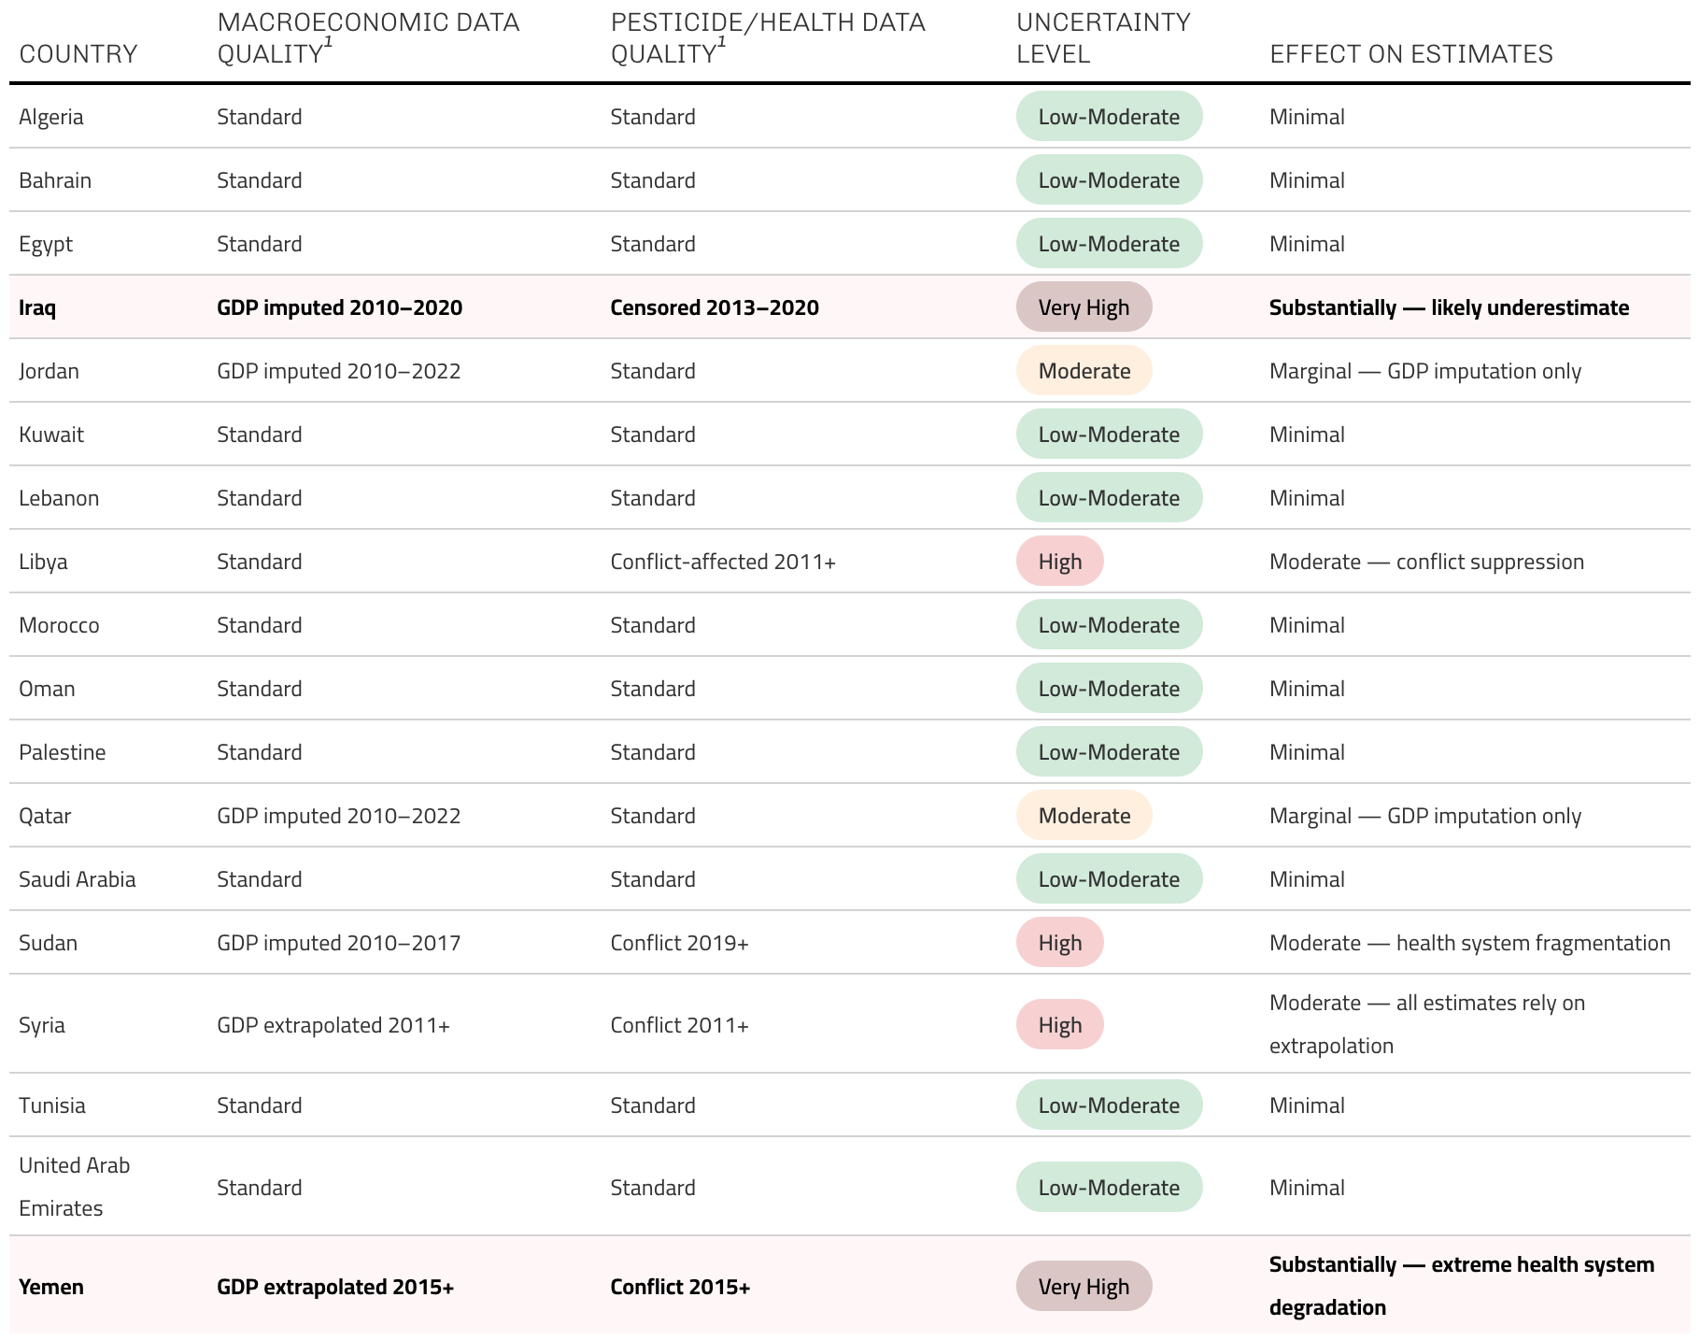
¹ Standard refers to primary data sourced from WHO-CHOICE, World Bank, and ILOStat without significant gaps.

Table S2. Sensetivity Analysis Decision Stability. Testing BCR roboustness against parameter variance.
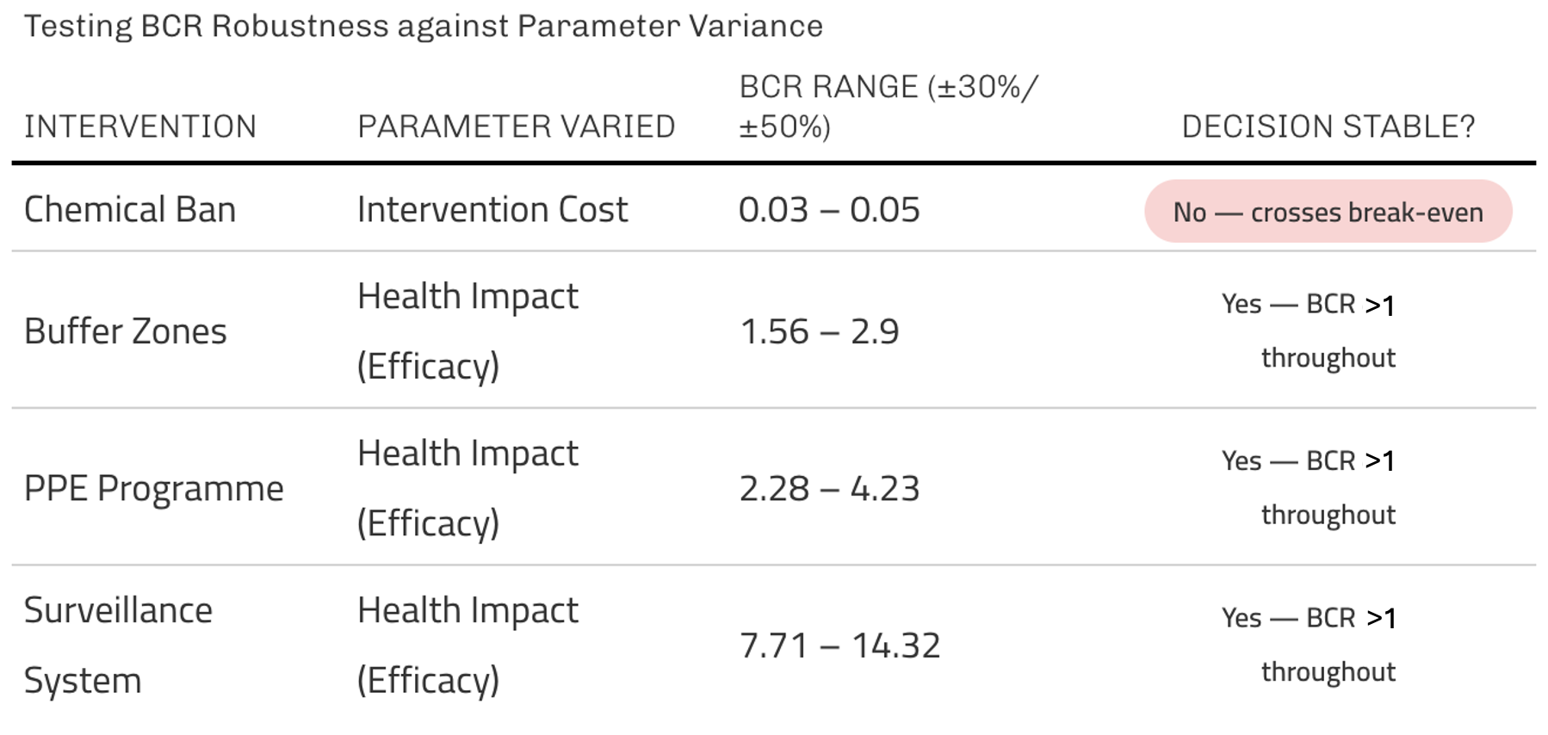

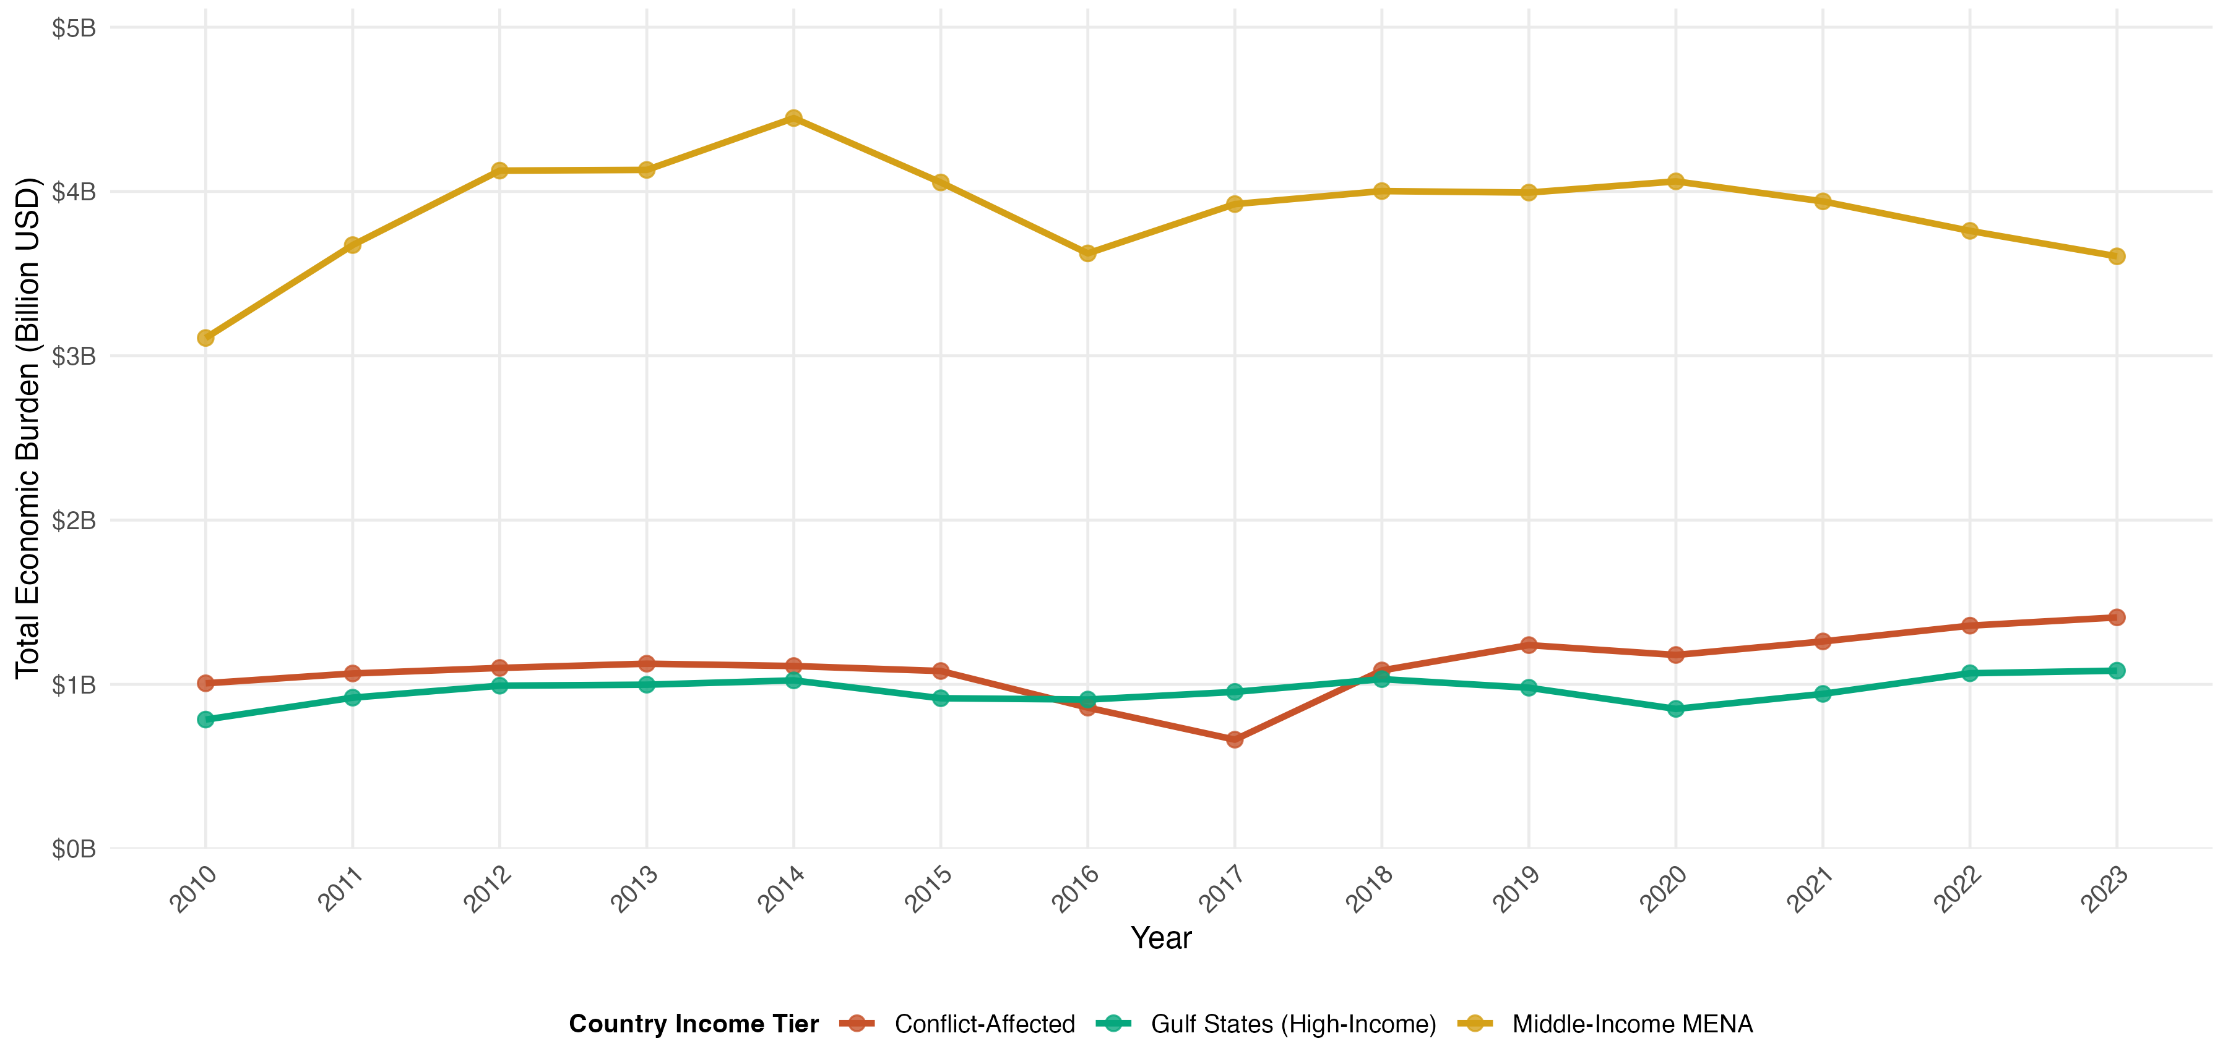
Figure S1. Economic Burden Trajectories by Country Income Tier (2010-2023). Line graph comparing total annual economic burden across three income tiers: Gulf States (Qatar, UAE, Saudi Arabia, Kuwait, Bahrain, Oman; green), Middle-Income MENA (Egypt, Jordan, Tunisia, Morocco, Algeria, Lebanon, Palestine, Iran; gold), and Conflict-Affected countries (Yemen, Sudan, Libya, Syria, Iraq; red). Middle-income countries bore the highest absolute burden ($3.1-4.4 billion annually) due to large populations and high agricultural workforce exposure. Conflict-affected countries showed pronounced volatility, with 2016-2017 decline corresponding to Syria war escalation and Yemen crisis onset, followed by gradual recovery. Gulf states maintained stable moderate burden ($0.8-1.1 billion) reflecting smaller populations, advanced healthcare systems, and lower pesticide intensity despite higher wage-based valuations.

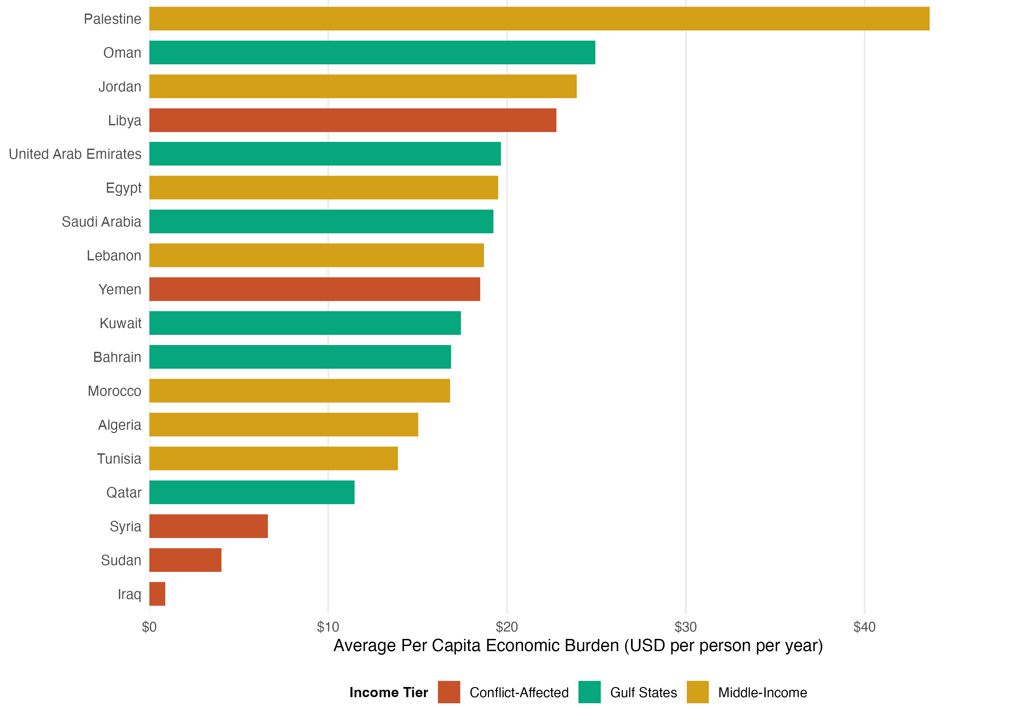
Figure S2. Average Annual Per Capita Economic Burden by Country (2010-2023). Horizontal bar chart ranking 18 MENA countries by mean per capita economic burden over 14 years. Palestine showed highest per capita burden ($43.63/person/year), followed by Oman ($24.95), Jordan ($23.91), and Libya ($22.76). Iraq exhibited lowest per capita burden ($0.88), reflecting pesticide intensity data censoring for 8 of 14 years. Gulf states (green) occupied mid-to-high range due to elevated wage valuations offsetting lower disease rates. Conflict-affected countries (red) spanned full distribution due to heterogeneous data quality, population displacement effects, and varying agricultural exposure patterns. Color coding denotes income tier classification used for healthcare cost adjustments.

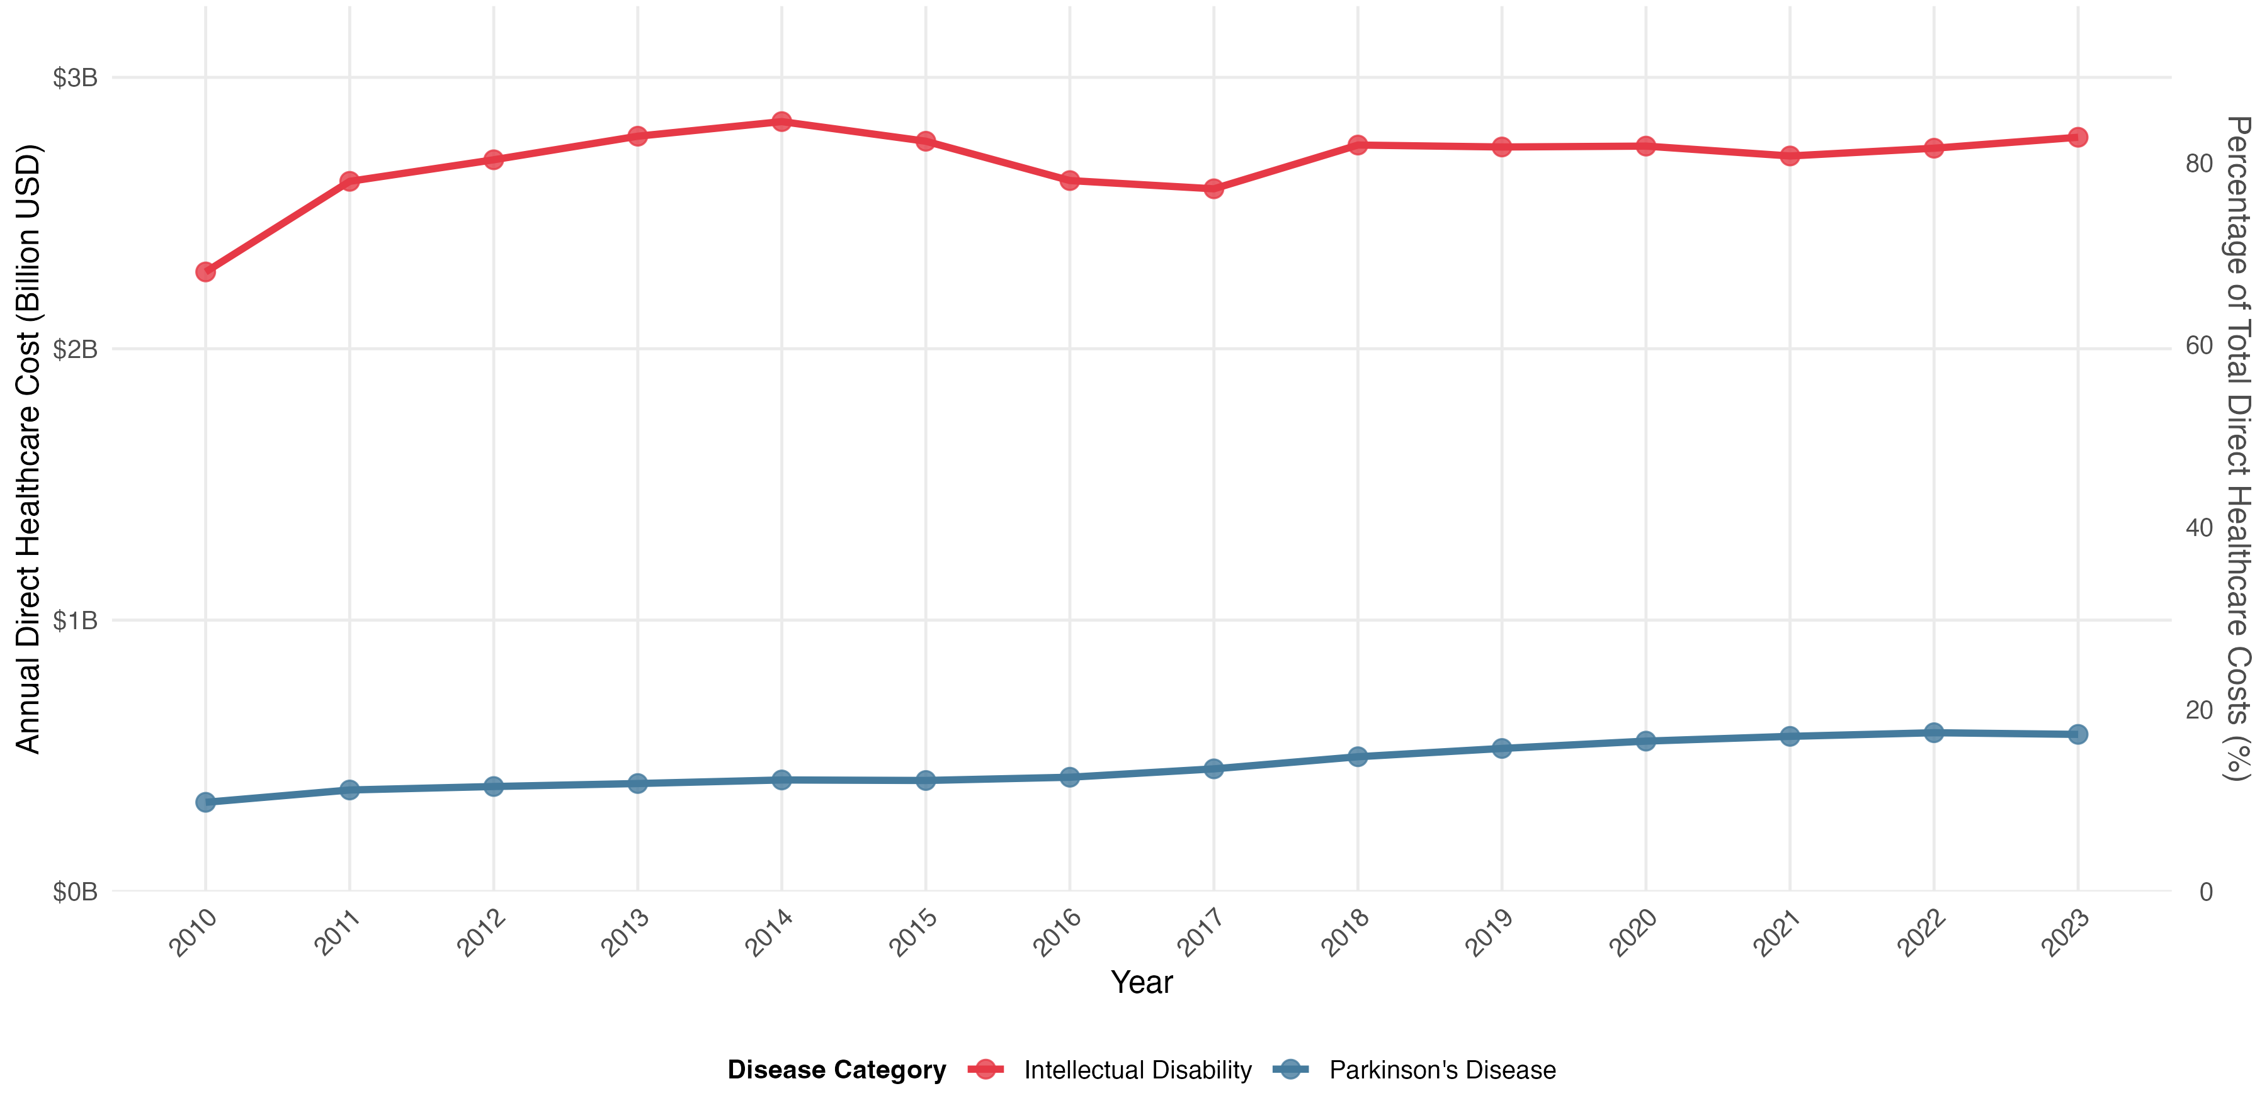
Figure S3. Annual Direct Healthcare Costs by Disease Category, MENA Region (2010-2023). Dual time series showing intellectual disability (ID; red line) and Parkinson's disease (PD; blue line) healthcare expenditures aggregated across 18 countries. ID costs remained stable at $2.3-2.8 billion annually (mean $2.66B), representing 82.8-87.4% of total direct healthcare burden, while PD costs increased 76% from $329 million (2010) to $579 million (2023), reflecting regional population aging and improved diagnostic capacity. Total 14-year direct healthcare expenditure: $44.2 billion ($38.7B ID, $5.5B PD). ID costs include healthcare service utilisation, pharmaceutical use, caregiver time, and broader family/social-care costs (Arora, Goodall et al. 2020). PD costs include inpatient and outpatient medical care, medication, nursing-home care, hospital admission, and productivity loss, with medication the largest direct medical cost item (Zhang, Zhou et al. 2022, Wijers, Ravi et al. 2024). All costs in 2020 USD, adjusted for country income tier per methodology.
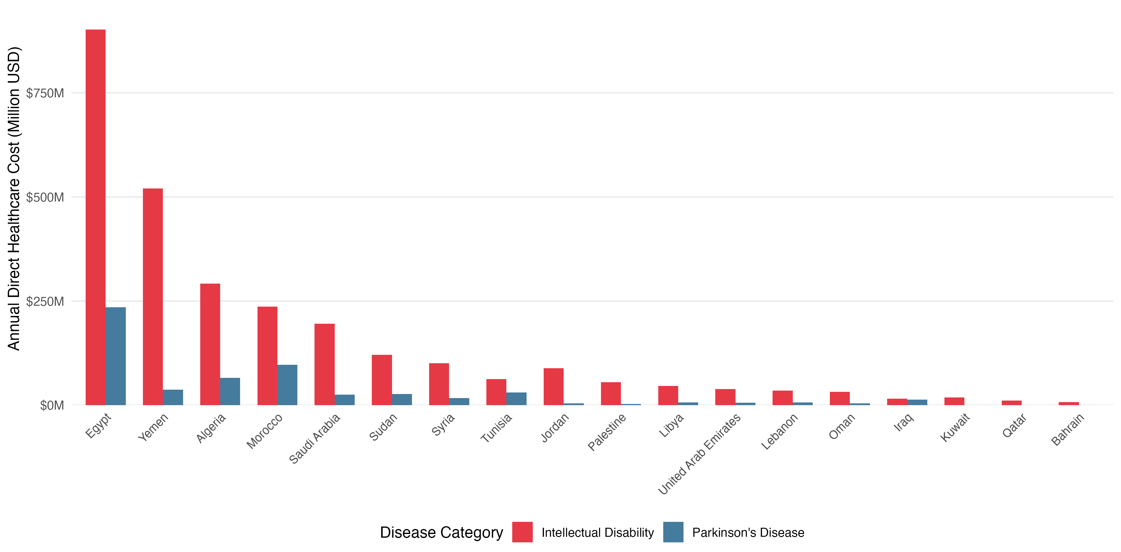
Figure S4. Direct Healthcare Costs by Country and Disease Category (2023). Grouped bar chart comparing intellectual disability (ID; red bars) and Parkinson's disease (PD; blue bars) healthcare expenditures across 18 MENA countries for most recent year. Countries ranked by total 2023 direct costs (ID + PD combined). Egypt dominated regional burden ($1.14 billion: $902M ID + $235M PD), followed by Yemen ($557M), Algeria ($358M), and Morocco ($333M). Gulf states clustered at lower end despite high per capita GDP due to small populations: UAE $45M, Oman $37M, Kuwait $19M, Qatar $11M, Bahrain $7M. Iraq exhibited anomalously low costs ($29M) due to pesticide intensity data censoring (8 of 14 years below reference threshold). ID-to-PD cost ratios varied 2.4× (Morocco) to 245× (Kuwait), reflecting heterogeneous age structures, fertility rates, and diagnostic infrastructure. Costs adjusted for country income tier: Gulf states 1.3× base estimate, middle-income 1.0×, low-income/conflict-affected 0.75×.
Figure S5. Health Budget Impact Trajectory: Yemen versus Saudi Arabia (2010–2023). Three-panel figure. Panel A: pesticide-attributable direct healthcare costs as a percentage of national health budget for Yemen (red) and Saudi Arabia (blue), with shading indicating the growing divergence. Policy events annotated: Yemen conflict escalation (2015), Saudi pesticide reduction policy (2016), Yemen health system collapse (2019). Panel B: absolute annual direct healthcare costs in USD millions (2020 PPP), with light shading representing Yemen's intellectual disability cost component. Panel C: year-by-year divergence expressed as Yemen's budget share minus Saudi Arabia's budget share (percentage points). All Yemen estimates from 2015 onward carry High uncertainty classification (conflict-affected).
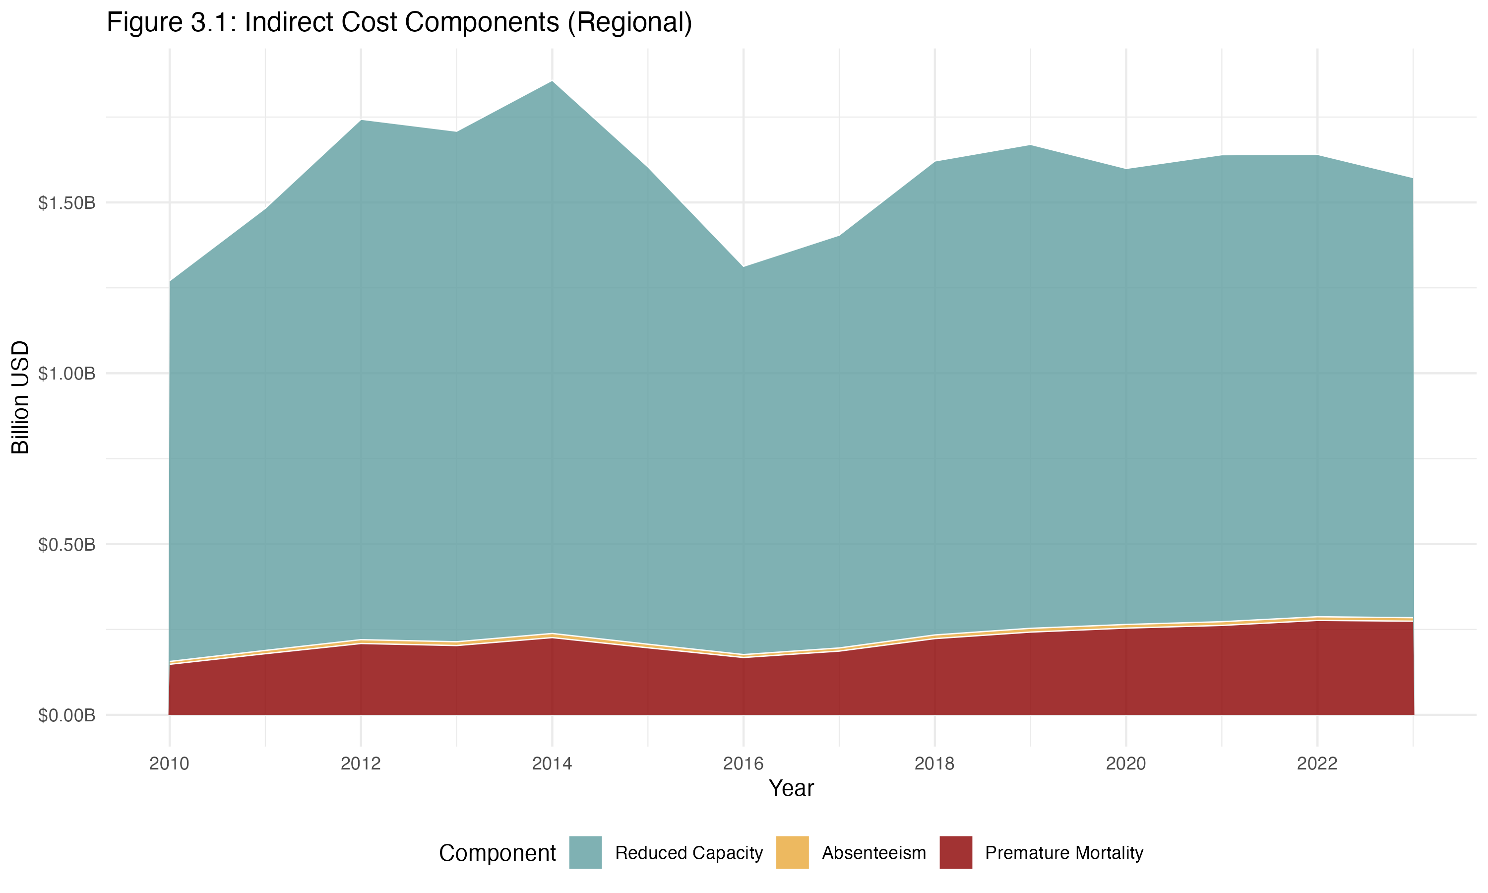
Figure S6. Annual Indirect Cost Components by Category, MENA Region (2010–2023). Stacked area chart showing regional aggregate indirect productivity losses decomposed into three components: reduced work capacity (teal), premature mortality (dark red), and absenteeism (yellow). Total regional indirect costs ranged from approximately $1.1 billion (2016) to $1.9 billion (2014), averaging $1.6 billion annually. Reduced work capacity dominated throughout, consistently comprising >85% of total indirect burden. Absenteeism contributed a negligible visible share (<2%). All values in 2020 USD, discounted at 4.5% annually over a 20-year horizon.
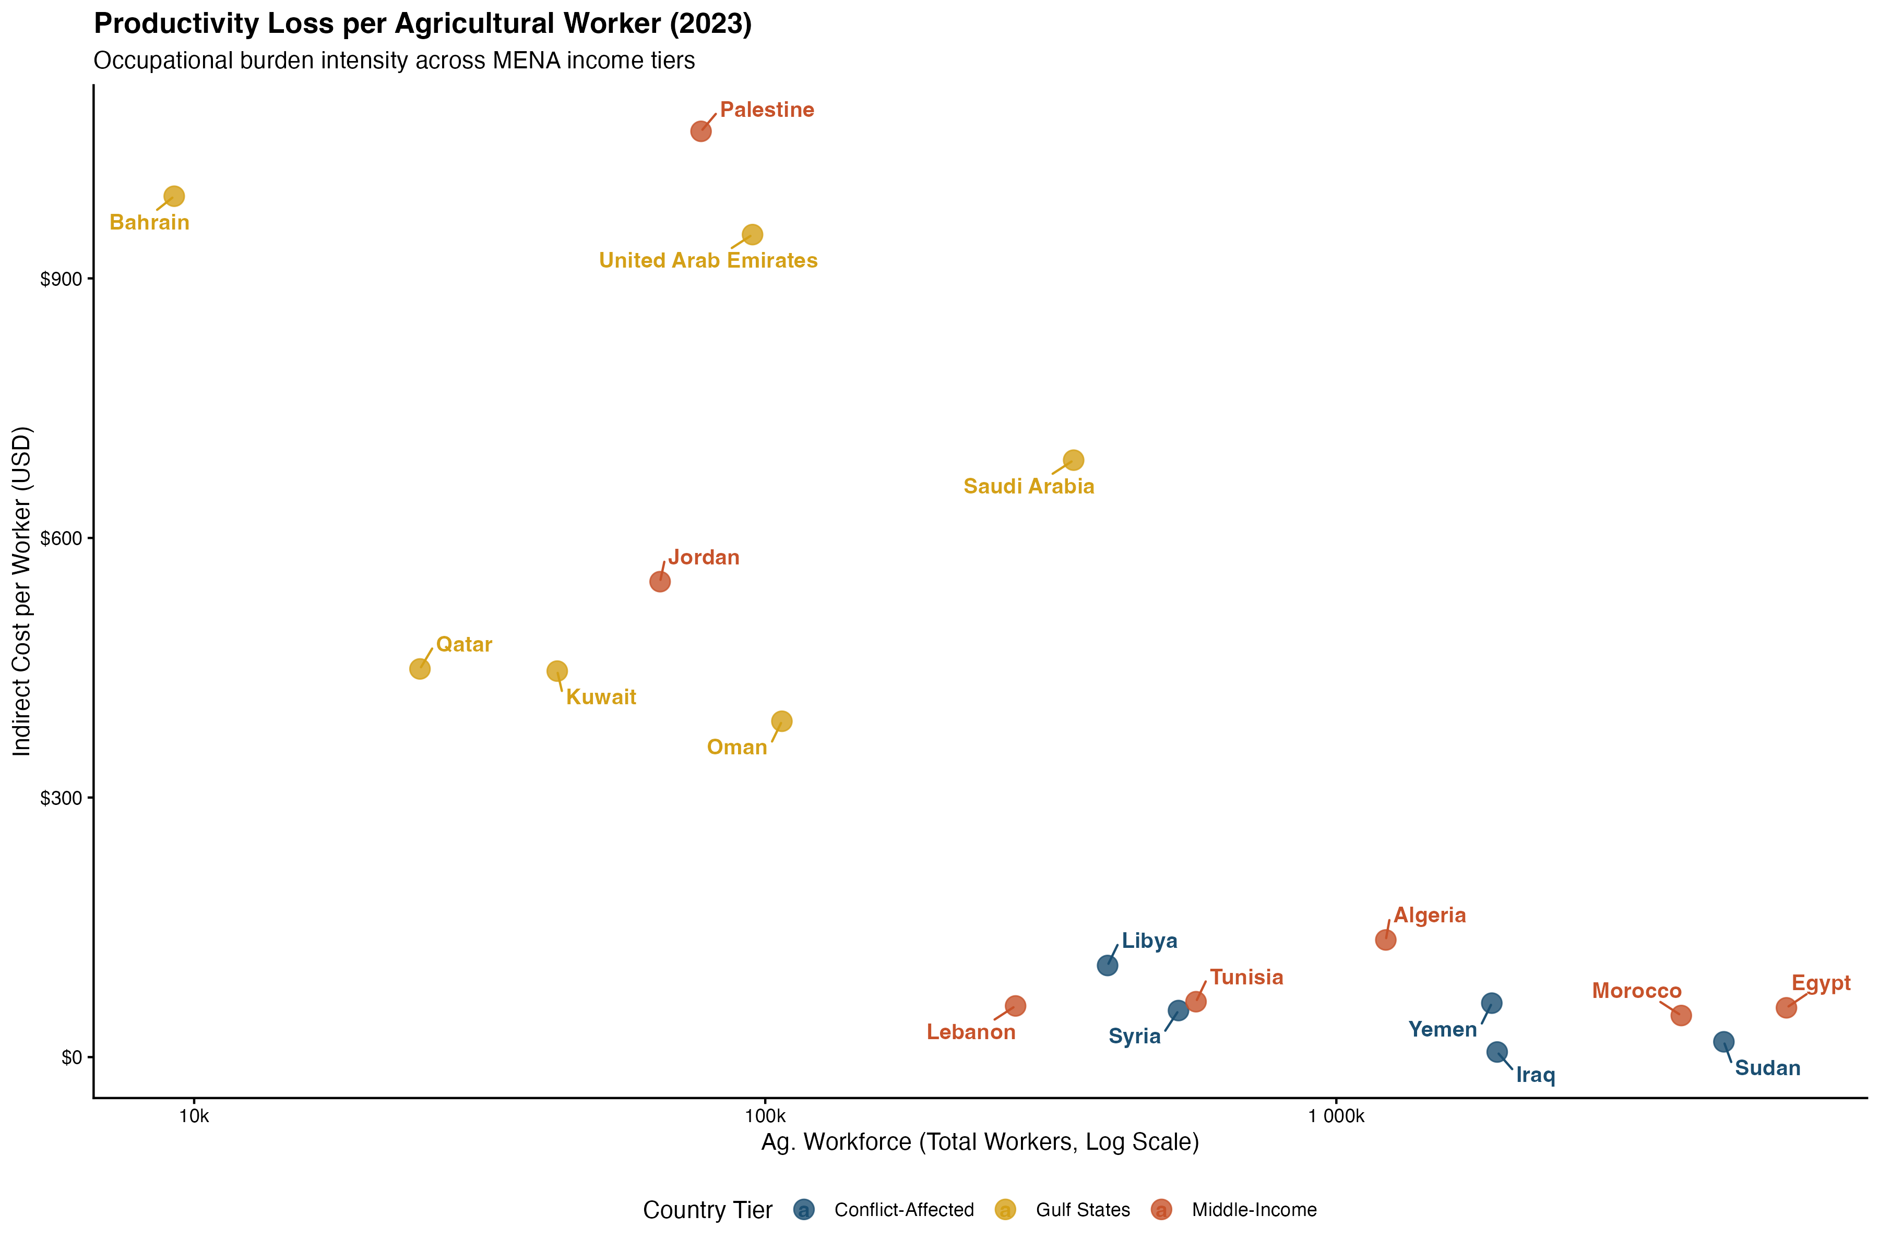
Figure S7. Productivity Loss per Agricultural Worker by Country (2023). Scatter plot displaying total annual indirect costs divided by national agricultural workforce size (log scale, x-axis) across 18 MENA countries, color-coded by income tier: Gulf States (gold), Middle-Income (red-orange), and Conflict-Affected (blue). Palestine exhibited the highest occupational burden intensity ($1,070/worker), followed by Bahrain ($995) and UAE ($951). Conflict-affected countries clustered at the lower right (large workforces, low per-worker costs), reflecting wage suppression and data quality limitations. Iraq showed the lowest per-worker burden ($5.90), consistent with pesticide intensity data censoring. All costs in 2020 USD.
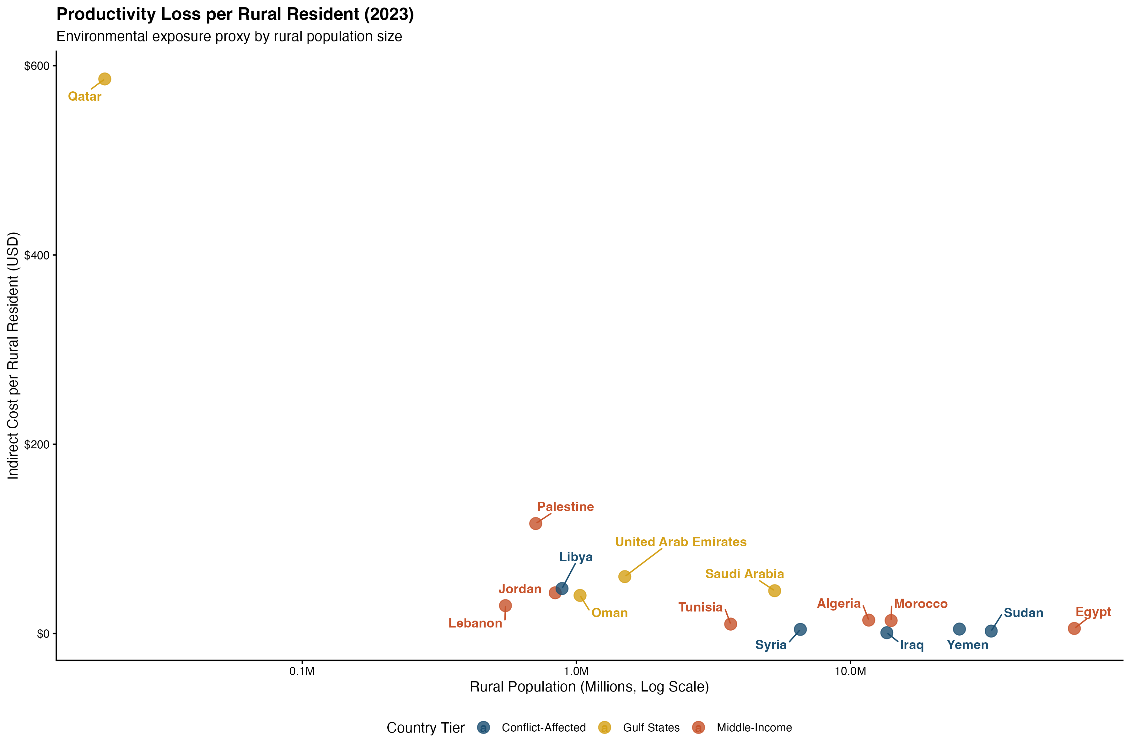
Figure S8. Productivity Loss per Rural Resident by Country (2023). Scatter plot displaying total annual indirect costs divided by rural population size (log scale, x-axis) across 18 MENA countries, color-coded by income tier. Qatar exhibited the highest environmental burden intensity ($586/rural resident) driven by an extremely small rural population (19,030 persons). Palestine ranked second ($116/resident), followed by UAE ($60) and Libya ($47). Countries with large rural populations—Egypt, Sudan, Yemen—clustered at the lower right with costs below $6/resident, reflecting dilution of burden across tens of millions of rural inhabitants. Iraq showed lowest per-resident burden ($0.83). All costs in 2020 USD.
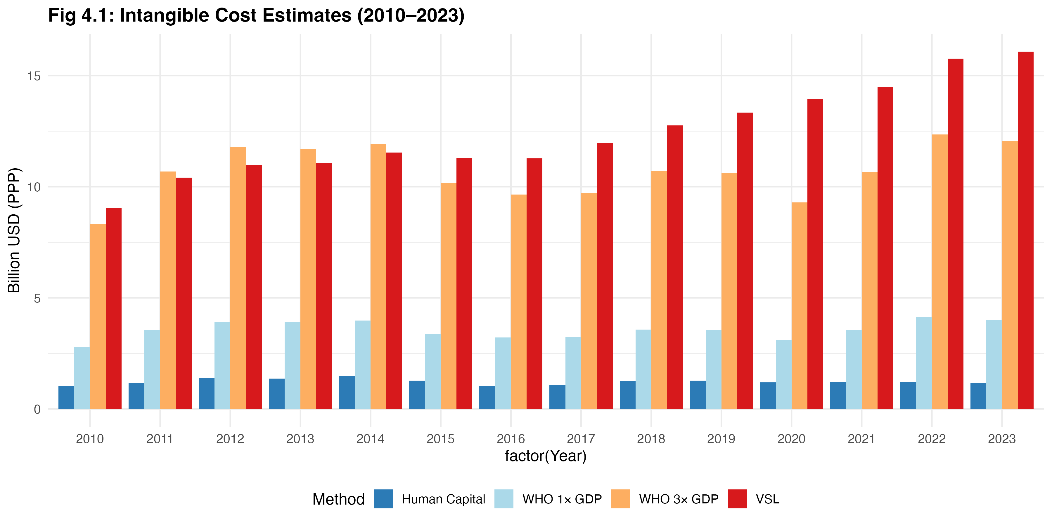
Figure S9. DALY Valuation Methods Comparison (Regional). Grouped bar chart comparing annual regional aggregate quality-of-life valuations using Human Capital (HC; dark blue), WHO 1×GDP threshold (light blue), WHO 3×GDP threshold (orange), and Value of Statistical Life (VSL; red) methods across 14 years. HC estimates were lowest and most stable ($1.0–1.5 billion annually), while VSL estimates showed the steepest growth trajectory ($9.0 billion in 2010 to $16.1 billion in 2023), driven by rising PD mortality among aging agricultural populations. WHO 3×GDP and VSL converged in the $10–16 billion range. All values in 2020 USD PPP.
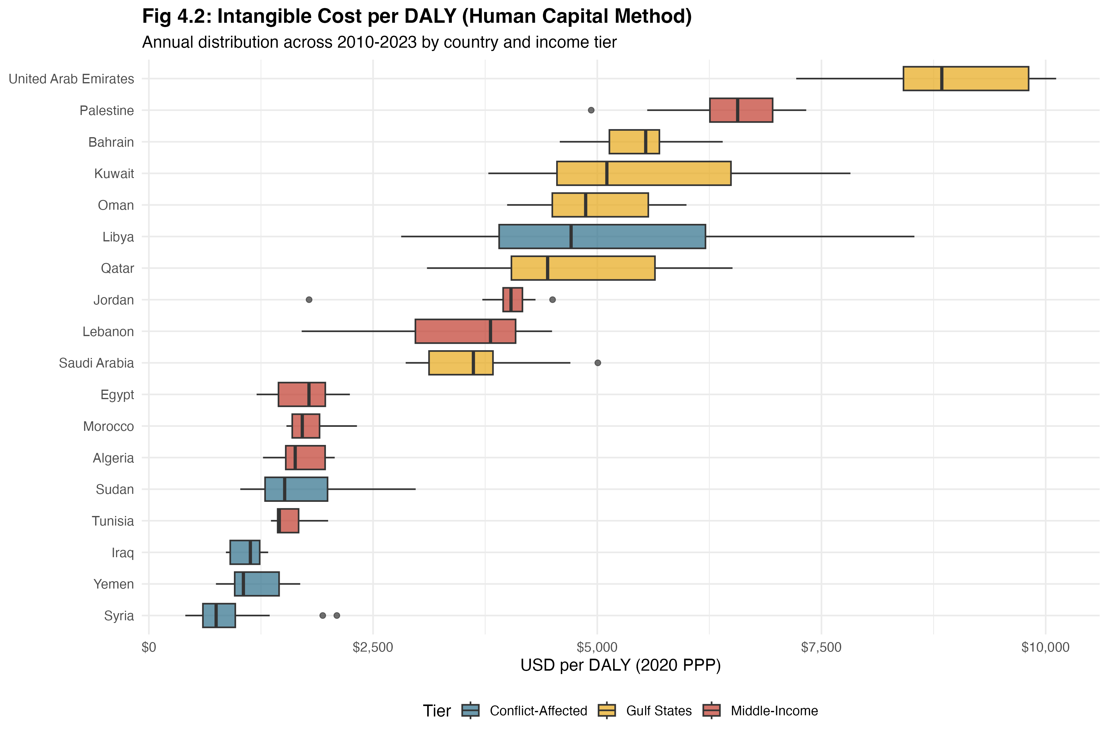
Figure S10: Intangible Costs per DALY (Human Capital Method). Horizontal box plots showing the median, interquartile range, and annual variation in per-DALY intangible valuations for 18 MENA countries, color-coded by income tier (Gulf States: gold; Middle-Income: red; Conflict-Affected: blue). UAE ranked highest (median ~$9,000/DALY), reflecting the region's highest economy-wide wages. Conflict-affected countries clustered at the lower end. Libya showed the widest IQR among conflict-affected countries, reflecting war-driven wage volatility. Countries ordered by median value ascending.
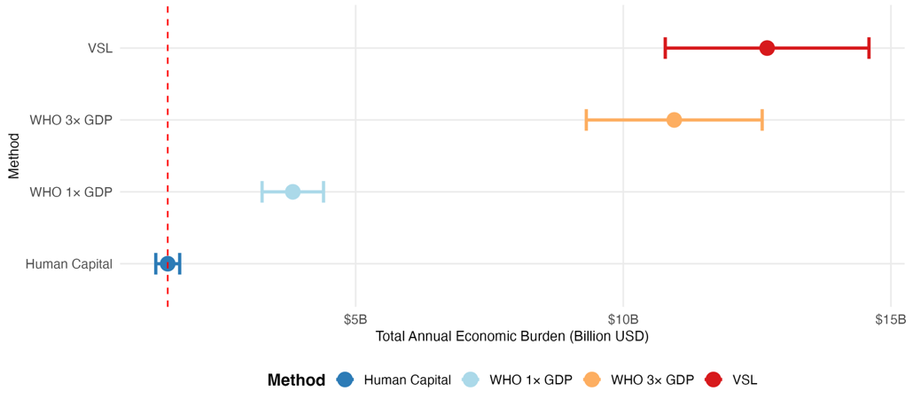
Figure S11. Sensitivity of Total Annual Economic Burden to Intangible Cost Valuation Method. Forest-plot style sensitivity diagram showing mean annual total economic burden (direct + indirect + intangible components) under four valuation methods, with error bars representing ±30% uncertainty on the intangible cost component. The dashed red line marks the Human Capital baseline (~$1.5 billion). WHO 1×GDP shifted the mean to ~$3.8 billion (±$0.57B); WHO 3×GDP to ~$11.0 billion (±$1.6B); VSL to ~$12.7 billion (±$1.9B). Direct and indirect components were held constant at Human Capital scenario values across all methods. All values in 2020 USD PPP, 18-country regional aggregate.
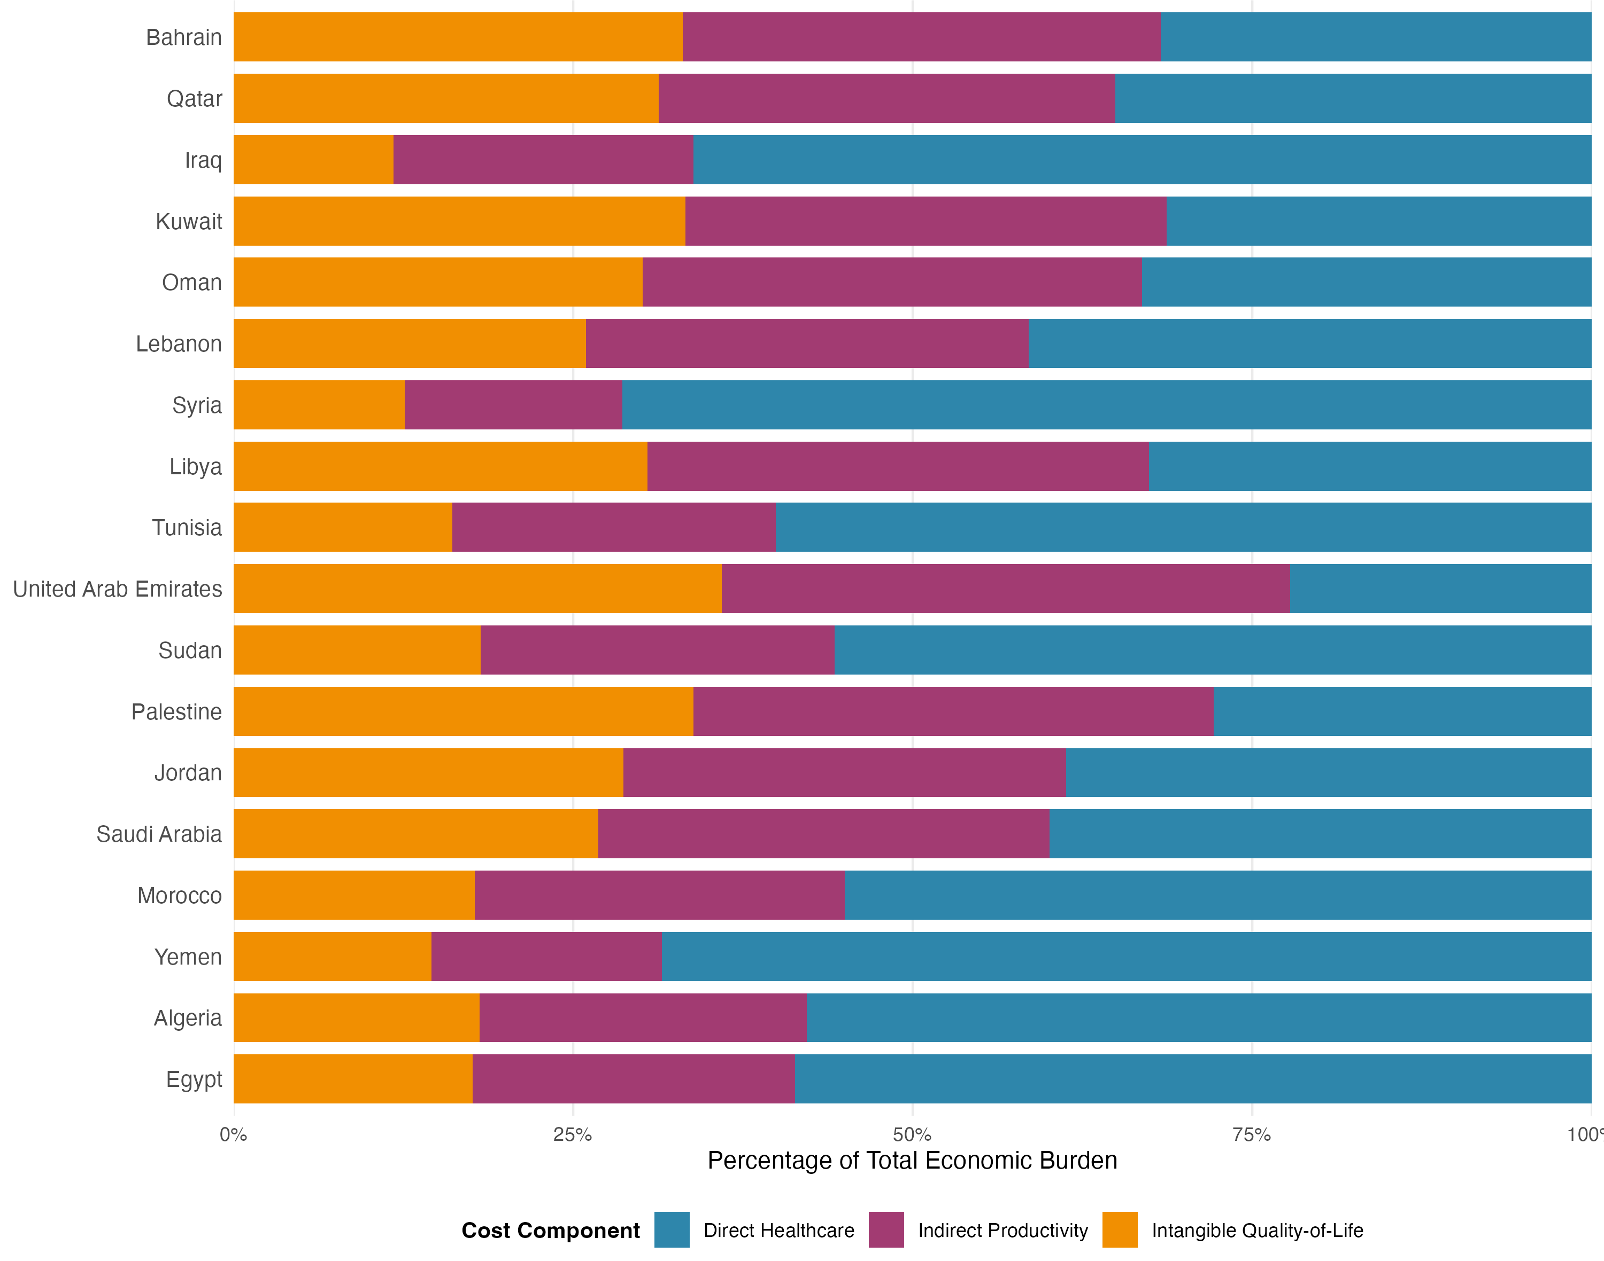
Figure S12. Economic Burden Composition by Country (2010-2023 Average). 100% stacked horizontal bar chart showing proportional contribution of direct healthcare costs (blue), indirect productivity losses (purple), and intangible quality-of-life costs (orange) for 18 MENA countries. Countries ranked by total absolute burden descending (Egypt highest, Bahrain lowest). Direct healthcare costs dominated burden in conflict-affected countries (Syria 71.4%, Yemen 68.5%, Iraq 66.2%, Sudan 55.7%) due to limited economic productivity capacity and suppressed wage-based valuations during instability. Intangible quality-of-life costs comprised largest share in Gulf states (Palestine 33.8%, UAE 35.9%, Kuwait 33.3%, Bahrain 33.1%, Oman 30.1%, Qatar 31.3%) reflecting high wage valuations in Human Capital DALY calculations. Indirect productivity losses showed greatest contribution in middle-income countries with large agricultural workforces (Saudi Arabia 33.2%, UAE 41.8%, Oman 36.8%, Jordan 32.6%, Lebanon 32.6%, Morocco 27.2%). Egypt and Algeria, despite ranking 1st and 2nd in absolute burden, exhibited middle-income typical composition (direct 59%, indirect 24%, intangible 18%) rather than extreme profiles.
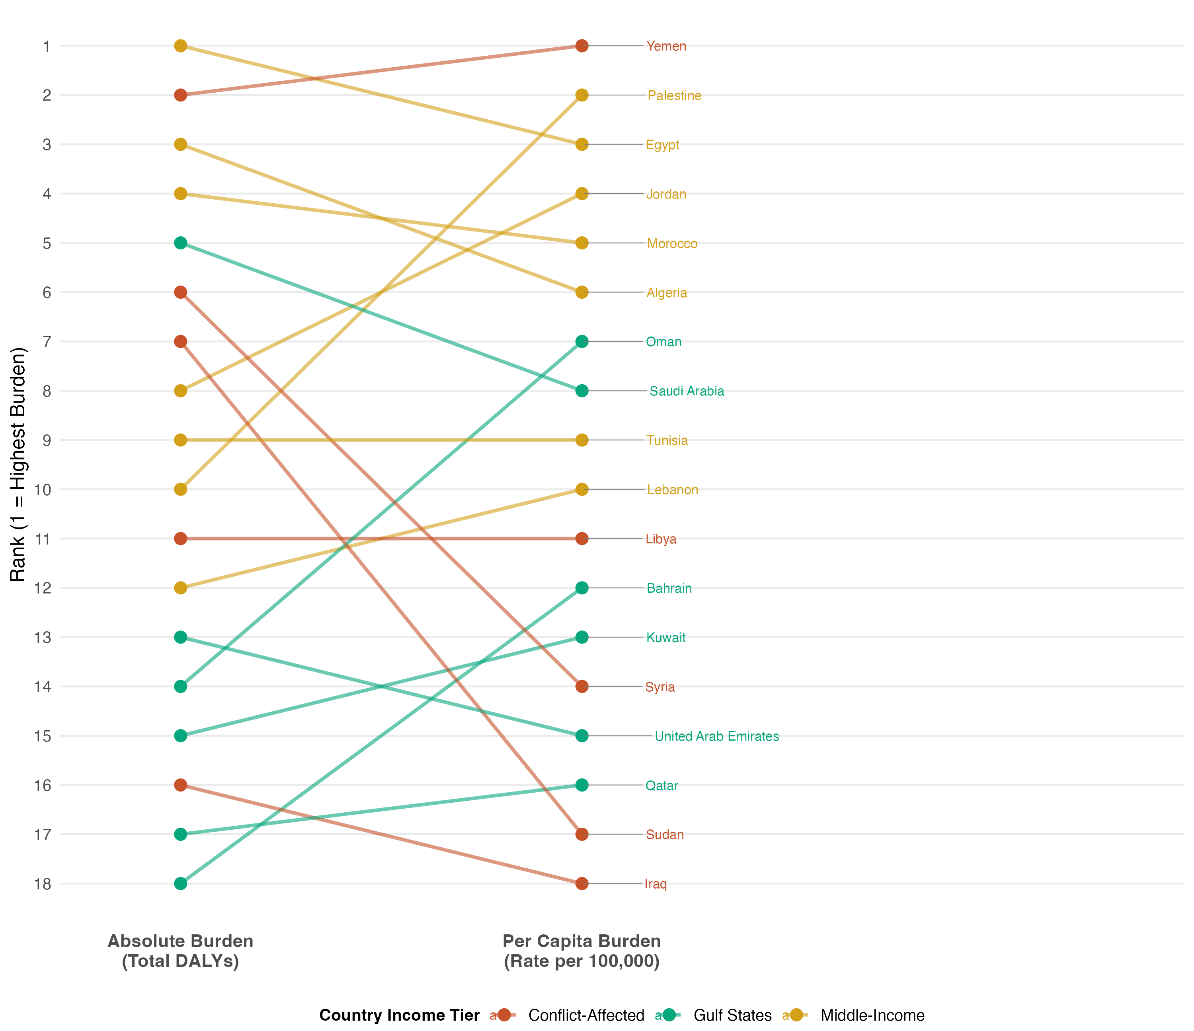
Figure S13. Absolute Burden vs Per Capita Burden Rankings (2010-2023). Slope graph comparing country rankings by total DALYs (left axis, absolute burden) versus DALY rate per 100,000 population (right axis, per capita burden intensity). Lines connect each country's two rankings; line slope indicates population-adjusted burden shift. Steep upward slopes (rank improves left-to-right) identify large-population countries with high absolute burden but moderate per capita intensity: Egypt (1→3), Algeria (3→6), Morocco (4→5). Steep downward slopes (rank worsens left-to-right) identify small-population countries with modest absolute burden but high per capita intensity: Palestine (10→2), Oman (14→7), Jordan (8→4), Bahrain (18→12). Near-horizontal lines indicate burden proportional to population size: Yemen (2→1, highest on both metrics), Tunisia (9→9), Lebanon (12→10). Iraq exhibited dramatic drop (16→18) due to data censoring artifact suppressing both absolute and per capita estimates. Yemen ranked #1 per capita (234.6/100k) and #2 absolute (1.09M DALYs), reflecting combination of high exposure intensity and large population. Countries with minimal slope change (parallel rankings) represent natural burden-population proportionality and should be policy priorities regardless of ranking metric chosen.
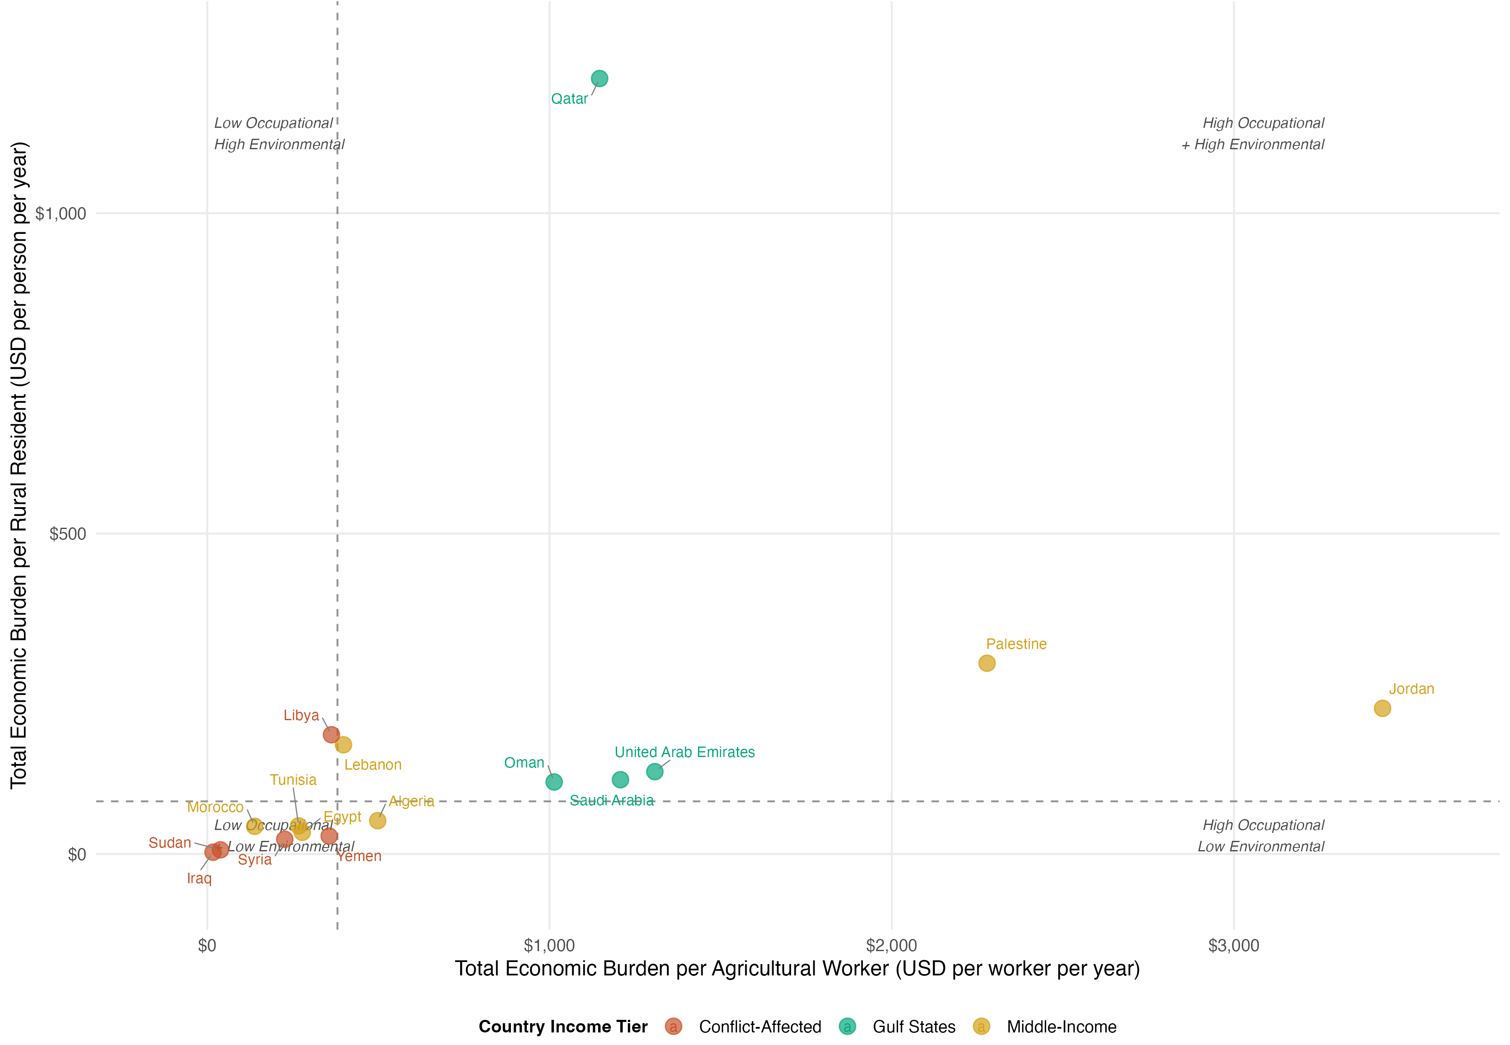
Figure S14. Burden per Agricultural Worker vs Burden per Rural Resident (2010-2023 Average). Scatter plot with quadrant analysis identifying occupational versus environmental exposure pathway dominance. X-axis: total economic burden per agricultural worker (occupational intensity); Y-axis: total economic burden per rural resident (environmental/residential exposure intensity). Quadrants defined by median values (dashed lines: $277/worker, $43/rural resident). Upper-right quadrant (high occupational + high environmental): Palestine ($2,279/worker, $298/rural resident) and Jordan ($3,434/worker, $227/rural resident), indicating intensive agriculture with concentrated residential exposure—require comprehensive interventions (PPE + buffer zones + community protection). Lower-right quadrant (high occupational, low environmental): Qatar ($1,146/worker, $1,210/rural resident) represents measurement artifact in highly urbanized Gulf state with minimal agricultural sector (24k workers, 23k rural residents). Upper-left quadrant (low occupational, high environmental): Libya ($363/worker, $186/rural resident) suggests residential proximity burden dominates. Lower-left quadrant (low both pathways): Egypt, Morocco, Algeria, Yemen, Sudan, Syria, Iraq—large agricultural workforces (0.6-7M workers) and rural populations (6-59M residents) dilute per-unit burden despite high absolute costs; surveillance and monitoring sufficient. Gulf states (except Qatar) cluster mid-range on occupational axis ($1,000-1,300/worker) due to high wage valuations but low-to-mid on environmental axis due to small-to-moderate rural populations.
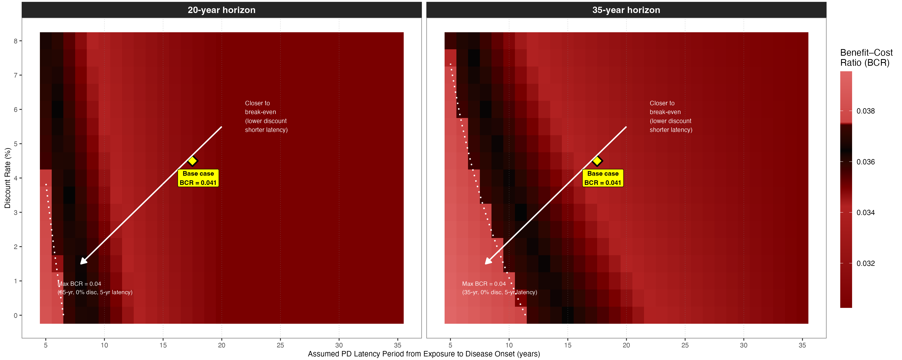
Figure S15. Chemical Ban: BCR Sensitivity Surface Across Assumed PD Latency and Discount Rate. Two-panel heat map. Left panel: 20-year modelling horizon. Right panel: 35-year horizon. Colour scale (dark = lower BCR, lighter red = higher BCR) reflects the magnitude of BCR across the full parameter grid; the entire surface remains below BCR = 1.0. Yellow diamond = base-case parameters (4.5% discount rate, 15–20 year PD latency). White arrow indicates the direction of parameter combinations approaching (but not reaching) break-even. The flat region visible at latency ≥ 20 years in the 20-year panel reflects the mathematical boundary condition: when assumed latency exceeds the modelling horizon, zero PD benefit accrues regardless of discount rate. Annual implementation cost: USD 897.8 million. ID benefit (6% risk reduction) accrues from implementation year 1; PD benefit (20% risk reduction) accrues only after the latency period. BCR range under ±30% efficacy and ±50% cost sensitivity: 0.029–0.053.
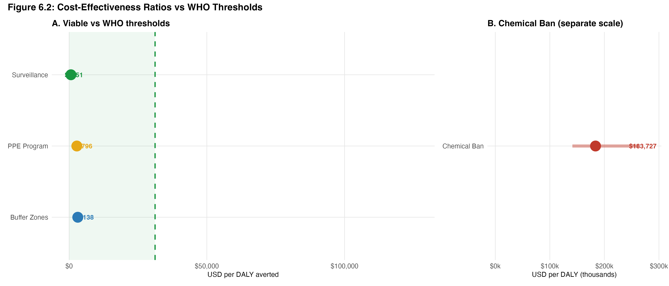
Figure S16. Cost-Effectiveness Ratios vs WHO GDP per Capita Thresholds, Typical MENA Country. Dual-panel lollipop chart. Panel A (linear scale, $0–$126,000): Surveillance ($651/DALY), PPE Program ($2,796/DALY), and Buffer Zones ($3,138/DALY) all fall within the green highly cost-effective zone (< WHO 1×GDP threshold = $31,201). Dashed green line = WHO 1×GDP; dashed red line = WHO 3×GDP ($93,603). Panel B ($0–$300,000): Chemical Ban ($183,727/DALY; sensitivity range $141,328–$262,467) substantially exceeds the WHO 3×GDP threshold. MENA-average GDP per capita (PPP 2020 USD) = $31,201. Error bars = ±30% sensitivity on CER.
Figure S17. Investment return timeline — payback period and net present value by intervention, typical MENA country. Panel A shows payback periods for the three cost-beneficial interventions: the Surveillance System recovers its implementation cost in approximately 5 weeks (0.10 years), the PPE Programme in 5 months (0.44 years), and Buffer Zones in 10 months (0.81 years). Panel B shows net present value (NPV) at 5-year (light blue) and 20-year (dark blue) horizons in USD millions (constant 2020 PPP), discounted at 4.5% annually. The Chemical Ban is excluded from both panels (20-year NPV = −$11,198M). All values derived from a typical MENA country profile; country-specific NPVs scale with agricultural workforce size and baseline disease burden.
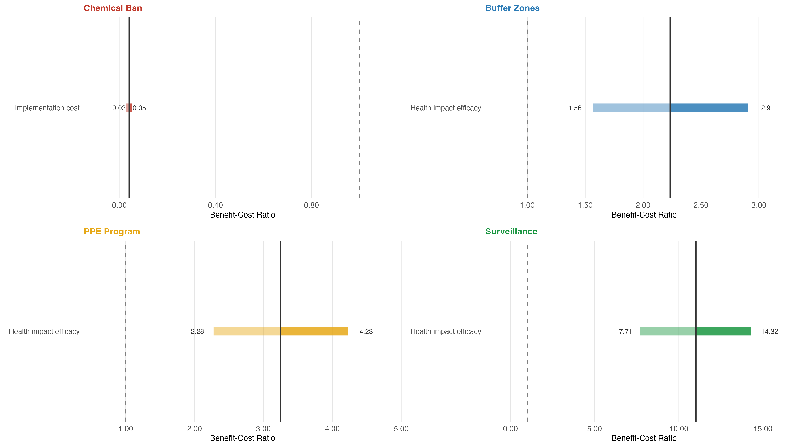
Figure S18. Tornado Diagrams — BCR Sensitivity to Key Parameters by Intervention (Typical MENA Country). Four-panel horizontal bar chart showing the BCR sensitivity range for the dominant parameter of each intervention under ±30% (efficacy) or ±50% (implementation cost) variation. Solid vertical line = base-case BCR; dashed vertical line = break-even (BCR = 1). Light shade = low estimate; dark shade = high estimate. Chemical Ban (top left): most sensitive parameter is implementation cost (±50%); BCR range 0.029–0.053 — entirely below break-even. Buffer Zones (top right): most sensitive parameter is health impact efficacy (±30%); BCR range 1.56–2.90 — above break-even in all scenarios. PPE Program (bottom left): health impact efficacy ±30%; BCR range 2.28–4.23. Surveillance (bottom right): health impact efficacy ±30%; BCR range 7.71–14.32. Parameter_Name, BCR_Low, BCR_High from sheet eROI_Sensitivity_Analy_Tornado (sheet 22). Human Capital valuation, 2020 USD PPP, 4.5% discount rate.
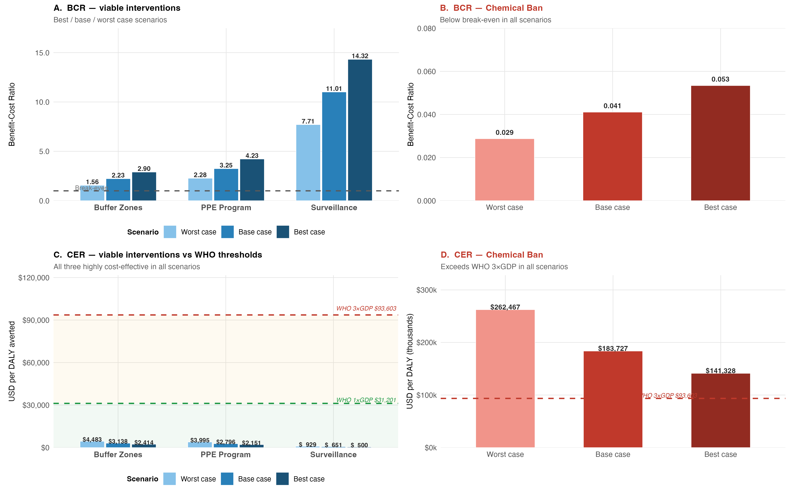
Figure S19. Scenario Analysis — Best Case, Base Case, and Worst Case BCR and CER by Intervention. Four-panel grouped bar chart. Panels A and B: BCR under three scenarios. Panel A (linear scale): viable interventions (Buffer Zones, PPE Program, Surveillance) maintain BCR > 1 in all scenarios; Surveillance BCR ranges 7.71–14.32. Panel B: Chemical Ban BCR ranges 0.029–0.053 — below break-even in all scenarios. Panels C and D: CER under three scenarios. Panel C: all three viable interventions remain well below WHO 1×GDP threshold ($31,201; green dashed) in all scenarios, including worst case (Buffer Zones $4,483, PPE $3,995, Surveillance $929). Panel D: Chemical Ban CER ranges $141,328 (best) to $262,467 (worst) — exceeding WHO 3×GDP ($93,603; red dashed) in all scenarios. Best case = BCR_High/CER_Low; worst case = BCR_Low/CER_High. WHO thresholds: 1×GDP = $31,201; 3×GDP = $93,603 (MENA average PPP 2020 USD).
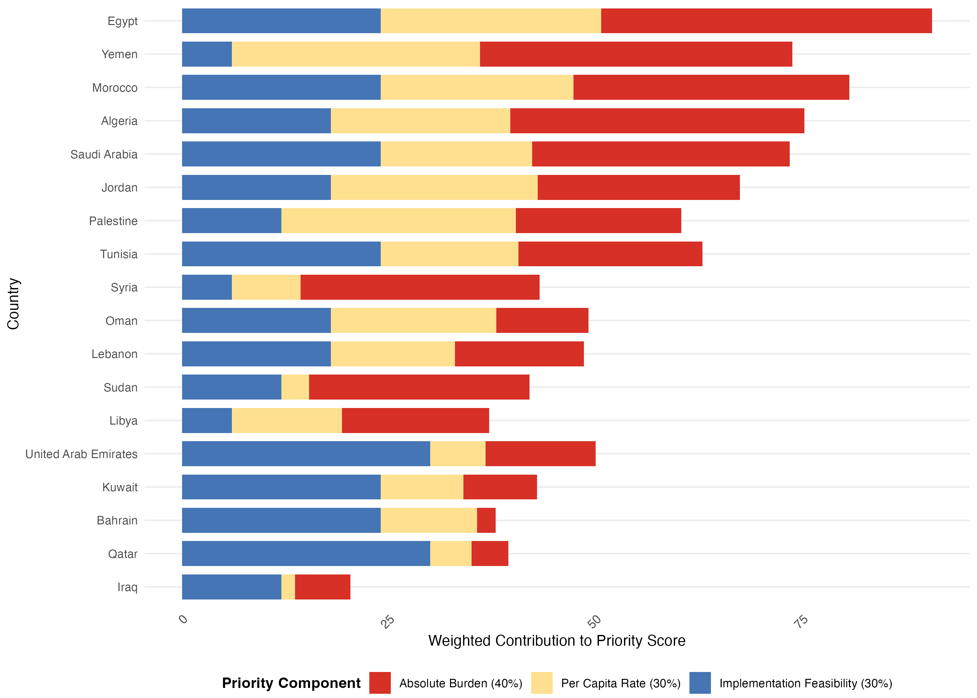
Figure S20. Composite priority score components by country for policy investment targeting. Stacked horizontal bars show weighted contributions of absolute disease burden (40%, red), per capita rate (30%, yellow), and implementation feasibility (30%, blue) to each country's composite priority score. Countries are ordered by final priority rank (Egypt = rank 1). Tier 1 countries (n=6) combine high burden with moderate-to-high feasibility; Tier 2 (n=6) have either high burden with low feasibility or moderate burden with high feasibility; Tier 3 (n=6) have low burden regardless of feasibility. Egypt's top ranking reflects both the highest absolute burden (203,275 DALYs) and strong feasibility (score=4/5), while Yemen ranks second due to exceptionally high per capita rate (235/100k) despite very low feasibility (score=1/5) due to active conflict.
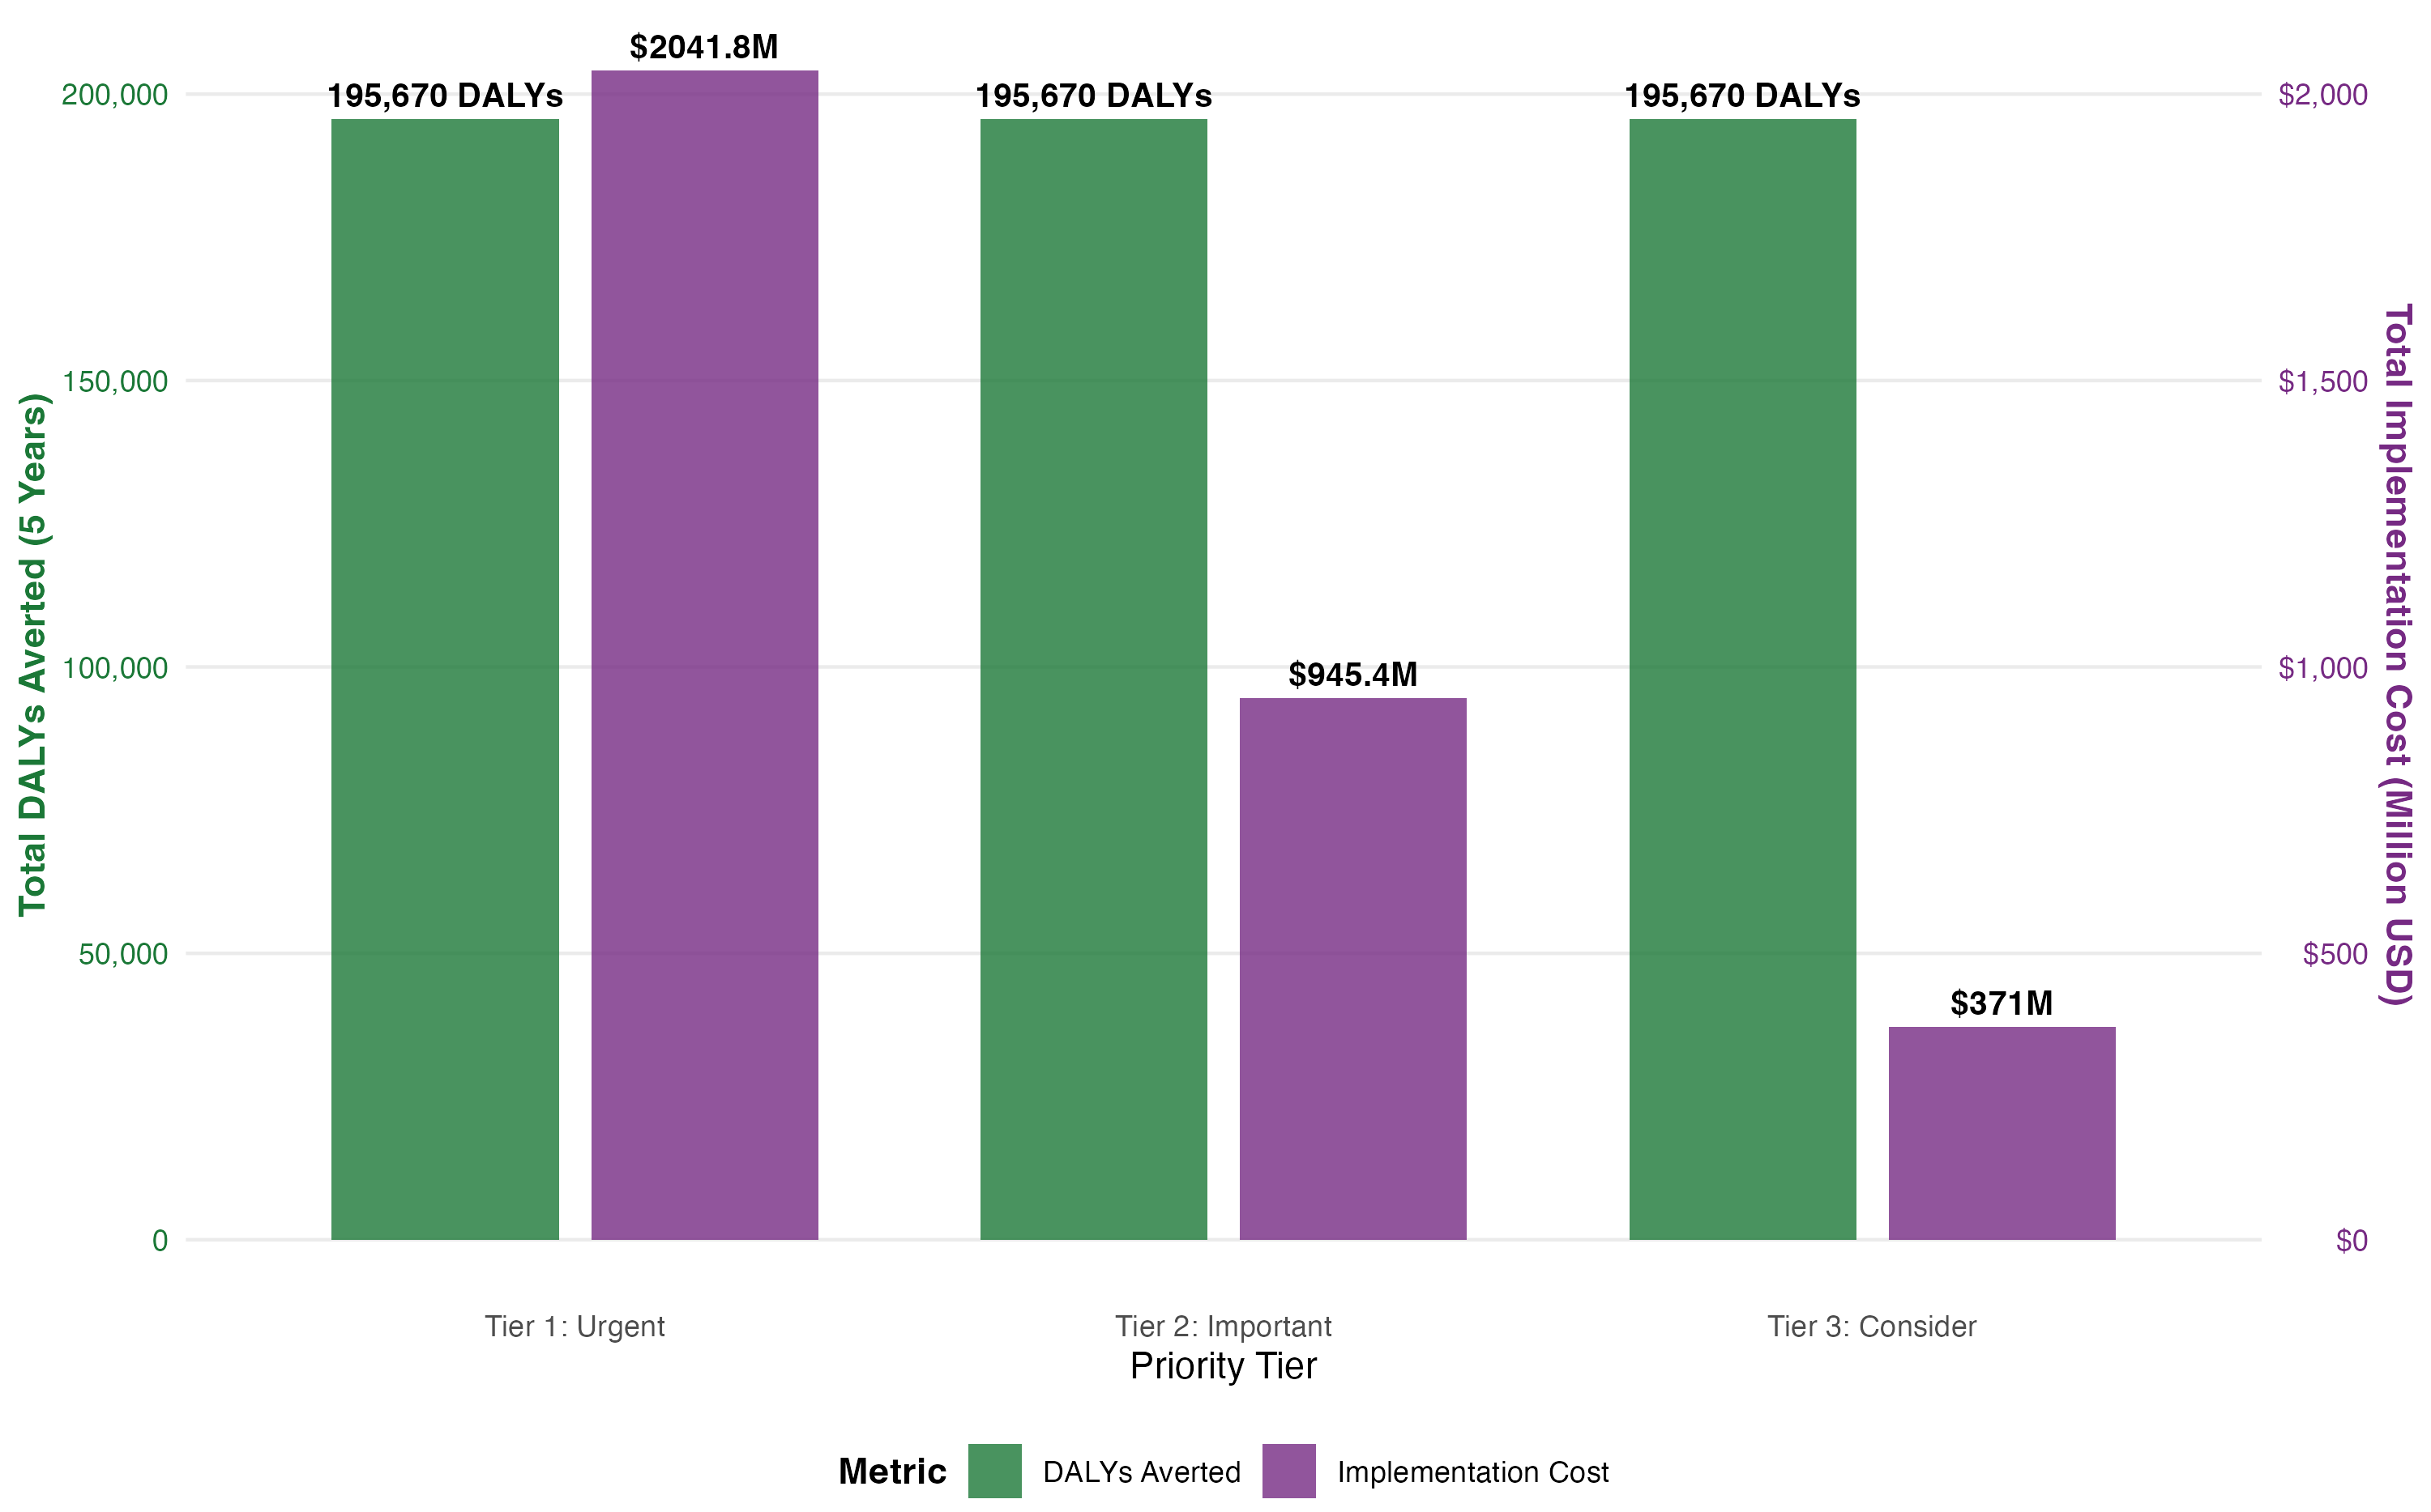
Figure S21. Estimated 5-year health impact and implementation costs by priority tier. Grouped bar chart compares projected DALYs averted (green bars, left y-axis) and total implementation costs (purple bars, right y-axis, millions USD) across three priority tiers over a 5-year horizon (2027–2031), assuming deployment of surveillance systems (highest benefit-cost ratio intervention, BCR=11.01) in each country. DALYs averted are uniform across tiers (195,670 per tier) because intervention efficacy assumptions are standardized; however, implementation costs decline sharply from Tier 1 ($2,041.8M for 6 countries) to Tier 2 ($945.4M) to Tier 3 ($371.0M), reflecting differences in agricultural workforce size and rural population scale. Tier 1 countries require 5.5× higher total investment than Tier 3 but offer the largest absolute health gains due to higher baseline burden.
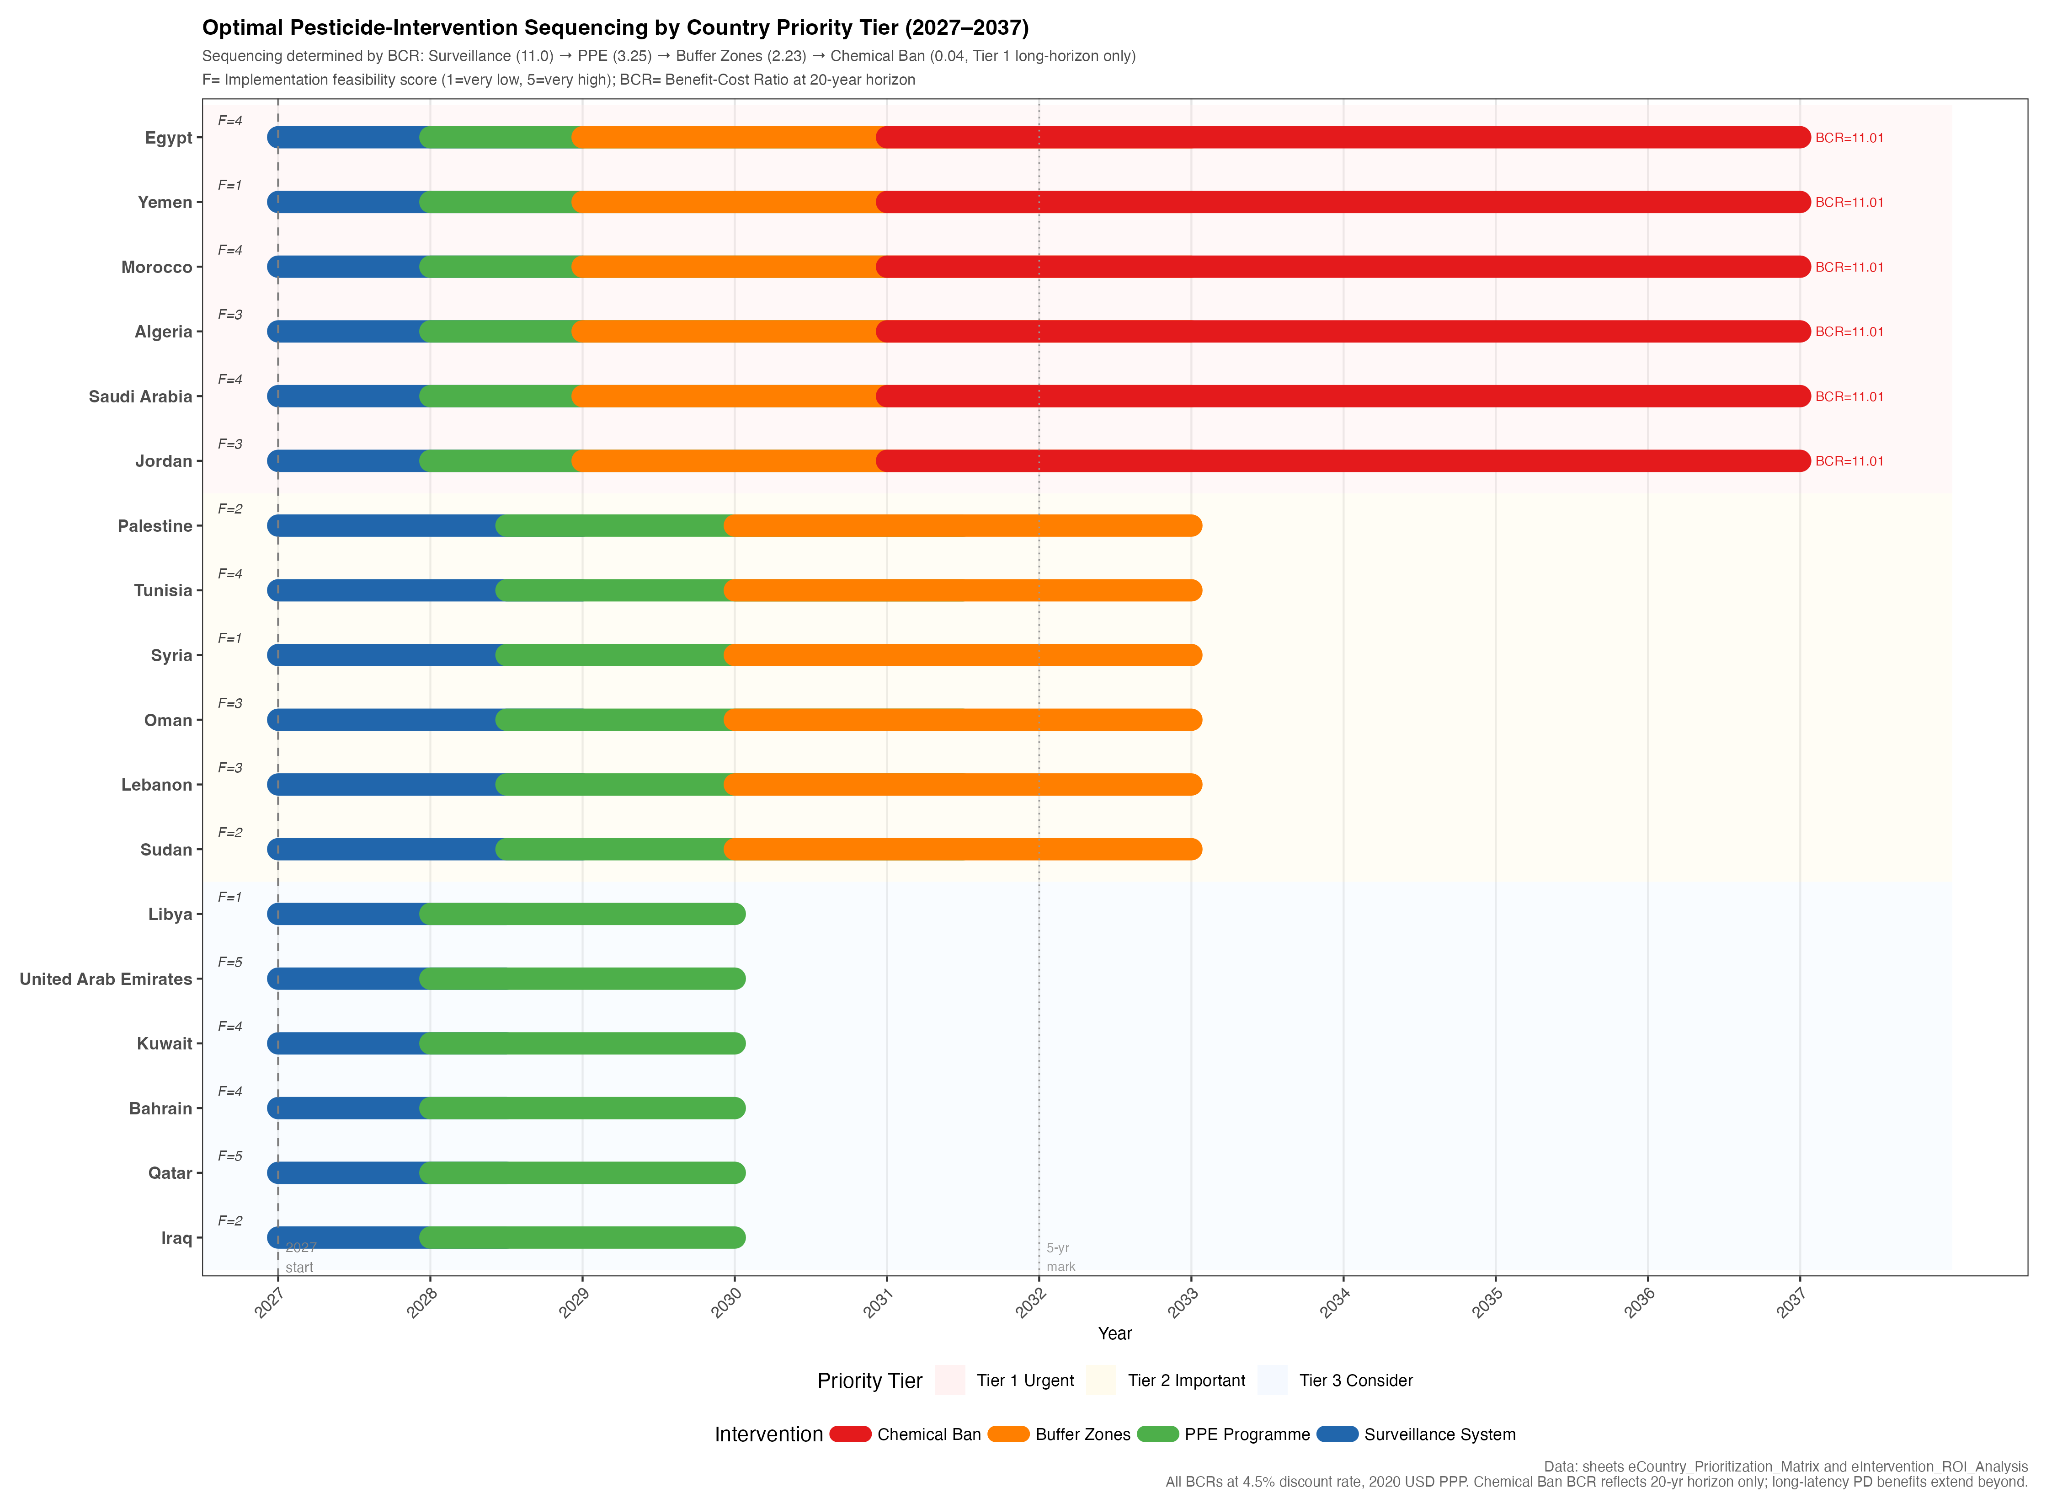
Figure S22. Optimal Pesticide-Intervention Sequencing by Country Priority Tier (2027–2037). Gantt-style chart showing recommended intervention rollout sequence for all 18 MENA countries. Countries ordered by priority rank (Egypt rank 1 at top). Colour coding: Surveillance System (blue), PPE Programme (green), Buffer Zones (orange), Chemical Ban (red). Background shading indicates priority tier (red = Tier 1 Urgent, yellow = Tier 2 Important, blue = Tier 3 Consider). F= Implementation feasibility score (1=very low, 5=very high). BCR labels shown for Tier 1 countries reflect best available ROI intervention. Sequencing is determined by BCR order: Surveillance (11.0) → PPE (3.25) → Buffer Zones (2.23) → Chemical Ban (0.04, Tier 1 long-horizon only). Chemical Ban BCR at 20-year horizon; PD latency benefits extend beyond this window.

