Supporting Information
Charge-Transfer Regulated Visible Light Driven Photocatalytic H₂ Production and CO₂ Reduction in Tetrathiafulvalene Based Coordination Polymer Gel

S1. Materials and Methods
Tetrathiafulvalene (TTF), 1,3-diaminopropane, 4′-chloro-2,2′:6′,2′′-terpyridine, Zinc nitrate (Zn(NO₃)₂.6H₂O), Ethyl-4-bromobenzoate (Br-C₆H₄COOEt), Cesium carbonate (CsCO₃), Palladium acetate, Tri-tertbutyl-phosphonium tetrafluoroborate (PtBu₃.HBF₄), Thionyl chloride (SOCl₂), Chloroplatinic acid (H₂PtCl₆.6H₂O) were purchased from Sigma-Aldrich chemical Co. Ltd. Spectroscopic grade solvents were used for all spectroscopic studies without further purification. UV-Vis absorption spectra were carried on a Perkin-Elmer lambda 900 spectrometer. ¹H-NMR spectra were recorded on a Bruker AVANCE-400 spectrometer (at 400 MHz) with chemical shifts recorded as ppm, and all spectra were calibrated against TMS. ¹³C-spectrum was recorded at 150 MHz frequency using a Varian Inova 600 MHz spectrometer. UV-Vis spectra were recorded in a Perkin-Elmer lambda 900 spectrometer. Fourier transform infrared spectra (FT-IR) were recorded by making KBr pellets using Bruker IFS 66v/S Spectro-photometer in the region 4000−400 cm⁻¹. Thermal stability of the materials was studied using Mettler Toledo TGA 850 instrument in the temperature range of 30-800°C with the heating rate of 5°C/min in N₂ atmosphere. Powder X-ray diffraction (PXRD) patterns were measured by a Bruker D8 Discover instrument using Cu Kα radiation. Atomic force microscopy (AFM) measurements were carried out with a Nasoscope model Multimode 8 Scanning Probe Microscope to analyze the morphologies of the sample surface. For this analysis, samples were dispersed in ethanol and then coated on Si wafer by a drop-casting method. The Field Emission Scanning Electron Microscopic (FE-SEM) images, elemental mapping and Energy-dispersive X-ray spectroscopy (EDAX) analysis were recorded on a Nova Nanosem 600 FEI instrument. The xerogels were dispersed in ethanol and then drop-casted onto a small piece of silicon wafer followed by gold (Au) sputtering for FE-SEM measurements. Transmission Electron Microscopy (TEM) studies were done on JEOL JEM -3010 with accelerating voltage of 300 kV. For this analysis, the xerogels were dispersed in ethanol and drop casted on a carbon copper grid. Elemental analyses were carried out using a Thermo Scientific Flash 2000 CHN analyzer. MALDI was performed on a Bruker daltonics Autoflex Speed MALDI TOF System (GT0263G201) spectrometer. High-resolution mass spectrometry was carried out using Agilent Technologies 6538 UHD Accurate-Mass Q-TOFLC/MS. Time resolved photoluminescence (TRPL) and photoluminescence (PL) studies were performed on an Edinburgh instrument (FLS 1000).

S2. Synthesis of Low Molecular Weight Gelator (LMWG) based linker (TPY-TTF):
Synthesis of TPY-TTF is described in the following three steps:
Step 1. Synthesis of 2,3,6,7-Tetra (4-carboxyphenyl) Tetrathiafulvalene [TTF(COOH)₄]: Synthesis and characterization of TTF(COOH)₄ is already reported in the literature.¹ We have followed similar procedure and characterization data was in good agreement to the literature report. Briefly, Pd(OAc)₂ (39.6 mg, 0.176 mmol), PtBu₃.HBF₄ (153.53 mg, 0.529 mmol), Cs₂CO₃ (1149.4 mg, 3.528 mmol) were placed in a 20 mL reaction flask under N₂ atmosphere. THF (5.0 mL) was added, and the reaction mixture was stirred for 10 min at reflux. Then, a solution of Tetrathiafulvalene (120 mg, 0.588 mmol) and Ethyl-4-bromobenzoate (673.46 mg, 2.94 mmol) in THF (5.0 mL) was added. The reaction mixture was heated to reflux for 15 h. The organic compound was extracted with chloroform three times. The combined organic layer was washed with brine, dried over anhydrous Na₂SO₄ and concentrated in vacuum. Chromatographic purification on silica gel using hexane-chloroform as eluent afforded tetrathiafulvalene-tetra-benzoate (Et₄TTFTB) as a red solid product (260 mg). Further, a 50 mL flask was charged with Et₄TTFTB (260 mg) and subjected to three cycles of evacuation and refilling with N₂. Next, degassed methanol (50 ml) and THF (20 ml) were added into it to generate a suspension. In a separate flask, sodium hydroxide aq. solution (6 g, 40 mL) was prepared, then degassed with N₂ and added to Et₄TTFTB solution under N₂ atmosphere. The reaction mixture was heated at 60ºC for 12 h. The reaction was then cooled to room temperature, and the solvents (THF and MeOH) were removed in a rotary evaporator under reduced pressure. Further, 1M solution of HCl was added to the reaction mixture that afforded a maroon precipitate of TTF(COOH)₄, which was collected by filtration and washed with water followed by drying under high vacuum for 12 h. Yield: 189 mg (0.276 mmol, 84 %). ¹H-NMR (400 MHz, DMSO-d₆): δ = 8.13 (d, 8H, ArH), 7.63 (d, 8H, ArH). CHN analysis for C₃₄H₂₀O₈S₄ Calc.: C, 58.65; H, 2.89; S, 18.71%. Expt.: C, 59.63; H, 2.94; S, 18.73 %. HRMS: 685.0045, Exact Mass: 684.0041
Step 2. Synthesis of 2,2′:6′,2′′-terpyridin-4´-yl-propane-1,3-diamine (TPY-NH₂):
The 2′;6′,2″-terpyridin-4′-yl-propane-1,3-diamine was synthesized by following a reported procedure.² Briefly, 4′-chloro- 2,2′:6′,2′′-terpyridine, (300 mg, 1.12 mmol) was dissolved in 1,3-diamino propane (2.16 ml). The reaction mixture was then refluxed at 120° C for 10 h. After cooling to room temperature, distilled water (25 mL) was added, which has yielded a white precipitate. The white solid was further dissolved in dichloromethane and washed twice with distilled water. The organic layer was combined and dried over anhydrous Na₂SO₄. The solvent was removed under reduced pressure to yield a solid white product. Yield: 82%. ¹H-NMR (400 MHz, CDCl₃): δ = 8.53 (d, 2H, ArH), 8.52 (d, 2H, ArH), 7.76 (t, 2H, ArH), 7.60 (s, 2H, ArH), 7.25 (t, 2H, ArH), 5.16 (t, 1H, NH), 3.41 (m, 2H, NHCH₂), 2.84 (m, 2H, CH₂), 1.77 (m, 2H,NH₂CH₂). Selected FT-IR data (KBr, cm⁻¹): 3340 (b), 2965 (m), 1610-1560 (s), 1464 (m), 1402 (m), 1261 (m), 1094-981 (s), 791 (s). CHN analysis for C₁₈H₁₉N₅ Calc.: C, 70.81; H, 6.22; N, 22.95%. Expt.: C, 70.90; H, 6.11; N, 22.83%.
Supplementary Figure 1. (a) Synthetic scheme and (b) ¹H NMR of TTF(COOH)₄ in DMSO-d_{6.}
Supplementary Figure 2. (a) Synthetic scheme and (b) ¹H NMR of TPY-NH₂ in DMSO-d_{6.}
Step 3: Synthesis of LMWG (TPY-TTF): TTF(COOH)₄ (634 mg, 1.65 mmol) was dissolved in 50 ml of dry THF and SOCl₂ (2.4 ml, 33 mmol) was added into it under inert condition. The reaction mixture was refluxed for 2 h at 65°C. Then the reaction mixture was distilled at 120°C to remove excess SOCl₂ and yielded solid precipitate of acid chloride. Next, solid ppt was dissolved in 40 ml of dry THF. Now the solution of TPY-NH₂ (2.21 g, 7.26 mmol) in 10 ml of dry THF along with triethylamine (1.25 ml, 9 mmol) was added to the solution of acid chloride dropwise at 0°C. The reaction was stirred at 0°C for 12 hr. The solid ppt was formed which was filtered and washed with chloroform and acetone to remove unreacted TPY-NH₂. The yield of isolated dark red solid precipitate was found to be 28%. ¹H NMR (400 MHz, DMSO -d₆): δ = 8.86 (d, 8H), 8.64 (broad, 4H), 7.86 (d, 8H), 7.76 (m, 8H), 7.69 (s, 8H), 7.29 (m, 8 H), 7.12 (m, 8H), 4.41 (m, 4H), 3.59 (m, 8 H), 3.44 (m, 8H), 1.94 (m, 8H). ¹³C NMR{1H} (150 MHz, DMSO -d₆): δ = 159.78, 150.02, 146.36, 138.95, 129.48, 127.20, 124.71, 121.95, 121.23, 106.59, 105.58, 59.76, 30.91, 28.09, 26.45. Selected FT-IR data (KBr, cm⁻¹): 3376 (b), 3232 (w), 3036 (s), 2930 (w), 1635 (s), 1573 (s), 1475, 1362, 1301 (w), 1102 (w), 990 (w), 849(w), 786 (s), 611(b). CHN analysis for C₁₀₆H₈₈N₂₀O₄S₄ Calc.: C, 69.81; H, 4.82; N, 15.25%; S: 6.78. Expt.: C, 69.41; H, 4.84; N, 15.27; S, 6.99. MALDI-TOF: m/z calculated for C₁₀₆H₈₈N₂₀O₄S₄: 1834.22; found: [M+H]1835.06.
Supplementary Figure 3. (a) Synthetic scheme and (b) ¹H-NMR spectrum of TPY-TTF in DMSO-d_{6.}
Supplementary Figure 4. ¹³C-NMR spectrum of TPY-TTF in DMSO-d_{6.}

Supplementary Figure 5. MALDI-TOF spectrum for TPY-TTF.

Supplementary Figure 6. FT-IR for TPY-TTF.
S3. Synthesis and characterizations of TPY-TTF-OG:
TPY-TTF (10 mg) was dissolved in a mixture of MeOH/DCM/H₂O (2:1:1 ratio) (300 μl) and sonicated for 2-3 min and then heated at 60 ºC to get a homogenous viscous solution. The mixture was cooled to room temperature and kept for 2 h which has resulted in an opaque organo gel (OG). The formation of the gel was confirmed by an inversion-test method. For various characterization, TPY-TTF OG was dried at 80°C under vacuum to form the xerogel. Selected FTIR data (KBr, cm⁻¹): 3392 (b), 3051 (s), 2945 (w), 1649 (s), 1581 (s), 1460 (s), 1362 (w), 1294-1096 (w), 976 (w), 839 (s), 786 (s), 619 (b).
Supplementary Figure 7. FT-IR for TPY-TTF OG.
Supplementary Figure 8. EDAX analysis for TPY-TTF OG.
Supplementary Figure 9. Kubelka-Munk plot for TPY-TTF OG and Zn-TPY-TTF CPG obtained by UV-visible diffused reflectance spectrum.
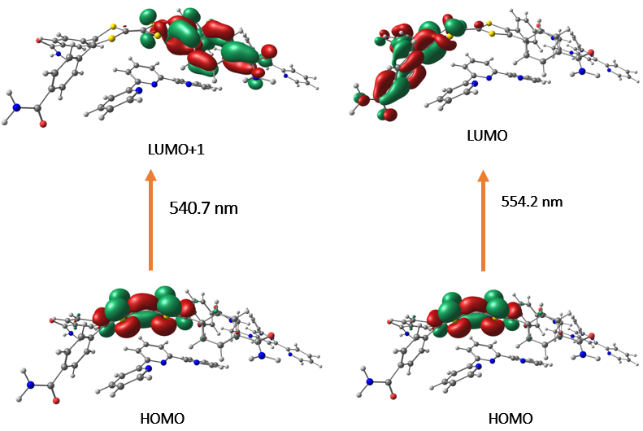
Supplementary Figure 10. Intramolecular charge transfer for TPY-TTF. (Isovalue=0.03).

S4. Synthesis and characterizations of Zn-TPY-TTF coordination polymer gel (CPG):
We have used Zn(NO₃)₂.6H₂O salt for the synthesis of Zn-TPY-TTF CPG. TPY-TTF (10 mg, 5 μmol) was taken in the 300 μl solvent mixture of MeOH/DCM/H₂O (2:1:1 ratio), and 10 μmol of Zn^{II} was added into it at 60°C. The reaction mixture was heated for a few minutes to get a viscous solution and kept for 4 h at room temperature which transformed into an opaque gel. Formation of Zn-TPY-TTF gel was confirmed by an inversion test method. Further, xerogel of Zn-TPY-TTF was synthesized by heating the gel at 80°C under vacuum for 8 h. FT-IR data for Zn-TPY-TTF (KBr, cm⁻¹): 3414 (b), 2922 (s), 2672 (s), 2490 (s), 1619 (s), 1468 (s), 1377 (w), 1233-1021 (w), 791 (s), 629 (b), 536 (b). CHN analysis for C₁₀₆H₈₈N₂₄O₁₆S₄Zn₂; Elemental Analysis: Calc.: C, 57.48; H, 4.10; N, 15.18; S, 5.79. Expt.: C, 57.34; H, 3.96; N, 15.12; S, 5.75.
Supplementary Figure 11. FT-IR for Zn-TPY-TTF CPG.
Supplementary Figure 12. EDAX analysis for Zn-TPY-TTF CPG.
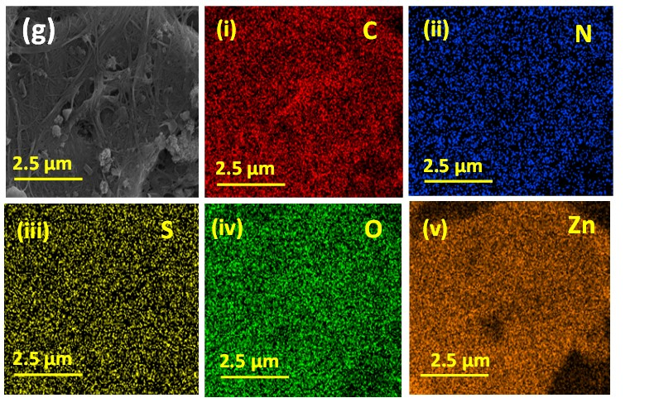
Supplementary Figure 13. Elemental mapping for Zn-TPY-TTF CPG.
Supplementary Figure 14. TGA plot for Zn-TPY-TTF CPG xerogel under N₂ atmosphere.
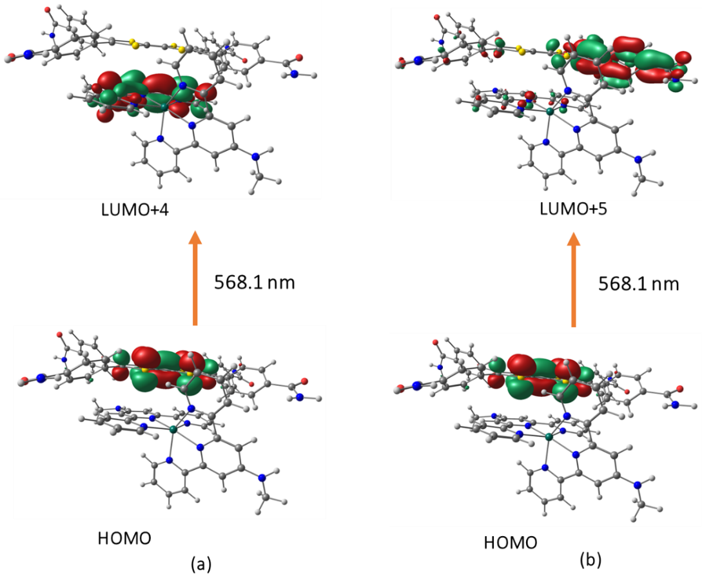
Supplementary Figure 15. (a) Intermolecular charge transfer (coefficient (c) = 0.31) at 568 nm. (b) Intramolecular charge transfer (coefficient (c) = 0.15) for Zn-TPY-TTF at 568 nm. (Isovalue = 0.03).
Table 1. Calculated CT transfer spectra (in nm) of TPY-TTF and Zn-TPY-TTF using different exchange correlation energy functional.
System | CAM-B3LYP | wB97XD
TPY-TTF | 540.7, 554.2 | 497.7, 527.0
Zn-TPY-TTF | 568.1, 588.9 | 541.0, 561.7

S5. Electrochemical characterizations:
- Mott–Schottky measurement
The energy band structure of TPY-TTF and Zn-TPY-TTF and Pt@Zn-TPY-TTF was depicted by the Mott Schottky (MS) analysis (at 1000 Hz, from -2.0 V to +2.0 V) using ITO as a working electrode (WE) in N₂-purged aqueous solution of 0.5 M Na₂SO₄ at pH=7, Pt as a counter electrode (CE) and Ag/AgCl as a reference electrode (RE). The curve was fitted by Eq. 1.³ An electrochemical ink prepared by making a dispersion of a mixture of catalyst (2.0 mg) in the solvent mixture of isopropanol (500 μl), water (500 µl) and Nafion (14 µl). Upon sonication for 20 minutes, a well-dispersed ink (3.5 μl) was drop cast over the ITO electrode and allowed to dry for 3 h under ambient condition.
1/C² = (2/ ε ε₀ A² e N_{D}) (E-E_{FB} - k_{B}T/e)- Eq.1
Where, C and A are the interfacial capacitance and area, respectively. ε is the dielectric constant of the semiconductor, and ε₀ is the permittivity of free space. k_{B} Boltzmann constant, T the absolute temperature and e is the electronic charge. N_{D} the number of donors, V the applied voltage. Therefore, a plot of 1/C² against V should yield a straight line from which V_{fb} can be determined from the intercept on the V axis.
Calculation of Conduction Band (E_{CB}) and Valance Band (E_{VB}) versus RHE (at pH=7):
The conduction band edge (CB_{Edge}) potentials for TPY-TTF and Zn-TPY-TTF was assigned based on flat band potentials and valance band (VB) position was calculated by using equation 2.
E_{VB} = E_{CB Edge} + Band Gap -Eq. 2
- For TPY-TTF- OG
E_{CB Edge (TPY-TTF)} = V_{fb}= -0.60 V
E_{VB (TPY-TTF)} = -0.60 + Band Gap _{(TPY-TTF)} = -0.60 + 2.26= 1.66 V
- Zn-TPY-TTF CPG
E_{CB Edge (Zn-TPY-TTF)} = V_{fb}= -0.54 V
E_{VB (Zn-TPY-TTF)} = -0.54 + Band Gap _{(Zn-TPY-TTF)} = -0.54 + 2.27= 1.73 V

(b) Photocurrent Measurement
The similar set up was used for photocurrent measurements as employed for Mott-Schottky analysis. Here, the photocurrent study was performed for TPY-TTF, Zn-TPY-TTF and Pt@ Zn-TPY-TTF upon consecutive light “ON–OFF” cycles for 30 s over 10 cycles.
(c) Impedance analysis
Electrochemical impedance spectroscopy (EIS) was performed in a three-electrode cell configuration with a glassy carbon electrode as the working electrode (WE), platinum as a counter electrode (CE) and Ag/AgCl as a reference electrode (RE). 0.5 M Na₂SO₄ was used as an electrolyte at pH = 7. An electrochemical ink prepared by making a dispersion of a mixture of catalyst (2.0 mg) in the solvent mixture of isopropanol (500 μl) and water (500 μl). Upon sonication for 30 minutes, a well-dispersed ink (3.5 μl) was drop cast over the GC electrode and allowed to dry for 3 h under ambient condition. EIS were recorded at -1.2 V_{RHE} applied bias from 0.1 Hz to 100 KHz (under the dark condition and visible light irradiation).

S6. Photocatalytic water reduction experiments:
Experimental set-up for photocatalytic water reduction: Photocatalytic H₂ evolution experiments were carried out in an 80 mL self-designed borosilicate glass cell containing a magnetic stir bar sealed with a small septum (picture of photocatalytic cell is given in Figure S21). For photocatalytic experiment, 1 mg catalyst was dispersed in 38 mL water containing 2 ml of triethylamine (TEA) as a sacrificial agent. The suspension was ultrasonicated to make a homogeneous dispersion. The reaction mixture was then purged with N₂ for 30 minutes to remove any traces of dissolved H₂ gas which was ensured by GC-analysis before performing the photocatalysis. The reaction mixture was irradiated with a 300 W Xe lamp (Newport) fitted with a 12 cm path length of water filter for removal of IR radiation. A visible bandpass filter (420 nm–750 nm) was used to block the UV light. The Headspace gases were sampled using Hamilton air-tight syringes by injecting 250 µL into the gas chromatograph (Agilent CN15343150). Gas Chromatography referencing was done against a standard (H₂/N₂) gas mixture with a known concentration of hydrogen for the calibration curve, where N₂ used as a carrier gas and a thermal conductivity detector (TCD) used for H₂ detection. Notably, no hydrogen evolution was observed for a mixture of water/5 Vol % TEA under visible light irradiation in the absence of a photocatalyst.

Calculation of TON
Formula; TON= Amount of product evolved (μmol) / Amount of catalyst (μmol)
- Calculation of TON for H₂ production:
- For TPY-TTF:
1 mg of TPY-TTF equivalent to 0.545 μmol and the amount of H₂ evolved was found to be 2 μmol from 1 mg of TPY-TTF in 20 h. Therefore, TON was calculated for TPY-TTF in 20 h is 3.6.
- For Zn-TPY-TTF:
The unit of Zn-TPY-TTF was calculated based on a binding ratio of TPY-TTF with Zn(NO₃)₂ in CPG (1:2). Therefore, unit formula weight= 2212.94. Then, 1 mg Zn-TPY-TTF catalyst contains 0.451 μmol. Therefore, the TON can be calculated for Zn-TPY-TTF in 20 h is 23.5.
- For Pt@Zn-TPY-TTF:
The unit of Pt@Zn-TPY-TTF was also calculated based on a binding ratio of TPY-TTF with Zn(NO₃)₂ in CPG (1:2) because of low wt% of Pt NP present on CPG. Therefore, the TON can be calculated for Pt@Zn-TPY-TTF in 11 h is 359.2.
Supplementary Figure 16. (a) Photocatalysis by Zn-TPY-TTF in xerogel and gel state and (b) stability test for Zn-TPY-TTF under visible light irradiation for water reduction. The reaction vessel was degassed by N₂ after every 6 h. (c) FE-SEM image and (d) TEM image of Zn-TPY-TTF CPG after photocatalytic water reduction.
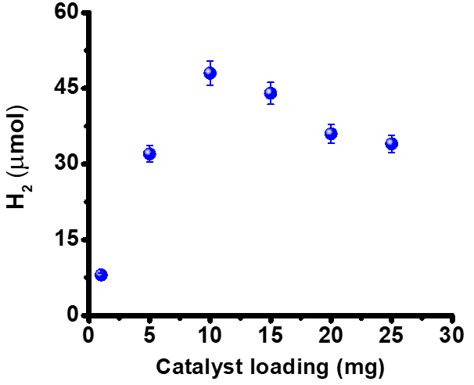
Supplementary Figure 17. Effect of Zn-TPY-TTF CPG loading (in mg) for photocatalytic water reduction under visible light irradiation for 10 h.
S7. Control experiments:
S7.1. Photocatalytic activity for structural units:
Supplementary Figure 18. TON of only triethylamine (TEA), TTF(COOH)₄, TPY-TTF OG, Zn-TPY-TTF (2:1 ratio) polymer and Zn-TPY-TTF CPG (2:1 ratio) under visible light irradiation for 6 h. (all the catalysts were dispersed in water and TEA as sacrificial agent).

S7.2. Synthesis of Zn-TPY-TTF (2:1) Polymer:
We have synthesized Zn-TPY-TTF polymer using TPY-TTF LMWG and metal salt in the ratio of 1:2. TPY-TTF (10 mg, 5 μmol) was taken in 2 ml MeOH and 500 μmol of Zn^{II} in MeOH was added TPY-TTF solution. The reaction mixture was stirred in a close vial for 2 h at 75°C which has resulted to a dark red precipitate.
Supplementary Figure 19. (a) FE-SEM image, (b) TEM of Zn-TPY-TTF polymer.
S7.3. Synthesis and characterization of Zinc-TTF-TA Coordination Polymer (Zn-CP): Zn-TTF-TA coordination polymer was prepared based on a reported procedure in the literature.⁴ In brief, TTF(COOH)₄ (100 mg, 0.146 mmol) was taken in a mixture of 12 ml dimethyl formamide (DMF) and 4 ml ethanol (EtOH). 8 ml aqueous solution of Zn(NO₃)₂.6H₂O (0.5 mmol) was added into it, and the reaction mixture was heated at 75°C for 72 h in a closed vial and resulted into brown powder. The obtained precipitate was washed with DMF and EtOH for three times. The obtained product Zn-CP was dried under vacuum at 120°C for 2 h and yield was found to be 78 mg. The thermal stability was analysed by TGA, which showed the stability upto ~398°C.
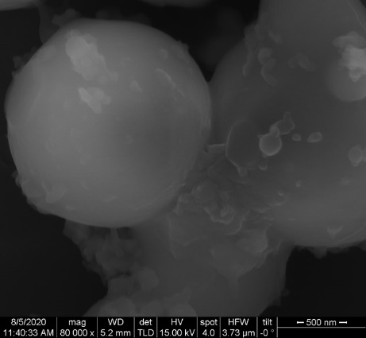
Supplementary Figure 20. FESEM image for Zn-CP.
Supplementary Figure 21. (a) EDAX and (b) elemental mapping for Zn-CP.
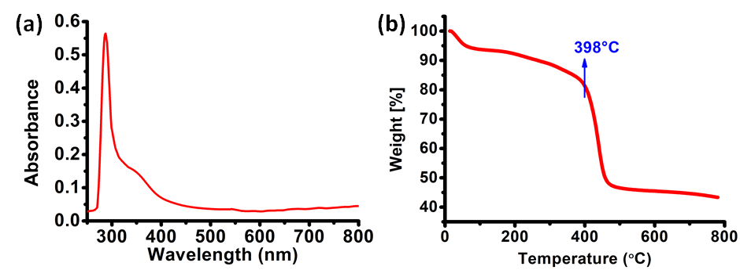
Supplementary Figure 22. (a) UV-Visible absorption spectrum for Zn-CP (thin film on quartz plate). (b) TGA plot for Zn-CP under N₂ atmosphere.
Supplementary Figure 23. PXRD for Zn-CP (as synthesized).

S8. Synthesis and characterization of Pt@Zn-TPY-TTF: In-situ platinum nanoparticles (Pt) has been stabilized in the matrix of Zn-TPY-TTF CPG using a reported procedure.⁵ Briefly, 1 mg of H₂PtCl₆·6H₂O was dispersed in 40 ml of water containing 10 mg of Zn-TPY-TTF. After continuous stirring for 1 h in a closed system, the well-dispersed solution was irradiated using 300 W xenon lamp (Newport) with a 6.0 cm long IR water filter for 2 h. Finally, the Pt nanoparticle stabilized CPG sample (Pt@Zn-TPY-TTF) was thoroughly washed with deionized (DI) water and dried under vacuum at 80°C for 12 h.
Supplementary Figure 24. (a) FE-SEM image and (b) EDAX analysis for Pt@Zn-TPY-TTF.
Supplementary Figure 25. Elemental mapping for Pt@Zn-TPY-TTF.
Supplementary Figure 26. (a) Effect of Pt@Zn-TPY-TTF loading (in mg) for photocatalytic water reduction under visible light irradiation for 10 h. (b) Stability test for Pt@Zn-TPY-TTF CPG under visible light irradiation for water reduction. The reaction vessel was degassed by N₂ after every 6 h. (c) Light On-Off experiments for visible light-driven H₂ formation during photocatalytic water reduction by Pt@Zn-TPY-TTF.
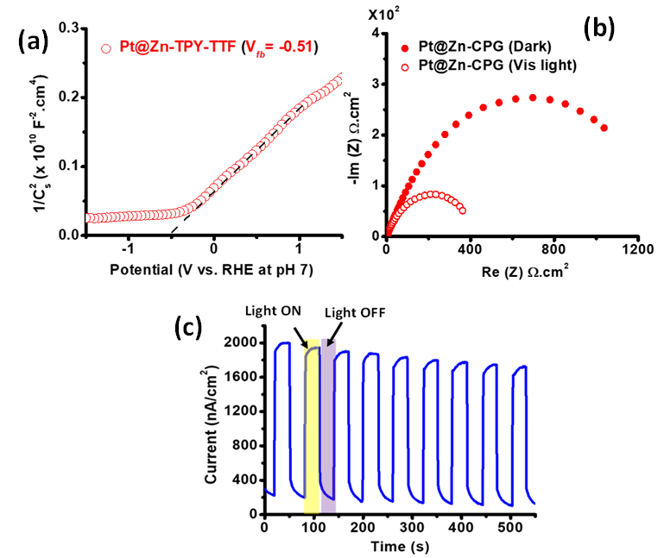
Supplementary Figure 27. (a) Mott-Schottky plot for Pt@Zn-TPY-TTF (at 1000 Hz, from -1.5 V to + 1.5 V). (b) Nyquist plots of Pt@Zn-TPY-TTF under visible light and the dark condition at -1.20 V_{RHE} applied bias (in 0.5 M Na₂SO₄). (c) Photocurrent study of Pt@Zn-TPY-TTF based on light ON-OFF cycles.

S9. Study of Time resolved photoluminescence (TRPL):
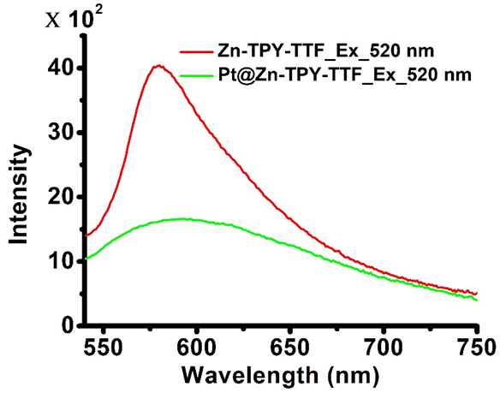
Supplementary Figure 28. PL spectra for Zn-TPY-TTF CPG and Pt@Zn-TPY-TTF CPG.
Supplementary Figure 29. TRPL decay spectra (a) For Zn-TPY-TTF. (b) For Pt@Zn-TPY-TTF.
Lifetime calculations: Lifetime data for Zn-TPY-TTF and Pt@Zn-TPY-TTF CPG were collected upon exciting at 510 nm. The average lifetime is calculated using following formula:
Average life time, τ_{avg}(ns) = (ΣA_{i}τ_{i}²/ΣA_{i}τ_{i})
Where, τ_{avg} = average lifetime in nano-seconds, ΣA_{i} = sum of percentage of all the components exist in the excited state, Στ_{i} = sum of excited state lifetime of all the component.
Table 2. Lifetime data:
Sample | 𝝉₁ | A1 | 𝝉₂ | A2 | 𝝉₃ | A3 | 𝝉_{av}
Zn-TPY-TTF | 1.95 | 53.66% | 1.95 | 42.31% | 6.01 | 4.03% | 1.95
Pt@Zn-TPY-TTF | 0.22 | 42.74% | 0.22 | 49.64% | 3.82 | 7.62% | 0.22

S10. Quantum efficiency measurements
The quantum efficiency is defined by the ratio of the effective electron used for product formation to the total input photon flux.
$$QE\%=\left[\frac{Effective electrons}{Total photons}\right]×100\%=\left[\frac{n×Y×N}{θ×T×S}\right]×100\%$$
Where n is the number of electrons used in the photocatalysis process, Y is the yield of evolved gas from the sample (mol), N is the Avogadro’s number (6.022$×$10²³ mol⁻¹), $θ$ is the photon flux, T is the irradiation time, and S is the illumination area (12.56 cm²). The photon flux was calculated at 400 nm, 450 nm, 500 nm, 550 nm, 600 nm, 650 nm, 700 nm by using separate bandpass filters with the help of power meter.
Since the reduction of a water molecule to the H₂ molecule requires two-electron (n=2). The following calculation is based on data from water photoreduction with Zn-TPY-TTF CPG for 1 h, QE% was calculated as 0.76 % at 550 nm. Meanwhile, the Q.E. of H₂ for the Pt@Zn-TPY-TTF CPG was also calculated at the various wavelength (400-700 nm), and the maximum was found at 550 nm, which was calculated to be 14.47%.
Supplementary Figure 30. Quantum efficiency for H₂ formation by Pt@Zn-TPY-TTF at a different wavelength (400 nm to 700 nm) (for this experiment 1 mg of sample was dispersed in 12 ml H₂O with TEA (0.6 ml) as sacrificial donor).

S11. Comparison table for photocatalytic H₂ evolution:
Table 3. Photocatalytic H₂ evolution activity of TPY-TTF, Zn-TPY-TTF and Pt@Zn-TPY-TTF under visible light irradiation (from 420-750 nm).

Catalyst | Reaction medium | Amount of H₂ production (mmol/g) | Irradiation Time (h) | Activity (μmol g⁻¹ h⁻¹) | TON
TPY-TTF | H₂O/TEA | 2.00 mmol/g | 20 h | 100 μmol g⁻¹ h⁻¹ | 3.6 in 20 h
Zn-TPY-TTF (1:2) CPG | H₂O/TEA | 10.60 mmol/g | 20 h | 530 μmol g⁻¹ h⁻¹ | 23.5 in 20 h
Zn-TPY-TTF Polymer | H₂O/TEA | 1.58 mmol/g | 6 h | 264 μmol g⁻¹ h⁻¹ | 3.5 in 6 h
Pt@Zn-TPY-TTF | H₂O/TEA | 162.42 mmol/g | 11 h | 14727 μmol g⁻¹ h⁻¹ | 360.1 in 11 h
Zn-TPY-TTF (1:2) CPG | H₂O | 0.92 mmol/g | 20 h | 46 μmol g⁻¹ h⁻¹ | 2.0 in 20 h
Pt@Zn-TPY-TTF CPG | H₂O | 2.93 mmol/g | 6 h | 488 μmol g⁻¹ h⁻¹ | 6.5 in 6 h

Table 4. Photocatalytic H₂ evolution activity of TPY-TTF, Zn-TPY-TTF and Pt@Zn-TPY-TTF under direct sunlight irradiation.
Catalyst | Amount of H₂ evolution (mmol/g) | Irradiation Time (h) | Activity (μmol g⁻¹ h⁻¹) | TON
Zn-TPY-TTF (1:2) CPG | 5.14 mmol/g on 15th April | 6 h (10 am to 4 pm) | 857 μmol g⁻¹ h⁻¹ | 11.9 in 6 h on 15th April 2019
Pt@Zn-TPY-TTF CPG | 72.02 mmol/g on 27th June | 6 h (10 am to 4 pm) | 12000 μmol g⁻¹ h⁻¹ | 159.7 in 6 h on 27th June

Table 5. Comparison table of the H₂ evolution of Zn-TPY-TTF and Pt@Zn-TPY-TTF with some of the reported benchmark hybrid materials under visible light irradiation.

S. No. | Catalyst | Reaction medium | activity for H₂ | QY | ref
 | Zn-TPY-TTF CPG | H₂O/ TEA | 530 μmol g⁻¹ h⁻¹ | 0.76 % at 550 nm | This work
 | Pt@Zn-TPY-TTF CPG | H₂O/ TEA | 14765 μmol g⁻¹ h⁻¹ | 14.47 % at 550 nm | This work
 | g-C₃N₄/ Pt Co-catalyst (urea-CNx) | H₂O/ MeOH | 17 nmol h⁻¹ | 17.9 % at 400 nm | ref⁶
 | NiFeSe]-hydrogenase (H₂ase)/ NiP+ CNx | H₂O/ TEOA | 155 mol (mol_{NiP})⁻¹ | 0.005 % at 465 nm | ref⁷
 | N₂-COF/ chloro(pyridine) cobaloxime co-catalyst | H₂O, acetonitrile/ TEOA | 782 μmol g⁻¹ h⁻¹ | 0.16% at 400 nm | ref⁸
 | Thiazolo[5,4-d]thiazole-COF (TpDTz)+ Ni- cluster co-catalyst | H₂O/ TEOA | 941 μmol g⁻¹ h⁻¹ | 0.2% at 400 nm | ref⁹
 | CN-ATZ-NaK/ 3wt% Pt NP | H₂O/ TEOA | 630 μmol h⁻¹ | 0.65 at 420 nm | ref¹⁰
 | FS-TEG | H₂O, MeOH/ TEA | 2.9 mmol g⁻¹ h⁻¹ | 10% at 420 nm | ref¹¹
 | dibenzo[b,d]thiophene sulfone-dibenzo[b,d]-thiophene co-polymer (P64) | H₂O, MeOH/ TEA | 6038.5 μmol g⁻¹ h⁻¹ | 20.7% at 420 nm | ref¹²
 | 27.5 wt % CdSe-loaded CdS / 1wt% Pt NP | H₂O/ Na₂S, Na₂SO₃ | 16353 μmol g⁻¹ after 4 h | NP | ref¹³
 | ZnSe Nanorods/ Ni-(BF₄)₂ co-catalyst | H₂O/ ascorbic acid | 54 mmol g_{ZnSe}⁻¹h⁻¹ | 50% at 400 nm | ref¹⁴
 | Tetraphenylethylene (TPE) Based CMP | H₂O/ MeOH/ Na₂S, Na₂SO₄ | 659.55 μmol g⁻¹ h⁻¹ | NP | ref¹⁵
 | ^{NCN}CN_{x} / NiP | Aq. K₂HPO₄/ 4-methyl benzyl alcohol | 0.061 μmol h⁻¹ | NP | ref¹⁶
 | C₃N₄ based gel (FD-CNB-G)/3 wt% Pt NP | H₂O/ TEOA | 20 μmol | NP | ref¹⁷
 | PTCDIs- C₃N₄ aggregates/ Pt NP | H₂O/ TEOA | 3.8 μmol h⁻¹ | 0.31 % at 420 nm | ref¹⁸
 | nano-TiO₂/ CdSe quantum dots/ Pt co-catalyst | H₂O /EtOH | 16.7 mmol g⁻¹ h⁻¹ | NP | ref¹⁹
 | Ir-complex (P1)/ Co(bpy)₃Cl₂ | H₂O, Acetone/ TEOA | 598 μmol | 1.02% at 420 nm | ref²⁰
 | Cu-complex | H₂O, THF/ TEA | 11.78 μmol g⁻¹ h⁻¹ | NP | ref²¹
 | PBI-F gel/ 1 mol % PVP capped Pt | H₂O/ MeOH | 3.0 μmol g⁻¹ h⁻¹ | 0.018% at 365 nm | ref²²
 | Ni (1%): TiO₂ | H₂O/ MeOH | 3390 μmol g⁻¹ h⁻¹ | 2.8 % | ref²³
(* NP=Not Produced)

S12. Photocatalytic CO₂ reduction:
Experimental set-up for the photocatalytic CO₂ reduction: The photocatalytic CO₂ reduction reaction was carried out in a similar reaction vessel as discussed above for the water reduction. Notably, a mixture of acetonitrile (MeCN) and water in 3:1 ratio was used as a solvent for the CO₂ reduction. In short, 38 ml solvent mixture (MeCN: H₂O in 3:1), 2 ml of TEA as a sacrificial electron donor and 1 mg of the catalyst was taken in a reaction flask and dispersed uniformly through sonication. The reaction vessel was sealed with a septum and then purged with CO₂ of 99.9 % purity for ~30 min in order to make CO₂ saturated atmosphere. The reaction mixture was irradiated with visible light as employed for water reduction. During the CO₂ reduction reaction, the gas in the headspace of the reaction vessel was analyzed qualitatively and quantitatively by GCMS-QP2020. During light exposure, the evolved gases in the headspace of the reaction vessel were collected by hamilton syringe and injected in GC-MS at every one-hour time-interval until product production ceased. The mass detector was used to analyze the mass of evolved products such as CO, CH₄, CH₃OH, HCOOH and CO₃²⁻. The H₂, CO, and CH₄ were detected by RT®-Msieve 5A column (45 meters, 0.32 mmID, 30 μmdf). To detect the HCOOH, Stabilwax®-DA (30 meters, 0.18 mmID, 0.18 μmdf) column was used and for Methanol, SH®-Rxi-5Sil MS (30 meters, 0.25 mmID, 0.32 μmdf) column was used in GCMS. The calibration was done by a standard gas mixture of H₂, CO, and CH₄ of different concentrations in ppm-level. Importantly, the GCMS has a detection limit of 1.0 ppm for H₂, CO, and CH₄. After the photocatalysis, the reaction mixture was filtered to remove the residual solid and the solution was further analyzed to determine the amount of HCOOH/MeOH. All described data points are the average of at least 3 experiments.
In situ Diffuse Reflectance Infrared Fourier Transform Spectroscopy (DRIFTs) measurements: The in situ DRIFTs measurements were carried out by FT-IR spectrophotometer (BRUKER, Pat. US, 034, 944) within a photoreactor. The 6 mg of photocatalyst was evenly spread over a glass disc of 1 cm diameter and placed inside the photoreactor for monitoring reaction progress of photocatalytic CO₂ reduction. Next, the vacuum was applied to remove the air inside the photoreactor and then 99.99 % CO₂ gas along with water vapour was passed for 15 minutes inside the photoreactor. At last, the visible light was irradiated on catalyst by 150 W white LED light (> 400 nm). In situ FT-IR signal was collected through MCT detector at regular time interval.

Effect on solvent composition variation:
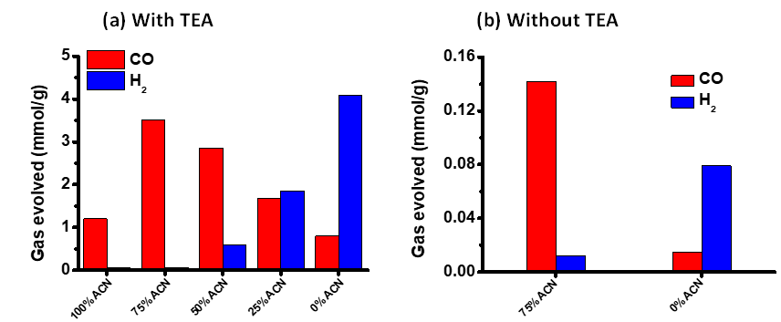
Supplementary Figure 31. Product distribution during the photocatalytic CO₂ reduction using Zn-TPY-TTF CPG in a different composition of acetonitrile/water as solvent under CO₂ atmosphere; 8 h visible light irradiation. (a) With TEA. (b) Without TEA.
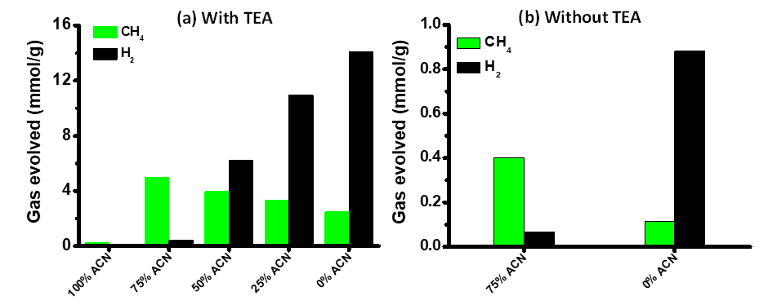
Supplementary Figure 32. Different composition of acetonitrile / water for CO₂ reduction using Pt@Zn-TPY-TTF under visible light irradiation for 12 h. (a) With TEA. (b) Without TEA.

S13. Isotopic labelling experiments
Supplementary Figure 33. (a) Chromatogram and (b) Mass analysis for ¹²CO as a product obtained from ¹²CO₂ saturated sample using Zn-TPY-TTF CPG under visible light irradiation for 1 h (for this experiment ¹²CO₂ gas was purged for 20 min in 10 ml solvent mixture of CH₃CN: H₂O containing 1 mg of catalyst and 0.5 ml TEA).

Supplementary Figure 34. (a) Chromatogram and (b) Mass analysis for ¹³CO as a product obtained from ¹³CO₂ saturated sample using Zn-TPY-TTF CPG under visible light irradiation for 1 h (for this experiment ¹³CO₂ gas was purged for 10 min in 10 ml solvent mixture of CH₃CN: H₂O containing 1 mg of catalyst and 0.5 ml TEA).

Supplementary Figure 35. (a) Chromatogram and (b) Mass analysis for ¹²CH₄ as a product obtained from ¹²CO₂ saturated sample using Pt@Zn-TPY-TTF CPG under visible light irradiation for 1 h (for this experiment ¹²CO₂ gas was purged for 10 min in 10 ml solvent mixture of CH₃CN: H₂O containing 1 mg of catalyst and 0.5 ml TEA).
Supplementary Figure. 36. (a) Chromatogram and (b) Mass analysis for ¹³CH₄ as a product obtained from ¹³CO₂ saturated sample using Pt@Zn-TPY-TTF CPG under visible light irradiation for 1 h (for this experiment ¹³CO₂ gas was purged for 10 min in 10 ml solvent mixture of CH₃CN: H₂O containing 1 mg of catalyst and 0.5 ml TEA).

S14. Quantum efficiency measurements for CO₂ reduction products:
The reduction of a CO₂ molecule to the CO molecule requires two-electron (n=2). The following calculation is based on data from CO₂ photoreduction with Zn-TPY-TTF CPG at 550 nm for 1h, Q.E. was calculated as 1.71%. Similarly, the reduction of a CO₂ molecule to the CH₄ molecule requires eight-electron (n=8). Further, we examined the quantum efficiency for CH₄ formation by Pt@Zn-TTF-TPY CPG at various wavelengths (400-700 nm) and found that the maximum efficiency at 550 nm. Therefore, the following calculation is based on data from CO₂ photoreduction with Pt@Zn-CPG for 1 h (at 550 nm) and the corresponding Q.E. was calculated as 0.81 %. Therefore, the quantum efficiency measurement confirms the charge transfer induced photocatalytic efficiency of Zn-TPY-TTF CPG, which enhances the absorption of visible light.

Supplementary Figure 37. Quantum efficiency for CH₄ formation by Pt@Zn-TPY-TTF at a different wavelength (400 nm to 700 nm) (for this experiment 1 mg of sample was dispersed in CO₂ saturated 12 ml solvent mixture of CH₃CN: H₂O in 3:1 ratio with TEA (0.6 ml) as sacrificial donor).

S15. Control experiments and stability test for CO₂ reduction:
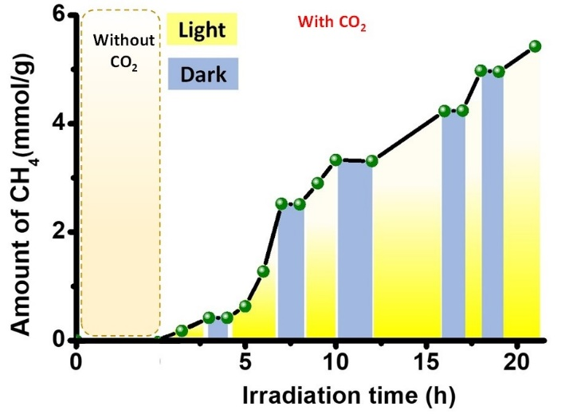
Supplementary Figure 38. Control experiment for visible light-driven CH₄ formation during photocatalytic CO₂ reduction by Pt@Zn-TPY-TTF.

Supplementary Figure 39. Stability test for Zn-TPY-TTF under visible light irradiation for CO₂ reduction to CO. The reaction vessel was degassed by N₂ after every 6 h. (b) Stability test for Pt@Zn-TPY-TTF CPG under visible light irradiation for CO₂ reduction. The reaction vessel was degassed by N₂ after every 6 h.

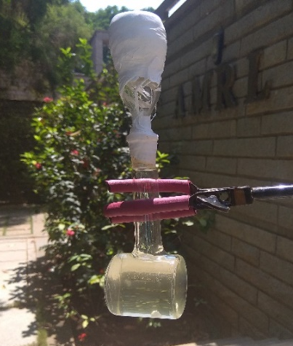
Supplementary Figure 40. A picture of an experimental set-up for sunlight driven photocatalytic experiments.
Supplementary Figure 41. (a) FESEM image, (b)TEM image and (c) EDAX analysis for Zn-TPY-TTF CPG after performing photocatalytic CO₂ reduction experiment for 1 week.
Supplementary Figure 42. (a) FESEM image, (b) TEM image and (c) EDAX analysis for Pt@Zn-TPY-TTF CPG after photocatalytic CO₂ reduction experiment for 1 week.
S16. Comparison Table for CO₂ reduction:

Table 6. Comparison table for the activity of TPY-TTF, Zn-TPY-TTF and Pt@Zn-TPY-TTF towards the photocatalytic CO₂ reduction under visible light irradiation (420-750 nm).
Catalyst | Reaction medium | Selectivity of CO₂ reduction and amount of product | Irradiation Time (h) | Activity (μmol g⁻¹ h⁻¹) | TON
TPY-TTF | CH₃CN: H₂O (3:1) + TEA | 99 % CO,  1.12 mmol/g | 11 h | 140 μmol g⁻¹ h⁻¹ | 2.1 in 11 h
Zn-TPY-TTF (1:2) | CH₃CN: H₂O (3:1) + TEA | 99 % CO,  3.51 mmol/g | 8 h | 438 μmol g⁻¹ h⁻¹ | 7.8 in  8 h
Pt@Zn-TPY-TTF | CH₃CN: H₂O (3:1) + TEA | 97 % CH₄, 8.74 mmol/g | 30 h | 292 μmol g⁻¹ h⁻¹ | 19.4 in 30 h
Zn-TPY-TTF (1:2) | CH₃CN: H₂O (3:1) | 92 % CO,  0.14 mmol/g | 8 h | 18 μmol g⁻¹ h⁻¹ | 0.3 in  12 h
Zn-TPY-TTF (1:2) | H₂O | 16 % CO,  0.01 mmol/g | 8 h | 2 μmol g⁻¹ h⁻¹ | 0.03 in  12 h
Pt@Zn-TPY-TTF | CH₃CN: H₂O (3:1) | 86 % CH₄, 0.40 mmol/g | 12 h | 33 μmol g⁻¹ h⁻¹ | 0.9 in  12 h
Pt@Zn-TPY-TTF | H₂O | 11 % CH₄, 0.11 mmol/g | 12 h | 9 μmol g⁻¹ h⁻¹ | 0.2 in  12 h

Table 7. Photocatalytic CO₂ reduction activity of TPY-TTF, Zn-TPY-TTF and Pt@Zn-TPY-TTF under sunlight irradiation.
Catalyst | Amount of CO₂ reduction Product (mmol/g) | Irradiation Time (h) | Rate (μmol g⁻¹ h⁻¹) | TON
Zn-TPY-TTF (1:2) | 1.79 mmol/g on 30th sept | 6 h | 298 μmol g⁻¹ h⁻¹ | 3.9 in 6 h
Pt@Zn-TPY-TTF | 0.96 mmol/g on 1st Oct | 6 h | 160 μmol g⁻¹ h⁻¹ | 2.1 in 6 h

Table 8. Comparison table of visible light driven photocatalytic CO₂ reduction of Zn-TPY-TTF and Pt@Zn-TPY-TTF with some of the reported benchmark hybrid materials reported in the literature.
S.N. | catalyst | reaction medium | activity for CH₄ | activity for CO | activity for H₂ | QY | ref
 | Zn-TPY_TTF | CO₂/ H₂O, CH₃CN/ TEA | -- | 438 μmol g⁻¹ h⁻¹ | -- | at 550 nm=1.71 % | This work
 | Pt@Zn-TPY-TTF | CO₂/ H₂O, CH₃CN/ TEA | 292 μmol g⁻¹ h⁻¹ | -- | >3% | at 550 nm=0.81 % | This work
 | (CoPPc)/ (mpg-CN_{x}) | CO₂/ CH₃CN/ TEOA | -- | 450 μmol g⁻¹ in 24 hr | -- | 0.03% at 400 nm | ref²⁴
 | Zn-Porphyrin-TTF-COF (TTCOF-Zn) | CO₂/ H₂O | -- | 123.3 μmol g⁻¹ >60 h | -- | 0.00027 % at 450 nm | ref²⁵
 | TRP | CO₂/ H₂O Vapour | 8.4 μmol g⁻¹ h⁻¹ | 488.8 μmol g⁻¹ h⁻¹ | -- | 6.7 % at 420 nm | ref²⁶
 | Zn_{0.4}Ca_{0.6}In₂S₄ | CO₂ | 0.877 μmol g⁻¹ h⁻¹ | 0.224 μmol g⁻¹ h⁻¹ | -- | NP | ref²⁷
 | 2,2′-bipyridine-based COF/ Ni-TpBpy, PS: Ru(bpy)₃]Cl₂ | CO₂/H₂O/ TEOA | -- | 811 μmol g⁻¹ h⁻¹ | 34 μmol g⁻¹ h⁻¹ | 0.3 % at 420 nm | ref²⁸
 | (CsPbBr3 QD/GO) composite | CO₂/ Ethyl acetate | 29.6 μmol g⁻¹ | 58.7 μmol g⁻¹ | 1.58 μmol g⁻¹ | ~ 0.022 % at 450 nm | ref²⁹
 | COF/ [Re(bpy)(CO)₃Cl] + Dye as PS: (Ir[dF(CF₃)ppy]₂(dtbpy))PF₆ | CO₂/ H₂O/ TEOA | -- | 1400 μmol g⁻¹ h⁻¹ | > 14 % | 0.5% at 420 nm | ref³⁰
 | NiCoOP NPs/ [Ru(bpy)₃]Cl₂·6H₂O | CO₂/ CH₃CN/ TEOA | -- | 16.6 μmol h⁻¹ | -- | NP | ref³¹
 | Coqpy@mpg-C₃N₄ | CH₃CN /BIH/ PhOH | -- | 1.15 μmol | 0.06 μmol | 0.25% | ref³²
 | CN-ATZ-NaK | CO₂ | 1 μmol g⁻¹ h⁻¹ | 14 μmol g⁻¹ h⁻¹ | -- | NP | ref¹⁰
 | COF-367 + PS: [Ru(bpy)₃] Cl₂ | CO₂/0.1 M KHCO₃ /ascorbic acid | -- | 10162 μmol g⁻¹ h⁻¹ | 2875 μmol g⁻¹ h⁻¹ | NP | ref³³
 | Ni-Complex PS: [Ru(bpy)₃] Cl₂ | CO₂/DMA, H₂O/ BIH | -- | 0.17 μmol min⁻¹ | 0.0473 μmol | 11.1 % at 450 nm | ref³⁴
 | 2D-triazine-COF-Re-complex | CO₂/CH₃CN/TEOA | -- | 15 mmol/g >20 h | 2% H₂ | NP | ref³⁵
 | Ni(II) complex  PS: [Ru(bpy)₃] Cl₂ | CO₂/ DMA, H₂O/ BIH | -- | ~90 μmol in >50 h | >1% H₂ | 1.42 % | ref³⁶
 | ZnPd-TiO₂ nanotube arrays (TNAs) | CO₂ | 26.83 μmol g^{–1} h^{–1} | -- | -- | NP | ref³⁷
 | g-CN/ Ni Nanoparticles | gas-phase CO₂ methanation at (150 °C) | 28 μmol g⁻¹ h⁻¹ | -- | -- | 0.01 % | ref³⁸
 | Ru₂-Mn / [MnBr(CO)₃ (BL)], [Ru(dmb)₂ (BL)]²⁺ | CO₂/DMA/ TEOA/ BIH | -- | 3.5 μmol | 0.10 μmol | 0.43% | ref³⁹
 | 1 % Pt/In₂O₃ | CO₂ + H₂ | 21.0 μmol g⁻¹ | 8.6 μmol g⁻¹ | -- | NP | ref⁴⁰
 | (HUY@S-TOH/AuPd) | CO₂/ H₂O | 126 μmol g⁻¹ | 8 μmol g⁻¹ | 37 μmol g⁻¹ | NP | ref⁴¹
 | Ni(terpy-S)₂/CdS | CO₂/ DMF/ TEOA | -- | ~1 μmol in 4 hr | ~ 0.1 μmol in 4 hr | At 400 nm=0.28 % | ref⁴²
 | Pt 3wt %/ ZnIn₂S₄@CNO | CO₂/ CH₃CN, H₂O/ TEOA | 1.18 μmol h^{‒1} | 12.69 μmol h^{‒1} | 188.4 μmol h^{‒1} | NP | ref⁴³
 | In−Fe_{n} TCPP-MOF | CO₂/ L-ascorbgyl palmitate/ ethyl acetate | -- | 3469 μmol g⁻¹ in 24 hr | -- | NP | ref⁴⁴
25. | 20% Mt/m-CN | CO₂/ H₂ | 345 μmol g⁻¹ h⁻¹ | 291 μmol g⁻¹ h⁻¹ | -- | 4.55 % for CH₄ and  0.96 for CO | ref⁴⁵
26. | Pd-g-C₃N₄/RGO | CO₂ | 6.4 μmol g⁻¹ h⁻¹ | -- | -- | NP | ref⁴⁶
27. | CsPbBr₃ /Cu-RGO | CO₂/ H₂O (g) | 12.7 | 0.46 | 0.27 | 1.1 % at 523 nm | ref⁴⁷
28. | Pt_{n}/3 DOM-SrTiO₃ | CO₂/ H₂O | 27.7 μmol g⁻¹ h⁻¹ | 4.1 μmol g⁻¹ h⁻¹ | -- | CO₂ +CH₄ = 0.66% | ref⁴⁸
29. | OD/1D Au/TiO₂ | CO₂/ H₂O | 70.34 μmol g⁻¹ h⁻¹ | 19.75 μmol g⁻¹ h⁻¹ | -- | NP | ref⁴⁹
30. | CsPbBr₃-Re(CO)₃Br(dcbpy) composite | CO₂/ Toluene/ IPA | -- | 104.37 μmol g⁻¹ in 3 hr | 5.64 μmol g⁻¹ in 3 hr | NP | ref⁵⁰
31. | Mo/g-C₃N₄ hybrids | CO₂/ H₂O | 3.8 μmol g⁻¹ h⁻¹ | -- | -- | NP | ref⁵¹
32. | CsPbBr₃/ MXene nano-composites | CO₂/ Ethyl acetate | 14.16 μmol g⁻¹ h⁻¹ | 32.15 μmol g⁻¹ h⁻¹ | -- | NP | ref⁵²
33. | UIO-66-NH₂/2.0GR hybrid | CO₂/ DMF, H₂O/ TEOA | 0.90 μmol in 4 h | 13.2 μmol in 4 h | -- | NP | ref⁵³
34. | fac-[Mn(phen)(CO)₃Br], PS: Zn-Porphyrin | CO₂/ CH₃CN, H₂O/ TEA | -- | TON 64 in 3 h | -- | NP | ref⁵⁴
35. | Co-ZIF-9 MOF/ CdS | Bipyridine, CH₃CN, H₂O/ TEOA | -- | 50.4 μmol h^{‒1} | 11.1 μmol h^{‒1} | NP | ref⁵⁵

S17. DFT calculations for CO₂ reduction mechanism:

Computational details: All electronic structure calculations are performed under the framework of Density Functional Theory. The molecular geometries are optimized using B3LYP-D3⁵⁶⁻⁶¹ exchange-correlation functional. For geometry optimization 6-31G(d,p) basis set is used for all atoms except for Zn atom, for which LANL2DZ, which uses a widely used effective core potential (ECP)- type basis set, is used.⁶²⁻⁶³ The optimized structures were subjected to harmonic vibrational frequency analysis to confirm the nature of the stationary points. Then, the optical properties were calculated using time-dependent density functional theory (TD-DFT) methods with long-range corrected CAM-B3LYP⁶⁴ exchange-correlation functional along with a different functional wB97XD⁶⁵⁻⁶⁶. For TD-DFT calculations, 6-31+G(d,p) basis set was used for all atoms except Zn, as previously mentioned. Solvent effects were taken into account using PCM model with the integral equation formalism variant.⁶⁷ However, for mechanistic studies the electronic energies are further refined with single point energy calculations using a higher basis set 6-311++g(d,p) for the lighter atoms. Transition states are further verified by intrinsic reaction coordinate (IRC) calculations by checking their connection to two respective minimum structures. All thermochemical data are obtained with the ideal gas-rigid rotor-simple harmonic oscillator approximations at 298.15 K and 1 atm. Zero point-energy corrections are included in the Gibbs free energy values along with a concentration correction for c = 1 mol/ dm3 condition in the solvent. All calculations were performed using Gaussian 16 package.⁶⁸

(a) (b)
Supplementary Figure 43. Spin-density distribution of (a) [Zn(TPY^{.-})( TPY)]¹⁺ and (b) [Zn(TPY^{.-})(MeCN)₂]¹⁺ . (Isovalue = 0.002).
Supplementary Figure 44. Optimized geometries of (a) [Zn(TPY)]²⁺, (b) [Zn(TPY^{.-})(MeCN)₂]¹⁺, (c) Transition state (TS), (d) [Zn(TPY)(MeCN)₂(CO₂⁻)]¹⁺, (e) [Zn(TPY^{.-})(MeCN)₂(CO₂⁻)], (f) [Zn(TPY.)(MeCN)₂(CO₂⁻)(CO₂], (g) [Zn(TPY)(MeCN)₂(CO)]²⁺.

Cartesian coordinates of the computed structures
B3LYP/6-31g(d,p) optimized structures are given in standard XYZ format
CO₂
Charge 0 multiplicity 1
C 0.00000000 0.00000000 0.00000000
O 0.00000000 0.00000000 1.16971600
O 0.00000000 0.00000000 -1.16971600

CO
Charge 0 multiplicity 1
C 0.00000000 0.00000000 -0.65013500
O 0.00000000 0.00000000 0.48760100

Acetonitrile
Charge 0 multiplicity 1
C 0.00000000 0.00000000 -1.18103800
H 0.00000000 1.02636400 -1.55947900
H 0.88885800 -0.51318200 -1.55947900
H -0.88885800 -0.51318200 -1.55947900
C 0.00000000 0.00000000 0.28022700
N 0.00000000 0.00000000 1.44047200

[Zn(TPY)]²⁺
Charge 2 multiplicity 1
C 4.92010678 0.04436090 0.28531671
C 4.13251273 0.89424675 1.10725492
C 2.75354560 0.86677599 0.99676345
C 2.84974656 -0.76976573 -0.67038605
C 4.23619624 -0.80436942 -0.62271431
H 4.62609896 1.55367761 1.81127430
H 4.79661204 -1.46742255 -1.26597225
C 2.03440528 -1.62153478 -1.58969604
C 2.58798126 -2.53326829 -2.49353651
C 1.74237669 -3.28333950 -3.31025461
H 3.66052643 -2.66385320 -2.56755091
C -0.11393945 -2.18091073 -2.28469964
C 0.36285479 -3.10828898 -3.20846684
H 2.15841967 -3.99468095 -4.01636968
H -1.17768352 -1.99954076 -2.15906190
H -0.32679872 -3.67256482 -3.82594681
C 1.83701218 1.71899280 1.81351200
C 2.28140082 2.63474051 2.77209374
C -0.37797250 2.27598457 2.25531600
C 1.34629207 3.38512761 3.48387353
H 3.33817863 2.76843427 2.96795699
C -0.01226969 3.20667682 3.22490337
H -1.41984414 2.09204628 2.00854703
H 1.67715985 4.09958253 4.23071720
H -0.76928926 3.77126715 3.75730883
N 0.51741231 1.55385494 1.57001410
N 2.12880733 0.04772437 0.12207743
N 0.69514785 -1.45942004 -1.49925032
N 6.26570819 0.05572426 0.37674556
H 6.68515662 0.68405531 1.04575825
C 7.16139328 -0.77431610 -0.41880312
H 8.18899697 -0.55082478 -0.13285979
H 6.97991618 -1.84010703 -0.23994780
H 7.05059351 -0.56608895 -1.48891046
C -4.92038122 0.04839704 -0.28102050
C -4.13370254 0.91404244 -1.08725104
C -2.75460268 0.88411156 -0.97921556
C -2.84890533 -0.78501468 0.65542353
C -4.23544760 -0.81809671 0.60926039
H -4.62807112 1.58747636 -1.77732594
H -4.79518878 -1.49294598 1.24072176
C -2.03252847 -1.65514511 1.55642117
C -2.58491056 -2.58678893 2.44048514
C -1.73834668 -3.35301565 3.24106031
H -3.65726822 -2.72060612 2.51137421
C 0.11653844 -2.22667957 2.23917803
C -0.35904917 -3.17405540 3.14305964
H -2.15347128 -4.07986776 3.93175089
H 1.18005341 -2.04144839 2.11726910
H 0.33135384 -3.75046857 3.74837345
C -1.83897404 1.75240118 -1.77990137
C -2.28429853 2.68550168 -2.72115215
C 0.37546129 2.31980830 -2.21113503
C -1.34993515 3.45011277 -3.41863767
H -3.34120320 2.82162766 -2.91464959
C 0.00880672 3.26829086 -3.16296489
H 1.41750229 2.13232583 -1.96780242
H -1.68151573 4.17808635 -4.15199041
H 0.76522967 3.84362903 -3.68460461
N -0.51922031 1.58393361 -1.53967064
N -2.12885044 0.04778451 -0.12176842
N -0.69346600 -1.48957434 1.46933515
N -6.26610137 0.06185793 -0.37035650
H -6.68637219 0.70470090 -1.02490672
C -7.16093057 -0.78295116 0.41046501
H -8.18875233 -0.55564315 0.12833701
H -6.97830256 -1.84517258 0.21267298
H -7.05040740 -0.59369147 1.48414249
Zn -0.00001038 0.04775450 0.00015002

[Zn(TPY^{.-})(TPY)]¹⁺
Charge 1 multiplicity 2
C 4.90542859 0.15890891 0.31130739
C 4.09179852 1.02358894 1.10241318
C 2.71570981 0.93768207 0.98805662
C 2.86352400 -0.77950819 -0.60968984
C 4.26806480 -0.74664006 -0.54915192
H 4.56282840 1.72909841 1.77648613
H 4.85492073 -1.41122728 -1.16763603
C 2.09351351 -1.68945124 -1.45627656
C 2.66704238 -2.70446930 -2.24985226
C 1.85512678 -3.52003661 -3.01934219
H 3.74044065 -2.85543485 -2.25305702
C -0.04187609 -2.32294713 -2.18125940
C 0.45998963 -3.32839769 -2.99475233
H 2.29229291 -4.30300310 -3.63085248
H -1.11040768 -2.13497099 -2.10761318
H -0.20838697 -3.94431480 -3.58509592
C 1.76900700 1.78847269 1.77185684
C 2.17725446 2.76285282 2.69014602
C -0.46555446 2.26461143 2.20696437
C 1.21336446 3.49810368 3.37716509
H 3.22893198 2.94771910 2.87176253
C -0.13804682 3.24857132 3.13666902
H -1.49785833 2.01931065 1.97208125
H 1.51581728 4.25610993 4.09290977
H -0.91696163 3.79786612 3.65361673
N 0.45836417 1.55929903 1.54549818
N 2.11772879 0.06518023 0.15461839
N 0.73272165 -1.52177902 -1.43491452
N 6.26191065 0.23988372 0.40757377
H 6.64629172 0.88932166 1.07440667
C 7.18234632 -0.61101783 -0.32145401
H 8.20363984 -0.34244036 -0.04852647
H 7.03001281 -1.67159753 -0.08252010
H 7.07375751 -0.48131438 -1.40551534
C -4.90544179 0.15879409 -0.31079099
C -4.09193495 1.02352787 -1.10196323
C -2.71582291 0.93753261 -0.98791106
C -2.86339525 -0.77981342 0.60970066
C -4.26794988 -0.74689140 0.54942705
H -4.56307148 1.72920211 -1.77578784
H -4.85471290 -1.41151406 1.16796025
C -2.09326675 -1.68984870 1.45606935
C -2.66668656 -2.70510071 2.24942864
C -1.85467729 -3.52077320 3.01870814
H -3.74006860 -2.85617939 2.25261232
C 0.04219669 -2.32332570 2.18084915
C -0.45956007 -3.32900745 2.99412780
H -2.29175976 -4.30392267 3.63004458
H 1.11070913 -2.13522869 2.10723588
H 0.20888641 -3.94500299 3.58431018
C -1.76923571 1.78835013 -1.77181900
C -2.17762377 2.76252538 -2.69026571
C 0.46525619 2.26473729 -2.20701098
C -1.21384165 3.49782781 -3.37737888
H -3.22932763 2.94716749 -2.87195564
C 0.13760616 3.24853707 -3.13683397
H 1.49759561 2.01961696 -1.97209619
H -1.51640281 4.25568072 -4.09324002
H 0.91644212 3.79788334 -3.65384581
N -0.45855743 1.55938504 -1.54544044
N -2.11771683 0.06491926 -0.15468041
N -0.73248631 -1.52205319 1.43471264
N -6.26194399 0.23991030 -0.40670696
H -6.64640555 0.88905920 -1.07377685
C -7.18225747 -0.61126449 0.32216087
H -8.20360004 -0.34249718 0.04960340
H -7.03005075 -1.67176619 0.08277964
H -7.07339650 -0.48198636 1.40624023
Zn -0.00002163 -0.05052128 -0.00003141

[Zn(TPY^{.-})(MeCN)₂]¹⁺
Charge 1 multiplicity 2
C -1.32234683 1.55141419 0.00948684
C -1.80592681 -0.77555181 0.01205647
C -2.66567117 1.86912809 0.01839098
C -3.17950140 -0.50602843 0.01531712
C -3.63374220 0.82385499 0.02422732
H -2.99964311 2.90086652 0.02670020
H -3.89183683 -1.32002662 0.01092523
C -0.22094102 2.53185750 0.00056232
C -0.40438414 3.92230670 0.00115503
C 0.69592233 4.76801557 -0.00767900
H -1.40551089 4.33711154 0.00887709
C 2.10171535 2.83083316 -0.01682499
C 1.98666139 4.21033330 -0.01706751
H 0.55896183 5.84435789 -0.00717024
H 3.07562140 2.34800716 -0.02367770
H 2.87317485 4.83434679 -0.02405766
C -1.20068831 -2.09368907 0.00576792
C -1.92621412 -3.30510997 0.01121095
C -1.26511581 -4.51650774 0.00386614
H -3.01017382 -3.28148991 0.02200022
C 0.81163451 -3.31950315 -0.01220358
C 0.15124790 -4.53068192 -0.00862830
H -1.82484691 -5.44606370 0.00809942
H 1.89854649 -3.27537062 -0.02095565
H 0.70844938 -5.46035137 -0.01465205
N -4.96888007 1.14253722 0.06253398
N 1.04122640 1.99862679 -0.00828333
N -0.90646082 0.25778003 0.00883626
N 0.18565913 -2.12175016 -0.00532222
N 2.46796280 -0.44402759 -1.65199403
N 2.45450572 -0.43895398 1.66048455
H -5.20917219 2.09989413 -0.14125815
C 2.95990572 -0.60039841 2.68872179
C 2.98913849 -0.61040427 -2.67152001
C 3.58938075 -0.80435891 3.98530749
H 4.65344661 -1.02017133 3.85363018
H 3.47802673 0.09665385 4.59528922
H 3.11264960 -1.64540538 4.49705672
C 3.63860016 -0.82047699 -3.95723124
H 4.69954024 -1.04009260 -3.80778073
H 3.16690973 -1.66110158 -4.47431608
H 3.54074277 0.07922908 -4.57144313
Zn 1.06481814 -0.18534812 -0.00184632
C -6.02371892 0.15875015 -0.08493778
H -6.00315965 -0.56094985 0.74177606
H -6.98811292 0.66830245 -0.05735702
H -5.95198487 -0.39948700 -1.02995040

TS
Charge 1 multiplicity 2
C -3.97863000 0.74020500 -0.04519800
C -3.05214700 1.80516800 0.09612400
C -1.69402700 1.54077000 0.03397200
C -2.08964700 -0.75555200 -0.27480500
C -3.46711800 -0.56595300 -0.22472900
H -3.42141700 2.81345900 0.24601400
H -4.14321100 -1.40327200 -0.32723900
C -1.42789700 -2.06999700 -0.43192700
C -2.11552300 -3.29123700 -0.46931500
C -1.40678300 -4.47528200 -0.63077700
H -3.19435300 -3.31651900 -0.37009000
C 0.61124500 -3.18772500 -0.67131700
C -0.00955900 -4.42682200 -0.74290900
H -1.93088600 -5.42489600 -0.66382400
H 1.69230700 -3.08993900 -0.72099100
H 0.57963000 -5.32700300 -0.87605800
C -0.62678800 2.56054000 0.18407800
C -0.87186800 3.90905900 0.47378400
C 1.67414600 2.96482300 0.13150900
C 0.19500700 4.79470200 0.57444600
H -1.88510300 4.26441600 0.61960400
C 1.49930100 4.31760300 0.39183000
H 2.66164700 2.52969100 0.00675000
H 0.01554400 5.84185300 0.79551700
H 2.35763600 4.97652400 0.45782400
N 0.64677800 2.10518900 0.02647400
N -1.23660400 0.28544600 -0.16884100
N -0.06715700 -2.03698300 -0.52768300
N -5.31581200 0.98692900 0.00045200
H -5.61141000 1.94257100 0.11976900
C -6.34322100 -0.02808200 -0.14269300
H -7.32102800 0.44954800 -0.07188200
H -6.27949100 -0.53337400 -1.11464300
H -6.27558600 -0.78408000 0.64953800
Zn 0.80309900 -0.08365200 -0.08245000
C 3.73800200 -0.51349000 0.47188400
O 3.67672900 -1.59705200 0.95656000
O 4.17967400 0.50121600 0.03622100
C 3.98701500 0.64518100 -3.39438500
H 4.82226500 0.73467100 -2.69000400
H 4.20904100 -0.13668600 -4.12587600
H 3.85168000 1.59526500 -3.91851800
C 2.78933800 0.30781100 -2.64311200
N 1.89396500 0.02982500 -1.95909800
C 2.30536200 -1.95967400 3.89810800
H 3.25599000 -2.21159700 3.41534900
H 1.77588000 -2.88031200 4.15827800
H 2.49897100 -1.39025900 4.81136100
C 1.51218700 -1.17022800 2.96862100
N 0.93987800 -0.54536700 2.17315700

[Zn(TPY)(MeCN)₂(CO₂⁻)]¹⁺
Charge 1 multiplicity 2
C -3.89428978 0.75340460 -0.03696335
C -2.95570988 1.80491053 -0.19224322
C -1.60099198 1.51481578 -0.17446382
C -2.01827323 -0.76101844 0.13677203
C -3.39364749 -0.56014078 0.13107430
H -3.31237104 2.82033875 -0.32067138
H -4.07621596 -1.38957763 0.24950050
C -1.37004818 -2.09905273 0.29560251
C -2.08072311 -3.28706518 0.48363394
C -1.37938115 -4.48665234 0.60596938
H -3.16270447 -3.28584768 0.53600855
C 0.65596180 -3.25358679 0.34616774
C 0.01216639 -4.47641533 0.53306571
H -1.91797880 -5.41727651 0.75435089
H 1.73619199 -3.16562101 0.26898219
H 0.59067529 -5.38930875 0.61921726
C -0.51907157 2.53591403 -0.31851127
C -0.75994250 3.89881790 -0.50956979
C 1.78512415 2.89747184 -0.33861371
C 0.32246866 4.77176225 -0.61771801
H -1.77138898 4.28132324 -0.57448081
C 1.61911412 4.26885700 -0.52793941
H 2.76289749 2.43231148 -0.24835233
H 0.15070467 5.83290862 -0.76815193
H 2.48467772 4.91741977 -0.60290998
N 0.74409622 2.06138957 -0.24334441
N -1.15747881 0.25583804 -0.01264651
N -0.01978860 -2.10351492 0.23741511
N -5.22414359 1.01492466 -0.05131993
H -5.51113927 1.97292647 -0.17731763
C -6.26429518 0.01101453 0.09995748
H -7.23571845 0.50362796 0.05105526
H -6.21965384 -0.73690637 -0.70079203
H -6.18926113 -0.50145036 1.06652125
Zn 0.93216514 -0.12497371 0.00079789
C 3.21310878 -0.54106943 0.01585374
O 3.42914669 -1.66711072 -0.42953725
O 3.80966775 0.43537432 0.46688326
C 2.88019745 -1.87998049 -3.60428330
H 3.30979838 -1.28818162 -4.41691780
H 3.65420163 -2.11623042 -2.86567572
H 2.46459917 -2.80523166 -4.01207012
C 1.85154358 -1.12143518 -2.91186007
N 1.07843915 -0.51610893 -2.29341881
C 2.10817464 0.48553011 2.92787772
C 3.32885410 0.83350359 3.63626352
H 4.14606592 0.78128597 2.90834394
H 3.26057564 1.84618570 4.04236715
H 3.51162938 0.12894154 4.45193914
N 1.17986241 0.19089334 2.29701685

[Zn(TPY^{.-})(MeCN)₂(CO₂⁻)]
Charge 0 multiplicity 1
C -3.90187301 0.30795179 0.30426171
C -3.16210527 1.49258639 0.08511704
C -1.77993054 1.42393370 -0.01622913
C -1.80171801 -0.88543238 0.30050271
C -3.18914587 -0.90368931 0.41725203
H -3.68092171 2.44282428 0.01900235
H -3.71012812 -1.83085585 0.61289768
C -0.95157369 -2.10312208 0.40402349
C -1.44597295 -3.40951217 0.34530969
C -0.54680941 -4.47220751 0.41792243
H -2.50561833 -3.59871912 0.21705690
C 1.24053845 -2.87926830 0.55773805
C 0.82031623 -4.20856788 0.52455920
H -0.90986866 -5.49466963 0.37276318
H 2.28728580 -2.57887492 0.56400313
H 1.54817823 -5.01175662 0.56852569
C -0.90169954 2.60903094 -0.23700599
C -1.36746964 3.89508243 -0.52815523
C 1.31817633 3.32566339 -0.34866507
C -0.43830198 4.91908781 -0.71212924
H -2.42841073 4.09871935 -0.62005854
C 0.92555512 4.63640769 -0.62295822
H 2.35510584 2.99039498 -0.29888012
H -0.77937010 5.92617489 -0.93342015
H 1.67221435 5.40944802 -0.76923359
N 0.41878925 2.35364620 -0.15217693
N -1.12341624 0.25285525 0.08500152
N 0.37024419 -1.86292041 0.51616088
N -5.26115730 0.35827969 0.41987163
H -5.70689812 1.24874431 0.27100259
C -6.10695062 -0.80654098 0.58371659
H -7.14887898 -0.48392990 0.61550798
H -5.99204984 -1.51636612 -0.24641147
H -5.88723713 -1.33339505 1.52084252
Zn 1.05842480 0.19287869 -0.13347657
C 3.13380025 0.12083503 -0.42665443
O 3.67448738 -1.02624830 -0.39634121
O 3.69141802 1.24109486 -0.32441022
C 2.15867754 -2.33420539 -2.80029720
H 2.63630808 -1.96770909 -3.71353517
H 2.70671731 -1.93239555 -1.92952504
H 2.20166429 -3.42755281 -2.79132336
C 0.76877013 -1.89479823 -2.75840953
N -0.33814741 -1.54420586 -2.70272232
C 2.70867711 0.47626853 2.59507743
C 4.15449417 0.31226369 2.51927810
H 4.57480284 1.17664562 1.99968152
H 4.58798691 0.18876096 3.51502847
H 4.36164604 -0.55469342 1.88140903
N 1.55150980 0.58712648 2.58950072

[Zn(TPY^{.-})(MeCN)₂(CO₂⁻)( CO₂ ) ]
Charge 0 multiplicity 1
C -2.51520140 1.11916010 -0.11374640
C -2.21157878 -1.18967936 -0.02907959
C -3.89418742 0.97961771 -0.16280147
C -3.58419401 -1.41889904 -0.07828809
C -4.46130068 -0.31599818 -0.15299847
H -4.54352026 1.84672359 -0.21044015
H -3.97422249 -2.42693344 -0.06723231
C -1.81343751 2.43896516 -0.08316738
C -2.46034807 3.67634745 -0.03155336
C -1.68462540 4.83491748 0.03880146
H -3.54204469 3.74581979 -0.03531063
C 0.28230300 3.46299579 0.01082349
C -0.29485261 4.73399553 0.06814657
H -2.16735961 5.80677985 0.08037466
H 1.35706600 3.28203999 0.05554136
H 0.33412996 5.61465846 0.13754671
C -1.19868874 -2.28281984 0.07791088
C -1.52173647 -3.62467339 0.29626788
C -0.48822736 -4.55497121 0.41053731
H -2.55278032 -3.94365260 0.39463764
C 1.07885957 -2.76900949 0.09889349
C 0.83385755 -4.12663676 0.31215543
H -0.71824986 -5.60180686 0.58473965
H 2.07728900 -2.34135273 0.03131603
H 1.66232843 -4.81997696 0.40640457
N -5.81254302 -0.47452567 -0.21244029
N -0.47054891 2.36049716 -0.07414143
N -1.70013063 0.04962660 -0.06169160
N 0.08283915 -1.88629743 -0.02035415
N 0.78148801 0.01343599 -2.52392321
N 0.39724473 -0.44878327 2.78626527
H -6.37841194 0.35745763 -0.25449663
C 2.46120981 0.72519678 0.13740089
O 3.00365977 1.79364066 0.43516972
O 3.15648294 -0.40166036 -0.08424437
C 1.51291529 -0.19188212 2.99345560
C 1.85944387 -0.14551910 -2.93096076
C 2.91170120 0.15201436 3.21303049
H 3.57145650 -0.44589672 2.56763790
H 3.06867756 1.19204181 2.91400828
H 3.17658240 0.01299468 4.26488895
C 3.22983495 -0.32043745 -3.37675867
H 3.91318623 -0.23436754 -2.50616615
H 3.35096110 -1.30776047 -3.83201568
H 3.48162692 0.44747677 -4.11383516
C 4.77565459 -0.36385009 0.02353201
O 5.26245901 -0.16003047 -1.08159003
O 5.14012486 -0.62746663 1.15688971
Zn 0.46738753 0.31061885 -0.16475473
C -6.48743753 -1.75763882 -0.19216527
H -6.27312688 -2.31331799 0.72966100
H -7.56406558 -1.58967099 -0.24500733
H -6.19710322 -2.38002566 -1.04801760

[Zn(TPY)(MeCN)₂(CO)]²⁺
Charge 2 multiplicity 1
C 3.56310497 1.13874230 -0.00061575
C 2.50125673 2.08601379 -0.00056500
C 1.19228894 1.64024258 -0.00031333
C 1.87923326 -0.59974119 -0.00008493
C 3.21843844 -0.23985992 -0.00035919
H 2.73700089 3.14357480 -0.00077577
H 3.99698486 -0.98908506 -0.00044189
C 1.38717649 -2.01186471 0.00021024
C 2.23936974 -3.11898258 0.00053946
C 1.69810476 -4.40407396 0.00083185
H 3.31447373 -2.98928617 0.00059524
C -0.47559664 -3.41222001 0.00042662
C 0.31272727 -4.55960662 0.00076165
H 2.35169159 -5.27037961 0.00112157
H -1.55972730 -3.47970275 0.00034417
H -0.14889952 -5.54047394 0.00098639
C -0.00713008 2.53210098 -0.00040924
C 0.07622224 3.92688057 -0.00050730
C -2.33493589 2.64489781 -0.00078148
C -1.09314802 4.68607871 -0.00077170
H 1.03863590 4.42342107 -0.00036975
C -2.32699690 4.03671752 -0.00094938
H -3.26982606 2.09184333 -0.00091573
H -1.03885147 5.76992065 -0.00085771
H -3.25973793 4.58915141 -0.00122918
N -1.21331964 1.90871498 -0.00049183
N 0.90202607 0.32365798 -0.00006768
N 0.03899285 -2.17352246 0.00017485
N 4.84579817 1.55049788 -0.00091422
H 5.01954778 2.54482996 -0.00109739
C 6.00642462 0.66741521 -0.00112606
H 6.90838856 1.27891118 -0.00142664
H 6.02246329 0.03319382 0.89214626
H 6.02199031 0.03300673 -0.89427330
Zn -1.07794533 -0.28258790 0.00011345
C -3.54852127 -1.04246714 0.00103689
C -1.90087444 -0.52937797 4.74273177
H -2.17866425 0.45966622 5.11897013
H -2.70011301 -1.23933095 4.97584099
H -0.97841741 -0.85432899 5.23303342
C -1.69831913 -0.47001722 3.30257256
N -1.53978590 -0.42358928 2.15632725
C -1.70019496 -0.47244917 -3.30178423
C -1.90348225 -0.53330558 -4.74177415
H -1.70273734 0.44621981 -5.18578001
H -1.22660266 -1.27244286 -5.18042809
H -2.93685496 -0.82026053 -4.95855074
N -1.54109164 -0.42486843 -2.15566586
O -4.62895147 -1.37472324 0.00121889

S18. References
1. Mitamura, Y., Yorimitsu, H., Oshima, K. & Osuka, A. Straightforward Access to Aryl-Substituted Tetrathiafulvalenes by Palladium-Catalysed Direct C–H Arylation and Their Photophysical and Electrochemical Properties. Chem. Sci. 2, 2017-2021 (2011).
2. Sutar, P., Suresh, V. M. & Maji, T. K. Tunable Emission in Lanthanide Coordination Polymer Gels Based on A Rationally Designed Blue Emissive Gelator. Chem. Commun. 51, 9876-9879 (2015).
3. Gelderman, K., Lee, L. & Donne, S. W. Flat-Band Potential of a Semiconductor: Using the Mott–Schottky Equation. J. Chem. Edu. 84, 685-688 (2007).
4. Narayan, T. C., Miyakai, T., Seki, S. & Dinca, M. High Charge Mobility in a Tetrathiafulvalene Based Microporous Metal−Organic Framework. J. Am. Chem. Soc. 134, 12932−12935 (2012).
5. Razzaq, A., Kang, A. S. T. H., Grimes, C. A., Yu, J. S. & In, S. Efficient Solar Light Photoreduction of CO₂ to Hydrocarbon Fuels via Magnesiothermally Reduced TiO₂ Photocatalyst. Appl. Catal. B: Environ. 215, 28-35 (2017).
6. Lau, V. W. et al. Urea-Modified Carbon Nitrides: Enhancing Photocatalytic Hydrogen Evolution by Rational Defect Engineering. Adv. Energy Mater. 7, 1602251-1602266 (2017).
7. Caputo, C. A. et al. Photocatalytic Hydrogen Production using Polymeric Carbon Nitride with a Hydrogenase and a Bioinspired Synthetic Ni Catalyst. Angew. Chem. Int. Ed. 53, 11538 –11542 (2014).
8. Banerjee, T. et al. Single-Site Photocatalytic H₂ Evolution from Covalent Organic Frameworks with Molecular Cobaloxime Co-Catalysts. J. Am. Chem. Soc. 139, 16228-16234 (2017).
9. Biswal, B. P. et al. Sustained Solar H₂ Evolution from a Thiazolo[5,4‑d]thiazole-Bridged Covalent Organic Framework and Nickel-Thiolate Cluster in Water. J. Am. Chem. Soc. 141, 11082-11092 (2019).
10. Zhang, G. et al. Tailoring the Grain Boundary Chemistry of Polymeric Carbon Nitride for Enhanced Solar Hydrogen Production and CO₂ Reduction. Angew. Chem. Int. Ed. 58, 3433 –3437 (2019).
11. Woods, D. J. et al. Side-Chain Tuning in Conjugated Polymer Photocatalysts for Improved Hydrogen Production from Water. Energy Environ. Sci. DOI: 10.1039/d0ee01213k (2020).
12. Bai, Y. et al. Accelerated Discovery of Organic Polymer Photocatalysts for Hydrogen Evolution from Water through the Integration of Experiment and Theory. J. Am. Chem. Soc. 141, 9063−9071 (2019).
13. Bera, R., Dutta, A., Kundu, S., Polshettiwar, V. & Patra, A. Design of a CdS/CdSe Heterostructure for Efficient H₂ Generation and Photovoltaic Applications. J. Phys. Chem. C 122, 12158−12167 (2018).
14. Kuehnel, M. F. et al. ZnSe Nanorods as Visible-Light Absorbers for Photocatalytic and Photoelectrochemical H₂ Evolution in Water. Angew. Chem. Int. Ed. 58, 5059 –5063 (2019).
15. Mothika, V. S. et al. Regulating Charge-Transfer in Conjugated Microporous Polymers for Photocatalytic Hydrogen Evolution. Chem. Eur. J. 25, 3867 – 3874 (2019).
16. Yang, W. et al. Electron Accumulation Induces Efficiency Bottleneck for Hydrogen Production in Carbon Nitride Photocatalysts. J. Am. Chem. Soc. 141, 11219-11229 (2019).
17. Sun, J., Schmidt, B. V. K. J., Wang, X. & Shalom, M. Self-Standing Carbon Nitride-Based Hydrogels with High Photocatalytic Activity. ACS Appl. Mater. Interfaces 9, 2029−2034 (2017).
18. Chena, S. et al. Enhancement of Visible-Light-Driven Photocatalytic H₂ Evolution From Water Over g-C₃N₄ Through Combination with Perylene Diimide Aggregates. Appl. Catal., A 498, 63–68 (2015).
19. Kundu, S. & Polshettiwar, V. Hydrothermal Crystallization of Nano-Titanium Dioxide for Enhanced Photocatalytic Hydrogen Generation. ChemPhotoChem 2, 796 –800 (2018).
20. Cai, J. G., Yu, Z. T., Yuan, Y. J., Li, F. & Zou, Z. G. Dinuclear Iridium(III) Complexes Containing Bibenzimidazole and Their Application to Water Photoreduction. ACS Catal. 4, 1953-1963 (2014).
21. Mej, E. et al. A Noble-Metal-Free System for Photocatalytic Hydrogen Production from Water. Chem. Eur. J. 19, 15972 – 15978 (2013).
22. Nolan, M. C. et al. pH Dependent Photocatalytic Hydrogen Evolution by Self-Assembled Perylene Bisimides. J. Mater. Chem. A 5, 7555-7563 (2017).
23. Montoya, A. T. & Gillan, E. G. Enhanced Photocatalytic Hydrogen Evolution from Transition-Metal Surface-Modified TiO₂. ACS Omega 3, 2947−2955 (2018).
24. Roy, S. & Reisner, E. Visible-Light-Driven CO₂ Reduction by Mesoporous Carbon Nitride Modified with Polymeric Cobalt Phthalocyanine. Angew. Chem. Int. Ed. 58, 12180–12184 (2019).
25. Lu, M. et al. Rational Crystalline Covalent Organic Frameworks Design for Efficient CO₂ Photoreduction with H₂O. Angew. Chem. Int. Ed. 58, 12392 –12397 (2019).
26. Jiang, Z. et al. Nature-based catalyst for visible-light-driven photocatalytic CO2 reduction. Energy Environ. Sci. 11, 2382 (2018).
27. Zeng, C. et al. Fabrication of Heterogeneous-Phase Solid-Solution Promoting Band Structure and Charge Separation for Enhancing Photocatalytic CO₂ Reduction: A Case of Zn_{X}Ca_{1−X}In₂S₄. ACS Appl. Mater. Interfaces 9, 27773−27783 (2017).
28. Zhong, W. et al. A Covalent Organic Framework Bearing Single Ni Sites as a Synergistic Photocatalyst for Selective Photoreduction of CO₂ to CO. J. Am. Chem. Soc. 141, 7615−7621 (2019).
29. Xu, Y. F. et al. A CsPbBr₃ Perovskite Quantum Dot/Graphene Oxide Composite for Photocatalytic CO₂ Reduction. J. Am. Chem. Soc. 139, 5660-5663 (2017).
30. Fu, Z. et al. A Stable Covalent Organic Framework for Photocatalytic Carbon Dioxide Reduction. Chem. Sci. 11, 543-550 (2020).
31. Wang, Y., Wang, S. & Lou, X. W. D. Dispersed Nickel Cobalt Oxyphosphide Nanoparticles Confined in Multichannel Hollow Carbon Fibers for Photocatalytic CO₂ Reduction. Angew. Chem. Int. Ed. 58, 17236 –17240 (2019).
32. Ma, B. et al. Efficient Visible-Light-Driven CO₂ Reduction by a Cobalt Molecular Catalyst Covalently Linked to Mesoporous Carbon Nitride. J. Am. Chem. Soc. 142, 6188−6195 (2020).
33. Liu, W. et al. A Scalable General Synthetic Approach toward Ultrathin Imine-Linked Two-Dimensional Covalent Organic Framework Nanosheets for Photocatalytic CO₂ Reduction. J. Am. Chem. Soc. 141, 17431−17440 (2019).
34. Hong, D. et al. Efficient Photocatalytic CO₂ Reduction by a Ni(II) Complex Having Pyridine Pendants through Capturing a Mg²⁺ Ion as a Lewis-Acid Cocatalyst. J. Am. Chem. Soc. 141, 20309−20317 (2019).
35. Yang, S. et al. 2D Covalent Organic Frameworks as Intrinsic Photocatalysts for Visible Light-Driven CO₂ Reduction. J. Am. Chem. Soc. 140, 14614−14618 (2018).
36. Hong, D., Tsukakoshi, Y., Kotani, H., Ishizuka, T. & Kojima, T. Visible-Light-Driven Photocatalytic CO₂ Reduction by a Ni(II) Complex Bearing a Bioinspired Tetradentate Ligand for Selective CO Production. J. Am. Chem. Soc. 139, 6538−6541 (2017).
37. Kar, P. et al. Enhanced CH₄ yield by photocatalytic CO₂ reduction using TiO₂ nanotube arrays grafted with Au, Ru, and ZnPd nanoparticles. Nano Res. 9, 3478–3493 (2016).
38. Barrio, J., Mateo, D., Albero, J., Garcia, H. & Shalom, M. A Heterogeneous Carbon Nitride–Nickel Photocatalyst for Efficient Low-Temperature CO₂ Methanation. Adv. Energy Mater. 9, 1902738-1902745 (2019).
39. Fabry, D. C. et al. A Ru(II)−Mn(I) Supramolecular Photocatalyst for CO₂ Reduction. Organometallics 39, 1511-1518 (2020).
40. Wang, Y., Zhao, J., Li, Y. & Wang, C. Selective Photocatalytic CO₂ Reduction to CH₄ over Pt/In₂O₃: Significant Role of Hydrogen Adatom. Appl. Catal. B: Environ. 226, 544–553 (2018).
41. Ziarati, A., Badiei, A., Luque, R., Dadras, M. & Burgi, T. Visible Light CO₂ Reduction to CH₄ Using Hierarchical Yolk@shell TiO_{2−x}H_{x} Modified with Plasmonic Au−Pd Nanoparticles. ACS Sustainable Chem. Eng. 8, 3689−3696 (2020).
42. Kuehnel, M. F., Orchard, K. L., Dalle, K. E. & Reisner, E. Selective Photocatalytic CO₂ Reduction in Water through Anchoring of a Molecular Ni Catalyst on CdS Nanocrystals. J. Am. Chem. Soc. 139, 7217−7223 (2017).
43. Zhu, K. et al. Fabrication of Hierarchical ZnIn₂S₄@CNO Nanosheets for Photocatalytic Hydrogen Production and CO₂ Photoreduction. Chinese. J. Catal. 41, 454–463 (2020).
44. Wang, S. S. et al. Encapsulation of Single Iron Sites in a Metal−Porphyrin Framework for High-Performance Photocatalytic CO₂ Reduction. Inorg. Chem. 59, 6301−6307 (2020).
45. Tahir, B. et al. 2D/2D Mt/m-CN Composite with Enriched Interface Charge Transfer for Boosting Photocatalytic CO₂ Hydrogenation by H₂ to CH₄ Under Visible Light. Appl. Surf. Sci. 520, 146296-146309 (2020).
46. Zhang, R., Huang, Z., Li, C., Zuo, Y. & Zhou, Y. Monolithic g-C₃N₄/reduced graphene oxide aerogel with in situ embedding of Pd nanoparticles for hydrogenation of CO₂ to CH₄. Appl. Surf. Sci. 475, 953-960 (2019).
47. Kumar, S., Regue, M., Isaacs, M. A., Freeman, E. & Eslava, S. All-Inorganic CsPbBr₃ Nanocrystals: Gram-Scale Mechanochemical Synthesis and Selective Photocatalytic CO₂ Reduction to Methane. ACS Appl. Energy Mater. 3, 4509-4522 (2020).
48. Wu, X. et al. Multifunctional photocatalysts of Pt-decorated 3DOM perovskite-type SrTiO₃ with enhanced CO₂ adsorption and photoelectron enrichment for selective CO₂ reduction with H₂O to CH₄. J. Catal. 377, 309–321 (2019).
49. Wang, R., Shen, J., Sun, K., Tang, H. & Liu, Q. Enhancement in Photocatalytic Activity of CO₂ Reduction to CH₄ by 0D/2D Au/TiO₂ Plasmon Heterojunction. Appl. Sur. Sci. 493, 1142–1149 (2019).
50. Kong, Z. C. et al. Immobilizing Re(CO)₃Br(dcbpy) Complex on CsPbBr₃ Nanocrystal for Boosted Charge Separation and Photocatalytic CO₂ Reduction. Sol. RRL 4, 1900365-1900372 (2020).
51. Huang, S. et al. Non-Precious Molybdenum Nanospheres as a Novel Cocatalyst for Fullspectrum-Driven Photocatalytic CO₂ Reforming to CH₄. J. Hazard. Mater. 393, 122324-122331 (2020).
52. Pan, A. et al. CsPbBr₃ Perovskite Nanocrystal Grown on MXene Nanosheets for Enhanced Photoelectric Detection and Photocatalytic CO₂ Reduction. J. Phys. Chem. Lett. 10, 6590−6597 (2019).
53. Wang, X., Zhao, X., Zhang, D., Li, G. & Li, H. Microwave Irradiation Induced UIO-66-NH₂ Anchored on Graphene with High Activity for Photocatalytic Reduction of CO₂. Appl. Catal. B: Environ. 228, 47-53 (2018).
54. Zhang, J. X., Hu, C. Y., Wang, W., Wang, H. & Bian, Z. Y. Visible light driven reduction of CO₂ catalyzed by an abundantmanganese catalyst with zinc porphyrin photosensitizer. Applied Catalysis A: General 522, 145-151 (2016).
55. Wang, S. & Wang, X. Photocatalytic CO₂ Reduction by CdS Promoted with a Zeolitic Imidazolate Framework. Appl. Catal. B: Environ. 162, 494–500 (2015).
56. Miehlich, B.; Savin, A.; Stoll H.; Preuss, H., Results Obtained with the Correlation Energy Density Functionals of Becke and Lee, Yang and Parr. Chem. Phys. Lett. 157, 200-206 (1989).
57. Grimme, S.; Antony, J.; Ehrlich S.; Krieg, H., A Consistent and Accurate ab Initio Parametrization of Density Functional Dispersion Correction (DFT-D) for the 94 Elements H-Pu. J. Chem. Phys. 132, 154104 (1-19) (2010).
58. Grimme, S., Accurate Description of Van der Waals Complexes by Density Functional Theory Including Empirical Corrections. J. Comput. Chem. 25, 1463-1476 (2004).
59. Grimme, S. Semiempirical GGA‐Type Density Functional Constructed with a Long‐Range Dispersion Correction. J. Comput. Chem. 27, 1787-1799 (2006).
60. Becke, A. D.;A new mixing of Hartree–Fock and local density‐functional theories. J. Chem. Phys. 98, 1372 (1993).
61. Lee, C.; Yang, W.; Parr, R. G.; Density-functional exchange-energy approximation with correct asymptotic behavior. Phys. Rev. B. 37, 785-789 (1988).
62. Hay, P. J.; Wadt, W. R., Ab Initio Effective Core Potentials for Molecular Calculations. Potentials for the Transition Metal Atoms Sc to Hg. J. Chem. Phys. 82, 270 (1985).
63. Wadt, W. R.; Hay, P. J., Ab Initio Effective Core Potentials for Molecular Calculations. Potentials for Main Group Elements Na to Bi. J. Chem. Phys. 82, 284 (1985).
64. Yanai, T.; Tew, D. P.; Handy, N. C., A New Hybrid Exchange–Correlation Functional using the Coulomb-Attenuating Method (CAM-B3LYP). Chem. Phys. Lett. 51, 393 (2004).
65. Chai, J.-D.; Head-Gordon, M., Systematic Optimization of Long-Range Corrected Hybrid Density Functionals. J. Chem. Phys. 128, 084106 (2008).
66. Chai, J.-D.; Head-Gordon, M., Long-Range Corrected Hybrid Density Functionals with Damped Atom–Atom Dispersion Corrections. Phys. Chem. Chem. Phys. 10, 6615 (2008).
67. Scalmani, G.; Frisch, M. J., Continuous Surface Charge Polarizable Continuum Models of Solvation. I. General Formalism. J. Chem. Phys. 132, 114110 (2010).
68. Frisch, M. J.; Trucks, G. W.; Schlegel, H. B.; Scuseria, G. E.; Robb, M. A.; Cheeseman, J. R.; Scalmani, G.; Barone, V.; Petersson, G. A.; Nakatsuji, H.; Li, X.; Caricato, M.; Marenich, A. V.; Bloino, J.; Janesko, B. G.; Gomperts, R.; Mennucci, B.; Hratchian, H. P.; Ortiz, J. V.; Izmaylov, A. F.; Williams, J. L.; Ding, F.; Lipparini, F.; Egidi, F.; Goings, J.; Peng, B.; Peltrone, A.; Henderson, T.; Ranasinghe, D.; Zakrzewski, V. G.; Gao, J.; Rega, N.; Zheng, G.; Liang, W.; Hada, M.; Ehara, M.; Toyota, K.; Fukuda, R.; Hasegawa, J.; Ishida, M.; Nakajima, T.; Honda, Y.; Kitao, O.; Nakai, H.; Vreven, T.; Throssell K.; Montgomery Jr, J. A.; Peralta, J. E.; Ogliaro, F.; Bearpark, M. J.; Heyd, J. J.; Brothers, E. N.; Kudin, K. N.; Staroverov, V. N.; Keith, T. A.; Kobayashi, R.; Normand, J.; Raghavachari, K.; Rendell, A. P.; Burant, J. C.; Iyengar, S. S.; Tomasi, J.; Cossi, M.; Millam, J. M.; Klene, M.; Adamo, C.; Cammi, R.; Ochterski, J. W.; Martin, R. L.; Morokuma, K.; Farkas, O.; Foresman, J. B.; Fox, D. J.; Gaussian 16, Revision A. 03, Gaussian. Inc., Wallingford CT, (2016).

