Supplementary File
Online only figures
Online Fig 1: Effect of PCV against IPD among HIV-infected Children based on Pre-post studies
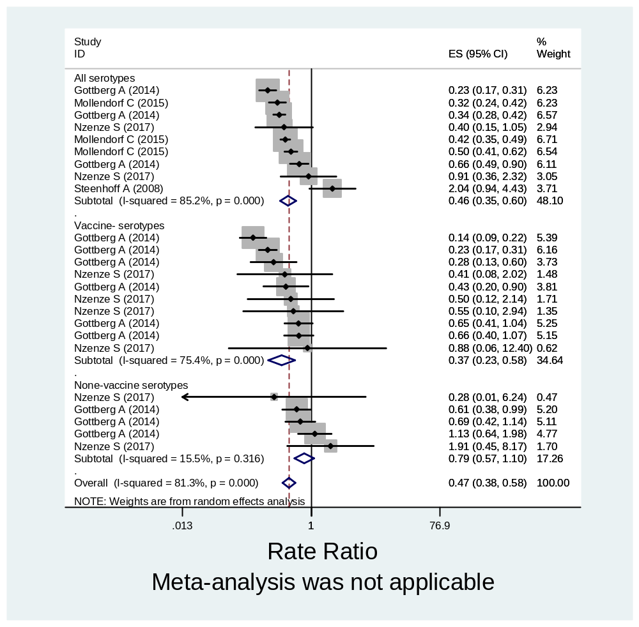

Online Fig 2: Effect of PCV against IPD among HIV-uninfected Children based on Pre-post studies
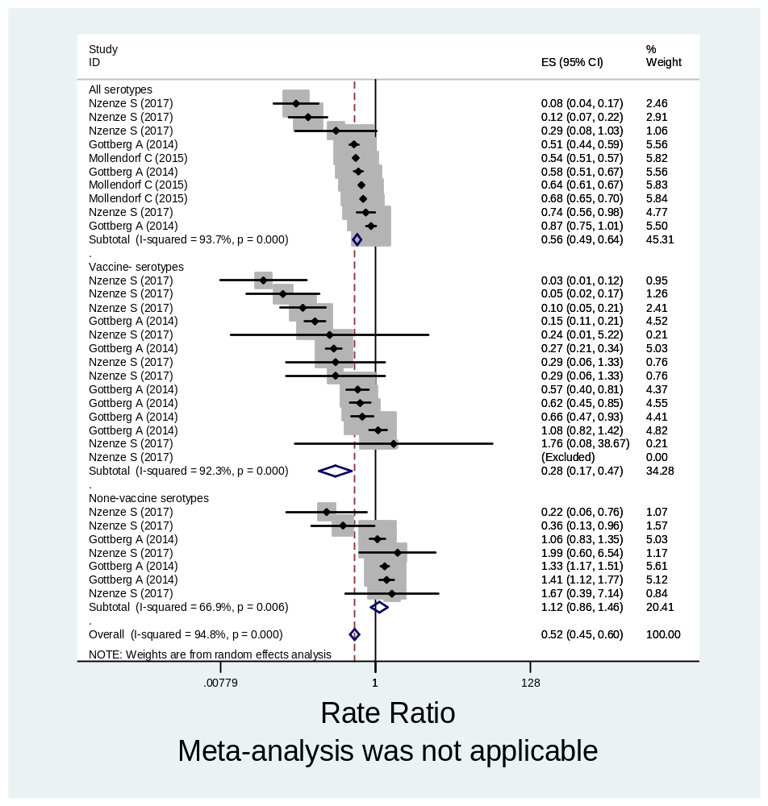

Online Fig 3: Effect of PCV against IPD among HIV-infected Children in pre-post studies according to age groups

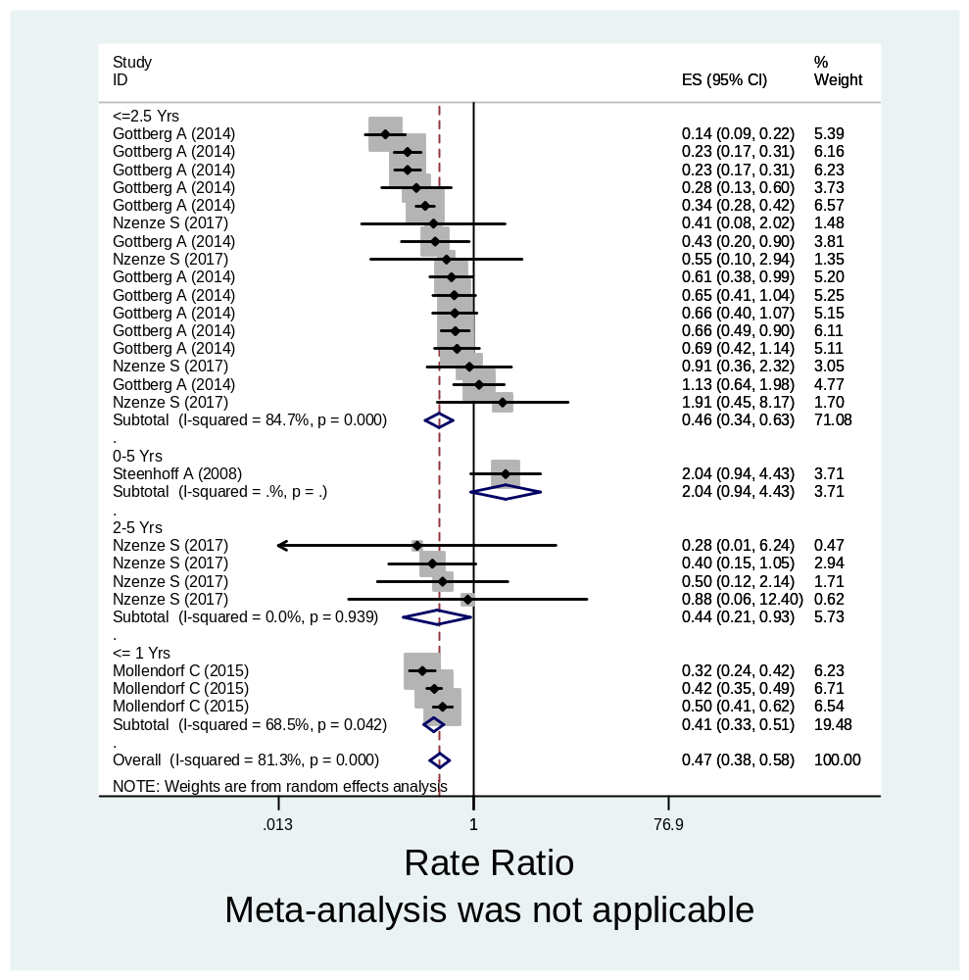

Online Fig 4: Effect of PCV against IPD among HIV-uninfected Children in pre-post studies according to age groups
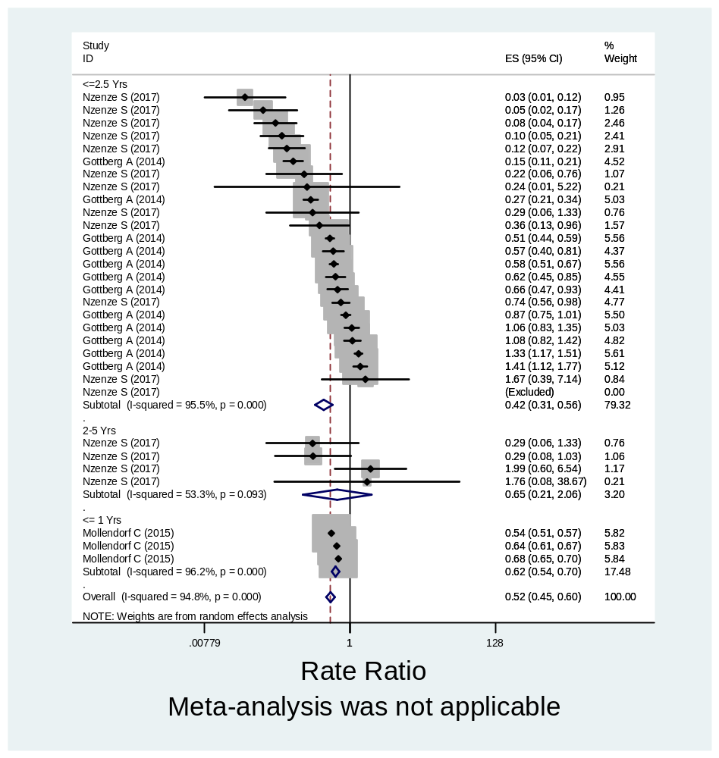

Online Fig 5: Effect of PCV against IPD among HIV-infected Children in case-control studies according to age groups
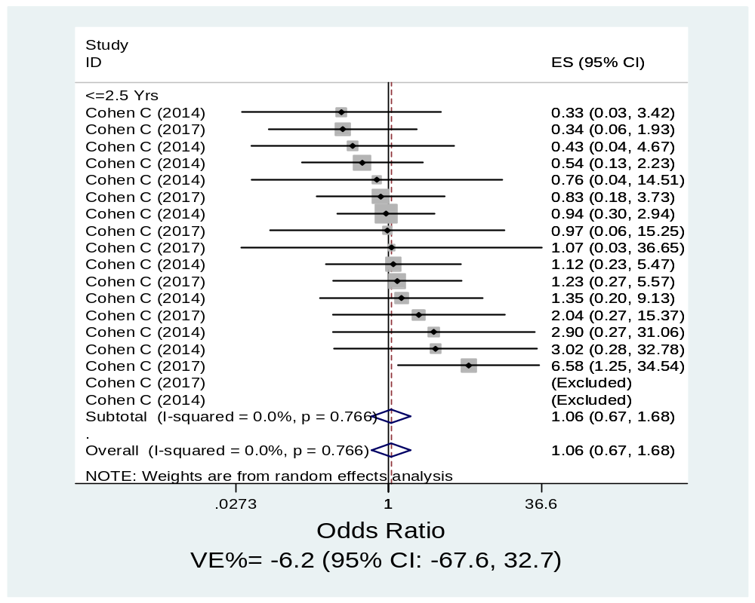

Online Fig 6: Effect of PCV against IPD among HIV-uninfected Children in case-control studies according to age groups
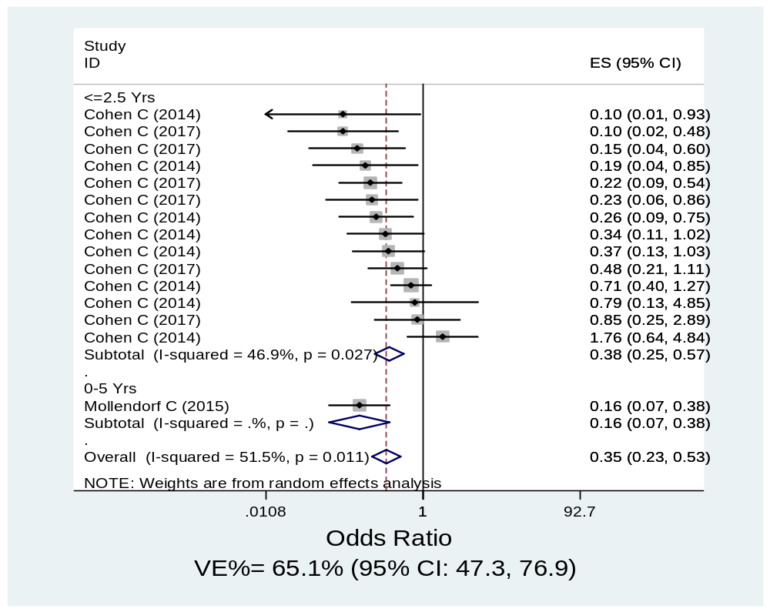
Online Fig 7: Effect of PCV against IPD among HIV-infected Children in randomized trials according to age groups
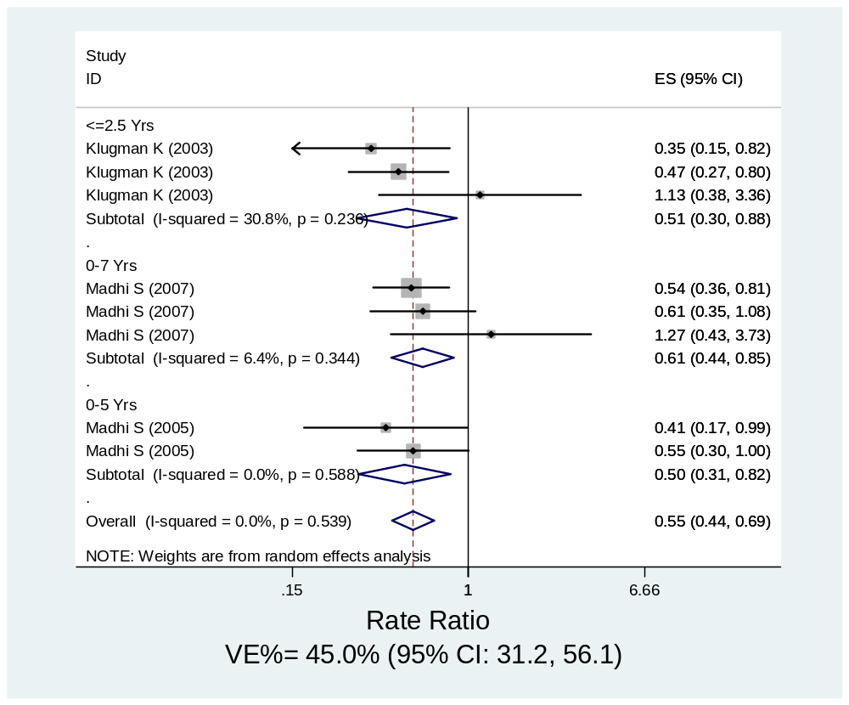

Online Fig 8: Effect of PCV against IPD among HIV-uninfected Children in randomized trials according to age groups
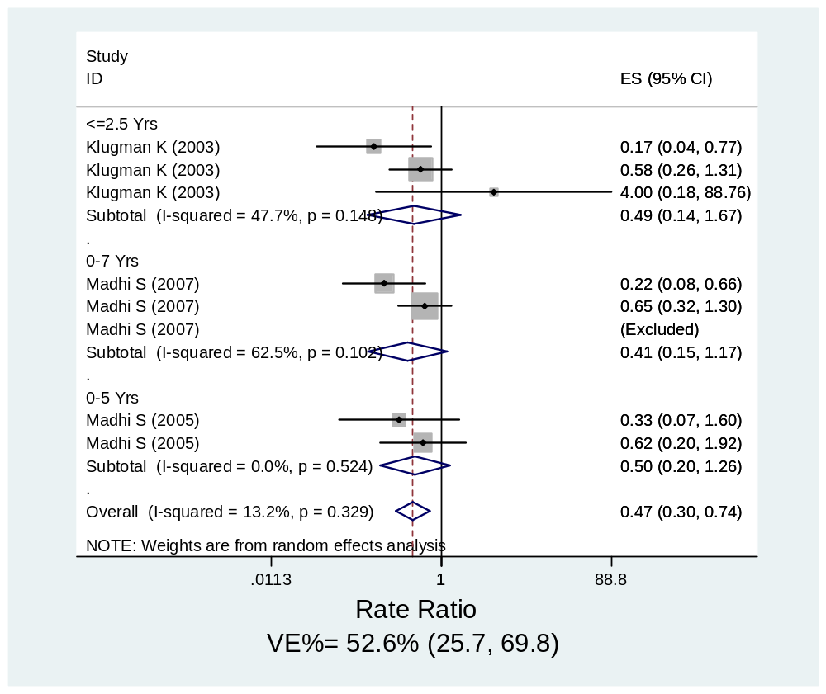

Online Fig 9: Effect of PCV against IPD among HIV-infected Children in pre-post studies according to vaccine valency
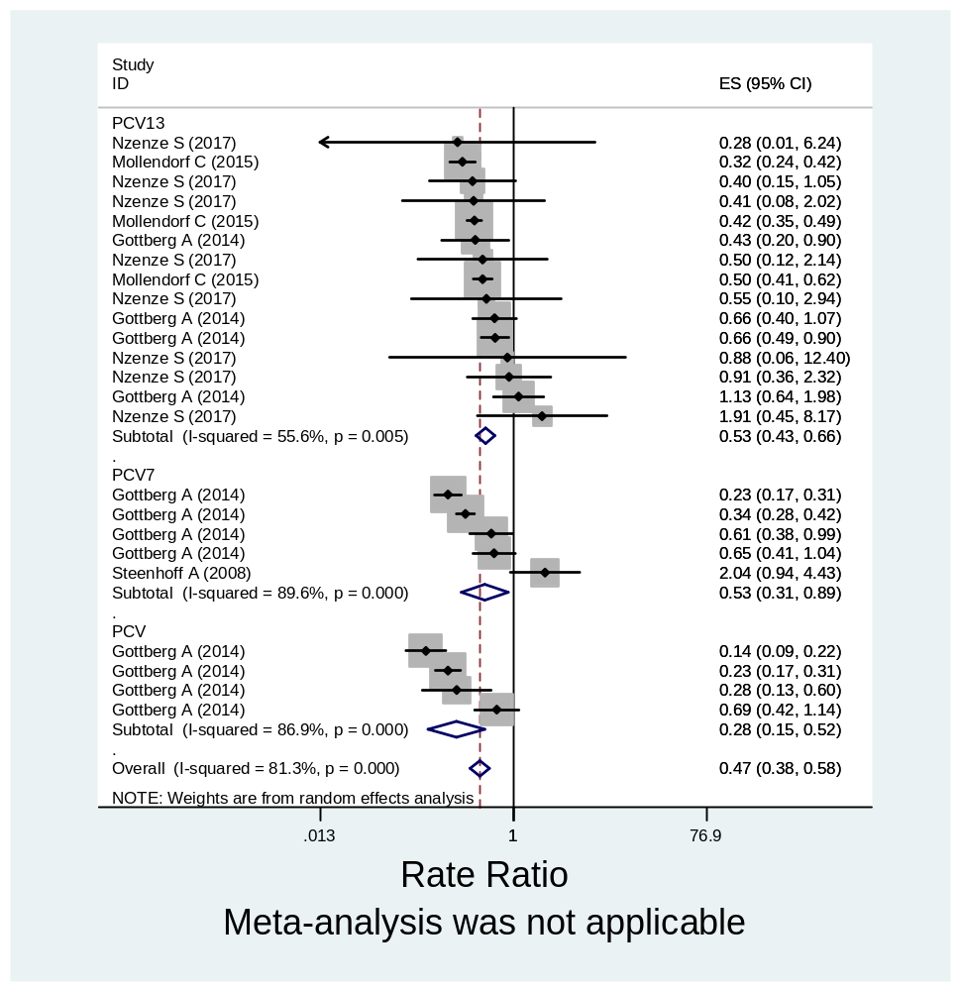

Online Fig 10: Effect of PCV against IPD among HIV-uninfected Children in pre-post studies according to vaccine valency
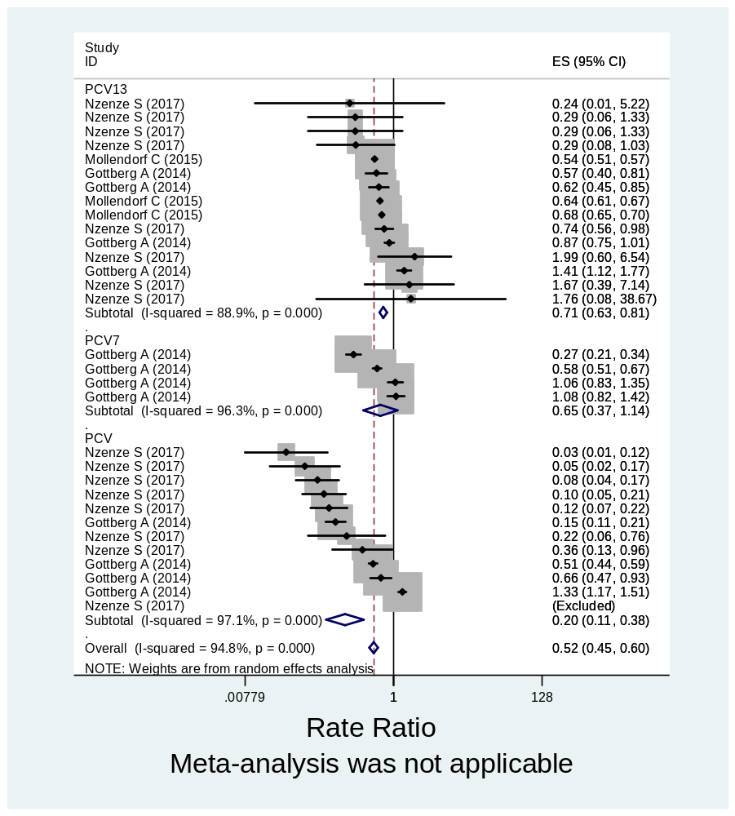

Online Fig 11: Effect of PCV against IPD among HIV-infected Children in case-control studies according to vaccine valency
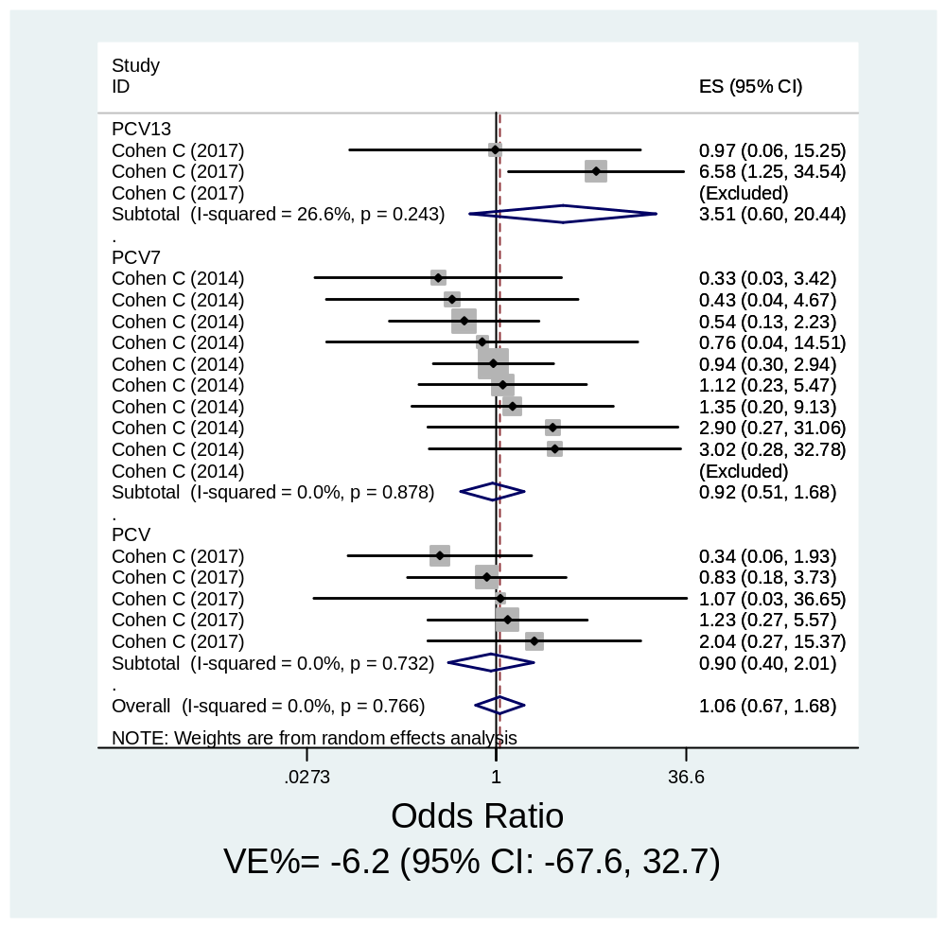

Online Fig 12: Vaccine effectiveness among HIV-uninfected Children in Case-Control studies according to vaccine valency
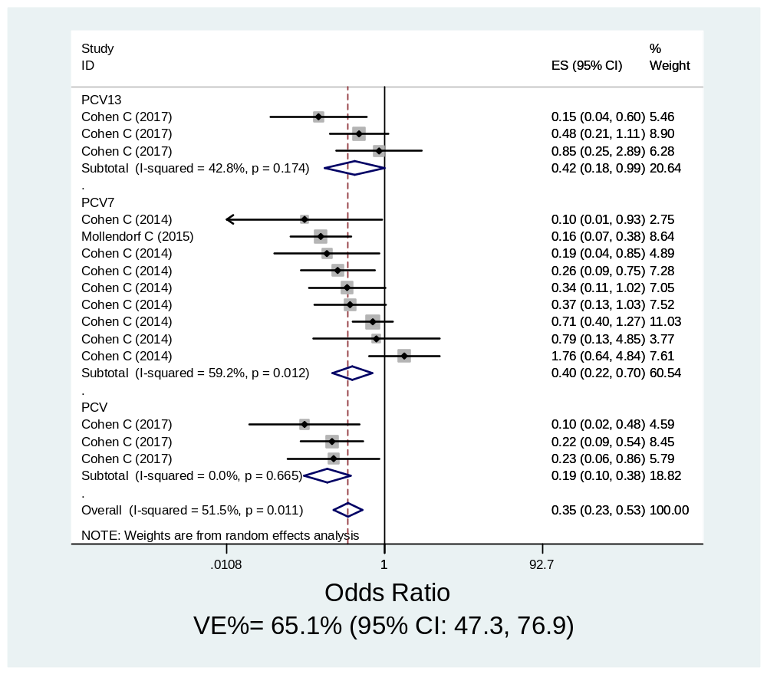

Online Fig 13: Influential observation analysis (HIV-infected Children, pre-post studies)
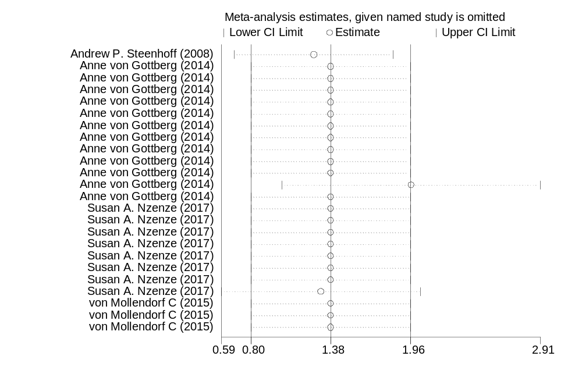
Online Fig 14: Influential observation analysis (HIV-uninfected Children, pre=post studies)
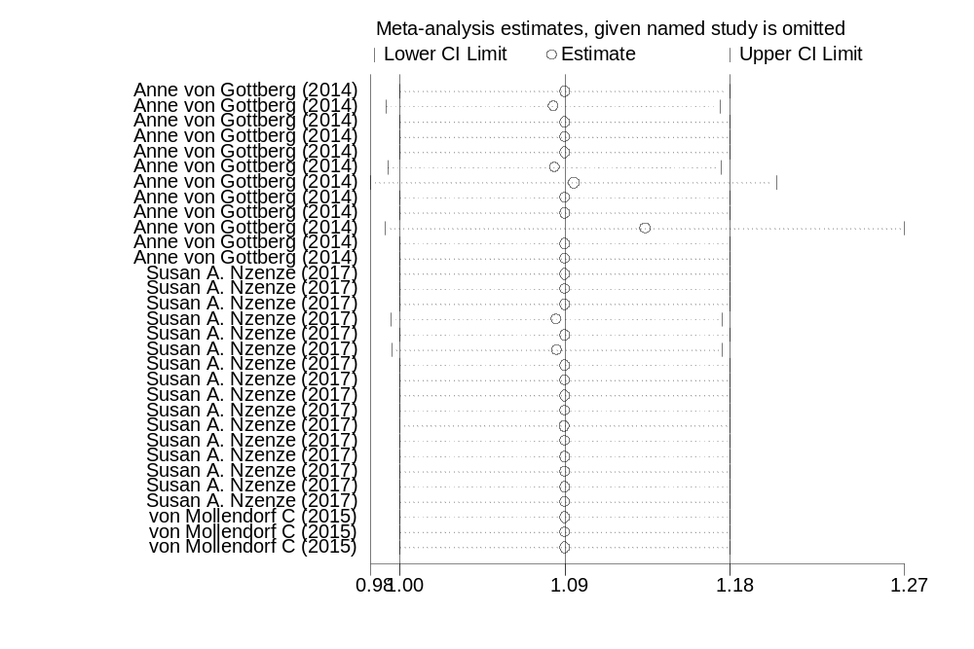

Online Fig 15: Influential observation analysis (HIV-infected Children, case-control studies)
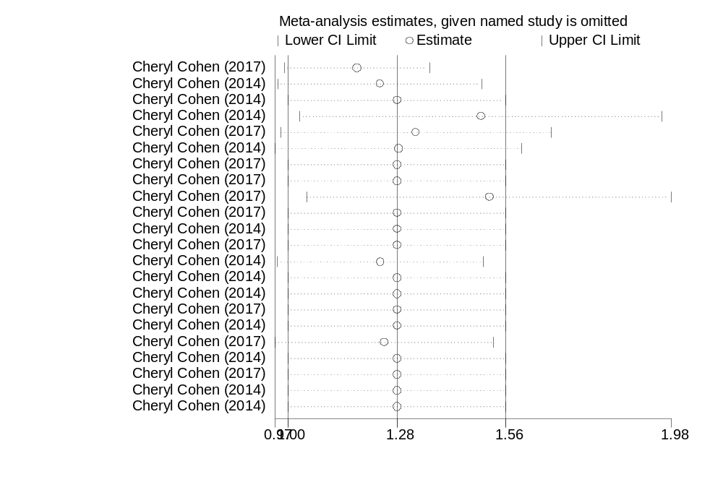
Online Fig 16: Influential observation analysis (HIV-uninfected Children, case-control studies)
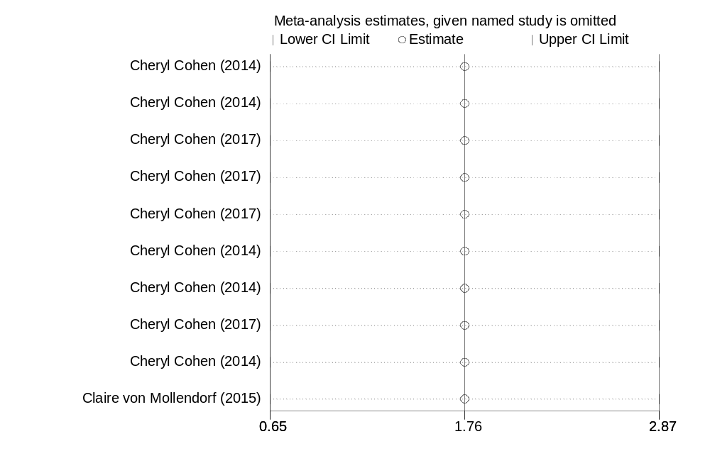

Online Fig 17: Influential observation analysis (HIV-infected Children, randomized trials)
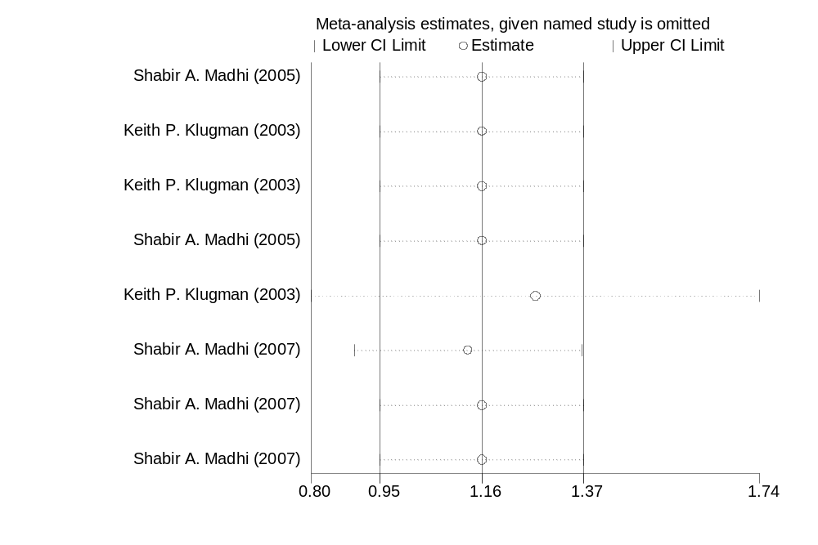
Online Fig 18: Influential observation analysis (HIV-uninfected Children, randomized trials)
