Supplementary material

Supplementary table 1. Descriptive statistics: Medicine programme (n=989) – page 2
Supplementary table 2. Descriptive statistics: Medicine for the Armed Forces programme (n=40) – page 3
Supplementary table 3. Descriptive statistics: Pediatrics programme (n=137) – page 4
Supplementary table 4. Descriptive statistics: Physical Therapy / Rehabilitation programme (n=67) – page 5
Supplementary table 5. Comparison between stations: Medicine programme (n=989) – pages 6-7
Supplementary table 6. Comparison between stations: Medicine for the Armed Forces programme (n=40) – pages 8-9
Supplementary table 7. Comparison between stations: Pediatrics programme (n=137) – pages 10-11
Supplementary table 8. Comparison between stations: Physical Therapy and Rehabilitation – page 12
Supplementary figure 1. Spearman correlation between stations: Medicine programme (n=989) – page 13
Supplementary figure 2. Spearman correlation between stations: Medicine for the Armed Forces programme (n=40) – page 14
Supplementary figure 3. Spearman correlation between stations: Pediatrics programme (n=137) – page 15
Supplementary figure 4. Spearman correlation between stations: Physical Therapy and Rehabilitation programme (n=67) – page 16
Supplementary table 9. Descriptive statistics: final exam scores for all the programmes – page 17
Supplementary table 10. Comparison between programmes: final exam scores – page 18

Supplementary table 1. Descriptive statistics: Medicine programme (n=989)
Stations | Mean | SD | SE | CI lower | CI upper | Min | Max | Median | IQR
M1 | 91.706 | 8.868 | 0.282 | 91.152 | 92.259 | 50.000 | 100.000 | 94.000 | 12.000
M2 | 80.100 | 14.794 | 0.470 | 79.176 | 81.023 | 25.000 | 100.000 | 80.000 | 23.000
M3 | 82.867 | 17.047 | 0.542 | 81.803 | 83.931 | 10.000 | 100.000 | 90.000 | 25.000
M4 | 85.635 | 15.245 | 0.485 | 84.684 | 86.586 | 5.000 | 100.000 | 90.000 | 20.000
M5 | 77.728 | 22.488 | 0.715 | 76.325 | 79.131 | 0.000 | 100.000 | 80.000 | 35.000
M6 | 92.793 | 10.481 | 0.333 | 92.139 | 93.447 | 30.700 | 100.000 | 100.000 | 10.000
M7 | 93.962 | 8.807 | 0.280 | 93.412 | 94.512 | 0.000 | 100.000 | 96.600 | 10.000
M8 | 94.490 | 7.137 | 0.227 | 94.045 | 94.935 | 60.000 | 100.000 | 96.600 | 10.000
M9 | 95.230 | 9.479 | 0.301 | 94.639 | 95.822 | 20.000 | 100.000 | 100.000 | 5.000
M10 | 94.781 | 7.518 | 0.239 | 94.312 | 95.250 | 60.000 | 100.000 | 100.000 | 7.000
M11 | 92.685 | 10.181 | 0.324 | 92.050 | 93.321 | 25.000 | 100.000 | 96.600 | 10.000
M12 | 89.918 | 11.512 | 0.366 | 89.199 | 90.636 | 25.000 | 100.000 | 95.000 | 15.000

Please refer to Table 1 (main manuscript) for the M1-M12 station details.
Abbreviations: SD, standard deviation; SE, standard error; CI, 95% confidence interval; min, minimum; max, maximum; IQR, interquartile range.

Supplementary table 2. Descriptive statistics: Medicine for the Armed Forces programme (n=40)
Stations | Mean | SD | SE | CI lower | CI upper | Min | Max | Median | IQR
M1 | 90.050 | 14.270 | 2.256 | 85.486 | 94.614 | 28.000 | 100.000 | 94.000 | 17.000
M2 | 76.363 | 14.034 | 2.219 | 71.874 | 80.851 | 40.000 | 100.000 | 80.000 | 17.500
M3 | 82.125 | 18.086 | 2.860 | 76.341 | 87.909 | 10.000 | 100.000 | 85.000 | 20.000
M4 | 82.625 | 17.021 | 2.691 | 77.181 | 88.069 | 10.000 | 100.000 | 85.000 | 12.500
M5 | 77.000 | 13.048 | 2.063 | 72.827 | 81.173 | 55.000 | 100.000 | 80.000 | 30.000
M6 | 97.518 | 5.579 | 0.882 | 95.733 | 99.302 | 73.300 | 100.000 | 100.000 | 3.400
M7 | 96.568 | 7.755 | 1.226 | 94.087 | 99.048 | 60.000 | 100.000 | 100.000 | 3.400
M8 | 92.973 | 5.439 | 0.860 | 91.233 | 94.712 | 83.300 | 100.000 | 93.300 | 6.600
M9 | 94.540 | 8.320 | 1.316 | 91.879 | 97.201 | 60.000 | 100.000 | 96.600 | 6.775
M10 | 91.558 | 8.690 | 1.374 | 88.778 | 94.337 | 70.000 | 100.000 | 93.000 | 14.000
M11 | 84.363 | 11.640 | 1.840 | 80.640 | 88.085 | 60.000 | 100.000 | 86.300 | 13.300
M12 | 92.875 | 6.591 | 1.042 | 90.767 | 94.983 | 75.000 | 100.000 | 95.000 | 6.250

Please refer to Table 1 (main manuscript) for the M1-M12 station details.
Abbreviations: SD, standard deviation; SE, standard error; CI, 95% confidence interval; min, minimum; max, maximum; IQR, interquartile range.

Supplementary table 3. Descriptive statistics: Pediatrics programme (n=137)
Stations | Mean | SD | SE | CI lower | CI upper | Min | Max | Median | IQR
P1 | 96.066 | 6.851 | 0.585 | 94.908 | 97.223 | 61.000 | 100.000 | 100.000 | 5.000
P2 | 85.125 | 12.656 | 1.081 | 82.987 | 87.263 | 60.000 | 100.000 | 88.000 | 16.000
P3 | 81.307 | 12.340 | 1.054 | 79.222 | 83.392 | 60.000 | 100.000 | 83.000 | 21.000
P4 | 82.445 | 16.810 | 1.436 | 79.605 | 85.285 | 0.000 | 100.000 | 87.500 | 20.000
P5 | 73.120 | 21.481 | 1.835 | 69.491 | 76.750 | 0.000 | 100.000 | 70.000 | 30.000
P6 | 83.942 | 15.476 | 1.322 | 81.327 | 86.556 | 20.000 | 100.000 | 90.000 | 30.000
P7 | 80.876 | 15.172 | 1.296 | 78.312 | 83.439 | 30.000 | 100.000 | 85.000 | 25.000
P8 | 88.638 | 12.713 | 1.086 | 86.490 | 90.786 | 0.000 | 100.000 | 90.000 | 20.000
P9 | 87.133 | 14.370 | 1.228 | 84.705 | 89.561 | 26.600 | 100.000 | 92.200 | 20.000
P10 | 92.604 | 13.233 | 1.131 | 90.369 | 94.840 | 16.000 | 100.000 | 100.000 | 10.000
P11 | 85.148 | 16.908 | 1.445 | 82.291 | 88.005 | 0.000 | 100.000 | 91.600 | 20.100
P12 | 92.880 | 14.473 | 1.237 | 90.434 | 95.325 | 0.000 | 100.000 | 97.500 | 10.000

Please refer to Table 1 (main manuscript) for the P1-P12 station details.
Abbreviations: SD, standard deviation; SE, standard error; CI, 95% confidence interval; min, minimum; max, maximum; IQR, interquartile range.

Supplementary table 4. Descriptive statistics: Physical Therapy / Rehabilitation programme (n=67)
Stations | Mean | SD | SE | CI lower | CI upper | Min | Max | Median | IQR
PTR1 | 80.995 | 17.672 | 2.159 | 76.685 | 85.306 | 6.667 | 100.000 | 85.000 | 17.500
PTR2 | 84.925 | 13.297 | 1.624 | 81.682 | 88.169 | 10.000 | 100.000 | 88.333 | 12.500
PTR3 | 84.403 | 15.338 | 1.874 | 80.662 | 88.144 | 25.000 | 100.000 | 88.333 | 10.000
PTR4 | 85.373 | 18.188 | 2.222 | 80.937 | 89.809 | 6.667 | 100.000 | 93.333 | 20.833
PTR5 | 88.259 | 12.396 | 1.514 | 85.235 | 91.282 | 53.333 | 100.000 | 93.333 | 22.500
PTR6 | 82.848 | 14.383 | 1.757 | 79.340 | 86.356 | 35.000 | 100.000 | 88.333 | 18.750

Please refer to Table 1 (main manuscript) for the PTR1-PTR6 station details.
Abbreviations: SD, standard deviation; SE, standard error; CI, 95% confidence interval; min, minimum; max, maximum; IQR, interquartile range.

Supplementary table 5. Comparison between stations: Medicine programme (n=989), part 1/2

Comparison | First station in pairs |  | Second station in pairs |  | Wilcoxon statistics
Comparison | Mean 1 | SE 1 | Mean 2 | SE 2 | W | z | η² | p | p BH
M1 vs M2 | 91.706 | 0.282 | 80.100 | 0.470 | 50344.000 | -19.459 | 0.422 | 2.33E-84 | 1.18E-83
M1 vs M3 | 91.706 | 0.282 | 82.867 | 0.542 | 85867.500 | -14.948 | 0.249 | 1.54E-50 | 3.76E-50
M1 vs M4 | 91.706 | 0.282 | 85.635 | 0.485 | 101384.500 | -11.255 | 0.148 | 2.12E-29 | 4.11E-29
M1 vs M5 | 91.706 | 0.282 | 77.728 | 0.715 | 59905.000 | -17.614 | 0.355 | 1.81E-69 | 6.28E-69
M1 vs M6 | 91.706 | 0.282 | 92.793 | 0.333 | 120362.000 | -3.781 | 0.019 | 1.54E-04 | 1.82E-04
M1 vs M7 | 91.706 | 0.282 | 93.962 | 0.280 | 116780.000 | -6.835 | 0.058 | 7.89E-12 | 1.18E-11
M1 vs M8 | 91.706 | 0.282 | 94.490 | 0.227 | 106950.000 | -8.689 | 0.093 | 3.54E-18 | 5.69E-18
M1 vs M9 | 91.706 | 0.282 | 95.230 | 0.301 | 65377.000 | -11.250 | 0.178 | 1.74E-29 | 3.49E-29
M1 vs M10 | 91.706 | 0.282 | 94.781 | 0.239 | 88585.500 | -9.295 | 0.114 | 1.32E-20 | 2.29E-20
M1 vs M11 | 91.706 | 0.282 | 92.685 | 0.324 | 136645.500 | -3.493 | 0.015 | 4.74E-04 | 5.48E-04
M1 vs M12 | 91.706 | 0.282 | 89.918 | 0.366 | 154511.500 | -3.142 | 0.012 | 1.67E-03 | 1.86E-03
M2 vs M3 | 80.100 | 0.470 | 82.867 | 0.542 | 143120.000 | -5.665 | 0.037 | 1.36E-08 | 1.79E-08
M2 vs M4 | 80.100 | 0.470 | 85.635 | 0.485 | 113035.000 | -9.766 | 0.111 | 1.32E-22 | 2.36E-22
M2 vs M5 | 80.100 | 0.470 | 77.728 | 0.715 | 171286.500 | -2.009 | 0.005 | 4.42E-02 | 4.71E-02
M2 vs M6 | 80.100 | 0.470 | 92.793 | 0.333 | 28377.000 | -21.227 | 0.532 | 4.35E-100 | 5.75E-99
M2 vs M7 | 80.100 | 0.470 | 93.962 | 0.280 | 29532.000 | -21.718 | 0.538 | 1.20E-104 | 1.98E-103
M2 vs M8 | 80.100 | 0.470 | 94.490 | 0.227 | 19799.000 | -23.092 | 0.605 | 4.99E-118 | 3.29E-116
M2 vs M9 | 80.100 | 0.470 | 95.230 | 0.301 | 20066.500 | -22.493 | 0.594 | 3.53E-112 | 7.78E-111
M2 vs M10 | 80.100 | 0.470 | 94.781 | 0.239 | 20141.500 | -22.621 | 0.596 | 2.30E-113 | 7.59E-112
M2 vs M11 | 80.100 | 0.470 | 92.685 | 0.324 | 40076.500 | -20.549 | 0.476 | 6.70E-94 | 5.53E-93
M2 vs M12 | 80.100 | 0.470 | 89.918 | 0.366 | 71442.500 | -15.790 | 0.288 | 2.41E-56 | 6.35E-56
M3 vs M4 | 82.867 | 0.542 | 85.635 | 0.485 | 132826.000 | -4.505 | 0.025 | 6.28E-06 | 7.97E-06
M3 vs M5 | 82.867 | 0.542 | 77.728 | 0.715 | 126755.500 | -6.563 | 0.052 | 4.80E-11 | 7.05E-11
M3 vs M6 | 82.867 | 0.542 | 92.793 | 0.333 | 59934.500 | -16.159 | 0.316 | 8.22E-59 | 2.36E-58
M3 vs M7 | 82.867 | 0.542 | 93.962 | 0.280 | 46085.500 | -18.662 | 0.413 | 8.47E-78 | 3.29E-77
M3 vs M8 | 82.867 | 0.542 | 94.490 | 0.227 | 39473.500 | -19.792 | 0.460 | 2.92E-87 | 1.75E-86
M3 vs M9 | 82.867 | 0.542 | 95.230 | 0.301 | 35816.500 | -19.428 | 0.463 | 2.83E-84 | 1.34E-83
M3 vs M10 | 82.867 | 0.542 | 94.781 | 0.239 | 43400.500 | -19.169 | 0.433 | 5.13E-82 | 2.26E-81
M3 vs M11 | 82.867 | 0.542 | 92.685 | 0.324 | 60520.500 | -16.804 | 0.332 | 1.87E-63 | 5.61E-63
M3 vs M12 | 82.867 | 0.542 | 89.918 | 0.366 | 86141.500 | -11.801 | 0.172 | 2.50E-32 | 5.32E-32
M4 vs M5 | 85.635 | 0.485 | 77.728 | 0.715 | 99216.000 | -10.597 | 0.135 | 2.53E-26 | 4.77E-26
M4 vs M6 | 85.635 | 0.485 | 92.793 | 0.333 | 76732.500 | -12.952 | 0.208 | 2.04E-38 | 4.64E-38
M4 vs M7 | 85.635 | 0.485 | 93.962 | 0.280 | 58295.000 | -15.809 | 0.310 | 2.41E-56 | 6.35E-56
M4 vs M8 | 85.635 | 0.485 | 94.490 | 0.227 | 55838.500 | -17.111 | 0.349 | 1.08E-65 | 3.39E-65
M4 vs M9 | 85.635 | 0.485 | 95.230 | 0.301 | 33389.500 | -18.447 | 0.446 | 3.34E-76 | 1.22E-75
M4 vs M10 | 85.635 | 0.485 | 94.781 | 0.239 | 46287.000 | -17.366 | 0.378 | 1.22E-67 | 4.03E-67
M4 vs M11 | 85.635 | 0.485 | 92.685 | 0.324 | 73885.500 | -13.634 | 0.229 | 2.26E-42 | 5.32E-42
M4 vs M12 | 85.635 | 0.485 | 89.918 | 0.366 | 118060.000 | -7.359 | 0.066 | 1.60E-13 | 2.51E-13
M5 vs M6 | 77.728 | 0.715 | 92.793 | 0.333 | 32050.500 | -19.502 | 0.478 | 8.92E-85 | 4.91E-84
M5 vs M7 | 77.728 | 0.715 | 93.962 | 0.280 | 27522.000 | -20.500 | 0.519 | 1.90E-93 | 1.39E-92
M5 vs M8 | 77.728 | 0.715 | 94.490 | 0.227 | 29324.000 | -20.939 | 0.522 | 2.12E-97 | 2.00E-96
M5 vs M9 | 77.728 | 0.715 | 95.230 | 0.301 | 19785.000 | -21.030 | 0.568 | 2.71E-98 | 2.98E-97
M5 vs M10 | 77.728 | 0.715 | 94.781 | 0.239 | 28754.000 | -20.454 | 0.513 | 4.86E-93 | 3.21E-92
M5 vs M11 | 77.728 | 0.715 | 92.685 | 0.324 | 41053.000 | -18.860 | 0.432 | 2.15E-79 | 8.87E-79
M5 vs M12 | 77.728 | 0.715 | 89.918 | 0.366 | 64713.000 | -15.072 | 0.279 | 1.76E-51 | 4.47E-51
M6 vs M7 | 92.793 | 0.333 | 93.962 | 0.280 | 103081.000 | -2.537 | 0.009 | 1.11E-02 | 1.20E-02
Supplementary table 5. Comparison between stations: Medicine programme (n=989), part 2/2

Comparison | First station in pairs |  | Second station in pairs |  | Wilcoxon statistics
Comparison | Mean 1 | SE 1 | Mean 2 | SE 2 | W | z | η² | p | p BH
M6 vs M8 | 92.793 | 0.333 | 94.490 | 0.227 | 112924.000 | -3.135 | 0.014 | 1.69E-03 | 1.86E-03
M6 vs M9 | 92.793 | 0.333 | 95.230 | 0.301 | 60229.500 | -6.990 | 0.082 | 2.64E-12 | 4.06E-12
M6 vs M10 | 92.793 | 0.333 | 94.781 | 0.239 | 95529.000 | -4.350 | 0.028 | 1.35E-05 | 1.68E-05
M6 vs M11 | 92.793 | 0.333 | 92.685 | 0.324 | 125415.500 | -0.529 | 0.000 | 5.96E-01 | 6.06E-01
M6 vs M12 | 92.793 | 0.333 | 89.918 | 0.366 | 104789.500 | -6.323 | 0.053 | 2.48E-10 | 3.55E-10
M7 vs M8 | 93.962 | 0.280 | 94.490 | 0.227 | 120061.000 | -0.294 | 0.000 | 7.68E-01 | 7.68E-01
M7 vs M9 | 93.962 | 0.280 | 95.230 | 0.301 | 66889.000 | -5.982 | 0.059 | 2.06E-09 | 2.90E-09
M7 vs M10 | 93.962 | 0.280 | 94.781 | 0.239 | 102681.000 | -1.686 | 0.004 | 9.16E-02 | 9.59E-02
M7 vs M11 | 93.962 | 0.280 | 92.685 | 0.324 | 104447.500 | -3.347 | 0.016 | 7.96E-04 | 9.05E-04
M7 vs M12 | 93.962 | 0.280 | 89.918 | 0.366 | 95054.500 | -9.138 | 0.107 | 5.98E-20 | 1.01E-19
M8 vs M9 | 94.490 | 0.227 | 95.230 | 0.301 | 80428.500 | -5.898 | 0.053 | 3.41E-09 | 4.69E-09
M8 vs M10 | 94.490 | 0.227 | 94.781 | 0.239 | 121924.000 | -0.592 | 0.000 | 5.54E-01 | 5.71E-01
M8 vs M11 | 94.490 | 0.227 | 92.685 | 0.324 | 104835.000 | -4.134 | 0.024 | 3.43E-05 | 4.19E-05
M8 vs M12 | 94.490 | 0.227 | 89.918 | 0.366 | 87378.500 | -10.564 | 0.142 | 4.13E-26 | 7.57E-26
M9 vs M10 | 95.230 | 0.301 | 94.781 | 0.239 | 73989.500 | -4.047 | 0.027 | 5.13E-05 | 6.16E-05
M9 vs M11 | 95.230 | 0.301 | 92.685 | 0.324 | 58462.500 | -8.810 | 0.124 | 1.12E-18 | 1.84E-18
M9 vs M12 | 95.230 | 0.301 | 89.918 | 0.366 | 61238.500 | -12.394 | 0.212 | 2.20E-35 | 4.85E-35
M10 vs M11 | 94.781 | 0.239 | 92.685 | 0.324 | 93567.000 | -5.004 | 0.036 | 5.49E-07 | 7.11E-07
M10 vs M12 | 94.781 | 0.239 | 89.918 | 0.366 | 72726.500 | -11.472 | 0.175 | 1.65E-30 | 3.39E-30
M11 vs M12 | 92.685 | 0.324 | 89.918 | 0.366 | 117658.500 | -5.707 | 0.042 | 1.12E-08 | 1.51E-08

Please refer to Table 1 (main manuscript) for the M1-M12 station details.
Bold denotes significant differences after adjustment.
Abbreviations: SE, standard error; W, Wilcoxon test statistics; z, z-value; η², effect size; p, p-value unadjusted; p BH, p-value adjusted by the Benjamini–Hochberg procedure.

Supplementary table 6. Comparison between stations: Medicine for the Armed Forces programme (n=40), part 1/2

Comparison | First station in pairs |  | Second station in pairs |  | Wilcoxon statistics
Comparison | Mean 1 | SE 1 | Mean 2 | SE 2 | W | z | η² | p | p BH
M1 vs M2 | 90.050 | 2.256 | 76.363 | 2.219 | 77.500 | -4.249 | 0.475 | 2.13E-05 | 6.38E-05
M1 vs M3 | 90.050 | 2.256 | 82.125 | 2.860 | 111.500 | -3.180 | 0.297 | 1.47E-03 | 2.49E-03
M1 vs M4 | 90.050 | 2.256 | 82.625 | 2.691 | 126.500 | -3.087 | 0.272 | 2.01E-03 | 3.24E-03
M1 vs M5 | 90.050 | 2.256 | 77.000 | 2.063 | 84.500 | -4.375 | 0.479 | 2.23E-06 | 7.79E-06
M1 vs M6 | 90.050 | 2.256 | 97.518 | 0.882 | 23.000 | -3.629 | 0.549 | 2.75E-04 | 5.51E-04
M1 vs M7 | 90.050 | 2.256 | 96.568 | 1.226 | 40.500 | -3.283 | 0.431 | 1.01E-03 | 1.75E-03
M1 vs M8 | 90.050 | 2.256 | 92.973 | 0.860 | 242.000 | -0.949 | 0.026 | 3.43E-01 | 3.83E-01
M1 vs M9 | 90.050 | 2.256 | 94.540 | 1.316 | 185.500 | -1.468 | 0.067 | 1.42E-01 | 1.73E-01
M1 vs M10 | 90.050 | 2.256 | 91.558 | 1.374 | 240.000 | -0.157 | 0.001 | 8.75E-01 | 8.89E-01
M1 vs M11 | 90.050 | 2.256 | 84.363 | 1.840 | 190.500 | -2.610 | 0.179 | 9.00E-03 | 1.35E-02
M1 vs M12 | 90.050 | 2.256 | 92.875 | 1.042 | 212.500 | -0.963 | 0.029 | 3.34E-01 | 3.80E-01
M2 vs M3 | 76.363 | 2.219 | 82.125 | 2.860 | 171.500 | -2.350 | 0.158 | 1.83E-02 | 2.63E-02
M2 vs M4 | 76.363 | 2.219 | 82.625 | 2.691 | 196.500 | -2.144 | 0.128 | 3.14E-02 | 4.31E-02
M2 vs M5 | 76.363 | 2.219 | 77.000 | 2.063 | 234.500 | -0.265 | 0.002 | 7.91E-01 | 8.16E-01
M2 vs M6 | 76.363 | 2.219 | 97.518 | 0.882 | 0.000 | -5.303 | 0.760 | 1.09E-07 | 1.44E-06
M2 vs M7 | 76.363 | 2.219 | 96.568 | 1.226 | 0.000 | -5.232 | 0.760 | 1.63E-07 | 1.80E-06
M2 vs M8 | 76.363 | 2.219 | 92.973 | 0.860 | 18.500 | -5.105 | 0.686 | 3.23E-07 | 2.67E-06
M2 vs M9 | 76.363 | 2.219 | 94.540 | 1.316 | 24.000 | -4.941 | 0.660 | 7.63E-07 | 4.19E-06
M2 vs M10 | 76.363 | 2.219 | 91.558 | 1.374 | 39.500 | -4.800 | 0.606 | 1.56E-06 | 6.45E-06
M2 vs M11 | 76.363 | 2.219 | 84.363 | 1.840 | 115.000 | -3.120 | 0.286 | 1.80E-03 | 2.97E-03
M2 vs M12 | 76.363 | 2.219 | 92.875 | 1.042 | 4.000 | -5.315 | 0.743 | 9.95E-08 | 1.44E-06
M3 vs M4 | 82.125 | 2.860 | 82.625 | 2.691 | 265.000 | -0.277 | 0.002 | 7.81E-01 | 8.16E-01
M3 vs M5 | 82.125 | 2.860 | 77.000 | 2.063 | 221.000 | -1.969 | 0.105 | 4.77E-02 | 6.18E-02
M3 vs M6 | 82.125 | 2.860 | 97.518 | 0.882 | 3.000 | -4.958 | 0.745 | 6.87E-07 | 4.12E-06
M3 vs M7 | 82.125 | 2.860 | 96.568 | 1.226 | 3.000 | -4.801 | 0.744 | 1.53E-06 | 6.45E-06
M3 vs M8 | 82.125 | 2.860 | 92.973 | 0.860 | 82.000 | -3.816 | 0.416 | 1.35E-04 | 3.06E-04
M3 vs M9 | 82.125 | 2.860 | 94.540 | 1.316 | 80.000 | -3.718 | 0.407 | 1.99E-04 | 4.23E-04
M3 vs M10 | 82.125 | 2.860 | 91.558 | 1.374 | 85.000 | -3.347 | 0.350 | 8.12E-04 | 1.45E-03
M3 vs M11 | 82.125 | 2.860 | 84.363 | 1.840 | 268.000 | -0.504 | 0.007 | 6.14E-01 | 6.54E-01
M3 vs M12 | 82.125 | 2.860 | 92.875 | 1.042 | 52.500 | -4.074 | 0.503 | 4.08E-05 | 1.12E-04
M4 vs M5 | 82.625 | 2.691 | 77.000 | 2.063 | 204.000 | -2.027 | 0.114 | 4.19E-02 | 5.53E-02
M4 vs M6 | 82.625 | 2.691 | 97.518 | 0.882 | 2.500 | -4.967 | 0.748 | 6.54E-07 | 4.12E-06
M4 vs M7 | 82.625 | 2.691 | 96.568 | 1.226 | 6.000 | -4.905 | 0.729 | 9.02E-07 | 4.58E-06
M4 vs M8 | 82.625 | 2.691 | 92.973 | 0.860 | 97.500 | -3.700 | 0.380 | 2.14E-04 | 4.42E-04
M4 vs M9 | 82.625 | 2.691 | 94.540 | 1.316 | 64.000 | -4.337 | 0.508 | 1.41E-05 | 4.43E-05
M4 vs M10 | 82.625 | 2.691 | 91.558 | 1.374 | 88.000 | -3.718 | 0.395 | 1.99E-04 | 4.23E-04
M4 vs M11 | 82.625 | 2.691 | 84.363 | 1.840 | 335.000 | -0.515 | 0.007 | 6.07E-01 | 6.54E-01
M4 vs M12 | 82.625 | 2.691 | 92.875 | 1.042 | 71.000 | -3.997 | 0.456 | 5.46E-05 | 1.44E-04
M5 vs M6 | 77.000 | 2.063 | 97.518 | 0.882 | 1.000 | -5.428 | 0.756 | 5.03E-08 | 1.44E-06
M5 vs M7 | 77.000 | 2.063 | 96.568 | 1.226 | 0.000 | -5.373 | 0.760 | 6.75E-08 | 1.44E-06
M5 vs M8 | 77.000 | 2.063 | 92.973 | 0.860 | 33.500 | -4.887 | 0.629 | 9.97E-07 | 4.70E-06
M5 vs M9 | 77.000 | 2.063 | 94.540 | 1.316 | 28.000 | -4.967 | 0.649 | 6.50E-07 | 4.12E-06
M5 vs M10 | 77.000 | 2.063 | 91.558 | 1.374 | 56.000 | -4.458 | 0.537 | 8.07E-06 | 2.66E-05
M5 vs M11 | 77.000 | 2.063 | 84.363 | 1.840 | 152.500 | -2.479 | 0.181 | 1.31E-02 | 1.92E-02
M5 vs M12 | 77.000 | 2.063 | 92.875 | 1.042 | 29.500 | -5.114 | 0.654 | 3.16E-09 | 2.09E-07
M6 vs M7 | 97.518 | 0.882 | 96.568 | 1.226 | 34.000 | -1.161 | 0.096 | 2.39E-01 | 2.82E-01
Supplementary table 6. Comparison between stations: Medicine for the Armed Forces programme (n=40), part 2/2
Comparison | First station in pairs |  | Second station in pairs |  | Wilcoxon statistics
Comparison | Mean 1 | SE 1 | Mean 2 | SE 2 | W | z | η² | p | p BH
M6 vs M8 | 97.518 | 0.882 | 92.973 | 0.860 | 68.000 | -3.527 | 0.401 | 4.00E-04 | 7.76E-04
M6 vs M9 | 97.518 | 0.882 | 94.540 | 1.316 | 78.000 | -2.274 | 0.207 | 2.26E-02 | 3.17E-02
M6 vs M10 | 97.518 | 0.882 | 91.558 | 1.374 | 26.000 | -3.916 | 0.568 | 8.36E-05 | 2.04E-04
M6 vs M11 | 97.518 | 0.882 | 84.363 | 1.840 | 4.000 | -5.094 | 0.741 | 3.21E-07 | 2.67E-06
M6 vs M12 | 97.518 | 0.882 | 92.875 | 1.042 | 52.000 | -3.841 | 0.476 | 8.36E-05 | 2.04E-04
M7 vs M8 | 96.568 | 1.226 | 92.973 | 0.860 | 72.500 | -2.972 | 0.315 | 2.74E-03 | 4.21E-03
M7 vs M9 | 96.568 | 1.226 | 94.540 | 1.316 | 85.500 | -2.072 | 0.172 | 3.62E-02 | 4.88E-02
M7 vs M10 | 96.568 | 1.226 | 91.558 | 1.374 | 41.500 | -3.403 | 0.445 | 6.46E-04 | 1.18E-03
M7 vs M11 | 96.568 | 1.226 | 84.363 | 1.840 | 21.500 | -4.719 | 0.655 | 2.24E-06 | 7.79E-06
M7 vs M12 | 96.568 | 1.226 | 92.875 | 1.042 | 73.000 | -3.429 | 0.379 | 5.06E-04 | 9.54E-04
M8 vs M9 | 92.973 | 0.860 | 94.540 | 1.316 | 181.000 | -1.313 | 0.056 | 1.88E-01 | 2.26E-01
M8 vs M10 | 92.973 | 0.860 | 91.558 | 1.374 | 244.000 | -0.915 | 0.025 | 3.60E-01 | 3.96E-01
M8 vs M11 | 92.973 | 0.860 | 84.363 | 1.840 | 87.500 | -3.857 | 0.413 | 1.14E-04 | 2.68E-04
M8 vs M12 | 92.973 | 0.860 | 92.875 | 1.042 | 325.500 | -0.118 | 0.000 | 9.06E-01 | 9.06E-01
M9 vs M10 | 94.540 | 1.316 | 91.558 | 1.374 | 199.500 | -1.892 | 0.102 | 5.82E-02 | 7.39E-02
M9 vs M11 | 94.540 | 1.316 | 84.363 | 1.840 | 26.500 | -4.725 | 0.638 | 2.24E-06 | 7.79E-06
M9 vs M12 | 94.540 | 1.316 | 92.875 | 1.042 | 223.000 | -1.507 | 0.065 | 1.31E-01 | 1.63E-01
M10 vs M11 | 91.558 | 1.374 | 84.363 | 1.840 | 142.000 | -3.001 | 0.250 | 2.66E-03 | 4.19E-03
M10 vs M12 | 91.558 | 1.374 | 92.875 | 1.042 | 266.000 | -1.053 | 0.031 | 2.91E-01 | 3.37E-01
M11 vs M12 | 84.363 | 1.840 | 92.875 | 1.042 | 82.000 | -4.184 | 0.461 | 2.83E-05 | 8.11E-05

Please refer to Table 1 (main manuscript) for the M1-M12 station details.
Bold denotes significant differences after adjustment.
Abbreviations: SE, standard error; W, Wilcoxon test statistics; z, z-value; η², effect size; p, p-value unadjusted; p BH, p-value adjusted by the Benjamini–Hochberg procedure.

Supplementary table 7. Comparison between stations: Pediatrics programme (n=137), part 1/2

Comparison | First station in pairs |  | Second station in pairs |  | Wilcoxon statistics
Comparison | Mean 1 | SE 1 | Mean 2 | SE 2 | W | z | η² | p | p BH
P1 vs P2 | 96.066 | 0.585 | 85.125 | 1.081 | 249.000 | -8.463 | 0.639 | 2.28E-17 | 3.76E-16
P1 vs P3 | 96.066 | 0.585 | 81.307 | 1.054 | 188.000 | -9.150 | 0.681 | 5.11E-20 | 1.69E-18
P1 vs P4 | 96.066 | 0.585 | 82.445 | 1.436 | 364.000 | -8.345 | 0.600 | 7.04E-17 | 7.75E-16
P1 vs P5 | 96.066 | 0.585 | 73.120 | 1.835 | 169.000 | -9.198 | 0.688 | 3.52E-20 | 1.69E-18
P1 vs P6 | 96.066 | 0.585 | 83.942 | 1.322 | 495.500 | -7.502 | 0.521 | 6.07E-14 | 3.08E-13
P1 vs P7 | 96.066 | 0.585 | 80.876 | 1.296 | 235.500 | -8.937 | 0.660 | 3.75E-19 | 8.25E-18
P1 vs P8 | 96.066 | 0.585 | 88.638 | 1.086 | 721.500 | -6.513 | 0.408 | 7.20E-11 | 2.50E-10
P1 vs P9 | 96.066 | 0.585 | 87.133 | 1.228 | 832.500 | -6.695 | 0.404 | 2.10E-11 | 8.68E-11
P1 vs P10 | 96.066 | 0.585 | 92.604 | 1.131 | 1074.500 | -3.299 | 0.128 | 9.62E-04 | 1.51E-03
P1 vs P11 | 96.066 | 0.585 | 85.148 | 1.445 | 607.000 | -7.675 | 0.508 | 1.62E-14 | 9.74E-14
P1 vs P12 | 96.066 | 0.585 | 92.880 | 1.237 | 1110.500 | -3.142 | 0.116 | 1.67E-03 | 2.40E-03
P2 vs P3 | 85.125 | 1.081 | 81.307 | 1.054 | 2212.500 | -3.712 | 0.115 | 2.03E-04 | 3.43E-04
P2 vs P4 | 85.125 | 1.081 | 82.445 | 1.436 | 3426.000 | -1.669 | 0.022 | 9.50E-02 | 1.12E-01
P2 vs P5 | 85.125 | 1.081 | 73.120 | 1.835 | 1855.000 | -5.670 | 0.245 | 1.42E-08 | 3.91E-08
P2 vs P6 | 85.125 | 1.081 | 83.942 | 1.322 | 3336.000 | -0.770 | 0.005 | 4.41E-01 | 4.77E-01
P2 vs P7 | 85.125 | 1.081 | 80.876 | 1.296 | 2842.500 | -2.939 | 0.068 | 3.28E-03 | 4.61E-03
P2 vs P8 | 85.125 | 1.081 | 88.638 | 1.086 | 2518.500 | -2.788 | 0.065 | 5.29E-03 | 7.27E-03
P2 vs P9 | 85.125 | 1.081 | 87.133 | 1.228 | 3313.000 | -2.067 | 0.033 | 3.87E-02 | 4.91E-02
P2 vs P10 | 85.125 | 1.081 | 92.604 | 1.131 | 1347.500 | -6.060 | 0.304 | 1.35E-09 | 4.23E-09
P2 vs P11 | 85.125 | 1.081 | 85.148 | 1.445 | 4204.000 | -0.420 | 0.001 | 6.74E-01 | 7.00E-01
P2 vs P12 | 85.125 | 1.081 | 92.880 | 1.237 | 889.000 | -7.040 | 0.420 | 1.90E-12 | 8.37E-12
P3 vs P4 | 81.307 | 1.054 | 82.445 | 1.436 | 3402.500 | -1.857 | 0.027 | 6.32E-02 | 7.73E-02
P3 vs P5 | 81.307 | 1.054 | 73.120 | 1.835 | 2833.000 | -3.644 | 0.100 | 2.68E-04 | 4.31E-04
P3 vs P6 | 81.307 | 1.054 | 83.942 | 1.322 | 3474.000 | -2.078 | 0.033 | 3.76E-02 | 4.87E-02
P3 vs P7 | 81.307 | 1.054 | 80.876 | 1.296 | 4223.000 | -0.230 | 0.000 | 8.18E-01 | 8.24E-01
P3 vs P8 | 81.307 | 1.054 | 88.638 | 1.086 | 1764.500 | -5.533 | 0.241 | 3.13E-08 | 8.26E-08
P3 vs P9 | 81.307 | 1.054 | 87.133 | 1.228 | 2303.500 | -4.639 | 0.164 | 3.48E-06 | 6.76E-06
P3 vs P10 | 81.307 | 1.054 | 92.604 | 1.131 | 666.000 | -8.119 | 0.523 | 4.60E-16 | 3.80E-15
P3 vs P11 | 81.307 | 1.054 | 85.148 | 1.445 | 3023.000 | -3.217 | 0.078 | 1.29E-03 | 1.98E-03
P3 vs P12 | 81.307 | 1.054 | 92.880 | 1.237 | 687.500 | -8.124 | 0.520 | 4.41E-16 | 3.80E-15
P4 vs P5 | 82.445 | 1.436 | 73.120 | 1.835 | 1762.500 | -4.694 | 0.187 | 2.61E-06 | 5.38E-06
P4 vs P6 | 82.445 | 1.436 | 83.942 | 1.322 | 3283.500 | -1.196 | 0.012 | 2.31E-01 | 2.59E-01
P4 vs P7 | 82.445 | 1.436 | 80.876 | 1.296 | 2750.000 | -1.491 | 0.020 | 1.35E-01 | 1.54E-01
P4 vs P8 | 82.445 | 1.436 | 88.638 | 1.086 | 2307.000 | -3.691 | 0.112 | 2.23E-04 | 3.68E-04
P4 vs P9 | 82.445 | 1.436 | 87.133 | 1.228 | 2371.500 | -3.178 | 0.085 | 1.48E-03 | 2.17E-03
P4 vs P10 | 82.445 | 1.436 | 92.604 | 1.131 | 956.000 | -6.639 | 0.383 | 3.11E-11 | 1.21E-10
P4 vs P11 | 82.445 | 1.436 | 85.148 | 1.445 | 3188.500 | -1.712 | 0.024 | 8.69E-02 | 1.04E-01
P4 vs P12 | 82.445 | 1.436 | 92.880 | 1.237 | 717.000 | -7.372 | 0.469 | 1.58E-13 | 7.44E-13
P5 vs P6 | 73.120 | 1.835 | 83.942 | 1.322 | 1357.000 | -5.339 | 0.252 | 8.95E-08 | 2.27E-07
P5 vs P7 | 73.120 | 1.835 | 80.876 | 1.296 | 1825.000 | -3.775 | 0.128 | 1.56E-04 | 2.71E-04
P5 vs P8 | 73.120 | 1.835 | 88.638 | 1.086 | 1334.000 | -6.492 | 0.335 | 8.28E-11 | 2.73E-10
P5 vs P9 | 73.120 | 1.835 | 87.133 | 1.228 | 1204.000 | -6.585 | 0.353 | 4.47E-11 | 1.64E-10
P5 vs P10 | 73.120 | 1.835 | 92.604 | 1.131 | 665.500 | -7.944 | 0.513 | 1.89E-15 | 1.39E-14
P5 vs P11 | 73.120 | 1.835 | 85.148 | 1.445 | 1395.500 | -5.852 | 0.285 | 4.82E-09 | 1.38E-08
P5 vs P12 | 73.120 | 1.835 | 92.880 | 1.237 | 434.500 | -8.422 | 0.586 | 3.51E-17 | 4.64E-16
P6 vs P7 | 83.942 | 1.322 | 80.876 | 1.296 | 2243.500 | -2.413 | 0.053 | 1.52E-02 | 2.01E-02
Supplementary table 7. Comparison between stations: Pediatrics programme (n=137), part 2/2
Comparison | First station in pairs |  | Second station in pairs |  | Wilcoxon statistics
Comparison | Mean 1 | SE 1 | Mean 2 | SE 2 | W | z | η² | p | p BH
P6 vs P8 | 83.942 | 1.322 | 88.638 | 1.086 | 2590.000 | -3.204 | 0.083 | 1.34E-03 | 2.00E-03
P6 vs P9 | 83.942 | 1.322 | 87.133 | 1.228 | 3048.000 | -1.524 | 0.019 | 1.27E-01 | 1.47E-01
P6 vs P10 | 83.942 | 1.322 | 92.604 | 1.131 | 1435.000 | -5.209 | 0.238 | 1.85E-07 | 4.53E-07
P6 vs P11 | 83.942 | 1.322 | 85.148 | 1.445 | 3397.500 | -0.758 | 0.005 | 4.48E-01 | 4.77E-01
P6 vs P12 | 83.942 | 1.322 | 92.880 | 1.237 | 1060.500 | -5.856 | 0.315 | 4.50E-09 | 1.35E-08
P7 vs P8 | 80.876 | 1.296 | 88.638 | 1.086 | 1836.500 | -5.083 | 0.208 | 3.63E-07 | 8.25E-07
P7 vs P9 | 80.876 | 1.296 | 87.133 | 1.228 | 1930.500 | -3.920 | 0.134 | 8.81E-05 | 1.62E-04
P7 vs P10 | 80.876 | 1.296 | 92.604 | 1.131 | 593.500 | -7.712 | 0.513 | 1.17E-14 | 7.70E-14
P7 vs P11 | 80.876 | 1.296 | 85.148 | 1.445 | 2800.000 | -2.557 | 0.053 | 1.05E-02 | 1.42E-02
P7 vs P12 | 80.876 | 1.296 | 92.880 | 1.237 | 670.500 | -7.564 | 0.489 | 3.67E-14 | 2.02E-13
P8 vs P9 | 88.638 | 1.086 | 87.133 | 1.228 | 3545.000 | -0.223 | 0.000 | 8.24E-01 | 8.24E-01
P8 vs P10 | 88.638 | 1.086 | 92.604 | 1.131 | 1428.500 | -3.886 | 0.149 | 1.01E-04 | 1.81E-04
P8 vs P11 | 88.638 | 1.086 | 85.148 | 1.445 | 3105.000 | -1.920 | 0.030 | 5.48E-02 | 6.82E-02
P8 vs P12 | 88.638 | 1.086 | 92.880 | 1.237 | 1564.000 | -4.645 | 0.193 | 3.37E-06 | 6.74E-06
P9 vs P10 | 87.133 | 1.228 | 92.604 | 1.131 | 1265.000 | -4.332 | 0.188 | 1.45E-05 | 2.73E-05
P9 vs P11 | 87.133 | 1.228 | 85.148 | 1.445 | 3022.500 | -0.872 | 0.007 | 3.83E-01 | 4.21E-01
P9 vs P12 | 87.133 | 1.228 | 92.880 | 1.237 | 1510.500 | -4.996 | 0.219 | 5.80E-07 | 1.23E-06
P10 vs P11 | 92.604 | 1.131 | 85.148 | 1.445 | 1469.500 | -5.016 | 0.223 | 5.23E-07 | 1.15E-06
P10 vs P12 | 92.604 | 1.131 | 92.880 | 1.237 | 2168.500 | -0.414 | 0.002 | 6.79E-01 | 7.00E-01
P11 vs P12 | 85.148 | 1.445 | 92.880 | 1.237 | 1821.000 | -5.122 | 0.212 | 3.00E-07 | 7.07E-07

Please refer to Table 1 (main manuscript) for the P1-P12 station details.
Bold denotes significant differences after adjustment.
Abbreviations: SE, standard error; W, Wilcoxon test statistics; z, z-value; η², effect size; p, p-value unadjusted; p BH, p-value adjusted by the Benjamini–Hochberg procedure.

Supplementary table 8. Comparison between stations: Physical Therapy and Rehabilitation (n=67)

Comparison | First station in pairs |  | Second station in pairs |  | Wilcoxon statistics
Comparison | Mean 1 | SE 1 | Mean 2 | SE 2 | W | z | η² | p | p BH
PTR1 vs PTR2 | 80.99502 | 2.158961 | 84.92537 | 1.624459 | 632 | -1.90964 | 0.061809 | 5.61E-02 | 1.40E-01
PTR1 vs PTR3 | 80.99502 | 2.158961 | 84.40299 | 1.873795 | 668 | -1.99322 | 0.06513 | 4.62E-02 | 1.39E-01
PTR1 vs PTR4 | 80.99502 | 2.158961 | 85.37313 | 2.221983 | 610 | -2.24529 | 0.084022 | 2.47E-02 | 1.20E-01
PTR1 vs PTR5 | 80.99502 | 2.158961 | 88.25871 | 1.514389 | 589 | -2.39988 | 0.095991 | 1.64E-02 | 1.20E-01
PTR1 vs PTR6 | 80.99502 | 2.158961 | 82.84826 | 1.757132 | 860 | -0.81679 | 0.01076 | 4.14E-01 | 5.17E-01
PTR2 vs PTR3 | 84.92537 | 1.624459 | 84.40299 | 1.873795 | 842.5 | -0.10065 | 0.000175 | 9.20E-01 | 9.20E-01
PTR2 vs PTR4 | 84.92537 | 1.624459 | 85.37313 | 2.221983 | 913 | -0.65038 | 0.006714 | 5.15E-01 | 5.52E-01
PTR2 vs PTR5 | 84.92537 | 1.624459 | 88.25871 | 1.514389 | 769 | -1.4548 | 0.034136 | 1.46E-01 | 2.51E-01
PTR2 vs PTR6 | 84.92537 | 1.624459 | 82.84826 | 1.757132 | 864 | -1.177 | 0.021646 | 2.39E-01 | 3.58E-01
PTR3 vs PTR4 | 84.40299 | 1.873795 | 85.37313 | 2.221983 | 785.5 | -1.52326 | 0.03683 | 1.27E-01 | 2.51E-01
PTR3 vs PTR5 | 84.40299 | 1.873795 | 88.25871 | 1.514389 | 771.5 | -1.43727 | 0.033318 | 1.50E-01 | 2.51E-01
PTR3 vs PTR6 | 84.40299 | 1.873795 | 82.84826 | 1.757132 | 876.5 | -0.90026 | 0.012865 | 3.68E-01 | 5.01E-01
PTR4 vs PTR5 | 85.37313 | 2.221983 | 88.25871 | 1.514389 | 873.5 | -0.72214 | 0.008411 | 4.70E-01 | 5.42E-01
PTR4 vs PTR6 | 85.37313 | 2.221983 | 82.84826 | 1.757132 | 624 | -2.14223 | 0.076486 | 3.21E-02 | 1.20E-01
PTR5 vs PTR6 | 88.25871 | 1.514389 | 82.84826 | 1.757132 | 738.5 | -2.18267 | 0.073293 | 2.90E-02 | 1.20E-01

Please refer to Table 1 (main manuscript) for the PTR1-PTR6 station details.
There were no significant differences in any case.
Abbreviations: SE, standard error; W, Wilcoxon test statistics; z, z-value; η², effect size; p, p-value unadjusted; p BH, p-value adjusted by the Benjamini–Hochberg procedure.

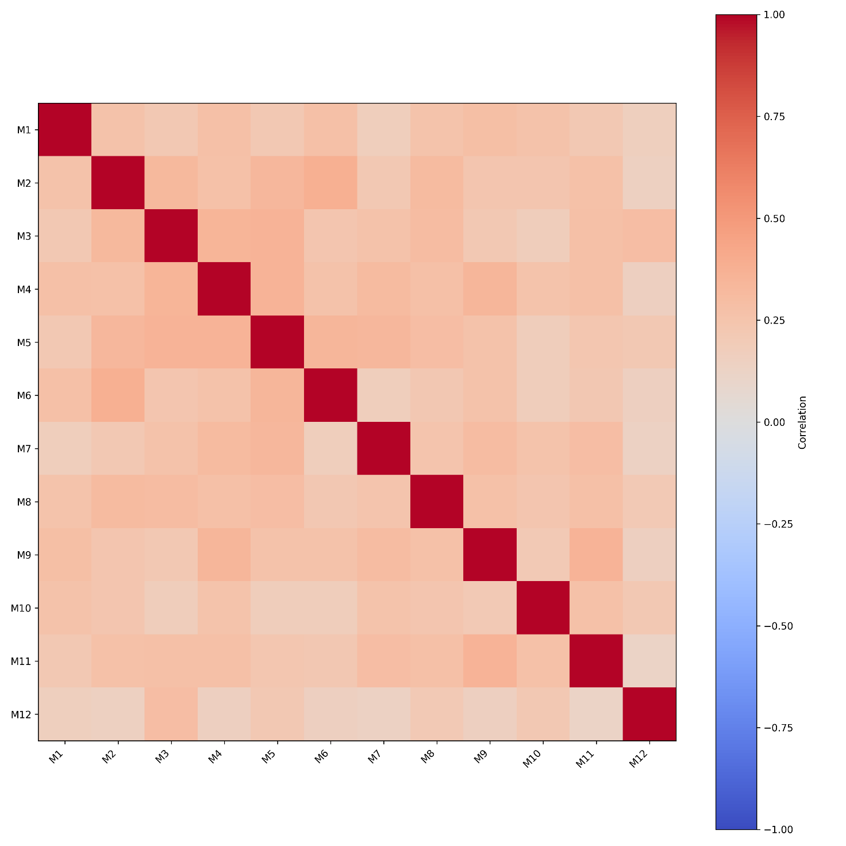
Supplementary figure 1. Spearman correlation between stations: Medicine programme (n=989)
Please refer to Table 1 (main manuscript) for the M1-M12 station details.

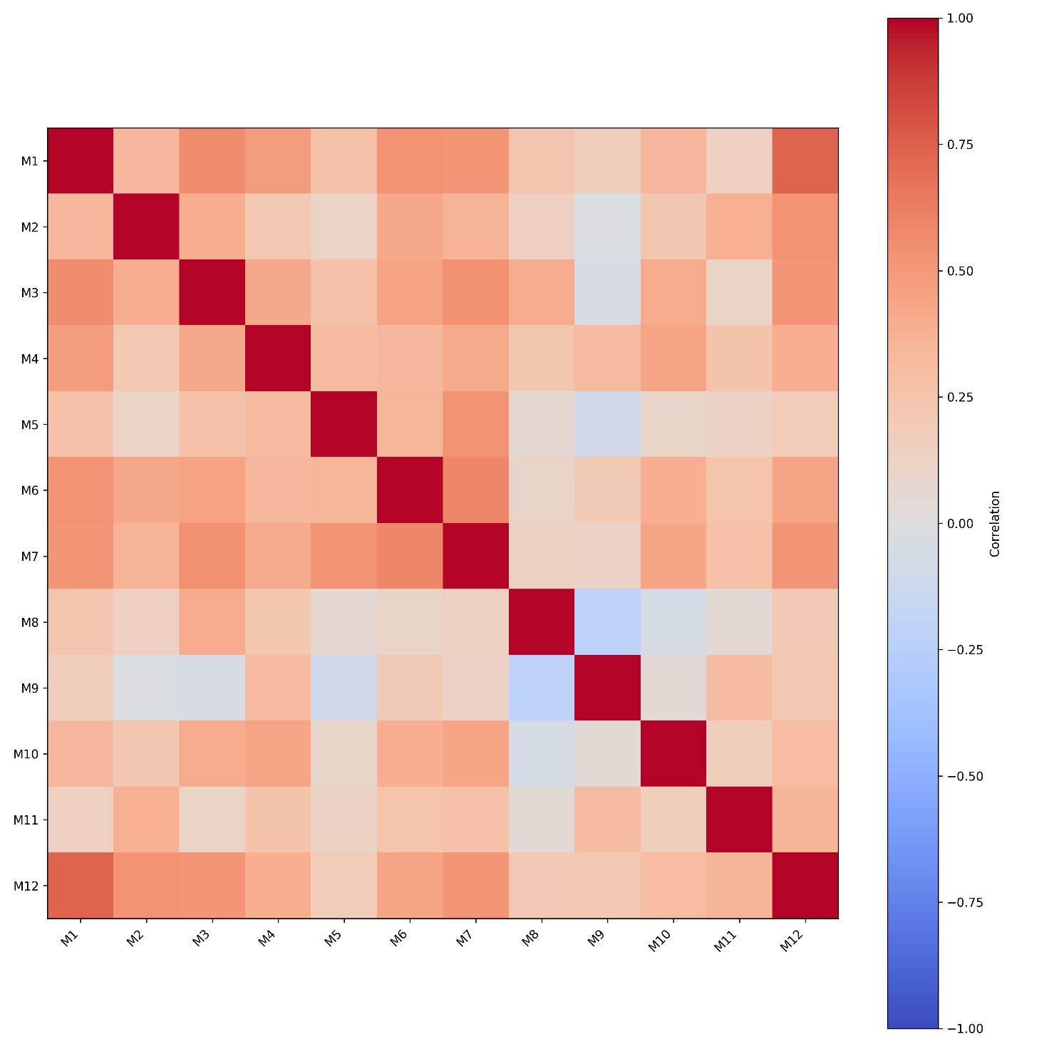
Supplementary figure 2. Spearman correlation between stations: Medicine for Armed Forces programme (n=40)
Please refer to Table 1 (main manuscript) for the M1-M12 station details.

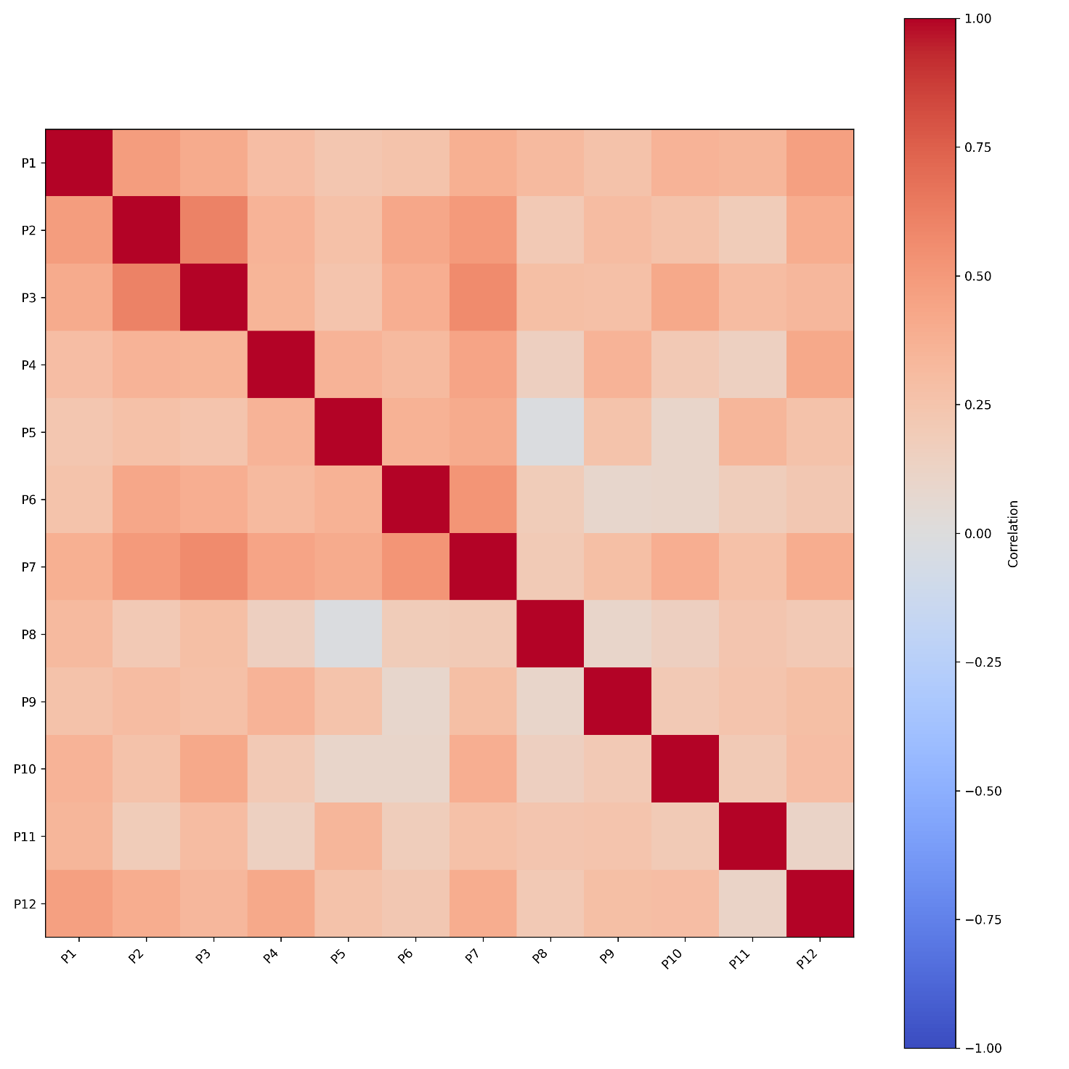
Supplementary figure 3. Spearman correlation between stations: Pediatrics programme (n=137)
Please refer to Table 1 (main manuscript) for the P1-P12 station details.

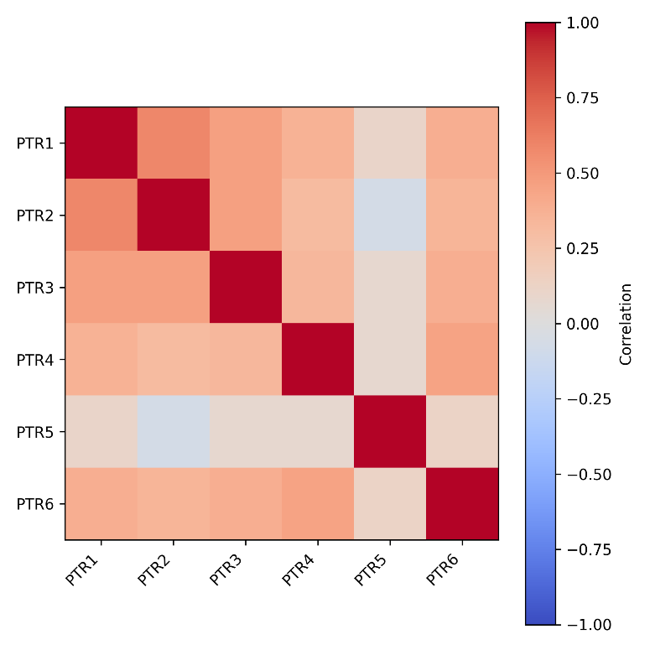
Supplementary figure 4. Spearman correlation between stations: Physical Therapy and Rehabilitation programme (n=67)
Please refer to Table 1 (main manuscript) for the PRT1-PRT6 station details.

Supplementary table 9. Descriptive statistics: final exam scores for all the programmes
Programme | n | Mean | SD | SE | CI lower | CI upper | Min | Max | Median | IQR
Medicine | 989 | 178.649 | 13.923 | 0.443 | 177.780 | 179.518 | 95.933 | 200.000 | 181.083 | 17.350
Medicine for the Armed Forces | 40 | 176.426 | 13.773 | 2.178 | 172.021 | 180.831 | 128.267 | 191.700 | 181.275 | 17.138
Pediatrics | 137 | 171.547 | 17.176 | 1.467 | 168.645 | 174.449 | 112.217 | 200.000 | 174.200 | 22.867
Physical Therapy and Rehabilitation | 67 | 168.936 | 19.633 | 2.399 | 164.147 | 173.725 | 110.834 | 197.224 | 175.557 | 20.556

Abbreviations: SD, standard deviation; SE, standard error; CI, 95% confidence interval; min, minimum; max, maximum; IQR, interquartile range.

Supplementary table 10. Comparison between programmes: final exam scores

Comparison | First programme in pairs |  | Second programme in pairs |  | Mann-Whitney statistics
Comparison | Mean 1 | SE 1 | Mean 2 | SE 2 | U | η² | p | p BH
Medicine vs  Medicine for the Armed Forces | 178.649 | 0.443 | 176.426 | 2.178 | 21835.000 | 0.035 | 2.65E-01 | 3.18E-01
Medicine vs  Pediatrics | 178.649 | 0.443 | 171.547 | 1.467 | 84679.000 | 0.141 | 2.07E-06 | 1.24E-05
Medicine vs  Physical Therapy and Rehabilitation | 178.649 | 0.443 | 168.936 | 2.399 | 43508.000 | 0.132 | 1.75E-05 | 5.24E-05
Medicine for the Armed Forces vs Pediatrics | 176.426 | 2.178 | 171.547 | 1.467 | 3170.500 | 0.113 | 1.32E-01 | 1.97E-01
Medicine for the Armed Forces vs  Physical Therapy and Rehabilitation | 176.426 | 2.178 | 168.936 | 2.399 | 1674.000 | 0.208 | 3.18E-02 | 6.35E-02
Pediatrics vs  Physical Therapy and Rehabilitation | 171.547 | 1.467 | 168.936 | 2.399 | 4909.000 | 0.056 | 4.20E-01 | 4.20E-01

Bold denotes significant differences after adjustment.
Medicine n=989, Medicine for the Armed Forces n=40, Pediatrics n=137, Physical Therapy and Rehabilitation n=67.
Abbreviations: SE, standard error; U, Mann-Whitney test statistics; η², effect size; p, p-value unadjusted; p BH, p-value adjusted by the Benjamini–Hochberg procedure.

