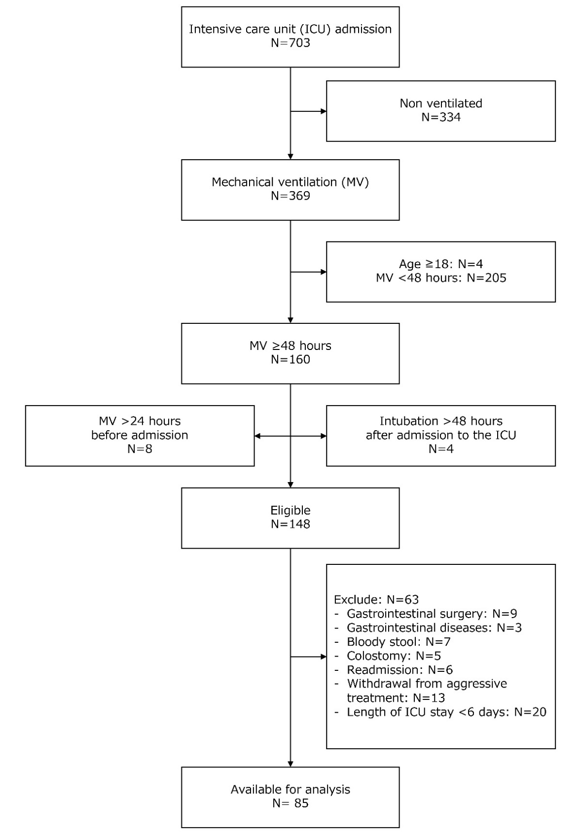
Supplementary Figure S1. Flow-chart of the study population.
This figure shows the flow-chart of participants with exclusion criteria, and the final enrolled patients.

