NO
NO
YES

YES
YES
On Immobilization/Simulation CT scan/X-ray Simulation

Emptied bladder

Measurement of BV by BVI 9400

Drank water 540ml immediately

Took every 0.5 hours

Measurement of BV
≥ 400ml by BVI 9400

Measurement of BV
≥ 600ml by BVI 9400

NO
Drain the moderation of urine

Whether chief Complaint
of urgency

Fig.1.Flow chart of measuring BV in three steps before radiotherapy.

YES
Measurement of bladder volume by BVI9400
A full bladder training before radiotherapy
Emptying bladder
Drinking water 540mL immediately

Suppressing urine
Recording the BV
Radiotherapy
NO

Whether achieving
the planned BV
Complaint of “urgency”
Human intervention
Figure2. BV monitoring process during radiotherapy.

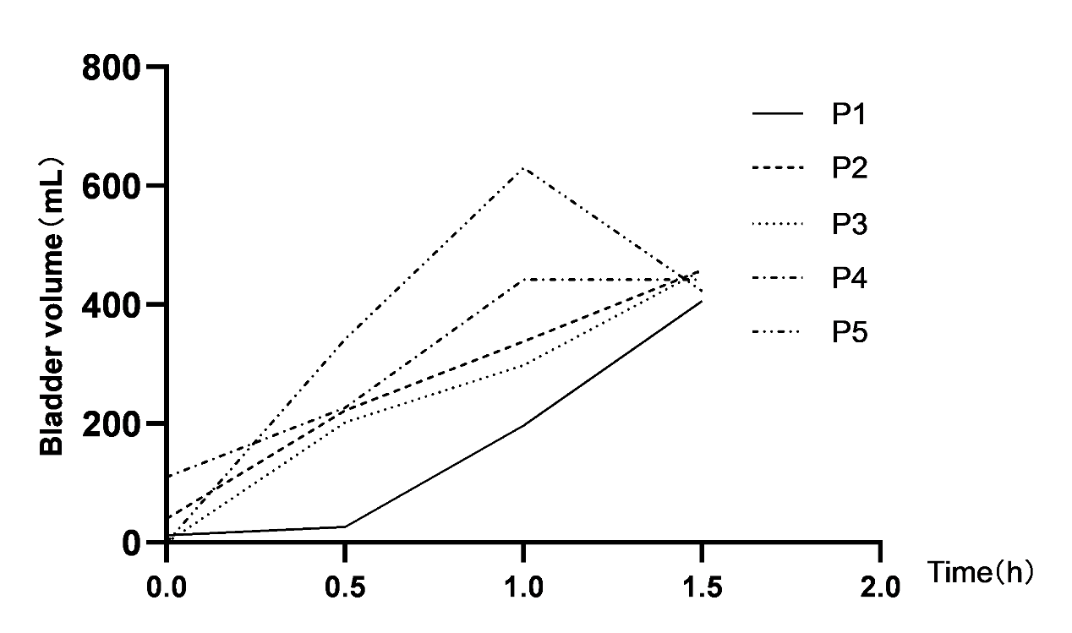
Fig. 3(a). Trend of the chief complaint of urgency in 5 typical patients.

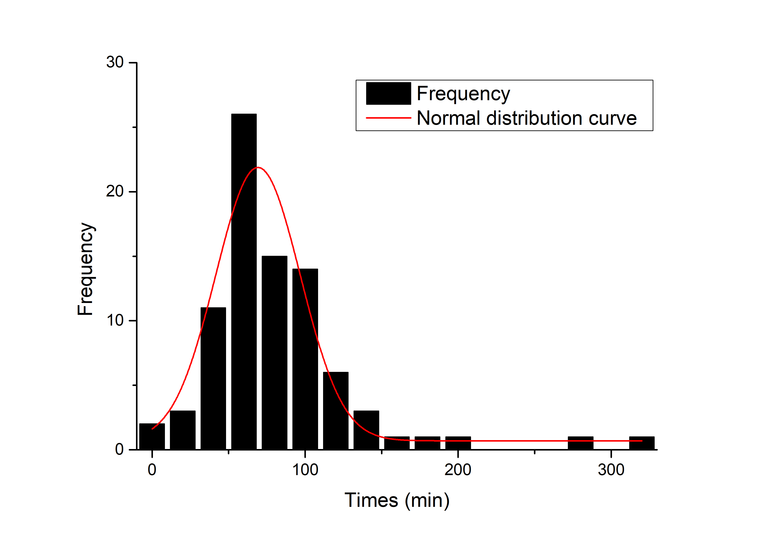
Fig.4(a). Time distribution about the chief complaint of urgency.

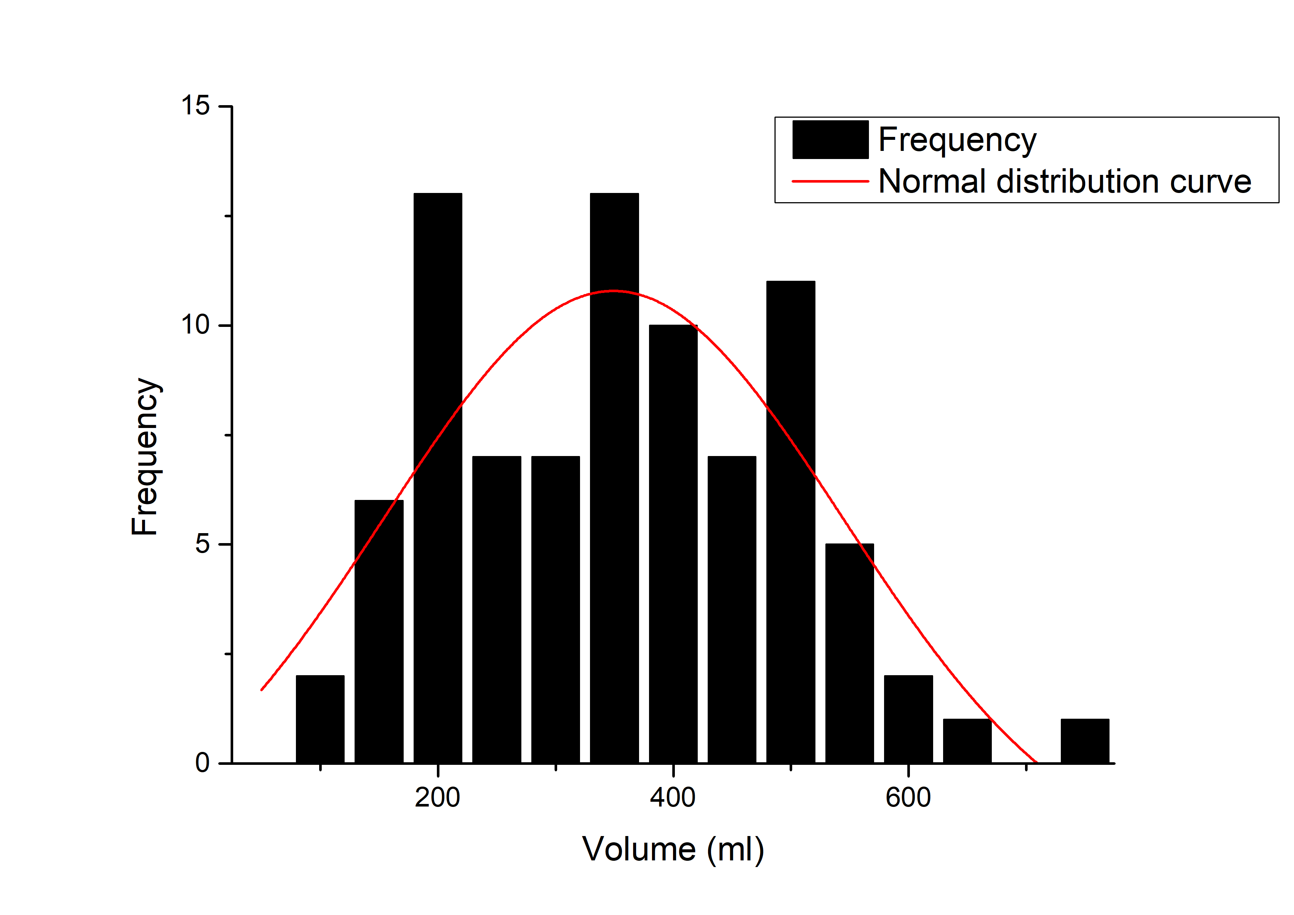
Fig.4(b). Volume distribution of the chief complaint of urgency.

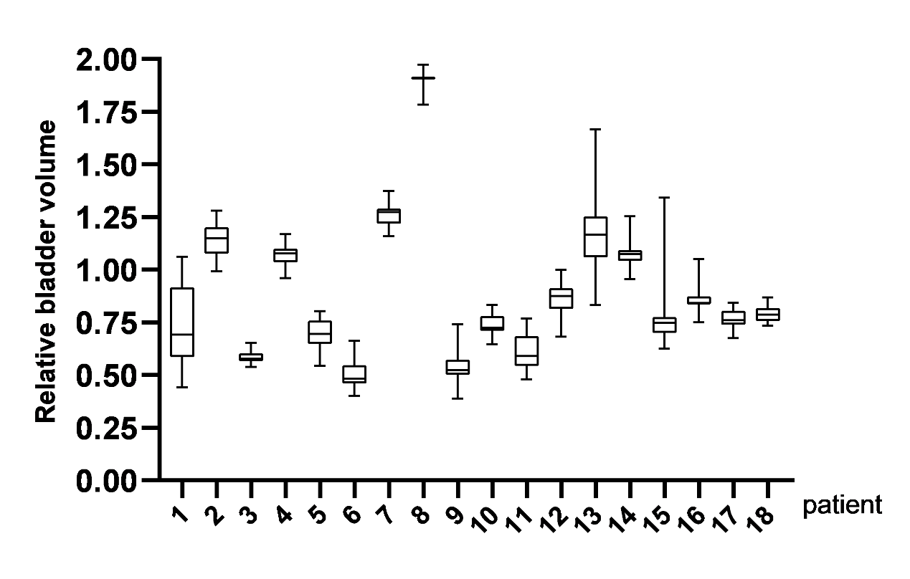
Fig.5. The RBV of 25 inter-fraction radiotherapy in 18 patients.

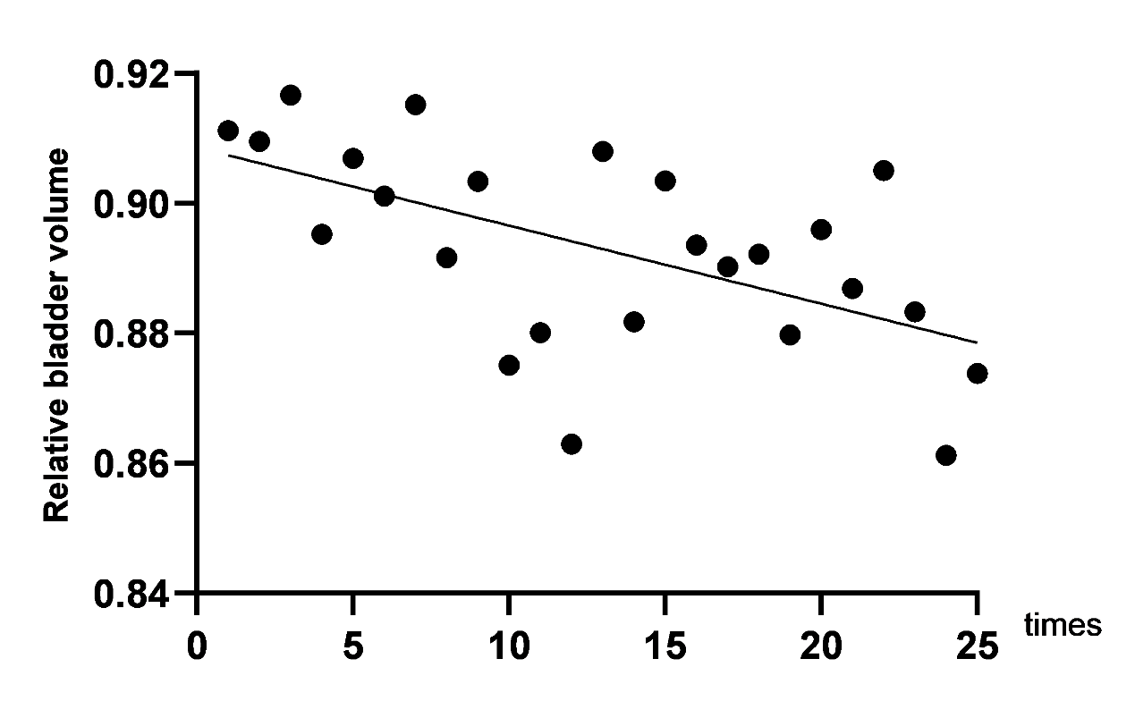
Fig.6. The RBV in 18 patients during inter-fraction radiotherapy. (p=0.0028, r= -0.5726; Y=-0.001201*X+0.9086)

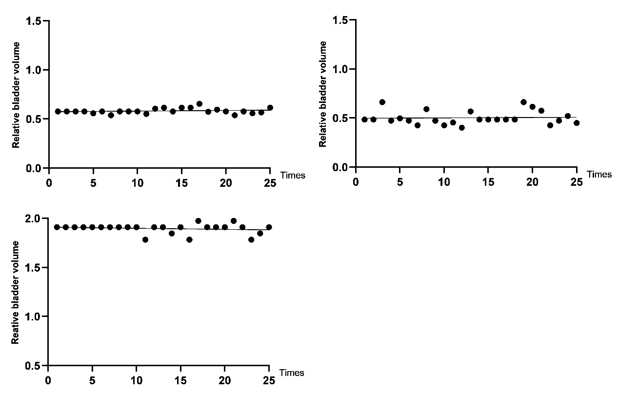
Fig. 7. Three patients’ BV failed.

