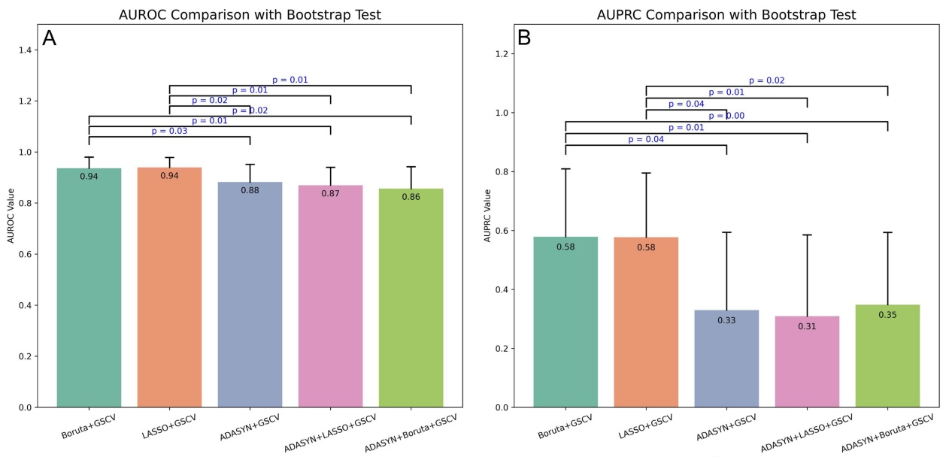
Figure S1: Comparison of fusion model performance across different data processing levels using bootstrap test. (A) Bootstrap test for AUROC comparison of processed fusion models. (B) Bootstrap test for AUPRC comparison of processed fusion models. Abbreviations: ADASYN, adaptive synthetic sampling; LASSO: least absolute shrinkage and selection operator; GSCV, grid search with cross-validation; AUROC, area under the receiver operating characteristic curve; AUPRC, area under the precision-recall curve.
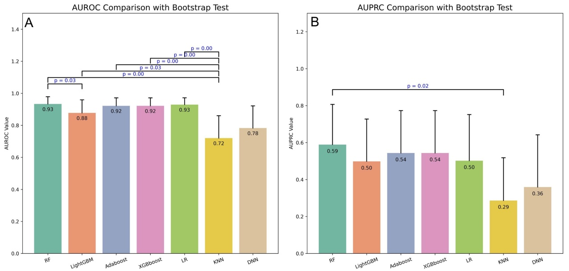
Figure S2: Comparison of fusion model performance across ML algorithms using bootstrap test. (A) Bootstrap test for AUROC comparison. (B) Bootstrap test for AUPRC comparison. Abbreviations: ML, machine learning; RF, random forest; LR, logistic regression; LightGBM, light gradient boosting machine; Adaboost: Adaptive Boosting; XGBoost, extreme gradient boosting; KNN, k-nearest neighbors; DNN, deep neural network; AUROC, area under the receiver operating characteristic curve; AUPRC, area under the precision-recall curve.

