Supplementary Figure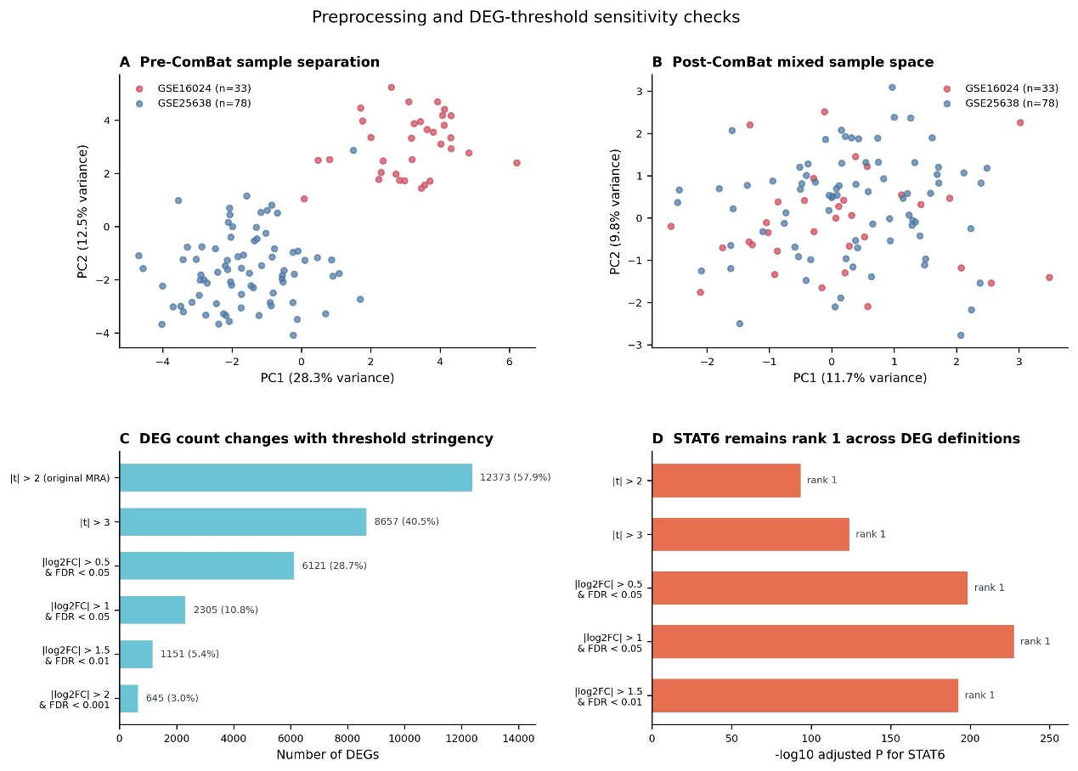
Supplementary Figure S1. Preprocessing and DEG-threshold sensitivity checks. (A,B) PCA before and after ComBat correction, showing reduction of batch-associated separation. (C) DEG counts across alternative threshold stringencies. (D) STAT6 MRA rank stability across DEG definitions.
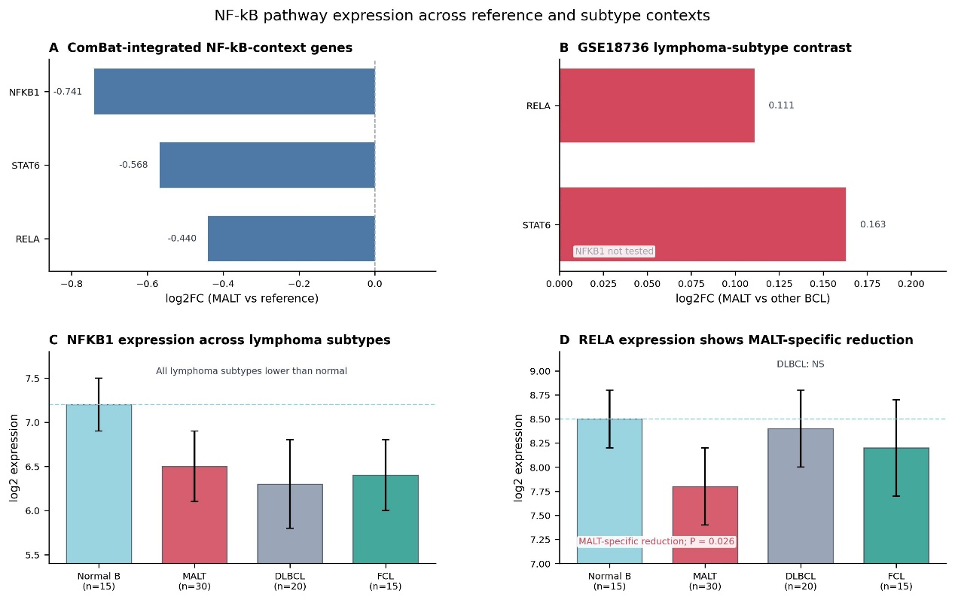
Supplementary Figure S2. NF-κB pathway expression across reference and subtype contexts, combining broad pathway-member context plots with focused NFKB1/RELA subtype comparisons.
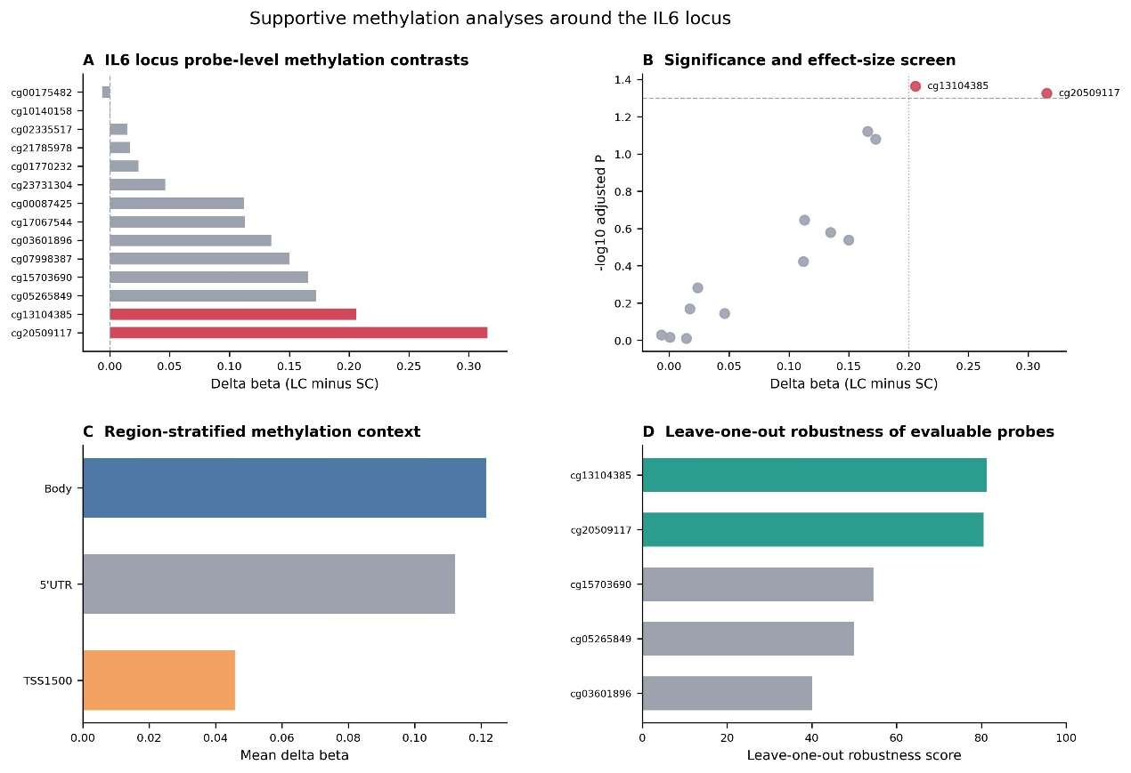
Supplementary Figure S3. Supportive IL6-locus methylation diagnostics, including probe-level delta beta, adjusted significance, region-stratified summaries, and leave-one-out robustness.
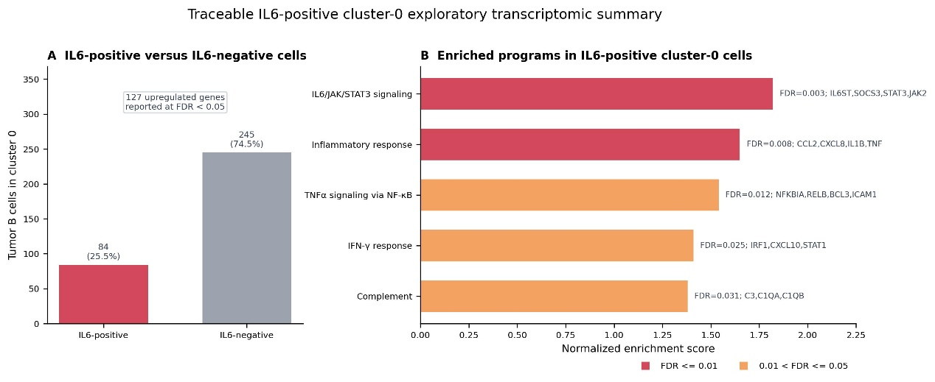
Supplementary Figure S4. Traceable IL6-positive cluster-0 exploratory transcriptomic summary. (A) Definition of the cluster-0 comparison, showing IL6-positive and IL6-negative cluster-0 cells used for the exploratory contrast. (B) Enriched programs among IL6-positive cluster-0 cells based on the reported pathway enrichment table; bars show normalized enrichment scores and labels provide adjusted P-values and leading-edge genes. Because the contrast is defined by IL6 detection, this panel is intended as exploratory transcriptional context rather than independent pathway validation.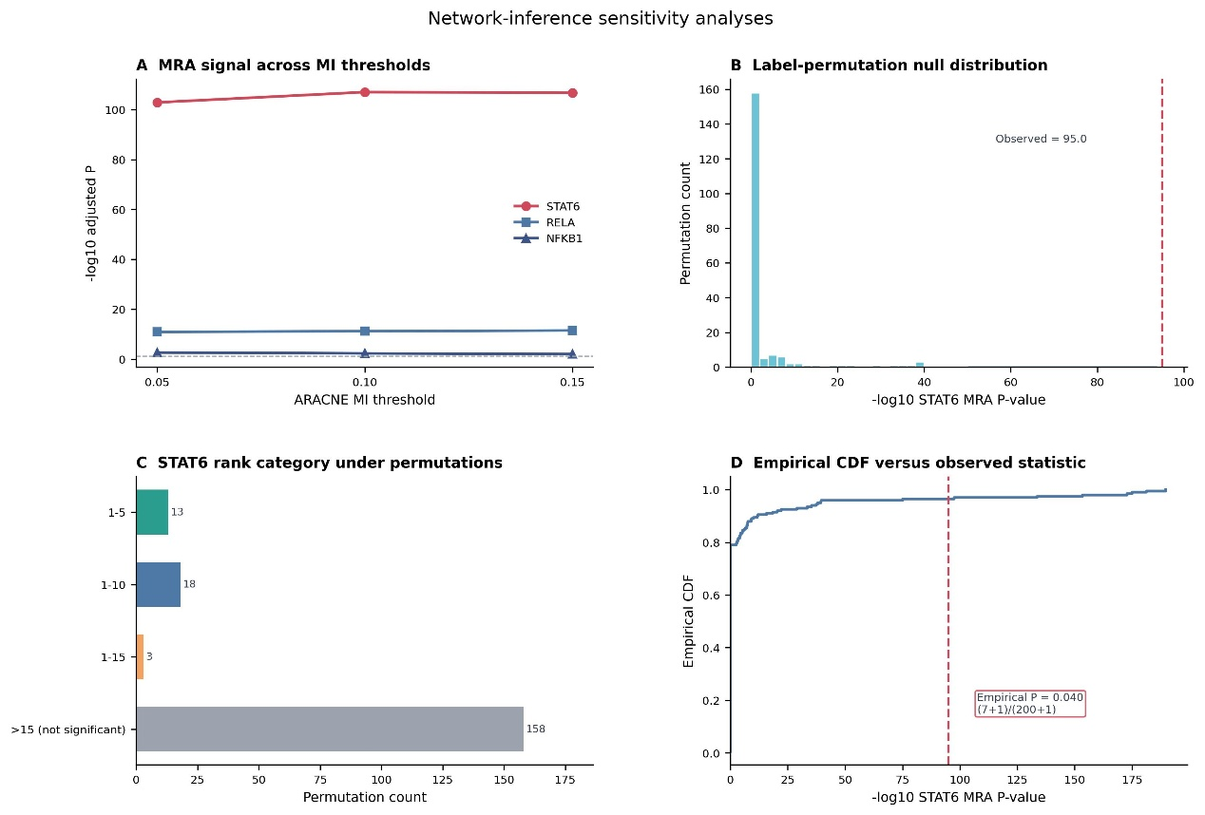
Supplementary Figure S5. Network-inference sensitivity analyses, combining ARACNE mutual-information threshold checks with MRA permutation-test robustness.
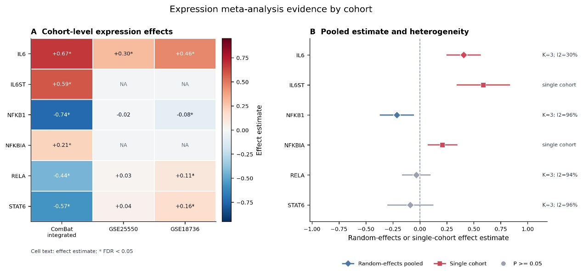
Supplementary Figure S6. Expression meta-analysis evidence by cohort for IL6, IL6ST, NFKB1, NFKBIA, RELA, and STAT6. (A) Cohort-level effect matrix; cell labels show effect estimates and asterisks denote FDR < 0.05, with unavailable cohort comparisons shown as NA. (B) Random-effects or single-cohort summary estimates with 95% confidence intervals; diamonds indicate pooled estimates, squares indicate single-cohort estimates, and right-side labels report K and I² where applicable.
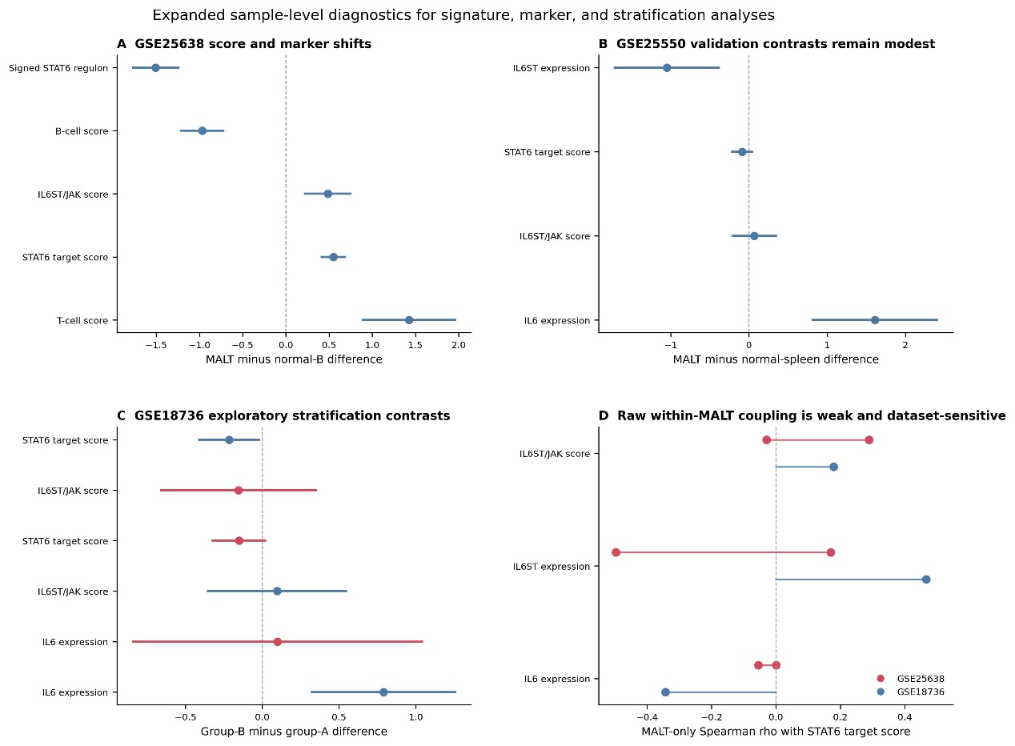
Supplementary Figure S7. Expanded sample-level diagnostics for signature, marker, and stratification analyses across GSE25638, GSE25550, and GSE18736, including group contrasts and within-MALT score coupling.
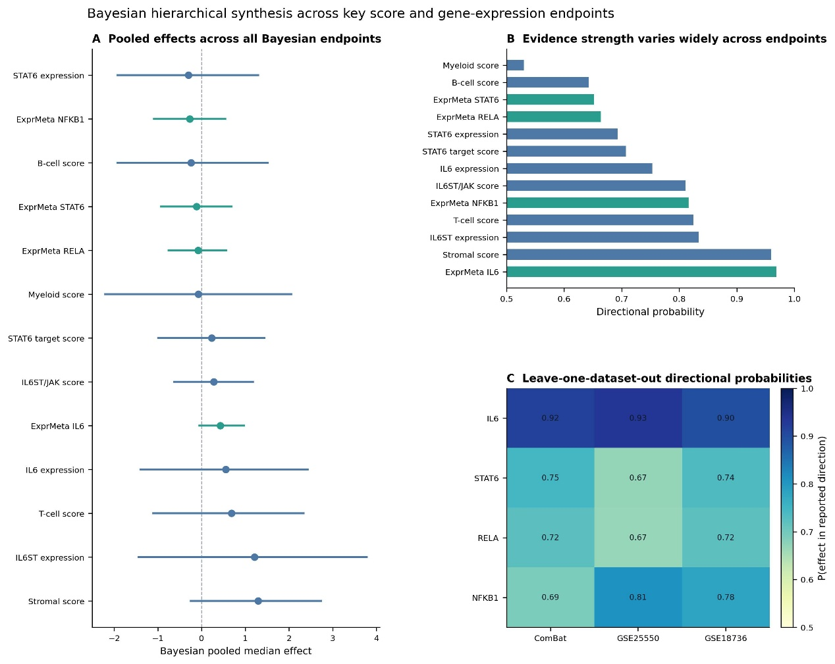
Supplementary Figure S8. Bayesian hierarchical evidence synthesis for key signature-score and gene-expression endpoints, including pooled effects, directional probabilities, and leave-one-dataset-out sensitivity.
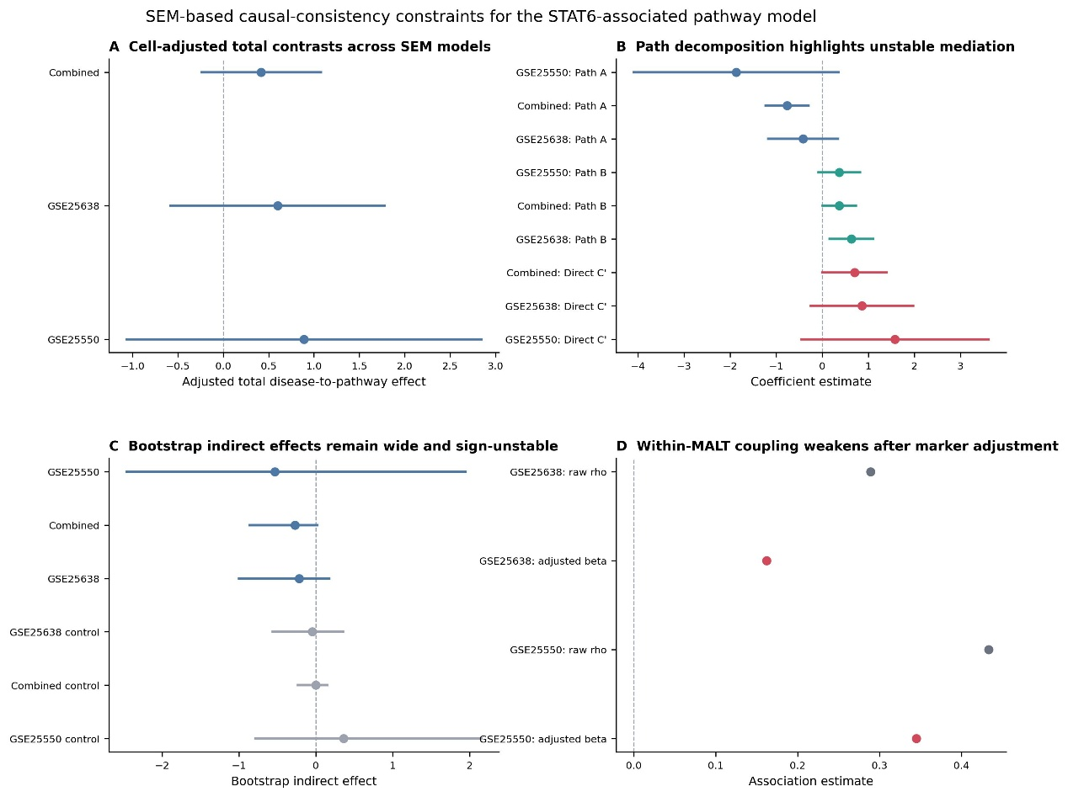
Supplementary Figure S9. SEM-based path-consistency constraints for the STAT6-associated pathway model, including cell-adjusted total contrasts, path decomposition, bootstrap indirect effects, and within-MALT adjusted associations.
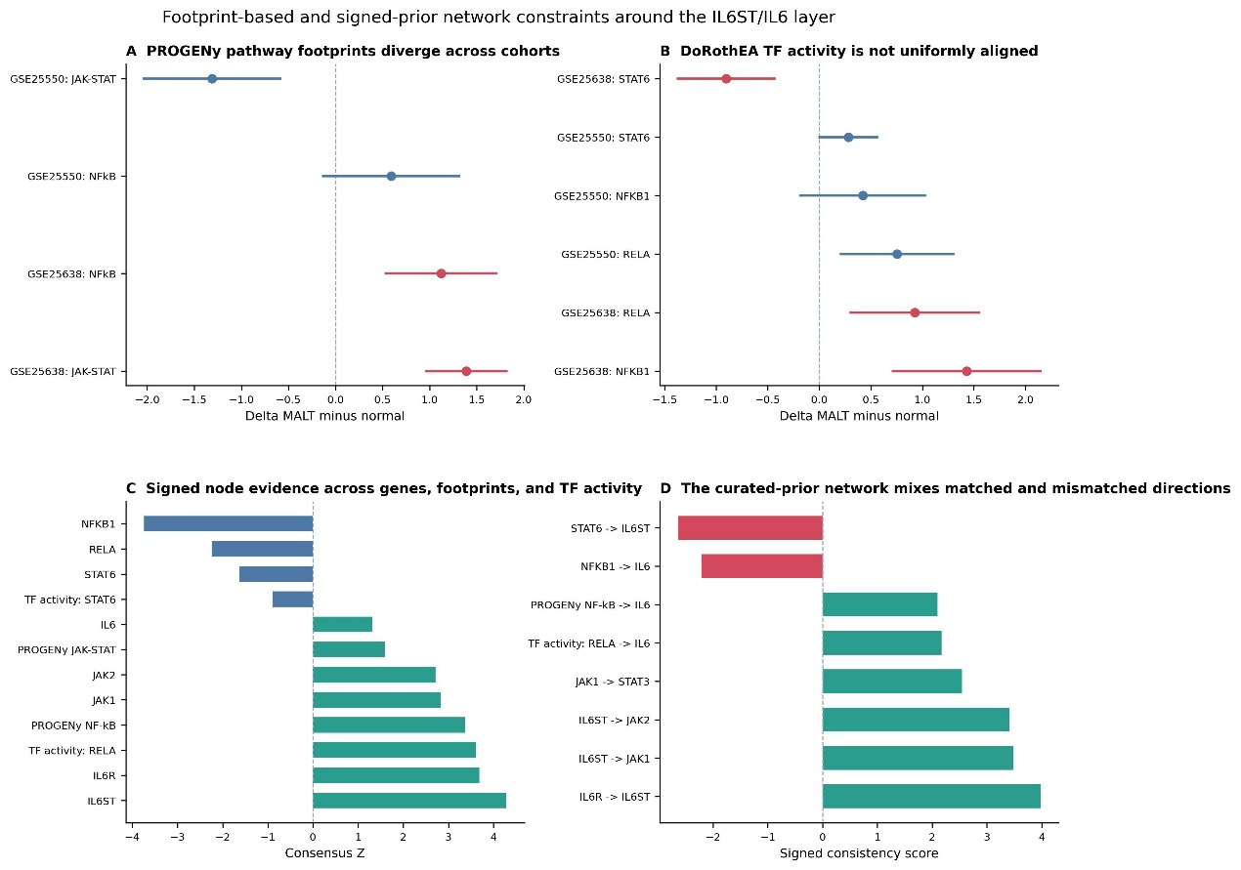
Supplementary Figure S10. PROGENy/DoRothEA footprint and signed-prior network constraints around the IL6ST/IL6 layer.
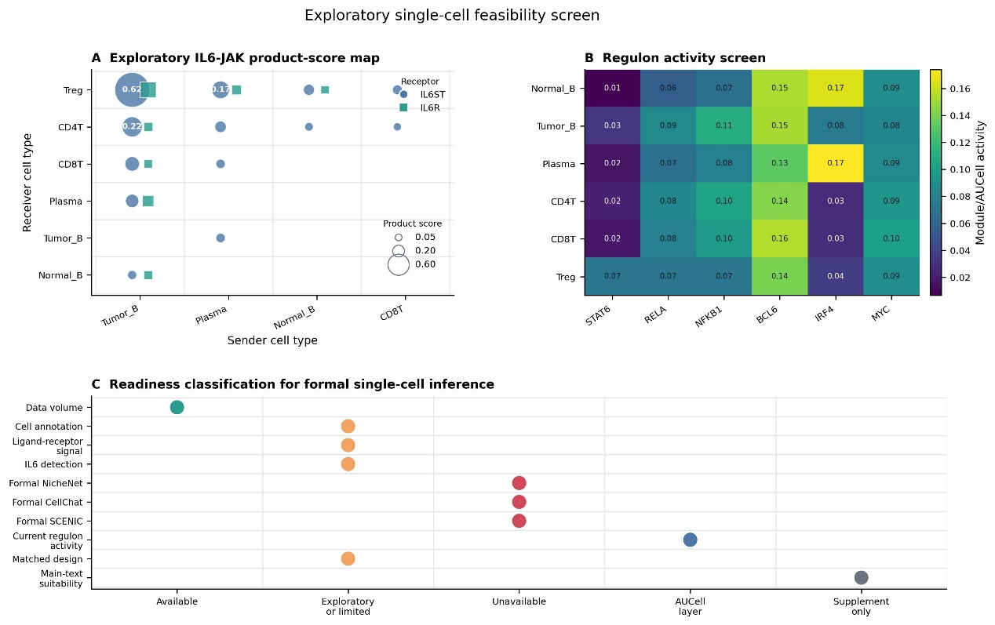
Supplementary Figure S11. Exploratory single-cell feasibility screen based on GSE239458-derived exported summaries. (A) Sender-by-receiver IL6-JAK product-score map, calculated as ligand expression in sender cells multiplied by receptor expression in receiver cells; circle and square markers denote IL6ST and IL6R, respectively, and bubble size reflects the exploratory product score. (B) Module/AUCell regulon activity screen across major cell types for STAT6, RELA, NFKB1, BCL6, IRF4, and MYC. (C) Readiness classification for formal single-cell inference, separating available, exploratory/limited, unavailable, AUCell-layer, and supplementary-only analysis components. This figure is hypothesis-generating and does not represent a formal CellChat, NicheNet, or full SCENIC inference.
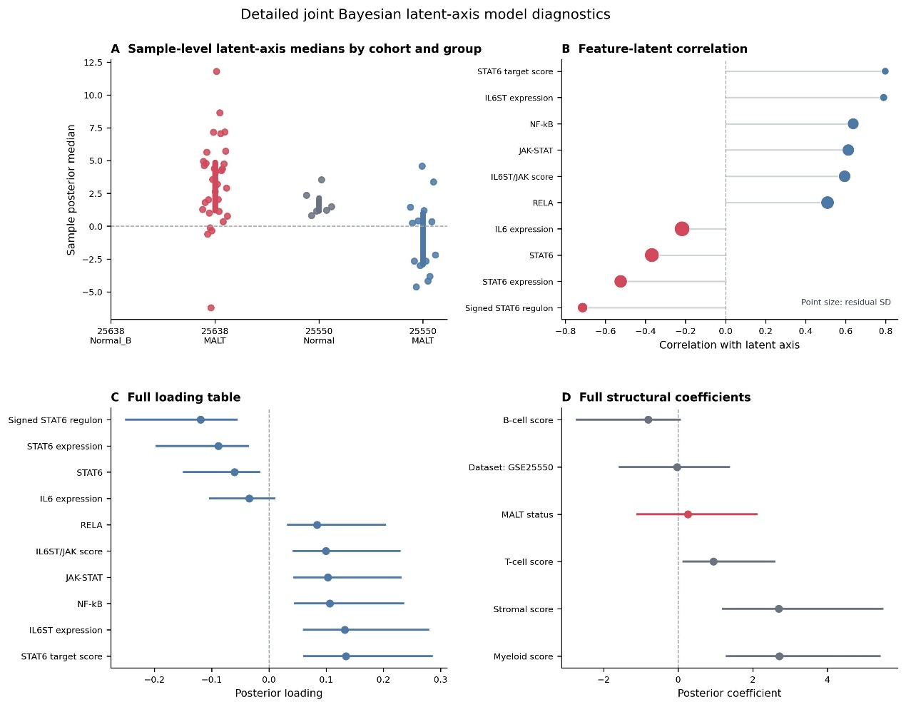
Supplementary Figure S12. Detailed joint Bayesian latent-axis model diagnostics, including sample-level posterior medians, feature-latent correlation diagnostics, and full loading/structural summaries.
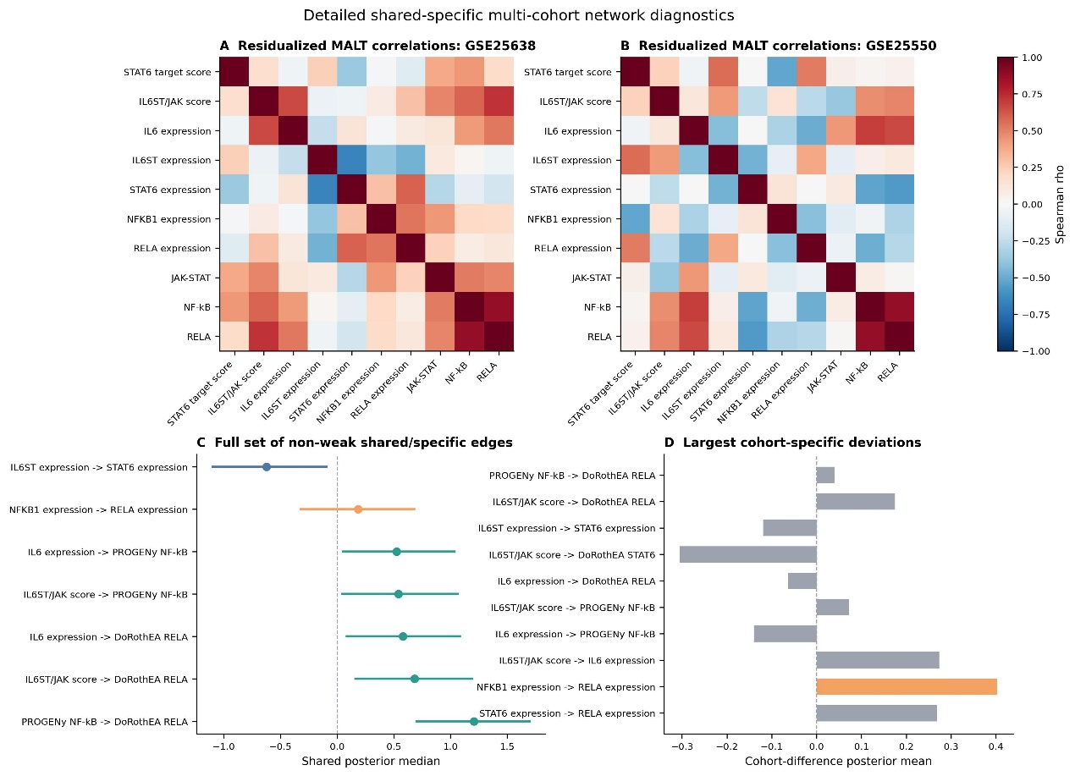
Supplementary Figure S13. Detailed shared-specific multi-cohort network diagnostics, including residualized MALT correlation matrices, non-weak shared/specific edges, and the largest cohort-specific deviations.
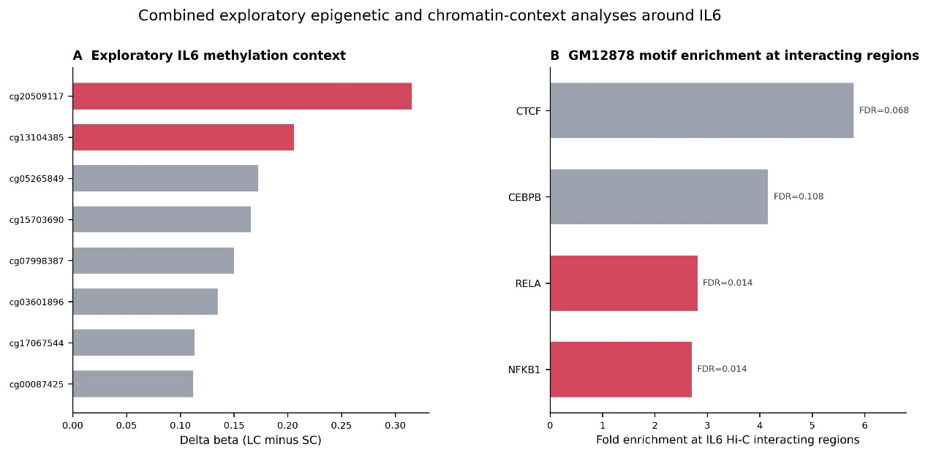
Supplementary Figure S14. Combined exploratory epigenetic and chromatin-context analyses around IL6, with IL6 methylation observations in panel A and GM12878 motif-enrichment context at IL6 Hi-C interacting regions in panel B.

