Table S1. Primers used for RT-qPCR
Gene name | Primer Sequence (5' -3') | Length (bp) | Tm (℃)
General bacteria | F: CGGCAACGAGCGCAACCC | 130 | 60
 | R: CCATTGTAGCACGTGTGTAGCC
Prevotella | R: ACCTTATGATGGCAACTAACAATA | 418 | 56
 | F: GAAGGTCCCCCACATTG
F. succinogenes | F: GTTCGGAATTACTGGGCGTAAA | 121 | 56
 | R: CGCCTGCCCCTGAACTATC
R. albus | F: CCCTAAAAGCAGTCTTAGTTCG | 175 | 55
 | R: CCTCCTTGCGGTTAGAACA
General protozoa | F: TTCCTAGAGATAGGAAGTTTCTTCGG | 275 | 60
 | R: GATGGCACTAGATGTCAAGACC
Entodinium | F: CAGCTAATACATGCTAAGGC | 260 | 60
 | R: CCCTCACTACAATCGAGATTTAAGG

Table S2. Topological properties of bacterial network between HY and LY groups.
Group | HY | LY
nodes | 152 | 161
Edges | 1490 | 1711
Modularity (MD) | 0.388 | 0.397
Clustering coefficient (CC) | 0.5 | 0.54
Average path length (APL) | 2.464 | 2.357
Graph density (GD) | 0.13 | 0.133
Average degree (AD) | 19.605 | 21.255

Table S3. Key Enzymes and Source Bacteria Associated with Propionate Production.
Enzyme | Source Bacterium | GenBank
Malate dehydrogenase | Succiniclasticum runitvis DSM 9236 | SFE68090.1
Methylmalonyl-CoA mutase | Succiniclasticum runitvis DSM 9236 | SFE43830.1
Methylmalonyl-CoA epimerase | Succiniclasticum runitvis | WP_093912429.1
Fumarase | Succiniclasticum runitvis | SDC72196.1
Succinate dehydrogenase | Prevotella fusca JCM 17724 | AKU69390.1

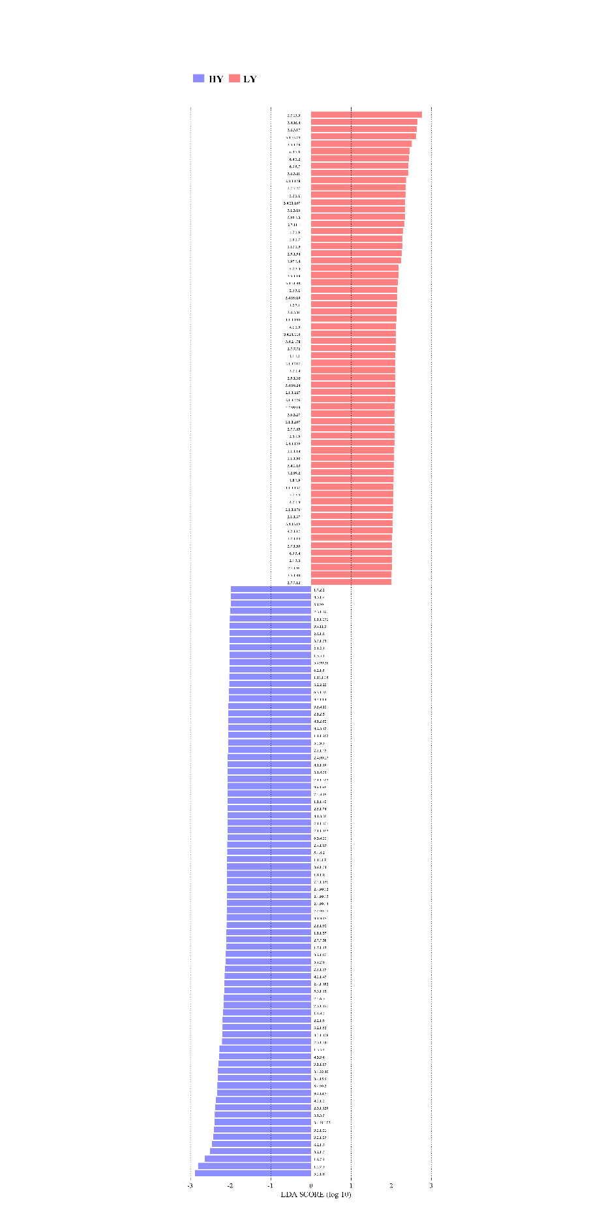
Fig S1. LEFSe plot of differential KEGG metabolic enzymes (P < 0.05, LDA > 2.0) in the HY and LY groups.

