Supplement
Table1. Based on voxels, the gray matter density results obtained from VBM analysis were subjected to one-way ANOVA for three groups, with total intracranial volume (TIV), age, and years of education as covariates, and an absolute threshold of 0.2. F greater than 0 represents significant differences in brain regions among the three groups, with the significance standard being voxel level FWE correction, voxel p<0.05。
Differential brain regions | MNI peak coordinates |  |  | F value | Cluster size
Differential brain regions | X | Y | Z | F value | Cluster size
ParaHippocampal_L | -21 | -13.5 | -25.5 | 18.1667 | 48
ParaHippocampal_R | 31.5 | -28.5 | -15 | 18.0958 | 121
Fusiform_L | -33 | -37.5 | -18 | 18.3569 | 109
Rectus_R | 15 | 15 | -12 | 19.0352 | 79
Putamen_R | 28.5 | 15 | -4.5 | 16.5297 | 19
Frontal_Mid_L | -37.5 | 45 | 7.5 | 18.0081 | 40

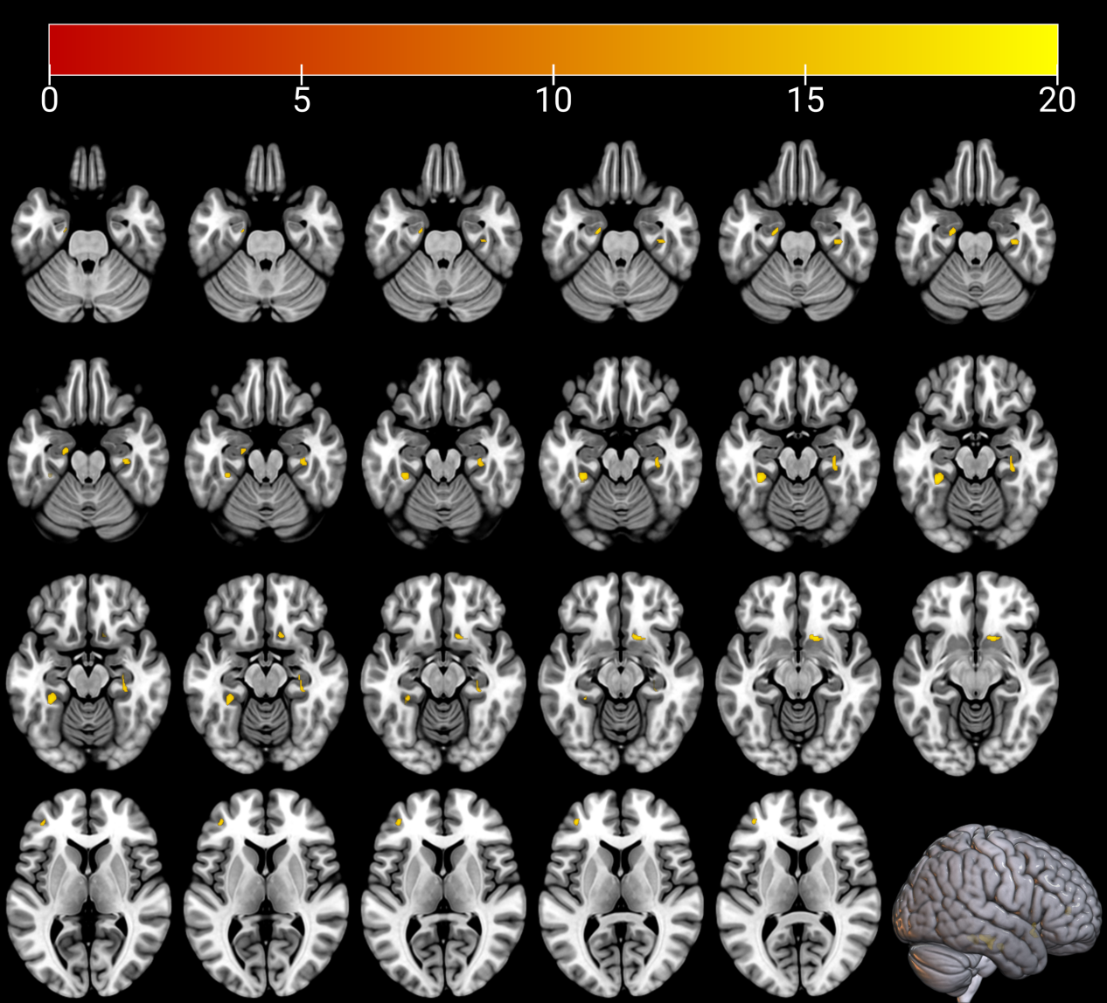
Table1.Visual difference chart.Three views covering significant brain regions on the MNI152 standard map.

