Table 1 Sample Information
Sample ID | Color | Size/cm（Length×Width×Height） | Description | Sample Pictures | Analytical Techniques
S1 | Blue | 1.40×1.20×0.70 | Impurity, containing white mineral particles among the blue grains | 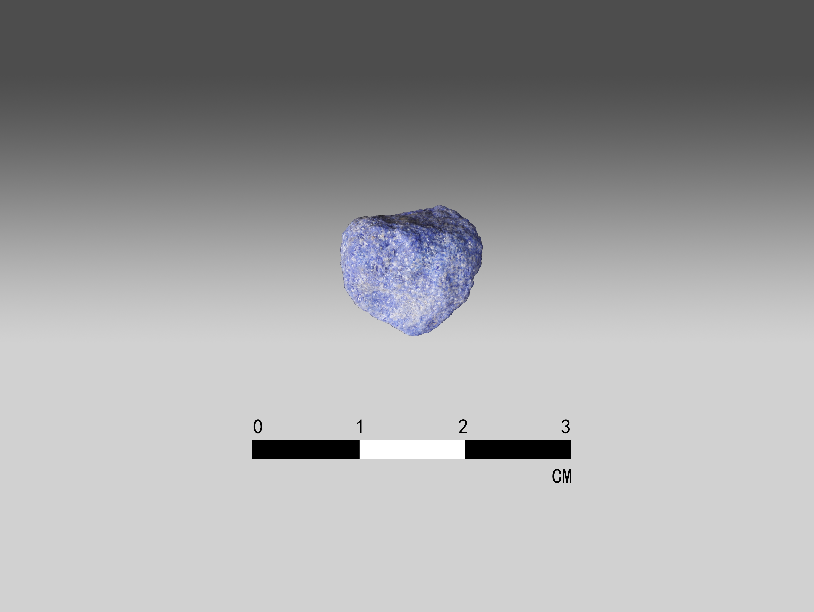 | DM; PLM; SEM-EDS; XRD; μ‑RS
S2 | Red | 3.20×2.50×0.90 | high-purity；with few impurities | 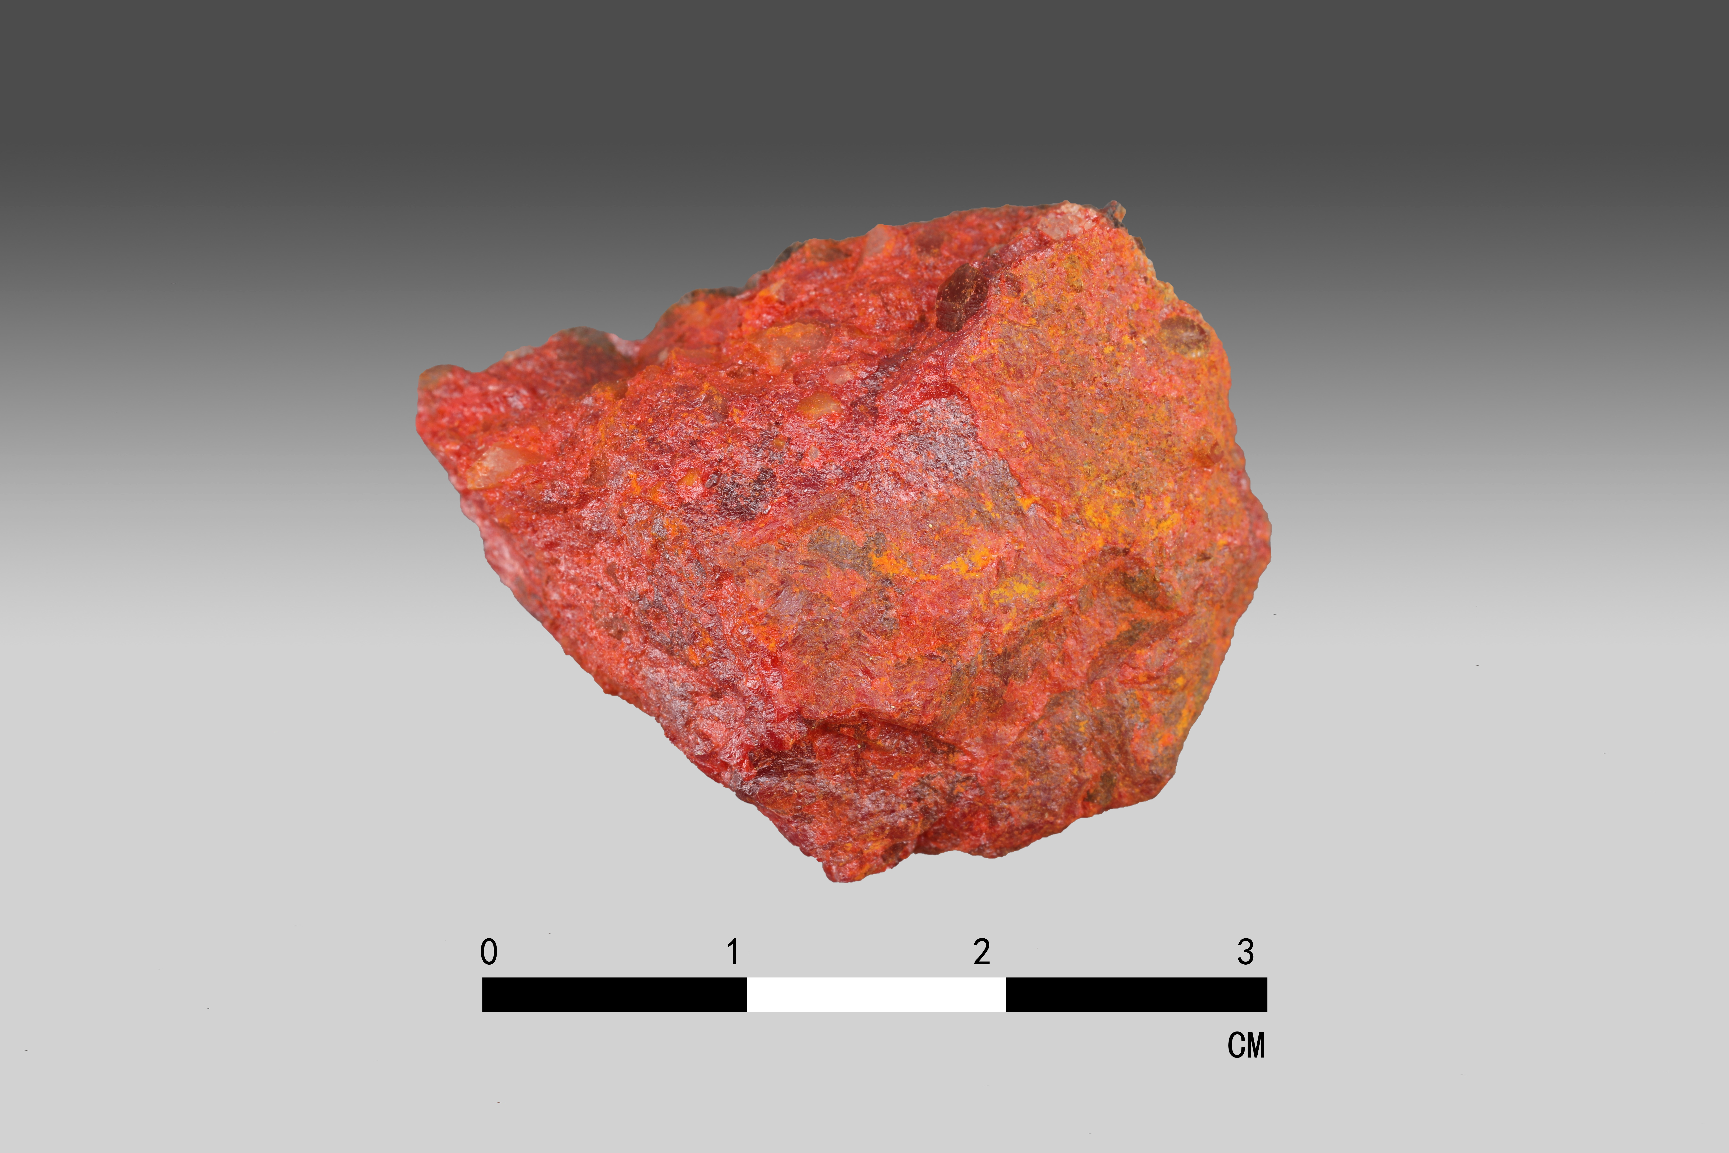 | DM; SEM-EDS; XRD; μ‑RS
S3 | Yellow | 3.60×1.90×0.40 | high-purity | 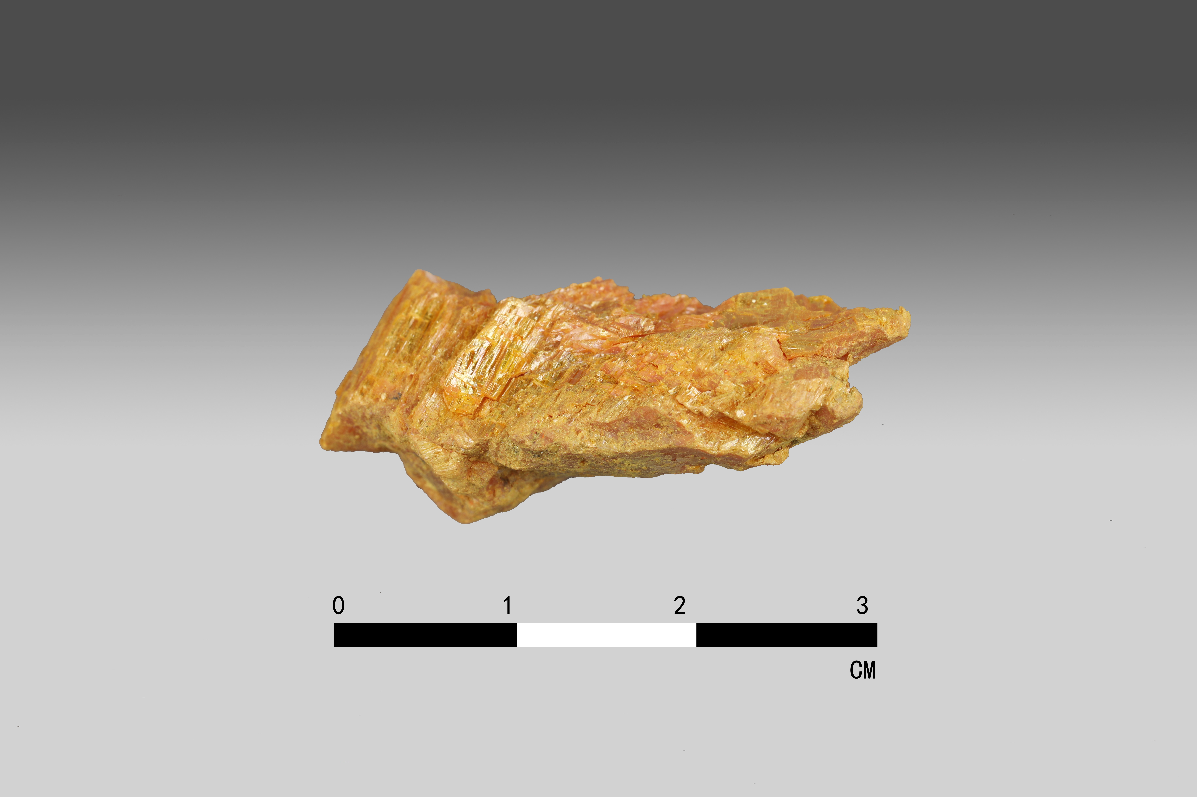 | DM; SEM-EDS; XRD; μ‑RS
S4 | Black | 2.40×1.60×0.70 | high-purity | 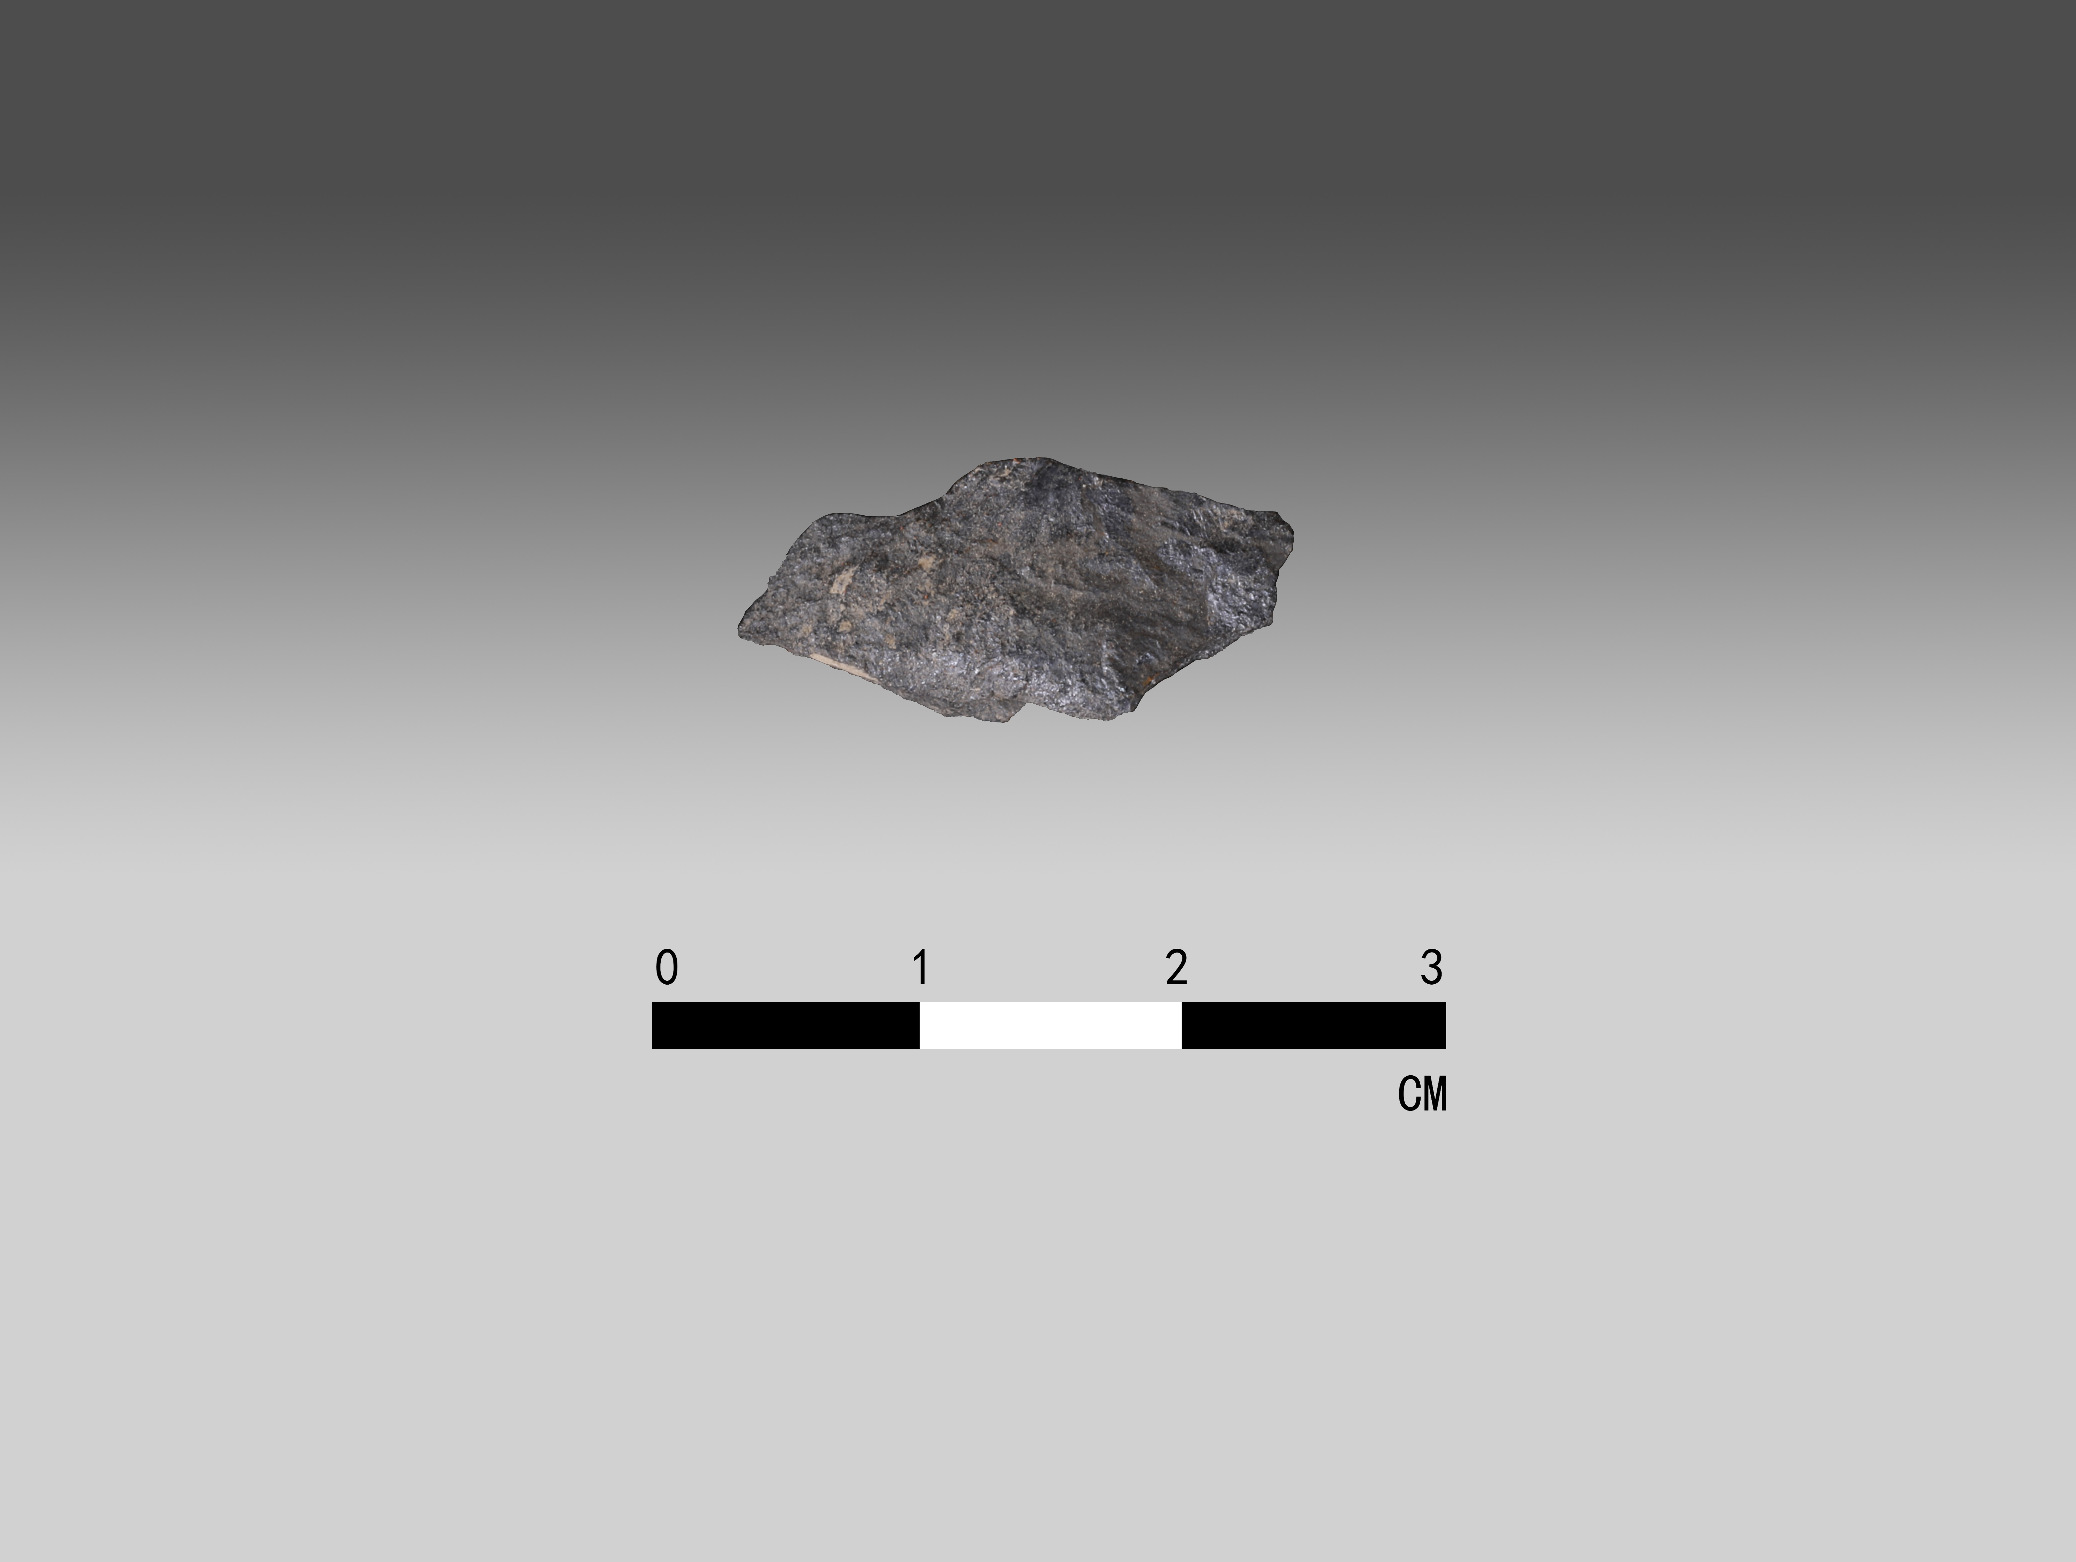 | DM; SEM-EDS; XRD
S5 | White | 1.80×1.50×0.80 | White, pure, transparent, exhibiting a conchoidal fracture | 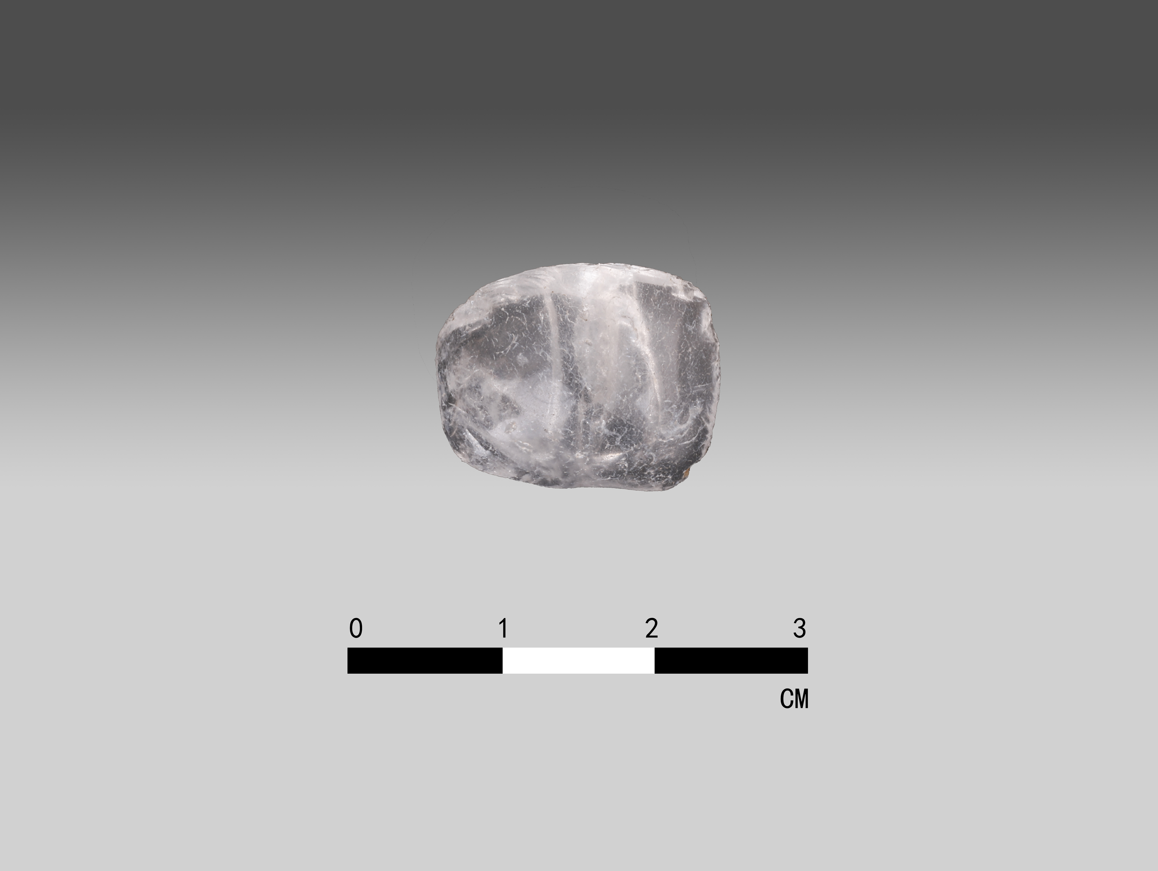 | DM; SEM-EDS; FTIR; μ‑RS

