Supplementary Material
Supplementary materials include the PRISMA 2020 flow diagram, completed PRISMA 2020 checklist, reviewer calibration procedures, conflict resolution workflow, and meta-analysis diagnostics.
Systematic Review Procedures, Reviewer Calibration, Conflict Resolution Protocol, and Meta-analysis Diagnostics
(Related to: Tire Microplastic Generation under Extreme Conditions: A Comparative Assessment of Transportation and Mining Sectors)

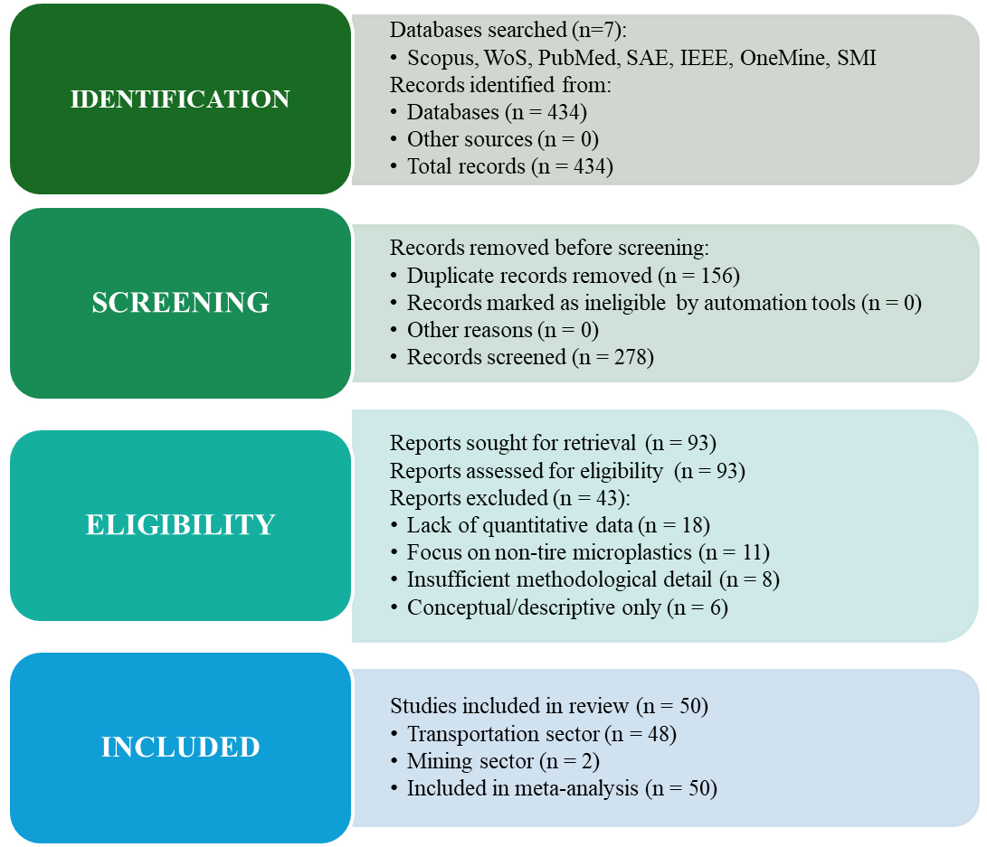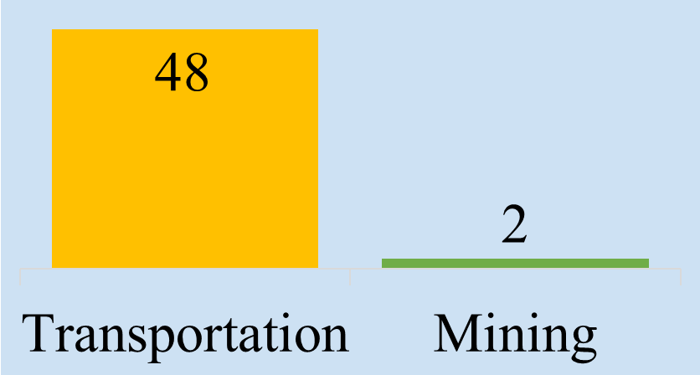
Figure S1. Preferred Reporting Items for Systematic Reviews and Meta-Analyses (PRISMA) 2020 flow diagram for the systematic review
PRISMA 2020 Checklist (Page et al., 2021)
Section and Topic | Item # | Checklist item | Location where item reported
TITLE
Title | 1 | Identify the report as a systematic review.
ABSTRACT
Abstract | 2 | See the PRISMA 2020 for Abstracts checklist.
INTRODUCTION
Rationale | 3 | Describe the rationale for the review in the context of existing knowledge.
Objectives | 4 | Provide an explicit statement of the objective(s) or question(s) the review addresses.
METHODS
Eligibility criteria | 5 | Specify the inclusion and exclusion criteria for the review and how studies were grouped for the syntheses.
Information sources | 6 | Specify all databases, registers, websites, organisations, reference lists and other sources searched or consulted to identify studies. Specify the date when each source was last searched or consulted.
Search strategy | 7 | Present the full search strategies for all databases, registers and websites, including any filters and limits used.
Selection process | 8 | Specify the methods used to decide whether a study met the inclusion criteria of the review, including how many reviewers screened each record and each report retrieved, whether they worked independently, and if applicable, details of automation tools used in the process.
Data collection process | 9 | Specify the methods used to collect data from reports, including how many reviewers collected data from each report, whether they worked independently, any processes for obtaining or confirming data from study investigators, and if applicable, details of automation tools used in the process.
Data items | 10a | List and define all outcomes for which data were sought. Specify whether all results that were compatible with each outcome domain in each study were sought (e.g. for all measures, time points, analyses), and if not, the methods used to decide which results to collect.
Data items | 10b | List and define all other variables for which data were sought (e.g. participant and intervention characteristics, funding sources). Describe any assumptions made about any missing or unclear information.
Study risk of bias assessment | 11 | Specify the methods used to assess risk of bias in the included studies, including details of the tool(s) used, how many reviewers assessed each study and whether they worked independently, and if applicable, details of automation tools used in the process.
Effect measures | 12 | Specify for each outcome the effect measure(s) (e.g. risk ratio, mean difference) used in the synthesis or presentation of results.
Synthesis methods | 13a | Describe the processes used to decide which studies were eligible for each synthesis (e.g. tabulating the study intervention characteristics and comparing against the planned groups for each synthesis (item #5)).
Synthesis methods | 13b | Describe any methods required to prepare the data for presentation or synthesis, such as handling of missing summary statistics, or data conversions.
Synthesis methods | 13c | Describe any methods used to tabulate or visually display results of individual studies and syntheses.
Synthesis methods | 13d | Describe any methods used to synthesize results and provide a rationale for the choice(s). If meta-analysis was performed, describe the model(s), method(s) to identify the presence and extent of statistical heterogeneity, and software package(s) used.
Synthesis methods | 13e | Describe any methods used to explore possible causes of heterogeneity among study results (e.g. subgroup analysis, meta-regression).
Synthesis methods | 13f | Describe any sensitivity analyses conducted to assess robustness of the synthesized results.
Reporting bias assessment | 14 | Describe any methods used to assess risk of bias due to missing results in a synthesis (arising from reporting biases).
Certainty assessment | 15 | Describe any methods used to assess certainty (or confidence) in the body of evidence for an outcome.
RESULTS
Study selection | 16a | Describe the results of the search and selection process, from the number of records identified in the search to the number of studies included in the review, ideally using a flow diagram.
Study selection | 16b | Cite studies that might appear to meet the inclusion criteria, but which were excluded, and explain why they were excluded.
Study characteristics | 17 | Cite each included study and present its characteristics.
Risk of bias in studies | 18 | Present assessments of risk of bias for each included study.
Results of individual studies | 19 | For all outcomes, present, for each study: (a) summary statistics for each group (where appropriate) and (b) an effect estimate and its precision (e.g. confidence/credible interval), ideally using structured tables or plots.
Results of syntheses | 20a | For each synthesis, briefly summarise the characteristics and risk of bias among contributing studies.
Results of syntheses | 20b | Present results of all statistical syntheses conducted. If meta-analysis was done, present for each the summary estimate and its precision (e.g. confidence/credible interval) and measures of statistical heterogeneity. If comparing groups, describe the direction of the effect.
Results of syntheses | 20c | Present results of all investigations of possible causes of heterogeneity among study results.
Results of syntheses | 20d | Present results of all sensitivity analyses conducted to assess the robustness of the synthesized results.
Reporting biases | 21 | Present assessments of risk of bias due to missing results (arising from reporting biases) for each synthesis assessed.
Certainty of evidence | 22 | Present assessments of certainty (or confidence) in the body of evidence for each outcome assessed.
DISCUSSION
Discussion | 23a | Provide a general interpretation of the results in the context of other evidence.
Discussion | 23b | Discuss any limitations of the evidence included in the review.
Discussion | 23c | Discuss any limitations of the review processes used.
Discussion | 23d | Discuss implications of the results for practice, policy, and future research.
OTHER INFORMATION
Registration and protocol | 24a | Provide registration information for the review, including register name and registration number, or state that the review was not registered.
Registration and protocol | 24b | Indicate where the review protocol can be accessed, or state that a protocol was not prepared.
Registration and protocol | 24c | Describe and explain any amendments to information provided at registration or in the protocol.
Support | 25 | Describe sources of financial or non-financial support for the review, and the role of the funders or sponsors in the review.
Competing interests | 26 | Declare any competing interests of review authors.
Availability of data, code and other materials | 27 | Report which of the following are publicly available and where they can be found: template data collection forms; data extracted from included studies; data used for all analyses; analytic code; any other materials used in the review.

S1. Reviewer Calibration Protocol
A calibration exercise was performed prior to formal screening to ensure consistent application of eligibility criteria by the two independent reviewers.
S1.1. Calibration Set
A random set of 30 records (approximately 11 percent of the 278 unique citations) was selected. The set intentionally included studies likely to be included, excluded, or considered borderline based on titles and abstracts.
S1.2. Calibration Procedure
- Both reviewers independently screened the 30 records using the pilot-tested screening tool in Covidence.
- Reviewers applied the eligibility criteria defined in Section 2.2 of the main manuscript and assigned each record as Include, Exclude, or Maybe.
- A calibration meeting was held immediately after independent review.
S1.3. Calibration Meeting Outcomes
- Initial inter-rater reliability
The initial Cohen Kappa statistic was 0.78, which reflects substantial agreement.
- Discussion of discrepancies
Four disagreements were identified. The main sources of disagreement were:
  - Clarification of the definition of extractable numerical data. Reviewers agreed that numerical values (e.g., emission factors, concentrations) or digitizable graphical data were necessary for inclusion.
  - Consistency in defining mining-related heavy vehicles. Reviewers agreed that quarry and large construction machinery would be included due to comparable operating conditions and wear mechanisms.
- Refinement of criteria
The eligibility criteria document was updated with additional notes and examples to guide the full screening phase.
S1.4. Post-Calibration Reliability
A second calibration set of 10 records was screened after refinements. Reviewers reached complete agreement (Cohen Kappa = 1.0), confirming readiness for independent full screening.

S2. Conflict Resolution Workflow
A structured protocol was applied to resolve disagreements during both screening stages. The workflow is summarized in Figure S2.
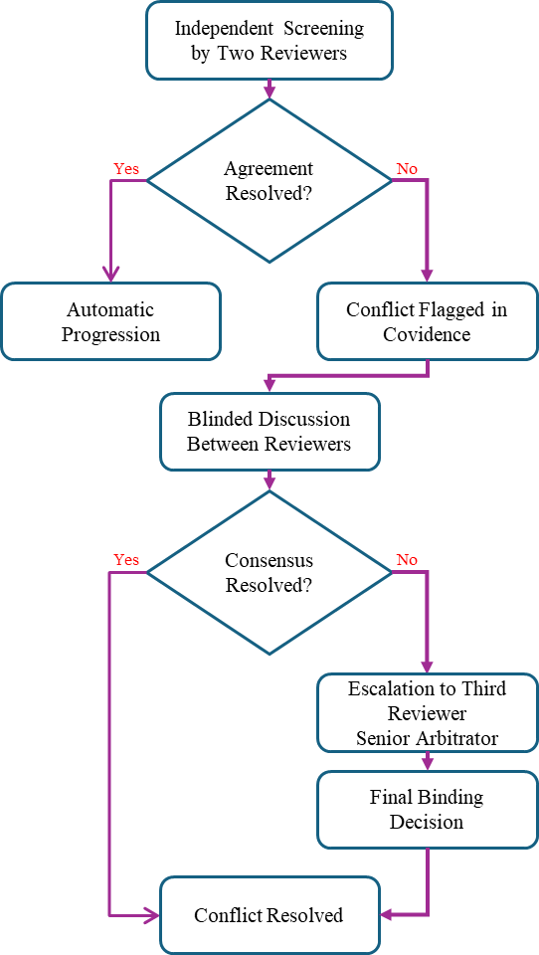
Figure S2. Structured multi-stage conflict resolution flowchart
S2.1. Conflict Identification
Covidence automatically flagged conflicts where reviewer decisions differed at either the title and abstract stage or the full-text screening stage.
S2.2. Blinded Discussion
- Reviewers held a structured discussion for each conflict.
- Reviewer identities behind initial decisions remained masked.
- Justifications were tied directly to the published eligibility criteria.
- The goal was to reach consensus through rule-based evaluation.
S2.3. Decision by a Third Reviewer
- Conflicts unresolved after discussion were escalated to a senior reviewer acting as an arbitrator.
- The arbitrator received the full citation, anonymized reviewer justifications, and the full text when applicable.
- The arbitrator made a final and binding decision using the protocol criteria.
S2.4. Documentation
All conflicts, reviewer justifications, and final resolutions were documented in Covidence and stored in an external Excel file. Records are available upon request.
S3. Summary of Screening Consistency
S3.1. Final Inter-rater Reliability
The final Cohen Kappa for the title and abstract stage was 0.91, which reflects almost perfect agreement.
S3.2. Conflict Resolution Statistics
Title and abstract screening:
- Total conflicts: 18 of 278 (6.5 percent)
- Resolved through discussion: 16
- Resolved through arbitration: 2
Full-text screening:
- Total conflicts: 7 of 93 (7.5 percent)
- Resolved through discussion: 7
- Resolved through arbitration: 0
A total of 50 studies met the full inclusion criteria. The structured procedures minimized selection bias and ensured high reproducibility.
S4. Meta-Analysis Diagnostics
S4.1. Heterogeneity
Random-effects models indicated substantial variability across the included studies.
- Overall heterogeneity: Q(48) = 157.89, p < 0.001
- Overall I squared = 69.3 percent
- Overall tau squared = 0.048
Domain-specific heterogeneity:
- Environmental factors: tau squared = 0.051, I squared = 71.7 percent
- Mitigation strategies: tau squared = 0.041, I squared = 58.1 percent
S4.2. Publication Bias
Egger regression tests indicated significant funnel asymmetry in:
- Traffic-related factors (intercept = 1.21, p = 0.033)
- Environmental factors (intercept = 1.92, p = 0.020)
Overall analysis also showed significant asymmetry (intercept = 1.38, p = 0.005).
S4.3. Bias-adjusted Effect Sizes
Trim-and-fill analysis imputed nine missing studies. Bias-corrected estimates indicated:
- Reduction in overall effect size by 10.3 percent (0.58 to 0.52)
- Maximum attenuation in environmental factors (13.8 percent)
- Minimum attenuation in vehicle characteristics (5.8 percent)
S4.4. Sensitivity Analysis
Leave-one-out analysis confirmed high robustness. The pooled effect size ranged from 0.56 to 0.61, indicating no disproportionate influence from any individual study.
All analyses were conducted in RStudio using the metafor package with restricted maximum likelihood estimation for tau squared and Knapp-Hartung adjustments for confidence intervals.
S5. Delphi-Style Expert Survey Instrument and Analysis Framework
S5.1. Purpose and scope of the expert survey
This Delphi-style expert survey was designed to identify, rank, and weight the dominant factors influencing tire wear and tire wear particle generation in large-scale open-pit mining haulage systems. The survey addresses the scarcity of direct empirical measurements in mining environments by systematically eliciting expert judgment under well-defined operating conditions characterized by high axle loads, low operating speeds, and unpaved haul roads.
The resulting expert-derived factor hierarchy provides the quantitative basis for (i) defining mining-specific correction coefficients in the semi-empirical emission model and (ii) prioritizing parameters for sensitivity analysis and mitigation assessment.
S5.2. Expert selection and participation
A total of 56 experts participated in the survey. Experts were purposively selected to ensure coverage of the mechanical, operational, and environmental dimensions relevant to mining-related tire wear. The panel included professionals with direct experience in:
- Open-pit mining operations
- Mine fleet management
- Haul-road design and construction
- Tire engineering and design
- Environmental management
Participation was anonymous, and responses were analyzed only in aggregate to reduce dominance bias and encourage independent judgment.
S5.3. Survey design and rating scale
The survey instrument consisted of a structured questionnaire in which participants were asked to score the relative importance of predefined influencing factors using a ten-point Likert scale, where:
- 1 = Negligible influence on tire wear and TWP generation
- 5 = Moderate influence
- 10 = Critically important (primary determinant)
All factors were presented with standardized operational definitions to minimize interpretation bias and ensure consistent understanding across disciplines. Participants were instructed to evaluate factor importance specifically for open-pit mining haulage systems operating under high-load, low-speed, unpaved conditions, rather than for transportation or paved-road contexts.
S5.4. Expert elicitation questionnaire
Table S1 presents the full questionnaire instrument used in the Delphi-style survey.
Table S1. Expert elicitation questionnaire for ranking factors affecting tire wear and microplastic generation in open-pit mines
No. | Influencing Factor | Operational Definition (Standardized) | Rate (1-10)
1 | Road Surface Quality | Degree of roughness, aggregate size and angularity, presence of ruts or potholes, and haul-road maintenance frequency
2 | Tire Type and Quality | Tire construction (radial or bias-ply), rubber compound properties, load and speed ratings, and manufacturing quality
3 | Tire Pressure | Deviation of operating pressure from manufacturer-recommended optimal pressure
4 | Load Distribution (Loading) | Uniformity of load across axles and tires during loading (e.g., shovel-induced asymmetry)
5 | Road Gradient | Average slope along loaded haul routes, including uphill and downhill segments
6 | Truck Speed | Typical operating speed under loaded haulage conditions
7 | Truck Capacity | Nominal truck capacity relative to actual payload
8 | Load Level (Empty or Full) | Proportion of fully loaded versus empty haul cycles
9 | Tire Age | Chronological age of the tire since manufacture
10 | Weather Conditions | Precipitation, dustiness, wind, and visibility conditions
11 | Tire Service Time | Total operational hours accumulated under load
12 | Road Layout and Design | Path geometry including curvature, intersections, and road width
13 | Ambient Temperature | Average air temperature at the mine site
14 | Driving Style | Acceleration, braking, and maneuvering behavior
15 | Number of Trips per Day | Average number of haul cycles completed per truck per day
16 | Tire Maintenance Condition | Adherence to inspection, repair, and rotation practices
17 | Traffic Volume from Other Vehicles | Density of ancillary equipment and light vehicles on haul roads
18 | Road Surface Moisture | Moisture content due to precipitation, watering, or natural conditions
19 | Air Humidity | Relative humidity of the ambient air
20 | Tire Size | Tire diameter and width

Respondents also optionally reported their primary field of expertise and years of experience to characterize the panel composition.
S5.5. Quantitative analysis of expert responses
Quantitative analysis of expert responses included calculation of mean scores, standard deviations, and rank ordering for each factor. Dispersion metrics were used to assess the level of interdisciplinary consensus and to identify factors associated with higher epistemic uncertainty.
No attempt was made to force convergence across expert groups. Instead, variability in responses was retained as an informative indicator of uncertainty relevant for subsequent sensitivity analysis and model robustness testing.
The resulting ranked factor hierarchy is summarized in Table 4 of the main manuscript, and the relative importance of factors is visualized in Figure 4. These expert-derived rankings directly inform the weighting structure and correction coefficients used in the mining-specific emission model (Section 3.5).
S5.6. Linkage to model development
High-ranked factors were treated as dominant drivers in the semi-empirical tribological model, influencing the magnitude and functional form of correction coefficients. Lower-ranked factors were retained to ensure completeness of the emission framework but were held at baseline values during probabilistic uncertainty propagation to avoid over-parameterization of the Monte Carlo simulation. Deterministic one-at-a-time sensitivity analysis and stochastic uncertainty propagation were applied only to the dominant operational drivers identified through expert ranking (see Sections 4.5–4.6 of the main manuscript).
This structured expert elicitation therefore provides a transparent, reproducible, and quantitatively defensible bridge between operational knowledge and model parameterization in a data-scarce mining context.

