Supporting information
Tables
Table 1s. Microhardness test results of the samples.
No. | Sample | Vickers microhardness  HV (kgf/mm²) | Image
1 | IPNGC01 | 23.4 | 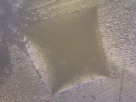
2 | IPNGC1 | 22.4 | 
3 | IPNGC5 | 22.1 | 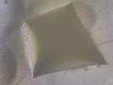
4 | IPNG01 | 22.4 | 
5 | IPNG1 | 22.9 | 
6 | IPNG5 | 25.6 | 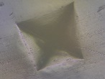
7 | IPNC01 | 23.2 | 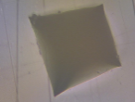
8 | IPNC1 | 23.2 | 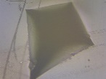
9 | IPNC5 | 23.2 | 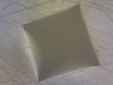
10 | VE | 9.8 | 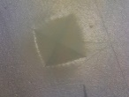
11 | EP | 24.8 | 
12 | IPN | 23.5 | 

