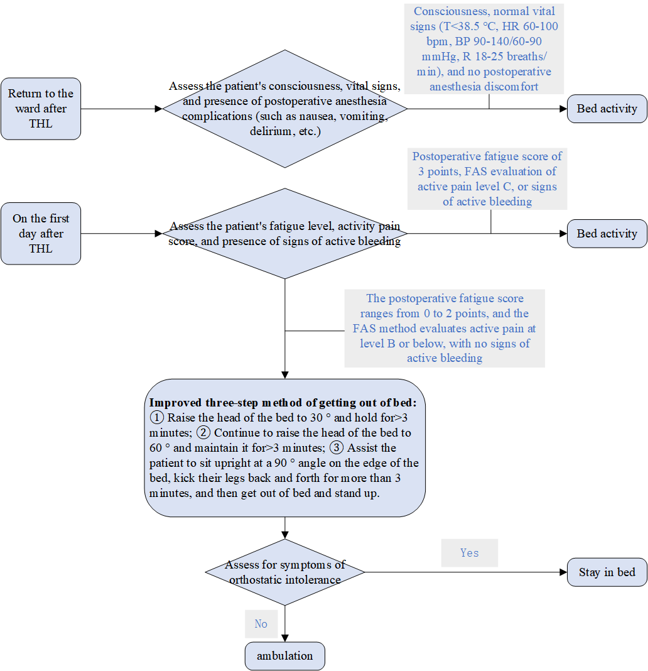
Figure S1. Flow chart of the first postoperative ambulation activity
Note.① Fatigue level: 0 points, no feeling of fatigue, normal activity, normal sleep; 1 point mild fatigue, able to complete bed activities; 2 points, feeling weak, struggling to complete bed activities, lethargic, and experiencing increased sleep; 3 points, exhausted, unable to sit up, drowsy, emotionally unstable or easily angered);② Functional Activity Rating (FAS) : Grade A: Pain with no restriction on functional activity, Grade B: Mild pain with restriction on functional activity; Grade C: Severe pain that restricts functional activity;③ Active bleeding: There is bleeding from the abdominal incision, with a bleeding rate of 100ml per hour for 3 consecutive hours

Table S2. The evidence of EPM after LTH
Themes | Evidence summaries
Preoperative education | 1.Medical staff use various methods such as display boards, brochures, multimedia, and mobile terminals to educate patients, family members, or caregivers on EPM.
Position management | 2.After the patient returns to the ward after surgery, they can lie flat or raise the head of the bed appropriately according to their condition and engage in bed activities.
Pain management | 3.Encourage patients to actively express their pain feelings, comprehensively select various methods such as "VAS", "digital rating system", and "facial expression score" based on actual situations for continuous dynamic evaluation, accurately record patients' feelings of pain, and provide multimodal analgesia according to medical advice, ensuring effective control of pain before getting out of bed and moving around.
Nausea and vomiting management | 4.Use a risk assessment scale to evaluate the risk of nausea and vomiting (PONV) in patients and take appropriate preventive measures according to medical advice. After PONV occurs, take appropriate measures according to medical advice.
Drainage tube management | 5.It is not recommended to routinely place a nasogastric tube after surgery. If the patient has significant gastric distension, it may be considered to insert a nasogastric tube during surgery and remove it before the end of the surgery.
Drainage tube management | 6.Except for extensive hysterectomy, conventional indwelling urinary catheterization is not recommended. If placement is necessary, it is recommended to remove it within 24 hours after surgery.
Drainage tube management | 7.It is not recommended to routinely place a drainage tube after surgery. For extensive hysterectomy, surgical wound infection, high anastomotic tension, poor blood flow, or other adverse factors that affect incision healing, a drainage tube may be considered for placement, but it should be removed as early as possible after surgery.
EPM assessment | 8.Before EPM, the patient's consciousness, vital signs, and any adverse anesthesia reactions such as nausea, vomiting, delirium, etc. should be evaluated.
EPM assessment | 9. Assess the psychological and social status of patients before getting out of bed activities, and ensure that patients have a correct understanding of the necessity of early getting out of bed activities.
EPM strategy | 10.Adopting the improved three-step getting out of bed method to prevent the occurrence of upright intolerance.
EPM strategy | 11.Develop clear and quantified early activity plans, list daily activity goals for patients, and guide patients to gradually carry out activities.
EPM strategy | 12.Encourage gynecological cancer patients to get out of bed and move around within 24 hours after surgery, gradually increasing their activity level with the guidance of medical staff and the companionship of caregivers.
EPM strategy | 13.For patients who cannot remove the tubing early, properly fix the tubing when getting out of bed and provide activity aids if necessary to ensure patient safety.
Note. EPM: Early postoperative mobilization; LTH: Laparoscopic total hysterectomy

Table S1. The assessment form of early postoperative mobilization
ID: Name: Date of Surgery:
- Return to ward after LTH
- Consciousness state:Alert Delirium Coma
- Vital Sign:Stable Unstable
- Anesthesia complications:None Nausea Vomit Dizziness
Note. Vital sign stable: T<38.5℃，HR 60-100 bpm，BP 90-140/60-90mmHg，R 18-25 breaths/min，SpO2 94-100%，CVP 5-12cmH2O.
- The First time ambulation after LTH
- Consciousness state:Alert Delirium Coma
- Vital Sign:Stable Unstable
- Anesthesia complications:None Nausea Vomit Dizziness
- Fatigue level: no feeling of fatigue, normal activity, normal sleep
able to complete bed activities
feeling weak, struggling to complete bed activities, lethargic
exhausted, drowsy, emotionally unstable or easily angered
- Functional Activity Rating (FAS):
Grade A: Pain with no restriction on functional activity
Grade B: Mild pain with restriction on functional activity
Grade C: Severe pain that restricts functional activity
- Active bleeding:No Yes
- Orthostatic intolerance:No Yes
Note. Orthostatic intolerance: onset of dizziness, palpitations, or diaphoresis upon standing, accompanied by a ≥20 mmHg drop in systolic BP, a ≥10 mmHg drop in diastolic BP, or a systolic BP <90 mmHg.
- Postoperative activity plan
- On the first day after LTH: Bedside activity 20-50 m, twice a day.
- On the second day after LTH: Walk 50-100m in the corridor of the ward, 3 times a day.
- On the third day after LTH: Walk 100-150m in the corridor of the ward, 3 times a day

