Supplementary Information
Performance Evaluation of Broadband Seismic Stations in Central India Tectonic Zone: Characterization of Ambient Noise Environments

Arun Kumar Dubey¹, Shreya Chandrakant Thakre¹, Nitarani Bishoyi¹, Ashwani Kant Tiwari^{1*}, Rishabh Tripathi¹, Subhkaran Mahla¹
¹ Indian Institute of Science Education and Research Bhopal, Bhopal, Madhya Pradesh India
*Corresponding Author: Dr. Ashwani Kant Tiwari, Indian Institute of Science Education and Research Bhopal, Madhya Pradesh, India. Email: aktiwari@iiserb.ac.in

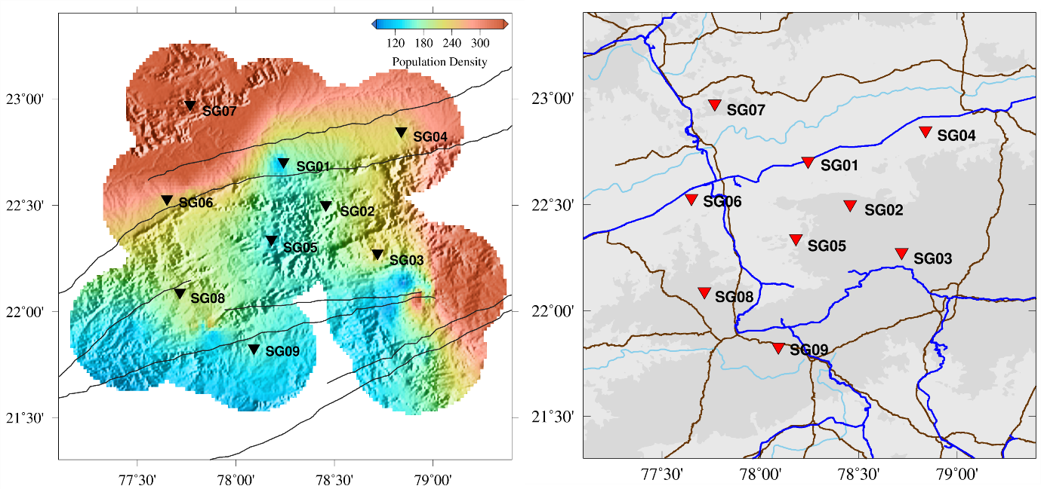

Figure S1: Studied area map illustrating population density (left panel) and rail and road (national highways) networks (right panel). Rail networks are represented in blue, whereas road networks are depicted in brown.

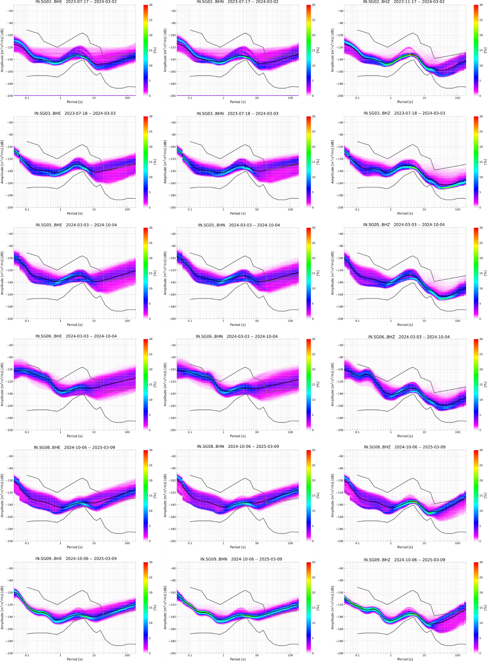
Figure S2: PSD plots for seismic stations SG02, SG03, SG05, SG06, SG08, and SG09, displayed for East (left panel), North (middle panel), and Vertical (right panel) components, organized in rows. The colored bar represents the probability of noise occurrence.
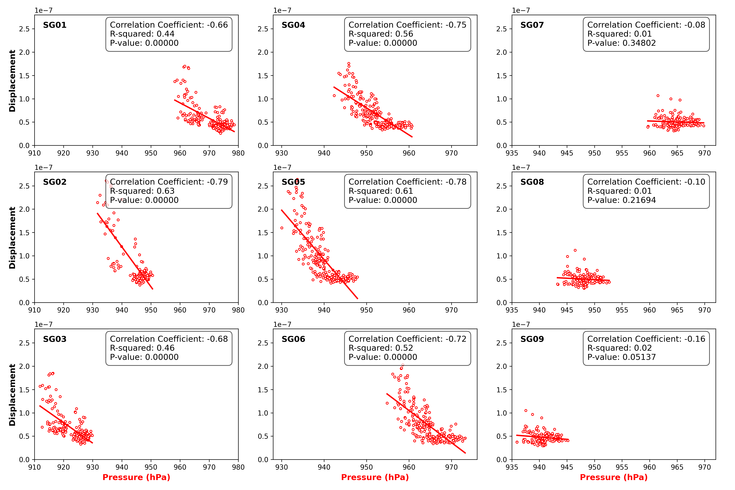

Figure S3: A correlation plot between daily mean RMS ground displacement and daily mean atmospheric surface pressure.

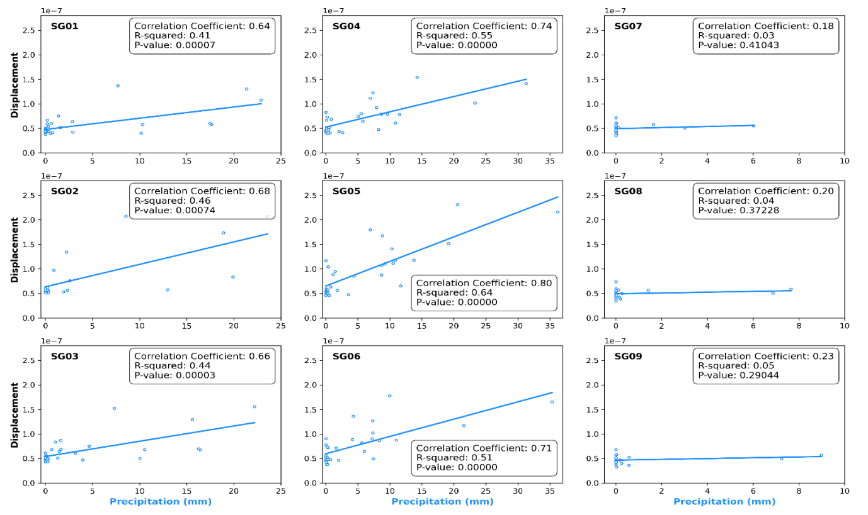

Figure S4: A correlation plot of RMS ground displacement and precipitation.

