Tables

Table 1: Description of Clinical 3D Modeling Cohort

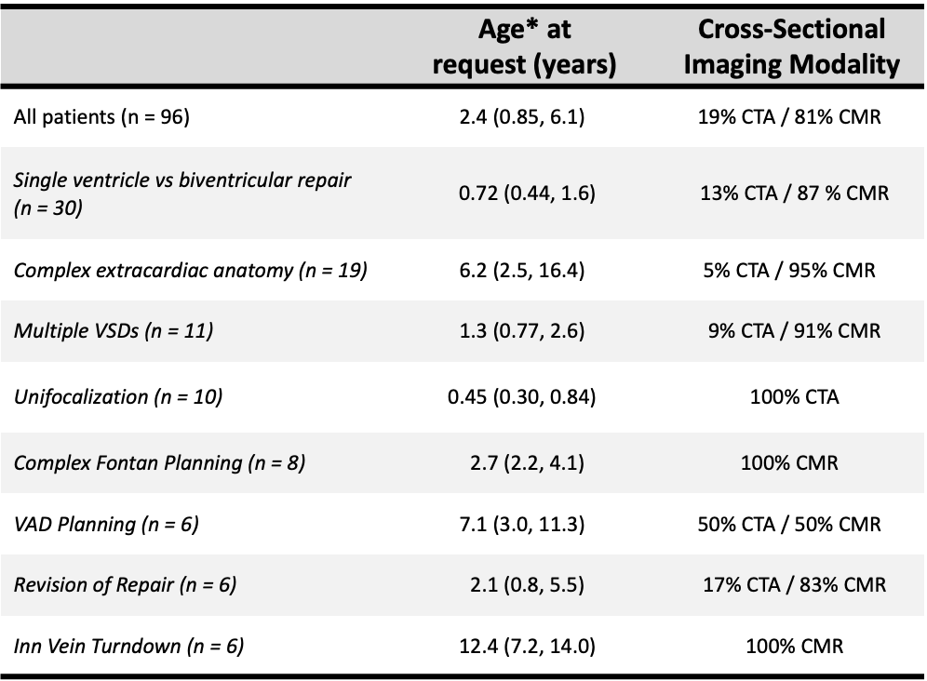

*Age presented as median and interquartile range
3D = Three-dimensional; CTA = computed tomography angiography; CMR = cardiac magnetic resonance imaging; VSD = ventricular septal defect; VAD = ventricular assist device; Inn Vein = Innominate Vein

Table 2: Anatomic or Procedural Indication for Modeling Request According to Year

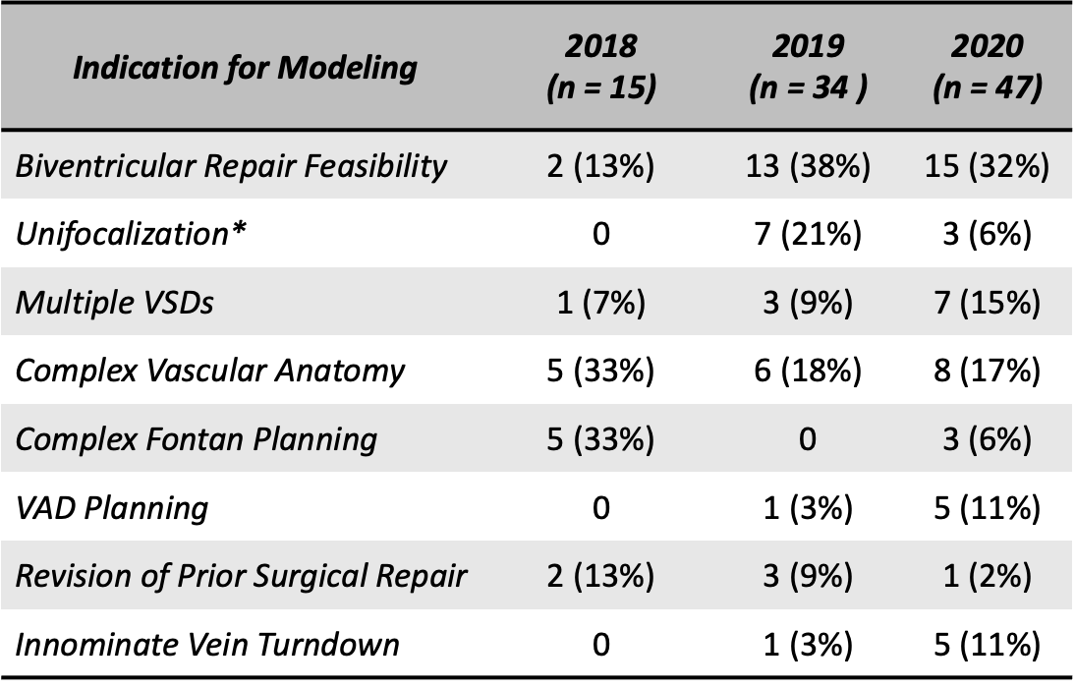

Results expressed as count (percentage)
*Refers to unifocalization of aortopulmonary collaterals
VSD = ventricular septal defect; VAD = ventricular assist device

Table 3: Number of Prospective and Retrospective Cases According to Year

