SUPPLEMENTARY MATERIAL FOR
Full-Spectrum Epidemiological Characteristics of Mycoplasma pneumoniae Infection Across All Age Groups and Healthcare Settings: A Citywide Population-Based Study in Jinhua, China, 2023–2025
I. Supplementary Tables
Supplementary Table-1. Baseline characteristics and positivity rates of Mycoplasma pneumoniae infection by year, season, sex, and age group.
Supplementary Table-2. Multivariable Logistic Regression Analysis for Mycoplasma pneumoniae Infection.
II.. Supplementary Figures
Supplementary Figure-1. Sensitivity analyses of MP infection risk.
Supplementary Table 1. Baseline characteristics and positivity rates of Mycoplasma pneumoniae infection by year, season, sex, and age group
Characteristic |  | No. tested | No. positive | Positivity rate, %
Year
2023 |  | 89394 | 15800 | 17.67
2024 |  | 148788 | 12911 | 8.68
2025 |  | 61842 | 586 | 0.95
Season
Spring |  | 68918 | 5041 | 7.31
Summer |  | 113720 | 8220 | 7.23
Autumn |  | 67950 | 10008 | 14.73
Winter |  | 49436 | 6028 | 12.19
Sex
Male |  | 160025 | 15182 | 9.49
Female |  | 139999 | 14115 | 10.08
Age group
<1 year |  | 15991 | 722 | 4.52
1–2 years |  | 31392 | 2453 | 7.81
3–5 years |  | 54223 | 8049 | 14.84
6–11 years |  | 65330 | 14297 | 21.88
12–17 years |  | 17419 | 1448 | 8.31
18–44 years |  | 34791 | 1385 | 3.98
45–59 years |  | 19697 | 382 | 1.94
60–74 years |  | 31548 | 336 | 1.07
75–89 years |  | 26241 | 168 | 0.64
≥90 years |  | 3392 | 57 | 1.68
Overall |  | 300024 | 29297 | 9.76
Abbreviation: No., number. Notes: Positivity rate (%) was calculated as positive cases divided by tested individuals. Data are presented as counts and percentages.
Supplementary Table 2. Multivariable Logistic Regression Analysis for Mycoplasma pneumoniae Infection
Variable |  | OR | 95% CI | P value
Age (RCS term 1) |  | 1.017 | 1.012–1.021 | <0.001
Age (RCS term 2) |  | 1.019 | 1.016–1.023 | <0.001
Sex: Female vs. Male |  | 1.001 | 0.847–1.182 | 0.990
Year
2023 vs. 2025 |  | 17.889 | 15.727–20.429 | <0.001
2024 vs. 2025 |  | 8.903 | 7.827–10.168 | <0.001
Interactions
Age × Sex |  | 1.001 | 0.999–1.003 | 0.341
Age × Year (2023) |  | 1.013 | 1.009–1.017 | <0.001
Age × Year (2024) |  | 1.01 | 1.006–1.014 | <0.001
Sex × Year (2023) |  | 1.069 | 0.904–1.265 | 0.435
Sex × Year (2024) |  | 1.085 | 0.917–1.283 | 0.343
OR, odds ratio; CI, confidence interval; RCS, restricted cubic spline. Reference group: Male sex, 2025. Overall age effect (RCS): P < 0.001. ORs for RCS terms and age-year interaction terms were reciprocally transformed for better interpretability (all presented as >1).
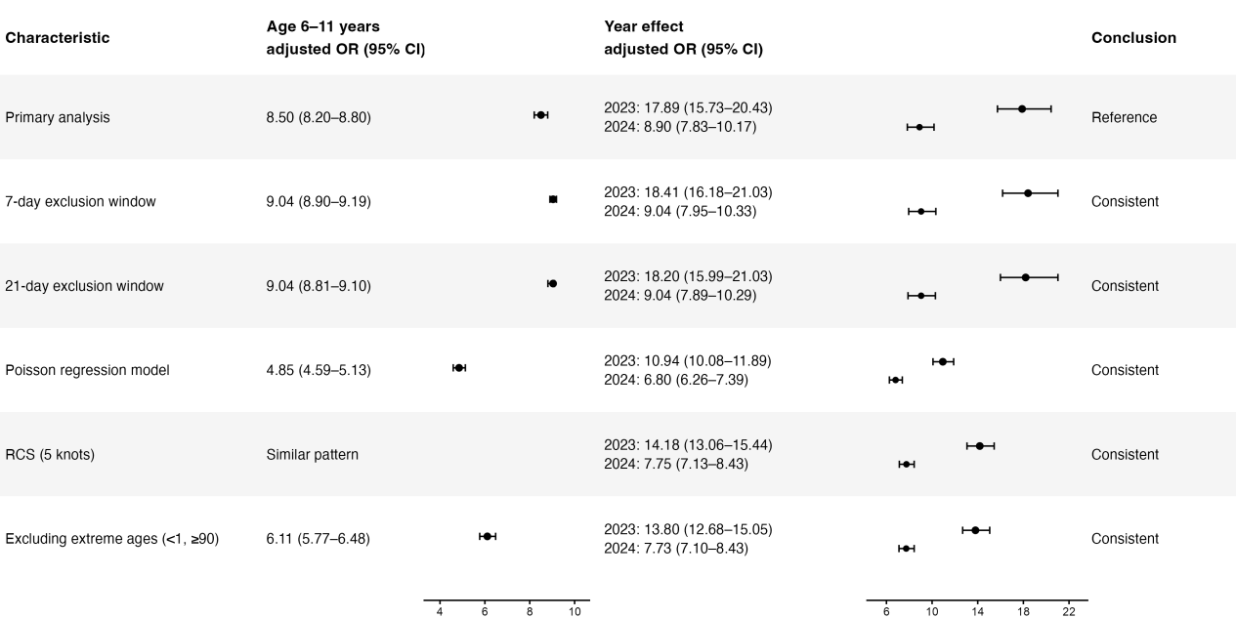
Supplementary Figure 1. Sensitivity analyses of MP infection risk
Age effects were estimated by comparing children aged 6–11 years with those aged 18–44 years (reference group). Year effects were estimated using 2025 as the reference group, with comparisons to 2023 and 2024. Results were defined as consistent if the significantly elevated risk in children aged 6–11 years and significant year effects remained stable across all analytic strategies. Footnotes: OR, odds ratio; CI, confidence interval; RCS, restricted cubic spline.

