Supplementary Information for

Iterative near-term forecasting of the transmission and management of SARS-CoV-2/COVID-19 using social interventions at the county-level in the United States

Kenneth Newcomb¹, Morgan E. Smith², Rose E. Donohue², Sebastian Wyngaard³, Caleb Reinking³, Christopher R. Sweet³, Marissa J. Levine⁴, Thomas R. Unnasch¹, Edwin Michael^{1*}

¹ Center for Global Health Infectious Disease Research, University of South Florida, Tampa, FL, USA
² Department of Biological Sciences, University of Notre Dame, Notre Dame, IN, USA
³ Center for Research Computing, University of Notre Dame, Notre Dame, IN, USA
⁴ Center for Leadership in Public Health Practice, University of Florida, Tampa, FL

* Edwin Michael
emichael@nd.edu

This PDF file includes:
Supplementary text
Figures S1 to S4
Tables S1 to S2
SI References

Supplementary text
The ordinary differential equations of our compartmental SARS-CoV-2 transmission model are:
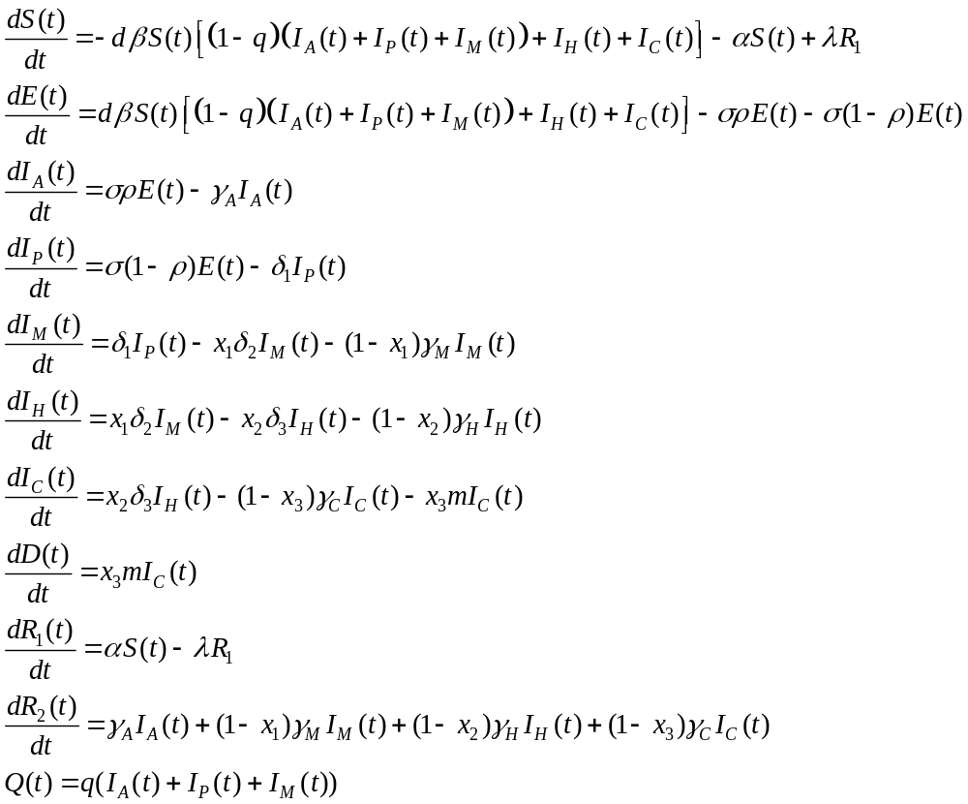

The population is divided into compartments representing infection status: susceptible (S), susceptible but removed from the transmission process via lockdown policies (R₁), exposed (E), infectious asymptomatic (I_{A}), infectious pre-symptomatic (I_{P}), infectious with mild symptoms (I_{M}), infectious with severe symptoms requiring hospitalization (I_{H}), infectious with severe symptoms requiring intensive care including ventilation (I_{C}), recovered and immune (R₂), and deceased (D). We also model a population which is quarantined (Q) after testing and/or contact tracing as a fraction of the relatively mild infectious classes I_{A}, I_{P}, and I_{M}. All model parameters are described in Table S3.

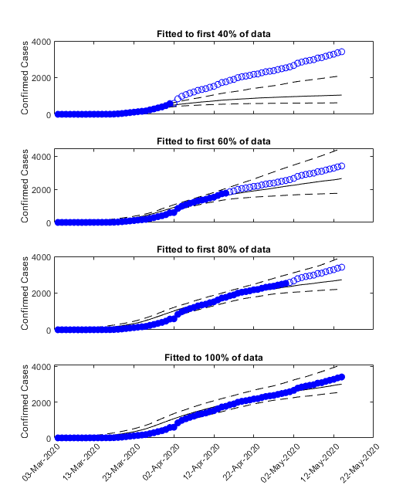
Figure S1. Iterative fits to segments of data. Solid points show which data points were used to calibrate the model and open circles show which data points were left out for validation purposes.

Figure S2. Description of modeled intervention scenarios. The colored bars indicate the duration of lockdown, social distancing measures, and contact tracing and quarantine efforts.

Figure S3. Compartmental model structure. Boxes represent infection status compartments, solid lines represent movement between compartments, and dashed arrows represent contribution to transmission. The compartments represent model state variables and the variables represent transmission rates and proportions. Full details are given in Table S3.

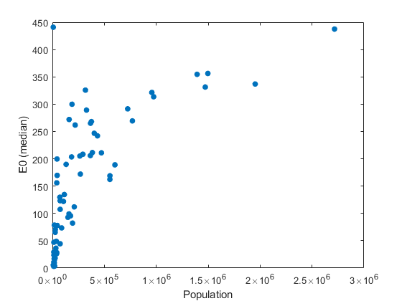

Figure S4. Relationship between the fitted value of E0 (initial exposed cases at start of simulation) and county population size.

Table S1. List of Florida counties and their population sizes.

County | Population | County | Population
Alachua | 269043 | Lee | 770577
Baker | 29210 | Leon | 293582
Bay | 174705 | Levy | 41503
Bradford | 28201 | Liberty | 8354
Brevard | 601942 | Madison | 18493
Broward | 1952778 | Manatee | 403253
Calhoun | 14105 | Marion | 365579
Charlotte | 188910 | Martin | 161000
Citrus | 149657 | Miami-Dade | 2716940
Clay | 219252 | Monroe | 74228
Collier | 384902 | Nassau | 88625
Columbia | 71686 | Okaloosa | 210738
DeSoto | 38001 | Okeechobee | 42168
Dixie | 16826 | Orange | 1393452
Duval | 957755 | Osceola | 375751
Escambia | 318316 | Palm Beach | 1496770
Flagler | 115081 | Pasco | 553947
Franklin | 12125 | Pinellas | 974996
Gadsden | 45660 | Polk | 724777
Gilchrist | 18582 | Putnam | 74521
Glades | 13811 | Santa Rosa | 184313
Gulf | 13639 | Sarasota | 433742
Hamilton | 14428 | Seminole | 471826
Hardee | 26937 | St. Johns | 264672
Hendry | 42022 | St. Lucie | 328297
Hernando | 193920 | Sumter | 132420
Highlands | 106221 | Suwannee | 44417
Hillsborough | 1471968 | Taylor | 21569
Holmes | 19617 | Union | 15237
Indian River | 159923 | Volusia | 553284
Jackson | 46414 | Wakulla | 33739
Jefferson | 14246 | Walton | 74071
Lafayette | 8422 | Washington | 25473
Lake | 367118

Table S2. Median and range of social distancing parameter (d) and lockdown fraction over the last 14 days of data, using the 500 best-fitting models. Shaded cells denote the counties for which state-level mobility data was used to estimate population movement restrictions due to lack of county-level data.

Class | County | Median, d | Range, d | Median, lockdown fraction | Range, lockdown fraction
Group A | Alachua | 0.233 | 0.104-0.396 | 0.299 | 0.076-0.35
Group A | Baker | 0.228 | 0.102-0.396 | 0.010 | 0.01-0.105
Group A | Bay | 0.267 | 0.103-0.398 | 0.334 | 0.219-0.389
Group A | Bradford | 0.231 | 0.101-0.394 | 0.032 | 0.002-0.146
Group A | Calhoun | 0.236 | 0.1-0.399 | 0.334 | 0.219-0.389
Group A | Clay | 0.251 | 0.103-0.397 | 0.274 | 0.192-0.347
Group A | Columbia | 0.233 | 0.101-0.397 | 0.010 | 0.01-0.166
Group A | DeSoto | 0.230 | 0.1-0.398 | 0.220 | 0.057-0.439
Group A | Flagler | 0.214 | 0.101-0.398 | 0.220 | 0.104-0.256
Group A | Franklin | 0.259 | 0.102-0.399 | 0.334 | 0.219-0.389
Group A | Gadsden | 0.224 | 0.103-0.398 | 0.189 | 0.035-0.416
Group A | Gilchrist | 0.221 | 0.103-0.399 | 0.012 | 0.01-0.365
Group A | Gulf | 0.240 | 0.103-0.397 | 0.334 | 0.219-0.389
Group A | Hamilton | 0.259 | 0.103-0.398 | 0.334 | 0.219-0.389
Group A | Hardee | 0.264 | 0.101-0.398 | 0.217 | 0.121-0.316
Group A | Highlands | 0.260 | 0.101-0.399 | 0.402 | 0.301-0.498
Group A | Holmes | 0.229 | 0.102-0.399 | 0.089 | 0.01-0.476
Group A | Jackson | 0.261 | 0.101-0.398 | 0.334 | 0.219-0.389
Group A | Jefferson | 0.237 | 0.101-0.398 | 0.023 | 0.01-0.314
Group A | Lafayette | 0.243 | 0.104-0.4 | 0.334 | 0.219-0.389
Group A | Lake | 0.220 | 0.101-0.399 | 0.268 | 0.169-0.36
Group A | Levy | 0.210 | 0.102-0.397 | 0.042 | 0.01-0.25
Group A | Liberty | 0.305 | 0.108-0.398 | 0.334 | 0.219-0.389
Group A | Madison | 0.245 | 0.1-0.398 | 0.353 | 0.293-0.481
Group A | Marion | 0.254 | 0.102-0.399 | 0.222 | 0.105-0.3
Group A | Monroe | 0.245 | 0.101-0.4 | 0.334 | 0.219-0.389
Group A | Nassau | 0.232 | 0.1-0.397 | 0.267 | 0.12-0.324
Group A | Okaloosa | 0.247 | 0.103-0.399 | 0.334 | 0.219-0.389
Group A | Putnam | 0.244 | 0.1-0.398 | 0.124 | 0.01-0.238
Group A | Santa Rosa | 0.227 | 0.101-0.398 | 0.334 | 0.219-0.389
Group A | Sumter | 0.248 | 0.101-0.398 | 0.406 | 0.285-0.461
Group A | Suwannee | 0.259 | 0.101-0.399 | 0.334 | 0.219-0.389
Group A | Taylor | 0.240 | 0.102-0.398 | 0.010 | 0.01-0.176
Group A | Union | 0.244 | 0.103-0.399 | 0.334 | 0.219-0.389
Group A | Wakulla | 0.219 | 0.101-0.4 | 0.107 | 0.01-0.219
Group A | Walton | 0.252 | 0.1-0.4 | 0.334 | 0.219-0.389
Group A | Washington | 0.247 | 0.101-0.4 | 0.334 | 0.219-0.389
Group B | Brevard | 0.262 | 0.102-0.396 | 0.232 | 0.049-0.317
Group B | Charlotte | 0.256 | 0.103-0.395 | 0.413 | 0.318-0.476
Group B | Citrus | 0.218 | 0.101-0.398 | 0.239 | 0.049-0.349
Group B | Collier | 0.242 | 0.103-0.4 | 0.389 | 0.235-0.473
Group B | Dixie | 0.232 | 0.102-0.398 | 0.334 | 0.219-0.389
Group B | Escambia | 0.241 | 0.103-0.398 | 0.359 | 0.112-0.873
Group B | Glades | 0.314 | 0.104-0.399 | 0.334 | 0.219-0.389
Group B | Hendry | 0.234 | 0.103-0.399 | 0.241 | 0.075-0.322
Group B | Hernando | 0.245 | 0.102-0.399 | 0.299 | 0.19-0.398
Group B | Hillsborough | 0.248 | 0.101-0.398 | 0.330 | 0.249-0.418
Group B | Indian River | 0.258 | 0.101-0.396 | 0.341 | 0.202-0.412
Group B | Leon | 0.240 | 0.105-0.4 | 0.390 | 0.261-0.444
Group B | Martin | 0.257 | 0.1-0.399 | 0.303 | 0.158-0.374
Group B | Okeechobee | 0.283 | 0.1-0.397 | 0.168 | 0.01-0.357
Group B | Pasco | 0.254 | 0.102-0.395 | 0.247 | 0.142-0.337
Group B | Pinellas | 0.258 | 0.101-0.399 | 0.369 | 0.251-0.434
Group B | St. Johns | 0.250 | 0.1-0.398 | 0.295 | 0.166-0.403
Group B | St. Lucie | 0.243 | 0.1-0.397 | 0.290 | 0.158-0.392
Group B | Sarasota | 0.260 | 0.104-0.4 | 0.383 | 0.239-0.464
Group C | Broward | 0.244 | 0.102-0.391 | 0.395 | 0.312-0.465
Group C | Duval | 0.254 | 0.101-0.393 | 0.282 | 0.16-0.334
Group C | Lee | 0.253 | 0.102-0.399 | 0.367 | 0.21-0.413
Group C | Manatee | 0.255 | 0.1-0.397 | 0.332 | 0.167-0.409
Group C | Miami-Dade | 0.257 | 0.101-0.396 | 0.397 | 0.348-0.472
Group C | Orange | 0.250 | 0.101-0.396 | 0.449 | 0.365-0.507
Group C | Osceola | 0.263 | 0.107-0.398 | 0.424 | 0.337-0.482
Group C | Palm Beach | 0.240 | 0.102-0.397 | 0.383 | 0.301-0.45
Group C | Polk | 0.245 | 0.1-0.396 | 0.265 | 0.173-0.354
Group C | Seminole | 0.249 | 0.102-0.398 | 0.287 | 0.194-0.34
Group C | Volusia | 0.246 | 0.101-0.397 | 0.356 | 0.204-0.453
State of Florida |  | 0.245 | 0.210-0.314 | 0.334 | 0.01-0.449
Kruskal – Wallis test |  | p < 0.001 |  | p < 0.001

Table S3. Model parameters definitions and prior distributions (reflects best understanding as of April 2020).

Parameter | Definition | Prior range | Units/notes | Published values | References
β | Infection transmission rate | 0.1428 – 1.5 | Estimated as R0*gamma in SIR model | R0 = 2-6  β = 0.6 – 1.7 | (1-4)
L | Lockdown ratio | 3-5 | Ratio of population under lockdown to susceptible population | - | -
α | Rate of entering lockdown | 2.0 (fixed) | Controls how quickly lockdown is enforced, linked to lockdown ratio and lambda | Model structure proposed by Peng | (2)
λ | Rate of leaving lockdown | = alpha/L |  | Model structure proposed by Jiwei | (5)
σ | Rate of moving from exposed class to infectious class | 0.16 – 0.5 | 1/σ is the latent period; assumed 2-6 days | 2.2-6 days latent period | (4)
p | Proportion of exposed who become asymptomatic | 0.1 – 0.3 |  |  | (6-8)
γ_{A} | Recovery rate of asymptomatic cases | 0.125 – 0.33 | 1/γ_{A} is the infectious period; assumed 3-8 days | 3-14 days infectious period, most <= 8 days | (3, 4, 9-11)
γ_{M} | Recovery rate of cases with mild symptoms | 0.125 – 0.33 | 1/γ_{M} is the infectious period; assumed 3-8 days | 3-14 days infectious period, most <= 8 days | (3, 4, 9-11)
γ_{H} | Recovery rate of cases with severe symptoms requiring hospitalization | 0.125 – 0.33 | 1/γ_{H} is the infectious period of severe cases; assumed 3-8 days | 3-14 days infectious period, most <= 8 days | (3, 4, 9-11)
γ_{C} | Recovery rate of cases with severe symptoms requiring intensive care | 0.125 – 0.33 | 1/γ_{C} is the infectious period; assumed 3-8 days | 3-14 days infectious period, most <= 8 days | (3, 4, 9-11)
δ₁ | Rate of moving from presymptomatic class to mild symptomatic | 0.05 – 1 | 1/time from start of infectious period to illness onset; assume 1-20 days | Latent period: 2-6 days  Incubation period: 2-12 days | (4, 12-14)
δ₂ | Rate of moving from mild case to hospitalized class | 0.06 – 0.25 | 1/time from illness onset to hospitalization; assume 4-15 days | 4-15 days | (14-16)
δ₃ | Rate of moving from hospitalized class to ICU | 0.09 – 1 | 1/time from hospitalization to ICU; assume 1-11 days | Illness onset to ICU: 6-15 days  Illness onset to hospital: 4-15 days | (14-16)
m | Mortality rate of ICU class | 0.08 – 0.25 | 1/time from ICU to death | 4-12 days | (16)
ε | Proportion of symptomatic cases that are not reported | 0.1 – 0.3 | Assume 10-30% of symptomatic cases are not getting tested | Diagnostic rate of symptomatic 1/9 -1/3; Diagnosis rate overall 25% | (5, 17)
x₁ | Proportion of mild cases that progress to hospital | 0.05 – 0.3 | 5-30% of mild cases are hospitalized | 5%, 20.7-31.4% | (18, 19)
x₂ | Proportion of hospital cases that progress to ICU | 0.2 – 0.3 | 20-30% of hospitalized cases require an ICU | 26-30% | (15, 16, 19, 20)
x₃ | Proportion of ICU cases that die | 0.2 – 0.8 | Proportion of ICU cases that die |  | (16, 20, 21)
d | Reduction in transmission due to social distancing, face masks, etc. | 0.1 – 0.4 |  | Masks are 58-85% effective | (22)

SI References

1. Q. Lin et al., A conceptual model for the outbreak of Coronavirus disease 2019 (COVID-19) in Wuhan, China with individual reaction and governmental action. International journal of infectious diseases (2020).
2. L. Peng, W. Yang, D. Zhang, C. Zhuge, L. Hong, Epidemic analysis of COVID-19 in China by dynamical modeling. arXiv preprint arXiv:2002.06563 (2020).
3. J. M. Read, J. R. Bridgen, D. A. Cummings, A. Ho, C. P. Jewell, Novel coronavirus 2019-nCoV: early estimation of epidemiological parameters and epidemic predictions. MedRxiv (2020).
4. L. Y. Sanche S, Xu C, Romero-Severson E, Hengartner N, Ke R., High contagiousness and rapid spread of severe acute respiratory syndrome coronavirus 2. Emerg Infect Dis. 26 (2020).
5. J. Jia et al., The impact of multilateral imported cases of COVID-19 on the epidemic control in China. arXiv preprint arXiv:2004.02398 (2020).
6. Y. Dong et al., Epidemiology of COVID-19 among children in China. Pediatrics (2020).
7. A. Kimball, Asymptomatic and presymptomatic SARS-CoV-2 infections in residents of a long-term care skilled nursing facility—King County, Washington, March 2020. MMWR. Morbidity and mortality weekly report 69 (2020).
8. H. Qiu et al., Clinical and epidemiological features of 36 children with coronavirus disease 2019 (COVID-19) in Zhejiang, China: an observational cohort study. The Lancet Infectious Diseases (2020).
9. B. F. Maier, D. Brockmann, Effective containment explains subexponential growth in recent confirmed COVID-19 cases in China. Science 368, 742-746 (2020).
10. C. M. Peak et al., Modeling the comparative impact of individual quarantine vs. active monitoring of contacts for the mitigation of COVID-19. medRxiv (2020).
11. K. Prem et al., The effect of control strategies to reduce social mixing on outcomes of the COVID-19 epidemic in Wuhan, China: a modelling study. Lancet Public Health 5, e261-e270 (2020).
12. J. A. Backer, D. Klinkenberg, J. Wallinga, Incubation period of 2019 novel coronavirus (2019-nCoV) infections among travellers from Wuhan, China, 20–28 January 2020. Eurosurveillance 25, 2000062 (2020).
13. W.-j. Guan et al., Clinical characteristics of coronavirus disease 2019 in China. New England journal of medicine 382, 1708-1720 (2020).
14. Q. Li et al., Early transmission dynamics in Wuhan, China, of novel coronavirus–infected pneumonia. New England Journal of Medicine (2020).
15. D. Wang et al., Clinical characteristics of 138 hospitalized patients with 2019 novel coronavirus–infected pneumonia in Wuhan, China. Jama 323, 1061-1069 (2020).
16. F. Zhou et al., Clinical course and risk factors for mortality of adult inpatients with COVID-19 in Wuhan, China: a retrospective cohort study. The lancet (2020).
17. W. C. Roda, M. B. Varughese, D. Han, M. Y. Li, Why is it difficult to accurately predict the COVID-19 epidemic? Infectious Disease Modelling (2020).
18. C. COVID, R. Team, Severe outcomes among patients with coronavirus disease 2019 (COVID-19)—United States, February 12–March 16, 2020. MMWR Morb Mortal Wkly Rep 69, 343-346 (2020).
19. R. Verity et al., Estimates of the severity of COVID-19 disease. MedRxiv (2020).
20. C. Wu et al., Risk factors associated with acute respiratory distress syndrome and death in patients with coronavirus disease 2019 pneumonia in Wuhan, China. JAMA internal medicine (2020).
21. X. Yang et al., Clinical course and outcomes of critically ill patients with SARS-CoV-2 pneumonia in Wuhan, China: a single-centered, retrospective, observational study. The Lancet Respiratory Medicine (2020).
22. N. C. Brienen, A. Timen, J. Wallinga, J. E. Van Steenbergen, P. F. Teunis, The effect of mask use on the spread of influenza during a pandemic. Risk Analysis: An International Journal 30, 1210-1218 (2010).

