Supplementary Information

Microbial exopolysaccharide–mediated enhancement of Deep eutectic solvent‑based eutectogels for sustainable functional biomaterials

Bryan Fernando Páramo Chávez¹; Blanca Rosa Aguilar Uscanga¹; Álvaro de Jesús Martínez Gómez¹; María Guadalupe Morán Aguilar^{1,2}; Fabiola Vilaseca²; Iván Costa Trigo³; Josué Raymundo Solís-Pacheco¹*

¹ Centro Universitario de Ciencias Exactas e Ingenierías (CUCEI), Universidad de Guadalajara, Guadalajara 4430, Jal; bryan.paramo7767@alumnos.udg.mx (B.F.P-C); blanca.aguilar@academicos.udg.mx (B.R.A.-U.); alvaro.mgomez@academicos.udg.mx (A.J.M.-G.).
² Advanced Biomaterials and Nanotechnology (BIMATEC), Department of Chemical and Agricultural Engineering, and Agrifood Technology, University of Girona, C/ M. Aurèlia Capmany, 61, 17003 Girona, Spain; lu.moag91@gmail.com (M.G.M.-A.).
³ LNEG —National Laboratory of Energy and Geology, Bioenergy and Biorefineries Unit, Estrada do Paço do Lumiar, 22, 1649-038 Lisbon, Portugal; ivan.trigo@lneg.pt (I.C.-T).

Corresponding authors: J.R.S.-P. (raymundo.solis@academicos.udg.mx).

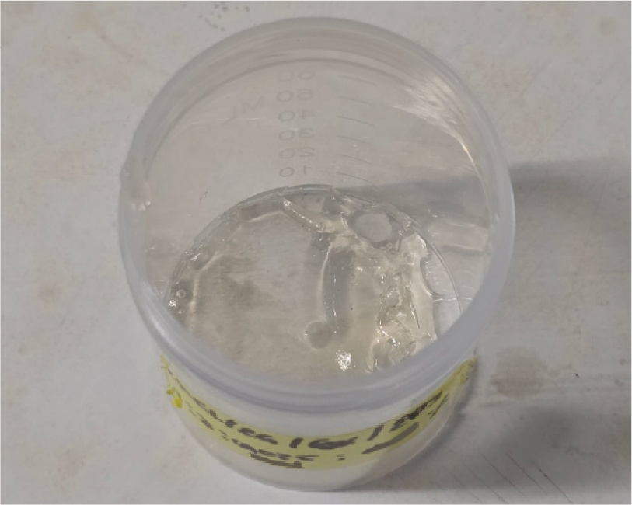 |  | 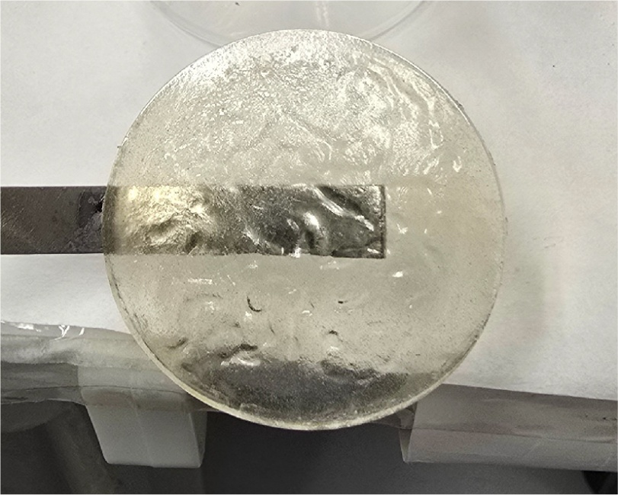 |  | 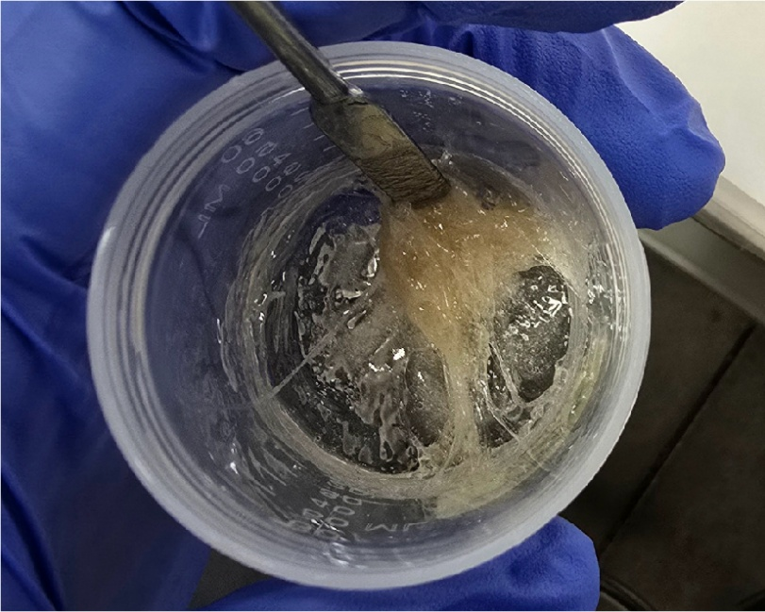 |  | 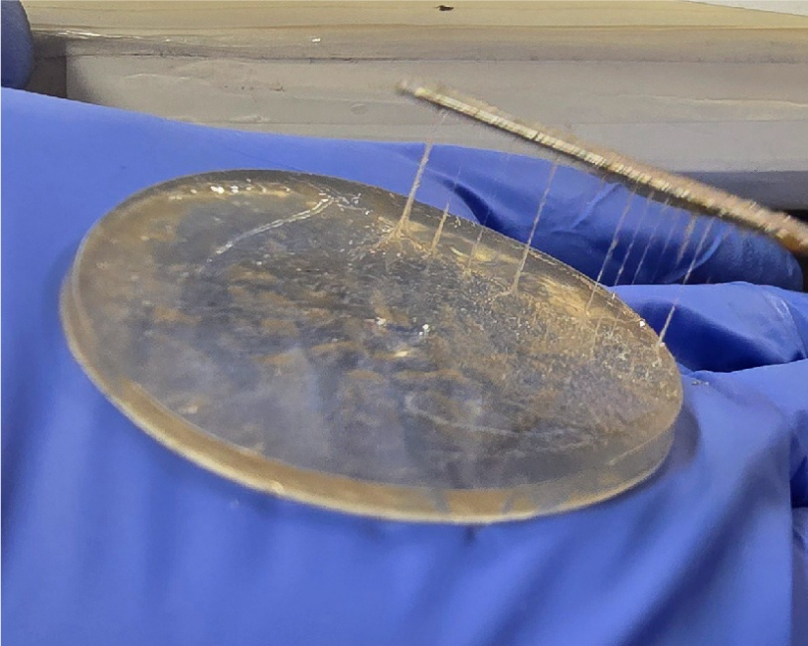
ChCl:EG:AA |  | ChCl:Xyl:AA |  | ChCl:LA:AA |  | ChCl:XG:AA

Fig. S1. Deep eutectic solvent (DES) combinations prepared using choline chloride with ethylene glycol (EG), xylitol (Xyl), lactic acid (LA), and xanthan gum (XG). All DESs were formulated at a 1:1 molar ratio and supplemented with 30 wt% acrylic acid (AA) and 1.0 wt% exopolysaccharide relative to AA.
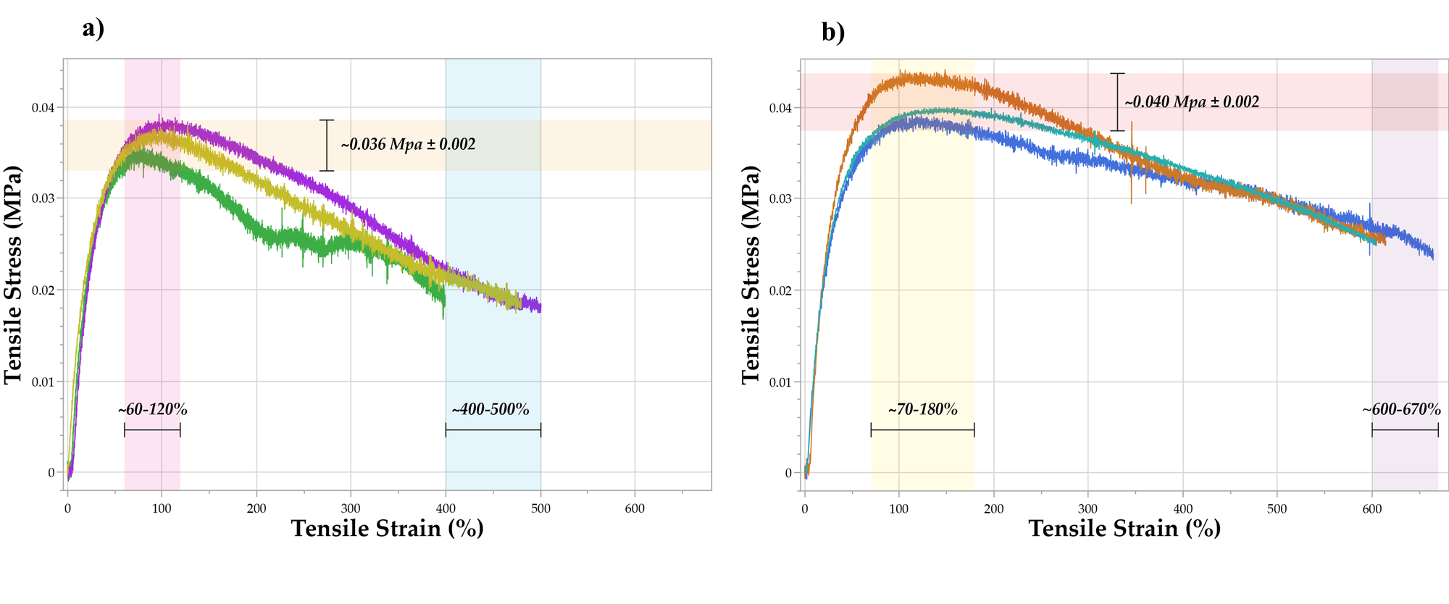
Figure S2. Tensile stress–strain profiles profiles of DES-based Egels: a) Egel without EPS; (b) Egel with EPS.

