Supplementary Material

- Predictors (explanatory Variables)
Fig. S1 (a-e) illustrates the composite map of years with the lowest and highest seasonal streamflow, with pre-season mean values of the selected predictors, along with the correlation between the average pre-season (SON) SST and the DJF streamflow. As indicated in Fig. S1a and S1b, the west-east wind gusts have a greater speed for the composite map of high flows than low flows, which might be an indication of moisture transport from the Atlantic Ocean to the basin (black rectangle). Similarly, the composite map with the sea level pressure (SLP) indicates a lower regional pressure system during high flow years than during the low flow years (Fig. S2). Unlike high SLP, the low SLP is a favorable condition for the rising of air, which will eventually create clouds and rain.

Fig. S1. Composite and correlation maps: a) Composite (October – November) vector wind anomaly with the first 10 years of lower DJF stream flow, b) Similar to (a) by with the first 10 years of highest DJF stream flow; c) same as (a) but composite is with specific humidity, d) same as (b) but composite is with specific humidity; e) correlation of the DJF stream flow with the pre-season (SON) average SST.

Fig. S2. a) Composite (October – November) Sea Level pressure with the first 10 years of lower DJF stream flow, b) Similar to (a) with the first 10 years of highest DJF stream flow.

Table S1. Selected global and local predictors for the three consecutive seasons for forecasting seasonal stream flow at Reach 30 and 32

Reach 30 |  |  |  | Reach 32
Predictor | Latitude | Region |  | Predictor | Latitude | Region
Predictor | Latitude | Longitude | Correlation | Predictor | Latitude | Longitude | Correlation
SON
Air Temperature (JJA) | 27–32°N | 2.5–12.5°E | 0.55 | Air Temperature (JJA) | 18–25°N | 27–12°W | -0.53
Air Temperature (JJA) | 23–27°N | 25–32°E | 0.43 | Air Temperature (JA) | 35–45°N | 30–35°E | -0.42
Geopotential Height (JJA) | 25–30°N | 0–10°E | 0.49 | Geopotential Height (A) | 50–55°N | 2°W–8°E | 0.39
Sea Level Pressure (A) | 14–19°N | 10–30°E | 0.59 | Sea Level Pressure (A) | 31–38°N | 17–32°E | 0.4
Specific Humidity (JJA) | 38–43°N | 1–9°E | 0.45 | Specific Humidity (A) | 21–26°N | 20–10°W | 0.61
Sea Surface Temp. (A) | 7–15°N | 170–180°E | 0.49 | Sea Surface Temperature (A) | 5°S–1°N | 119–99°W | 0.43
Obs. Precipitation (A) | - | - | 0.46 | Soil Moisture (A) | - | - | 0.53
Soil Moisture (A) | - | - | 0.39 | Pseudo-Obs. Streamflow (A) | - | - | 0.46
DJF
Air Temperature (ON) | 26–29°N | 27–29°E | 0.3 | Air Temperature (SON) | 37–42°N | 20–8°W | -0.45
Merid. Wind Speed (ON) | 25–33°N | 0–8°E | 0.43 | Meridional Wind Speed (SON) | 25–30°N | 5–10°E | 0.44
Merid. Wind Speed (ON) | 23–31°N | 32–37°E | -0.55 | Meridional Wind Speed (SON) | 27–32°N | 30–35°E | -0.43
Specific Humidity (ON) | 45–50°N | 21–14°W | -0.4 | Meridional Wind Speed (SON) | 39–43°N | 45–50°E | 0.56
Specific Humidity (ON) | 28–32°N | 29–34°E | -0.61 | Specific Humidity (N) | 31.5–34°N | 2°W–13°E | -0.43
Sea Surface Temp. (SON) | 60–60.5°N | 11–1°W | 0.48 | Sea Surface Temperature (SON) | 31.5–35°N | 28.5–33.5°E | -0.41
MAM
Geopotential Height (JF) | 55–60°N | 33–46°E | 0.49 | Air Temperature (JF) | 36–41°N | 27–14°W | -0.5
Merid. Wind Speed (JF) | 38–50°N | 24–32°E | 0.5 | Meridional Wind Speed (JF) | 17–22°N | 13–19°E | 0.44
Sea Level Pressure (JF) | 22–27°N | 9°W–9°E | -0.38 | Specific Humidity (JF) | 32–37°N | 11–18°E | 0.59
Specific Humidity (JF) | 46–51°N | 10–3°W | -0.42 | Sea Surface Temperature (DJF) | 6–16°N | 47–37°W | 0.42
Specific Humidity (JF) | 34–39°N | 12–17°E | 0.45 | Sea Surface Temperature (DJF) | 50–55°N | 45–38°W | 0.4
Sea Surface Temp. (DJF) | 10–15°N | 38–28°W | 0.31 | Zonal Wind Speed (JF) | 47–51°N | 25–45°E | -0.55

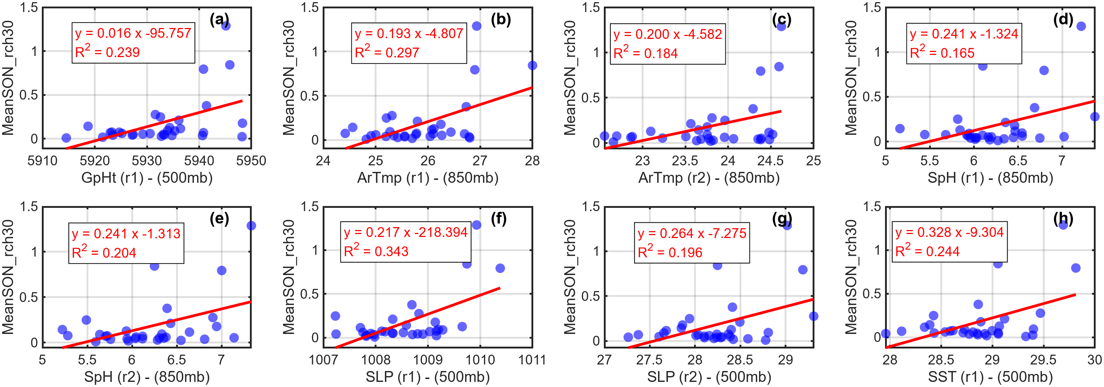
- SON Predictors (reach 30)
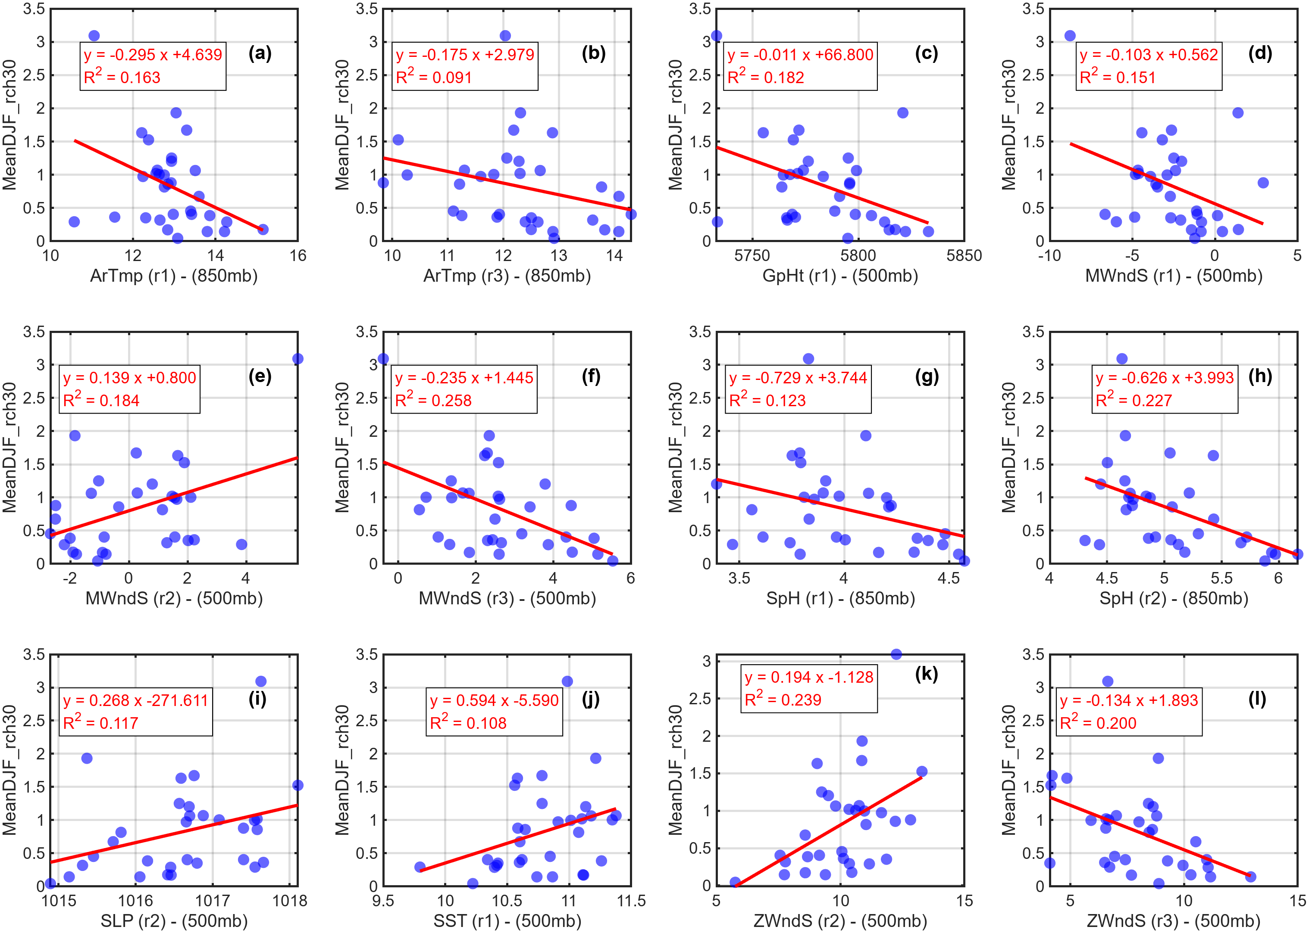
- DJF predictors
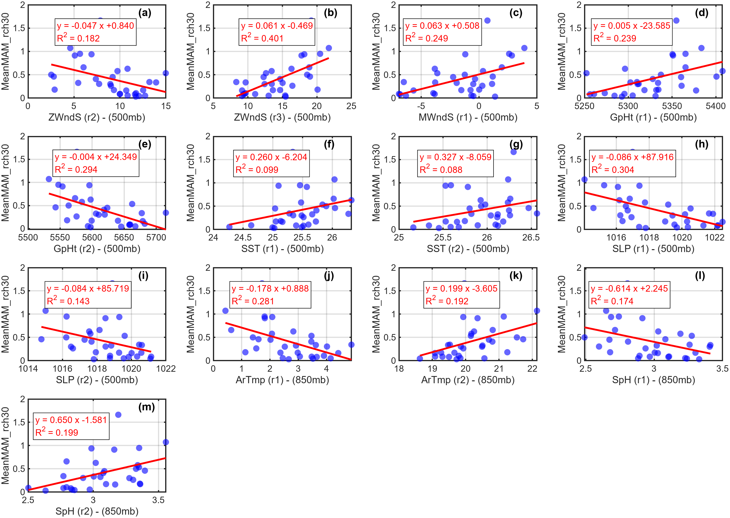
- MAM Predictors (reach 30)

Fig. S3. Scatter plots of selected oceanic and atmospheric variables with observed seasonal streamflow of: A) SON season, B) DJF season, C) MAM season. NB: ZWndS: Zonal wind Speed, MWndS: Meridional Wind Speed, GpHt: Geopotential height, SST: See Surface temperature, SLP: Sea level Pressure, ArTmp: Air temperature, SpH: Specific Humidity

- Results

Cross-validation and model selection
The LOOCV is used to select the number of PCs and LVs that give the minimum MSE at the two forecast locations for SON, DJF, and MAM seasons (Fig. S2). Since PLSR considers the covariance between the predictors and response variables when developing the LVs, it usually requires fewer components than PCR, as illustrated in the SON season prediction plot in the figure. Only the first component is adequate to build the DJF and MAM season (reach32) and MAM season (reach 30) predictions. In Fig. S2, the larger errors before the occurrence of the minimum error values are due to underfitting, which means that the components in this zone are not sufficient to capture the variations. On the other hand, the error increases after the minimum value, which indicates the model is overfitting and starts capturing noise.
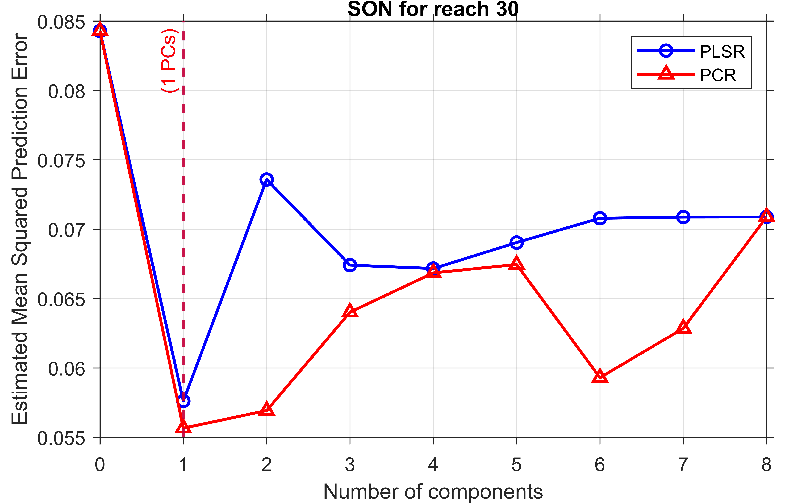
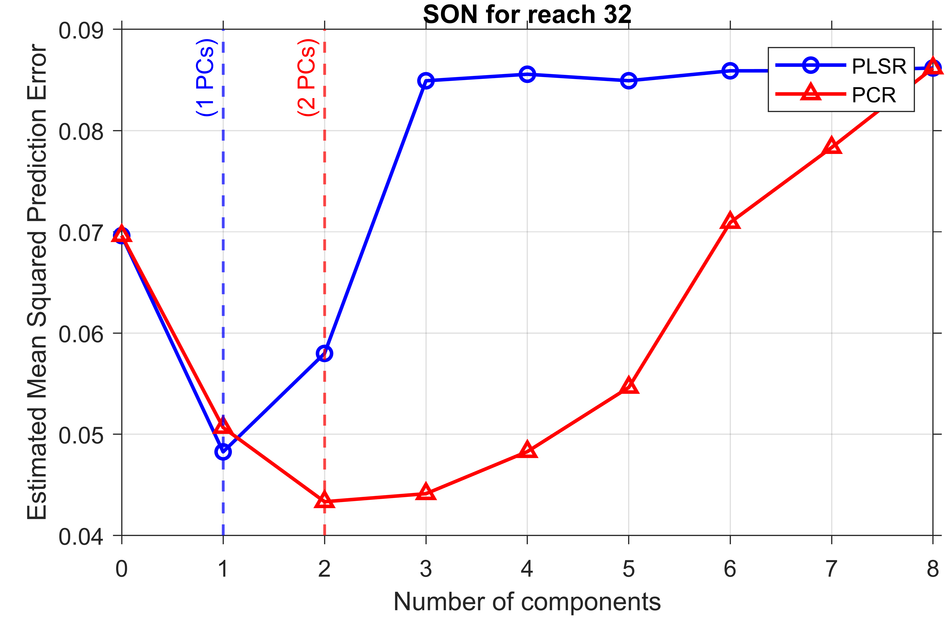

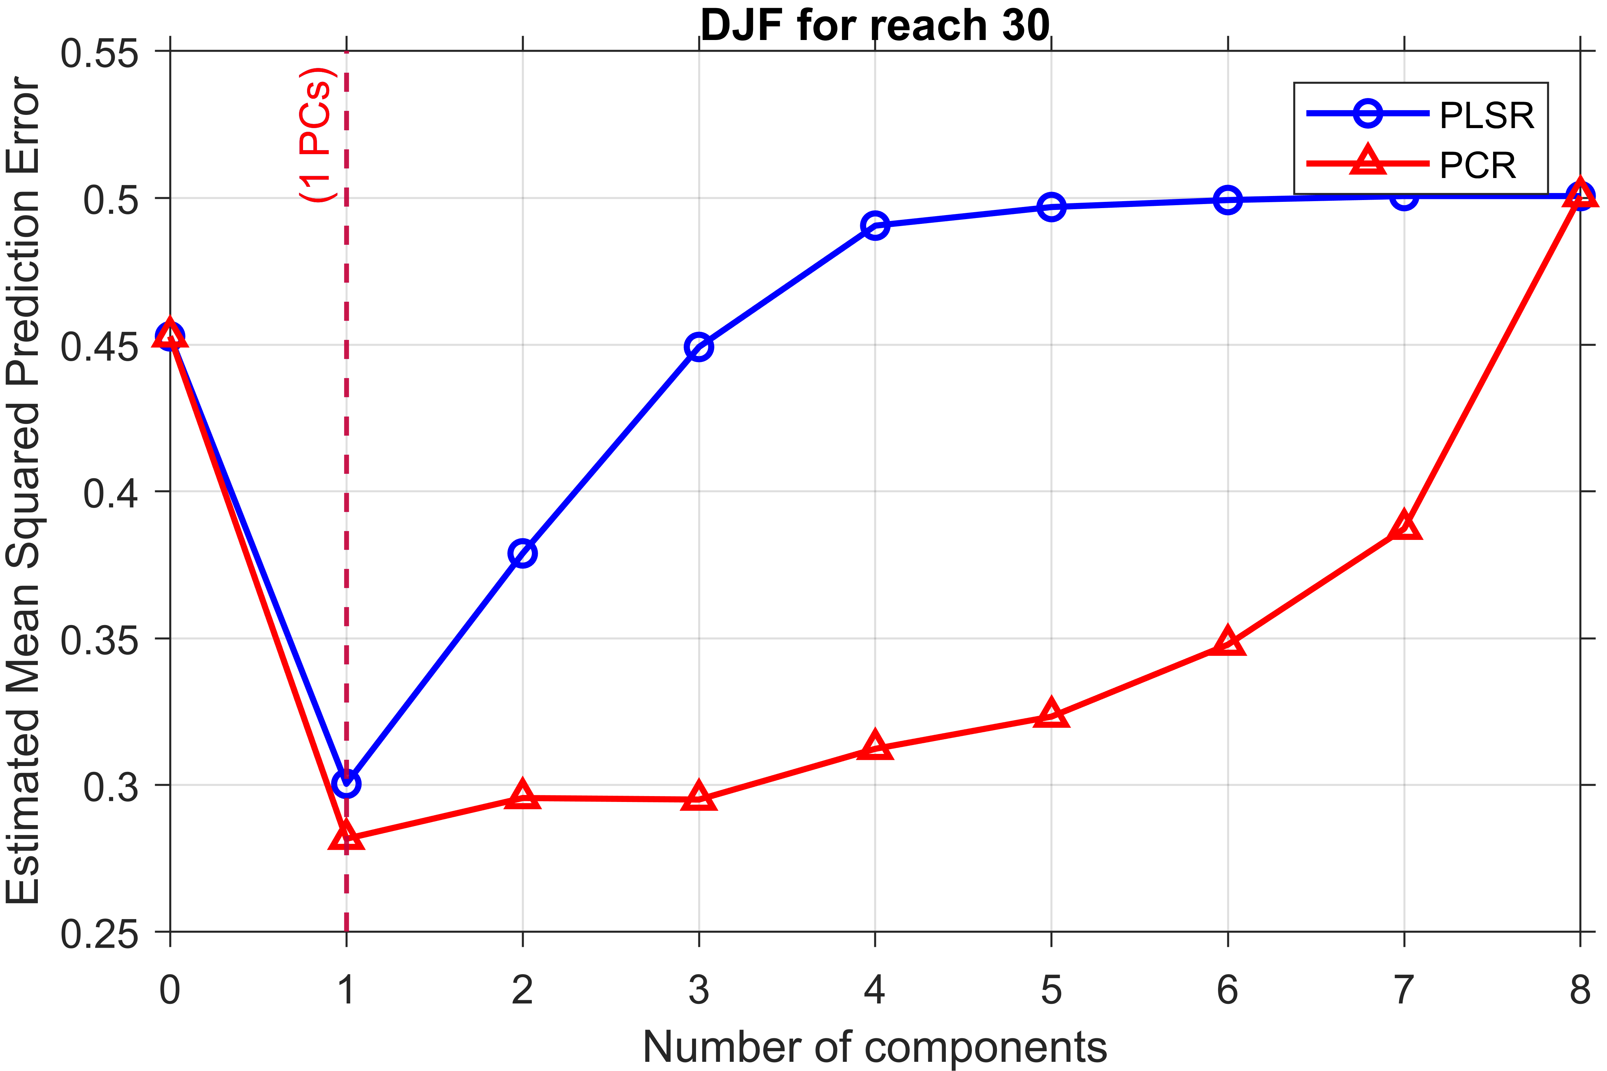
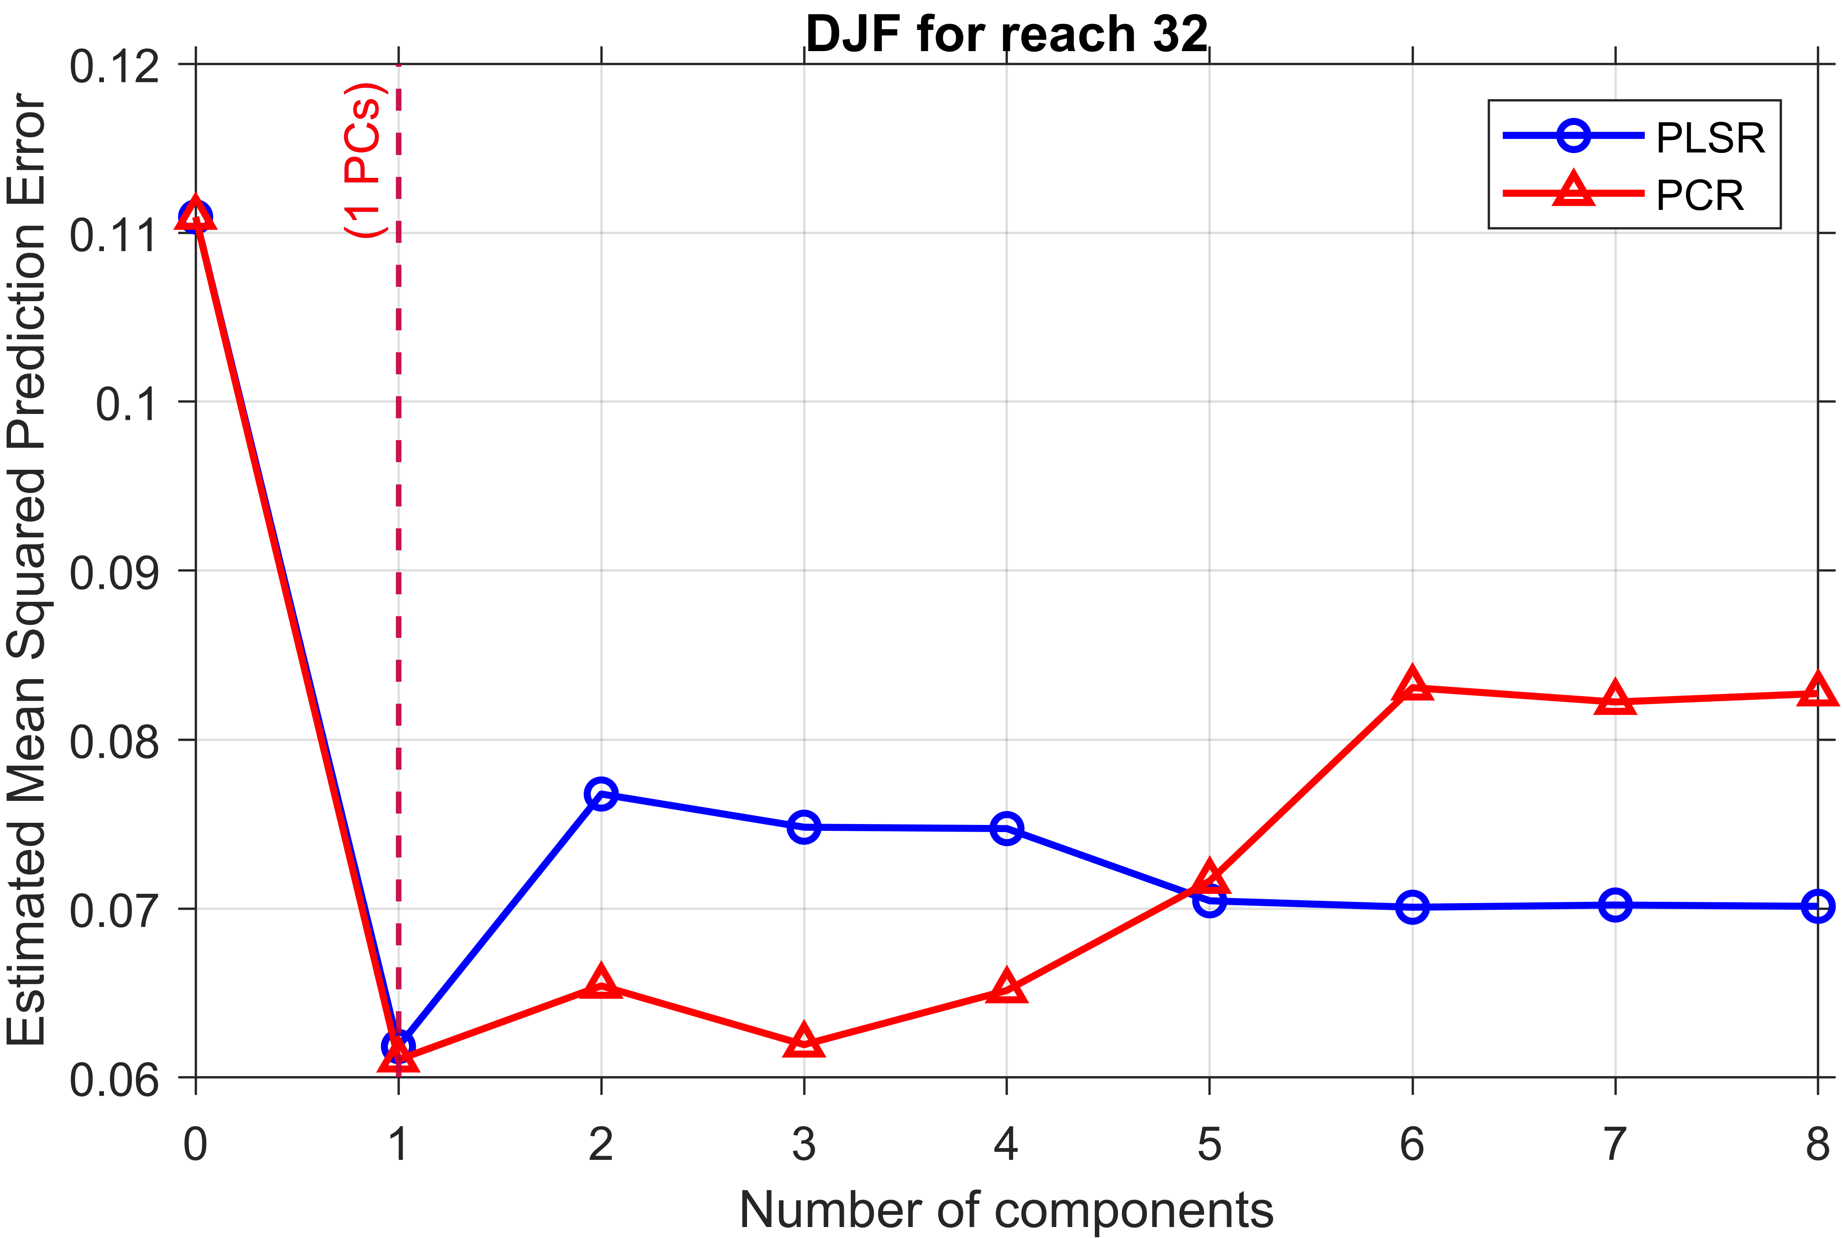

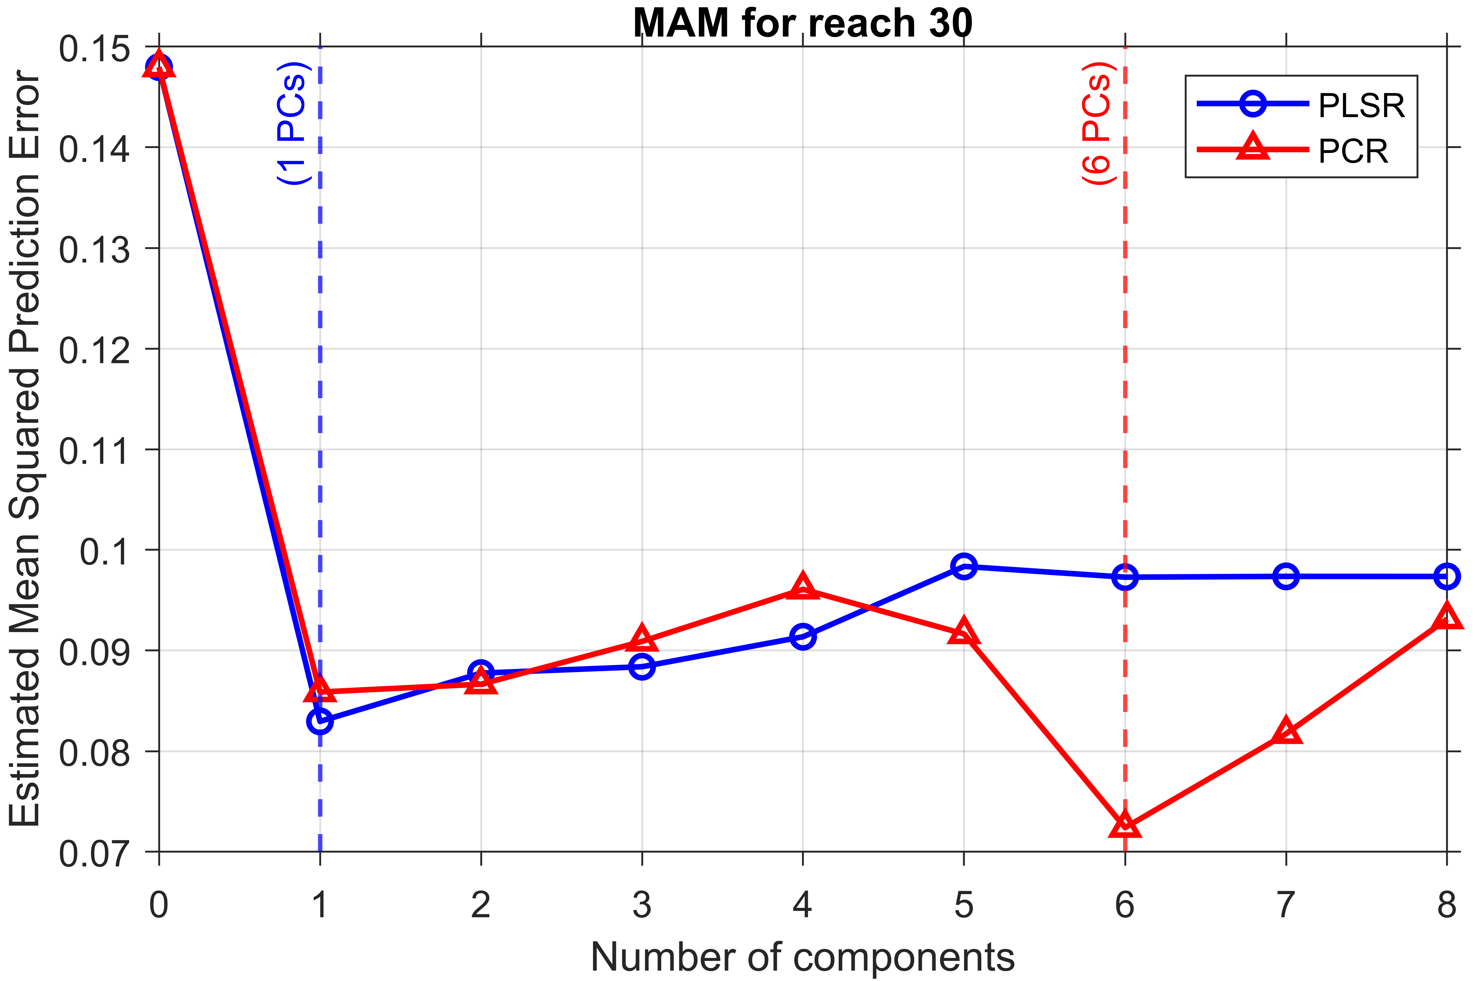

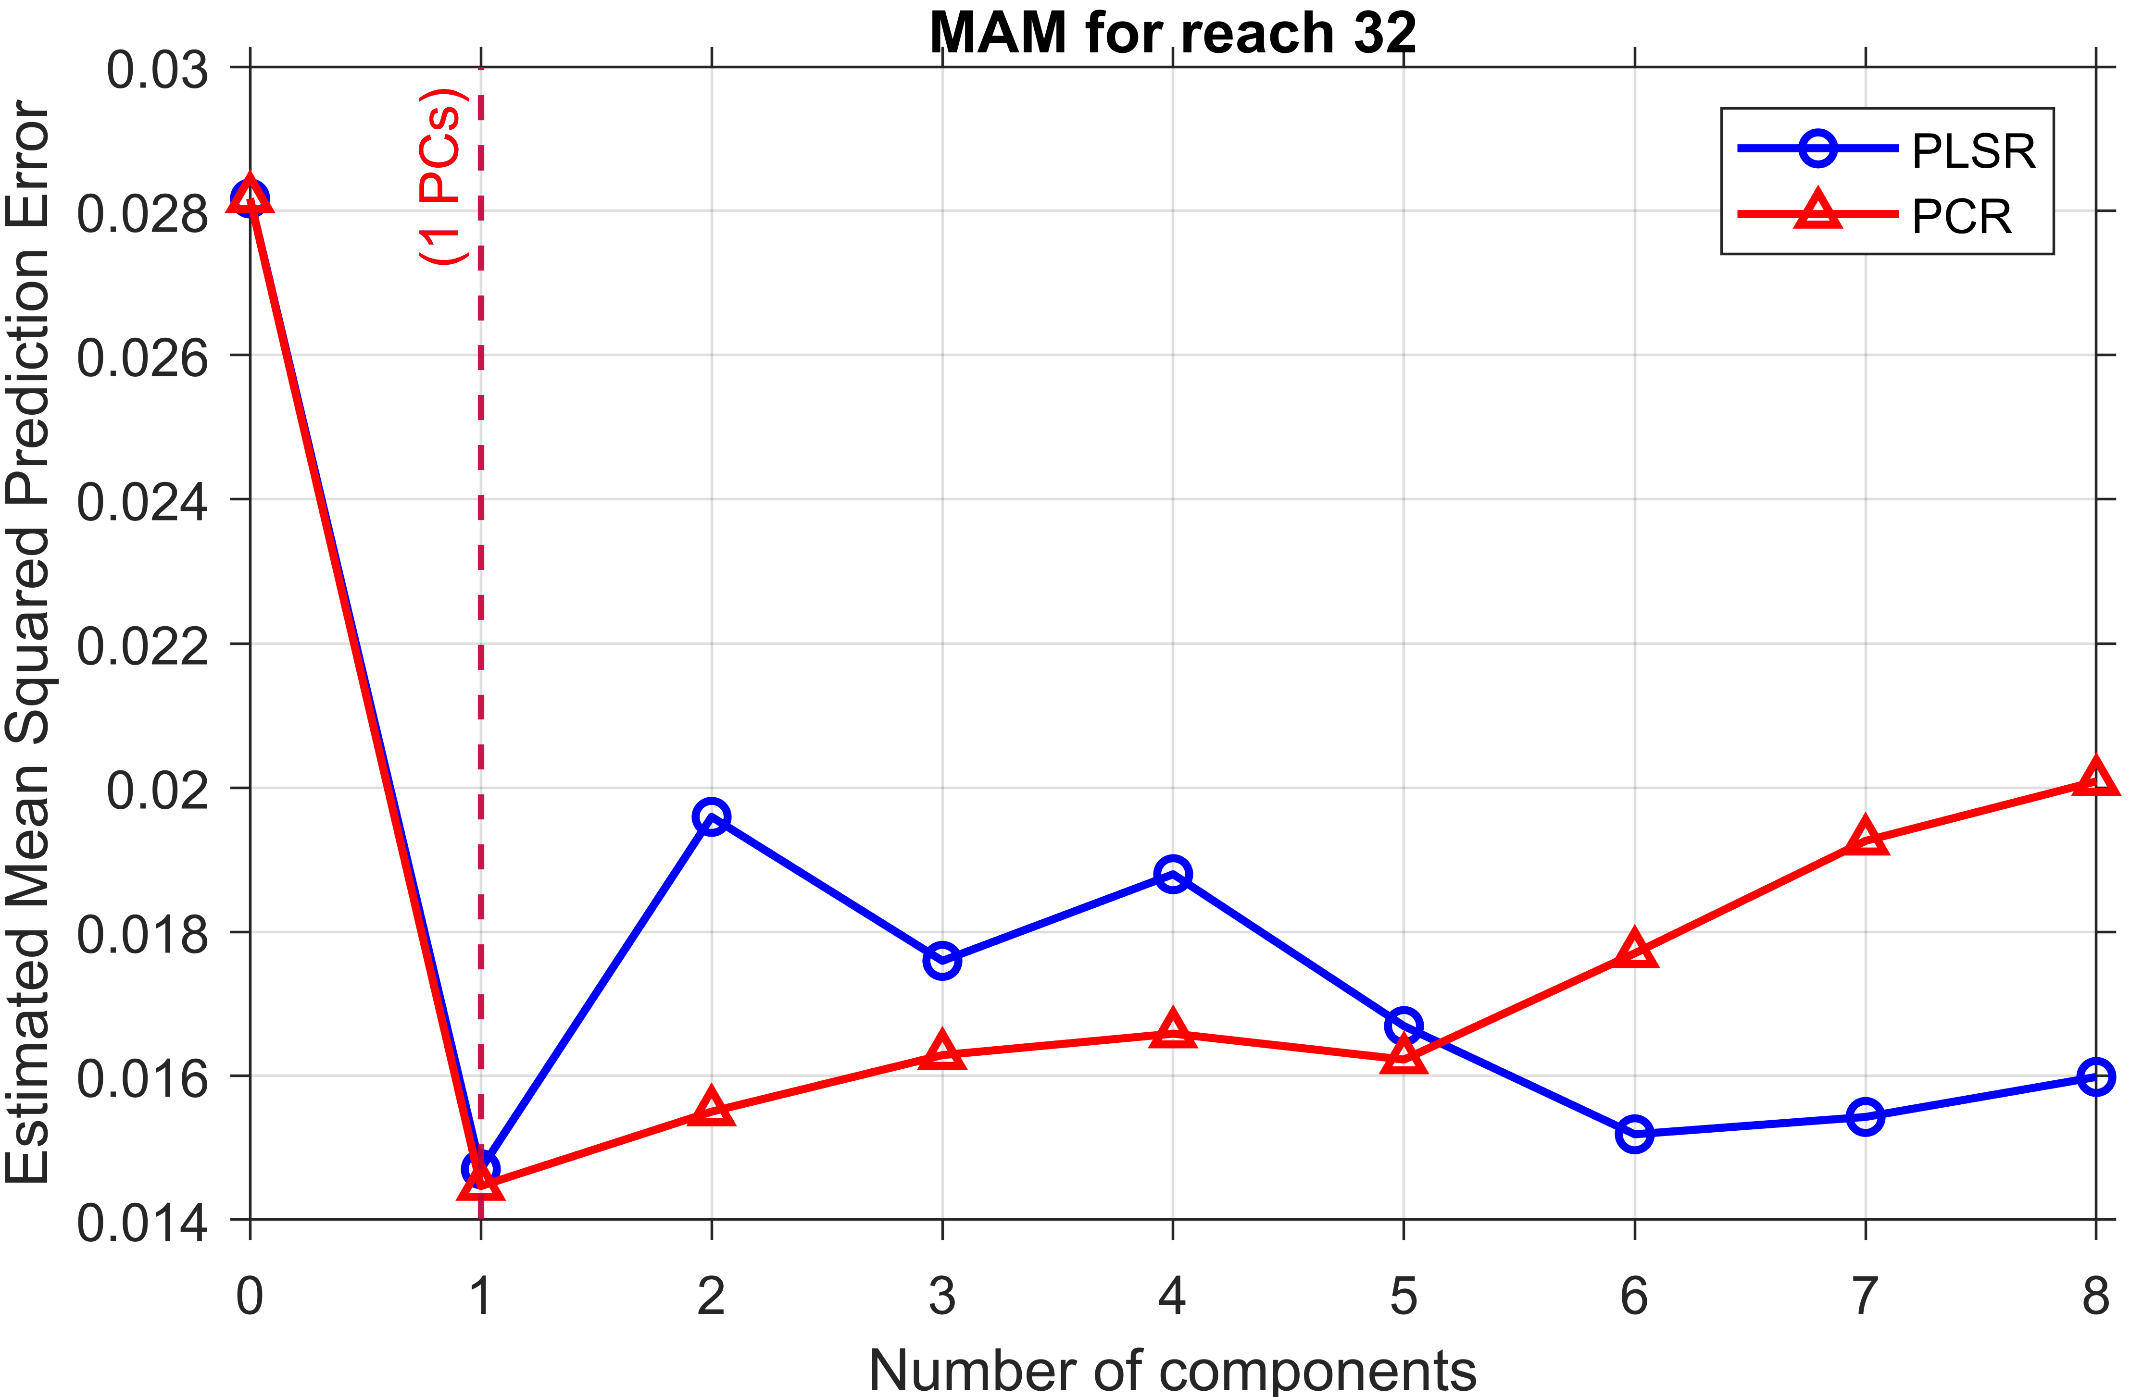
Fig. S4. Optimized number of components using LOOCV to reach 32 for SON, DJF, and MAM seasons

Deterministic seasonal streamflow forecasting
After determining the optimal number of components for both models, deterministic statistical predictions were made using the selected components. Seasonal mean streamflow at the two locations was predicted using PLSR and PCR regression models (Fig. S3).

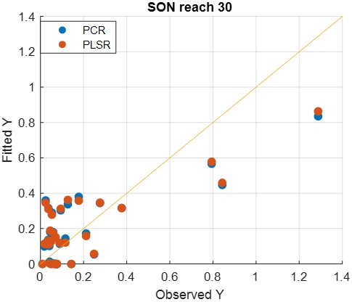 | 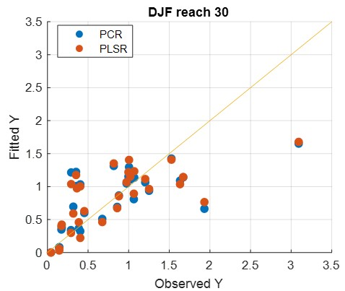 | 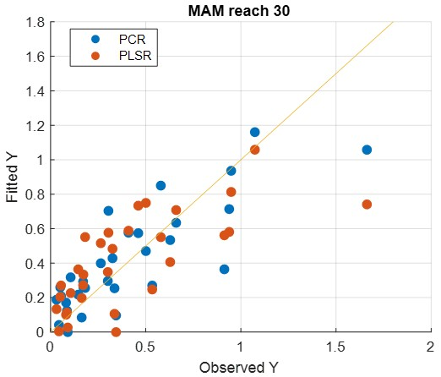
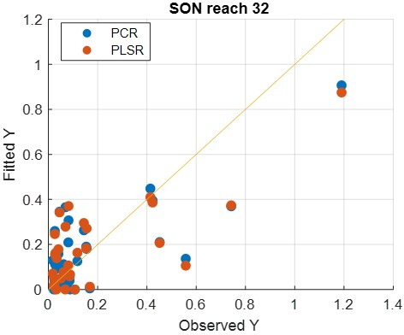 | 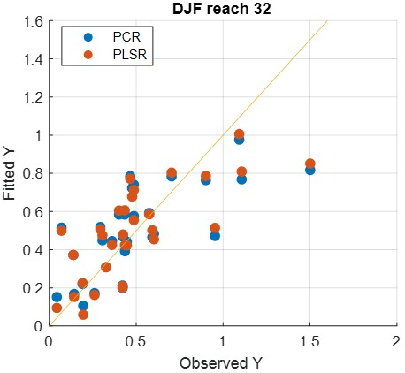 | 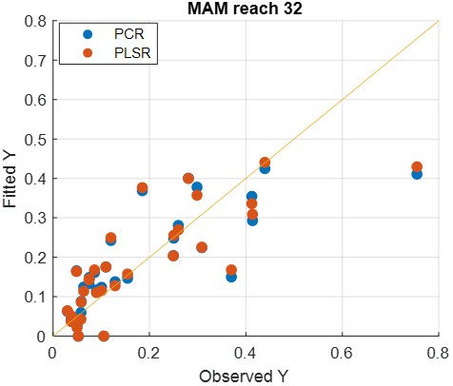
Fig. S5. Deterministic Seasonal stream flow forecasting for SON, DJF, and MAM seasons

  - Probabilistic Forecast
Probabilistic ensemble forecasts generated from a deterministic forecast using the residuals. 30 Ensemble members were generated from 31 data points, and box plots of SON and MAM seasons are presented in Fig. S4 for both PCR and PLSR models.
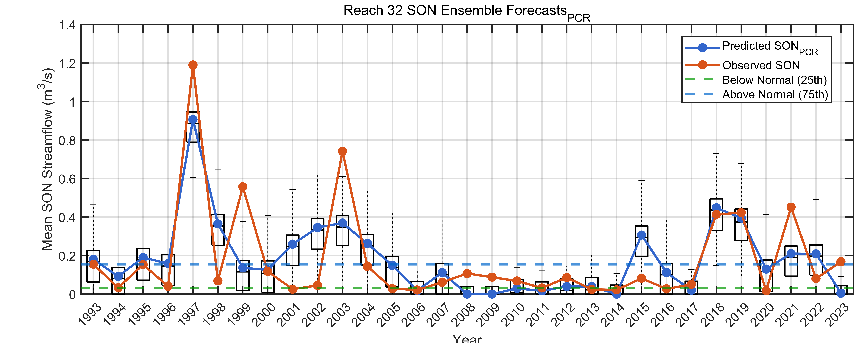
- SON PCR at reach 32
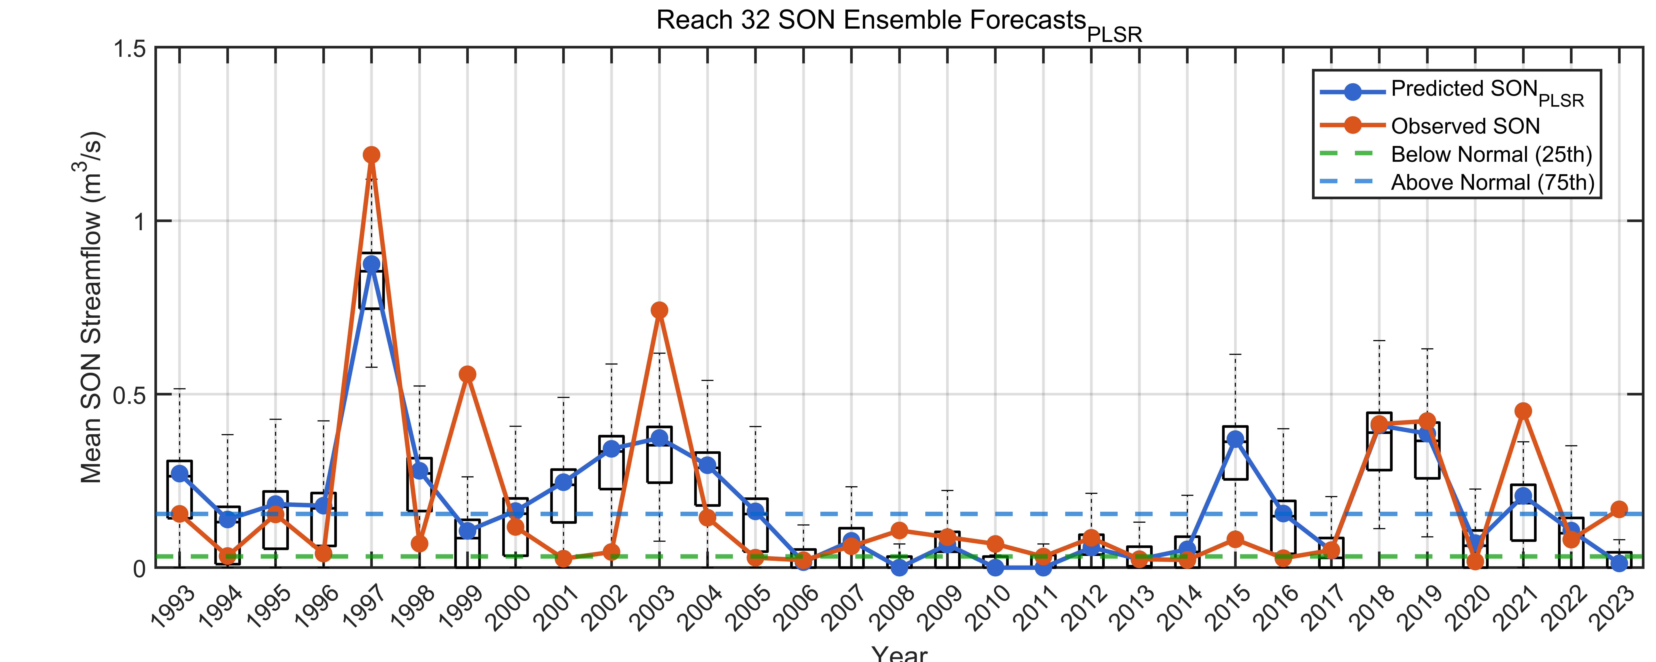
- SON PLSR at reach 32
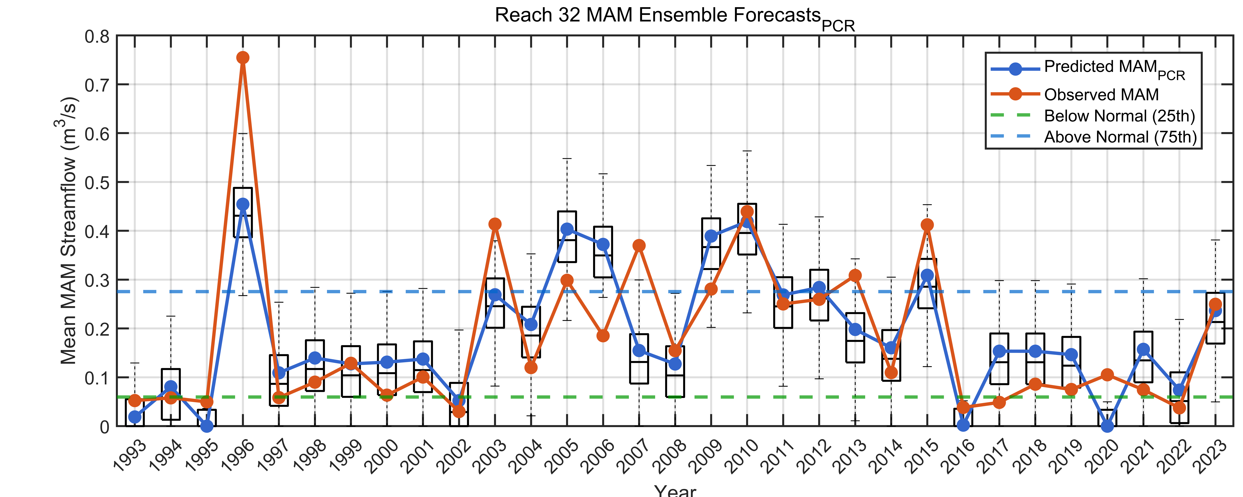
- MAM PCR at reach 32
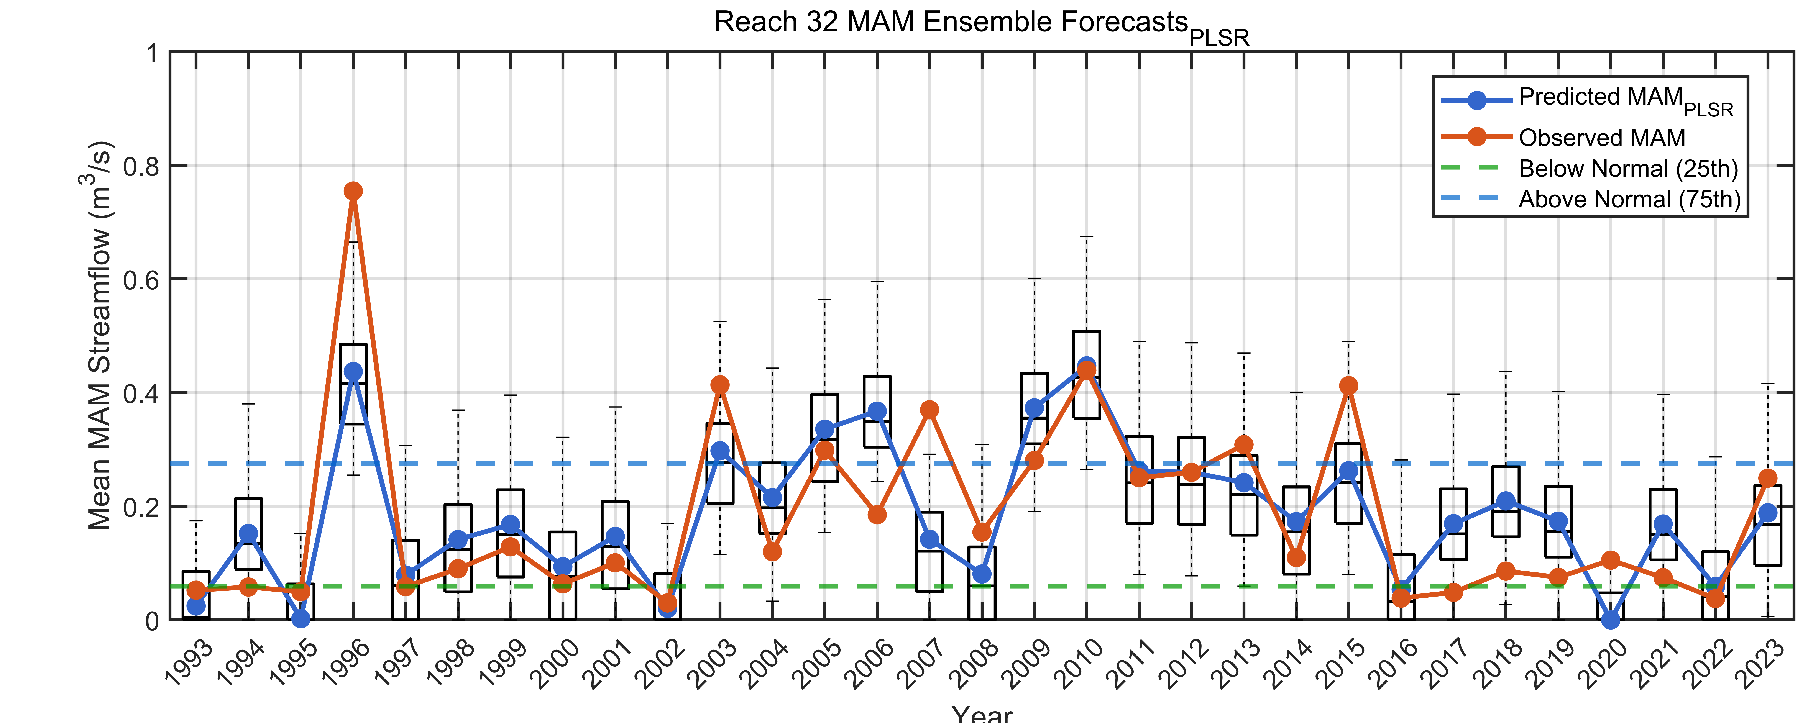
- MAM PLSR at reach 32
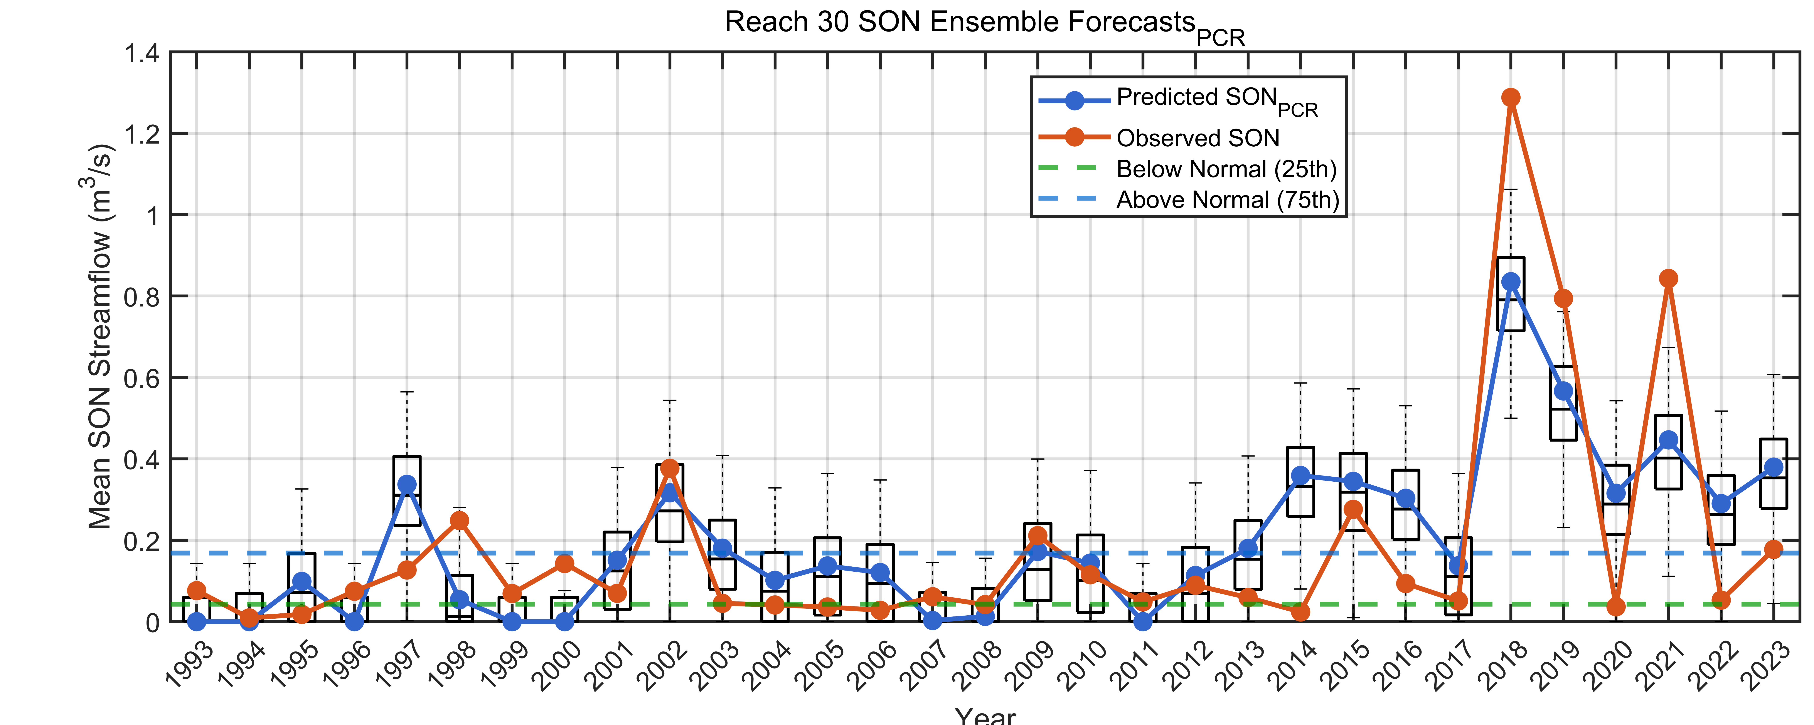
- SON PCR at reach 30
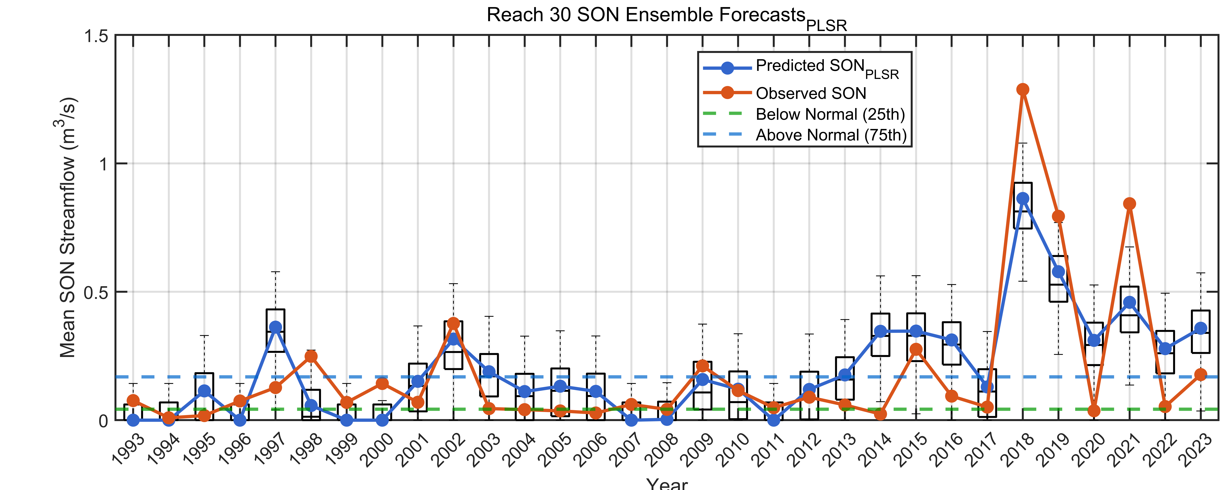
- SON PLSR at reach 30
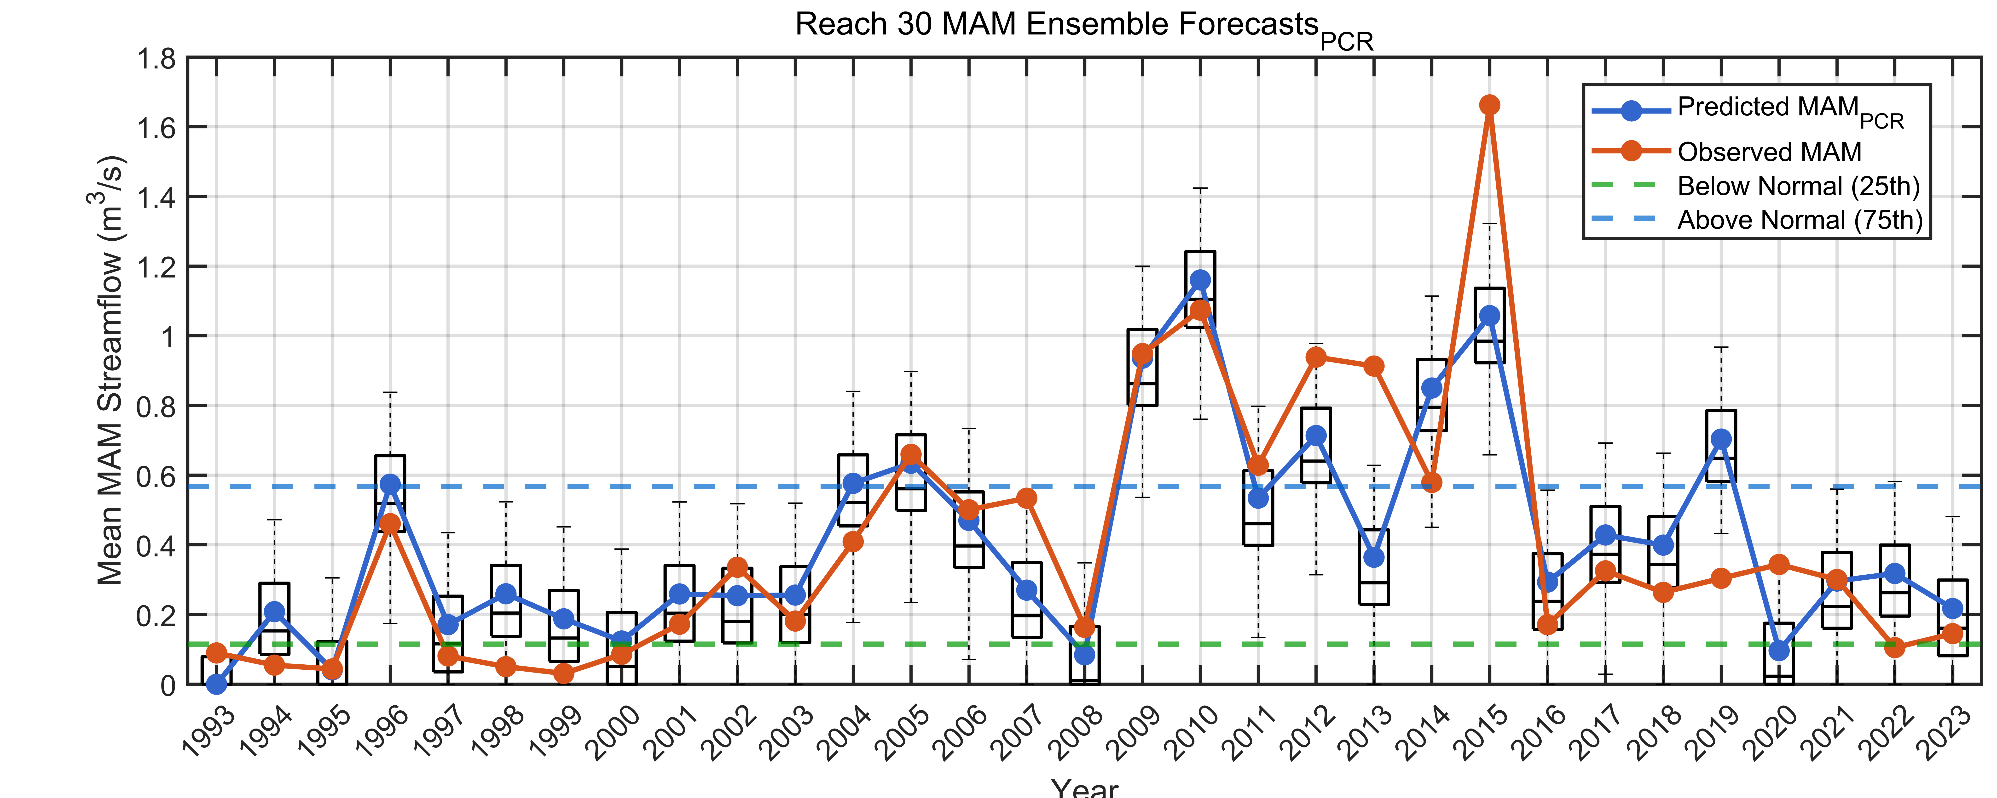
- MAM PCR at reach 30
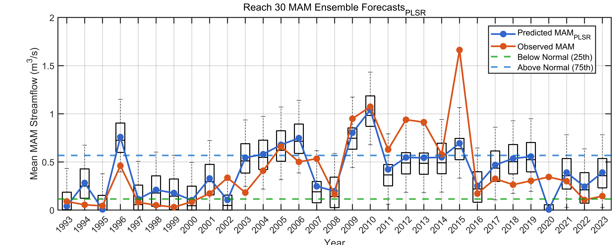
- MAM PLSR at reach 30
Fig. S6. Box plot of the ensemble forecast for reach 32 and 30 using the PCR and PLSR models: SON and MAM seasons
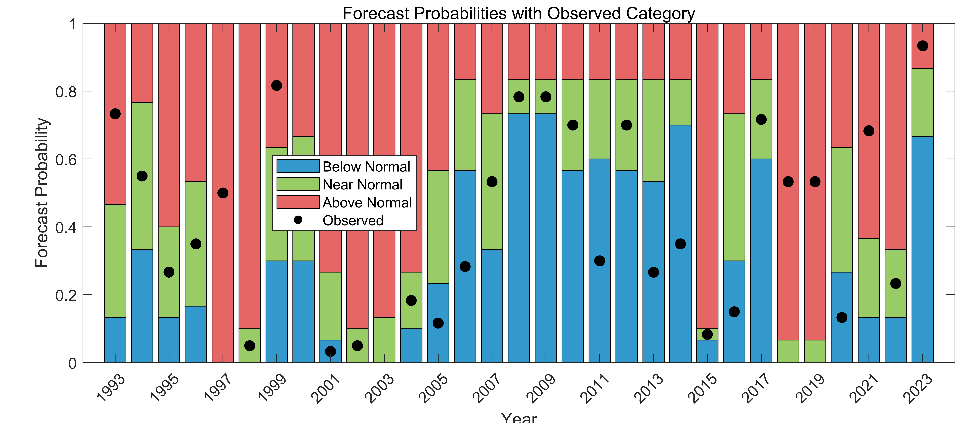
- SON PCR model at Reach 32
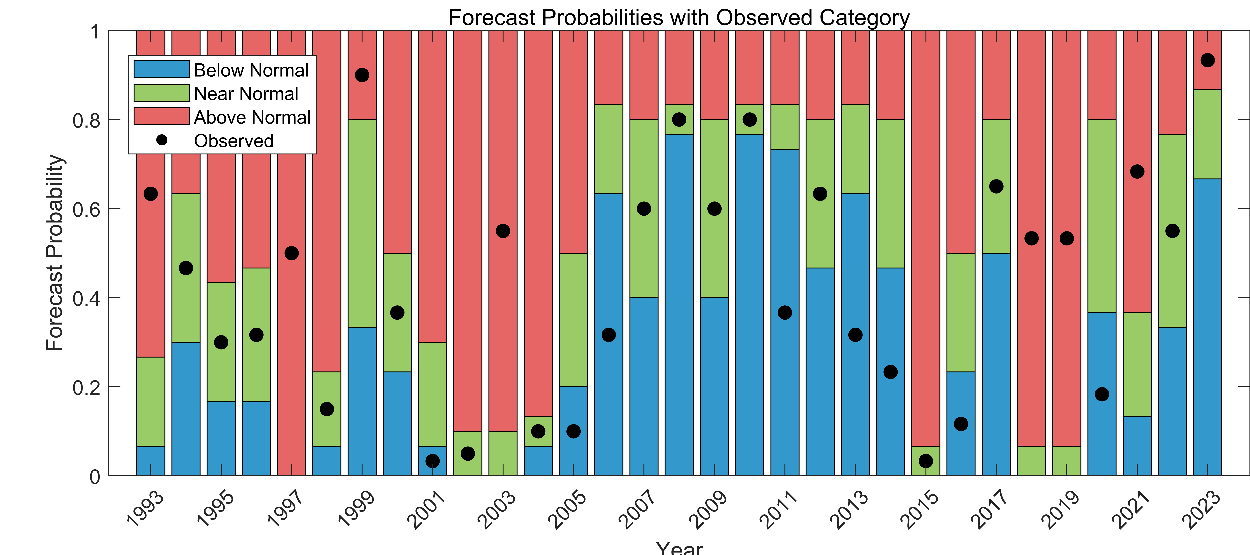
- SON PLSR model at Reach 32
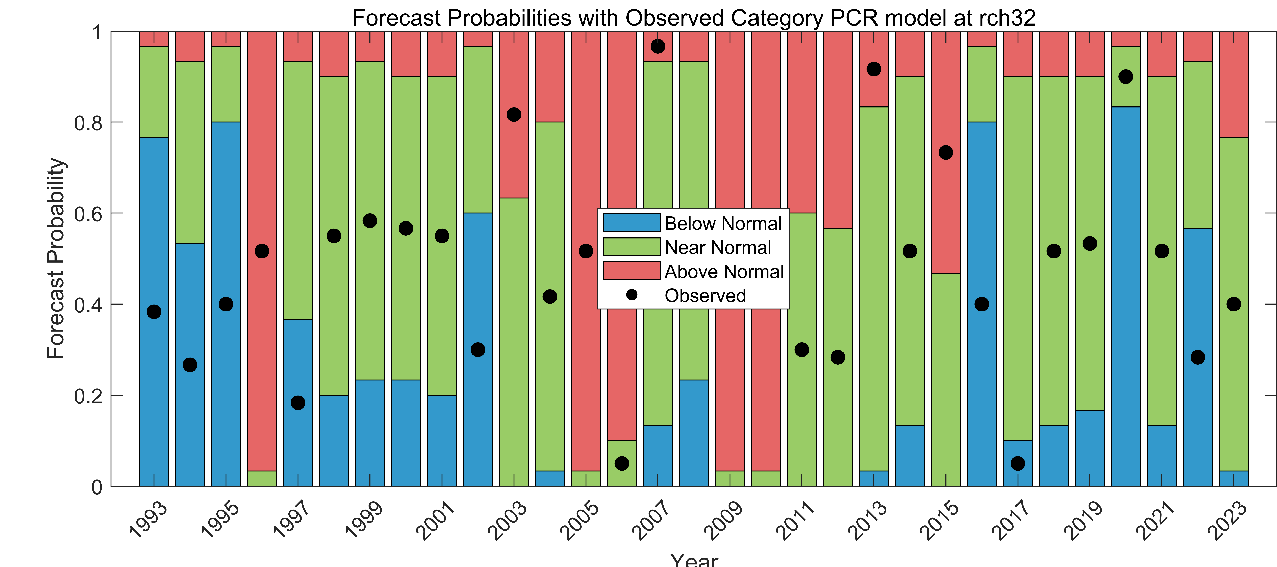
- MAM PCR model at Reach 32
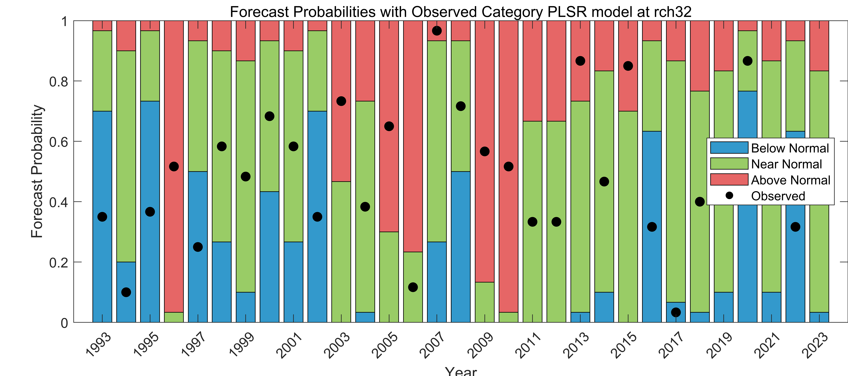
- MAM PLSR model at Reach 32
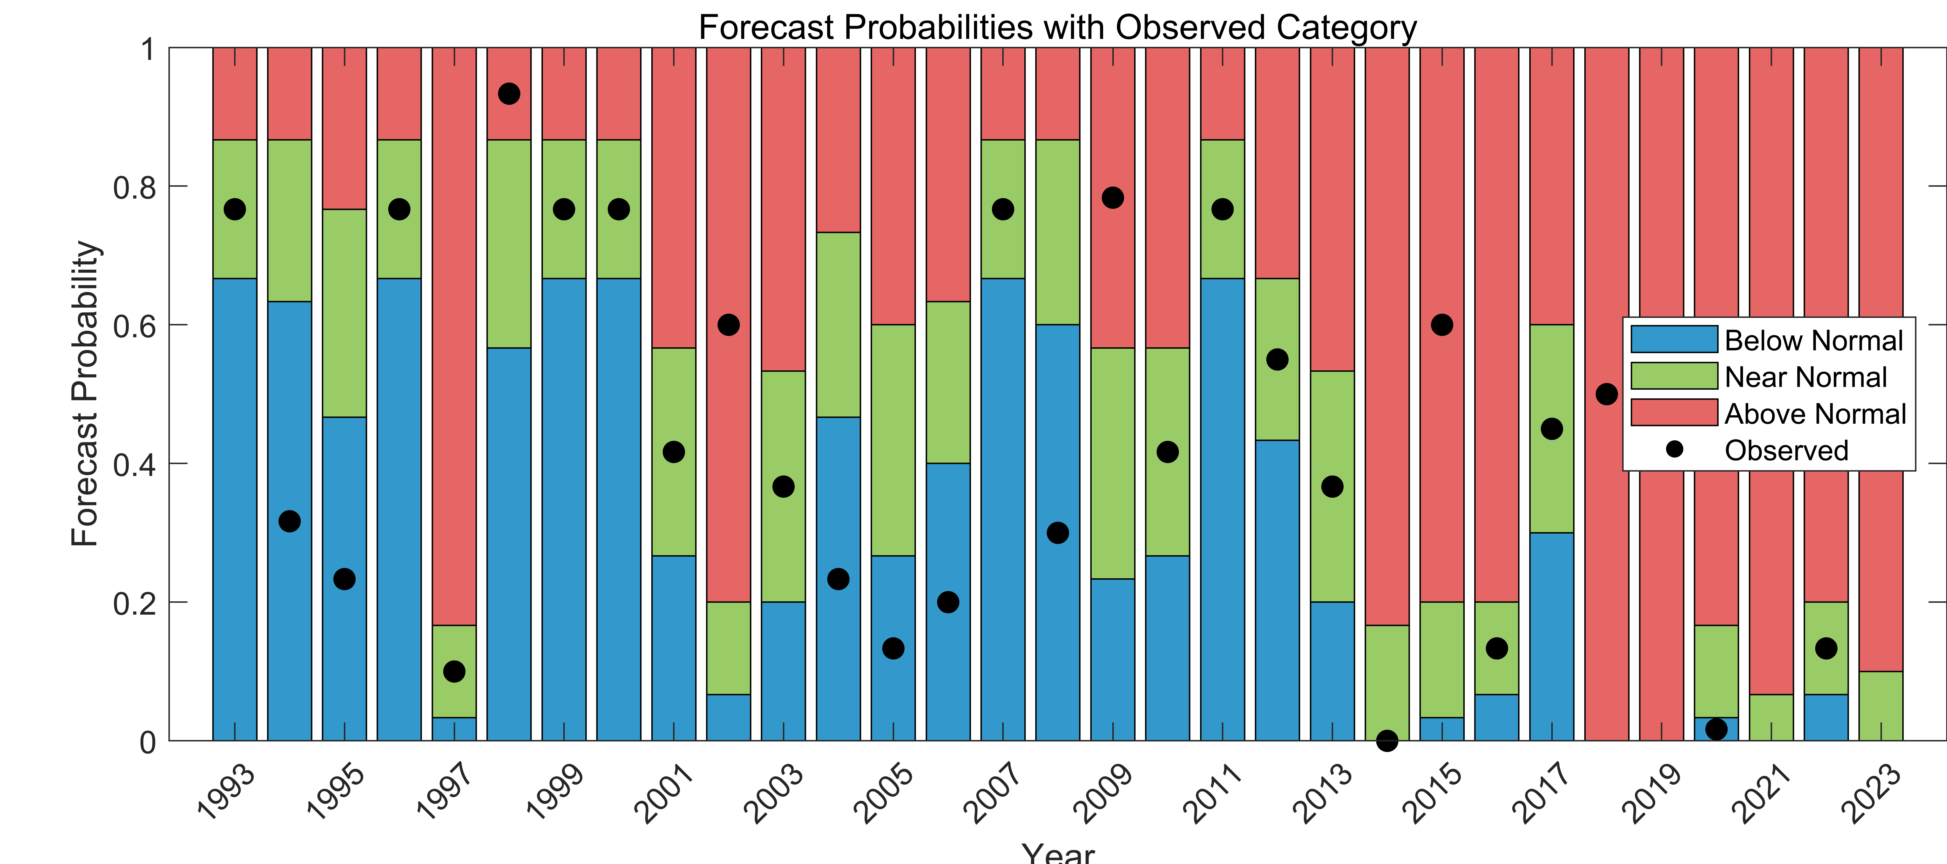
- SON PCR model at Reach 30
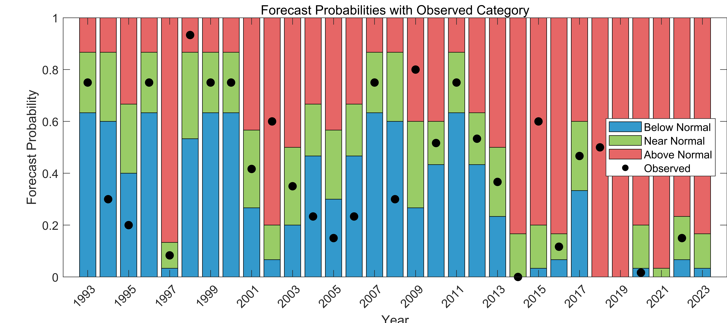
- SON PLSR model at Reach 30
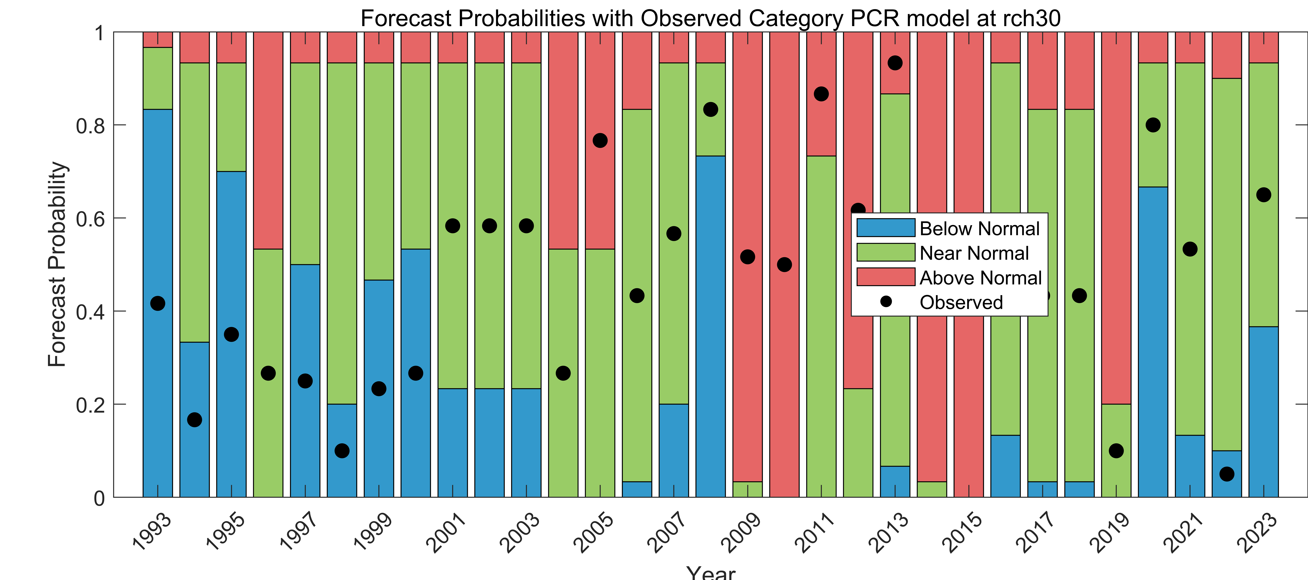
- MAM PCR model at Reach 30
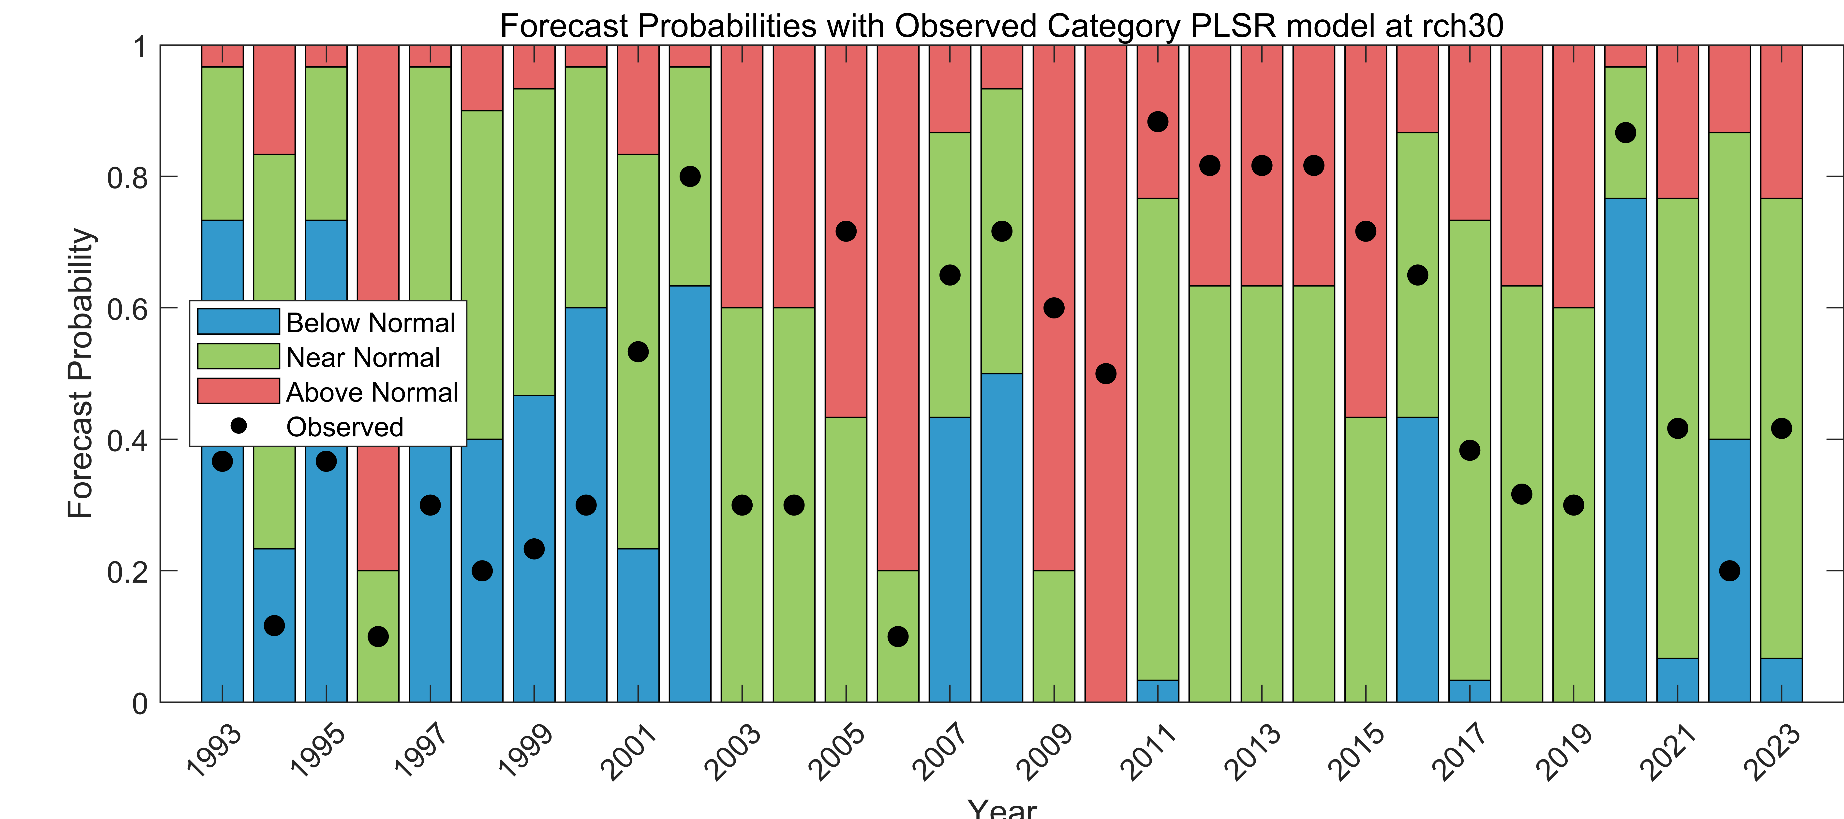
- MAM PLSR model at Reach 30
Fig. S7. Forecast probabilities for each category for both PCR and PLSR models at Reach 32 and 30 SON and MAM seasons

Probability density functions of ensemble forecasts (PDF) for extremely dry and wet years
- PCR at Reach 32 for SON
- PLSR at Reach 32 for SON

- PCR at Reach 32 for MAM
- PLSR at Reach 32 for MAM
Fig. S8 PDFs for the three top driest (a – c) and three wettest (d – e) years, during the SON and MAM season forecasts Reach 32

Table S2. Exceedance and non-exceedance probability analysis of the top three driest and wettest years of the SON (A), DJF (B), and MAM (C) seasons
- SON season
Year | Average Obs. Q(m³/s) | Threshold Value (m³/s) | Flood/drought Conditions | Model and season
2020_Dry1 | 0.018 | 0.022 | Drought (≤ 5th) | PLSR_SON_RCH32
2006_Dry2 | 0.022 | 0.022 | Drought (≤ 5th) | PLSR_SON_RCH32
2014_Dry3 | 0.022 | 0.027 | Drought (≤ 15th) | PLSR_SON_RCH32
1999_Wet1 | 0.557 | 0.414 | Flood (≥ 85th) | PLSR_SON_RCH32
2003_Wet2 | 0.742 | 0.557 | Flood (≥ 95th) | PLSR_SON_RCH32
1997_Wet3 | 1.190 | 0.557 | Flood (≥ 95th) | PLSR_SON_RCH32
1994_Dry1 | 0.009 | 0.024 | Drought (≤ 5th) | PLSR_SON_RCH30
1995_Dry2 | 0.018 | 0.024 | Drought (≤ 5th) | PLSR_SON_RCH30
2014_Dry3 | 0.024 | 0.037 | Drought (≤ 15th) | PLSR_SON_RCH30
2019_Wet1 | 0.794 | 0.248 | Flood (≥ 85th) | PLSR_SON_RCH30
2021_Wet2 | 0.843 | 0.794 | Flood (≥ 95th) | PLSR_SON_RCH30
2018_Wet3 | 1.288 | 0.794 | Flood (≥ 95th) | PLSR_SON_RCH30
2020_Dry1 | 0.018 | 0.022 | Drought (≤ 5th) | PCR_SON_RCH32
2006_Dry2 | 0.022 | 0.022 | Drought (≤ 5th) | PCR_SON_RCH32
2014_Dry3 | 0.022 | 0.027 | Drought (≤ 15th) | PCR_SON_RCH32
1999_Wet1 | 0.557 | 0.414 | Flood (≥ 85th) | PCR_SON_RCH32
2003_Wet2 | 0.742 | 0.557 | Flood (≥ 95th) | PCR_SON_RCH32
1997_Wet3 | 1.190 | 0.557 | Flood (≥ 95th) | PCR_SON_RCH32
1994_Dry1 | 0.009 | 0.024 | Drought (≤ 5th) | PCR_SON_RCH30
1995_Dry2 | 0.018 | 0.024 | Drought (≤ 5th) | PCR_SON_RCH30
2014_Dry3 | 0.024 | 0.037 | Drought (≤ 15th) | PCR_SON_RCH30
2019_Wet1 | 0.794 | 0.248 | Flood (≥ 85th) | PCR_SON_RCH30
2021_Wet2 | 0.843 | 0.794 | Flood (≥ 95th) | PCR_SON_RCH30
2018_Wet3 | 1.288 | 0.794 | Flood (≥ 95th) | PCR_SON_RCH30

- DJF Season
Year | Average Obs. Q(m³/s) | Threshold Values (m³/s) | Flood/drought Conditions | Model and season
2015_Dry1 | 0.043 | 0.138 (5th) | Drought (≤ 5th) | PLSR_DJF_RCH32
2001_Dry2 | 0.070 | 0.138 (5th) | Drought (≤ 5th) | PLSR_DJF_RCH32
2017_Dry3 | 0.138 | 0.195 (15th) | Drought (≤ 15th) | PLSR_DJF_RCH32
2005_Wet1 | 1.093 | 0.704 (85th) | Flood (≥ 85th) | PLSR_DJF_RCH32
1995_Wet2 | 1.107 | 1.093 (59th) | Flood (≥ 95th) | PLSR_DJF_RCH32
2008_Wet3 | 1.501 | 1.093 (95th) | Flood (≥ 95th) | PLSR_DJF_RCH32
1994_Dry1 | 0.043 | 0.145 (5th) | Drought (≤ 5th) | PLSR_DJF_RCH30
2022_Dry2 | 0.145 | 0.145 (5th) | Drought (≤ 5th) | PLSR_DJF_RCH30
2023_Dry3 | 0.145 | 0.145 (5th) | Drought (≤ 5th) | PLSR_DJF_RCH30
2021_Wet1 | 1.671 | 1.251 (5th) | Flood (≥ 85th) | PLSR_DJF_RCH30
2009_Wet2 | 1.932 | 1.671 (5th) | Flood (≥ 95th) | PLSR_DJF_RCH30
2008_Wet3 | 3.092 | 1.671 (5th) | Flood (≥ 95th) | PLSR_DJF_RCH30
2015_Dry1 | 0.043 | 0.138 (5th) | Drought (≤ 5th) | PCR_DJF_RCH32
2001_Dry2 | 0.070 | 0.138 (5th) | Drought (≤ 5th) | PCR_DJF_RCH32
2017_Dry3 | 0.138 | 0.195 (15th) | Drought (≤ 15th) | PCR_DJF_RCH32
2005_Wet1 | 1.093 | 0.704 (85th) | Flood (≥ 85th) | PCR_DJF_RCH32
1995_Wet2 | 1.107 | 1.093 (95th) | Flood (≥ 95th) | PCR_DJF_RCH32
2008_Wet3 | 1.501 | 1.093 (95th) | Flood (≥ 95th) | PCR_DJF_RCH32
1994_Dry1 | 0.043 | 0.145 (5th) | Drought (≤ 5th) | PCR_DJF_RCH30
2022_Dry2 | 0.145 | 0.145 (5th) | Drought (≤ 5th) | PCR_DJF_RCH30
2023_Dry3 | 0.145 | 0.145 (5th) | Drought (≤ 5th) | PCR_DJF_RCH30
2021_Wet1 | 1.671 | 1.251 (85th) | Flood (≥ 85th) | PCR_DJF_RCH30
2009_Wet2 | 1.932 | 1.671 (95th) | Flood (≥ 95th) | PCR_DJF_RCH30
2008_Wet3 | 3.092 | 1.671 (95th) | Flood (≥ 95th) | PCR_DJF_RCH30
- MAM Season
Year | Average Obs. Q(m³/s) | Threshold Value (m³/s) | Flood/drought Conditions | Model and season
2002_Dry1 | 0.030 | 0.038 | Drought (≤ 5th) | PLSR_MAM_RCH32
2022_Dry2 | 0.037 | 0.038 | Drought (≤ 5th) | PLSR_MAM_RCH32
2016_Dry3 | 0.038 | 0.052 | Drought (≤ 15th) | PLSR_MAM_RCH32
2003_Wet1 | 0.414 | 0.309 | Flood (≥ 85th) | PLSR_MAM_RCH32
2010_Wet2 | 0.439 | 0.414 | Flood (≥ 95th) | PLSR_MAM_RCH32
1996_Wet3 | 0.755 | 0.414 | Flood (≥ 95th) | PLSR_MAM_RCH32
1999_Dry1 | 0.031 | 0.051 | Drought (≤ 5th) | PLSR_MAM_RCH30
1995_Dry2 | 0.044 | 0.051 | Drought (≤ 5th) | PLSR_MAM_RCH30
1998_Dry3 | 0.051 | 0.086 | Drought (≤ 15th) | PLSR_MAM_RCH30
2009_Wet1 | 0.949 | 0.660 | Flood (≥ 85th) | PLSR_MAM_RCH30
2010_Wet2 | 1.074 | 0.949 | Flood (≥ 95th) | PLSR_MAM_RCH30
2015_Wet3 | 1.662 | 0.949 | Flood (≥ 95th) | PLSR_MAM_RCH30
2002_Dry1 | 0.030 | 0.038 | Drought (≤ 5th) | PCR_MAM_RCH32
2022_Dry2 | 0.037 | 0.038 | Drought (≤ 5th) | PCR_MAM_RCH32
2016_Dry3 | 0.038 | 0.052 | Drought (≤ 15th) | PCR_MAM_RCH32
2003_Wet1 | 0.414 | 0.309 | Flood (≥ 85th) | PCR_MAM_RCH32
2010_Wet2 | 0.439 | 0.414 | Flood (≥ 95th) | PCR_MAM_RCH32
1996_Wet3 | 0.755 | 0.414 | Flood (≥ 95th) | PCR_MAM_RCH32
1999_Dry1 | 0.031 | 0.051 | Drought (≤ 5th) | PCR_MAM_RCH30
1995_Dry2 | 0.044 | 0.051 | Drought (≤ 5th) | PCR_MAM_RCH30
1998_Dry3 | 0.051 | 0.086 | Drought (≤ 15th) | PCR_MAM_RCH30
2009_Wet1 | 0.949 | 0.660 | Flood (≥ 85th) | PCR_MAM_RCH30
2010_Wet2 | 1.074 | 0.949 | Flood (≥ 95th) | PCR_MAM_RCH30
2015_Wet3 | 1.662 | 0.949 | Flood (≥ 95th) | PCR_MAM_RCH30

- SON PCR model at Reach 32
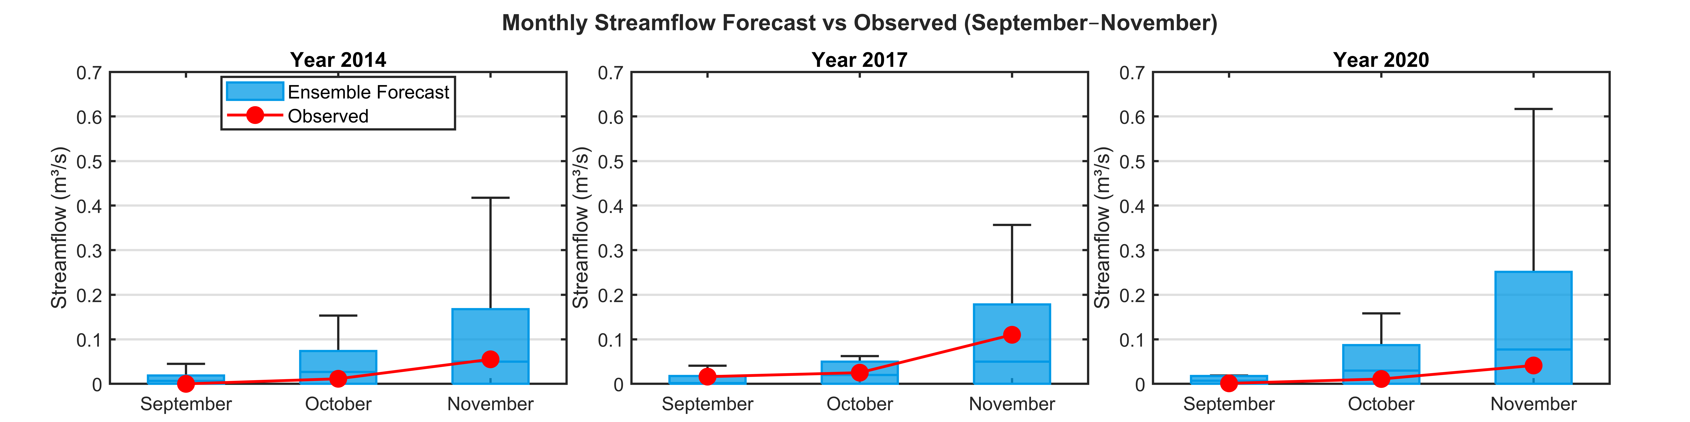
- SON PLSR model at Reach 32
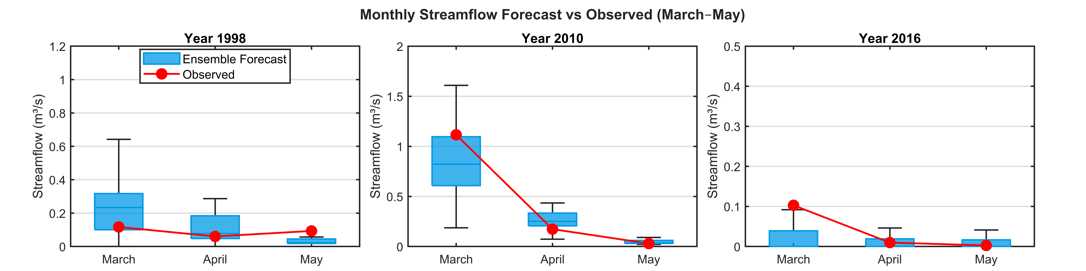
- MAM PCR model at Reach 32
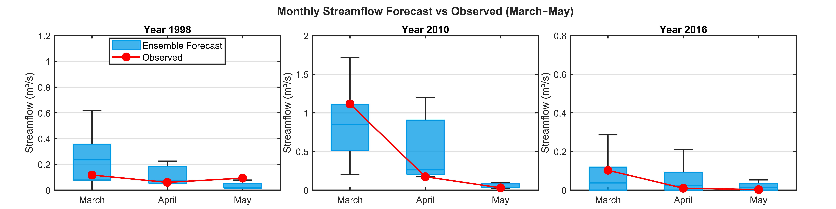
- MAM PLSR model at Reach 32

Fig. S9. Box plots of disaggregated monthly ensemble forecasts at Reach 32: SON (A & B), DJF (C & D), and MAM (E & F)
4 Discussions

- MAM at reach 30 using PCR
- MAM at reach 30 using PLSR
Fig. S10. Forecasting dry years (years that fall below the 25th percentile)

