Cohort 1 and cohort 2 patient count before and after propensity score matching
 |  |  | Cohort |  |  | Patient count before matching |  |  |  | Patient count after matching
 |  |  | 1 – Control: DM + HTN + Female |  |  | 792,822 |  |  |  | 23,349
 |  |  | 2 - GLP-1 + DM + HTN + Female |  |  | 28,970 |  |  |  | 23,349
Propensity score density function - Before and after matching (cohort 1 - purple, cohort 2 - green)
 |  |  | 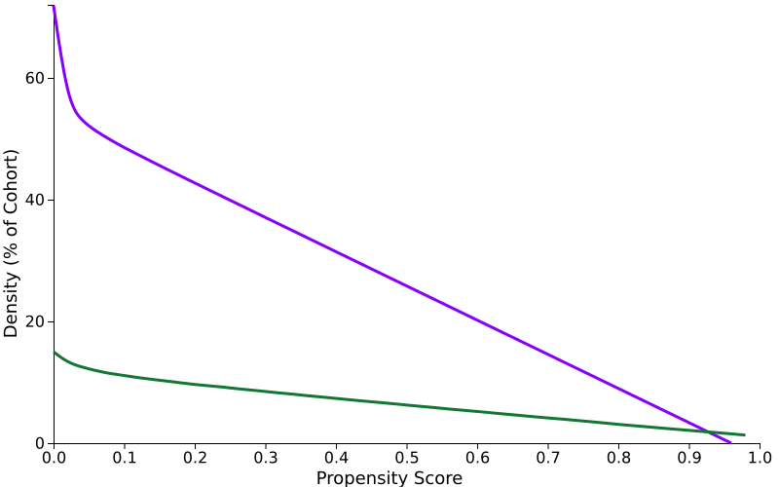 |  |  |  | 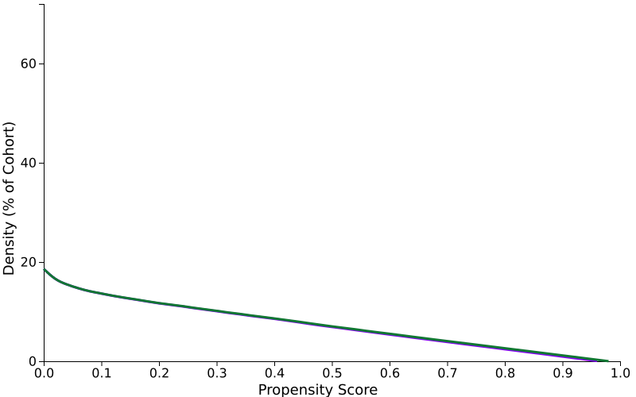
Cohort 1 (N = 792,822) and cohort 2 (N = 28,970) characteristics before propensity score matching
 | Demographics
 |  | Cohort |  |  |  | Mean ± SD |  | Patients | % of Cohort |  | P-Value | Std diff.
 |  | 1  2 |  | Age | Current Age | 77.0 +/- 9.0  68.3 +/- 11.4 |  | 792,822  28,970 | 100%  100% |  | <0.001 | 0.840
 |  | 1  2 |  | AI | Age at Index | 68.2 +/- 10.0  60.6 +/- 11.6 |  | 792,822  28,970 | 100%  100% |  | <0.001 | 0.707
 |  | 1  2 |  | 2106-3 | White |  |  | 509,877  18,145 | 64.3%  62.6% |  | <0.001 | 0.035
 |  | 1  2 |  | F | Female |  |  | 792,822  28,970 | 100%  100% |  | -- | --
 |  | 1  2 |  | 2186-5 | Not Hispanic or Latino |  |  | 655,820  23,044 | 82.7%  79.5% |  | <0.001 | 0.081
 |  | 1  2 |  | 2135-2 | Hispanic or Latino |  |  | 81,569  3,535 | 10.3%  12.2% |  | <0.001 | 0.061
 |  | 1  2 |  | 2028-9 | Asian |  |  | 62,251  1,677 | 7.9%  5.8% |  | <0.001 | 0.082
 | Diagnosis
 |  | Cohort |  |  |  | Mean ± SD |  | Patients | % of Cohort |  | P-Value | Std diff.
 |  | 1  2 |  | I10 | Essential (primary) hypertension |  |  | 381,585  20,478 | 48.1%  70.7% |  | <0.001 | 0.472
 |  | 1  2 |  | E08-E13 | Diabetes mellitus |  |  | 323,596  23,010 | 40.8%  79.4% |  | <0.001 | 0.858
 |  | 1  2 |  | J44 | Other chronic obstructive pulmonary disease |  |  | 51,281  1,972 | 6.5%  6.8% |  | 0.021 | 0.014
 |  | 1  2 |  | N18 | Chronic kidney disease (CKD) |  |  | 69,716  3,872 | 8.8%  13.4% |  | <0.001 | 0.146
 |  | 1  2 |  | E78.5 | Hyperlipidemia, unspecified |  |  | 246,307  15,956 | 31.1%  55.1% |  | <0.001 | 0.500
 | Medication
 |  | Cohort |  |  |  | Mean ± SD |  | Patients | % of Cohort |  | P-Value | Std diff.
 |  | 1  2 |  | 6809 | metformin |  |  | 131,576  17,785 | 16.6%  61.4% |  | <0.001 | 1.034
 |  | 1  2 |  | A10BK | Sodium-glucose co-transporter 2 (SGLT2) inhibitors |  |  | 2,299  3,746 | 0.3%  12.9% |  | <0.001 | 0.526
 |  | 1  2 |  | HS501 | INSULIN |  |  | 129,883  14,383 | 16.4%  49.6% |  | <0.001 | 0.756
 | Laboratory
 |  | Cohort |  |  |  | Mean ± SD |  | Patients | % of Cohort |  | P-Value | Std diff.
 |  | 1  2 |  | 9083 | BMI | 30.2 +/- 6.3  30.8 +/- 5.3 |  | 419,342  22,882 | 52.9%  79.0% |  | <0.001 | 0.095
 |  | 1  2 |  |  | 0 - 0 kg/m2 |  |  | 419,509  22,883 | 52.9%  79.0% |  | <0.001 | 0.572
Cohort 1 (N = 23,349) and cohort 2 (N = 23,349) characteristics after propensity score matching
 | Demographics
 |  | Cohort |  |  |  | Mean ± SD |  | Patients | % of Cohort |  | P-Value | Std diff.
 |  | 1  2 |  | Age | Current Age | 71.8 +/- 8.3  70.9 +/- 10.0 |  | 23,349  23,349 | 100%  100% |  | <0.001 | 0.101
 |  | 1  2 |  | AI | Age at Index | 63.8 +/- 9.0  63.0 +/- 10.3 |  | 23,349  23,349 | 100%  100% |  | <0.001 | 0.086
 |  | 1  2 |  | 2106-3 | White |  |  | 14,910  14,739 | 63.9%  63.1% |  | 0.100 | 0.015
 |  | 1  2 |  | F | Female |  |  | 23,349  23,349 | 100%  100% |  | -- | --
 |  | 1  2 |  | 2186-5 | Not Hispanic or Latino |  |  | 18,416  18,708 | 78.9%  80.1% |  | 0.001 | 0.031
 |  | 1  2 |  | 2135-2 | Hispanic or Latino |  |  | 2,895  2,689 | 12.4%  11.5% |  | 0.003 | 0.027
 |  | 1  2 |  | 2028-9 | Asian |  |  | 1,196  1,338 | 5.1%  5.7% |  | 0.004 | 0.027
 | Diagnosis
 |  | Cohort |  |  |  | Mean ± SD |  | Patients | % of Cohort |  | P-Value | Std diff.
 |  | 1  2 |  | I10 | Essential (primary) hypertension |  |  | 15,932  16,086 | 68.2%  68.9% |  | 0.125 | 0.014
 |  | 1  2 |  | E08-E13 | Diabetes mellitus |  |  | 18,243  17,694 | 78.1%  75.8% |  | <0.001 | 0.056
 |  | 1  2 |  | J44 | Other chronic obstructive pulmonary disease |  |  | 1,761  1,719 | 7.5%  7.4% |  | 0.459 | 0.007
 |  | 1  2 |  | N18 | Chronic kidney disease (CKD) |  |  | 3,390  3,227 | 14.5%  13.8% |  | 0.031 | 0.020
 |  | 1  2 |  | E78.5 | Hyperlipidemia, unspecified |  |  | 12,190  12,288 | 52.2%  52.6% |  | 0.364 | 0.008
 | Medication
 |  | Cohort |  |  |  | Mean ± SD |  | Patients | % of Cohort |  | P-Value | Std diff.
 |  | 1  2 |  | 6809 | metformin |  |  | 13,763  12,764 | 58.9%  54.7% |  | <0.001 | 0.086
 |  | 1  2 |  | A10BK | Sodium-glucose co-transporter 2 (SGLT2) inhibitors |  |  | 1,594  1,217 | 6.8%  5.2% |  | <0.001 | 0.068
 |  | 1  2 |  | HS501 | INSULIN |  |  | 11,877  10,619 | 50.9%  45.5% |  | <0.001 | 0.108
 | Laboratory
 |  | Cohort |  |  |  | Mean ± SD |  | Patients | % of Cohort |  | P-Value | Std diff.
 |  | 1  2 |  | 9083 | BMI | 31.2 +/- 6.5  30.7 +/- 5.2 |  | 17,304  17,565 | 74.1%  75.2% |  | <0.001 | 0.085
 |  | 1  2 |  |  | 0 - 0 kg/m2 |  |  | 17,311  17,566 | 74.1%  75.2% |  | 0.007 | 0.025

