SUPPLEMENTARY INFORMATION
Gadolinium-oxide nanoparticles for cryogenic magnetocaloric application

A. Zeleňákováª*, P. Hrubovčák^{a,b}, A. Berkutovaª, O. Šofranko^{a,c}, N. Kučerka^{b,d}, O. Ivankov^{b}, A. Kuklin^{b,e}, V. Girmanª, V. Zeleňák^{f}

ªInstitute of Physics, P.J. Šafárik University, Park Angelinum 9, 04001 Košice, Slovakia
^{b}Frank Laboratory of Neutron Physics, Joint Institute for Nuclear Research, Joliot-Curie 6, Dubna, 141980 Russia
^{c}Institute of Experimental Physics, Slovak Academy of Science, Watsonova 47, 04001 Košice, Slovakia
^{d}Comenius University in Bratislava, Department of Physical Chemistry of Drugs, Mlynská dolina, 832 32 Bratislava, Slovakia
^{e}Moscow Institute of Physics and Technology, Institutsky per. 9, Dolgoprudny, Moscow Region, 141700, Russia
^{f}Institute of Chemistry, Faculty of Science, P.J. Šafárik University, Moyzesova 11, 041 54 Košice, Slovakia

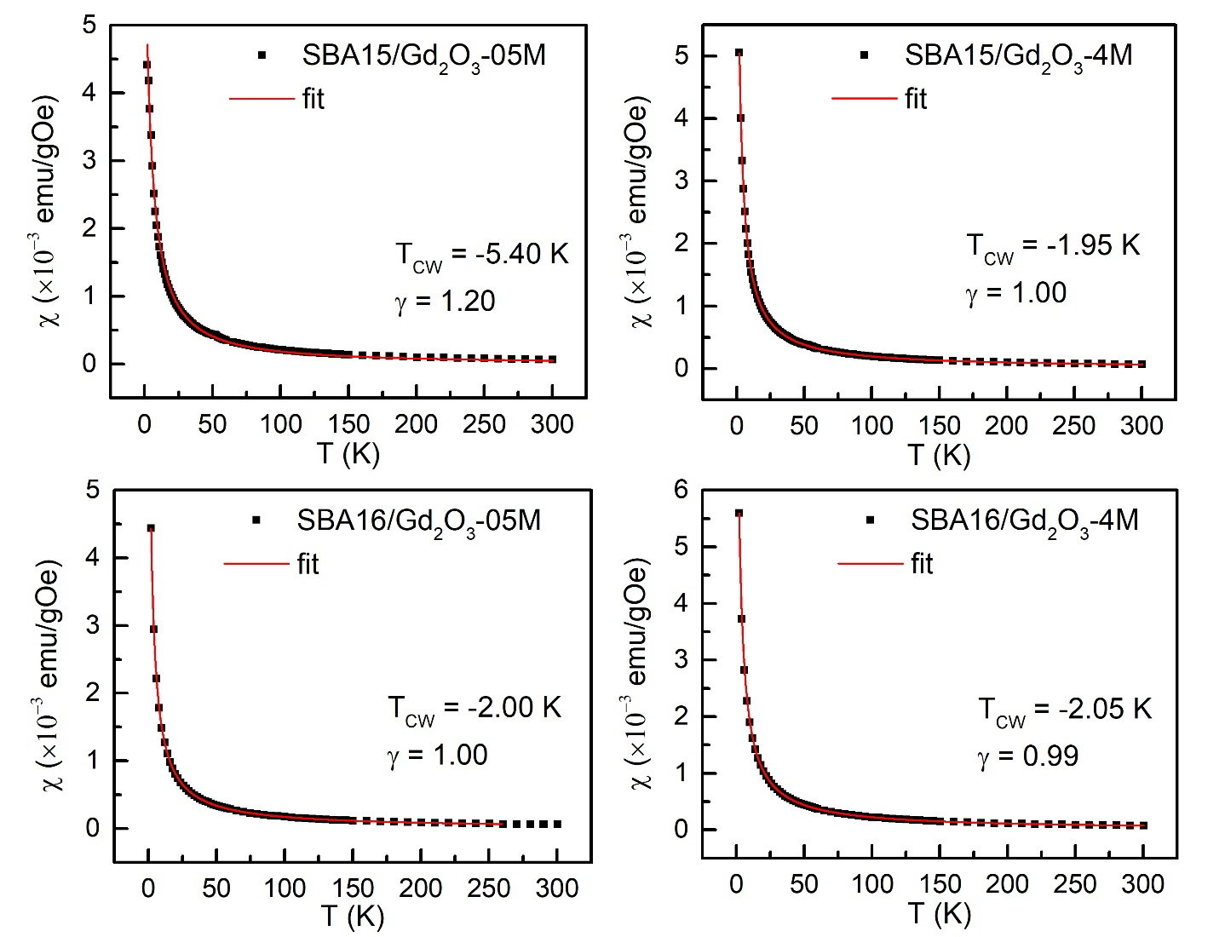
Supplementary Fig. 1 Susceptibility (black squares) of the systems SBA15/Gd₂O₃-0.5M; 4M and SBA16/Gd₂O₃-0.5M; 4M calculated from the magnetization obtained in ZFC regime in the applied static field 100 Oe. Red lines represent the best fits to the experimental data according to the Curie-Weiss law χ=C/(T-T_{CW})^{γ}, where C and T_{CW} is Curie-Weiss constant and temperature, respectively.
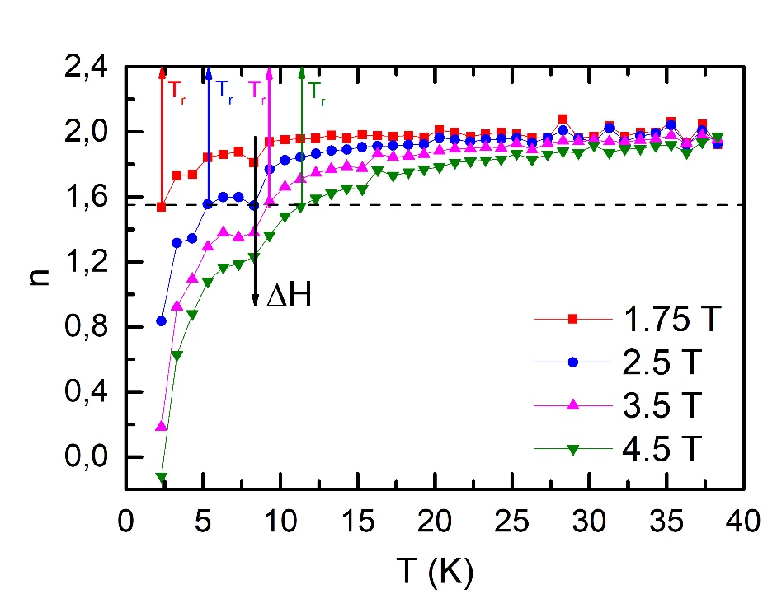
Supplementary Fig. 2 Temperature and applied field change dependence of the exponent n calculated for the system SBA16/Gd₂O₃-4M. The reference temperatures T_{r} have been determined as the temperatures corresponding to the value n = 1.55 (dashed line) of each n(T) curve. Black arrow indicates applied field change dependence of n(T) local minimum.

