Informed Consent Form
For Clinical Case Report & Spinal System Needle-Knife Therapy

1. Patient Information
Name: Lai-Min He Gender: male Age: 45 ID Number: 1236851 Diagnosis: Massive multilevel lumbar disc herniation; lumbar spinal stenosis; lumbar degenerative disease; paraspinal muscle spasm, fibrosis and adhesion; global spinal dynamic mechanical imbalance

2. Purpose of Treatment
I have been diagnosed with massive lumbar disc herniation and related spinal disorders. I will receive spinal system needle-knife therapy to release soft-tissue adhesions, muscular attachments, and contractures in the cervical, thoracolumbar, lumbar, and sacral regions, aiming to restore global spinal mechanical balance, relieve pain, numbness, and improve lumbar function.

3. Treatment Procedure
- Treatment consists of 4 sessions of minimally invasive needle-knife manipulation.
- Only a small dose of local anesthesia may be used if necessary.
- No steroids, vitamins, or other adjuvant drugs will be used during treatment.
- Strict aseptic technique will be applied throughout the procedure.

4. Potential Benefits
- Relief of low back pain, radiating leg pain, and numbness
- Improvement of lumbar mobility and daily living ability
- Improvement of spinal mechanical balance and long-term symptom control

5. Possible Risks & Complications
I have been informed that potential risks may include:
- Local subcutaneous hemorrhage, hematoma, or transient pain
- Local infection (prevented by strict disinfection)
- Temporary local discomfort or mild nerve irritation
- Uncertain therapeutic effect due to individual differences
The physician has explained that all operations will follow standardized protocols to minimize risks.

6. Rights of the Patient
- I have the right to ask questions and all my questions have been answered clearly.
- I may refuse or terminate the treatment at any time without affecting my other medical rights.
- My privacy and personal information will be strictly protected.

7. Consent for Publication
I voluntarily consent that clinical data, physical examination results, imaging findings (MRI), treatment process, and outcome data related to this case may be used for academic research, case report writing, and peer-reviewed journal publication. All personally identifiable information will be kept anonymous and confidential.

8. Ethical Statement
I confirm that this study is conducted in accordance with the Declaration of Helsinki. I have been fully informed and understand the content above.
Patient’s Signature: Date: 2026.03.02

eFigure1 Ethical approval materials for research projects
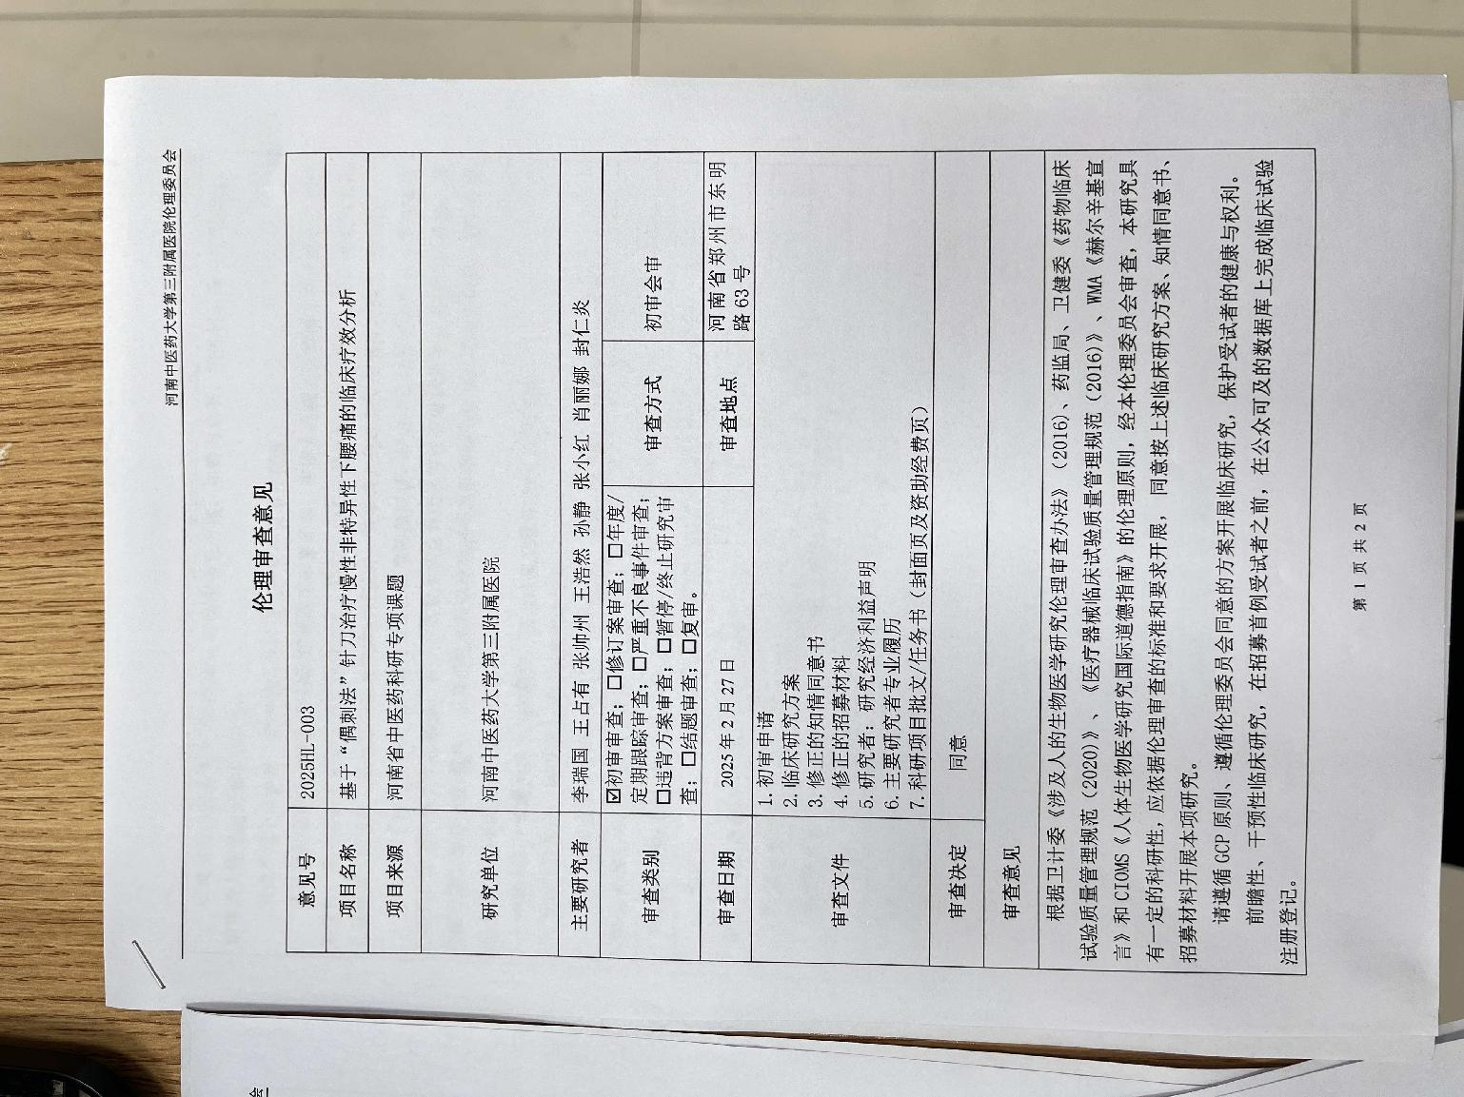

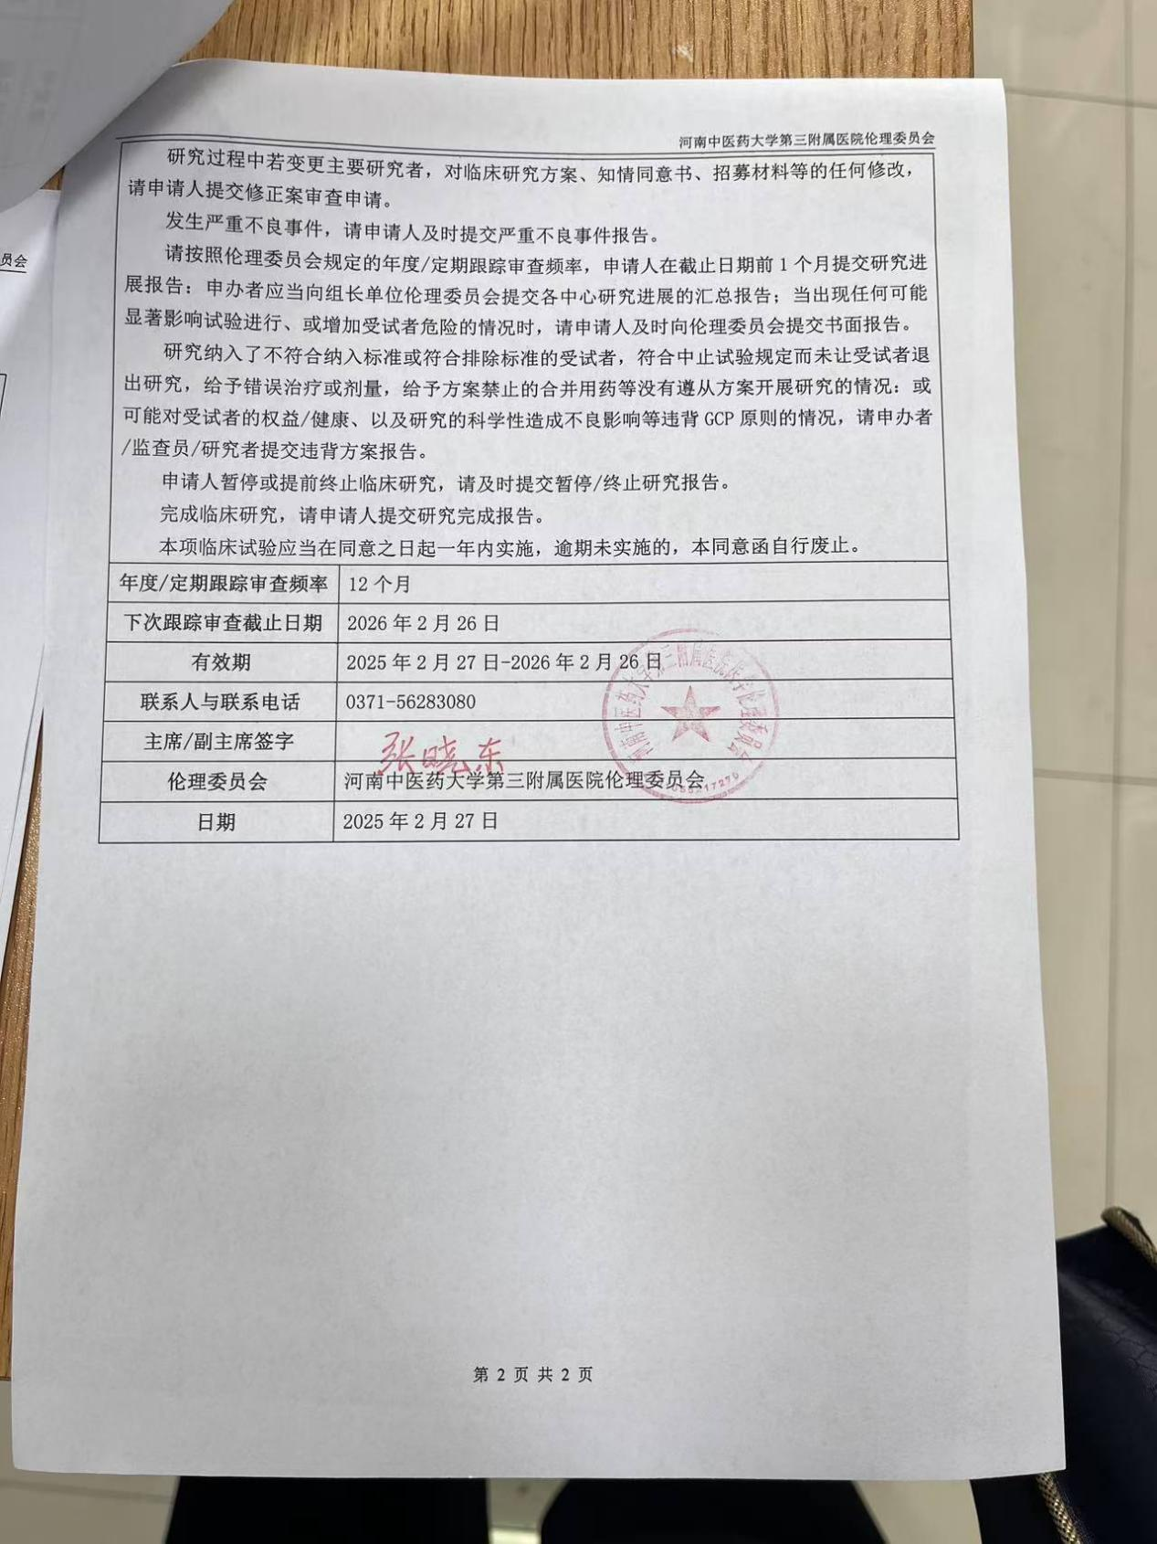

Review date | January 14, 2025
Location of review | Jinshui District, Zhengzhou City, Henan Province
Clinical research approvals | NA
Clinical Research Program | Clinical Efficacy Analysis of Chronic Nonspecific Low Back Pain Treated by "Occasional Stabbing Method" with Needle Knife
Review of  documentation | informed consent
Contract Research Organization/CRO | The Third Affiliated Hospital of Henan University of Chinese Medicine
Clinical Research Organization | The Third Affiliated Hospital of Henan University of Chinese Medicine
Principal Investigator | Li Ruiguo, Wang Zhanzong, Zhang Shuai zhou
Review methods | ■Conference review □Expedited review
Approval validity date | February 27, 2025, to February 26, 2026
The Third Affiliated Hospital of Henan University of Chinese Medicine
Date : February 27,2025

