Supplementary Information

Efficacy and Engagement of Generative versus Retrieval-based AI conversational agents for Mental Health: A Systematic Review and Meta-Analysis

Contents

Supplementary Table 1: Inclusion and exclusion criteria 3
Supplementary Table 2: Search strategies and databases 4
Supplementary Table 3: Data extraction and definitions 7
Supplementary Table 4: List of the included studiess 11
Supplementary Table 5: Characteristics of studies 19
Supplementary Table 6: Heterogeneity analyses 33
Supplementary Table 7: Engagement, user experience and user feedback 34
Supplementary Table 8: PRISMA checklists 45
Supplementary Figure 1: Risk of bias 50
Supplementary Figure 2: Cooke distance plot 51
Supplementary Figure 3: Publication bias 52
Supplementary Figure 4: Doi plot and LFK index for short-term overall psychological distress 53
Supplementary Figure 5: Doi plot and LFK index for short-term overall psychological well-being 54
Supplementary Figure 6: Doi plot and LFK index for long-term overall psychological distress 55
Supplementary Figure 7: Summary of findings and GRADE assessment results 56
Supplementary Figure 8: Forest plot of effect sizes for uptake and adherence 57
References 58

Supplementary Table 1: Inclusion and exclusion criteria
Criteria | Inclusion Criteria | Exclusion Criteria
Population | All types of groups are considered, including adolescents, adults, and elderly individuals. | No exclusion criteria
Intervention | We define AI-based CA as software systems that employ artificial intelligence technologies (such as natural language processing, machine learning, deep learning, or generative artificial intelligence such as GPT) to enable human-like conversations. Conversational agents can be presented in either embodied (e.g., physical entities such as robots) or disembodied (e.g., software or digital interfaces such as applications) forms. They can operate on any platform, including web-based and integrated messaging platforms. | (1) Rule-based computer-assisted tools—which respond to user queries through predefined rule sets and do not employ any artificial intelligence algorithms or technologies—are excluded; (2) Studies that involve agents fully or partially operated by human operators (known as Wizard-of-Oz) and those that use asynchronous response systems are excluded.
Comparator | Any control group was considered, such as routine care, waiting lists, allocation of electronic manuals, or other types of CA. | No exclusion criteria
Outcomes | Articles must report relevant mental health outcomes, which may serve as primary or secondary endpoints. These encompass a broad range of indicators, including both positive (e.g., mindfulness, well-being) and negative (e.g., psychological distress, anxiety) dimensions of mental health. | Articles unrelated to mental health (such as those measuring participants' physical health or cognitive dimensions) were excluded.
Study Design | Given that AI-based clinical assessment tools represent an emerging technology within the digital health domain, and that randomized controlled trials provide the highest level of evidence, this review exclusively includes English-language studies reporting randomized controlled trials (RCTs). These RCTs may encompass any design type, such as cluster randomized controlled trials, crossover randomized controlled trials, or pilot randomized controlled trials. Article types include peer-reviewed journal articles and conference proceedings. | No exclusion criteria

Supplementary Table 2: Search strategies and databases
Database | Search strings
PubMed | (("Conversational Agents"[Mesh] OR "Chatbots"[Mesh] OR "Artificial Intelligence"[Mesh] OR "Natural Language Processing"[Mesh] OR "Machine Learning"[Mesh] OR chatbot* OR "chat bot*" OR chatterbot* OR "conversational agent*" OR "conversational bot*" OR "conversational system*" OR "conversational interface*" OR "virtual agent*" OR "virtual assistant*" OR "virtual coach*" OR "virtual human*" OR "virtual character*" OR "embodied agent*" OR "relational agent*" OR avatar* OR "dialog system*" OR "social bot*" OR smartbot* OR "smart bot*" OR "counseling agent*" OR "generative AI" OR NLP) AND ("Mental Health"[Mesh] OR "Mental Disorders"[Mesh] OR "Psychotherapy"[Mesh] OR "Depression"[Mesh] OR "Anxiety"[Mesh] OR "Stress, Psychological"[Mesh] OR "Well Being"[Mesh] OR "Psychological Distress"[Mesh] OR "Mindfulness"[Mesh] OR mental health OR mental disorder* OR mental illness* OR affective disorder* OR psychotic disorder* OR "posttraumatic stress disorder" OR PTSD OR distress OR depress* OR anxiety OR bipolar OR schizophrenia OR psychosis OR "mental wellness" OR wellbeing OR "wellbeing" OR SWB OR happiness OR "positive affect" OR "negative affect" OR "positive emotion*" OR "negative emotion*" OR mood OR "life satisfaction" OR resilience OR "self-efficacy" OR mindfulness OR loneliness OR "panic disorder" OR "fear avoidance" OR pain OR "psychological distress") AND ("Randomized Controlled Trial"[Publication Type] OR RCT OR randomized OR randomized OR "controlled trial" OR "randomized controlled trial" OR "randomized controlled trial"))
PsycINFO | ((DE "Chatbots" OR DE "Artificial Intelligence" OR DE "Natural Language Processing" OR DE "Machine Learning" OR chatbot* OR "chat bot*" OR chatterbot* OR "conversational agent*" OR "conversational bot*" OR "conversational system*" OR "conversational interface*" OR "virtual agent*" OR "virtual assistant*" OR "virtual coach*" OR "virtual human*" OR "virtual character*" OR "embodied agent*" OR "relational agent*" OR avatar* OR "dialog system*" OR "social bot*" OR smartbot* OR "smart bot*" OR "counseling agent*" OR "generative AI" OR NLP) AND (DE "Mental Health" OR DE "Mental Disorders" OR DE "Psychotherapy" OR DE "Depression (Emotion)" OR DE "Anxiety" OR DE "Psychological Stress" OR DE "Well Being" OR DE "Psychological Distress" OR DE "Mindfulness" OR mental health OR mental disorder* OR mental illness* OR affective disorder* OR psychotic disorder* OR "posttraumatic stress disorder" OR PTSD OR distress OR depress* OR anxiety OR bipolar OR schizophrenia OR psychosis OR "mental wellness" OR wellbeing OR "well-being" OR SWB OR happiness OR "positive affect" OR "negative affect" OR "positive emotion*" OR "negative emotion*" OR mood OR "life satisfaction" OR resilience OR "self-efficacy" OR mindfulness OR loneliness OR "panic disorder" OR "fear avoidance" OR pain OR "psychological distress") AND (DE "Clinical Trials" OR DE "Randomized Clinical Trials" OR RCT OR randomized OR randomized OR "controlled trial" OR "randomized controlled trial" OR "randomized controlled trial"))
EMBASE | (('conversational agent'/exp OR 'chatbot'/exp OR 'artificial intelligence'/exp OR 'natural language processing'/exp OR 'machine learning'/exp OR chatbot* OR "chat bot*" OR chatterbot* OR "conversational agent*" OR "conversational bot*" OR "conversational system*" OR "conversational interface*" OR "virtual agent*" OR "virtual assistant*" OR "virtual coach*" OR "virtual human*" OR "virtual character*" OR "embodied agent*" OR "relational agent*" OR avatar* OR "dialog system*" OR "social bot*" OR smartbot* OR "smart bot*" OR "counseling agent*" OR "generative AI" OR NLP) AND ('mental health'/exp OR 'mental disease'/exp OR 'psychotherapy'/exp OR 'depression'/exp OR 'anxiety'/exp OR 'mental stress'/exp OR 'wellbeing'/exp OR 'psychological distress'/exp OR 'mindfulness'/exp OR mental health OR mental disorder* OR mental illness* OR affective disorder* OR psychotic disorder* OR "posttraumatic stress disorder" OR PTSD OR distress OR depress* OR anxiety OR bipolar OR schizophrenia OR psychosis OR "mental wellness" OR wellbeing OR "well-being" OR SWB OR happiness OR "positive affect" OR "negative affect" OR "positive emotion*" OR "negative emotion*" OR mood OR "life satisfaction" OR resilience OR "self-efficacy" OR mindfulness OR loneliness OR "panic disorder" OR "fear avoidance" OR pain OR "psychological distress") AND ('randomized controlled trial'/exp OR RCT OR randomized OR randomized OR "controlled trial" OR "randomized controlled trial" OR "randomized controlled trial"))
Cochrane Library | ([mh "Conversational Agents"] OR [mh "Chatbots"] OR [mh "Artificial Intelligence"] OR [mh "Natural Language Processing"] OR [mh "Machine Learning"] OR chatbot* OR "chat bot*" OR chatterbot* OR "conversational agent*" OR "conversational bot*" OR "conversational system*" OR "conversational interface*" OR "virtual agent*" OR "virtual assistant*" OR "virtual coach*" OR "virtual human*" OR "virtual character*" OR "embodied agent*" OR "relational agent*" OR avatar* OR "dialog system*" OR "social bot*" OR smartbot* OR "smart bot*" OR "counseling agent*" OR "generative AI" OR NLP) AND ([mh "Mental Health"] OR [mh "Mental Disorders"] OR [mh "Psychotherapy"] OR [mh "Depression"] OR [mh "Anxiety Disorders"] OR [mh "Stress, Psychological"] OR [mh "Well Being"] OR [mh "Psychological Distress"] OR [mh "Mindfulness"] OR mental health OR mental disorder* OR mental illness* OR affective disorder* OR psychotic disorder* OR "posttraumatic stress disorder" OR PTSD OR distress OR depress* OR anxiety OR bipolar OR schizophrenia OR psychosis OR "mental wellness" OR wellbeing OR "well-being" OR SWB OR happiness OR "positive affect" OR "negative affect" OR "positive emotion*" OR "negative emotion*" OR mood OR "life satisfaction" OR resilience OR "self-efficacy" OR mindfulness OR loneliness OR "panic disorder" OR "fear avoidance" OR pain OR "psychological distress") AND ([pt "Randomized Controlled Trial"] OR RCT OR randomized OR randomized OR "controlled trial" OR "randomized controlled trial" OR "randomized controlled trial")
Web of Science | TS=((chatbot* OR "chat bot*" OR chatterbot* OR "conversational agent*" OR "conversational bot*" OR "conversational system*" OR "conversational interface*" OR "virtual agent*" OR "virtual assistant*" OR "virtual coach*" OR "virtual human*" OR "virtual character*" OR "embodied agent*" OR "relational agent*" OR avatar* OR "dialog system*" OR "social bot*" OR smartbot* OR "smart bot*" OR "counseling agent*" OR "natural language processing" OR "machine learning" OR "generative AI" OR NLP) AND (mental health OR mental disorder* OR mental illness* OR affective disorder* OR psychotic disorder* OR "posttraumatic stress disorder" OR PTSD OR distress OR depress* OR anxiety OR bipolar OR schizophrenia OR psychosis OR "mental wellness" OR wellbeing OR "well-being" OR SWB OR happiness OR "positive affect" OR "negative affect" OR "positive emotion*" OR "negative emotion*" OR mood OR "life satisfaction" OR resilience OR "self-efficacy" OR mindfulness OR loneliness OR "panic disorder" OR "fear avoidance" OR pain OR "psychological distress") AND (RCT OR randomized OR randomized OR "controlled trial" OR "randomized controlled trial" OR "randomized controlled trial"))
CINAHL | (MH "Chatbots" OR MH "Artificial Intelligence" OR MH "Natural Language Processing" OR MH "Machine Learning" OR chatbot* OR "chat bot*" OR chatterbot* OR "conversational agent*" OR "conversational bot*" OR "conversational system*" OR "conversational interface*" OR "virtual agent*" OR "virtual assistant*" OR "virtual coach*" OR "virtual human*" OR "virtual character*" OR "embodied agent*" OR "relational agent*" OR avatar* OR "dialog system*" OR "social bot*" OR smartbot* OR "smart bot*" OR "counseling agent*" OR "generative AI" OR NLP) AND (MH "Mental Health" OR MH "Mental Disorders" OR MH "Psychotherapy" OR MH "Depression" OR MH "Anxiety" OR MH "Stress, Psychological" OR MH "Well Being" OR MH "Psychological Distress" OR MH "Mindfulness" OR mental health OR mental disorder* OR mental illness* OR affective disorder* OR psychotic disorder* OR "posttraumatic stress disorder" OR PTSD OR distress OR depress* OR anxiety OR bipolar OR schizophrenia OR psychosis OR "mental wellness" OR wellbeing OR "well-being" OR SWB OR happiness OR "positive affect" OR "negative affect" OR "positive emotion*" OR "negative emotion*" OR mood OR "life satisfaction" OR resilience OR "self-efficacy" OR mindfulness OR loneliness OR "panic disorder" OR "fear avoidance" OR pain OR "psychological distress") AND (MH "Randomized Controlled Trials" OR RCT OR randomized OR randomized OR "controlled trial" OR "randomized controlled trial" OR "randomized controlled trial")

Supplementary Table 3: Data extraction and definitions
Characteristics | Moderator | Description
Sample-related characteristics | Participants' age | Participants' age was coded as a categorical variable and divided into two age groups based on the sample mean age [1]: (1) Adolescents/young adults (13–40 years old); and (2) Middle-aged/older adults (≥40 years old). We defined age as a categorical rather than continuous variable for two reasons. First, some studies reported only age ranges without sufficient information to calculate the mean age. Second, most studies focused on adult samples with limited inclusion of adolescents or older adults, which may have obscured important differences between age groups. For studies that did not provide mean age information but explicitly indicated that participants were parents of kindergarten and elementary school children [2], this population's average age could fall below or above 40 years. Therefore, such studies were excluded from the age subgroup analysis to avoid the influence of subjective judgment on statistical results.
Sample-related characteristics | Participants' health status | Participants' health status was coded as a categorical variable. Based on definitions and selection criteria from prior research [3,4], participants were classified into three categories: (1) Clinical group (individuals with formally diagnosed physical or mental health conditions); (2) Subclinical group (individuals who screened positive or self-reported symptoms of mental health disorders such as depression or anxiety during the study period); and (3) Nonclinical group (participants without self-reported symptoms, positive screening results, or diagnosed health conditions).
Design Features of AI-Based CA | Expertise scope | Expertise scope refers to the breadth of a conversational agent's knowledge base and its predefined functional domains. Based on the framework proposed by Li et al. (2025) [5], We categorize conversational agents into two types: (1) General-purpose conversational agents: These agents possess extensive and diverse knowledge across domains, unrestricted by a single field. They can handle various open-domain tasks (e.g., ChatGPT, Gemini) without requiring adjustments to their core architecture. Their output is standardized through human supervision or feature engineering. (2) Specialized Dialogue Agents: These agents are customized or architecturally adapted for specific domains (e.g., mental health counseling, cognitive behavioral therapy), often integrating specialized medical models. They possess deep expertise within narrow domains (e.g., Woebot) and are designed to address specific user needs within the boundaries of that domain.
Design Features of AI-Based CA | Delivery platform | Delivery platform refers to the medium or channel through which the CA interacted with users or delivered its services, and was coded as a categorical variable. Consistent with prior research [4], delivery platforms were categorized into four types: (1) Smartphone/tablet application (CAs deployed as standalone applications on smartphones, tablets, or other mobile devices); (2) Instant messaging platform (CAs operating within common instant messaging platforms such as WhatsApp or Facebook Messenger); (3) Web-based platform (CAs accessible via web browsers on computers or mobile devices); and (4) Robot (CAs integrated into physical robotic systems).
Design Features of AI-Based CA | Response generation mode | Response generation mode refers to the technique employed by the CA to formulate responses to user inputs [4] and was coded as a categorical variable. Three modes were identified: (1) Retrieval-based, CAs that select appropriate responses from a predefined repository of conversational utterances); (2) Generative, automatically generating responses through large language models or deep learning architectures); and (3) Hybrid, such systems typically prioritize retrieval-based approaches to ensure precise responses to standard queries, while employing generative models as a backup or augmentation layer to handle complex, out-of-scope, or nuanced interaction scenarios not covered by predefined databases.
Design Features of AI-Based CA | Interaction mode | Interaction mode refers to the primary mode of communication between users and the conversational agent, operationalized as a binary categorical variable: (1) Text-based (wherein interactions occur exclusively through written text input and output); and (2) Multimodal/voice-based (wherein interactions incorporate voice, audio, visual, or other nontextual communication channels).
Design Features of AI-Based CA | Emotional and empathic responses | Emotional and empathic responses refer to the capability of conversational agents (CAs) to recognize users' emotional states and provide empathic responses. Its function includes using machine learning and natural language processing algorithms to classify real-time multimodal inputs, identify users' emotional states, and enable CAs to respond empathically [6]. This variable is coded as a categorical variable with two levels: (1) Yes, representing that the CA supports emotional and empathic response functions, i.e., it can recognize user emotions and provide empathic responses; and (2) No, representing that the CA does not support emotional and empathic response functions and lacks such emotion recognition and empathic capabilities.
Design Features of AI-Based CA | Personalization and tailoring | Personalization and tailoring refer to the conversational agent dynamically adjusting its dialog content, intervention strategies, and feedback based on the user's personal characteristics, needs, and real-time feedback to provide more targeted mental health support [6]. It is encoded as a categorical variable, including (1) Yes, representing that the conversational agent used in the study possesses the "personalization and tailoring" function. (2) No: representing that the conversational agent used in the study does not possess the "personalization and tailoring" function.
Intervention-related characteristics | Intervention length | Intervention duration refers to the time interval from baseline to the first measurement after the intervention concludes. It is coded as a categorical variable comprising: (1) 0–4 weeks; (2) 5–8 weeks; (3) ≥9 weeks.
Intervention-related characteristics | Follow-up length | Follow-up length refers to the time interval from the end of the intervention to the follow-up measurement. It is coded as a categorical variable and includes: (1) 0–8 weeks; (2) 9–16 weeks; (3) ≥17 weeks.
Intervention-related characteristics | Cognitive behavioral therapy components | Cognitive behavioral therapy components refers to whether the conversational agent's design and interactive content are grounded in Cognitive Behavioral Therapy (CBT) as the theoretical foundation. It is coded as a binary categorical variable, comprising (1) Yes, representing CAs whose design and interactive content are theoretically grounded in CBT; and (2) No, representing CAs whose design and interactive content are not grounded in CBT, i.e., either lacking a theoretical foundation or based on alternative theoretical frameworks such as Problem-Solving Therapy (PST; [7].
Intervention-related characteristics | Human guidance  offered | Human guidance offered refers to a scalable, cost-effective alternative to human therapist support [8] and is coded as a categorical variable, comprising (1) Yes, representing fully automated CA, wherein no therapist involvement is required during the intervention process; and (2) No, representing therapist-involved CA, wherein the system requires therapist involvement during the intervention process; for example, a therapist must review AI-generated content before being sent to participants [9].
Intervention-related characteristics | Incentive provision | Incentive provision refers to the provision of monetary compensation [10], vouchers [11], or academic credit [12] and other rewards to participants who completed posttest questionnaires in the included studies, and was coded as a categorical variable: (1) Yes, representing incentives were provided; and (2) No, representing no incentives were provided. This coding was based on evidence that study-level factors most predictive of attrition rates and adherence include the provision of financial incentives or participation reminders and the low barriers to entry and ease of withdrawal characteristic of online intervention trials [13]. Given that the effectiveness of monetary incentives in reducing attrition has been empirically established [14], findings from studies with lower attrition rates may more accurately reflect true treatment efficacy.
Intervention-related characteristics | Safety measures | Safety measures refer to implementing telephone follow-ups or monitoring within the conversational agent (CA) intervention to supervise participants experiencing acute emergencies or crises. This variable is coded as categorical: (1) Yes, representing that the study explicitly described safety Measures; and (2) No, representing that the study did not report safety Measures. The rationale for defining this variable is primarily based on participant attrition rates. Specifically, monitoring or telephone follow-ups may make participants feel protected and cared for, enhancing their trust and potentially reducing attrition rates. Conversely, excessive monitoring may lead to higher attrition rates due to participants feeling overly surveilled.
Intervention-related characteristics | Engagement reminders | Engagement reminders refer to proactive reminders provided by researchers or systems to intervention group participants during the intervention period to encourage their continued use of CA. Specifically, this includes email reminders sent by researchers, timed notifications automatically pushed by the system, etc. However, passive feedback generated by CA based on user-initiated input (e.g., notes; [15]) is not included in the category of engagement reminders, as this study focuses on researcher-initiated proactive reminder strategies and their impact on participant behavior. This variable was coded as a categorical variable, including (1) Yes, indicating the study had engagement reminders; and (2) No, indicating no engagement reminders. Consistent with the logic of incentive provision, given that the effectiveness of engagement reminders in reducing attrition rates has been empirically supported [16], studies that provide participation reminders may be associated with lower dropout rates and better reflect actual treatment outcomes.
Intervention-related characteristics | Control group type | Control group type was coded as a categorical variable. Unlike previous studies [3,6], which categorized controls as either “Waitlist or assessment only”, “Information or attentional control”, or “Active control”, we further subdivided the “ Active control ” category into healthcare professional control, CA control, and usual care. This refined stratification approach facilitates a more comprehensive understanding of heterogeneity sources, thereby enabling a more precise evaluation of treatment efficacy differences across varying control groups when comparing. Therefore, the control groups were categorized as follows: (1) Healthcare professional control; (2) CA control; (3) Usual care; (4) Information or attentional control; and (5) Waitlist.
Intervention-related characteristics | Protocol/Registration | Protocol/Registration refers to whether researchers prospectively prepared and publicly registered a detailed research protocol before formal data extraction and analysis. It is coded as a binary categorical variable: (1) Yes, representing studies with preregistration; and (2) No, representing studies without preregistration.

Supplementary Table 4: List of the included studiess
No. | Reference
1 | Akdogan, O., Uyar, G. C., Yesilbas, E., Baskurt, K., Malkoc, N. A., Ozdemir, N., Yazici, O., Oksuzoglu, B., Uner, A., & Ozet, A. (2025). Effect of a ChatGPT-based digital counseling intervention on anxiety and depression in patients with cancer: A prospective, randomized trial. European Journal of Cancer, 221, 115408. https://doi.org/10.1016/j.ejca.2025.115408
2 | Ali, M., Rehman, S., & Cheema, E. (2025). Impact of artificial intelligence on the academic performance and test anxiety of pharmacy students in objective structured clinical examination: A randomized controlled trial. International Journal of Clinical Pharmacy, 1–8. https://doi.org/10.1007/s11096-025-01876-5
3 | Bennion, M. R., Hardy, G. E., Moore, R. K., Kellett, S., & Millings, A. (2020). Usability, acceptability, and effectiveness of web-based conversational agents to facilitate problem solving in older adults: Controlled study. Journal of Medical Internet Research, 22(5), e16794. https://doi.org/10.2196/16794
4 | Bird, T., Mansell, W., Wright, J., Gaffney, H., & Tai, S. (2018). Manage your life online: A web-based randomized controlled trial evaluating the effectiveness of a problem-solving intervention in a student sample. Behavioural and Cognitive Psychotherapy, 46(5), 570–582. https://doi.org/10.1017/s1352465817000820
5 | Cachia, J. Y., Zhao, X., Hunter, J., Wu, D., Lin, E., & De Freitas, J. (2025). AI for proactive mental health: A longitudinal, multi-institutional trial. Multi-Institutional Trial.
6 | Chen, C., Lam, K. T., Yip, K. M., So, H. K., Lum, T. Y. S., Wong, I. C. K., Yam, J. C., Chui, C. S. L., & Ip, P. (2025). Comparison of an AI chatbot with a nurse hotline in reducing anxiety and depression levels in the general population: Pilot randomized controlled trial. JMIR Human Factors, 12, e65785. https://doi.org/10.2196/65785
7 | Drouin, M., Sprecher, S., Nicola, R., & Perkins, T. (2022). Is chatting with a sophisticated chatbot as good as chatting online or FTF with a stranger? Computers in Human Behavior, 128, 107100. https://doi.org/10.1016/j.chb.2021.107100
8 | Danieli, M., Ciulli, T., Mousavi, S. M., & Riccardi, G. (2021). A conversational artificial intelligence agent for a mental health care app: Evaluation study of its participatory design. JMIR Formative Research, 5(12), e30053. https://doi.org/10.2196/30053
9 | Danieli, M., Ciulli, T., Mousavi, S. M., Silvestri, G., Barbato, S., Di Natale, L., & Riccardi, G. (2022). Assessing the impact of conversational artificial intelligence in the treatment of stress and anxiety in aging adults: Randomized controlled trial. JMIR Mental Health, 9(9), e38067. https://doi.org/10.2196/38067
10 | Ehrlich, C., Hennelly, S. E., Wilde, N., Lennon, O., Beck, A., Messenger, H., Sergiou, K., & Davies, E. L. (2024). Evaluation of an artificial intelligence enhanced application for student wellbeing: Pilot randomised trial of the mind tutor. International Journal of Applied Positive Psychology, 9(1), 435–454. https://doi.org/10.1007/s41042-023-00133-2
11 | Fitzpatrick, K. K., Darcy, A., & Vierhile, M. (2017). Delivering cognitive behavior therapy to young adults with symptoms of depression and anxiety using a fully automated conversational agent (woebot): A randomized controlled trial. JMIR Mental Health, 4(2), e7785. https://doi.org/10.2196/mental.7785
12 | Fulmer, R., Joerin, A., Gentile, B., Lakerink, L., & Rauws, M. (2018). Using psychological artificial intelligence (Tess) to relieve symptoms of depression and anxiety: Randomized controlled trial. JMIR Mental Health, 5(4), e9782. https://doi.org/10.2196/mental.9782
13 | Gan, W., Ouyang, J., She, G., Xue, Z., Zhu, L., Lin, A., Mou, W., Jiang, A., Qi, C., & Cheng, Q. (2025). ChatGPT’s role in alleviating anxiety in total knee arthroplasty consent process: A randomized controlled trial pilot study. International Journal of Surgery, 111(3), 2546–2557. https://doi.org/10.1097/JS9.0000000000002223
14 | Gaffney, H., Mansell, W., Edwards, R., & Wright, J. (2014). Manage your life online (MYLO): A pilot trial of a conversational computer-based intervention for problem solving in a student sample. Behavioural and Cognitive Psychotherapy, 42(6), 731–746. https://doi.org/10.1017/S135246581300060X
15 | Guțu, S. M., Cosmoiu, A., Cojocaru, D., Turturescu, T., Popoviciu, C. M., & Giosan, C. (2021). Bot to the rescue? Effects of a fully automated conversational agent on anxiety and depression: A randomized controlled trial. Ann Depress Anxiety, 8(1), 1107. https://doi.org/10.26420/anndepressanxiety.2021.1107
16 | He, Y., Yang, L., Zhu, X., Wu, B., Zhang, S., Qian, C., & Tian, T. (2022). Mental health chatbot for young adults with depressive symptoms during the COVID-19 pandemic: Single-blind, three-arm randomized controlled trial. Journal of Medical Internet Research, 24(11), e40719. https://doi.org/10.2196/40719
17 | Heinz, M. V., Mackin, D. M., Trudeau, B. M., Bhattacharya, S., Wang, Y., Banta, H. A., Jewett, A. D., Salzhauer, A. J., Griffin, T. Z., & Jacobson, N. C. (2025). Randomized trial of a generative AI chatbot for mental health treatment. NEJM AI, 2(4), AIoa2400802. https://doi.org/10.1056/aioa2400802
18 | Indrayanti, I., Salsabila, A. K., Amrita, V., Alhaddad, M. M., Saskia, A. B., & Ramadhani, D. P. (2025). PsyBot: A randomized controlled trial of WhatsApp-based psychological first aid to reduce loneliness among 18–22-year-old students in yogyakarta, indonesia. SSM-Mental Health, 100504. https://doi.org/10.1016/j.ssmmh.2025.100504
19 | Jang, S., Kim, J.-J., Kim, S.-J., Hong, J., Kim, S., & Kim, E. (2021). Mobile app-based chatbot to deliver cognitive behavioral therapy and psychoeducation for adults with attention deficit: A development and feasibility/usability study. International Journal of Medical Informatics, 150, 104440. https://doi.org/10.1016/j.ijmedinf.2021.104440
20 | Kannampallil, T., Ajilore, O. A., Lv, N., Smyth, J. M., Wittels, N. E., Ronneberg, C. R., Kumar, V., Xiao, L., Dosala, S., & Barve, A. (2023). Effects of a virtual voice-based coach delivering problem-solving treatment on emotional distress and brain function: A pilot RCT in depression and anxiety. Translational Psychiatry, 13(1), 166. https://doi.org/10.1038/s41398-023-02544-w
21 | Karhiy, M., Sagar, M., Antoni, M., Loveys, K., & Broadbent, E. (2023). Mindfulness based stress reduction: A randomised trial of a virtual human, teletherapy, and a chatbot. 2023 11th International Conference on Affective Computing and Intelligent Interaction Workshops and Demos (ACIIW), 1–7. https://doi.org/10.1109/aciiw59127.2023.10388195
22 | Karkosz, S., Szymański, R., Sanna, K., & Michałowski, J. (2024). Effectiveness of a web-based and mobile therapy chatbot on anxiety and depressive symptoms in subclinical young adults: Randomized controlled trial. JMIR Formative Research, 8(1), e47960. https://doi.org/10.2196/47960
23 | Klos, M. C., Escoredo, M., Joerin, A., Lemos, V. N., Rauws, M., & Bunge, E. L. (2021). Artificial intelligence–based chatbot for anxiety and depression in university students: Pilot randomized controlled trial. JMIR Formative Research, 5(8), e20678. https://doi.org/10.2196/20678
24 | Lee, S., Jeong, J., Kim, M., Lee, S., Kim, S.-P., & Jung, D. (2025). Development of a mobile intervention for procrastination augmented with a semigenerative chatbot for 25university students: Pilot randomized controlled trial. JMIR Mhealth and Uhealth, 13(1), e53133. https://doi.org/10.2196/53133
25 | Liu, H., Peng, H., Song, X., Xu, C., & Zhang, M. (2022). Using AI chatbots to provide self-help depression interventions for university students: A randomized trial of effectiveness. Internet Interventions, 27, 100495. https://doi.org/10.1016/j.invent.2022.100495
26 | Liu, I., Chen, W., Ge, Q., Song, D., & Ni, S. (2022). Enhancing psychological resilience with chatbot-based cognitive behavior therapy: A randomized control pilot study. Proceedings of the Tenth International Symposium of Chinese CHI, 216–221. https://doi.org/10.1145/3565698.3565787
27 | MacNeill, A. L., Doucet, S., & Luke, A. (2024). Effectiveness of a mental health chatbot for people with chronic diseases: Randomized controlled trial. JMIR Formative Research, 8, e50025. https://doi.org/10.2196/50025
28 | Maeda, E., Miyata, A., Boivin, J., Nomura, K., Kumazawa, Y., Shirasawa, H., Saito, H., & Terada, Y. (2020). Promoting fertility awareness and preconception health using a chatbot: A randomized controlled trial. Reproductive BioMedicine Online, 41(6), 1133–1143. https://doi.org/10.1016/j.rbmo.2020.09.006
29 | McFadyen, J., Habicht, J., Dina, L.-M., Harper, R., Hauser, T. U., & Rollwage, M. (2024). AI-enabled conversational agent increases engagement with cognitive-behavioral therapy: A randomized controlled trial. Medrxiv, 2024.11. https://doi.org/10.1101/2024.11.01.24316565
30 | Nicol, G., Wang, R., Graham, S., Dodd, S., & Garbutt, J. (2022). Chatbot-delivered cognitive behavioral therapy in adolescents with depression and anxiety during the COVID-19 pandemic: Feasibility and acceptability study. JMIR Formative Research, 6(11), e40242. https://doi.org/10.2196/40242
31 | Oh, J., Jang, S., Kim, H., & Kim, J.-J. (2020). Efficacy of mobile app-based interactive cognitive behavioral therapy using a chatbot for panic disorder. International Journal of Medical Informatics, 140, 104171. https://doi.org/10.1016/j.ijmedinf.2020.104171
32 | Ogawa, M., Oyama, G., Morito, K., Kobayashi, M., Yamada, Y., Shinkawa, K., Kamo, H., Hatano, T., & Hattori, N. (2022). Can AI make people happy? The effect of AI-based chatbot on smile and speech in parkinson’s disease. Parkinsonism & Related Disorders, 99, 43–46. https://doi.org/10.1016/j.parkreldis.2022.04.018
33 | Papadopoulos, C., Castro, N., Nigath, A., Davidson, R., Faulkes, N., Menicatti, R., Khaliq, A. A., Recchiuto, C., Battistuzzi, L., & Randhawa, G. (2022). The CARESSES randomised controlled trial: Exploring the health-related impact of culturally competent artificial intelligence embedded into socially assistive robots and tested in older adult care homes. International Journal Of Social Robotics, 14(1), 245–256. https://doi.org/10.1007/s12369-021-00781-x
34 | Prochaska, J. J., Vogel, E. A., Chieng, A., Baiocchi, M., Maglalang, D. D., Pajarito, S., Weingardt, K. R., Darcy, A., & Robinson, A. (2021). A randomized controlled trial of a therapeutic relational agent for reducing substance misuse during the COVID-19 pandemic. Drug and Alcohol Dependence, 227, 108986. https://doi.org/10.1016/j.drugalcdep.2021.108986
35 | Romanovskyi, O., Pidbutska, N., & Knysh, A. (2021). Elomia chatbot: The effectiveness of artificial intelligence in the fight for mental health. Colins, 1215–1224. https://api.semanticscholar.org/CorpusID:235271819
36 | Sabour, S., Zhang, W., Xiao, X., Zhang, Y., Zheng, Y., Wen, J., Zhao, J., & Huang, M. (2023). A chatbot for mental health support: Exploring the impact of emohaa on reducing mental distress in China. Frontiers in Digital Health, 5, 1133987. https://doi.org/10.3389/fdgth.2023.1133987
37 | Sahab, S., Haqbeen, J., Sapkota, D., & Ito, T. (2025). GPT chatbots for alleviating anxiety and depression: A pilot randomized controlled trial with afghan women. arXiv Preprint arXiv:2508.00847. https://doi.org/10.48550/arXiv.2508.00847
38 | Selaskowski, B., Reiland, M., Schulze, M., Aslan, B., Kannen, K., Wiebe, A., Wallbaum, T., Boll, S., Lux, S., & Philipsen, A. (2023). Chatbot-supported psychoeducation in adult attention-deficit hyperactivity disorder: Randomised controlled trial. BJPsych Open, 9(6), e192. https://doi.org/10.1192/bjo.2023.573
39 | So, R., Emura, N., Okazaki, K., Takeda, S., Sunami, T., Kitagawa, K., Takebayashi, Y., & Furukawa, T. A. (2024). Guided versus unguided chatbot-delivered cognitive behavioral intervention for individuals with moderate-risk and problem gambling: A randomized controlled trial (GAMBOT2 study). Addictive Behaviors, 149, 107889. https://doi.org/10.1016/j.addbeh.2023.107889
40 | Suharwardy, S., Ramachandran, M., Leonard, S. A., Gunaseelan, A., Lyell, D. J., Darcy, A., Robinson, A., & Judy, A. (2023). Feasibility and impact of a mental health chatbot on postpartum mental health: A randomized controlled trial. AJOG Global Reports, 3(3), 100165. https://doi.org/10.1016/j.xagr.2023.100165
41 | Tawfik, E., Ghallab, E., & Moustafa, A. (2023). A nurse versus a chatbot‒the effect of an empowerment program on chemotherapy-related side effects and the self-care behaviors of women living with breast cancer: A randomized controlled trial. BMC Nursing, 22(1), 102. https://doi.org/10.1186/s12912-023-01243-7
42 | Vowels, L. M., Vowels, M. J., Sweeney, S. K., Hatch, S. G., & Darwiche, J. (2025). The efficacy, feasibility, and technical outcomes of a GPT-4o-based chatbot amanda for relationship support: A randomized controlled trial. PLOS Mental Health, 2(9), e0000411. https://doi.org/10.1371/journal.pmen.0000411
43 | Wang, Y., Li, X., Zhang, Q., Yeung, D., & Wu, Y. (2025). Effect of a cognitive behavioral therapy–based AI chatbot on depression and loneliness in chinese university students: Randomized controlled trial with financial stress moderation. JMIR mHealth and uHealth, 13, e63806. https://doi.org/10.2196/63806
44 | Xu, S., & Ma, T. (2025). Depression intervention using AI chatbots with social cues: A randomized trial of effectiveness. Journal of Affective Disorders, 119760. https://doi.org/10.1016/j.jad.2025.119760
45 | Yahagi, M., Hiruta, R., Miyauchi, C., Tanaka, S., Taguchi, A., & Yaguchi, Y. (2024). Comparison of conventional anesthesia nurse education and an artificial intelligence chatbot (ChatGPT) intervention on preoperative anxiety: A randomized controlled trial. Journal of Perianesthesia Nursing, 39(5), 767–771. https://doi.org/10.1016/j.jopan.2023.12.005
56 | Zhang, H., Wang, X., Luo, H., Zeng, W., Hong, X., Feng, J., Lu, G., Su, Y., Tong, W., & Xiao, Y. (2025). Comparison of preoperative education by artificial intelligence versus traditional physicians in perioperative management of urolithiasis surgery: A prospective single-blind randomized controlled trial conducted in China. Frontiers in Medicine, 12, 1543630. https://doi.org/10.3389/fmed.2025.1543630
47 | Zhao, Y., Qian, W., Chen, Y., Wu, D., Luo, Y., Gao, C., Wu, K., & Liu, Z. (2025). Effect of an AI agent trained on a large language model (LLM) as an intervention for depression and anxiety symptoms in young adults: A 28-day randomized controlled trial. Applied Psychology: Health and Well‐Being, 17(5), e70067. https://doi.org/10.1111/aphw.70067

Supplementary Table 5: Characteristics of studies
Author, year, region | Participants type | Intervention target | Intervention group | Control group | Intervention length | Follow-up length | Response generation approach | AI technique | Outcomes | Uptake and Adherence | Adherence definition
Akdogan et al, 2025 [17]; Turkey | Clinical (160 newly diagnosed adult patients with solid tumours) | Investigating whether digital counselling interventions based on ChatGPT can alleviate anxiety and depression in newly diagnosed cancer patients before chemotherapy. | ChatGPT-4 | Standard Education Group | 3 weeks | None | Generative | GPT | Anxiety and depression | Uptake=75/80 | NR
Ali et al, 2025 [18]; Pakistan | Nonclinical (92 pharmacy students) | Evaluating the impact of AI-generated learning materials and feedback on pharmacy students' academic performance and examination anxiety in Objective Structured Clinical Examinations (OSCEs). | ChatGPT, Gemini, and Perplexity | Usual OSCE preparation instructions | 4 weeks | None | Generative | LLM, GPT | Test anxiety | Uptake=44/46 | NR
Bennion et al, 2020 [19]; UK | Nonclinical (112 older adults) | Comparing the usability, acceptability, and effectiveness of two web-based conversational agents (with differing theoretical orientations) in supporting older adults' problem-solving. | MYLO | ELIZA | Single session (average duration approximately 24 minutes) | 2 weeks | Retrieval-based | NLP | Problem distress, anxiety, and depression | Uptake=57/59  Adherence=52/59 | Completed the single session.
Bird et al, 2018 [12]; UK | Nonclinical (213 healthy volunteers) | Assess the effectiveness of MYLO in assisting university students with problem-solving and reducing distress. | MYLO | ELIZA | Single session (average duration approximately 13 minutes) | 2 weeks | Retrieval-based | NLP | Problem distress, anxiety, depression, and stress | Uptake=85/85  Adherence=34/85 | >15 min use (suggested minimum)
Cachia et al, 2025[20]; US | Nonclinical (486 university students) | Evaluating the efficacy of generative AI-based “advantage-oriented” interventions in promoting mental wellbeing among university students. | Flourish | Waitlist | 6 weeks | None | Generative | GPT, RAG | Positive affect, negative affect, loneliness, belonging, closeness to school, resilience, mindfulness, anxiety, anger, and Flourishing | Uptake=229/239  Adherence=103/239 | ≥ 2 days of use per week.
Chen et al, 2025 [2]; China | Nonclinical (124 parents) | Comparing the effectiveness of AI chatbots versus traditional nurse helplines in reducing anxiety and depression levels among the general population during the pandemic. | Chatbot | Nurse Hotline | Single session (instant consultation) | None | Generative | LLM | Depression, and anxiety | Uptake=62/62  Adherence=62/62 | Completed the single session.
Drouin et al, 2022 [21]; US | Nonclinical (417 university students) | Comparing emotional and relational experiences during initial encounters when conversing with a high-EQ chatbot (Replika) versus interacting with humans face-to-face (FTF) or online. | Replika | Face-to-Face; Online chat with human | Single session (20 minutes) | None | Generative | LSTM | Positive affect, and negative affect | Uptake=133/133  Adherence=133/133 | Converse for 20 minutes (lab setting).
Danieli et al, 2021 [22]; Italy | Subclinical (21 employed older workers screened with depression or anxisty) | Evaluating the feasibility and preliminary efficacy of an AI chatbot (TEO) developed through participatory design in stress management training (SMT-CBT). | TEO | SMT-CBT | 8 weeks | 3 months | Retrieval-based | NLP, ML | Obsessiveness-compulsiveness, depression, anxiety, and stress | Uptake=11/11 | None
Danieli et al, 2022 [15]; Italy | Nonclinical (45 employed older workers) | Evaluating the efficacy of TEO as an adjunct to conventional CBT in alleviating stress and anxiety among older working adults. | Conventional treatment and TEO; TEO ; Conventional treatment | Waiting list | 8 weeks | 3 months | Retrieval-based | NLP, ML | Depression, anxiety, stress, Obsessiveness-compulsiveness, phobic anxiety, psychoticism, and mental health | Uptake=16/16 (group2)  Uptake=12/14 (group3) | None
Ehrlich et al, 2024 [11]; UK | Nonclinical (Trial 1: 177 university students; Trial 2: 240 university students) | Evaluating the Impact of the Mind Tutor App on First-Year University Students' Well-being. | Mind Tutor | Inactive Control | Trial 1: 6 weeks; Trial 2: 8 weeks | None | Retrieval-based | NLP | Well-being, life satisfaction, mindfulness, positive affect, and negative affect | Trail:Uptake=60/92  Trai2:Uptake=84/125 | None
Fitzpatrick et al, 2017 [10]; US | Subclinical (70 university students screened with depression or anxiety) | To evaluate the feasibility, acceptability, and preliminary efficacy of the fully automated chatbot Woebot in delivering CBT (Cognitive Behavioural Therapy) to university students experiencing symptoms of anxiety and depression. | Woebot | E-book | 2 weeks | None | Retrieval-based | NLP | Depression, anxiety, positive affect, and negative affect | Uptake=34/34 | None
Fumler et al, 2018 [23]; US | Subclinical (75 university students screened with depression or anxiety) | Assessing the feasibility and efficacy of the Comprehensive Psychological AI (Tess) in alleviating self-identified symptoms of depression and anxiety among university students. | Tess | E-book | 4 weeks | None | Retrieval-based | NLP, ML, Emotion algorithms | Depression, anxiety, positive affect, and negative affect | Uptake=50/50 | None
Gan et al, 2025 [24]; China | Clinical (60 patients with knee arthroplasty) | To evaluate whether employing ChatGPT as an auxiliary tool during the preoperative informed consent process for total knee arthroplasty (TKA) can alleviate perioperative anxiety and enhance patient satisfaction. | ChatGPT-4 | Traditional informed consent | Single session | 5 days | Generative | GPT | Anxiety, and perioperative anxiety | Uptake=27/29  Adherence=29/29 | Completed the informed consent consultation.
Gaffney et al, 2014 [25]; UK | Nonclinical (42 students) | Evaluating the feasibility and preliminary efficacy of MYLO, an automated programme based on the Method of Levels (MOL) therapy, in assisting students with problem-solving and alleviating distress. | MYLO | ELIZA | Single session (maximum 20 minutes) | 2 weeks | Retrieval-based | NLP | Distress, depression, and anxiety | Uptake=22/26  Adherence=22/22 | Completed the single session.
Guțu et al, 2021 [26]; Romania | Subclinical (95 adults screened with depression or anxiety) | Comparing the efficacy of the fully automated chatbot Woebot versus a positive control group (psychoeducational materials) in alleviating symptoms of anxiety and depression, and examining their impact on cross-diagnostic factors. | Woebot | Psychological Education Materials | 2 weeks | None | Retrieval-based | NLP | Depression, anxiety, self-compassion, guilt and shame | Uptake=43/106 | None
He et al, 2022 [27]; China | Subclinical (148 university students screened with depression) | Evaluating the clinical efficacy and non-clinical performance of the CBT-based chatbot XiaoE in alleviating depressive symptoms among university students during the COVID-19 pandemic. | XiaoE | E-book; Xiaoai | 1 weeks | 3 weeks | Generative | NLP, DL | Depression | Uptake=48/49 | None
Heinz et al, 2025 [9]; US | Clinical (210 patients with depression, anxiety, or high risk of eating disorder ) | Verify the efficacy and safety of Therabot, a generative AI chatbot fine-tuned by specialists, in treating clinical-level depression, anxiety, and eating disorders. | Therabot | Waitlist | 4 weeks | 4 weeks | Generative | LLM | Major depressive disorder, and anxiety | Uptake=101/106 | None
Indrayanti et al, 2025 [28]; Indonesia | Subclinical (32 university students screened with loneliness) | Evaluate the effectiveness of WhatsApp-based AI chatbots in delivering psychological first aid (PFA) to reduce student loneliness. | PsyBot | Neutral activity | Single session (30 minutes) | None | Generative | LLM, GPT | Loneliness, and mental well-being | Uptake=16/16  Adherence=16/16 | Interacted with PsyBot for at least 30 min.
Jang et al, 2021 [29]; South Korea | Subclinical (46 adults screened with attention deficit disorder) | Assessing the feasibility and usability of the mobile chatbot Todaki in alleviating symptoms of adult attention deficit hyperactivity disorder (ADHD). | Todaki | Paperback | 4 weeks | None | Retrieval-based | NLP | ADHD, depression, anxiety, and stress | Uptake=23/23 | None
Kannampallil et al, 2023 [7]; US | Subclinical (63 adults screened with depression or anxiety) | Evaluating the effects of the voice-based virtual coach Lumen implementing Problem-Solving Therapy (PST) on the neural mechanisms (brain function) and clinical symptoms of patients with mild to moderate depression/anxiety. | Lumen | Waitlist | 12 weeks | None | Retrieval-based | NLP, ASR | Depression, and anxiety | Uptake=42/42  Adherence=34/42 | Completed all 8 PST sessions.
Karhiy et al, 2023 [30]; New Zealand | Nonclinical (108 university students) | Comparing the stress reduction effects, adherence, and perceived empathy of virtual humans, human remote therapists, and text-based chatbots when delivering Mindfulness-Based Stress Reduction (MBSR) interventions. | Virtual Human, Human Teletherapist, chatbot | Teletherapist; Virtual Human | 4 weeks | None | Retrieval-based | NLP, ML | Perceived stress, and mindfulness | Uptake=36/36 (Virtual Human)  Uptake=36/36 (Chatbot) | None
Karkosz et al, 2024 [31]; Poland | Subclinical (81 young adults screened with depression or anxiety) | Evaluating the efficacy of the Polish-language CBT chatbot Fido in reducing anxiety and depressive symptoms among subclinical young adults. | Fido | Paperback | 2 weeks | 1 mounth | Retrieval-based | NLP, ML | Depression, satisfaction with life, state-trait anxiety, loneliness, worry, positive affect, and negative affect | Uptake=36/40 | None
Klos et al, 2021 [32]; Argentina | Nonclinical (181 university students) | Assessing the feasibility, acceptability and potential efficacy of deploying chatbots among university students to alleviate symptoms of depression and anxiety. | Tess | E-book | 8 weeks | None | Retrieval-based | NLP | Depression and anxiety | None | None
Lee et al, 2025 [33]; South Korea | Nonclinical (85 university students) | To determine the effectiveness of Moa, a semi-generative chatbot integrated into a to-do app, in improving procrastination behavior and psychological stress among college students. | Moa | To-Do application | 1 mounth | 1 mounth | Hybrid (Combines a generative model (Fine-tuned GPT-2) with predefined CBT scenario scripts. A BERT model is employed for intent classification). | GPT, BERT | Stress | Uptake=47/47  Adherence=41/47 | At least 3 or 4 times a week for a month.
Liu et al, 2022 [34]; China | Subclinical (83 university students) | Comparing the efficacy of chatbot therapy versus bibliotherapy in alleviating depressive symptoms among university students. | XiaoNan | Paperback | 16 weeks | None | Retrieval-based | NLP, ML | Depression, anxiety, positive affect, and negative affect | Uptake=41/41 | None
Liu lvan et al, 2022 [35]; China | Nonclinical (107 adults) | Evaluate the effectiveness and feasibility of cognitive behavioral therapy (CBT) delivered via chatbot in enhancing psychological resilience. | Philobot | Bibliotherapy | 4 days | None | Hybrid | NLP, DL, BERT, | Psychological Resilience, life satisfaction, positive affect, negaitive affect, depression, anxiety, and loneliness | Uptake=52/52  Adherence=35/52 | Completed the four-day session.
MacNeill et al, 2024 [36]; Canada | Clinical (68 adults with arthritis or diabetes) | To determine whether mental health chatbots can improve the psychological wellbeing of individuals with chronic conditions, particularly those suffering from arthritis and diabetes. | Wysa | Waitlist | 4 weeks | None | Retrieval-based | NLP | Depression, anxiety, and stress | Uptake=40/41 | None
Maeda et al, 2020 [37]; Japan | Nonclinical (927 females of childbearing age) | Evaluate the effectiveness of chatbot interventions on reproductive awareness, preconception health knowledge, and anxiety levels among women of childbearing age. | AI chatbot | Fertility and Preconception Health E-book; National Pension System E-book | Single session (average duration approximately 8 minutes) | None | Retrieval-based | NLP | State-trait anxiety | Uptake=309/309 | None
McFadyen et al, 2024 [38]; UK and US | Subclinical (540 adults screened with depression or anxiety) | Comparing the effectiveness of generative AI-driven CBT applications versus traditional static PDF workbooks in terms of treatment engagement and symptom improvement, particularly for patients with anxiety/depression on waiting lists. | Limbic Care | PDF Workbook | 6 weeks | None | Generative | LLM | Depression and anxiety | Uptake=264/322 | None
Nicol et al, 2022 [39]; US | Clinical (18 adolescents newly diagnosed with moderate depression in primary care) | To assess the feasibility, acceptability and preliminary efficacy of a CBT-based chatbot for adolescents with moderate depression and anxiety within a primary care setting. | Woebot (W-GenZ) | Waitlist | 12 weeks | None | Retrieval-based | NLP | Depression, anxiety and mental health | Uptake=10/10 | None
Oh et al, 2020 [40]; South Korea | Clinical (41 individuals with panic disorder) | Evaluating the feasibility and effectiveness of a mobile app-based interactive CBT chatbot in alleviating symptoms among individuals with panic disorder. | Todaki | Bibliotherapy | 4 weeks | None | Retrieval-based | NLP | Panic disorder severity, depression, and anxiety | None | None
Ogawa et al, 2022 [41]; Japan | Clinical (20 individuals with Parkinson's disease) | Evaluate the efficacy of AI chatbots in improving facial expressions (smiles) and vocal characteristics among Parkinson's disease (PD) patients, and investigate whether these features can predict patients' motor, cognitive, and emotional states. | AI chatbot | Video consultation with a doctor | 5 mounths | None | Retrieval-based | NLP, ML, ASR | Depression | Uptake=10/10  Adherence=10/10 | Completed the 5-month randomized phase.
Papadopoulos et al, 2022 [42]; UK and Japan | Nonclinical (33 elderly individuals) | Evaluating the effectiveness of social assistance robots (SARs) embedded with cultural competence AI in improving the mental health and reducing loneliness among residents in senior care facilities. | Pepper | Pepper without cultural competence;  Usual care | 2 weeks | None | Retrieval-based | NLP, ML | Loneliness and mental health | Uptake=12/12 (Exp)  Uptake=11/11(Control 1) | None
Prochaska et al, 2021 [43]; US | Subclinical (180 adults screened with substance abuse issues) | Evaluating the effectiveness of CBT-based chatbots in reducing substance misuse during the COVID-19 pandemic. | Woebot | Waitlist | 8 weeks | None | Retrieval-based | NLP | Depression and anxiety | Uptake=78/88  Adherence=74/88 | Complete at least one module.
Romanovskyi et al, 2021 [44]; Ukraine | Subclinical (412 university students) | Testing the effectiveness of the AI-powered chatbot Elomia in reducing depressive and anxious tendencies and negative emotions among college students. | Elomia | Self-Help Guide | 4 weeks | None | Generative | LLM, RoBERTa (NER) | Depression, anxiety, positive affect, and negative affect | Uptake=41/42 | None
Sabour et al, 2023 [45]; China | Subclinical (247 Adults screened with moderate psychological distress) | Investigating the impact of chatbots integrating cognitive behavioural therapy (CBT) and emotional support (ES) on reducing psychological distress (depression/anxiety/insomnia) among the Chinese population. | Emohaa (CBT-Bot); Emohaa (Full) | Waitlist | 3 weeks | None | Hybrid (Composed of two subsystems: CBT-Bot is template-based and rule-driven, while ES-Bot is a generative emotional support system based on a large-scale dialogue model). | NLP, LLM | Depression, anxiety, positive affect, and negative affect | None | None
Sahab et al, 2025 [46]; Afghanistan and Japan | Subclinical (60 Afghan women facing high levels of suffering and risk) | Investigate the difference in effectiveness between GPT-4 fine-tuned with specific instructions (as a supportive listener) and standard GPT-4 in alleviating anxiety and depression symptoms among Afghan women. | Supportive Listener; ChatGPT-4 | Waitlist | Single session (1 hour) | None | Generative | GPT | Depression and anxiety | Uptake=20/20 (GPT-4)  Uptake=20/20 (Supportive Listener)  Adherence=20/20 (GPT-4)  Adherence=20/20 (Supportive Listener) | Minimum chat duration of 50 minutes.
Selaskowski et al, 2023 [47]; Germany | Clinical (40 individuals with ADHD) | Comparing the effectiveness of interactive chatbot-based psychological education versus traditional app-based psychological education in improving core symptoms of adult ADHD. | AI chatbot | Traditional Application of Psychological Education | 3 weeks | None | Retrieval-based | NLP | ADHD | Uptake=17/20(CBP)  Uptake=17/20(ABP)  Adherence=17/20(CBP)  Adherence=17/20(ABP) | Self-guided psychological education over a three-week period
So et al, 2024 [48]; Japan | Subclinical (139 adults with gambling problems) | Compare the differences in effectiveness between therapist-guided and unguided chatbot interventions in improving symptoms, behaviors, and willingness to seek help among individuals with moderate-risk and problem gambling. | GAMBOT2 | Unguided Group | 4 weeks | 8 weeks | Retrieval-based | NLP | Severity of gambling symptoms | Uptake=72/72(Guided) | None
Suharwardy et al, 2023 [49]; Pakistan | Nonclinical (192 postpartum females) | Evaluate the feasibility, acceptability, and preliminary effectiveness of mental health chatbots for emotional management among the general postpartum population. | Woebot | Usual care | 6 weeks | None | Retrieval-based | NLP | Depression, postnatal depression, and anxiety | None | None
Tawfik et al, 2023 [50]; Egypt | Clinical (150 female breast cancer patients) | Compare the effectiveness of using chatbots versus nurse-led education or standard care in improving self-care behaviors and reducing chemotherapy side effects among breast cancer patients. | ChemoFreeBot | Nurse-led education; Usual care | 3 mounths | None | Retrieval-based | NLP | Psychological symptom distress, and psychological symptom severity | Uptake=50/50 | None
Vowels et al, 2025 [51]; UK and Switzerland | Nonclinical (258 Adults in romantic relationships screened with specific relationship issuess) | Evaluate the effectiveness, feasibility, and technical outcomes of GPT-4o-based chatbots delivering single-session relationship interventions (targeting specific relationship conflicts), comparing them with writing tasks. | Amanda | Writing Task | Single session (20-30 minutes) | 2 weeks | Generative | GPT | Well-being | Adherence=130/130 | Complete single session
Wang et al, 2025 [52]; China | Subclinical (100 university students screened with mental health problems) | Investigating the effectiveness of culturally adapted CBT chatbots in improving mental health among Chinese college students, and examining the moderating role of financial stress. | Psy-Bot | Waitlist | 1 week | None | Hybrid (70% pre-scripted therapeutic responses, 20% template-based dynamic responses, and 10% context-generated responses). | NLP, BERT | Depression, anxiety, and loneliness | Uptake=50/50  Adherence=47/50 | completed all seven sessions
Xu & Ma, 2025 [53]; China | Subclinical (84 university students screened with depression) | Comparing the effectiveness of chatbots with “high social cues” (voice + animation + text) versus “low social cues” (text-only) in alleviating depressive symptoms among college students. | Neil (High Social Cues) | Neil (Low Social Cues) | 16 weeks | None | Retrieval-based | NLP, ML | Depression, anxiety, positive affect, and negative affect | Uptake=42/42 | None
Yahagi et al, 2024 [54]; Japan | Clinical (100 surgical patients) | Evaluate the effectiveness of AI chatbots in reducing preoperative anxiety and enhancing patient satisfaction among adult patients undergoing general anesthesia surgery. | ChatGPT | Usual care | About 3 hours | About 32 hours | Generative | GPT | Preoperative anxiety | Uptake=46/50 | NR
Zhang et al, 2025 [55]; China | Clinical (75 patients undergoing urological stone surgery) | Comparing the effectiveness of AI (ChatGPT and Ernie Bot) versus traditional physician-led preoperative education in reducing preoperative anxiety, enhancing satisfaction, and improving information quality among patients undergoing urological stone surgery. | ChatGPT; Ernie Bot | Physician Education | Single session (30 minutes) | 9 hours and 12 hours | Generative | GPT, LLM | Preoperative anxiety | Uptake=25/25 (ChatGPT)  Uptake=25/25 (Ernie Bot)  Adherence=25/25 (ChatGPT)  Adherence=25/25 (Ernie Bot) | Complete a single Q&A session
Zhao et al, 2025 [56]; China | Subclinical (865 youth screened with anxiety or depression) | To verify whether LLM-based AI conversational agents can serve as an effective tool for intervening and alleviating negative emotions (depression and anxiety) in young people, while reinforcing positive emotions. | Douyin Xiaoqing | Waitlist | 4 weeks | None | Hybrid (Employing large language models and reinforcement learning from human feedback (RLHF) to generate personalized responses, while ensuring safety through supervised fine-tuning and sentiment-topic corpora). | LLM, RLHF | Depression, anxiety, positive affect, and negative affect | Adherence=269/429 | Complete at least 16 daily check-ins within 28 days.
Abbreviations for AI techniques: NLP Natural Language Processing, ML Machine learning, DL Deep learning, GPT Generative Pre-trained Transformer, LLM Large Language Model, BERT Bidirectional Encoder Representations from Transformers, Emotion algorithm, LSTM Long Short-Term Memory, RAG Retrieval-Augmented Generation, RLHF Reinforcement Learning from Human Feedback, ASR Automatic Speech Recognition, NER Named Entity Recognition.
- Intervention length refers to the period during which the CA-based intervention remains effective, excluding any subsequent follow-up period.
- Follow-up length refers to the follow-up period after the conclusion of CA-based interventions.

Supplementary Table 6: Heterogeneity analyses
Measure | Positive mental health outcomes (short-term) | Negative mental health outcomes (short-term) | Positive mental health outcomes (long-term) | Negative mental health outcomes (long-term)
k | 37 | 134 | 3 | 51
τ² | 0.236 | 0.671 | 0.547 | 1.09
I² | 91.4% | 95.1% | 92.3% | 87.6%
I²₍₂₎ | 34.0% | 62.0% | 0.0% | 28.1%
I²₍₃₎ | 57.4% | 33.1% | 92.27% | 59.5%
Q-statistic | Q₍₃₆₎=190.790 | Q₍₁₃₃₎=1319.979 | Q₍₂₎=22.157 | Q₍₅₀₎=274.226
P-value | 0.000 | 0.000 | 0.000 | 0.000
We conducted an independent meta-analysis model for all results and reported measures of heterogeneity for short-term positive mental health outcomes, short-term negative mental health outcomes, long-term positive mental health outcomes, and long-term negative mental health outcomes. These measures include k (number of effect sizes), τ², I², I²₍₂₎, I²₍₃₎, Q-statistic (and its corresponding degrees of freedom), and p, which is the two-tailed p-value from the Q-test.

Supplementary Table 7: Engagement, user experience and user feedback
Study | Engagement | User experience (UX) and user feedback (UF)
Akdogan et al, 2025 [17] | 750 patient consultations and 30% home use | NR
Ali et al, 2025 [18] | NR | NR
Bennion et al, 2020 [19] | Participants demonstrated markedly higher engagement when using MYLO: the average interaction duration was 24.17 minutes, significantly longer than ELIZA's 15.17 minutes. | UX: in terms of user experience, the study employed the validated System Usability Scale (SUS) alongside subjective evaluation metrics, including usability ratings and willingness to reuse. Results indicated that although both MYLO and ELIZA failed to meet the recognised acceptable SUS threshold (68 points), scoring 63.56 and 56.97, respectively, MYLO demonstrated significantly superior subjective experience compared to ELIZA. Participants consistently perceived MYLO as more helpful and expressed greater willingness to reuse it when encountering future issues. This preference was evident not only in immediate post-intervention evaluations but also persisted in follow-up assessments conducted two weeks later. Notably, a significant positive correlation existed between system usability and user experience: for MYLO, SUS scores showed moderate positive correlations with perceived usefulness, willingness to reuse, and problem-solving effectiveness. In contrast, such associations were weaker for ELIZA, with virtually no significant correlation observed regarding problem-solving effectiveness.
Bird et al, 2018 [12] | Participants in the MYLO condition spent an average of 13 minutes using the program, while those in the ELIZA group spent an average of 5 minutes. Overall, approximately 20% of sessions lasted longer than 15 minutes (40% MYLO; 7% ELIZA). | UX: regardless of whether MYLO or ELIZA was used, participants rated the programme as more helpful at the two-week follow-up than at the end of treatment. (F(1, 60) = 4.23, p < .05, η² = 0.07). Moreover, MYLO was consistently rated as superior to ELIZA at both the end of treatment and the two-week follow-up (p=0.001).
Cachia et al, 2025 [20] | Participants' average number of days used per week was 3.49 days/week (SD = 3.46); the average number of activities completed per week was 3.39 activities/week (SD = 2.52); approximately 5-20 minutes per week. | UF: 58% of participants reported an improvement in overall well-being; 24% noted an improvement in emotional state; 10% experienced enhanced social connection; 8% found the recommended activities useful; 1% found the generated weekly summaries useful.
Chen et al, 2025 [2] | NR | UX: following a single consultation, users' overall satisfaction with the AI chatbot (mean 16.11, SD 6.88, total score 30) showed no significant difference compared to satisfaction with the nursing helpline (mean 17.39, SD 5.59, total score 30) (p=0.32). Both demonstrated moderate levels of satisfaction.
Drouin et al, 2022 [21] | NR | UX: In establishing positive interpersonal relationships, including ratings of liking toward partners, perceived responsiveness, perceived background similarity, and perceived attitude similarity, chatting with chatbots consistently scored lowest. However, in providing a low-risk, non-judgmental social environment, including ratings of concerns about self-presentation and inferring the other person's liking, chatting with chatbots consistently scored highest.
Danieli et al, 2021 [22] | NR | UX: the article primarily reports qualitative findings from the perspective of intervention practitioners, indicating that psychotherapists demonstrated favourable acceptance of this AI health application, particularly affirming its enhancement of patient engagement in pursuing therapeutic objectives. Therapists observed that the application effectively promoted patient initiative by guiding them through cognitive-behavioural tasks, such as ABC note-taking between sessions, thereby enabling treatment sessions to focus more deeply on personal narratives and core issues. Professionals generally regarded this technology as a promising adjunct tool that could be integrated into hybrid psychotherapy models.
Danieli et al, 2022 [15] | NR | UX: in the TEO-only group (Group 3), some participants expressed dissatisfaction, with a few reporting that interacting with the agent felt like "a waste of time" relative to the perceived benefits. The group receiving both conventional therapy and TEO (Group 2) reported the highest levels of satisfaction and perceived usefulness. However, the study did not conduct statistical comparisons of user experience measures between groups, and only descriptive differences were reported.
Ehrlich et al, 2024 [11] | In Trial 1, 57 of 87 participants (65.5%) in the intervention group downloaded the Mind Tutor app. Among those who downloaded it, usage was limited: the app was used on average for 3.5 days, and the median number of conversation turns (i.e., user–chatbot interactions) was 9. Notably, the study did not report a breakdown of users by engagement frequency (e.g., number of sessions) in this trial.  In Trial 2, 84 out of 125 intervention participants (67.2%) downloaded the app. Engagement declined sharply over time: the average daily interactions were 9.7 in the first week, falling to 1.8 in the second week. Among those who downloaded the app, 56% engaged only once, 26% interacted between two and four times, and 18% engaged more than four times. | UX: about the acceptability of the Mind Tutor app, students were asked to rate how useful they found each of the five core topics covered in the app, using a 5-point Likert scale ranging from 1 (not at all useful) to 5 (very useful). On average, all topics were rated above the scale midpoint (3.0), indicating moderate perceived usefulness. The highest-rated topics were transitions (M = 3.75, SD = 1.71) and worry/anxiety (M = 3.68, SD = 1.65), followed by low mood (M = 3.33, SD = 1.51), academic study goals (M = 3.14, SD = 1.20), and relationships (M = 3.07, SD = 1.56).
Fitzpatrick et al, 2017 [10] | Participants in the Woebot condition checked in with the bot—an interaction defined as providing at least context and mood information—an average of 12.14 times (SD = 2.23; median = 12; range = 8–18) over the 2 weeks. Session or conversation length varied from approximately 90 seconds to 10 minutes, depending on the psychoeducational content delivered. | UF: regarding positive experiences, five participants cited daily check-ins and accountability as among the most valuable aspects; four appreciated Woebot's empathy and engaging personality; and all 8 who completed the interview reported gaining new knowledge. Negative experiences were primarily centered on unnatural dialogue, the bot's inability to comprehend complex inputs, technical glitches, and repetitive content.
Fumler et al, 2018 [23] | The intervention group was divided into two subgroups: Group 1 (Tess Daily Push Group) comprised participants who received unlimited access to Tess alongside daily proactively delivered psychological support messages. Group 2 (Tess On-Demand Use Group) comprised participants who similarly received unlimited access to Tess but did not receive daily messages, initiating conversations only when required (on-demand use only). During the two-week intervention period, participants assigned to the daily proactive messaging group (Group 1) interacted with the chatbot Tess an average of 3.95 times per day, totaling 55.29 interactions throughout the study period. In contrast, participants in the on-demand use group (Group 2) interacted with Tess an average of 1.79 times daily, totalling approximately 25.14 interactions over the two weeks. | NR
Gan et al, 2025 [24] | NR | UX: patients in the ChatGPT group demonstrated significantly higher satisfaction with preoperative education (4.22 ± 0.51 vs 3.43 ± 0.84, P < 0.001) and overall hospital experience (4.11 ± 0.65 vs 3.46 ± 0.69, P = 0.001) compared to the traditional control group. Furthermore, the authors invited three orthopaedic surgeons to evaluate ChatGPT's responses to ten common patient queries. They deemed these responses excellent in terms of accuracy, completeness, objectivity, and acceptability."
Gaffney et al, 2014 [25] | All participants whose data were included in the analysis for the MYLO group (n = 22) successfully utilised the programme. The average usage duration among these participants was 19.23 minutes (SD = 0.002). | UX: participants in the MYLO group rated the program as significantly more helpful than those in the ELIZA group both immediately post-intervention and at 2-week follow-up, F(1, 40) = 8.22, p < .05. The MYLO group also showed significantly greater improvement in problem resolution (i.e., perceived problem-solving proficiency) compared to the ELIZA group, F(1, 40) = 5.47, p < .05. The study further revealed that participants' positive expectations towards the computerised intervention significantly predicted higher ratings of MYLO's helpfulness and improved problem-solving outcomes. This relationship was partially mediated by PCT psychological mechanisms such as conflict awareness and higher-order goal consciousness, indicating that expectations function not merely as a placebo effect but by facilitating deep reflection. In contrast, expectations exerted no significant influence on the ELIZA group, underscoring the importance of MYLO's unique conversational mechanisms.
Guțu et al, 2021 [26] | NR | NR
He et al, 2022 [27] | In the XiaoE intervention group, 48 participants received the intervention (98%), with an average of 25.54 total interactions over the 7-day intervention period (SD = 26.45; range = 0–172). The average session duration was 22.46 seconds (SD = 79.88), ranging from 0 to 758 seconds. | UF: in positive experiences, users described XiaoE as a companion, offering a safe outlet for emotional expression and providing both enlightenment and practical suggestions through tailored responses. Conversely, negative experiences highlighted rigid, repetitive, and mechanical dialogue, as well as technical issues such as system lag and crashes, which diminished the overall user experience. Overall, users expressed a desire for smoother conversational flow, richer emotional responses, and server upgrades to improve performance.
Heinz et al, 2025 [9] | Within the intervention group, 95% (101/106) of participants interacted with Therabot at least once. The average number of messages sent was 260 (range, 1–1557), the average number of interaction days was 24 (range, 1–60), and the average total interaction duration was 6.18 hours. | UX: Overall satisfaction with Therabot was high (mean = 5.30, SD = 1.89; 7-point Likert scale), and it was rated as highly similar to a real therapist (mean = 4.90, SD = 2.21; 7-point Likert scale).
Indrayanti et al, 2025 [28] | NR | NR
Jang et al, 2021 [29] | Over the 4-week intervention period, participants used the chatbot an average of 20.32 times (SD = 12.89), accessing it on an average of 13.53 days (SD = 8.24), with a total average usage duration of 1 hour and 15 minutes (SD = 1 hour 20 minutes). Regarding the use of specific programs over four weeks, the average frequencies were as follows: daily check-up was used 7.74 times (SD = 9.69), psychoeducation session 4.05 times (SD = 3.94), mindfulness 2.89 times (SD = 4.32), and breath exercise & muscle relaxation 1.63 times (SD = 2.11). | UF: users most frequently valued an empathic and friendly mascot (n = 7), alarm (n = 2), tracking record (n = 2), and easy accessibility (n = 1). Among content-related features, daily check-up (n = 6) and easy explanation (n = 6) were the most mentioned. Regarding the worst experiences, feedback was categorized into process, content, and technical problems. Process-related complaints primarily included unnatural conversation (n = 7) and non-intuitive interface (n = 6). Content-related criticisms included repetitiveness. Technical problems involved difficulty in accessing desired functions and system errors.
Kannampallil et al, 2023 [7] | Of the 42 Lumen participants, 38 (90.5%) completed at least 4 PST sessions, and 34 (81.0%) completed all 8 PST sessions. | NR
Karhiy et al, 2023 [30] | NR | UX: The chatbot group scored significantly lower than both the virtual avatar group and the remote therapy group in terms of satisfaction with assignments and the appeal/engagement of assignment delivery methods. Remote therapists were rated as the most empathetic (Mean=33.88, SD=4.31). Virtual humans and chatbots were rated as significantly less empathetic (Virtual humans: Mean=29.84, SD=5.01; Chatbots: Mean=30.14, SD=4.51), with no significant difference between the two.
Karkosz et al, 2024 [31] | Groups did not differ in the frequency of use they reported after the intervention (t=1.44, P=.15; d=0.36, 95% CI -0.13 to 0.84). However, the control group (mean 117.57, SD 72.40 minutes) actually spent more time reading the book than the chatbot group (mean 79.44, SD 42.96 minutes) spent on the interaction with Fido (t59=2.75, P=.008; d=0.64, 95% CI 0.17 to 1.11). | UF: In positive feedback, users felt that Fido encouraged them to proceed with conventional treatment. In negative feedback, the most frequently reported issue was the chatbot's repeated failure to recognize user intent, which often led it to respond, "I do not know what you are talking about."
Klos et al, 2021 [32] | The average number of messages exchanged between users and Tess over eight weeks was 472 (SD 249.52), with an average of 116 messages sent to Tess (SD 73.87; message volume ranged from 162 to 1290). | UF: In positive experiences, most users felt Tess could “understand” them and provided helpful conversational support. In negative experiences, the accuracy of responses and comprehension ability were the primary issues affecting user experience.
Lee et al, 2025 [33] | Participation scores in the intervention group declined significantly over the course of the intervention (F_s, 355 ≤ 43.44; P < .001). | UX: Acceptability was significantly higher in the treatment group than in the intervention group (p=0.03), with no significant differences between groups in satisfaction or feasibility.  UF: Regarding positive experiences, users found Moa's suggestions and helpful feedback comforting and encouraging, facilitating reflective dialogue. In negative experiences, users mainly perceived Moa's responses as illogical and provided feedback on technical issues.
Liu et al, 2022 [34] | During the 16-week intervention period, self-reported adherence declined. | UF: Positive experiences primarily encompass ease of access, a preference for CBT-based dialogue formats, and the ability to learn information related to depression proactively. Negative experiences chiefly involve repetitive content, overly generalised material, and excessive harmful content.
Liu et al, 2022 [35] | NR | UX: The study employed the System Usability Scale (SUS) to assess the usability of the chatbot Philobot quantitatively. Results indicated that the chatbot group achieved an average SUS score of 70.43, exceeding the threshold typically regarded as “good” (68 points), suggesting its overall usability is at an acceptable level. However, this score showed no significant difference compared to the control group (using book reading), which scored 66.08.
MacNeill et al, 2024 [36] | NR | UF: In positive experiences, participants indicated they appreciated the application's functional features and overall design. In negative experiences, their dissatisfaction primarily centred on conversational aspects, noting that dialogue occasionally felt stilted and repetitive, and that the bot's responses were overly generic.
Maeda et al, 2020 [37] | All participants had a total of 574 sessions, with an average session duration of approximately 8 minutes. | Most users find the tool easy to use, engaging, and a stress-free way to discuss sensitive topics, particularly praising its chat format for making knowledge easier to understand than traditional reading. However, technical issues are pretty prominent, including the conversation system frequently failing to accurately interpret user input, inconsistent response speeds, and occasional system freezes or even complete unavailability. At the same time, many users feel the bot's interactions lack warmth, with responses appearing mechanical and impersonal—more like one-way information delivery than genuine conversation. Regarding content, some users find the information rather basic, lacking depth for those with prior knowledge or actively preparing for pregnancy. They recommend consulting a doctor for more detailed guidance when needed.
McFadyen et al, 2024 [38] | Intervention participants opened the app a total of 9.6 ± 10.2 times over six weeks, more than double (2.4 times) the frequency of the control group." "Intervention participants spent a total of 60.7 ± 69.0 minutes using the app, significantly longer than the control group... This represents a 3.8-fold increase in total usage duration." "81.99% sent at least one message using the 'Let's Chat' feature... 29.81% completed at least one guided session. | UF: In positive experiences, users—particularly those utilising the guided conversation feature—reported high levels of usability, satisfaction, and perceived personalisation. They described the application as easy to use, rewarding, and clearly structured, whilst their trust in the AI health tool significantly increased following the study. Regarding negative experiences, the research did not explicitly report or analyse specific negative user feedback.
Nicol et al, 2022 [39] | Users in the intervention group utilised the platform for an average of 6 days (SD 6.9) over 4 weeks, conducted an average of 55 mood checks (SD 7.14), sent an average of 313.17 messages (SD 447.30), accessed an average of 13.63 psychoeducation modules (SD 4.5), and employed an average of 9 tools (SD 14.91). | UX: Among adolescent participants, the application was rated highly for effectiveness, efficiency, and satisfaction. Among parental participants, the application was deemed highly acceptable and feasible. Following use of the tools provided, 69% (7 out of 10) of participants reported feeling ‘better’. All completed psychoeducation modules received positive user feedback.
Oh et al, 2020 [40] | Within the intervention group (over 4 weeks), all participants (n=21) utilised the chatbot for an average duration of 9.0 days (SD 6.7), with a median of 7 days and a range of 3–25 days. The average usage time was 50.0 minutes (SD 34.6), with a median of 44.6 minutes and a range of 7.3–140.4 minutes. | UF: In positive experiences, users found the application easy to use, perceived the information provided as reliable, and found the interaction process engaging. They also appreciated the chatbot's demonstrated character traits and the empathy, support, and encouragement it offered. Furthermore, users highly valued the application's coping skills training, interactive learning experience, and self-management support features (such as recording daily moods and panic attacks). Negative experiences included users perceiving repetitive interaction patterns that led to boredom or fatigue; some found the interface difficult to comprehend, with dialogue patterns described as rigid and seemingly designed to elicit predetermined responses. Users also noted a lack of diversity in learning content, with some information deemed redundant or already familiar.
Ogawa et al, 2022 [41] | Over a five-month period, the average number of sessions was 58 (SD=155). | NR
Papadopoulos et al, 2023 [42] | All participants assigned to the robotics group received robotic intervention and participated in up to 6 sessions with the robot over 2 weeks, each lasting up to 3 hours. | UX: The primary reasons participants declined to participate during the consent phase included: ‘Too tired’ (n=14), Lack of interest in the project (n=5), Opposition to the use of robots in care homes (n=3), Being too busy (n=3), Family refusal to give consent (n=3).
Prochaska et al, 2021 [43] | 88% (77/88) of intervention group participants registered to use the W-SUDs application, utilising it for an average of 34.9 days (SD=28.9, median=31), sending an average of 1052 messages (SD=878, median=881). 4% of participants completed at least one module, with an average of 20 modules completed (SD=12). Moreover, 68% of registrants continued using the application after 8 weeks. | UX: User acceptance and satisfaction are exceptionally high, as evidenced by: 88% of users would recommend W-SUDs to friends; 86% felt it provided the required range of services, 89% rated interaction quality as good to excellent, and 89% believed it effectively helped resolve issues. Furthermore, in therapeutic alliance measurements, users' emotional connection scores with Woebot significantly exceeded their agreement scores regarding therapeutic goals and tasks.
Romanovskyi et al, 2021 [44] | In the intervention group, 14% of participants used the chatbot daily; 17% used it 4–5 times weekly; 45% used it twice weekly; 22% used it once weekly; and 2% never used it. | UF: In positive experiences, participants perceived the chatbot as offering opportunities for self-expression and helping them understand life's challenges from diverse perspectives. The most significant shift was a transformation in worldview—towards a more positive, inclusive, and resourceful outlook. Users recognised that seeking assistance was not a matter of shame, thereby breaking through psychological barriers. The study did not report negative experiences.
Sabour et al, 2023 [45] | During the experiment, participants engaged in an average of seven conversational sessions with Emohaa (SD = 6.62), with each session comprising an average of 17 conversational turns (SD = 10.68). | UF: In positive experiences, most participants expressed moderate to high satisfaction with the functionality (81.16%) and exercise design (68.12%) of the CBT-Bot platform (Retrieval-based CA), with more than 70% of users willing to recommend the platform to others. Regarding the ES-Bot platform (Generative CA), the majority of users considered it a suitable chat companion (77.42%) and an effective emotional outlet (64.5%). In comparison, over half of the users felt listened to (58.1%). In negative experiences, the CBT-Bot platform was reported to have issues such as repetitive content, limited exercises and options, unclear guidance, impractical suggestions, and technical problems (e.g., lagging, progress loss due to misoperations). The ES-Bot platform, on the other hand, was criticized for rigid conversations, responses that were irrelevant to the context, a lack of proactivity, an inability to recall earlier dialogue, and an inability to understand multimodal inputs such as images, videos, or audio.
Sahab et al, 2025 [46] | NR | User Experience: Compared to the standard GPT-4 chatbot, the Supportive Listener (SL) chatbot received significantly higher ratings on the “Empathetic Response” dimension (mean=12.00 vs mean=7.40, p=0.021). No significant difference was found on the “Empathetic Understanding” dimension.
Selaskowski et al, 2023 [47] | The chatbot group used the application for an average of 22.5 days (standard deviation 2.2). | UX; Fourteen participants in the chatbot group encountered technical issues with a specific module, preventing them from completing the entire project.
So et al, 2024 [48] | During Week 3, 19 participants (26%) used the chatbot 4–5 times or daily, compared to only 9 participants (17%) in the unguided group. However, there was no statistically significant difference in engagement levels between the two groups. | NR
Suharwardy et al, 2023 [49] | Seventy-four percent (n=50) of participants in the intervention group used the chatbot at least once during the first two weeks of the six-week study period. | UF: In positive experiences, participants felt the chatbot helped them consciously monitor emotional shifts; provided tools and techniques to influence mood and behaviour; and expressed satisfaction with its high accessibility and convenience for on-demand use. The study did not report any negative experiences.
Tawfik et al, 2023 [50] | NR | UF: In positive experiences, the vast majority of users (94%) found its responses helpful, appropriate, and informative, while also being easy to use (94%). It demonstrated a good understanding of user input (72%), with initial guidance being clear and user-friendly (88%). In negative experiences, the vast majority of users found the personality overly mechanical (86%), appeared very unfriendly (80%), and were easily confused during use (88%).
Vowels et al, 2025 [51] | NR | UX: High usability scores (mean=4.19/5), with therapeutic skills (mean=3.99/5) and working alliance (mean=4.75/6) also receiving positive evaluations.  UF: Participants rated the chatbot's empathy and comprehensibility highly, though some responses were noted as mechanical/repetitive. Users valued its non-judgmental nature and ease of use. However, safety concerns emerged—despite screening mechanisms, the bot failed to consistently identify potential risks (e.g., severe anxiety).
Wang et al, 2025 [52] | 94% (47 out of 50) of participants completed the full 7-day module course. The daily module completion time was approximately 20-30 minutes. | UX: The chatbot ("Psy-Bot") received excellent usability ratings (SUS score: 82.3/100) and good comprehension of therapeutic content (MARS mean rating: 4.4/5). UF: Participants appreciated the culturally adapted features (e.g., indirect communication, face concern). The chatbot was praised for being accessible and non-stigmatizing, particularly for financial stress management.
Xu & Ma, 2025 [53] | NR | UX: The HSC group reported significantly higher user satisfaction (CSQ-8, P=0.02) and therapeutic alliance (WAI-SR, P<0.001) than the LSC group. UF: HSC users praised the anthropomorphic design (voice, animation) for enhancing emotional connection (n=108 responses). LSC users emphasized functional efficiency but criticized the unnatural, text-only interactions. Three participants expressed trust in the AI but still preferred professional help.
Yahagi et al, 2024 [54] | In the intervention group, 46 participants interacted with the chatbot (4 declined to participate). Engagement was relatively low, with participants asking an average of 1 question (median of 1–2 questions). | UE: Participants reported moderate satisfaction (median of 3 on a 4-point scale). Compared to nurses, participants perceived AI as less relevant (median 2/4) and demonstrated a moderate understanding of treatment processes (median 2/4). Notably, four participants declined to use the AI chatbot after initially agreeing, citing privacy concerns or a strong preference for human nurses.  UF: 4 out of 59 inquiries (6.8%) resulted in hallucinations, including fabricating non-existent anesthetic agents and providing incorrect medical advice regarding DVT prevention.
Zhang et al, 2025 [55] | Engagement was measured by the number of questions asked during a 30-minute session. Participants in the ChatGPT group asked significantly more questions (Median=23, IQR=22-28) compared to the Ernie Bot group (Median=10, IQR=9-11) and the traditional Urologist group (Median=11, IQR=10-11) (p < 0.05). | UX: ChatGPT significantly outperformed Ernie Bot in empathy (median 8 vs 4), readability (median 6 vs 4), and level of detail (median 8 vs 5). User satisfaction with ChatGPT (median 8) matched that of urologists (median 7) and exceeded Ernie Bot (median 4).  UF: ChatGPT received praise for its thorough and empathetic responses, though it contained 3 factual errors (hallucinations). Ernie Bot was perceived as overly cautious and conservative, resulting in less comprehensive replies.
Zhao et al, 2025 [56] | 388 participants (59.1%) met the high adherence standard (≥16 entries recorded within 28 days). However, 25% of participants did not use the product as recommended. | UF: Among participants who completed the tasks, 59.1% reported the dialogue was fun, 50.9% felt accompanied, 40.9% felt comforted and understood, and 27.2% felt valued. However, 56.5% indicated that monetary incentives were a factor in their perseverance.

Supplementary Table 8: PRISMA checklists
Section and Topic | Item # | Checklist item | Location where item is reported
TITLE
Title | 1 | Identify the report as a systematic review. | Page 1, Title
ABSTRACT
Abstract | 2 | See the PRISMA 2020 for Abstracts checklist. | Page 3, Abstract
INTRODUCTION
Rationale | 3 | Describe the rationale for the review in the context of existing knowledge. | Page 4, Introduction (Paragraphs 1–3)
Objectives | 4 | Provide an explicit statement of the objective(s) or question(s) the review addresses. | Page 5, Introduction
METHODS
Eligibility criteria | 5 | Specify the inclusion and exclusion criteria for the review and how studies were grouped for the syntheses. | Page 36, Methods (Eligibility criteria and search strategy); Supplementary Table 2
Information sources | 6 | Specify all databases, registers, websites, organisations, reference lists and other sources searched or consulted to identify studies. Specify the date when each source was last searched or consulted. | Page 36-37, Methods (Eligibility criteria and search strategy)
Search strategy | 7 | Present the full search strategies for all databases, registers and websites, including any filters and limits used. | Page 36-37, Methods (Eligibility criteria and search strategy); Supplementary Table 1
Selection process | 8 | Specify the methods used to decide whether a study met the inclusion criteria of the review, including how many reviewers screened each record and each report retrieved, whether they worked independently, and if applicable, details of automation tools used in the process. | Page 37, Methods (Data selection, extraction, and quality appraisal)
Data collection process | 9 | Specify the methods used to collect data from reports, including how many reviewers collected data from each report, whether they worked  independently, any processes for obtaining or confirming data from study investigators, and if applicable, details of automation tools used in the process. | Page 37, Methods (Data selection, extraction, and quality appraisal)
Data items | 10a | List and define all outcomes for which data were sought. Specify whether all results that were compatible with each outcome domain in each study were sought (e.g. for all measures, time points, analyses), and if not, the methods used to decide which results to collect. | Page 37, Methods (Data selection, extraction, and quality appraisal); Supplementary Table 3 & 5
Data items | 10b | List and define all other variables for which data were sought (e.g. participant and intervention characteristics, funding sources). Describe any assumptions made about any missing or unclear information. | Page 37, Methods (Data selection, extraction, and quality appraisal); Supplementary Table 3 & 5
Study risk of bias assessment | 11 | Specify the methods used to assess risk of bias in the included studies, including details of the tool(s) used, how many reviewers assessed each study and whether they worked independently, and if applicable, details of automation tools used in the process. | Page 37, Methods (Data selection, extraction, and quality appraisal, paragraph 2)
Effect measures | 12 | Specify for each outcome the effect measure(s) (e.g. risk ratio, mean difference) used in the synthesis or presentation of results. | Page 37 & 39, Methods (Meta-analysis methods & Effect sizes calculation)
Synthesis  methods | 13a | Describe the processes used to decide which studies were eligible for each synthesis (e.g. tabulating the study intervention characteristics and comparing against the planned groups for each synthesis (item #5)). | Page 37, Methods (Meta-analysis methods)
Synthesis  methods | 13b | Describe any methods required to prepare the data for presentation or synthesis, such as handling of missing summary statistics, or data conversions. | Page 37, Methods (Data extraction - missing numerical data); Page 39, Methods (Effect sizes calculation)
Synthesis  methods | 13c | Describe any methods used to tabulate or visually display results of individual studies and syntheses. | Page 37-38, Methods (Meta-analysis methods)
Synthesis  methods | 13d | Describe any methods used to synthesize results and provide a rationale for the choice(s). If meta-analysis was performed, describe the model(s), method(s) to identify the presence and extent of statistical heterogeneity, and software package(s) used. | Page 38, Methods (Meta-analysis methods - three-level meta-analytic model)
Synthesis  methods | 13e | Describe any methods used to explore possible causes of heterogeneity among study results (e.g. subgroup analysis, meta-regression). | Page 38, Methods (Meta-analysis methods - subgroup analyses and univariate meta-regressions)
Synthesis  methods | 13f | Describe any sensitivity analyses conducted to assess robustness of the synthesized results. | Page 39, Methods (Meta-analysis methods - three distinct sensitivity analyses)
Reporting bias assessment | 14 | Describe any methods used to assess risk of bias due to missing results in a synthesis (arising from reporting biases). | Page 39, Methods (Meta-analysis methods - publication bias)
Certainty  assessment | 15 | Describe any methods used to assess certainty (or confidence) in the body of evidence for an outcome. | Page 37, Methods (Data selection, extraction, and quality appraisal - GRADE framework)
Section and Topic | Item # | Checklist item | Location where item is reported
RESULTS
Study selection | 16a | Describe the results of the search and selection process, from the number of records identified in the search to the number of studies included in the review, ideally using a flow diagram. | Page 5-6, Results (Paragraph 1); Page 7, Fig. 1 PRISMA flow diagram
Study selection | 16b | Cite studies that might appear to meet the inclusion criteria, but which were excluded, and explain why they were excluded. | Supplementary Table 2
Study  characteristics | 17 | Cite each included study and present its characteristics. | Page 6, Results (Characteristics of included studies); Supplementary Table 4 & 5
Risk of bias in studies | 18 | Present assessments of risk of bias for each included study. | Page 9, Results (Risk of bias assessment); Supplementary Fig. 1
Results of  individual studies | 19 | For all outcomes, present, for each study: (a) summary statistics for each group (where appropriate) and (b) an effect estimate and its precision (e.g. confidence/credible interval), ideally using structured tables or plots. | Page 10, Fig. 3 (Forest plots); Supplementary Table 6
Results of  syntheses | 20a | For each synthesis, briefly summarize the characteristics and risk of bias among contributing studies. | Page 9, Results (Risk of bias assessment & Overall effects)
Results of  syntheses | 20b | Present results of all statistical syntheses conducted. If meta-analysis was done, present for each the summary estimate and its precision (e.g. confidence/credible interval) and measures of statistical heterogeneity. If comparing groups, describe the direction of the effect. | Page 9-10, Results (Overall effects); Page 10, Fig. 3
Results of  syntheses | 20c | Present results of all investigations of possible causes of heterogeneity among study results. | Page 11-18, Results (Subgroup analysis, Table 1 & 2); Page 19-20, Results (Meta-regression)
Results of  syntheses | 20d | Present results of all sensitivity analyses conducted to assess the robustness of the synthesized results. | Page 21-22, Results (Sensitivity analysis)
Reporting biases | 21 | Present assessments of risk of bias due to missing results (arising from reporting biases) for each synthesis assessed. | Page 22, Results (paragraph 2 - publication bias); Supplementary Fig. 3-6.
Certainty of evidence | 22 | Present assessments of certainty (or confidence) in the body of evidence for each outcome assessed. | Supplementary Fig. 7
DISCUSSION
Discussion | 23a | Provide a general interpretation of the results in the context of other evidence. | Page 30-31, Discussion
Discussion | 23b | Discuss any limitations of the evidence included in the review. | Page 34-35, Discussion (Limitations and future research)
Discussion | 23c | Discuss any limitations of the review processes used. | Page 34-35, Discussion (Limitations and future research)
Discussion | 23d | Discuss implications of the results for practice, policy, and future research. | Page 31-33 (The "human-in-the-loop" advantage & Reimagining the dose-response paradigm); Page 35 (Conclusions)
OTHER INFORMATION
Registration and protocol | 24a | Provide registration information for the review, including register name and registration number, or state that the review was not registered. | Page 3, Abstract; Page 36, Methods. (PROSPERO: CRD420261285571)
Registration and protocol | 24b | Indicate where the review protocol can be accessed, or state that a protocol was not prepared. | Page 36, Methods (Prospectively registered with PROSPERO)
Registration and protocol | 24c | Describe and explain any amendments to information provided at registration or in the protocol. | N/A
Support | 25 | Describe sources of financial or nonfinancial support for the review, and the role of the funders or sponsors in the review. | Page 41, Funding
Competing interests | 26 | Declare any competing interests of review authors. | Page 41, Conflicts of interest
Availability of data, code and  other materials | 27 | Report which of the following are publicly available and where they can be found: template data collection forms; data extracted from included studies; data used for all analyses; analytic code; any other materials used in the review. | Page 41, Data availability & Code availability

Supplementary Figure 1: Risk of bias
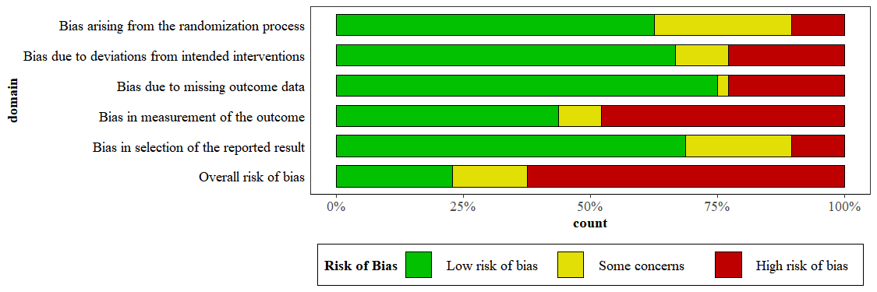

Supplementary Figure 2: Cooke distance plot
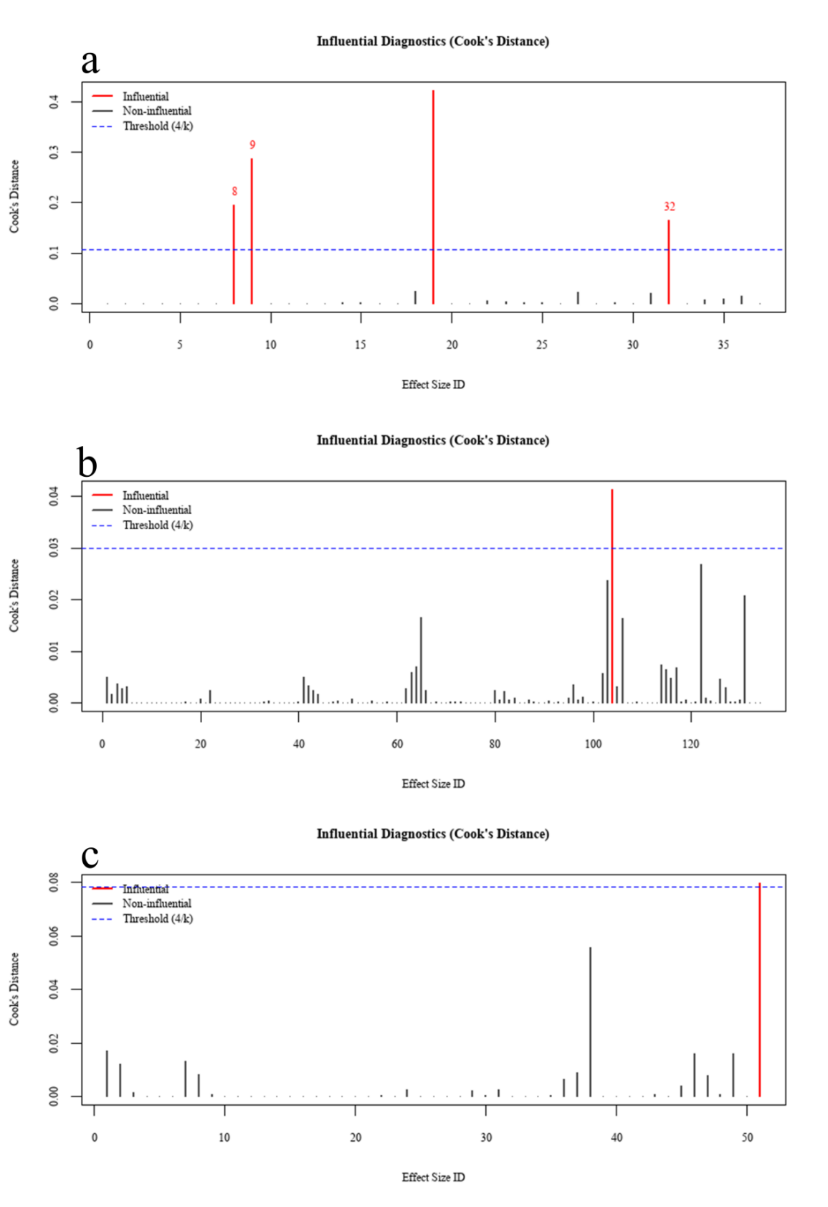
a, b, and c represent the Cooke distance identification results for short-term overall psychological well-being, short-term overall psychological distress, and long-term overall psychological distress, respectively.

Supplementary Figure 3: Publication bias
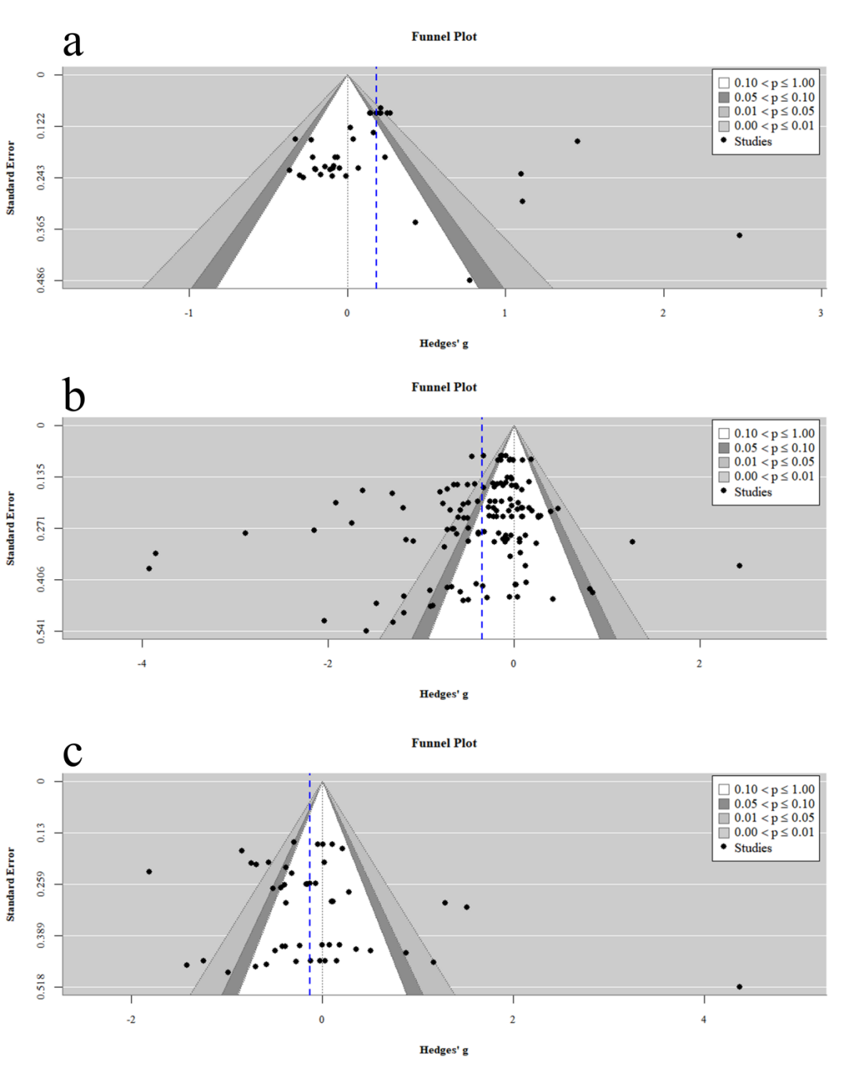
This figure show the panels a, b, and c represent the funnel plots for short-term overall psychological well-being, short-term overall psychological distress, and long-term overall psychological distress, respectively.

Supplementary Figure 4: Doi plot and LFK index for short-term overall psychological distress
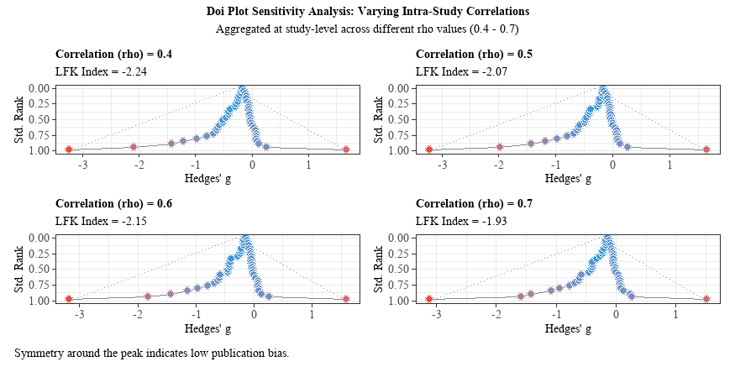
Where rho denotes the correlation coefficient between effect sizes. We aggregated effect sizes at the study level using different coefficients to examine publication bias. According to the standard, an LFK index absolute value within 1 indicates no asymmetry, between 1 and 2 suggests mild asymmetry, and exceeding 2 indicates severe asymmetry.

Supplementary Figure 5: Doi plot and LFK index for short-term overall psychological well-being
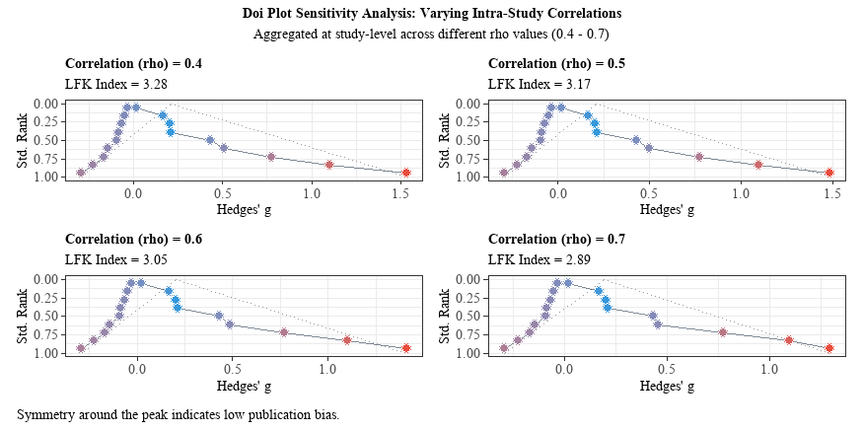
Where rho represents the correlation coefficient between effect sizes. We aggregated effect sizes at the study level using different coefficients to examine publication bias. According to the standard, an LFK index absolute value within 1 indicates no asymmetry, between 1 and 2 suggests mild asymmetry, and exceeding 2 indicates severe asymmetry.

Supplementary Figure 6: Doi plot and LFK index for long-term overall psychological distress
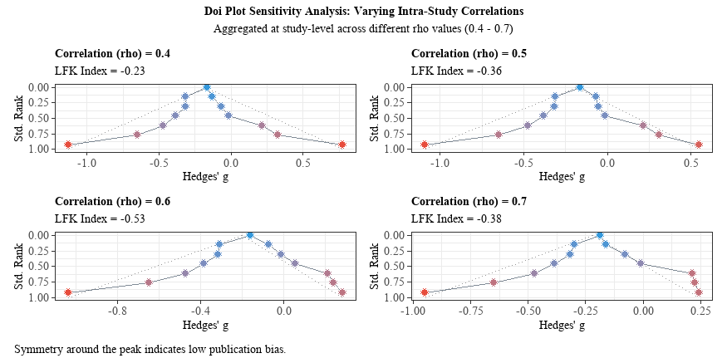
Where rho denotes the correlation coefficient between effect sizes. We aggregated effect sizes at the study level using different coefficients to examine publication bias. According to the standard, an LFK index absolute value within 1 indicates no asymmetry, between 1 and 2 suggests mild asymmetry, and exceeding 2 indicates severe asymmetry.

Supplementary Figure 7: Summary of findings and GRADE assessment results
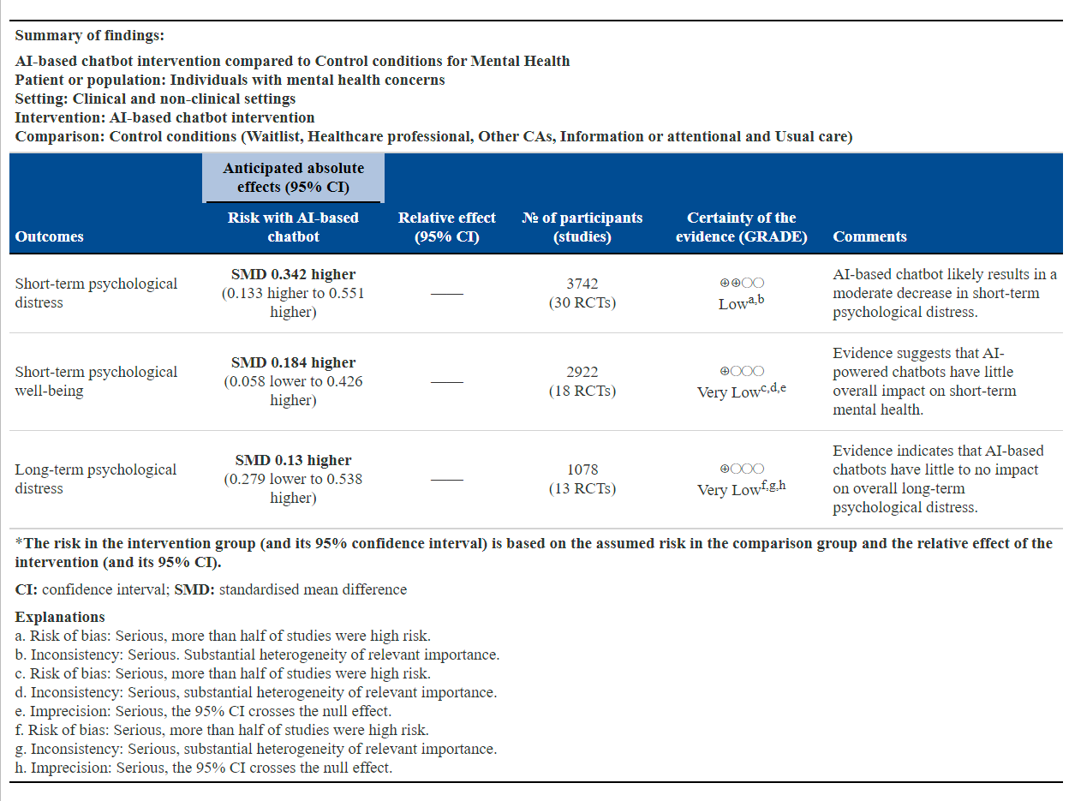

Supplementary Figure 8: Forest plot of effect sizes for uptake and adherence
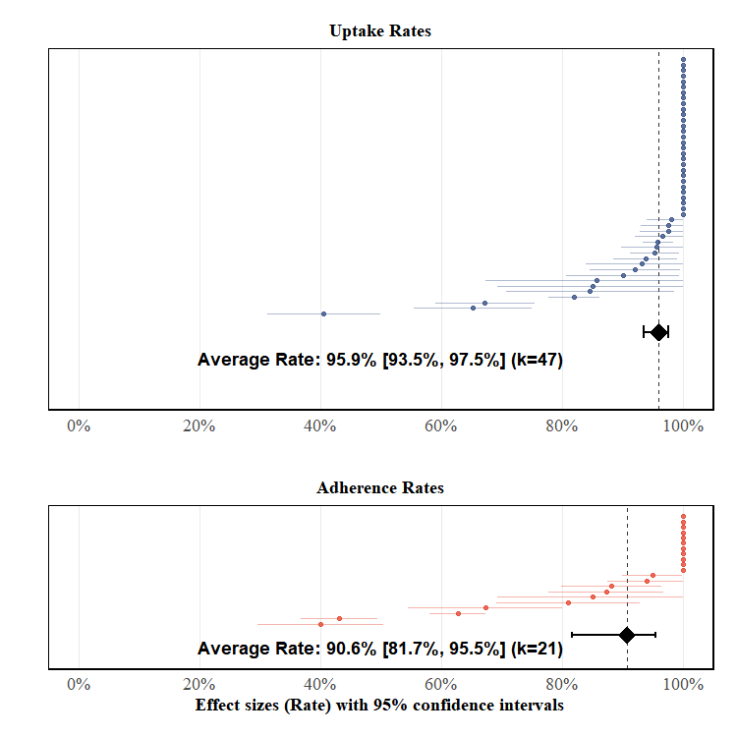
This forest plot combines uptake and adherence rates, where k represents the number of effect sizes.

References
1. Massetti GM, Thomas CC, King J, Ragan K, Lunsford NB. Mental health problems and cancer risk factors among young adults. Am J Prev Med. 2017;53(3):S30-S39. doi:https://doi.org/10.1016/j.amepre.2017.04.023
2. Chen C, Lam KT, Yip KM, et al. Comparison of an AI chatbot with a nurse hotline in reducing anxiety and depression levels in the general population: pilot randomized controlled trial. JMIR Hum Factors. 2025;12:e65785. doi:10.2196/65785
3. Feng Y, Hang Y, Wu W, et al. Effectiveness of AI-driven conversational agents in improving mental health among young people: systematic review and meta-analysis. J Med Internet Res. 2025;27:e69639. doi:10.2196/69639
4. Li H, Zhang R, Lee YC, Kraut RE, Mohr DC. Systematic review and meta-analysis of AI-based conversational agents for promoting mental health and well-being. npj Digital Med. 2023;6(1):236. doi:10.1038/s41746-023-00979-5
5. Li B, Lai EY, Wang X. From tools to agents: meta-analytic insights into human acceptance of AI. J mark. Published online 2025.
6. He Y, Yang L, Qian C, et al. Conversational agent interventions for mental health problems: systematic review and meta-analysis of randomized controlled trials. J Med Internet Res. 2023;25:e43862. doi:10.2196/43862
7. Kannampallil T, Ajilore OA, Lv N, et al. Effects of a virtual voice-based coach delivering problem-solving treatment on emotional distress and brain function: a pilot RCT in depression and anxiety. Transl Psychiatry. 2023;13(1):166. doi:10.1038/s41398-023-02544-w
8. Balan R, Dobrean A, Poetar CR. Use of automated conversational agents in improving young population mental health: a scoping review. npj Digital Med. 2024;7(1):75. doi:10.1038/s41746-024-01072-1
9. Heinz MV, Mackin DM, Trudeau BM, et al. Randomized trial of a generative AI chatbot for mental health treatment. NEJM AI. 2025;2(4):AIoa2400802. doi:10.1056/aioa2400802
10. Fitzpatrick KK, Darcy A, Vierhile M. Delivering cognitive behavior therapy to young adults with symptoms of depression and anxiety using a fully automated conversational agent (woebot): a randomized controlled trial. JMIR Ment Health. 2017;4(2):e7785. doi:10.2196/mental.7785
11. Ehrlich C, Hennelly SE, Wilde N, et al. Evaluation of an artificial intelligence enhanced application for student wellbeing: pilot randomised trial of the mind tutor. Int J Appl Posit Psychol. 2024;9(1):435-454. doi:10.1007/s41042-023-00133-2
12. Bird T, Mansell W, Wright J, Gaffney H, Tai S. Manage your life online: a web-based randomized controlled trial evaluating the effectiveness of a problem-solving intervention in a student sample. Behav Cogn Psychother. 2018;46(5):570-582. doi:10.1017/s1352465817000820
13. Eysenbach G. The law of attrition. J Med Internet Res. 2005;7(1):e402. doi:10.2196/jmir.7.1.e11
14. Khadjesari Z, Murray E, Kalaitzaki E, et al. Impact and costs of incentives to reduce attrition in online trials: two randomized controlled trials. J Med Internet Res. 2011;13(1):e1523. doi:10.2196/jmir.1523
15. Danieli M, Ciulli T, Mousavi SM, et al. Assessing the impact of conversational artificial intelligence in the treatment of stress and anxiety in aging adults: randomized controlled trial. JMIR Ment Health. 2022;9(9):e38067. doi:10.2196/38067
16. Linardon J. Rates of attrition and engagement in randomized controlled trials of mindfulness apps: systematic review and meta-analysis. Behav Res Ther. 2023;170:104421. doi:10.1016/j.brat.2023.104421
17. Akdogan O, Uyar GC, Yesilbas E, et al. Effect of a ChatGPT-based digital counseling intervention on anxiety and depression in patients with cancer: a prospective, randomized trial. Eur J Cancer. 2025;221:115408. doi:10.1016/j.ejca.2025.115408
18. Ali M, Rehman S, Cheema E. Impact of artificial intelligence on the academic performance and test anxiety of pharmacy students in objective structured clinical examination: a randomized controlled trial. Int J Clin Pharm. Published online 2025:1-8.
19. Bennion MR, Hardy GE, Moore RK, Kellett S, Millings A. Usability, acceptability, and effectiveness of web-based conversational agents to facilitate problem solving in older adults: controlled study. J Med Internet Res. 2020;22(5):e16794. doi:10.2196/16794
20. Cachia JY, Zhao X, Hunter J, Wu D, Lin E, De Freitas J. AI for proactive mental health: a longitudinal, multi-institutional trial. Multi-Institutional Trial. Published online 2025.
21. Drouin M, Sprecher S, Nicola R, Perkins T. Is chatting with a sophisticated chatbot as good as chatting online or FTF with a stranger? Comput Hum Behav. 2022;128:107100. doi:10.1016/j.chb.2021.107100
22. Danieli M, Ciulli T, Mousavi SM, Riccardi G. A conversational artificial intelligence agent for a mental health care app: evaluation study of its participatory design. JMIR Form Res. 2021;5(12):e30053. doi:10.2196/30053
23. Fulmer R, Joerin A, Gentile B, Lakerink L, Rauws M. Using psychological artificial intelligence (Tess) to relieve symptoms of depression and anxiety: randomized controlled trial. JMIR ment health. 2018;5(4):e9782. doi:10.2196/mental.9782
24. Gan W, Ouyang J, She G, et al. ChatGPT’s role in alleviating anxiety in total knee arthroplasty consent process: a randomized controlled trial pilot study. Int J Surg. 2025;111(3):2546-2557. doi:10.1097/JS9.0000000000002223
25. Gaffney H, Mansell W, Edwards R, Wright J. Manage your life online (MYLO): a pilot trial of a conversational computer-based intervention for problem solving in a student sample. Behav Cogn Psychother. 2014;42(6):731-746. doi:10.1017/S135246581300060X
26. Guțu SM, Cosmoiu A, Cojocaru D, Turturescu T, Popoviciu CM, Giosan C. Bot to the rescue? Effects of a fully automated conversational agent on anxiety and depression: a randomized controlled trial. Ann Depress Anxiety. 2021;8(1):1107. doi:10.26420/anndepressanxiety.2021.1107
27. He Y, Yang L, Zhu X, et al. Mental health chatbot for young adults with depressive symptoms during the COVID-19 pandemic: single-blind, three-arm randomized controlled trial. J Med Internet Res. 2022;24(11):e40719. doi:10.2196/40719
28. Indrayanti I, Salsabila AK, Amrita V, Alhaddad MM, Saskia AB, Ramadhani DP. PsyBot: a randomized controlled trial of WhatsApp-based psychological first aid to reduce loneliness among 18–22-year-old students in yogyakarta, indonesia. SSM-Ment Health. Published online 2025:100504.
29. Jang S, Kim JJ, Kim SJ, Hong J, Kim S, Kim E. Mobile app-based chatbot to deliver cognitive behavioral therapy and psychoeducation for adults with attention deficit: a development and feasibility/usability study. Int J Med Inf. 2021;150:104440. doi:10.1016/j.ijmedinf.2021.104440
30. Karhiy M, Sagar M, Antoni M, Loveys K, Broadbent E. Mindfulness based stress reduction: a randomised trial of a virtual human, teletherapy, and a chatbot. In: 2023 11th International Conference on Affective Computing and Intelligent Interaction Workshops and Demos (ACIIW). IEEE; 2023:1-7.
31. Karkosz S, Szymański R, Sanna K, Michałowski J. Effectiveness of a web-based and mobile therapy chatbot on anxiety and depressive symptoms in subclinical young adults: randomized controlled trial. JMIR Form Res. 2024;8(1):e47960. doi:10.2196/47960
32. Klos MC, Escoredo M, Joerin A, Lemos VN, Rauws M, Bunge EL. Artificial intelligence–based chatbot for anxiety and depression in university students: pilot randomized controlled trial. JMIR Form Res. 2021;5(8):e20678. doi:10.2196/20678
33. Lee S, Jeong J, Kim M, Lee S, Kim SP, Jung D. Development of a mobile intervention for procrastination augmented with a semigenerative chatbot for university students: pilot randomized controlled trial. JMIR Mhealth Uhealth. 2025;13(1):e53133. doi:10.2196/53133
34. Liu H, Peng H, Song X, Xu C, Zhang M. Using AI chatbots to provide self-help depression interventions for university students: a randomized trial of effectiveness. Internet Interventions. 2022;27:100495. doi:10.1016/j.invent.2022.100495
35. Liu I, Chen W, Ge Q, Song D, Ni S. Enhancing psychological resilience with chatbot-based cognitive behavior therapy: a randomized control pilot study. In: Proceedings of the Tenth International Symposium of Chinese CHI. 2022:216-221.
36. MacNeill AL, Doucet S, Luke A. Effectiveness of a mental health chatbot for people with chronic diseases: randomized controlled trial. JMIR Form Res. 2024;8:e50025. doi:10.2196/50025
37. Maeda E, Miyata A, Boivin J, et al. Promoting fertility awareness and preconception health using a chatbot: a randomized controlled trial. Reprod Biomed Online. 2020;41(6):1133-1143. doi:10.1016/j.rbmo.2020.09.006
38. McFadyen J, Habicht J, Dina LM, Harper R, Hauser TU, Rollwage M. AI-enabled conversational agent increases engagement with cognitive-behavioral therapy: a randomized controlled trial. Medrxiv. Published online 2024:2024.11. 1.24316565.
39. Nicol G, Wang R, Graham S, Dodd S, Garbutt J. Chatbot-delivered cognitive behavioral therapy in adolescents with depression and anxiety during the COVID-19 pandemic: feasibility and acceptability study. JMIR Form Res. 2022;6(11):e40242. doi:10.2196/40242
40. Oh J, Jang S, Kim H, Kim JJ. Efficacy of mobile app-based interactive cognitive behavioral therapy using a chatbot for panic disorder. Int J Med Inf. 2020;140:104171. doi:10.1016/j.ijmedinf.2020.104171
41. Ogawa M, Oyama G, Morito K, et al. Can AI make people happy? The effect of AI-based chatbot on smile and speech in parkinson’s disease. Park Relat Disord. 2022;99:43-46. doi:10.1016/j.parkreldis.2022.04.018
42. Papadopoulos C, Castro N, Nigath A, et al. The CARESSES randomised controlled trial: exploring the health-related impact of culturally competent artificial intelligence embedded into socially assistive robots and tested in older adult care homes. Int J Social Rob. 2022;14(1):245-256. doi:10.1007/s12369-021-00781-x
43. Prochaska JJ, Vogel EA, Chieng A, et al. A randomized controlled trial of a therapeutic relational agent for reducing substance misuse during the COVID-19 pandemic. Drug Alcohol Depend. 2021;227:108986. doi:10.1016/j.drugalcdep.2021.108986
44. Romanovskyi O, Pidbutska N, Knysh A. Elomia chatbot: the effectiveness of artificial intelligence in the fight for mental health. In: Colins. 2021:1215-1224. https://api.semanticscholar.org/CorpusID:235271819
45. Sabour S, Zhang W, Xiao X, et al. A chatbot for mental health support: exploring the impact of emohaa on reducing mental distress in China. Front Digital Health. 2023;5:1133987. doi:10.3389/fdgth.2023.1133987
46. Sahab S, Haqbeen J, Sapkota D, Ito T. GPT chatbots for alleviating anxiety and depression: a pilot randomized controlled trial with afghan women. arXiv prepr arXiv:2508,00847. Published online 2025.
47. Selaskowski B, Reiland M, Schulze M, et al. Chatbot-supported psychoeducation in adult attention-deficit hyperactivity disorder: randomised controlled trial. BJPsych open. 2023;9(6):e192. doi:10.1192/bjo.2023.573
48. So R, Emura N, Okazaki K, et al. Guided versus unguided chatbot-delivered cognitive behavioral intervention for individuals with moderate-risk and problem gambling: a randomized controlled trial (GAMBOT2 study). Addict Behav. 2024;149:107889. doi:10.1016/j.addbeh.2023.107889
49. Suharwardy S, Ramachandran M, Leonard SA, et al. Feasibility and impact of a mental health chatbot on postpartum mental health: a randomized controlled trial. AJOG Glob Rep. 2023;3(3):100165. doi:10.1016/j.xagr.2023.100165
50. Tawfik E, Ghallab E, Moustafa A. A nurse versus a chatbot‒the effect of an empowerment program on chemotherapy-related side effects and the self-care behaviors of women living with breast cancer: a randomized controlled trial. BMC Nurs. 2023;22(1):102. doi:10.1186/s12912-023-01243-7
51. Vowels LM, Vowels MJ, Sweeney SK, Hatch SG, Darwiche J. The efficacy, feasibility, and technical outcomes of a GPT-4o-based chatbot amanda for relationship support: a randomized controlled trial. PLOS Ment Health. 2025;2(9):e0000411. doi:10.1371/journal.pmen.0000411
52. Wang Y, Li X, Zhang Q, Yeung D, Wu Y. Effect of a cognitive behavioral therapy–based AI chatbot on depression and loneliness in chinese university students: randomized controlled trial with financial stress moderation. JMIR mHealth uHealth. 2025;13:e63806. doi:10.2196/63806
53. Xu S, Ma T. Depression intervention using AI chatbots with social cues: a randomized trial of effectiveness. J Affect Disord. Published online 2025:119760.
54. Yahagi M, Hiruta R, Miyauchi C, Tanaka S, Taguchi A, Yaguchi Y. Comparison of conventional anesthesia nurse education and an artificial intelligence chatbot (ChatGPT) intervention on preoperative anxiety: a randomized controlled trial. J Perianesth Nurs. 2024;39(5):767-771. doi:10.1016/j.jopan.2023.12.005
55. Zhang H, Wang X, Luo H, et al. Comparison of preoperative education by artificial intelligence versus traditional physicians in perioperative management of urolithiasis surgery: a prospective single-blind randomized controlled trial conducted in China. Front Med. 2025;12:1543630. doi:10.3389/fmed.2025.1543630
56. Zhao Y, Qian W, Chen Y, et al. Effect of an AI agent trained on a large language model (LLM) as an intervention for depression and anxiety symptoms in young adults: a 28-day randomized controlled trial. Appl Psychol: Health Well‐Being. 2025;17(5):e70067. doi:10.1111/aphw.70067

