Figure S1 Phylogram (NJ tree) based on 16S rDNA sequence (ca. 1350 bp) showing relationship of the non-symbiotic rhizobia isolated from agroforestry legumes in Ethiopia (16 strains marked ∆) and reference type strains of rhizobia. Tree constructed using MEGA4 software. Methylobacterium and Bradryrhizobium type strains were used as outgroups and scale bar represent % nucleotide substitution rate.

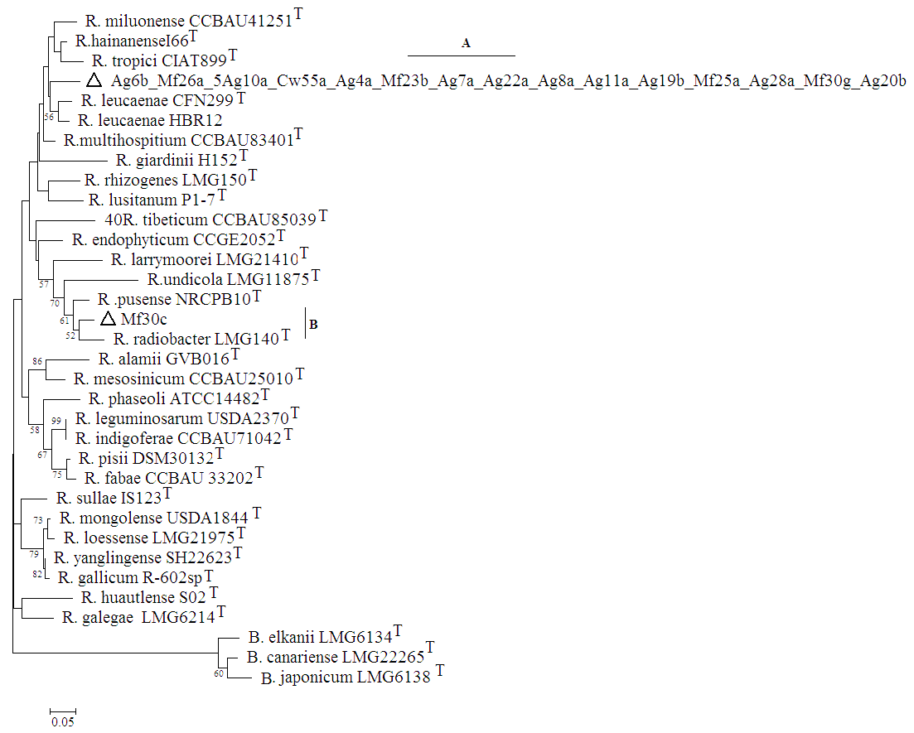

Figure S2. Maximum likelihood phylogram based on recA gene sequence (ca. 450 bp) revealed the relationship of the non-symbiotic rhizobia (16 strains ∆) isolated from agroforestry legumes in Ethiopia and recognized type strains of rhizobia. Tree generated using MEGA4 software. Species names of type strains followed by strain umber and superscript ^{T}. Scale bar represent % nucleotide substitution rate. The type strains of bradyrhizobia were included as outgroup in the analysis to root the tree.

Figure S3 Maximum likelihood Phylogram based on rpoB gene sequence (ca 900 bp) showing relationship of the non-symbiotic rhizobia (15 strains ∆) isolated from agroforestry legumes in Ethiopia and reference type strains. Tree generated using MEGA4 software, percentages of bootstrap test values >50% of 500 replicates shown next to branches. Strain number and superscript ^{T} follow species names of type strains, Bradyrhizobia used as outgroups.

