Additional file 1. Supplementary Tables and Figures
Supplementary materials for the BMC Geriatrics submission
This final supplementary file contains Tables S1-S11 and Figures S1-S14, matching the Additional file description and in-text citations in the main manuscript. Superseded diagnostic outputs are retained only as source data or archived files and are not part of the formal Additional file 1 content.

Supplementary Tables

Table S1. Covariate usage map by analysis layer
Variable | Label | Layer 1 (GBDTM) | Layer 2 (PSM) | Layer 2 (DID adj.) | Layer 3 (ML)
adlab_c | Baseline ADL score | Outcome | Yes | Yes | Yes
age | Age (years) | - | Yes | Yes | Yes
arthre_b | Arthritis | - | Yes | - | Yes
asthmae_b | Asthma | - | - | - | Yes
cancre_b | Cancer | - | Yes | - | Yes
cesd10 | CESD-10 depression score | - | Yes | Yes | Yes
diabe_b | Diabetes | - | Yes | - | Yes
digeste_b | Digestive disease | - | - | - | Yes
doctor_b | Outpatient visit (baseline) | - | - | - | Yes
drink_ever | Ever drank alcohol | - | Yes | - | Yes
dyslipe_b | Dyslipidemia | - | - | - | Yes
edu_level | Education level (0-4) | - | Yes | - | Yes
executive | Executive function score | - | - | - | Yes
exercise_b | Regular exercise | - | - | - | Yes
family_size | Family size | - | - | - | Yes
has_insurance | Health insurance | - | - | - | Yes
hchild | Number of children | - | - | - | Yes
hearte_b | Heart disease | - | Yes | - | Yes
hibpe_b | Hypertension | - | Yes | - | Yes
hospital_b | Hospitalized (baseline) | - | - | - | -
iadl | IADL score | - | Yes | - | Yes
is_rural | Rural residence | - | Yes | - | Yes
kidneye_b | Kidney disease | - | - | - | Yes
livere_b | Liver disease | - | - | - | Yes
lunge_b | Lung disease | - | Yes | - | Yes
male | Male sex | - | Yes | Yes | Yes
married | Married | - | Yes | - | Yes
memeory | Memory score | - | - | - | Yes
memrye_b | Memory-related disease | - | - | - | Yes
n_chronic | Number of chronic diseases | - | Yes | Yes | Yes
psyche_b | Psychiatric disorder | - | - | - | Yes
sleep | Sleep hours | - | - | - | Yes
smoke_ever | Ever smoked | - | Yes | - | Yes
stroke_b | Stroke | - | Yes | - | Yes
total_cognition | Total cognition score | Outcome | Yes | Yes | Yes
Table S1. Covariate usage map across the three analytical layers (GBDTM, PSM-DID, ML). Rows list all covariates; columns indicate inclusion in each analysis.

Table S2. Standardized mean differences between trajectory classes
Variable | SMD (1 vs 2) | SMD (1 vs 3) | SMD (2 vs 3)
Age (years) | 0.149 | -0.254 | -0.407
Baseline ADL score | 0.596 | -0.41 | -1.054
IADL score | 0.481 | -0.388 | -0.843
Total cognition score | -0.456 | 0.064 | 0.518
Memory score | -0.296 | 0.09 | 0.382
Executive function score | -0.39 | 0.026 | 0.429
CESD-10 depression score | 0.582 | 0.041 | -0.563
Number of chronic diseases | 0.219 | -0.219 | -0.452
Sleep hours | -0.236 | -0.206 | 0.0
Family size | -0.082 | 0.129 | 0.23
Number of children | 0.227 | -0.06 | -0.286
Male sex | -0.108 | -0.097 | 0.011
Married | -0.229 | -0.08 | 0.149
Rural residence | 0.392 | 0.194 | -0.194
Hypertension | 0.104 | 0.033 | -0.071
Diabetes | 0.01 | 0.028 | 0.018
Heart disease | 0.035 | 0.071 | 0.036
Stroke | 0.217 | -0.41 | -0.611
Lung disease | 0.024 | -0.084 | -0.108
Arthritis | 0.368 | 0.054 | -0.312
Cancer | -0.102 | -0.181 | -0.087
Psychiatric disorder | 0.097 | 0.063 | -0.034
Dyslipidemia | -0.154 | -0.219 | -0.065
Liver disease | -0.049 | -0.035 | 0.014
Kidney disease | -0.056 | -0.121 | -0.065
Digestive disease | 0.096 | 0.13 | 0.035
Asthma | 0.043 | -0.101 | -0.143
Memory-related disease | -0.038 | -0.415 | -0.386
Ever smoked | 0.037 | -0.107 | -0.144
Ever drank alcohol | 0.002 | -0.031 | -0.033
Regular exercise | -0.049 | 0.164 | 0.214
Health insurance | -0.043 | -0.027 | 0.016
Outpatient visit (baseline) | 0.218 | 0.14 | -0.078
Hospitalized (baseline) | 0.0 | 0.0 | 0.0
Education level (0-4) | -0.382 | 0.006 | 0.397
Table S2. Standardized mean differences (SMD) of baseline characteristics between trajectory classes. Values > 0.10 indicate meaningful imbalance.

Table S3. GBDTM model adequacy
Number of classes | Log-likelihood | BIC | AIC | Number of parameters | Convergence code | APPA overall | entropy | Min class N | Min class %
1 | -27107.22 | 54289 | 54234.43 | 10 | 2 | NA | NA | NA | 100
2 | -26648.89 | 53402 | 53325.79 | 14 | 2 | 0.9852 | 0.9479 | 173 | 10
3 | -26386.11 | 52906 | 52808.21 | 18 | 2 | 0.961 | 0.9044 | 124 | 7.1
4 | -26385.45 | 52935 | 52814.9 | 22 | 2 | 0.6384 | 0.5235 | 129 | 7.4
Table S3. GBDTM model adequacy diagnostics for the three-class solution, including APPA, entropy, OCC, and class-specific posterior probabilities.

Table S4. GBDTM classification table for the three-class solution
Assigned class | n | pct | APPA | OCC | Mean P(Class 1) | Mean P(Class 2) | Mean P(Class 3)
1 | 145 | 8.3 | 0.8788 | 79.6 | 0.8788 | 0.0851 | 0.0361
2 | 1468 | 84.5 | 0.9698 | 5.9 | 0.0267 | 0.9698 | 0.0036
3 | 124 | 7.1 | 0.9528 | 262.8 | 0.0276 | 0.0196 | 0.9528
Table S4. GBDTM classification table for the three-class solution (ng = 3). Rows show modal assignment; columns show posterior probability distributions.

Table S5. Propensity score matching caliper sensitivity
Caliper | N pairs | Outcome | DID estimate | SE | t statistic | P-value
0.01 | 731 | ADL | 0.1573 | 0.0595 | 2.644 | 0.0083
0.01 | 731 | Cognition | -0.3358 | 0.1624 | -2.068 | 0.0388
0.02 | 739 | ADL | 0.1448 | 0.0591 | 2.449 | 0.0144
0.02 | 739 | Cognition | -0.3762 | 0.1612 | -2.333 | 0.0198
0.05 | 757 | ADL | 0.1295 | 0.058 | 2.232 | 0.0258
0.05 | 757 | Cognition | -0.3283 | 0.1599 | -2.054 | 0.0402
0.1 | 792 | ADL | 0.1174 | 0.0568 | 2.069 | 0.0387
0.1 | 792 | Cognition | -0.2841 | 0.1564 | -1.817 | 0.0694
None | 816 | ADL | 0.125 | 0.0569 | 2.198 | 0.0281
None | 816 | Cognition | -0.3775 | 0.1534 | -2.461 | 0.014
Table S5. PSM caliper sensitivity analysis. DID estimates for ADL and cognition across caliper specifications (0.01, 0.02, 0.05, 0.10, no caliper).

Table S6. IPTW and method comparison
Section | Method | Outcome | Estimate | SE | P-value | 95% CI lower | 95% CI upper | N
IPTW results | IPTW (ATT, trimmed) | ADL | 0.116 | 0.0564 | 0.0398 | 0.0054 | 0.2267 | 1736
IPTW results | IPTW (ATT, trimmed) | Cognition | -0.238 | 0.1476 | 0.107 | -0.5275 | 0.0514 | 1736
Method comparison | PSM 1:1 (c=0.05) | ADL | 0.1295 | 0.0258 | 757
Method comparison | IPTW (ATT) | ADL | 0.116 | 0.0398 | 1736
Method comparison | PSM 1:1 (c=0.05) | Cognition | -0.3283 | 0.0402 | 757
Method comparison | IPTW (ATT) | Cognition | -0.238 | 0.107 | 1736
Table S6. IPTW and method comparison. DID estimates for ADL and cognition using PSM (primary), IPTW, and unadjusted approaches.

Table S7. Subgroup DID results
Subgroup | N | N pairs | ADL DID | ADL SE | ADL P-value | Cog DID | Cog SE | Cog P-value
Male | 917 | 391 | 0.1535 | 0.0803 | 0.0563 | -0.321 | 0.2161 | 0.1379
Female | 819 | 358 | 0.0866 | 0.0868 | 0.319 | -0.3017 | 0.2418 | 0.2125
Age < 70 | 1243 | 546 | 0.1062 | 0.0678 | 0.1174 | -0.3049 | 0.1855 | 0.1005
Age >= 70 | 493 | 208 | 0.2356 | 0.1094 | 0.0319 | -0.5264 | 0.3053 | 0.0853
Urban | 779 | 332 | 0.0994 | 0.0786 | 0.2065 | -0.3042 | 0.2392 | 0.2038
Rural | 957 | 425 | 0.1482 | 0.0834 | 0.0759 | -0.3576 | 0.2167 | 0.0992
Chronic <= 2 | 892 | 399 | 0.1153 | 0.075 | 0.1248 | -0.3271 | 0.2123 | 0.1239
Chronic > 2 | 844 | 356 | 0.1601 | 0.0906 | 0.0777 | -0.3483 | 0.2432 | 0.1525
Table S7. Subgroup DID results. DID estimates stratified by sex, age, residence, comorbidity burden, and trajectory class membership.

Table S8. Wave-by-wave DID contrasts
Outcome | Wave | Year | DID estimate | t statistic | P-value | N treated | N control
ADL | 1 | 2013 | 0.0307 | 0.511 | 0.6093 | 712 | 703
ADL | 2 | 2015 | 0.1377 | 1.998 | 0.0459 | 690 | 647
ADL | 3 | 2018 | 0.1995 | 2.385 | 0.0172 | 639 | 515
ADL | 4 | 2020 | 0.2638 | 3.096 | 0.002 | 579 | 495
Cognition | 1 | 2013 | 0.0206 | 0.121 | 0.9039 | 603 | 593
Cognition | 2 | 2015 | -0.0402 | -0.228 | 0.8199 | 596 | 560
Cognition | 3 | 2018 | -0.302 | -1.257 | 0.2092 | 402 | 337
Cognition | 4 | 2020 | 0.0159 | 0.068 | 0.9456 | 384 | 343
Table S8. Wave-by-wave DID estimates. Post-baseline DID contrasts for ADL and cognition at each follow-up wave.

Table S9. Subgroup machine-learning performance
Subgroup | N | Class distribution | Macro AUC
Male | 915 | Class 1: 69; Class 2: 780; Class 3: 66 | 0.9569
Female | 814 | Class 1: 74; Class 2: 681; Class 3: 59 | 0.9391
Age < 70 | 1238 | Class 1: 94; Class 2: 1073; Class 3: 71 | 0.9484
Age >= 70 | 491 | Class 1: 49; Class 2: 388; Class 3: 54 | 0.9438
Urban | 776 | Class 1: 40; Class 2: 689; Class 3: 47 | 0.9585
Rural | 953 | Class 1: 103; Class 2: 772; Class 3: 78 | 0.9396
Table S9. Subgroup ML performance. Macro-averaged AUC and F1 for the random forest model across demographic and clinical subgroups.

Table S10. Feature ablation analysis
Top k features | Macro AUC | Macro F1
5 | 0.7163 | 0.4121
10 | 0.7355 | 0.4417
15 | 0.7407 | 0.4556
20 | 0.7423 | 0.4683
25 | 0.7447 | 0.4551
30 | 0.7447 | 0.4609
34 | 0.7457 | 0.4588
Table S10. Feature ablation results. Macro-averaged AUC as a function of number of features included, showing contribution of incrementally added predictors.

Table S11. HRS DID comparison
Outcome | Dataset | DID estimate | SE | P-value
ADL | HRS | 0.2202 | 0.0234 | 0.0
Cognition | HRS | -0.2114 | 0.1024 | 0.039
ADL | CHARLS | 0.1295 | 0.058 | 0.0256
Cognition | CHARLS | -0.3283 | 0.1599 | 0.04
Table S11. HRS DID comparison. DID estimates for ADL and cognition in the HRS validation cohort, alongside the corresponding CHARLS estimates.

Supplementary Figures

Figure S1. BIC elbow plot
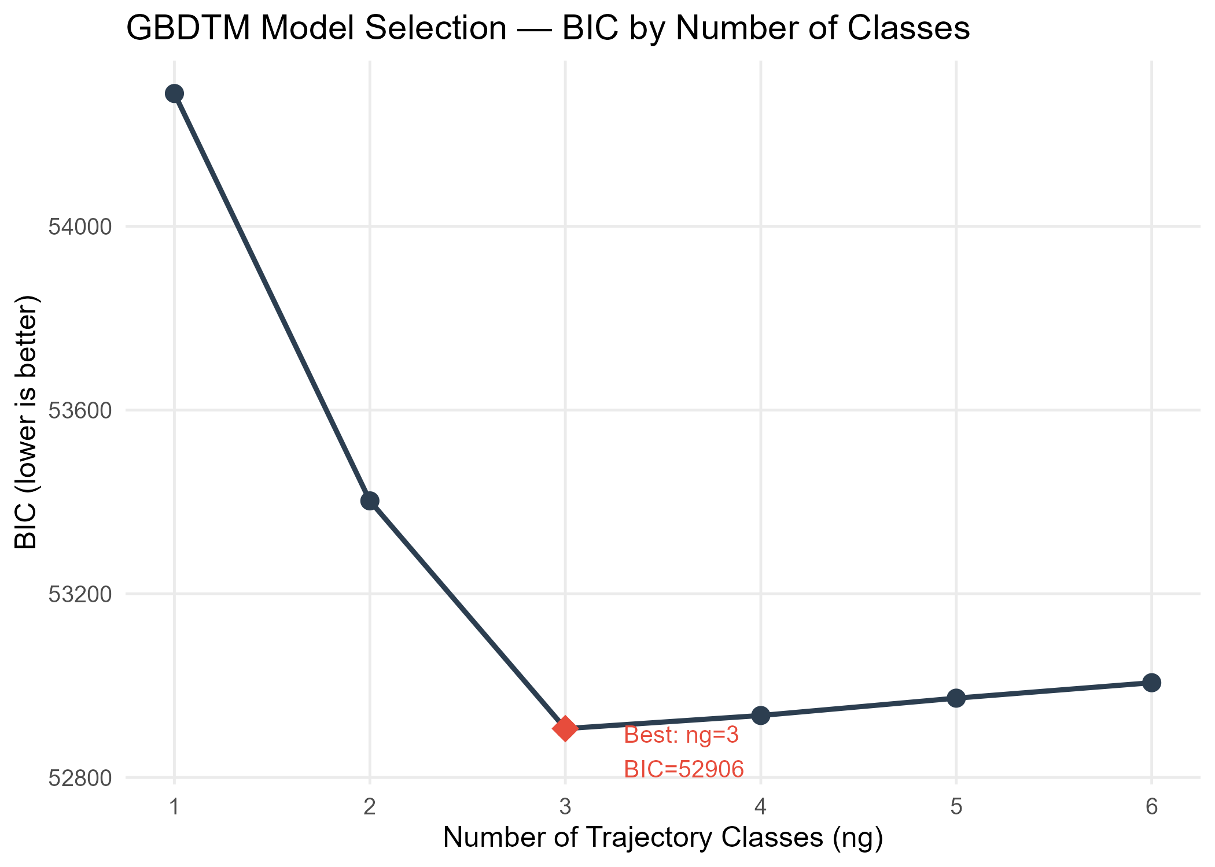
Figure S1. BIC elbow plot for GBDTM class selection. The x-axis shows the number of latent classes (1–4); the y-axis shows the Bayesian Information Criterion. The three-class solution (arrow) achieved the lowest BIC, supporting its selection as the optimal model.

Figure S2. APPA and entropy plot
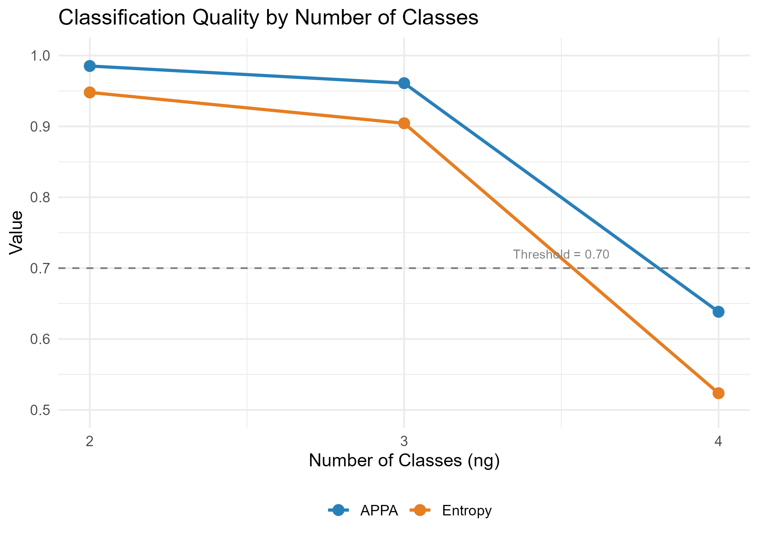
Figure S2. Average posterior probability of assignment (APPA) and relative entropy as a function of number of latent classes (2–6). Higher values indicate better classification quality. The three-class solution maintained APPA > 0.96 and entropy > 0.90, both well above recommended thresholds (dashed lines: APPA ≥ 0.70, entropy > 0.60).

Figure S3. Love plot for PSM balance
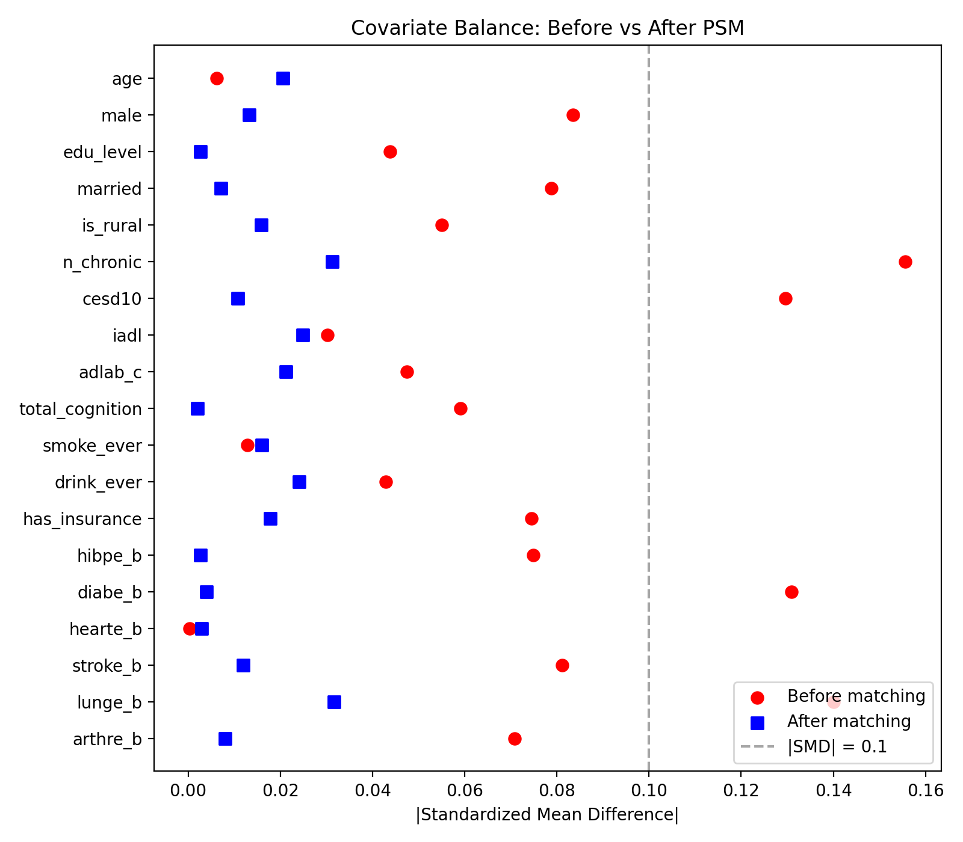
Figure S3. Love plot showing standardized mean differences (SMD) for all covariates before (circles) and after (triangles) propensity score matching. Dashed vertical lines indicate the ±0.10 threshold. All post-matching SMDs fell within this range, confirming adequate covariate balance.

Figure S4. Trajectory comparison in matched and unmatched samples
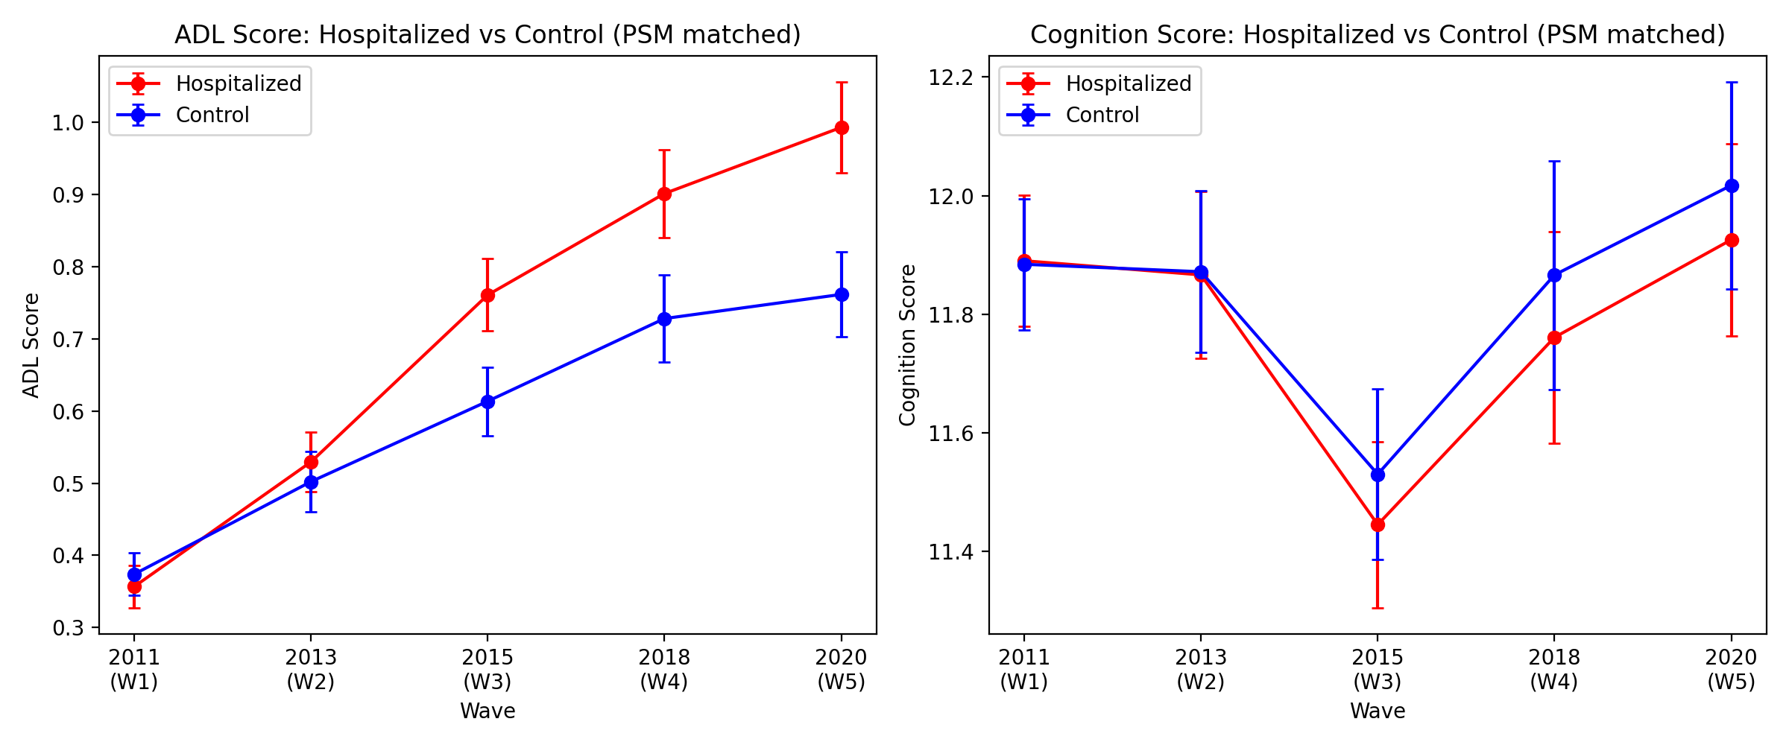
Figure S4. Trajectory comparison in matched and unmatched samples. Left panels show ADL and cognition trajectories for the full unmatched sample; right panels show the matched sample. Trajectories remain qualitatively similar after matching, indicating that PSM did not distort the underlying trajectory structure.

Figure S5. Parallel-trends diagnostic
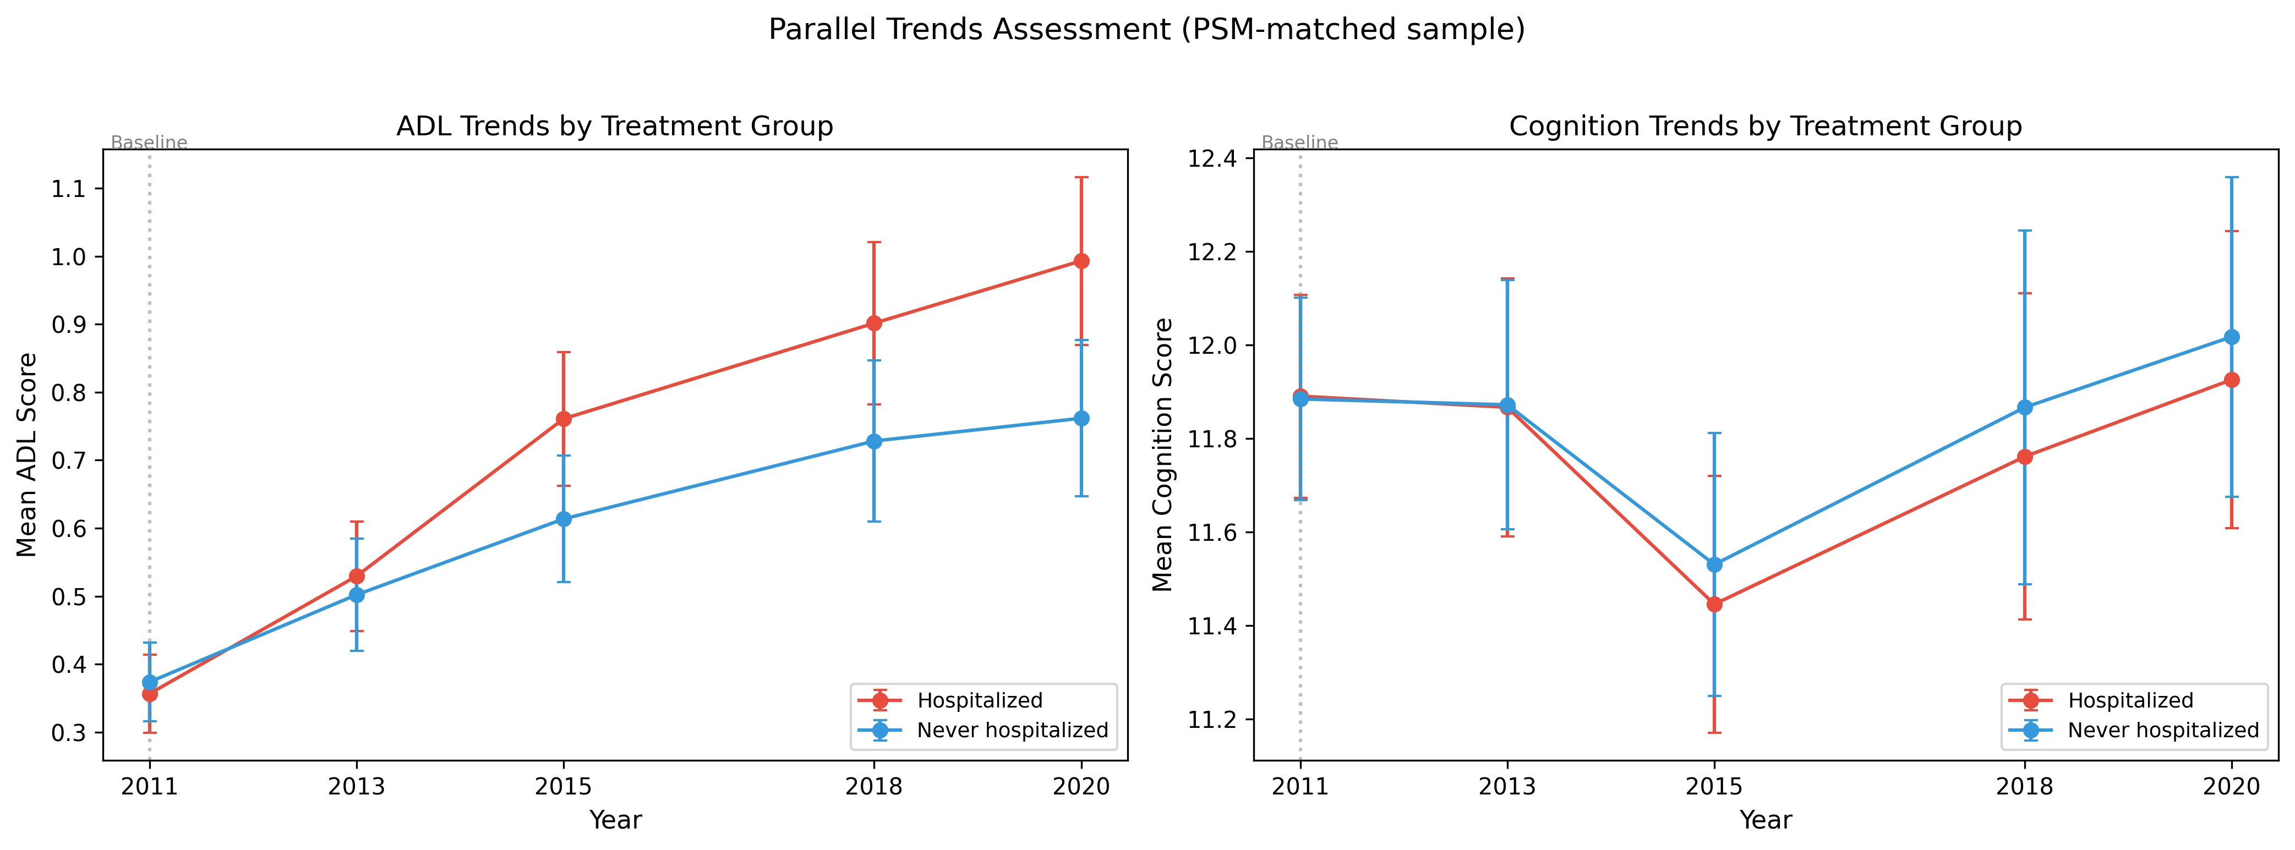
Figure S5. Parallel-trends diagnostic for ADL and cognition before hospitalization. Lines show mean pre-exposure trajectories in matched hospitalized (solid) and non-hospitalized (dashed) groups. Similar pre-follow-up patterns are broadly compatible with the DID parallel-trends assumption.

Figure S6. Event-study DID contrasts
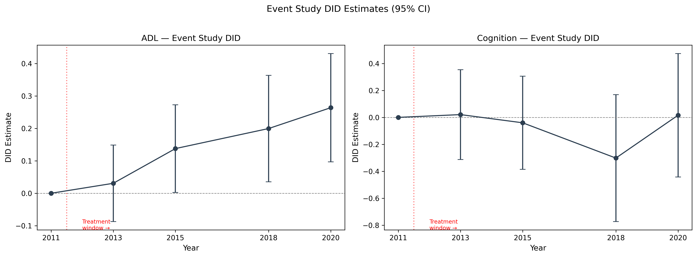
Figure S6. Event-study DID contrasts for ADL (left) and cognition (right) at each post-baseline wave relative to wave 1. Points show DID estimates; error bars show 95% CIs. ADL divergence grew progressively across follow-up; cognition contrasts were directionally negative but not temporally stable.

Figure S7. PSM caliper sensitivity
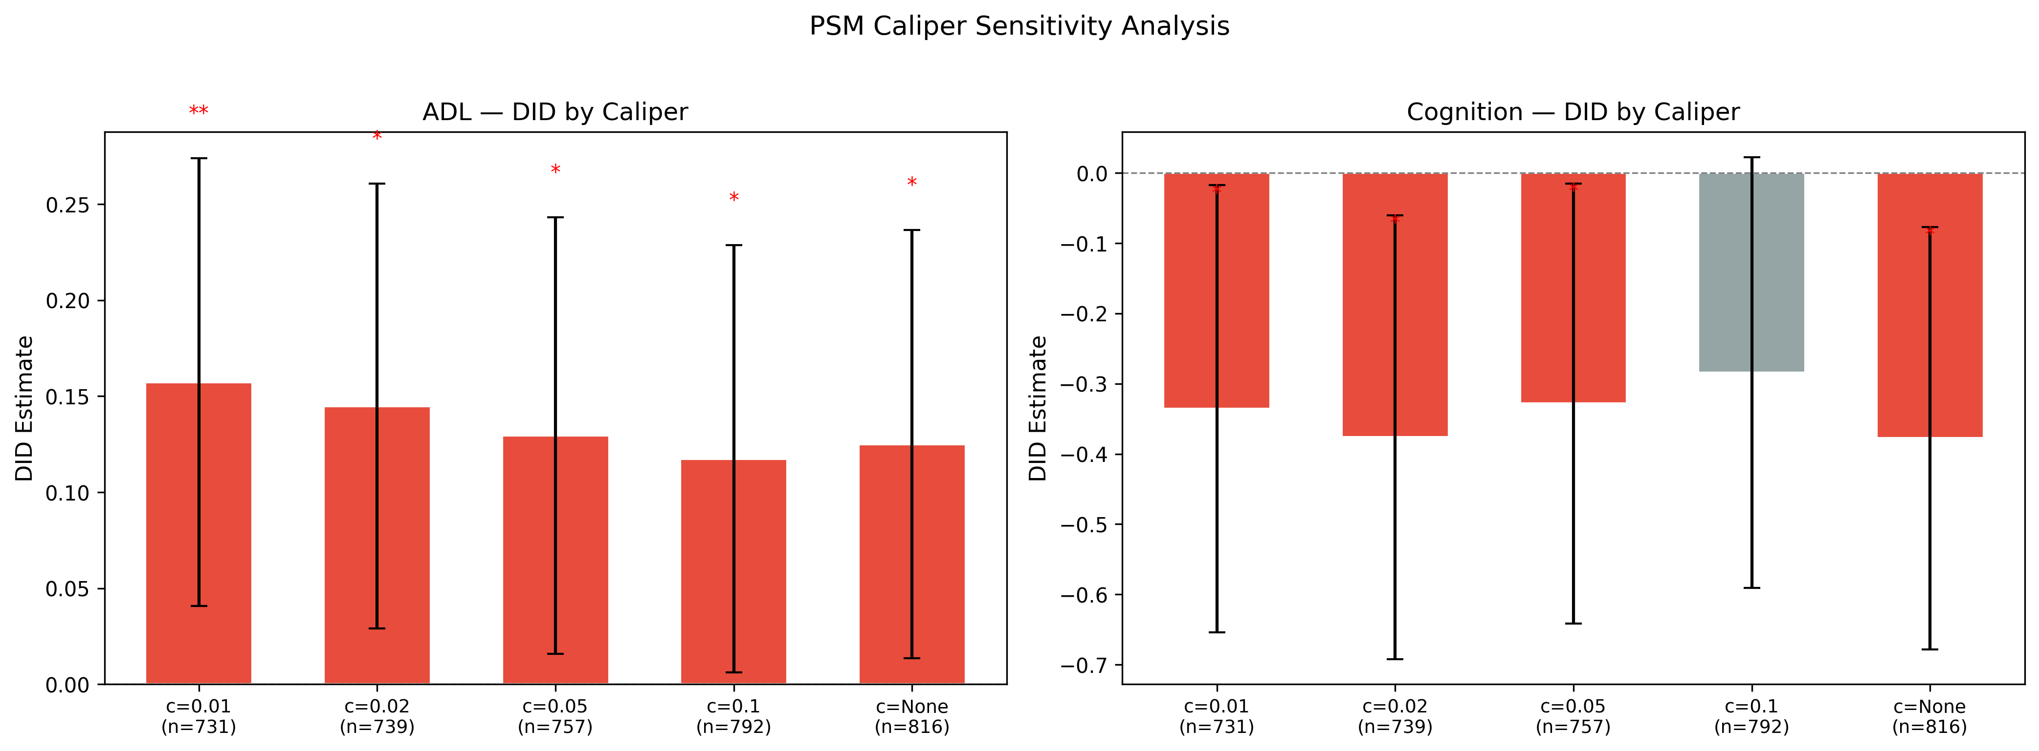
Figure S7. PSM caliper sensitivity analysis. DID estimates for ADL (top) and cognition (bottom) across five caliper specifications (0.01, 0.02, 0.05, 0.10, no caliper). Error bars show 95% CIs. The ADL effect was robust across all calipers; the cognition effect was directionally consistent but attenuated under the widest caliper.

Figure S8. Method-comparison forest plot
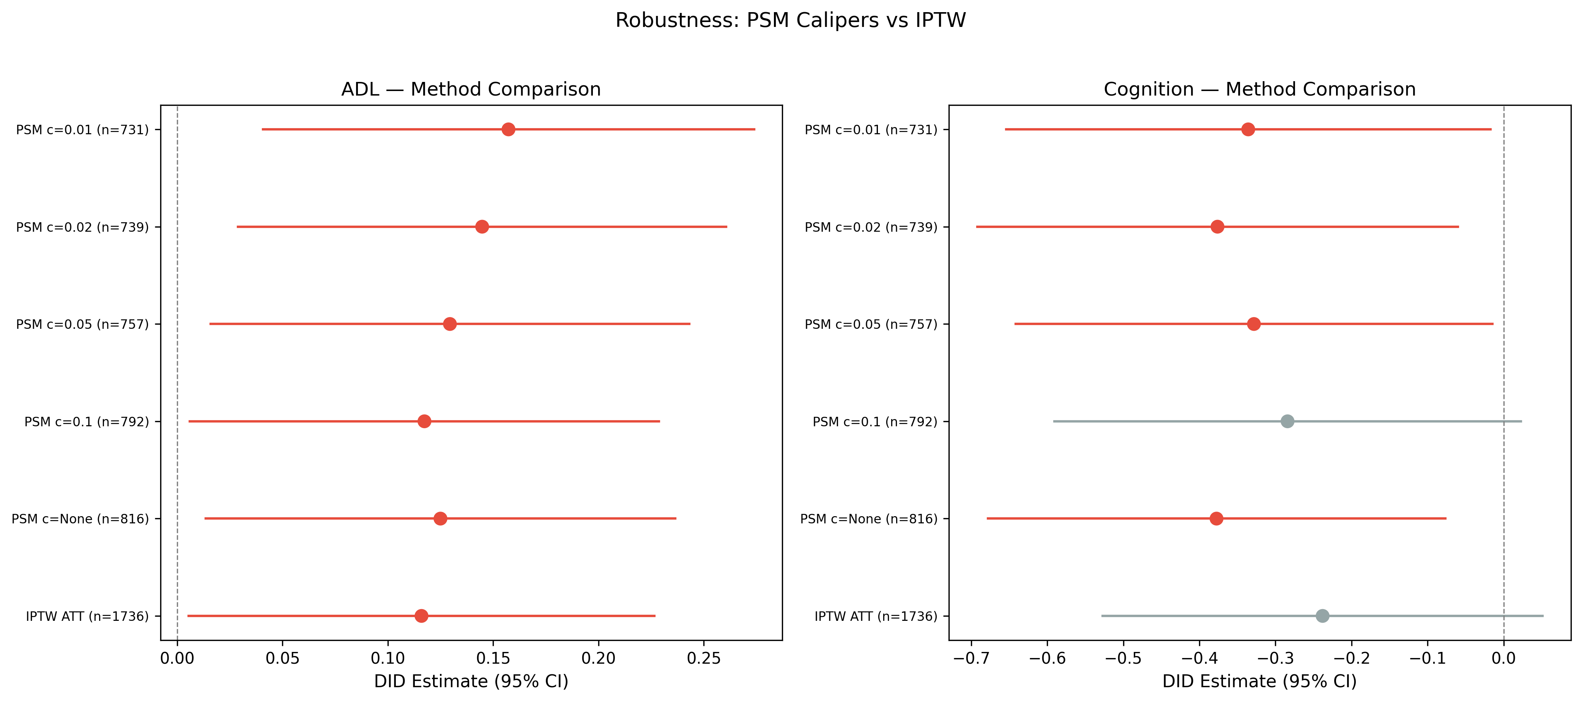
Figure S8. Method comparison forest plot. DID estimates for ADL and cognition from PSM (primary), IPTW, and unadjusted comparisons. Error bars show 95% CIs. The ADL effect was consistent across methods; the cognition effect attenuated under IPTW.

Figure S9. Subgroup DID forest plot
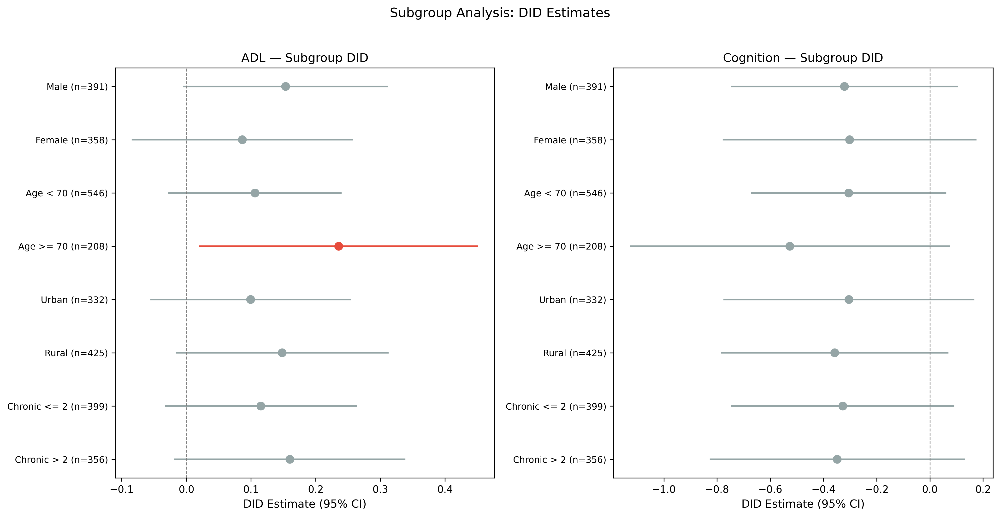
Figure S9. Subgroup DID forest plot. DID estimates for ADL and cognition stratified by sex, age (< 70 vs. ≥ 70), residence (urban vs. rural), comorbidity burden (≤ 2 vs. > 2), and trajectory class. Error bars show 95% CIs. The largest ADL effects were observed among participants aged ≥ 70.

Figure S10. Calibration curves
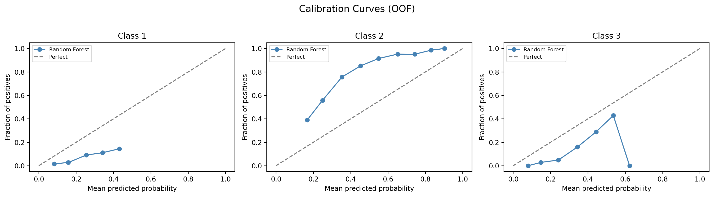
Figure S10. Calibration curves for the random forest model. Predicted probability versus observed frequency for each trajectory class. The diagonal line represents perfect calibration. The majority class (Class 2) shows adequate calibration; minority classes show expected overconfidence, consistent with class imbalance.

Figure S11. Confusion matrix
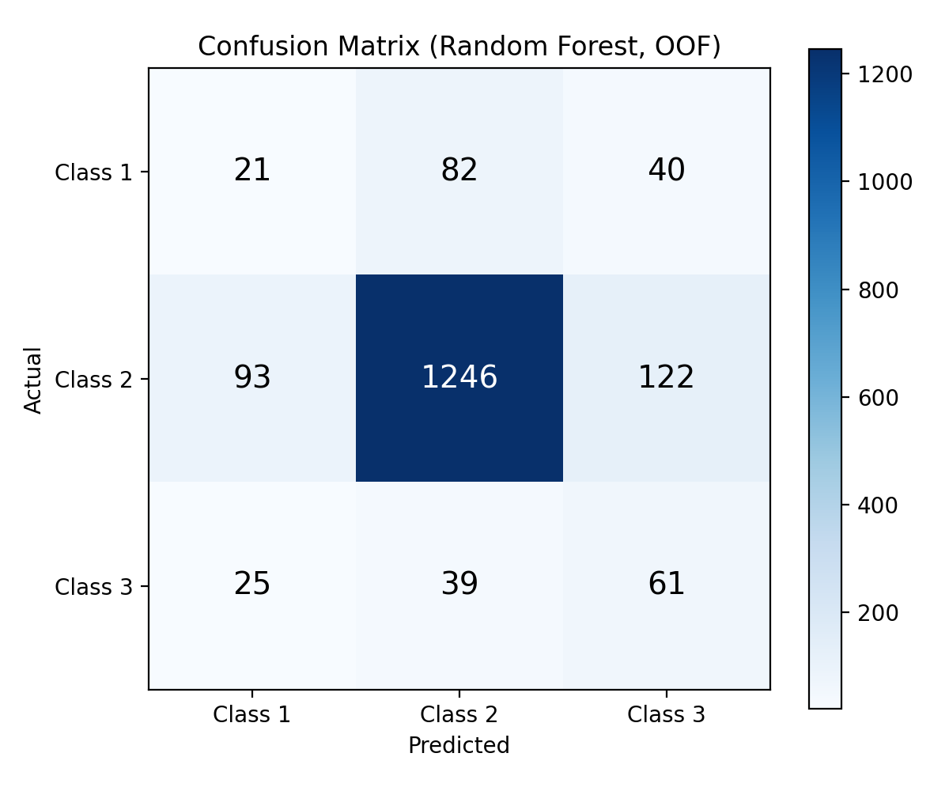
Figure S11. Confusion matrix for the random forest model (out-of-fold predictions). Rows represent true class membership; columns represent predicted class. The model achieves high accuracy for the majority class (Class 2) but lower sensitivity for minority classes.

Figure S12. Subgroup machine-learning AUC
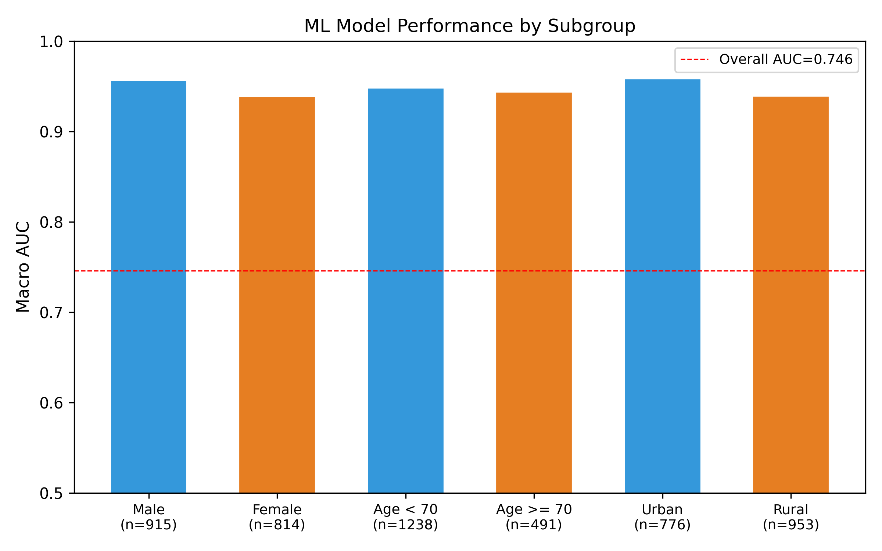
Figure S12. Subgroup machine learning AUC. Macro-averaged AUC for the random forest model across subgroups defined by sex, age, residence, and comorbidity burden. Error bars show 95% CIs from bootstrap resampling.

Figure S13. Feature ablation plot
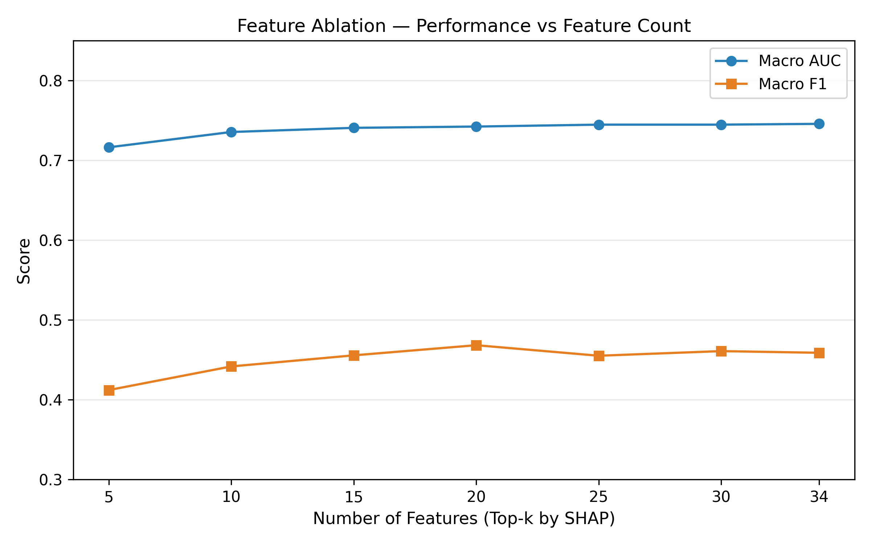
Figure S13. Feature ablation plot. Macro-averaged AUC as a function of the number of features included (top 5, 10, 15, 20, 25, 30, all 34). A parsimonious five-feature model retains 96.0% of the full model’s performance, with diminishing returns beyond 15 features.

Figure S14. HRS DID cross-validation
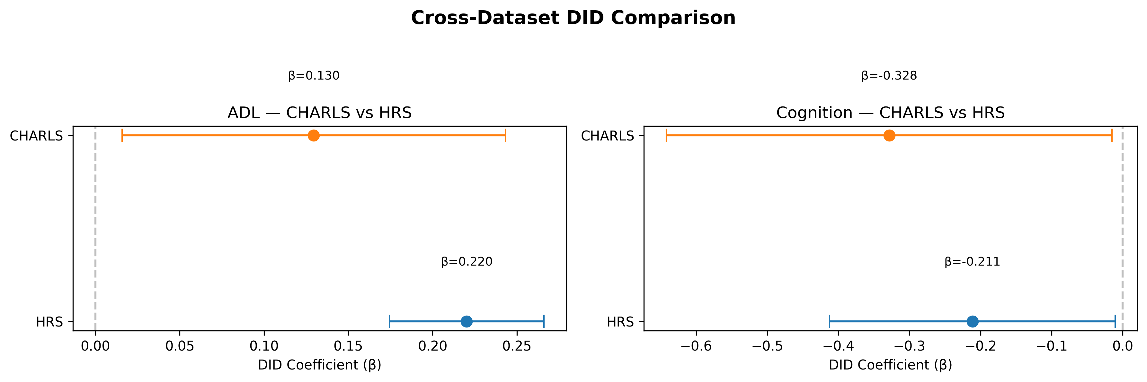
Figure S14. HRS DID cross-validation. DID estimates for ADL and cognition in the HRS cohort, replicating the CHARLS primary analysis. Error bars show 95% CIs. Both effects were significant and directionally consistent with the CHARLS findings.

