SUPPLEMENTARY FIGURES

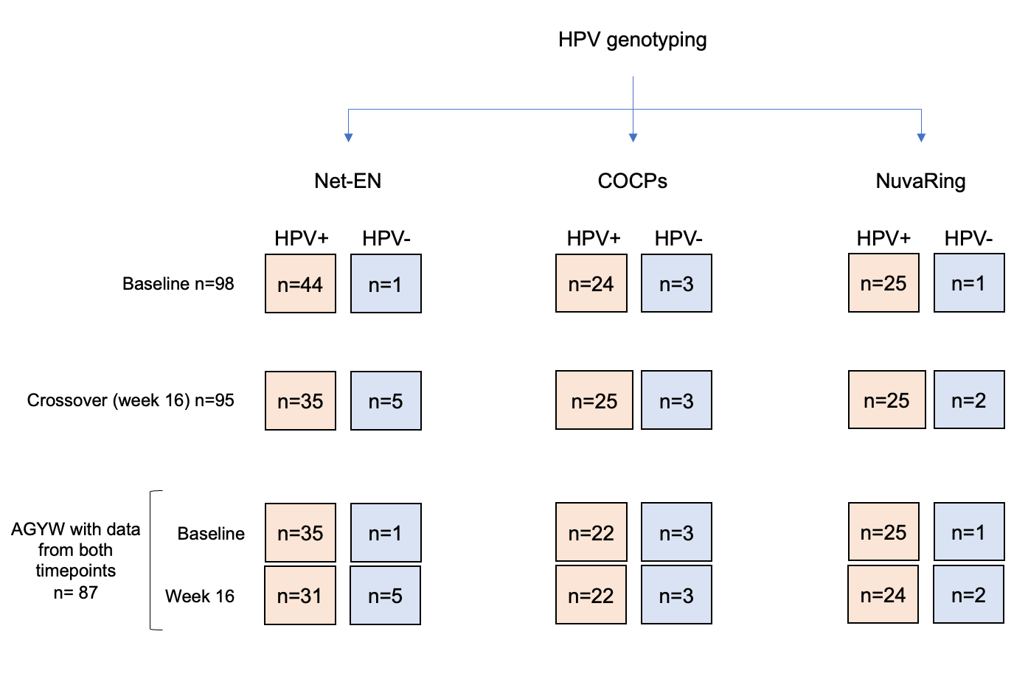
Supplemental Figure 1. Study design overview
Study design for the open-label, randomized crossover uChoose trial conducted among adolescent girls and young women (AGYW). Participants were randomized to one of three hormonal contraceptive methods: combined oral contraceptive pills (COCPs), injectable norethisterone enanthate (Net-EN), or the combined contraceptive vaginal ring (CCVR). In the parent uChoose trial, participants used an assigned hormonal contraceptive method for 16 weeks before crossing over to an alternative method, with no washout period between interventions; the primary outcomes of the parent trial were acceptability, feasibility, and adherence. The present HPV sub-study was restricted to samples collected at baseline and after the initial 16-week randomized exposure period, prior to crossover, and evaluated HPV prevalence and genotype dynamics. Accordingly, analyses presented here reflect comparisons across contraceptive methods during the first exposure period only. Numbers (n) indicate the number of participants with available and typeable HPV genotyping data for the specific outcome and time point shown; variation in n across contraceptive arms reflects missing or insufficient samples for genotyping at specific visits.

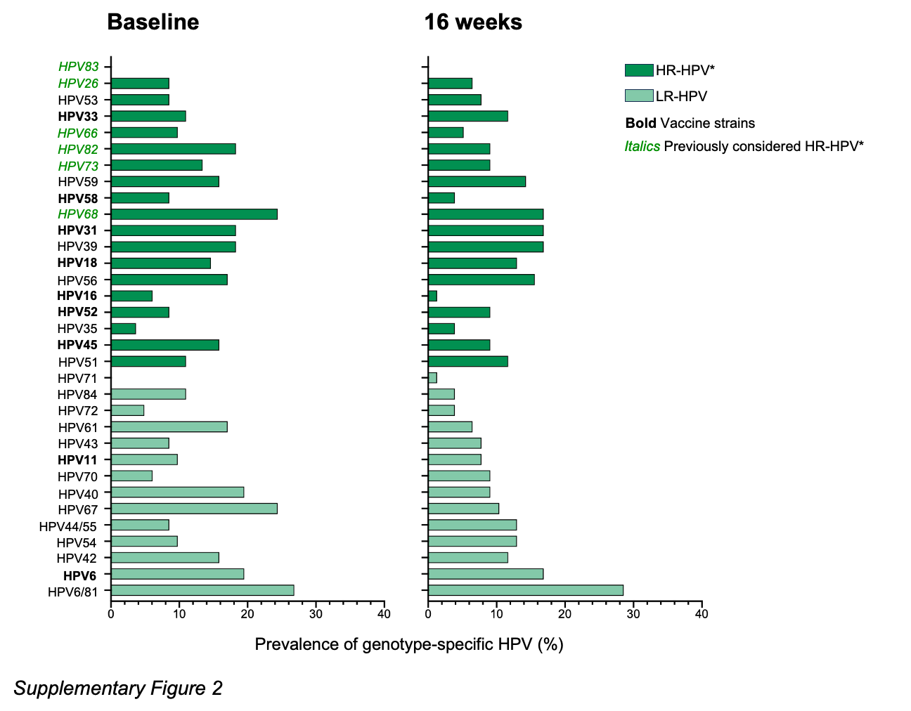
Supplementary Figure 2. Distribution of HPV genotypes at baseline and 16 weeks by randomized contraceptive arm.
Distribution of HPV genotypes among adolescent girls and young women (AGYW) at baseline and at 16 weeks, using all available samples at each time point. Each bar graph represents the prevalence of a specific HPV genotype. Light colours indicate low-risk HPV (LR-HPV) types, while dark colours represent high-risk HPV (HR-HPV) types. Genotypes no longer classified as high-risk by the International Agency for Research on Cancer (IARC) are shown in green italics. Genotypes targeted by the bivalent (HPV-16, -18), quadrivalent (HPV-6, -11, -16, -18), and nonavalent (HPV-6, -11, -16, -18, -31, -33, -45, -52, -58) vaccines are highlighted in bold. Although the parent uChoose trial employed a crossover design, the present HPV sub-study includes only data from the first randomized exposure period (baseline to 16 weeks), prior to crossover.

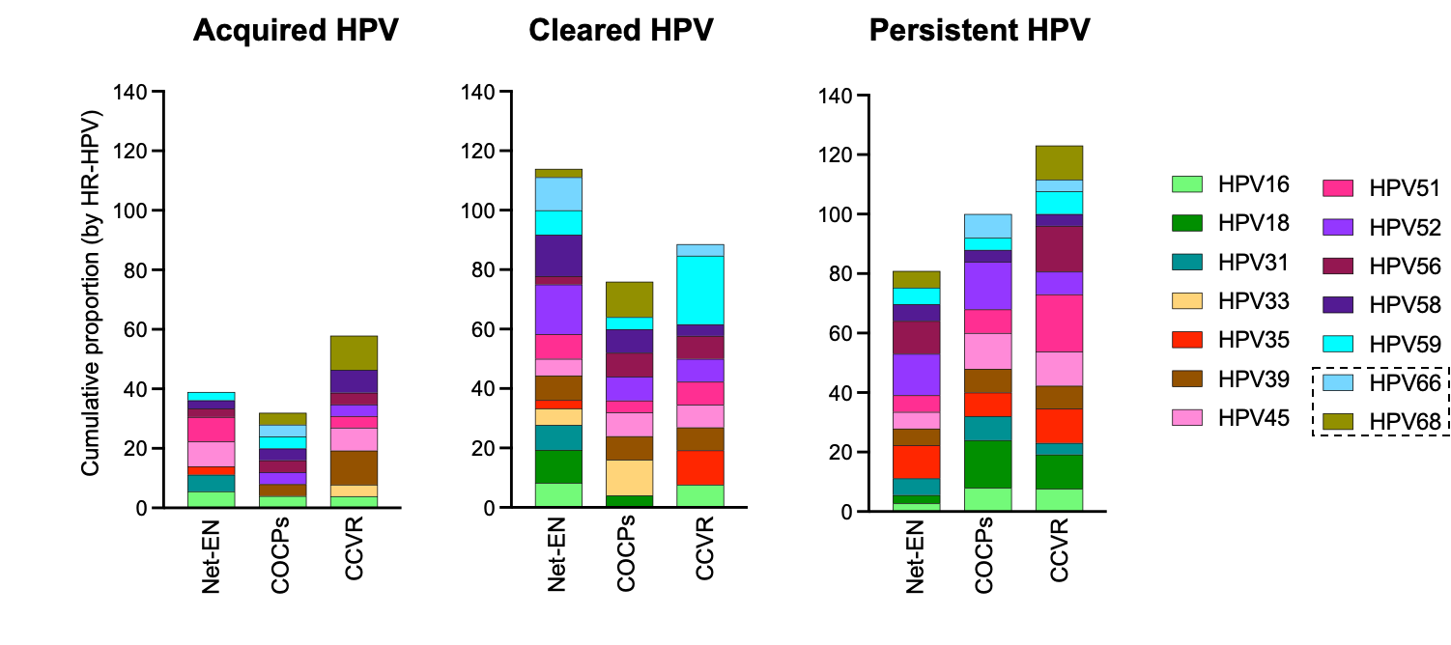
Supplementary Figure 3. HPV Genotype Distribution Across Contraceptive Arms.
Stacked bars show the prevalence of HR HPV types (including HPV-66 and -68 which were previously classified as HR) that were newly acquired between 0 and 16 weeks (left panel), cleared (middle panel), or persisted (right panel), stratified by genotype and contraceptive method, based on paired baseline and week 16 samples only. Panels represent data for Net-EN (n=36), COCPs (n=25), and CCVR (n=26), based on paired samples between baseline and week 16 visits.

