Supplementary Materials for

The Viral Respiratory Diseases of Sorok Island at Pandemic

Correspondence to: science@research.re.kr

Materials and Methods
Supplementary Text
Figs. S1 to S4
Tables S1 to S14

목차
Statistical Analysis Plan 3
Section 1. Administrative Information 4
Section 2. Introduction 5
2.1 Background and Rationale 5
2.2. Objectives 6
2.3. Statistical Principles 6
Section 3. Statistical analysis for the study 7
3.1. Study Method of Sorok Island 7
3.1.1. Trial Design of The Cohort study of Sorok Island 7
3.1.2. Complete blinded - Randomization 8
Fig. S1. The flow of Participants of Dapsone for Viral Respiratory Disease Infection in Sorok Island 9
3.1.3. Sample size and ratio 10
Table S1. T1:T2:T3:T4 study for the retrospective cohort study at Sorok Island. 10
3.1.4. Study Setting for ICD-10 code 11
Table S2. ICD-10 Study Code 11
3.1.5. Statistical framework 12
Section 4. Statistical analysis for the cohort study in the Sorok Island 13
Table S3. T1:T2:T3:T4 study for comparison analysis 13
Table S4. T1:T2:T3:T4 Study for One-Way ANOVA Calculator 14
Table S5. Post Hoc Tukey HSD 15
Table S6. T1:T2:T3:T4 study for comparison analysis for R² graph 16
Table S7. One-tailed T-Test Calculator for T1:T4 Independent Means 17
Table S8. Two-tailed T-Test Calculator for T1:T4 Independent Means 18
Fig. S2. T1:T4 Test Results 19
Table S9. One-tailed T-Test Calculator for T2:T3 Independent Means 20
Table S10. Two-tailed T-Test Calculator for T2:T3 Independent Means 21
Fig. S3. T2:T3 Test Results 22
Table S11. Treatment Study 23
Table S12. One-tailed Treatment Test Calculator for Independent Means 24
Table S13. Two-tailed Treatment Test Calculator for Independent Means 25
Table S14. Mann-Whitney U Test Calculator for Treatment Test 26
Fig. S4. Treatment Test Results 27

Statistical Analysis Plan

- Administrative Information

Funder: None
Principal Investigators: Jong-hoon Lee
Statistics Calculators of SPSS: https://www.socscistatistics.com/tests/
Contributor: Statistical responsible:

Jong-hoon Lee¹

¹Science & Research Center, Seoul National University College of Medicine, Seoul, South Korea

Section 1. Administrative Information
The Korea National Institute for Bioethics Policy (KoNIBP) approved this study to manage life-sustaining treatment properly (approval number P01-202007-22-006).
Funder: None
Principal Investigators: Jong-hoon Lee
Statistics Calculators of SPSS: https://www.socscistatistics.com/tests/

The content of this Statistical Analysis Plan meets the requirements stated by the US Food and Drug Administration and conforms to the American Statistical Association's Ethical Guidelines. This protocol was organized following guidelines proposed in:
Gamble C, Krishan A, Stocken D, Lewis S, Juszczak E, Doré C, et al. Guidelines for the Content of Statistical Analysis Plans in Clinical Trials. JAMA. 2017;318: 2337–2343. PMID: 29260229

Section 2. Introduction

2.1 Background and Rationale
Identification of safe, effective treatment for individuals with mild or moderate COVID-19 acute respiratory distress syndrome (ARDS) that prevents disease progression would reduce mortality. Dapsone is being evaluated for SARS-CoV-2 ARDS prevention and COVID-19 related diseases. Recent evidence has indicated that the broad-spectrum Dapsone may have some activity against SARS-CoV-2 inflammasome of coronaviruses. A randomized controlled trial (RCT) in intensive care unit (ICU) will demonstrate reduced viral inflammasome load among patients like Familial Mediterranean Fever (FMF) caused by homozygous or compounded heterozygous gain-of-function mutations in the Mediterranean fever gene, which encodes pyrin, an inflammasome protein It is a hereditary autoinflammatory disease that presents with recurrent febrile attacks and polyserositis. Pyrin—the protein involved in FMF—has a role in activating the proinflammatory cytokine interleukin (IL)-1β, and colchicine is the only known treatment in this disease, but nearly 5–10% of patients are resistant to colchicine. In five of ten patients prescribed with DDS, FMF attacks did not occur during at least six months (mean, eight months and six days) with colchicine efficacy of 80% and 50% response. Thus, DDS may be helpful as an alternative therapy in some, especially colchicine resistant patients.
The Sorokdo National Hospital is responsible for the treatment of respiratory infectious diseases and has reported no prevalence of each pandemic of SARS-CoV (2002), influenza A virus subtype H1N1 (2009), MERS (2015), or SARS-CoV-2 (2020). Furthermore, the Sorokdo National Hospital reported a relationship between Dapsone and AD in Sorok Island from January 2020 to June 2021. Under the Information Disclosure Act, the National Sorokdo Hospital responded as follows in the response form to the request for information disclosure on April 15 2021—7767726:

"Regarding the "COVID-19 infection status among Hansen people of Sorokdo National Hospital" requested by the claimant (Number-7767726-2021/4/15), we will respond as follows: We are pleased to inform you that there are no patients infected with COVID-19 among Hansen Disease patients at National Sorokdo Hospital".
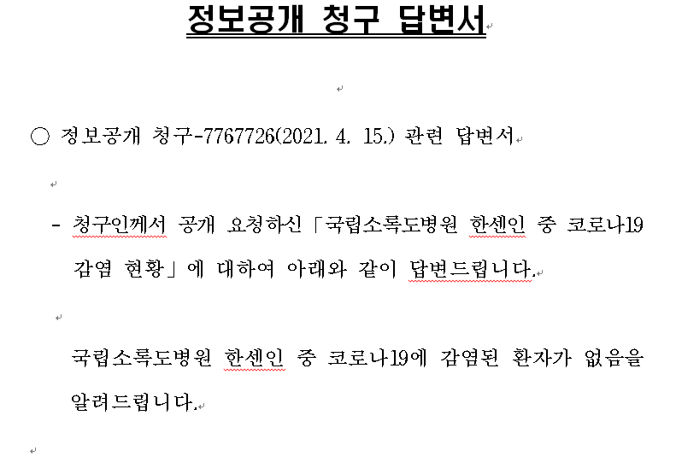

2.2. Objectives
To study the targeting of Nod-like receptor family pyrin domain-containing 3 (NLRP3) itself or up-/downstream factors of the NLRP3 inflammasome by Dapsone should be responsible for its observed preventive treatment effects, functioning as a competitor.

2.3. Statistical Principles
2.3.1. Confidence intervals and P-values
The trial will report 95% confidence intervals and permutation P-values estimated from the primary analysis.
2.3.2. Protocol deviations
The analysis population will be an intention to treat and will include all participants enrolled and randomized. Adherence to the protocol will be determined during the cross-sectional assessment based on patient reports of whether they took the medication by the trial. At that time, the trial will assess whether patients have taken other medication during the study period, including Dapsone or other medicines not provided by the trial. Patients who take Dapsone not provided by the study will be considered protocol deviations but will be included according to the randomized group in the intention-to-treat analysis.

Section 3. Study of DDS group
  - Study Method of Sorok Island
    - Trial Design of The Cohort study of Sorok Island
The Sorok island as a Japanese leper colony was established in May 1916 to quarantine leprosy patients. During the colonial period, the notorious expansion project for the Sorok Leprosarium was supposed from 1933 to 1941 because of its supposed competition with the Culion Leprosarium in the American –Occupied Philippines. The public health report filed on June 4, 1946, succinctly stated that they would increase the capacity of Sorokdo Leper Colony to 8,000 – 9,000 and make it the largest leprosarium in the world (1, 2). However, it was not easy for those patients to see a doctor. So they self-administer a prescribed medication steadily. Finally, the missionaries went to Sorok Island to care for the leprosy patients. This study is a cohort study with a history of more than 100 years. This study analyzed the medical records of Sorokdo National Hospital from 2005 to 2020. Sister M. Stoeger and Sister M. Pissarek cared for the patients for forty years(3). So we regarded those as a kind of control group initiated from 1962 to 2005. After graduating from the University of Innsbruck Nursing School in Tyrol, Western Austria, Sister Marianne Stoeger, who worked at a hospital in Innsbruck, joined Sorok Island in February 1962. Sister Margaritha Pissarek entered Sorok Island in October 1967. They left Sorok island on November 21, 2005.
After President Dae-Jung Kim came to power in 1998, Hansen’s disease (HD) patients were given freedom. Many were devout Christians, but respiratory infectious diseases increased in a typical rural village as more and more became smokers. Sorok Island has become a tourist destination, and patients have come and gone freely. Medical data on the correlation between DDS and respiratory diseases were then analyzed, but SARS-CoV (2002), Influenza A virus subtype H1N1 (2009), MERS (2015), and SARS-CoV-2 (2020) have not occurred. International Classification of Diseases (ICD) codes of respiratory infectious diseases (RIS) are J00 (acute nasopharyngitis), J01 (acute sinusitis), J01.8 (other acute sinusitis), J02 (acute pharyngitis), J02.9 (acute pharyngitis, unspecified), J03 (acute tonsillitis), J03.0 (streptococcal tonsillitis), J03.9 (acute tonsillitis, unspecified), J04.0 (acute laryngitis), J06.0 (acute laryngopharyngitis), J06.9 (acute upper respiratory infection, unspecified), J09 (Influenza due to identified zoonotic or pandemic influenza virus), J10.8 (Influenza with other manifestations, seasonal influenza virus identified), J12.9 (viral pneumonia, unspecified), J15.8 (other bacterial pneumonia), J15.9 (bacterial pneumonia, unspecified), J18.0 (bronchopneumonia, unspecified), J18.9 (pneumonia, unspecified), J20.9 (acute bronchitis, unspecified), J31 (chronic rhinitis, nasopharyngitis and pharyngitis), J31.0 (chronic rhinitis), J31.1 (chronic nasopharyngitis), J31.2 (chronic pharyngitis), J32 (chronic sinusitis), J32.4 (chronic pansinusitis), J32.8 (other chronic sinusitis), J35. 0 (chronic tonsillitis), and J37.0 (chronic laryngitis)(4).
So, we connected to the EMR database of the Sorokdo National Hospital, archived from January 2005 to June 2019, and searched the ICD-9 and -10 codes of viral respiratory diseases (VRD) with DDS.

    - Complete blinded - Randomization
South Korea declared war against dementia in 2008 and prepared a National Dementia Plan every five years. The Korean National Assembly unanimously passed the Dementia Management Act' in 2011 and was enacted to diagnose and treat all Hansen subjects for Alzheimer's disease without exception(5). However, medical staff treated HD patients with VRD, while no one knew about dapson's relationship with viral inflammasomes. Therefore, all were in complete-blinded states. Participants were randomized in a 1:1 ratio to DDS prescribed (+) group or matching DDS unprescribed (-) control group. Randomization was unrestricted (no blocking or stratification), and the study's data team analyzed the ICD codes in EMR databases of Sorokdo National Hospital. According to the Dementia Management Act, the medical staff of Sorokdo National Hospital started a full investigation in 2011 for the treatment of dementia for all HD patients in Sorok Island. As a result, an anti-Alzheimer's disease drug was prescribed for Hansen subjects diagnosed with dementia, and doctors stopped prescribing Dapsone for inactive HD patients. They have followed up for all HD patients from 2011. Dementia Management Act administered Dapsone to the trial group if we classified Dapsone unprescribed subjects as the control group.

Fig. S1. The flow of Participants of Dapsone for Viral Respiratory Disease Infection in Sorok Island
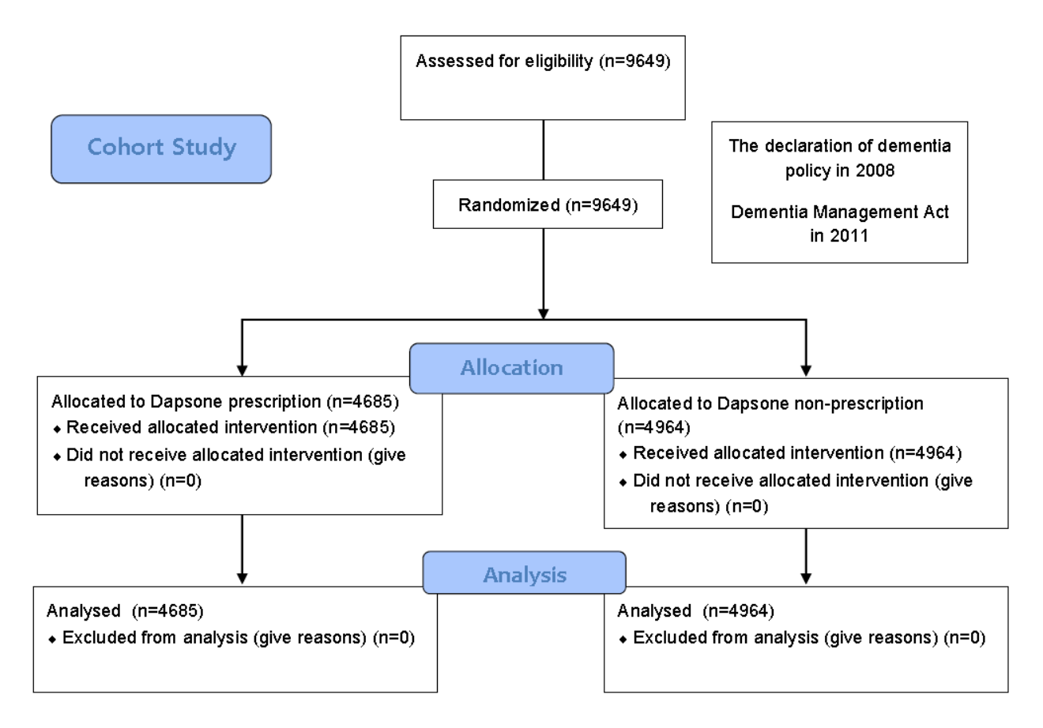

    - Sample size and ratio

A total of 9649 participants were enrolled, of whom 4685 were randomized to dapsone prescription (DDS(+)) group and 4964 to Dapsone nonprescription (DDS(-)) group: 6983 viral respiratory disease (VRD) diagnosed (+) group and 2666 VRD undiagnosed (-) group, from 2005 to 2020 in Sorok Island.

Table S1. T1:T2:T3:T4 study for the retrospective cohort study at Sorok Island.
Year | T1:DDS(+):VRD(+)/Total | T2:DDS(-)VRD(+)/Total | T3:DDS(+):VRD(-)/Total | T4:DDS(-):VRD(-)/Total
2005 | 0.1989 | 0.1694 | 0.3132 | 0.3185
2006 | 0.2299 | 0.2036 | 0.3283 | 0.2382
2007 | 0.2355 | 0.2078 | 0.3490 | 0.2078
2008 | 0.2949 | 0.2821 | 0.3120 | 0.1111
2009 | 0.3323 | 0.3084 | 0.2934 | 0.0659
2010 | 0.3047 | 0.3635 | 0.2805 | 0.0513
2011 | 0.3125 | 0.3704 | 0.2591 | 0.0579
2012 | 0.3629 | 0.3966 | 0.1577 | 0.0827
2013 | 0.4145 | 0.5501 | 0.0123 | 0.0231
2014 | 0.3788 | 0.5811 | 0.0096 | 0.0305
2015 | 0.3765 | 0.5771 | 0.0116 | 0.0348
2016 | 0.3503 | 0.5804 | 0.0068 | 0.0626
2017 | 0.3428 | 0.5826 | 0.0249 | 0.0497
2018 | 0.3201 | 0.5899 | 0.0270 | 0.0629
2019 | 0.2903 | 0.6086 | 0.0243 | 0.0768

    - Study Setting for ICD-10 code

Table S2. ICD-10 Study Code
Study Code | description
J00 Acute nasopharyngitis [common cold]
J01 Acute sinusitis
J01.8 Other acute sinusitis | Acute sinusitis involving more than one sinus but not pansinusitis
J02 Acute pharyngitis
J02.9 Acute pharyngitis, unspecified | Pharyngitis (acute):  - NOS  - gangrenous  - infective NOS  - suppurative  - ulcerative  Sore throat (acute) NOS
J03 Acute tonsillitis
J03.9 Acute tonsillitis, unspecified | Tonsillitis (acute):  - NOS  - follicular  - gangrenous  - infective  - ulcerative
J04.0 Acute laryngitis | Laryngitis (acute):  - NOS  - oedematous  - subglottic  - suppurative  - ulcerative  Excl.: chronic laryngitis (J37.0)  influenzal laryngitis, influenza virus:  - identified (J09, J10.1)  - not identified (J11.1)
J06.0 Acute laryngopharyngitis
J06.9 Acute upper respiratory infection, unspecified | Upper respiratory:  - disease, acute  - infection NOS
J09 Influenza due to identified zoonotic or pandemic influenza virus
J10.8 Influenza with other manifestations, seasonal influenza virus identified | Encephalopathy due to influenza  Influenzal: seasonal influenza virus identified  - gastroenteritis  - myocarditis (acute)
J12.9 Viral pneumonia, unspecified
J20.9 Acute bronchitis, unspecified
(https://icd.who.int/browse10/2019/en#/J20-J22)
'J00', 'J01', 'J01.81', 'J02', 'J02.9', 'J03', 'J03.9', 'J04.0', 'J06.0', 'J06.9', 'J09', 'J10.8', 'J12.9', 'J20.9'

(The Korea National Institute for Bioethics Policy (KoNIBP) approved this study to manage life-sustaining treatment properly (approval number P01-202007-22-006). The KoNIBP approved the observational study of patients ethically based on FDA guidelines following the World Medical Association Declaration of Helsinki. Therefore, we carried out all methods following relevant ethical guidelines, regulations and reported the study results. Sorokdo National Hospital obtained informed consent from all participants or under 18 from a parent or legal guardian.)

    - Statistical framework
We used the software programs Object-Relational DBMS, Google spreadsheet with SPSS. T-Test, the Mann-Whitney U Test, One-Way Repeated Measures ANOVA Calculator and Post Hoc Tukey honestly significant difference (HSD) were applied. A significant T-test was performed among the each group of T1: DDS(+)/VRD(+), T2: DDS(-)/VRD(+), T3: DDS(+)/VRD(-), T4: DDS(-)/VRD(-).

Section 4. Statistical analysis for the cohort study in the Sorok Island

Table S3. T1:T2:T3:T4 study for comparison analysis
Year | T1 | T2 | T3 | T4 | Sum | Mean | SD | 95% CI | [CI | CI]
2005 | 148 | 126 | 233 | 237 | 744 | 235 | 2.83 | 0.20 | 234.80 | 237.83
2006 | 166 | 147 | 237 | 172 | 722 | 204.5 | 45.96 | 3.36 | 201.14 | 250.46
2007 | 170 | 150 | 252 | 150 | 722 | 201 | 72.12 | 5.27 | 195.73 | 273.12
2008 | 207 | 198 | 219 | 78 | 744 | 148.5 | 99.70 | 895.79 | -747.29 | 248.20
2009 | 222 | 206 | 196 | 44 | 722 | 110 | 107.48 | 965.67 | -855.67 | 217.48
2010 | 202 | 241 | 186 | 34 | 722 | 104 | 93.34 | 838.61 | -734.61 | 197.34
2011 | 205 | 243 | 170 | 38 | 702 | 78.5 | 93.34 | 838.61 | -760.11 | 171.84
2012 | 237 | 259 | 103 | 54 | 668 | 78.5 | 34.65 | 311.30 | -232.80 | 113.15
2013 | 269 | 357 | 8 | 15 | 663 | 11.5 | 4.95 | 44.47 | -32.97 | 16.45
2014 | 236 | 362 | 6 | 19 | 656 | 12.5 | 9.19 | 82.59 | -70.09 | 21.69
2015 | 227 | 348 | 7 | 21 | 653 | 14 | 9.90 | 88.94 | -74.94 | 23.90
2016 | 207 | 343 | 4 | 37 | 649 | 20.5 | 23.33 | 209.65 | -189.15 | 43.83
2017 | 193 | 328 | 14 | 28 | 623 | 21 | 9.90 | 88.94 | -67.94 | 30.90
2018 | 178 | 328 | 15 | 35 | 603 | 25 | 14.14 | 127.06 | -102.06 | 39.14
2019 | 155 | 325 | 13 | 41 | 591 | 27 | 19.80 | 177.89 | -150.89 | 46.80
Sum | 3022 | 3961 | 1663 | 1003
Mean | 201 | 264 | 111 | 67
SD | 34 | 84 | 104 | 66
95% CI | 1 | 3 | 5 | 4
[ | 200 | 261 | 106 | 63
] | 203 | 267 | 116 | 71
The chi-square is 281.826.
The p value is < 0.00001. I t is significant at p < .05.

Table S4. T1:T2:T3:T4 Study for One-Way ANOVA Calculator
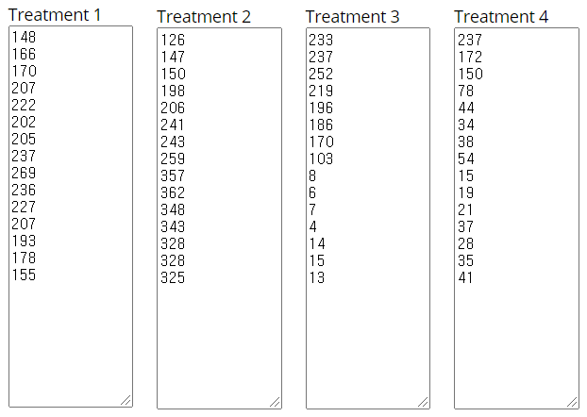
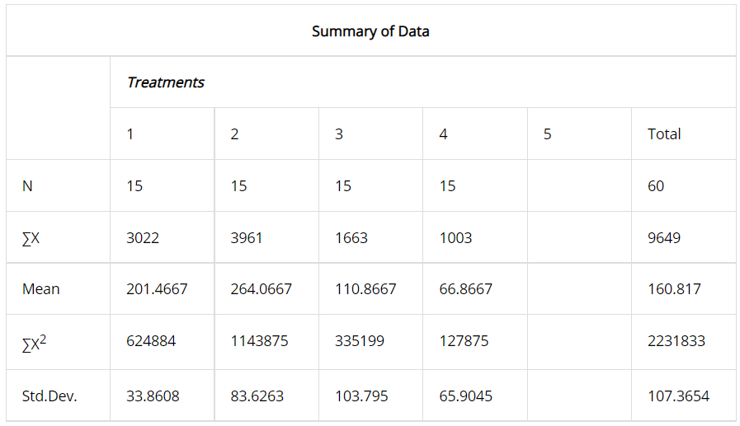

Source | SS | df | MS
Between-treatments | 354518.85 | 3 | 118172.95 | F = 20.32495
Within-treatments | 325594.1333 | 56 | 5814.181
Total | 680112.9833 | 59
Including Tukey HSD
The f-ratio value is 20.32495. The p-value is < .00001. The result is significant at p < .05.

Table S5. Post Hoc Tukey HSD

Pairwise Comparisons |  | HSD_{.05} = 73.7252  HSD_{.01} = 90.7335 | Q_{.05} = 3.7447 Q_{.01} = 4.6086
T₁:T₂ | M₁ = 201.47  M₂ = 264.07 | 62.60 | Q = 3.18 (p = .12292)
T₁:T₃ | M₁ = 201.47  M₃ = 110.87 | 90.60 | Q = 4.60 (p = .01014)
T₁:T₄ | M₁ = 201.47  M₄ = 66.87 | 134.60 | Q = 6.84 (p = .00006)
T₂:T₃ | M₂ = 264.07  M₃ = 110.87 | 153.20 | Q = 7.78 (p = .00001)
T₂:T₄ | M₂ = 264.07  M₄ = 66.87 | 197.20 | Q = 10.02 (p = .00000)
T₃:T₄ | M₃ = 110.87  M₄ = 66.87 | 44.00 | Q = 2.23 (p = .39798)

Table S6. T1:T2:T3:T4 study for comparison analysis for R² graph

Year | T1:DDS(+):VRD(+)/Total | T2:DDS(-)VRD(+)/Total | T3:DDS(+):VRD(-)/Total | T4:DDS(-):VRD(-)/Total
2005 | 0.1989 | 0.1694 | 0.3132 | 0.3185
2006 | 0.2299 | 0.2036 | 0.3283 | 0.2382
2007 | 0.2355 | 0.2078 | 0.3490 | 0.2078
2008 | 0.2949 | 0.2821 | 0.3120 | 0.1111
2009 | 0.3323 | 0.3084 | 0.2934 | 0.0659
2010 | 0.3047 | 0.3635 | 0.2805 | 0.0513
2011 | 0.3125 | 0.3704 | 0.2591 | 0.0579
2012 | 0.3629 | 0.3966 | 0.1577 | 0.0827
2013 | 0.4145 | 0.5501 | 0.0123 | 0.0231
2014 | 0.3788 | 0.5811 | 0.0096 | 0.0305
2015 | 0.3765 | 0.5771 | 0.0116 | 0.0348
2016 | 0.3503 | 0.5804 | 0.0068 | 0.0626
2017 | 0.3428 | 0.5826 | 0.0249 | 0.0497
2018 | 0.3201 | 0.5899 | 0.0270 | 0.0629
2019 | 0.2903 | 0.6086 | 0.0243 | 0.0768

Table S7. One-tailed T-Test Calculator for T1:T4 Independent Means
The t-value is 7.03568. The p-value is < .00001. The result is significant at p < .05.
Significance Level: 0.05

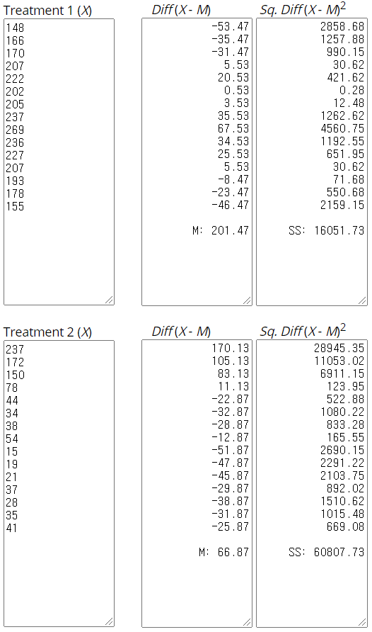 | 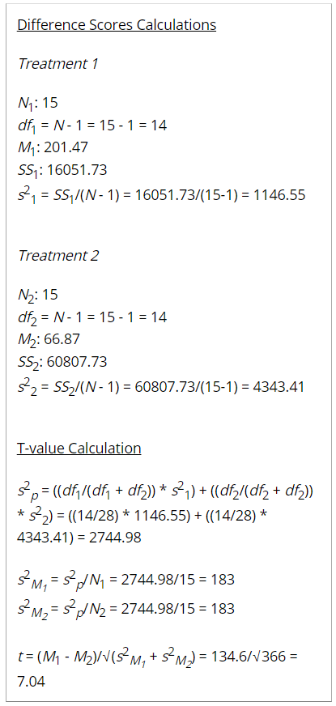

Table S8. Two-tailed T-Test Calculator for T1:T4 Independent Means
The t-value is 7.03568. The p-value is < .00001. The result is significant at p < .05.
Significance Level: 0.05

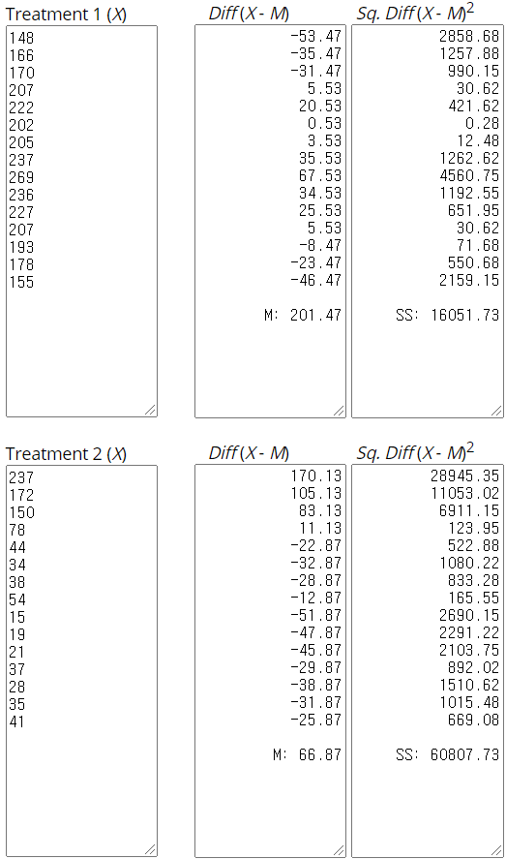 | 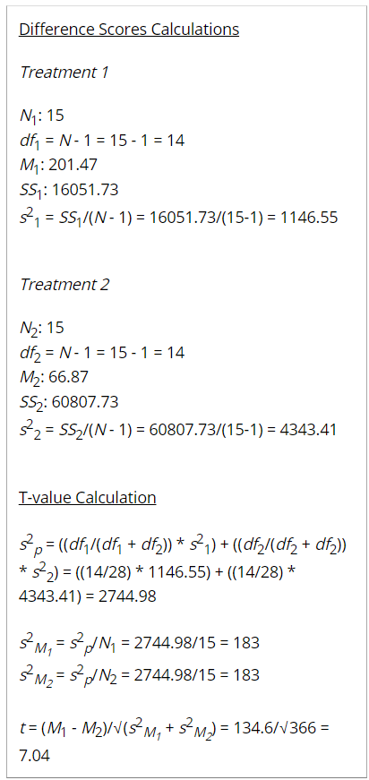

Fig. S2. T1:T4 Test Results
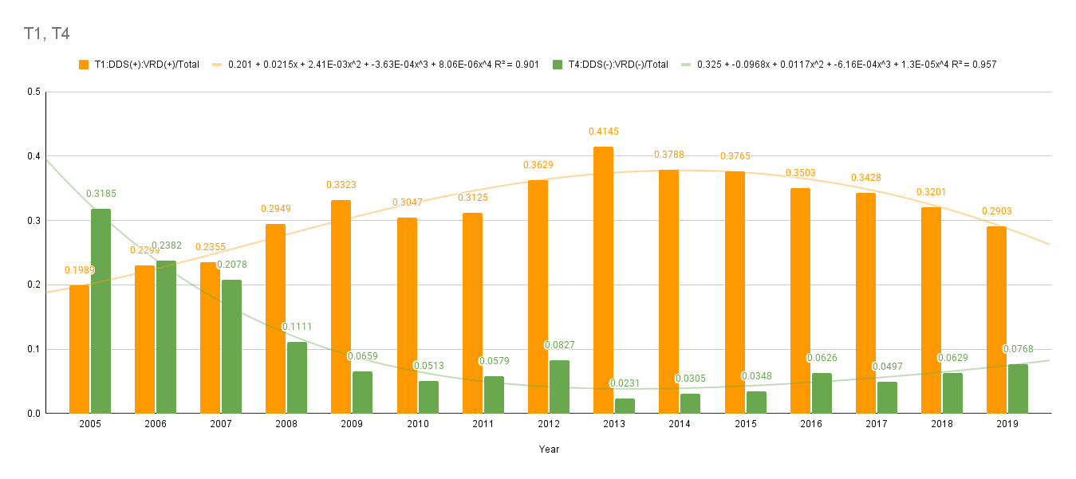
One is DDS (+) with VRD (+) subgroup, and the other is DDS (-) VRD (-). The 3022 participants (T1) who received the dapsone intervention (M = 201, SD = 34) compared to the 1003 participants (T4) in the control group (M = 67, SD = 66) demonstrated significantly better peak flow scores, t(28) = 7.0, p < .00001.

Table S9. One-tailed T-Test Calculator for T2:T3 Independent Means
The t-value is 4.45144. The p-value is .000062. The result is significant at p < .05.
Significance Level: 0.05

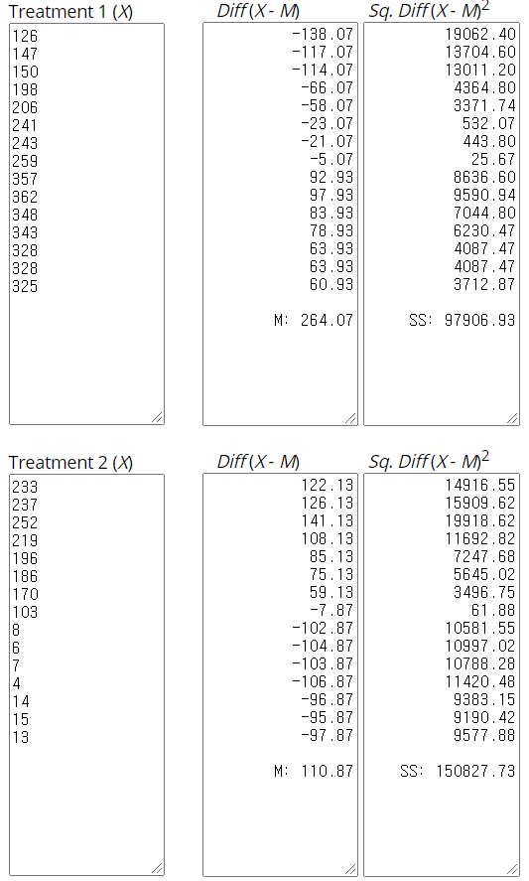 | 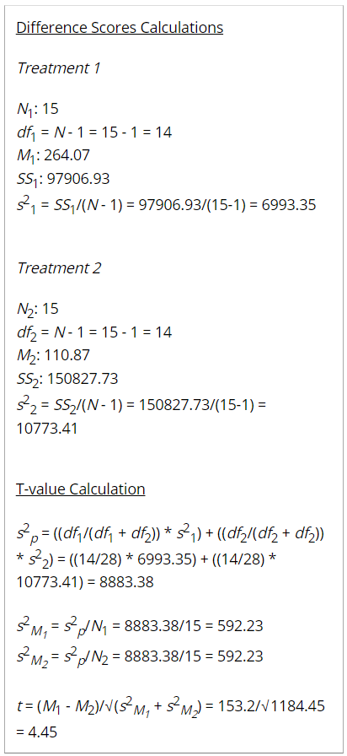

Table S10. Two-tailed T-Test Calculator for T2:T3 Independent Means
The t-value is 4.45144. The p-value is .000124. The result is significant at p < .05.
Significance Level: 0.05

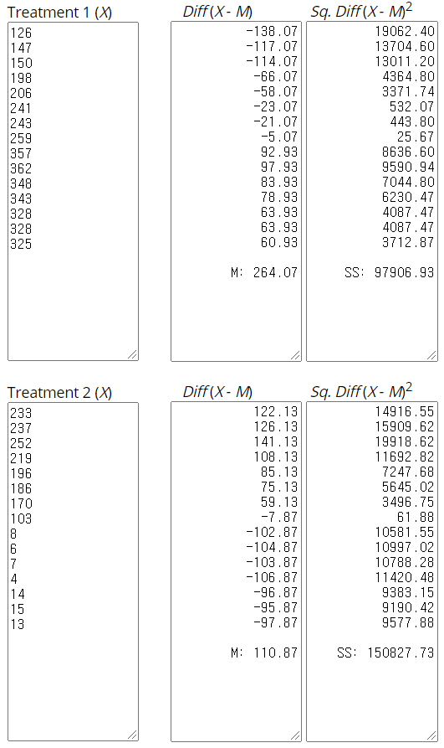 | 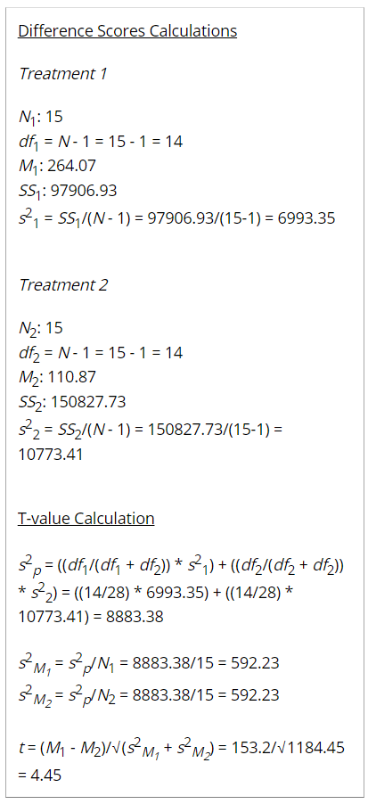

Fig. S3. T2:T3 Test Results
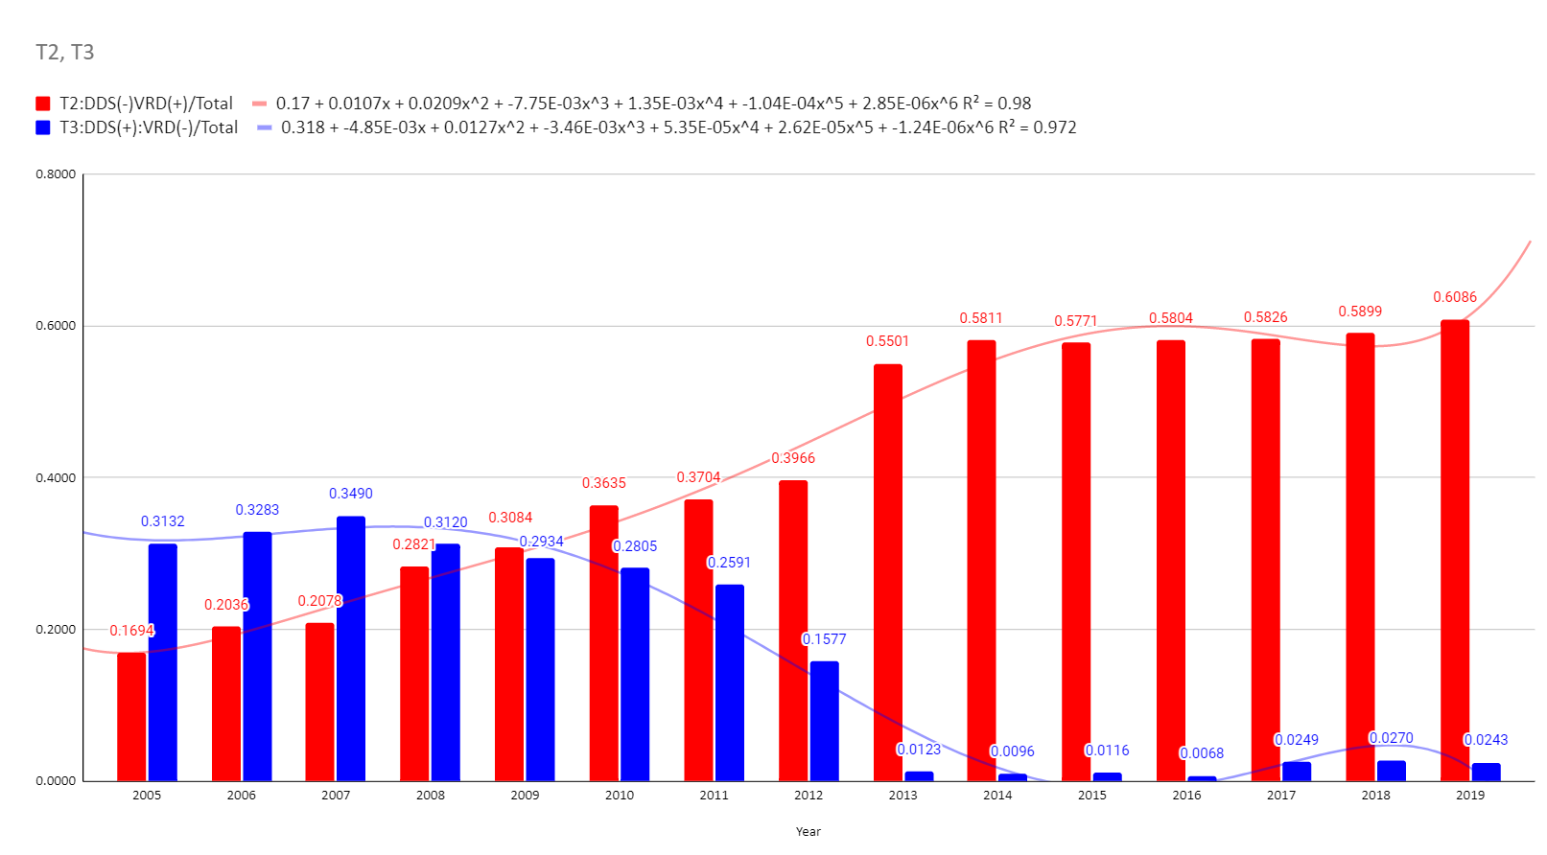
One is DDS (-) with VRD (+) subgroup, and the other is DDS (+) VRD (-). The 3961 participants (T2) who received the dapsone intervention (M = 264, SD = 84) compared to the 1663 participants (T3) in the control group (M = 111, SD = 104) demonstrated significantly better peak flow scores, t(28) = 4.5, p < .0001. HD patients with prescribed dapsone have a very low prevalence of VRD.

Table S11. Treatment Study
Year | DDS (+) TOTAL | DDS (-) TOTAL | ALL | DDS(+)-VRD(+) | DDS(-)-VRD(+) | Sum | Mean | SD | 95% CI | [CI | CI]
2005 | 381 | 363 | 744 | 148 | 126 | 274 | 137 | 15.56 | 1.85 | 135.15 | 152.56
2006 | 403 | 319 | 722 | 166 | 147 | 313 | 156.5 | 13.44 | 1.49 | 155.01 | 169.94
2007 | 422 | 300 | 722 | 170 | 150 | 320 | 160 | 14.14 | 1.56 | 158.44 | 174.14
2008 | 426 | 276 | 702 | 207 | 198 | 405 | 202.5 | 6.36 | 0.62 | 201.88 | 208.86
2009 | 418 | 250 | 668 | 222 | 206 | 428 | 214 | 11.31 | 1.07 | 212.93 | 225.31
2010 | 388 | 275 | 663 | 202 | 241 | 443 | 221.5 | 27.58 | 2.58 | 218.92 | 249.08
2011 | 375 | 281 | 656 | 205 | 243 | 448 | 224 | 26.87 | 2.49 | 221.51 | 250.87
2012 | 340 | 313 | 653 | 237 | 259 | 496 | 248 | 15.56 | 1.37 | 246.63 | 263.56
2013 | 277 | 372 | 649 | 269 | 357 | 626 | 313 | 62.23 | 4.88 | 308.12 | 375.23
2014 | 242 | 381 | 623 | 236 | 362 | 598 | 299 | 89.10 | 7.16 | 291.84 | 388.10
2015 | 234 | 369 | 603 | 227 | 348 | 575 | 287.5 | 85.56 | 7.01 | 280.49 | 373.06
2016 | 211 | 380 | 591 | 207 | 343 | 550 | 275 | 96.17 | 8.05 | 266.95 | 371.17
2017 | 207 | 356 | 563 | 193 | 328 | 521 | 260.5 | 95.46 | 8.22 | 252.28 | 355.96
2018 | 193 | 363 | 556 | 178 | 328 | 506 | 253 | 106.07 | 9.26 | 243.74 | 359.07
2019 | 168 | 366 | 534 | 155 | 325 | 480 | 240 | 120.21 | 10.78 | 229.22 | 360.21
Sum | 4685 | 4964 | 9649 | 3022 | 3961 | 6983
Mean | 312.33 | 330.93 | 643.27 | 201.47 | 264.07 | 436.44
SD | 95.71 | 45.18 | 64.39 | 33.86 | 83.63 | 154.59
95% CI | 2.74 | 1.26 | 1.28 | 1.21 | 2.61 | 3.63
[CI | 309.59 | 329.68 | 641.98 | 200.26 | 261.46 | 432.81
CI] | 315.07 | 332.19 | 644.55 | 202.67 | 266.67 | 440.06

Table S12. One-tailed Treatment Test Calculator for Independent Means
The t-value is -2.68726. The p-value is .005993. The result is significant at p < .05.
Significance Level: 0.05

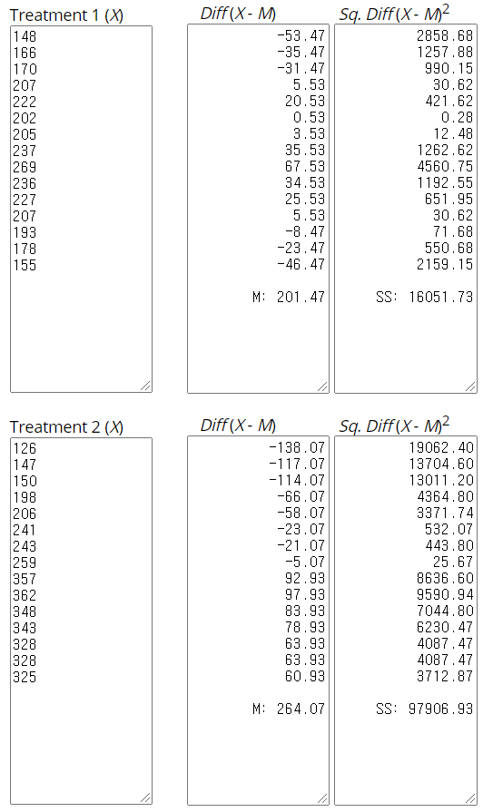 | 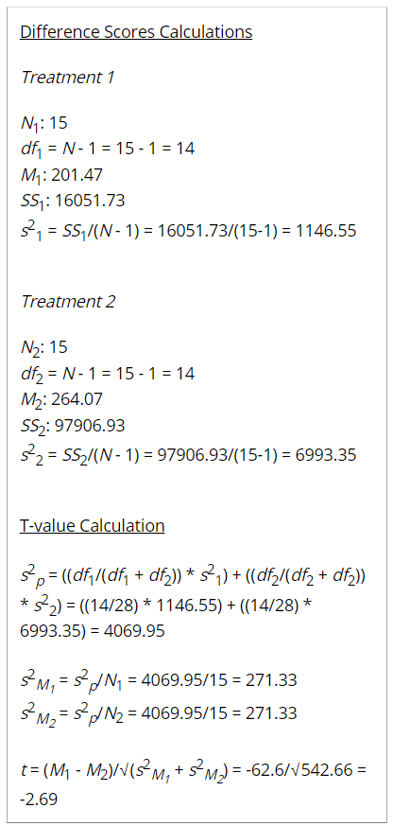

Table S13. Two-tailed Treatment Test Calculator for Independent Means
The t-value is -2.68726. The p-value is .011985. The result is significant at p < .05.
Significance Level: 0.05

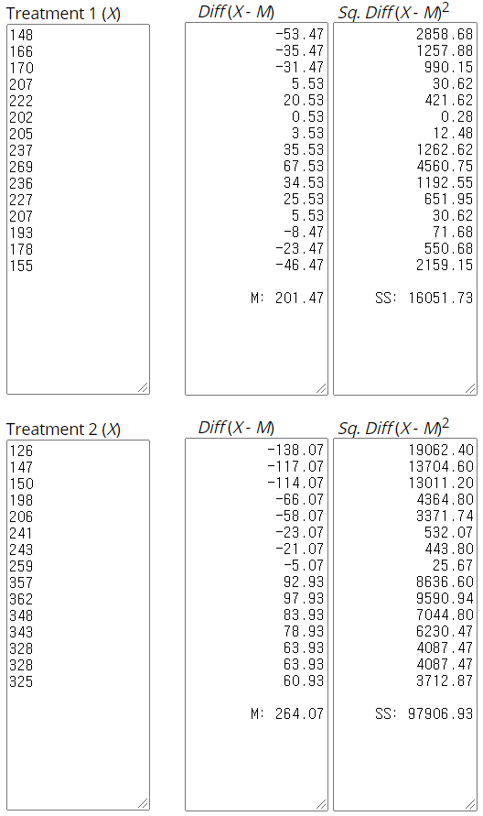 | 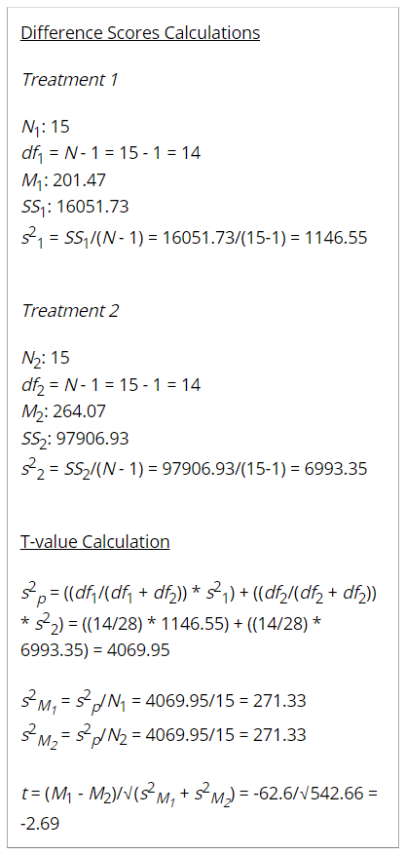

Table S14. Mann-Whitney U Test Calculator for Treatment Test

Result 1 - U-value
The U-value is 63. The critical value of U at p < .05 is 64. Therefore, the result is significant at p < .05.
Result 2 - Z-ratio
The Z-Score is -2.03243. The p-value is .04236. The result is significant at p < .05.

Significance Level: 0.05
Two-tailed
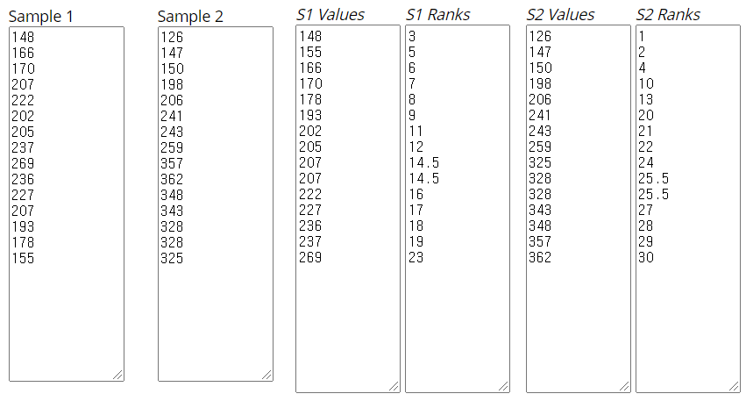 | 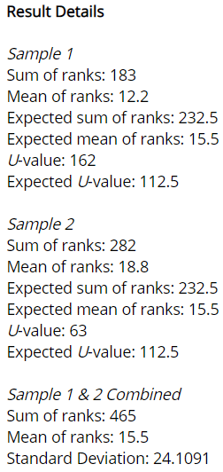

Result 1 - U-value
The U-value is 63. The critical value of U at p < .05 is 72. Therefore, the result is significant at p < .05.
Result 2 - Z-ratio
The Z-Score is -2.03243. The p-value is .02118. The result is significant at p < .05.

Significance Level: 0.05
One-tailed
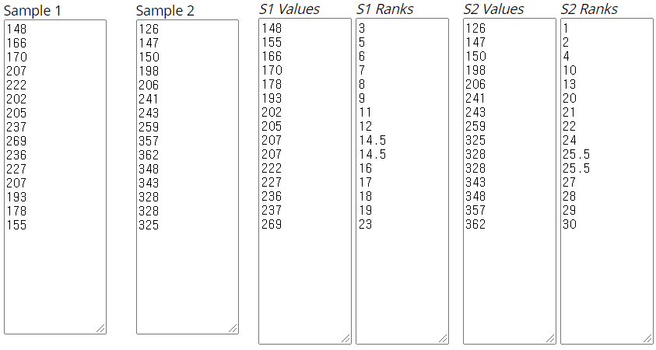 | 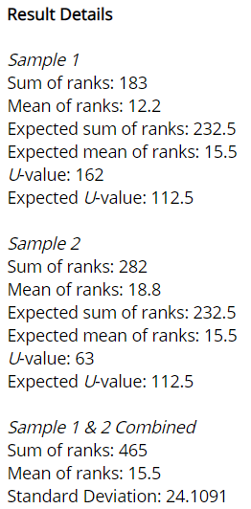

Fig. S4. Treatment Test Results

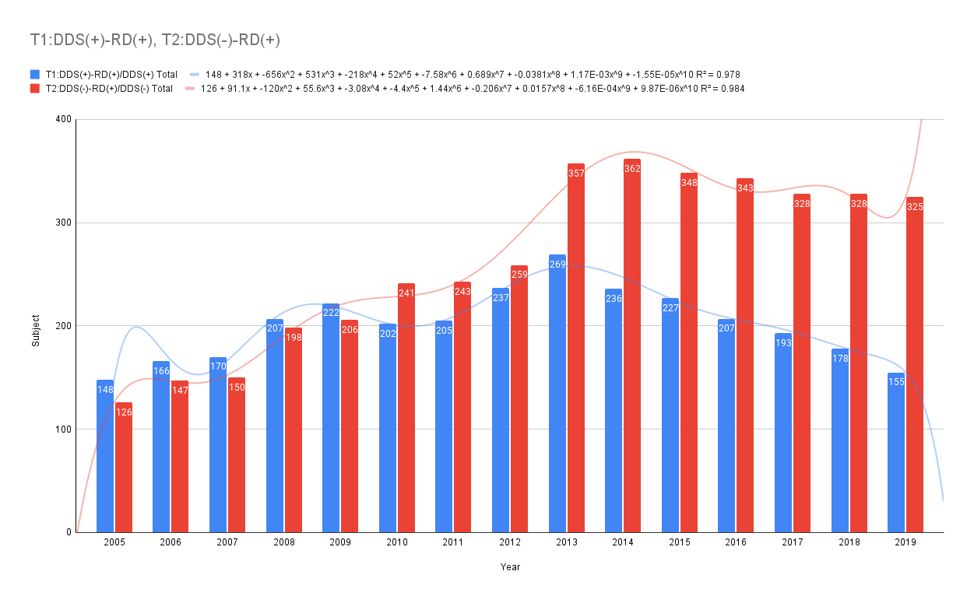

One is DDS (+) with VRD (+) subgroup, and the other is DDS (+) VRD (-). The 3022 participants (T1) who received the dapsone intervention (M = 201, SD = 34) compared to the 3961 participants (T2) in the control group (M = 264, SD = 84) demonstrated significantly better peak flow scores, t(28) = -2.7, p = .0059. HD patients with prescribed dapsone have a low prevalence of VRD

References

1. J. S. H. Kim, Leprosy in Korea: A global history. (University of California, Los Angeles, 2012).
2. S. H. K. Jane, Leprosy and Citizenship in Korea under American Occupation (1945~1948). Sahak Yonku : The Review of Korean History, 253-283 (2010).
3. M. Anthony. (LWW, 2019).
4. J.-h. Lee, H. K. An, M.-G. Sohn, P. Kivela, S. Oh, 4,4′-Diaminodiphenyl Sulfone (DDS) as an Inflammasome Competitor. International Journal of Molecular Sciences 21, 5953 (2020).
5. J. W. Han et al., Overview of the Korean Longitudinal Study on Cognitive Aging and Dementia. Psychiatry Investig 15, 767-774 (2018).

