Supporting Information

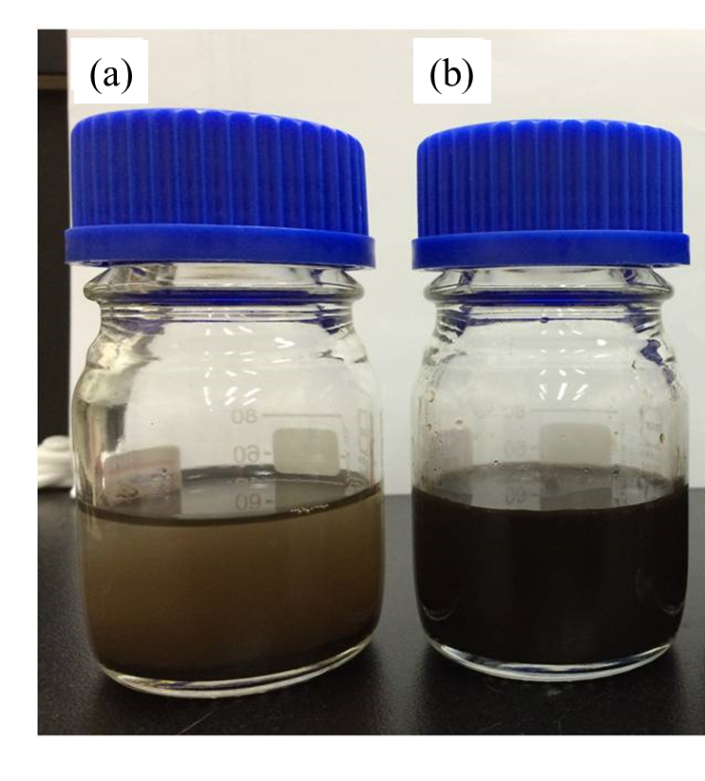
Figure S1. The photographs of (a) Fe₃O₄ MNP and (b) Fe₃O₄/HA MNP

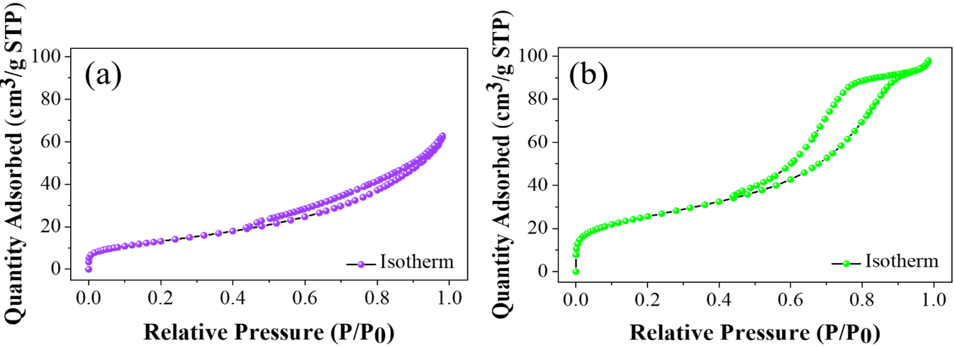
Figure S2. BET isotherms of (a) Fe₃O₄ MNP and (b) Fe₃O₄/HA MNP

Table S1. Removal efficiencies and the S/N of the Taguchi Method.
Run | Factor |  |  |  | Removal efficiency |  |  |  | S/N
Run | pH | MNP dosage  (g/L) | Time  (min) | Ionic conc.  (PO₄³⁻, SO₄²⁻, NO₃⁻, Ca²⁺) | y₁  (%) | y₂  (%) | y₃  (%) | Avg.  (y) | S/N
1 | 3 | 1 | 30 | 20 | 92.6 | 92.6 | 93.5 | 92.9 | 39.4
2 | 3 | 3 | 80 | 40 | 92.0 | 92.3 | 93.0 | 92.4 | 39.3
3 | 3 | 5 | 130 | 60 | 92.8 | 93.1 | 93.8 | 93.2 | 39.4
4 | 3 | 7 | 180 | 80 | 93.4 | 92.2 | 91.8 | 92.5 | 39.3
5 | 5 | 1 | 30 | 60 | 92.4 | 92.4 | 92.8 | 92.5 | 39.3
6 | 5 | 3 | 80 | 80 | 90.8 | 89.9 | 90.1 | 90.3 | 39.1
7 | 5 | 5 | 180 | 20 | 94.6 | 94.3 | 94.0 | 94.3 | 39.5
8 | 5 | 7 | 130 | 40 | 93.1 | 92.7 | 93.2 | 93.0 | 39.4
9 | 7 | 1 | 130 | 80 | 87.9 | 88.9 | 89.1 | 88.6 | 39.0
10 | 7 | 3 | 180 | 60 | 92.5 | 93.5 | 92.2 | 92.7 | 39.3
11 | 7 | 5 | 30 | 40 | 92.2 | 93.3 | 91.9 | 92.5 | 39.3
12 | 7 | 7 | 80 | 20 | 93.7 | 93.8 | 93.6 | 93.7 | 39.4
13 | 9 | 1 | 180 | 40 | 88.8 | 87.5 | 88.2 | 88.2 | 38.9
14 | 9 | 3 | 130 | 20 | 88.3 | 88.3 | 89.8 | 88.8 | 39.0
15 | 9 | 5 | 80 | 80 | 92.0 | 92.2 | 92.3 | 92.2 | 39.3
16 | 9 | 7 | 30 | 60 | 91.2 | 91.0 | 90.2 | 90.8 | 39.2

Table S2. Average S/N ratios as the responses for each experimental factor in As(V) adsorption
Level | Factor
Level | pH | Adsorbent dosage | Time | Ionic conc.
Level 1 | 39.35 | 39.15 | 39.25 | 39.33
Level 2 | 39.33 | 39.18 | 39.33 | 39.23
Level 3 | 39.25 | 39.38 | 39.20 | 39.30
Level 4 | 39.10 | 39.33 | 39.25 | 39.18
S/N ratio  (S/N_{max} - S/N_{min} ) | 0.25 | 0.23 | 0.13 | 0.15
Rank | 1 | 2 | 4 | 3

Table S3. Pseudo-second-order rate constants for As(V) adsorption onto adsorbents
Adsorbent |  | Fe₃O₄/HA MNP
Heavy metals |  | As(V)
MNP adsorbent (g/L) |  | 3 |  | 5
As(V) Conc. (mg/L) |  | 2 | 2
q_{e} (mg/g) |  | 0.421 |  | 0.452
k₂ (g/(mg⸳min)) |  | 0.156 |  | 0.222
t/q_{t} (g⸳min/mg) |  | 445.2 |  | 407.9
R² |  | 0.9823 |  | 0.9934

