Additional file
file 1
Table 1 List of 475 Lymphoma-Associated Genes
475 lymphoma-associated genes
ABCB1 | BMPR1A | CKS1B | ERCC3 | HBA1 | KMT2C | NFKB1 | PTEN | SMARCB1 | TRAF2
ABCC2 | BRAF | CMCT6 | ERCC4 | HBA2 | KMT2D | NFKB2 | PTPN1 | SMC1A | TRAF3
ABL1 | BRCA1 | CREBBP | ERCC5 | HBB | KRAS | NFKBIA | PTPN11 | SMC3 | TRAF5
ABL2 | BRCA2 | CSF1R | ERG | HDAC1 | LAMP1 | NFKBIE | PTPN13 | SMO | TSC1
ACTB | BRD4 | CSF3R | ESR1 | HDAC2 | LEF1 | NKX2-1 | PTPN2 | SOCS1 | TSC2
ADH1B | BRIP1 | CTCF | ETNK1 | HDAC4 | LMO1 | NOTCH1 | PTPN6 | SOX2 | TSHR
AIM1 | BTG1 | CTLA4 | ETS1 | HDAC7 | LMO2 | NOTCH2 | PTPRD | SPEN | TTF1
AIP | BTG2 | CTNNB1 | ETV1 | HGF | LYN | NPM1 | PTPRK | SPOP | TUBB3
AKT1 | BTK | CUX1 | ETV4 | HIST1H1E | LYST | NQO1 | PTPRO | SRC | TYMS
AKT2 | BTLA | CXCR4 | ETV6 | HNF1A | MAF | NRAS | RAB27A | SRP72 | U2AF1
AKT3 | BUB1B | CYLD | EWSR1 | HNF1B | MAFB | NSD1 | RAC3 | SRSF2 | UGT1A1
ALDH2 | CALR | CYP19A1 | EZH2 | HRAS | MALT1 | NT5C2 | RAD21 | SRY | UNC13D
ALK | CARD11 | CYP2A6 | FANCA | HSD3B1 | MAP2K1 | NTRK1 | RAD50 | STAG2 | VEGFA
ANKRD26 | CBFB | CYP2B6*6 | FANCC | ID3 | MAP2K2 | NTRK3 | RAD51 | STAT3 | VHL
AP3B1 | CBL | CYP2C19*2 | FANCD2 | IDH1 | MAP2K4 | NUP98 | RAF1 | STAT5A | WHSC1 (NSD2)
APC | CBLB | CYP2C9*3 | FANCE | IDH2 | MAP3K1 | P2RY8 | RARA | STAT5B | WT1
AR | CCND1 | CYP2D6 | FANCF | IGF1R | MAP3K14 | PAG1 | RASGEF1A | STAT6 | XIAP
ARHGAP26 | CCND2 | CYP3A4*4 | FANCG | IKBKE | MAP4K3 | PAK3 | RB1 | STIL | XPC
ARID1A | CCND3 | CYP3A5*3 | FANCL | IKZF1 | MAPK1 | PALB2 | RECQL4 | STK11 | XPO1
ARID1B | CCNE1 | DAXX | FAS | IKZF2 | MCL1 | PAX5 | REL | STMN1 | XRCC1
ARID2 | CCR4 | DDR2 | FAT1 | IKZF3 | MDM2 | PBRM1 | RELN | STT3A | YAP1
ARID5B | CCT6B | DDX3X | FAT4 | IL7R | MDM4 | PC | RET | STX11 | ZAP70
ASXL1 | CD22 | DDX41 | FBXO11 | INPP4B | MED12 | PDCD1 | RHOA | STXBP2 | ZBTB7A
ASXL2 | CD274 | DHFR | FBXW7 | INPP5D | MEF2B | PDCD1LG2 | RICTOR | SUFU | ZNF2
ASXL3 | CD28 | DHX15 | FGFR1 | IRF1 | MEN1 | PDE11A | RNF43 | SUZ12 | ZRSR2
ATG5 | CD58 | DICER1 | FGFR2 | IRF4 | MET | PDGFRA | ROS1 | SYK
ATM | CD70 | DNM2 | FGFR3 | IRF8 | MFHAS1 | PDGFRB | RPTOR | TAL1
ATR | CD74 | DNMT3A | FGFR4 | ITPKB | MGA | PDK1 | RRM1 | TBL1XR1
ATRX | CD79A | DNMT3B | FH | JAK1 | MGMT | PGR | RUNX1 | TBX21
AURKA | CD79B | DOT1L | FIP1L1 | JAK2 | MITF | PHF6 | RUNX1T1 | TCF3
AURKB | CD83 | DPYD | FLCN | JAK3 | MLH1 | PHOX2B | RUNX3 | TCL1A
AXIN1 | CDA | DTX1 | FLT1 | JARID2 | MLH3 | PIK3CA | SBDS | TEK
AXL | CDC73 | DUSP2 | FLT3 | JUN | MPL | PIK3CD | SDC4 | TEKT4
B2M | CDH1 | DUSP22 | FLT4 | KDM2B | MRE11A | PIK3R1 | SDHA | TERT
BAP1 | CDK10 | EBF1 | FOXO1 | KDM5A | MSH2 | PIK3R2 | SDHB | TET2
BARD1 | CDK12 | ECSIT | FOXO3 | KDM5C | MSH3 | PIM1 | SDHC | TGFBR2
BCL10 | CDK4 | ECT2L | FYN | KDM6A | MSH6 | PLCG2 | SDHD | TLE1
BCL11B | CDK6 | EED | GADD45B | KDR | MTHFR | PML | SERP2 | TLE4
BCL2 | CDK8 | EGFR | GATA1 | KIF5B | MTOR | PMS1 | SETBP1 | TMPRSS2
BCL2L1 | CDKN1B | EGR1 | GATA2 | KIR2DL4 | MUTYH | PMS2 | SETD2 | TNFAIP3
BCL2L2 | CDKN1C | EML4 | GATA3 | KIR3DL2 | MYC | POLE | SF3B1 | TNFRSF11A
BCL6 | CDKN2A | EP300 | GNA11 | KIT | MYCL | POT1 | SGK1 | TNFRSF14
BCL7A | CDKN2B | EPCAM | GNA13 | KLF2 | MYCN | POU2AF1 | SH2B3 | TNFRSF17
BCOR | CDKN2C | EPHA2 | GNAQ | KLHL6 | MYD88 | PPM1D | SH2D1A | TNFRSF19
BCORL1 | CEBPA | EPHA3 | GNAS | KLLN | MYH11 | PPP2R1A | SLC34A2 | TOP1
BCR | CEP57 | ERBB2 | GRIN2A | KLRC1 | NAT1 | PRDM1 | SLC7A8 | TOP2A
BIM (BCL2L11) | CHD8 | ERBB3 | GSTM1 | KLRC2 | NBN | PRF1 | SMAD2 | TP53
BIRC3 | CHEK1 | ERBB4 | GSTP1 | KLRK1 | NCSTN | PRKAR1A | SMAD4 | TP63
BIRC5 | CHEK2 | ERCC1 | GSTT1 | KMT2A | NF1 | PRKCB | SMAD7 | TP73
BLM | CIITA | ERCC2 | HACE1 | KMT2B | NF2 | PTCH1 | SMARCA4 | TPMT

file 2
Figure1 Transcripts, primer sequences, and CpG islands of all detected genes of HH pathway
a SHH gene
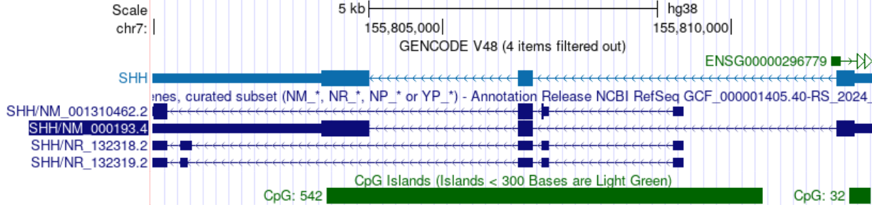
 | primer sequences | lengths
SHH-T1 | F 5' AAAGTTTTTGGGGAAGAAAAATTAA 3' | 216 bp
 | R 5' TCTTATAATAACAACAATTACTCCC 3'
 | F 5' TTTTTTGTTTTTTGATTGTTGTTT 3' | 299 bp
 | R 5' CCCATAAAACTAATAACTTCC 3'
 | F 5' GGAAGAGGAGGTATTTTAAAAAGTTG 3' | 215 bp
 | R 5' TCCTACCTAAATCATCAACCTATCC 3'
SHH-T2 | F 5' ATTTTTAATTGGAAAAGTTAGGAGG 3' | 216 bp
 | R 5' ATTCTAAATCCCTCCCCTAAAATAC 3'
 | F 5' TGGTTTTGATTTTTTTGTTTTTTTT 3' | 162 bp
 | R 5' AAAAACTCCCTCCAACCAACTAC 3'
 | F 5' GTTTGTTTGGTTTTTAGGTTTT 3' | 256 bp
 | R 5' TCCTTCCCCCTCCTTTTATATTA 3'
 | F 5' GTTTTTGGGTTTTTAATGTGATTGT 3' | 217 bp
 | R 5' CCTCTAACCTCCTACCCCTTAAA 3'
 | F 5' GGTGAAAGTAGGTAAGTTGGTTTTG 3' | 284 bp
 | R 5' ACCCCCTACAATAAAAACTCCAA 3'
 | F 5' TTTTTATTTGTAAAAAGTATGATTT 3' | 266 bp
 | R 5' TATTTACACAACCAAACCTCTCTTC 3'
The primer sequences for two transcripts with different transcription start sites, NM_000193.4 and NM_001310462.2, were designed and are divided into two segments, T1 and T2. Segment T1 (SHH-T1) contains 43 CpG sites, 31 of which are located in CpG island 32. Segment T2 (SHH-T2) contains 88 CpG sites, 78 of which are located in CpG island 542.

b PTCH1 gene
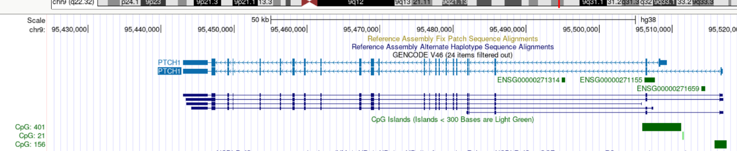
 | primer sequences | lengths
PTCH1-T1 | F 5' ATTTTTATTTATAATGTGGTTTATTTAAAG 3' | 232 bp
 | R 5' ACCCAAATACTCCCACCTACTATAC 3'
 | F 5' TTATTTTGGTTTTTTTTAGAAGAAA 3' | 277 bp
 | R 5' CACCACCTTTCATACTTACATTCTC 3'
 | F 5' TGGTTAAATGTTAGTAAATAATGTGTG 3' | 221 bp
 | R 5' ATCAACACAACCCTCCTAAATAAAC 3'
 | F 5' GAGGGTTATGGAATTGTTTAATAGAAATA3' | 300 bp
 | R 5' TAAATTTCACATCAATTCCTTTTT3'
PTCH1-T2 | F 5' TTAAAGATGAAATTGGTAATGTGTG 3' | 353 bp
 | R 5' CTAACCACCTTCCCTCCAAC 3'
 | F 5' TAAAGTGAAGTAAATTAAGGGTTTG 3' | 283 bp
 | R 5' CTAAATTCATTAAAAACAAACTATAC 3'
 | F 5' GTTTGAGGTTAAGGTGTTTTTGAAA 3' | 211 bp
 | R 5' TACTCCCCCTCCTTTCTCTCTTAT 3'
 | F 5' GAGTTGTTGTTAAGTAGTTAATAATAG 3' | 204 bp
 | R 5' AAAAACTCTCTCCATTTAAAAAAAA3'
 | F 5' TTATTTATTGAATTAAGGAGTTGTTG 3' | 428 bp
 | R 5' CCCTTCACTACAAAAAAAACCAA 3'
Based on two transcripts with different transcription start sites, ENST00000437951.6 and ENST000000331920.11, primer sequences were designed and are divided into two segments, T1 and T2, as follows. Segment T1 (PTCH1-T1) contains 40 CpG sites, all of which are located in CpG island 156. Segment T2 (PTCH1-T2) contains 58 CpG sites, of which 13 are located in CpG island 21 and 43 are located in CpG island 401.

c HHIP gene

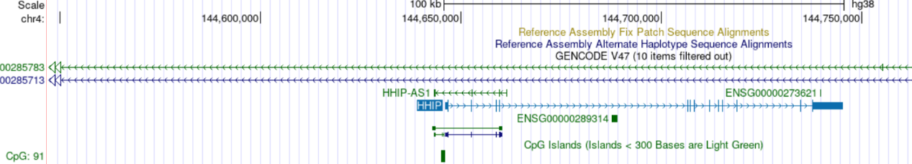

 | primer sequences | lengths
HHIP | F 5' AGTTGGGGAAAAGGTTAATTTATTT 3' | 178 bp
 | R 5' CACACACACACACACACCTACAC 3'
 | F 5' GAATATATGTGGGGATTTGAAAGG3' | 227 bp
 | R 5' AACTTAAAAACAAAAAAACATCCCA 3'
 | F 5' AAGTGGGGAGGAGAGAGGAGTTT3' | 384 bp
 | R 5' CCTCTTTTCTTCTTCTTTTTAACTAAC3'
 | F 5' ATGAGAGGTTGTGTGAGAAGTTGTA3' | 180 bp
 | R 5' AAAAAAACAACCACAAATATTCACTTAT3'
 | F 5' GTTTTAGTGTTTTTGTTGGGTAGTG3' | 244 bp
 | R 5' ACATCATCCTCCTATCTCTCCTTTT3'
 | F 5' TTTTTTGGGGGAGTTTTTTTTATA 3' | 262 bp
 | R 5' CAACCACCTTAATTTACAATTTCAC3'
Based on the reference transcript ENST00000296575.8 of the HHIP gene, primer sequences were designed. It contains 53 CpG sites, 17 of which are located in CpG island 91.

d GLI1 gene
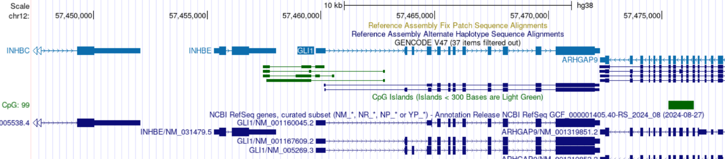
 | primer sequences | lengths
GLI1 | F 5' TAGAGATTGAAATGTTGTTTTTTTT 3' | 276 bp
 | R 5' AACTTTCTACTCCCTCTACTAACC3'
 | F 5' GGAAGAGTAGTTAGAGTTTGTAGTGA 3' | 178 bp
 | R 5' ATAAAACATAAAAACAAAAAACAAC 3'
 | F 5' TTTTAATTTAATTTGATTTGTTTTAAAT3' | 225 bp
 | R 5' ACTAACCCCAAAAAAACCCC 3'
 | F 5' TAGTATAGGGTTTTTTAAGGGAGGG 3' | 195 bp
 | R 5' CAAAAACTTTTTCTCTCTCCAACC 3'
 | F 5' AAAAAGTTTTTGTAAAAGGGAAAAA 3' | 304 bp
 | R 5' TAAAAAACTAAACATCCCCTCAAAC3'
 | F 5' TAAGTTTAAGAGGTTGGAGGGATG3' | 215 bp
 | R 5' TCACAAAACAAATCAAAAATTCAAA 3'
Based on the reference transcript ENST00000228682.7 of the GLI1 gene, primer sequences were designed. It contains 16 CpG sites and does not involve any CpG islands.

e SMO gene
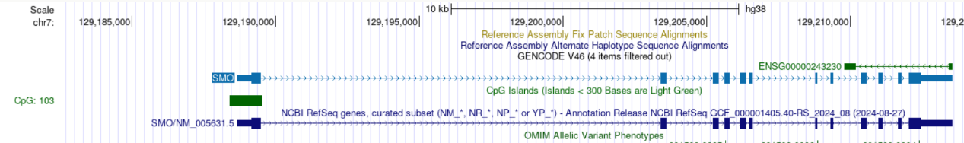
 | primer sequences | lengths
SMO | F 5' AGTTTTTGTTTTTGGAGAAGTTTTAG 3' | 187 bp
 | R 5' TAAATAATTTAACACCATCCTCCTC 3'
 | F 5' ATTTAATTAAAGTAGGAAAAATTGG 3' | 252 bp
 | R 5' AACTAAAAAAATCTAATAACCCC 3'
 | F 5' AGGGTTGAAGATAATTTGGATTG 3' | 350 bp
 | R 5' CAACAACAACAACAACAACAAC 3'
 | F 5' TTGTTGTTGTTGTTGTTGGG 3' | 225 bp
 | R 5' CAACAATATAAAAATAACCCC 3'
 | F 5' GGGGTTATTTTTATATTGTTGGT 3' | 166 bp
 | R 5' AAAACTCAAACCTAAACCTATTCTTTC 3'
Based on the reference transcript NM_005631.5 of the SMO gene, primer sequences were designed. It contains 50 CpG sites, 38 of which are located in CpG island 103.

f SUFU gene
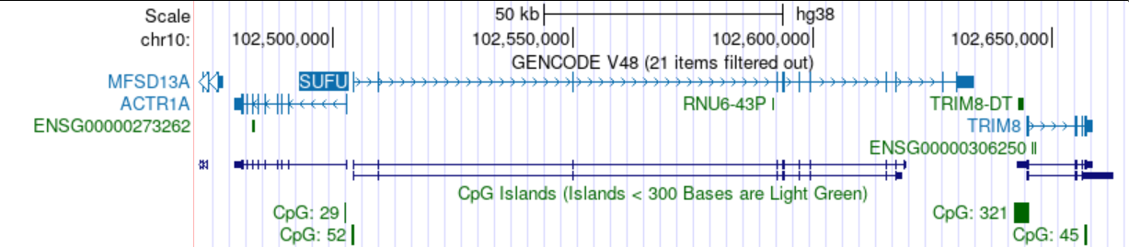
 | primer sequences | lengths
SUFU | F 5' TTTTATTTTATTTTTGTTGGTTGGT 3' | 174 bp
 | R 5' TAAAAAAACTTAAACTCTCCTCCTC3'
 | F 5' TTTGGGGAAGGAATTGTTTAGT 3' | 230 bp
 | R 5' AAAACCACAAATCCCAAAATACTAC 3'
 | F 5' ATTAGTTAATGGGTGTTTGGATAGG3' | 243 bp
 | R 5' CACTAAAAAAACTAAAAAAAACAAAC 3'
 | F 5' GAGGGAAGGAGTTAAGGTTTAAGTT 3' | 281 bp
 | R 5' CTCCAAAACCCTCTCAAATACTC 3'
Based on the reference transcript ENST00000369902.8 of the SUFU gene, primer sequences were designed. It contains 18 CpG sites, 13 of which are located in CpG island.

file 3
Table 2 The primer sequences and lengths of the HH relevant genes
Gene | Primer sequences | Lengths | Tm
SHH | F 5' CTAGTCCTCGTCTCCTCGC 3' | 166 | 58℃
 | R 5' GTCACCCGCAGTTTCACT 3'
PTCH1 | F 5' TTCGCTCTGGAGCAGATTTC 3' | 152 | 58℃
 | R 5' CCAAATATGAGGAGGCCCAC 3'
SMO | F 5' CAGGACATGCACAGCTACAT 3' | 157 | 58℃
 | R 5' CAATGCTGCCCACAAAGAAG 3'
GLI1 | F 5' CCACCAGAGAATGGAGCATC 3' | 137 | 58℃
 | R 5' AGACCACCTATCCGATCCAG 3'
HHIP | F 5' TGATTTGAGAACAGCCAGAGTC 3' | 184 | 58℃
 | R 5' CAGCCGTAGCACTGAGCC 3'
GAPDH | F 5' AGAAGGCTGGGGCTCATTTG 3' | 140 | 60℃
（内参） | R 5' GCAGGAGGCATTGCTGATGAT 3'

file 4
Figure 2 Clustering heatmap of methylation levels for DMCs and DMRs and their distribution on genomic elements

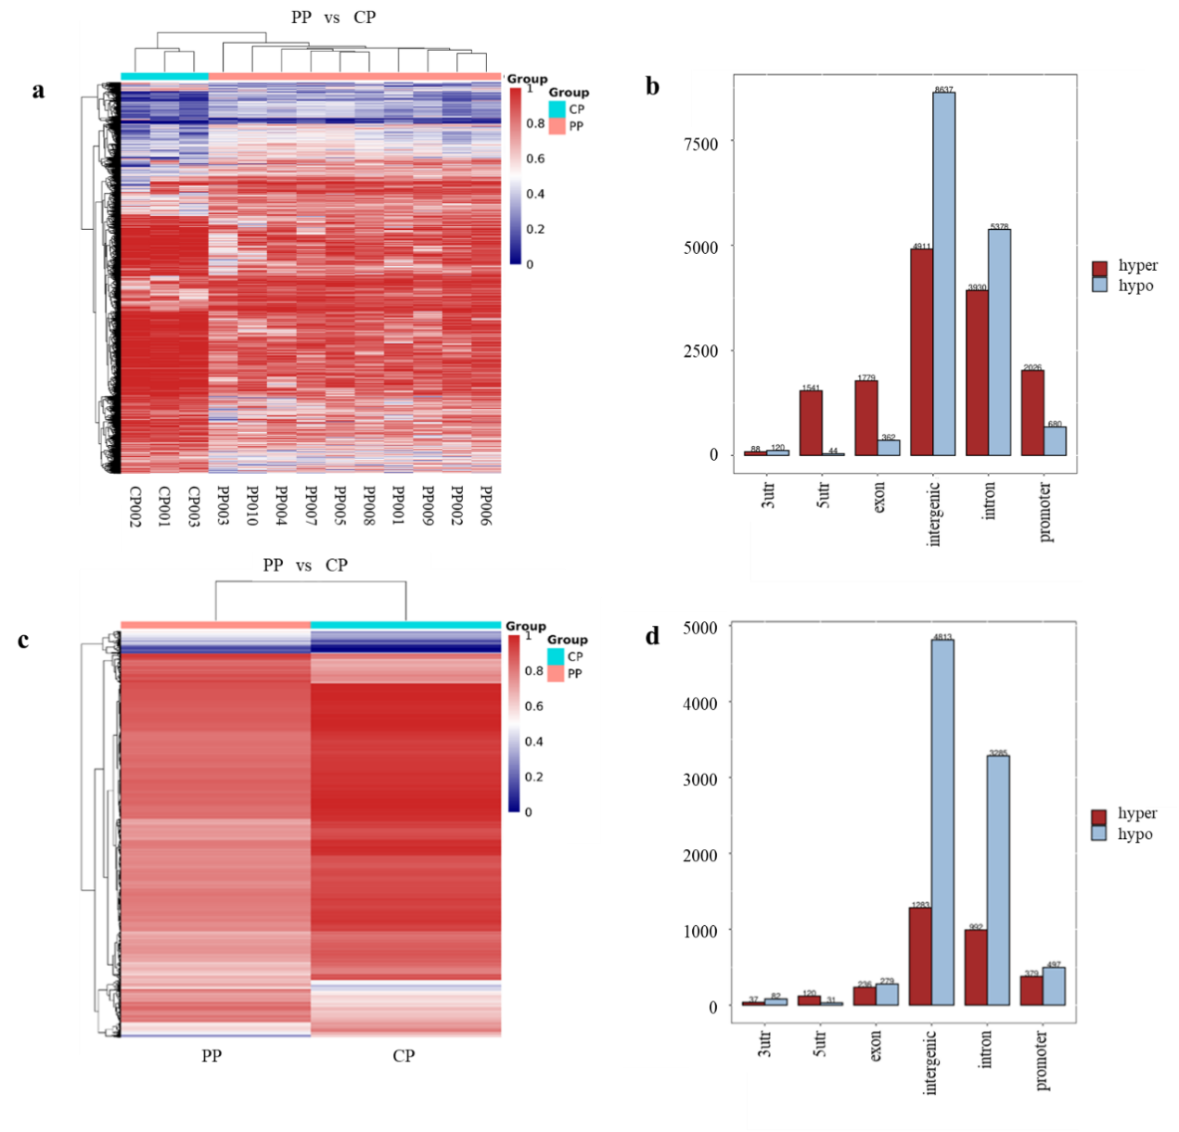
a clustering heatmap of DMC methylation levels; b distribution of DMCs across genetic elements; c clustering heatmap of DMR methylation levels; d distribution of DMRs across genetic elements;
PP: peripheral blood cfDNA from DLBCL patients, CP: peripheral blood cfDNA from controls.

file 5
Figure 3 Association analysis of PTCH1-T1 methylation with its expression and pathway activation in DLBCL

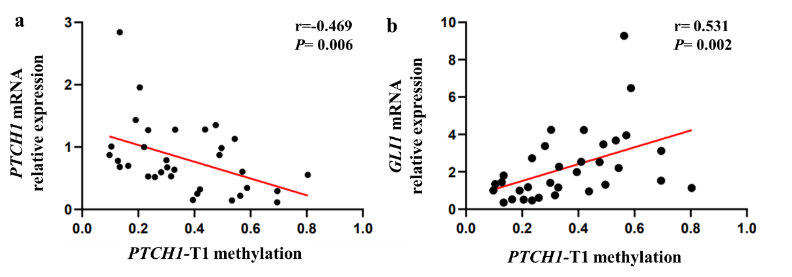
a correlation between PTCH1-T1 methylation level and PTCH1 mRNA expression (n = 33); b correlation between PTCH1-T1 methylation level and GLI1 mRNA expression (n = 33);

File 6
Figure 4 Heatmap of CpG site methylation of HH pathway-related genes in DLBCL cell lines

